PILLAI COLLEGE OF ENGINEERING

Snake Game using Java
A Mini Project Report
Java Programming
Submitted by
Tanishq Salunkhe
Roll No. A-561
T.Y. B.Tech, Electronics and Telecommunication (EXTC), Division A
Under the guidance of
Prof. Aboli Khedkar
Department of Electronics and Telecommunication Engineering
Pillai College of Engineering
Academic Year: 2026–2027

TABLE OF CONTENTS

Chapter / Section | Page
List of Figures | 3
List of Tables | 4
Chapter 1: Introduction | 5
Chapter 2: Existing and Proposed System | 7
Chapter 3: Software Requirements and Technologies Used | 8
Chapter 4: System Design | 9
Chapter 5: Modules and Implementation | 12
Chapter 6: Working of the System and Output Screens | 15
Chapter 7: Results | 18
Chapter 8: Advantages, Limitations, Future Scope and Conclusion | 19
References | 21

LIST OF FIGURES
Figure No. | Title | Page
Figure 4.1 | Overall architecture of the Snake Game | 10
Figure 4.2 | Flowchart of the Snake Game | 11
Figure 6.1 | Snake Game start screen | 15
Figure 6.2 | Active game screen showing score, snake and food | 16
Figure 6.3 | Game-over screen with final score | 17

LIST OF TABLES
Table No. | Title | Page
Table 2.1 | Traditional game approach versus proposed Java game | 7
Table 3.1 | Software requirements | 8
Table 3.2 | Technologies and programming concepts used | 8
Table 4.1 | Main game elements | 10
Table 5.1 | Module description | 12
Table 5.2 | Important game variables and their purpose | 13
Table 7.1 | Observed test cases and results | 18

CHAPTER 1: INTRODUCTION
1.1 Introduction
Snake is a classic arcade-style game in which the player controls a moving snake inside a bounded game area. The objective is to collect food, increase the score and continue moving without colliding with the boundary or the snake itself. The game is simple to understand, but its implementation requires continuous movement, keyboard input, collision detection, score handling and game-state control.
This mini project presents a Snake Game developed using Java. The project provides a graphical game interface in which the player first enters the snake's name and starts the game. During play, the score is displayed along with the player's snake name. The snake is controlled using the arrow keys, while food is placed inside the game area. When the snake successfully reaches the food, the score increases and the game continues.
The project demonstrates how core Java programming concepts can be combined to build an interactive game. The implementation focuses on keyboard events, movement logic, game-state management, score updating, random food placement, collision detection and restarting the game after a game-over condition.
1.2 Problem Statement
The objective is to design and implement a simple interactive Snake Game in Java that responds to real-time keyboard input and maintains the state of the game while the player is moving the snake.
- The player must be able to enter a name before starting the game.
- The snake should move continuously according to the selected direction.
- The player should control the snake using the four arrow keys.
- Food should appear inside the playable game area and should be collected by the snake.
- The score should increase when food is collected.
- The game should detect collision conditions and end the game when the snake can no longer continue.
- A restart option should allow the player to start another game.
1.3 Objectives
- To develop a simple Snake Game using Java.
- To provide an interactive start screen where the player can enter the snake's name.
- To implement continuous snake movement controlled by arrow keys.
- To implement food generation and score increment.
- To detect collision and display a game-over message.
- To provide a restart mechanism for a new game.
- To apply Java programming concepts such as variables, conditions, loops, event handling and modular program design.
1.4 Scope of the Project
The current project covers the following features:
- Player name entry before starting the game.
- A dedicated game board for snake movement.
- Arrow-key based movement: Up, Down, Left and Right.
- Food displayed inside the game area.
- Live score display and player/snake name display.
- Collision-based game termination.
- Game-over message containing the player's score.
- Restart button for starting a fresh game.
The project is intended as a compact academic game application. Features such as online multiplayer, persistent high-score storage, user accounts, network play and advanced game levels are outside the present scope.

CHAPTER 2: EXISTING AND PROPOSED SYSTEM
2.1 Existing / Traditional Approach
A traditional Snake Game implementation is often created as a basic program with a fixed game area, simple movement and minimal user interaction. In a very basic implementation, the player may start immediately without a name, the interface may not provide a dedicated restart control, and the game state may be difficult to extend.
For a learning project, such an approach is useful for understanding the basic movement algorithm, but it does not demonstrate the complete interaction flow used in the present project.
2.2 Proposed System
The proposed system is a Java-based Snake Game with a clear start screen and a dedicated gameplay interface. The player enters the snake's name, presses START, and then controls the snake using the arrow keys. The active screen displays the score and the snake name, while the game board contains the snake and food.
- Name-based game start.
- Continuous keyboard-controlled movement.
- Food collection and score increment.
- Collision detection and game-over handling.
- Restart control for beginning a new game.
- Clear visual separation between the start screen and the gameplay screen.
2.3 Comparison
Aspect | Traditional / Basic Approach | Proposed Java Snake Game
Player identification | May start directly | Player enters a snake name
Movement | Basic directional movement | Arrow-key controlled movement
Score | Basic or minimal display | Live score shown during gameplay
Food | Food item placed in game area | Food is displayed and collected to increase score
Game termination | Collision ends the game | Game-over message displays the final score
Restart | May require rerunning the program | Restart button is provided
Interface | Minimal | Dedicated start and gameplay screens

CHAPTER 3: SOFTWARE REQUIREMENTS AND TECHNOLOGIES USED
3.1 Software Requirements
The project is lightweight and can be developed and executed on a standard computer with a Java development environment.
Software | Details
Programming Language | Java
Development Kit | Java Development Kit (JDK)
Development Environment | Any Java-supported IDE / code editor
Operating System | Windows or another operating system supporting Java
Input | Keyboard arrow keys

3.2 Technologies and Programming Concepts Used
Concept / Technology | Use in the Project
Java | Core programming language used to implement the game logic.
Object-Oriented Programming | Helps organize the game into logical components and reusable program structures.
Variables and Data Types | Store score, player name, direction, position and game-state information.
Conditional Statements | Used for collision checks, food collection and game-over conditions.
Loops / Timed Updates | Used to repeatedly update the snake's position during gameplay.
Keyboard Event Handling | Reads Up, Down, Left and Right arrow-key actions.
Randomization | Used for placing food at changing positions within the game area.
Graphical Interface | Displays the start screen, game board, score, snake, food and controls.

3.3 Key Concepts
The game depends on a repeated update cycle. The current direction determines the next snake position. After the position is updated, the program checks whether food has been reached and whether a collision has occurred. The score and visible game state are then updated before the next movement cycle.
Keyboard event handling is important because the user interacts with the game in real time. The four arrow keys change the direction of the snake, while the game loop continues to move the snake until the game ends.

CHAPTER 4: SYSTEM DESIGN
4.1 Overall Design
The overall design of the Snake Game can be divided into input, processing and output stages.
Stage | Description
Input | Player name and arrow-key direction controls.
Processing | Movement update, food detection, score update, collision detection and game-state management.
Output | Start screen, game board, snake, food, score, player name, game-over message and restart control.

4.2 Main Game Elements
Element | Purpose
Start Screen | Accepts the snake/player name and starts the game.
Game Board | Defines the area in which the snake moves.
Snake | Player-controlled object that moves continuously.
Food | Target collected by the snake to increase the score.
Score | Indicates the number of successful food collections.
Direction | Stores the current movement direction.
Collision Detection | Determines whether the game should end.
Restart | Resets the game so another round can be played.

4.3 System Architecture
USER INPUT | JAVA GAME LOGIC | OUTPUT / GAME STATE
Enter name | Initialize game | Start screen
Arrow keys | Update direction & position | Moving snake
Movement | Check food & collision | Score / game board
Restart | Reset state | New game
Figure 4.1: Overall architecture of the Snake Game
4.4 Flowchart
START
Enter snake name
Press START
Initialize snake, food and score
Read arrow-key input
Move snake and check food collection
Check collision
If collision → show Game Over and final score; otherwise continue
Press RESTART → initialize a new game
Figure 4.2: Flowchart of the Snake Game

CHAPTER 5: MODULES AND IMPLEMENTATION
5.1 Module Description
Module | Function
Name Entry Module | Accepts the player's snake name before the game begins.
Game Initialization Module | Creates the initial game state, snake position, food position and score.
Movement Module | Updates the snake's position according to the current direction.
Keyboard Control Module | Processes Up, Down, Left and Right arrow-key input.
Food Module | Places food in the game area and detects when the snake collects it.
Score Module | Increases and displays the score after successful food collection.
Collision Module | Checks collision conditions and determines whether the game should end.
Game Over Module | Displays the final score and stops active gameplay.
Restart Module | Resets the game state and starts a fresh round.

5.2 Important Game Variables and Their Purpose
Variable / Data | Purpose
Player / Snake Name | Stores the name entered on the start screen.
Score | Stores the current game score.
Snake Position / Body | Represents the current location and length of the snake.
Food Position | Stores the location of the food item.
Direction | Stores the current movement direction.
Game State | Indicates whether the game is running or over.
Board Dimensions | Defines the playable area and its boundaries.

5.3 Implementation
The implementation begins with the start screen. The user enters the name 'Tanishq' in the provided field and presses START. The game then initializes the snake, score and food before displaying the main game board.
During gameplay, arrow-key events are used to change the snake's direction. A repeated update mechanism moves the snake across the board. The program continuously compares the snake's position with the food position. When food is collected, the score is increased and another food position is generated.
Collision detection is used to determine whether the snake has reached a losing condition. When the collision condition is detected, active movement stops and a game-over message is displayed. The supplied output screenshot shows the message 'Game Over, Tanishq! Your score is 5.' This confirms that the game stores the player name and final score in the game-over state.
5.4 Game Logic
- Initialize the game with a starting snake position and score.
- Accept a direction from the arrow keys.
- Move the snake one update step in the selected direction.
- Check whether the snake has reached the food.
- If food is collected, increase the score and generate a new food position.
- Check for collision with the game boundary and other losing conditions implemented in the program.
- If collision occurs, end the game and display the final score.
- Allow the player to restart and repeat the game.

CHAPTER 6: WORKING OF THE SYSTEM AND OUTPUT SCREENS
The following steps describe the working of the implemented Snake Game from the user's point of view. The screenshots included in this chapter are the actual output screens supplied for the project.
Step 1: Launching the program
When the program is launched, the Snake Game start screen is displayed. The screen contains the game title, a field for entering the snake's name and a START button.
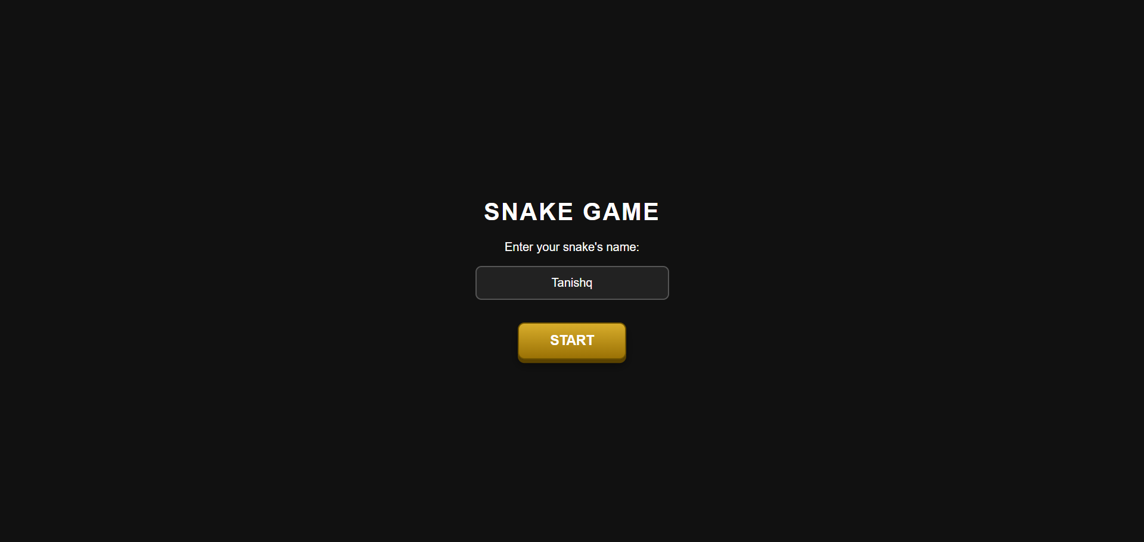
Figure 6.1: Snake Game start screen
Step 2: Entering the snake name
The player enters the name in the input field. In the supplied demonstration, the entered name is 'Tanishq'. Pressing START initializes the gameplay screen.

CHAPTER 6: WORKING OF THE SYSTEM AND OUTPUT SCREENS (CONTINUED)
Step 3: Playing the game
After starting the game, the interface displays a game board, the current score and the snake name. The instruction below the board tells the player to use the Up, Down, Left and Right arrow keys to move.
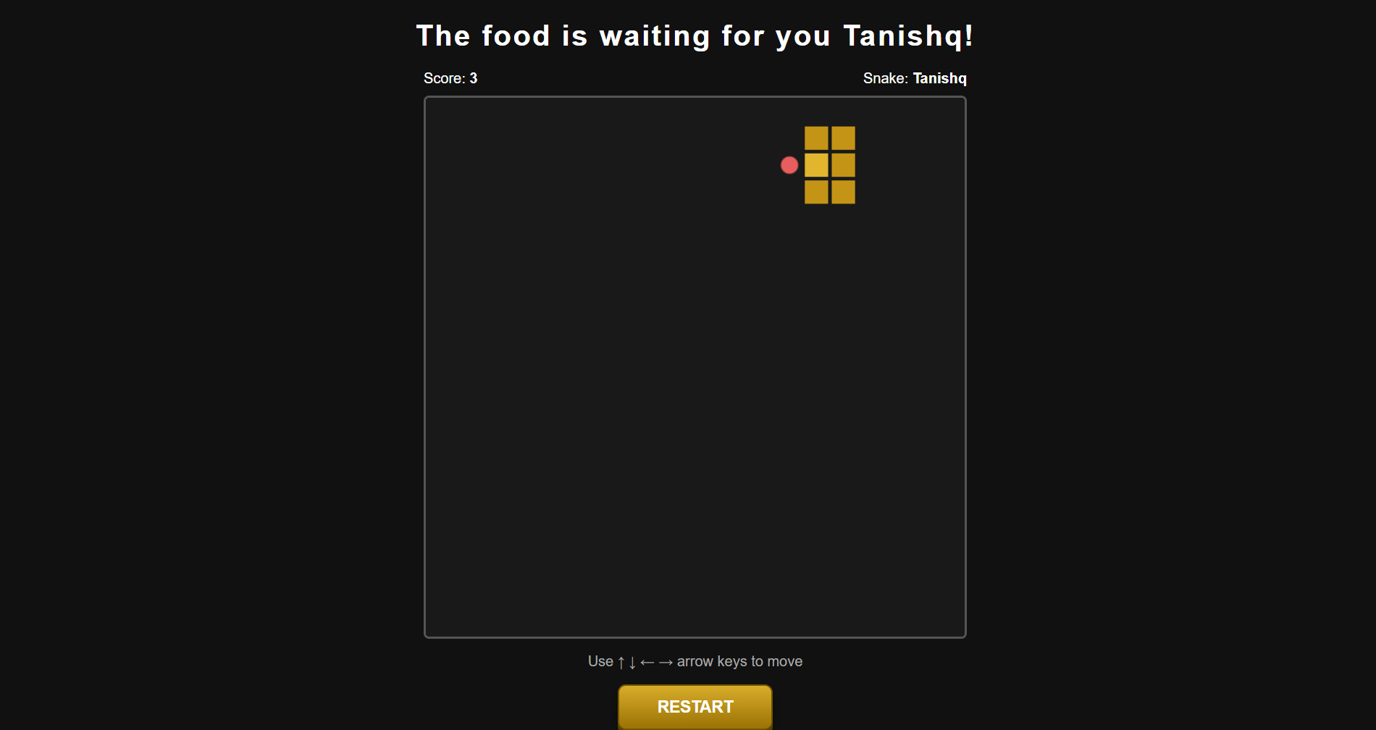
Figure 6.2: Active game screen showing score, snake and food
In the supplied output, the score is 3 and the snake name is Tanishq. The game board contains the snake and a food item. The visible score demonstrates that the game can maintain and display the progress of the current round.
Step 4: Food collection and score update
The player moves the snake toward the food using the arrow keys. When the snake reaches the food, the score is increased and the game continues. This repeated food-collection process forms the main gameplay loop.

CHAPTER 6: WORKING OF THE SYSTEM AND OUTPUT SCREENS (CONTINUED)
Step 5: Game-over condition
When a collision condition is reached, the game stops and a message is displayed with the player's name and final score. The supplied demonstration shows a final score of 5.
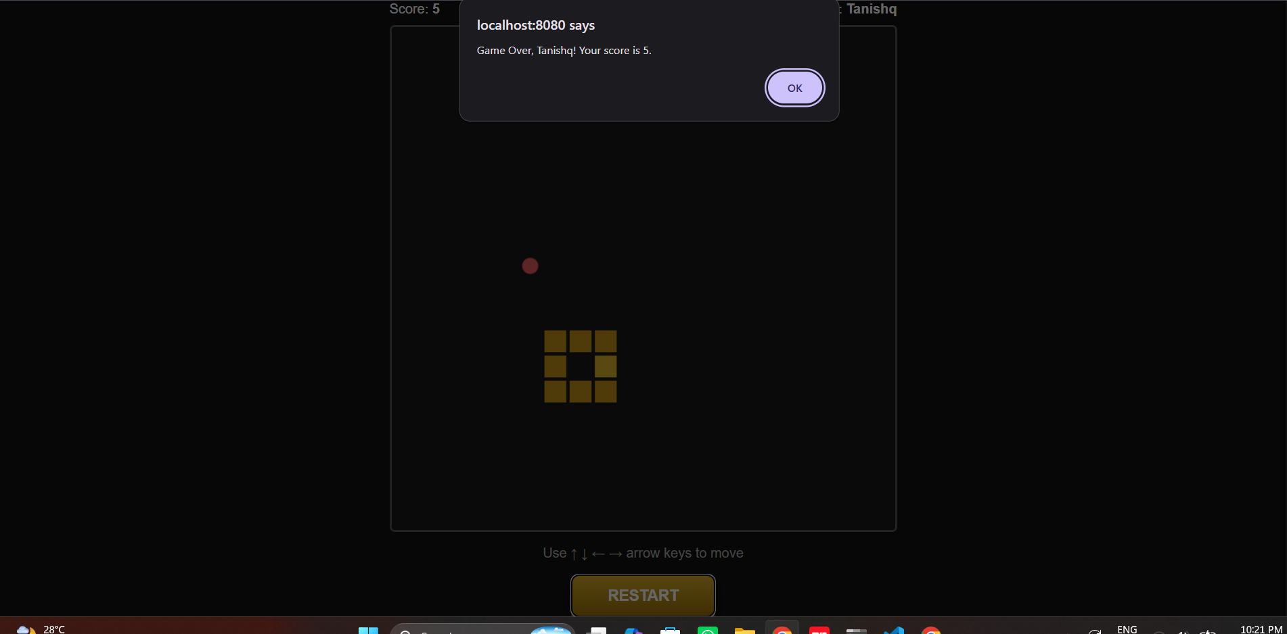
Figure 6.3: Game-over screen showing the final score
The message shown in the screenshot is 'Game Over, Tanishq! Your score is 5.' This demonstrates that the game correctly preserves the entered name and current score when the game ends.
Step 6: Restarting the game
The gameplay screen contains a RESTART button. The restart operation allows the player to reset the current game and begin another round without manually reopening the application.

CHAPTER 7: RESULTS
7.1 Results
The Snake Game was successfully implemented and tested using the supplied demonstration screens. The output confirms that the project provides a complete basic gameplay cycle from player identification to game-over handling.
Test Case | Action / Condition | Observed Result
TC01 | Launch application | Snake Game start screen is displayed.
TC02 | Enter snake name | Name 'Tanishq' is shown in the input field.
TC03 | Press START | Gameplay screen opens with score and snake name.
TC04 | Use arrow keys | Snake can be controlled in the selected direction.
TC05 | Collect food | Score increases as food is collected.
TC06 | Continue until collision | Game stops and game-over state is displayed.
TC07 | Game over at score 5 | Message displays the player name and score 5.
TC08 | Press RESTART | Game can be started again from a fresh state.

7.2 Demonstrated Output
- The start screen accepts a player/snake name.
- The gameplay screen displays the current score and snake name.
- Arrow keys are provided as the movement controls.
- The game board visibly contains the snake and food.
- The game can reach a game-over condition.
- The final score is included in the game-over message.
- A restart control is available for another attempt.

CHAPTER 8: ADVANTAGES, LIMITATIONS, FUTURE SCOPE AND CONCLUSION
8.1 Advantages
- Simple and easy-to-understand gameplay.
- Provides direct keyboard control using arrow keys.
- Displays the player's name and live score.
- Provides a clear game-over message with the final score.
- Includes a restart feature for repeated play.
- Demonstrates practical use of Java programming concepts.
- Provides an interactive graphical interface instead of a purely text-based program.
8.2 Limitations
- The present version is designed for a single player.
- There is no persistent high-score database or online leaderboard.
- The game uses a simple visual design and limited game modes.
- There are no multiple difficulty levels in the demonstrated version.
- The current project does not provide multiplayer or network-based gameplay.
- Advanced features such as sound effects, animations and power-ups are not included in the demonstrated version.
8.3 Future Scope
- Add multiple difficulty levels with different movement speeds.
- Store and display a high-score leaderboard.
- Add sound effects and background music.
- Introduce power-ups, obstacles and bonus food.
- Add pause and resume functionality.
- Provide multiple themes and improved visual effects.
- Add multiplayer or network-based gameplay.
- Store player profiles and game history.
- Add mobile or touch-based controls in a future version.
8.4 Conclusion
In this project, a Snake Game was developed using Java with an interactive interface for entering the player's name, controlling the snake, collecting food and maintaining the score. The supplied output demonstrates the complete basic flow: the user enters a name, starts the game, controls the snake using arrow keys, collects food, and receives a game-over message when a collision condition occurs.
The project provides practical experience in implementing real-time user interaction, movement logic, score management, collision detection and game-state handling. It also demonstrates how a familiar game can be used as a compact programming project to apply Java concepts in an interactive application.
The current version meets the basic objectives of a Snake Game. It can be extended in the future with high scores, difficulty levels, sound, power-ups, obstacles and multiplayer functionality.

REFERENCES
1. Oracle, Java Documentation. Online documentation for Java language and platform concepts.
2. Oracle, Java Tutorials. Object-Oriented Programming Concepts.
3. Oracle, Java Tutorials. Classes and Objects.
4. Oracle, Java Documentation. Event Handling and Keyboard Input concepts.
5. Oracle, Java Documentation. Collections and data structures.
6. H. Schildt, Java: The Complete Reference, McGraw-Hill Education.
7. E. Balagurusamy, Programming with Java: A Primer, McGraw-Hill Education.

