****************************************************************************************

**UNIFIED HOME**

*********************************************************************************

***ABSTRACT***

…………………………………………………..

*21st Century is the age of technical revolution & automation of even the smallest human tasks.*

*Concept of a smart home is thus developed beyond imagination in recent years. Major tech giants such as Google Inc, Amazon & Philipps have entered the smart home market. But still home automation remains a dream for many because of the initial setup cost.*

*Therefore, an initiative to develop a cost-effective smart socket that turns even dumb devices into IOT powered smart appliances. This save the cost of buying new WiFi enabled devices.*

**INTRODUCTION**

**________________________________________________________________________________________**

Project Outline:

Smart Socket build around ESP8266 microcontroller packaged in NodeMCU development board which has WiFi inbuilt and can control various hardware elements like relay(10Amp AC) and current sensor(5Amp ACS712) using it’s onboard GPIO Pins.

Google Firebase used as backend & extended frontend:

* *Firebase’s Realtime Database for Database*
* *Firebase’s Hosting for WebApp*
* *Firebase’s Functions for Smart Home API and Data Management*

Key Features:

1. *WiFi On/Off Control using App*
2. *Control and Query using Voice Assistant*
3. *Power Consumption Monitoring*
4. *Handle Appliance Up to 1100W*
5. *Excess Power Consumption Warnings*

**COMPONENTS**

________________________________________________________________________________________

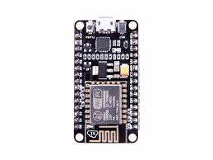

NodeMCU Development Board v2

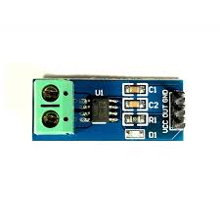

ACS712 5A

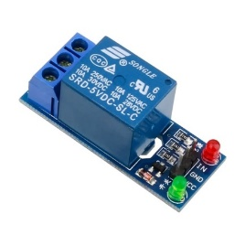 Electromechanical Relay

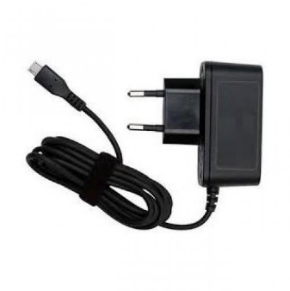

5v Power Supply

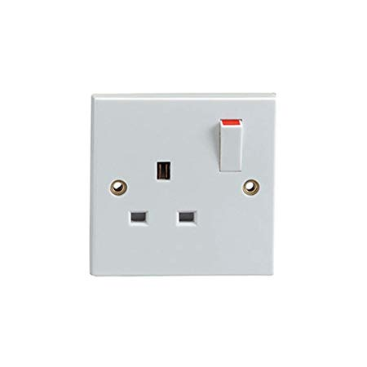

Generic Wall Socket

**RESOURCE FLOW**

________________________________________________________________________________________

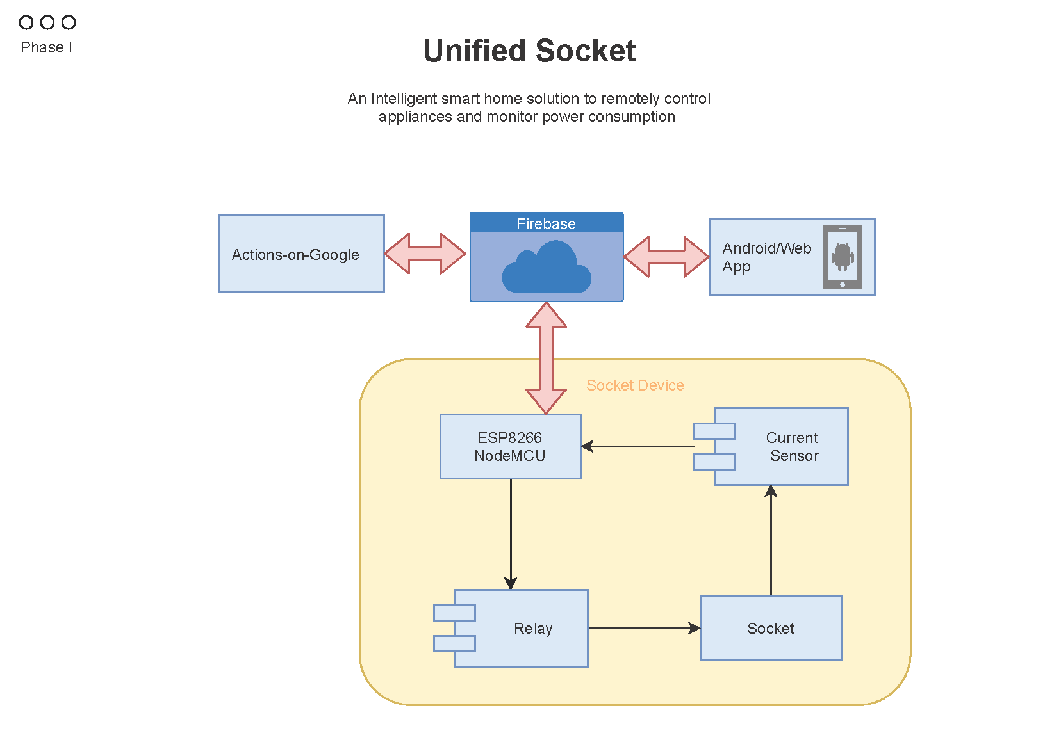

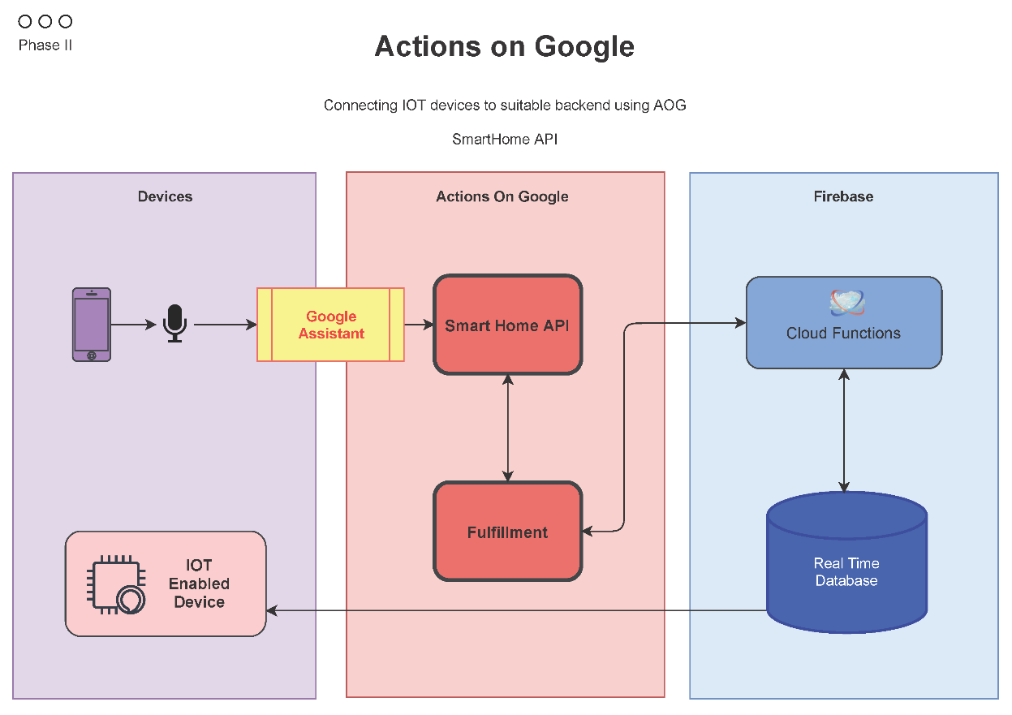

**WORKING**

________________________________________________________________________________________

NodeMCU:

Powered by a 5v Power Adapter

Controls relay module and collect analog data from current sensor module

Read and Upload data to Firebase using WiFi

Current Sensor:

Powered by NodeMCU

Uses Hall Effect sensor to calculate current amplitude

Firebase:

Act as a common database for NodeMCU, WebApp and Actions on Google Smart Home API to manipulate connected devices

**FUTURE SCOPE**

________________________________________________________________________________________

* Connecting Multiple Sockets in a Mesh Network
* Increasing Device/MCU Ratio
* Fail-Safe feature if Microcontroller fails
* Shrinking Size and Power Optimization

**REFERENCES**

________________________________________________________________________________________

* <https://developers.google.com/actions/smarthome/develop>
* <https://firebase.google.com/docs>
* <https://angular.io/docs>