OBJECTIVE

*To develop a cost-effective home automation device using easily available components that can automate even dumb devices (devices without prebuilt WiFi), as smart devices available in market a highly priced and also buying new appliances, will make your existing ones redundant.*

*Socket can be controlled manually, using mobile application or using voice commands. It will also be able to measure real-time power consumption to save electricity which will benefit the environment.*

INTRODUCTION

Project Outline:

Smart Socket build around ESP8266 microcontroller packaged in NodeMCU development board which has WiFi inbuilt and can control various hardware elements like relay (10Amp AC) and current sensor (5Amp ACS712) using it’s onboard GPIO Pins.

Google Firebase used as backend & extended frontend:

* Firebase’s Realtime Database for Database
* Firebase’s Hosting for WebApp
* Firebase’s Functions for Smart Home API and Data Management

Key Features:

1. WiFi On/Off Control using App
2. Control and Query using Voice Assistant
3. Power Consumption Monitoring
4. Handle Appliance Up to 1100W
5. Excess Power Consumption Warnings

COMPONENTS

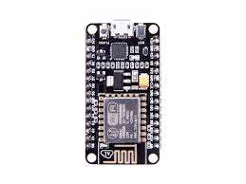

NodeMCU Development Board v2

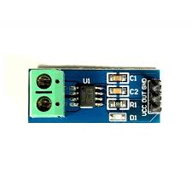

ACS712 5A

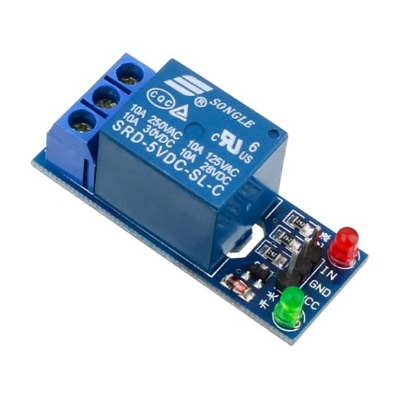

Electromechanical Relay

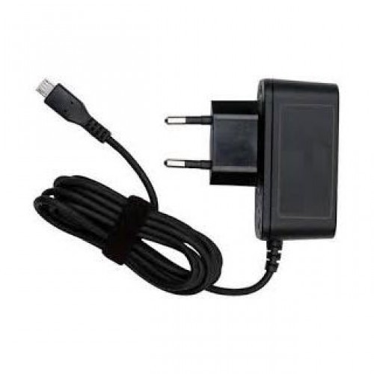

5v Power Supply

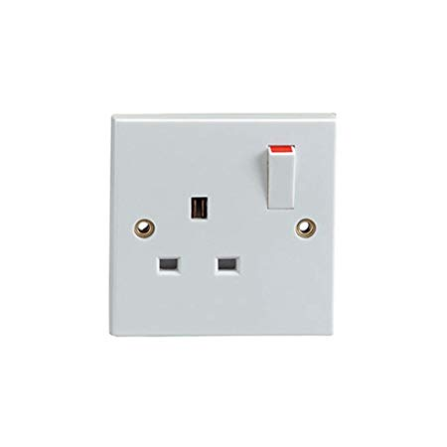

Generic Wall Socket

RESOURCE FLOW

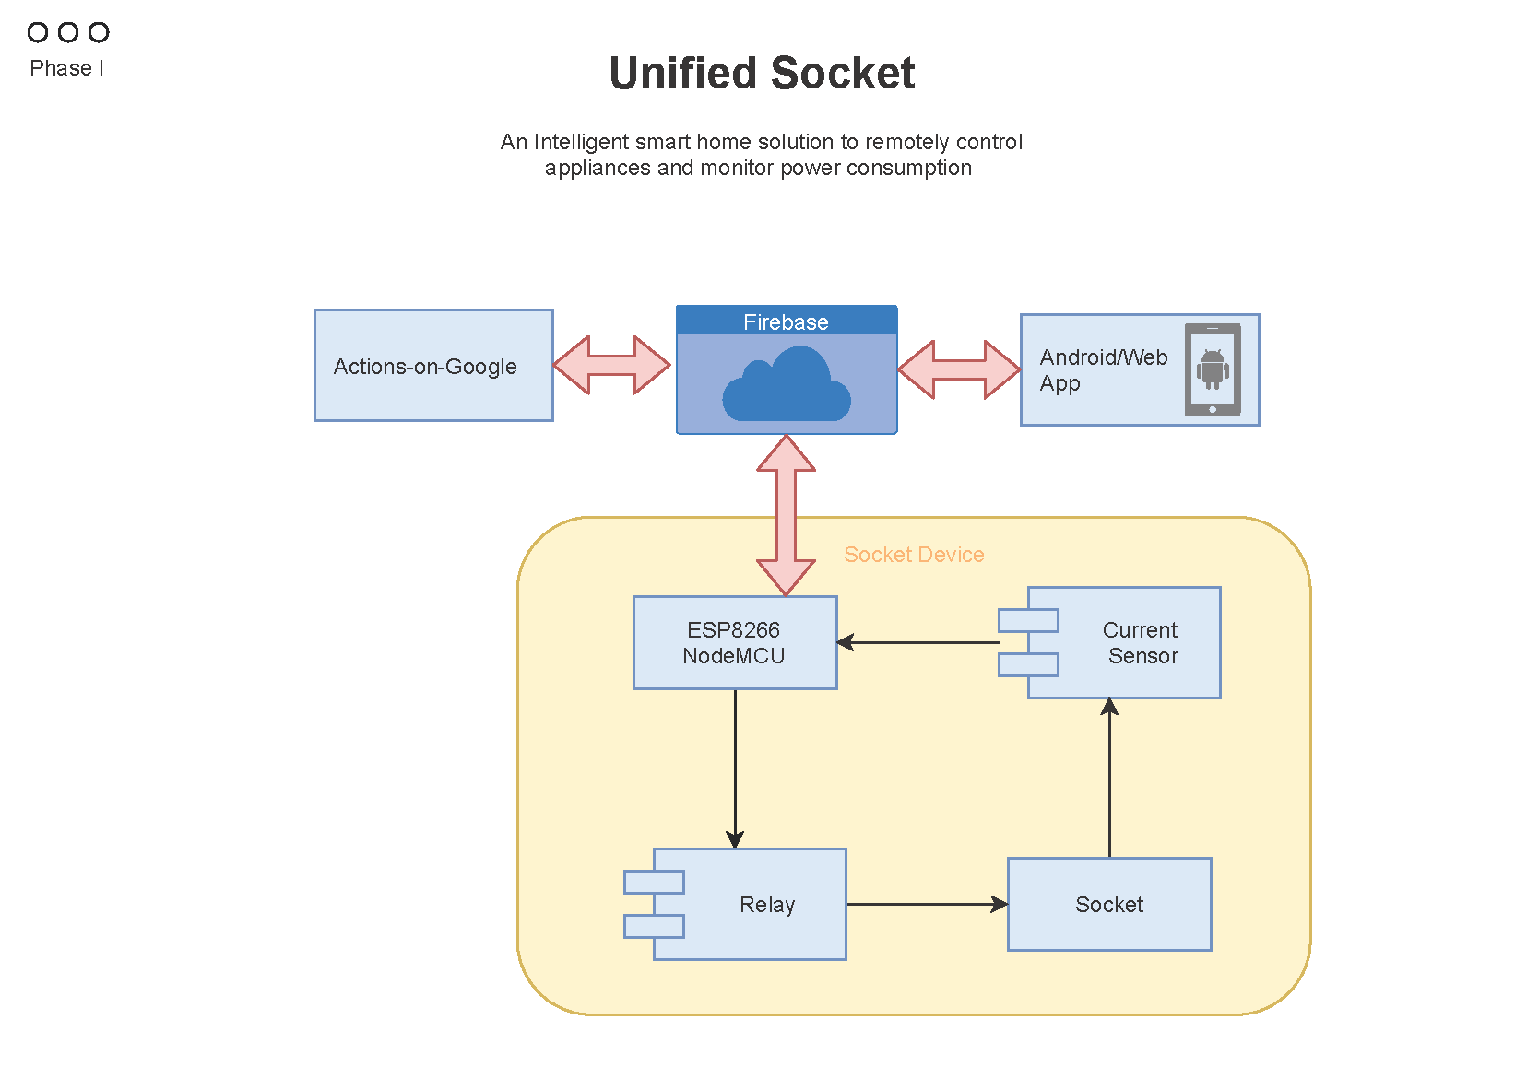

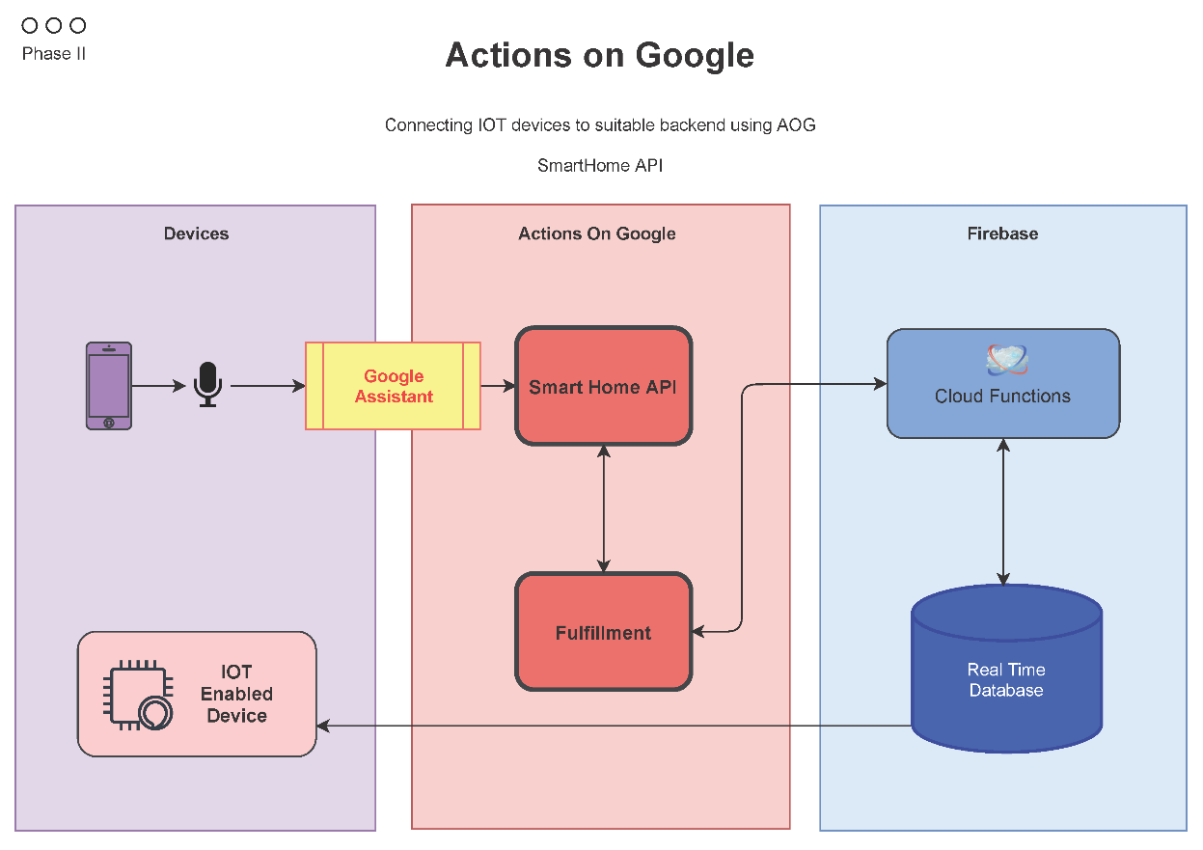

WORKING

NodeMCU:

Powered by a 5v Power Adapter

Controls relay module and collect analog data from current sensor module

Read and Upload data to Firebase using WiFi

Current Sensor:

Powered by NodeMCU

Uses Hall Effect sensor to calculate current amplitude

Firebase:

Act as a common database for NodeMCU, WebApp and Actions on Google Smart Home API to manipulate connected devices

FUTURE SCOPE

* Connecting Multiple Sockets in a Mesh Network
* Increasing Device/MCU Ratio
* Fail-Safe feature if Microcontroller fails
* Shrinking Size and Power Optimization

REFERENCES

* <https://developers.google.com/actions/smarthome/develop>
* <https://firebase.google.com/docs>
* <https://angular.io/docs>