Project Synopsis
HCLTech Career Shaper Programme | III Year Industry Project

Field | Details (Learner to complete)
Project Title | Fake News Detection using Natural Language Processing (NLP)
Project No. | 201
Domain | Digital-Data-AI
Difficulty | Intermediate
Duration | 4 Weeks
Format | Individual Project
Learner Name | Tanishq Joshi
Roll Number | 2400320101165
College / Campus | ABES Engineering College
Mentor Name
Submission Date

1. Problem Statement
Newspaper readers, social media users and journalists (who) are exposed every day to fake news — false or misleading articles written to look like genuine news (what). It spreads fastest on social media, messaging apps and low-credibility websites, especially around elections, health crises and major events (when/where). Fake news can mislead public opinion, harm public health and damage trust in genuine media, and manual fact-checking is far too slow for the volume of content published daily (why). This project uses Natural Language Processing and Machine Learning to automatically classify a news article as Real or Fake, show how confident the model is, and explain which words drove the decision (how).

2. Proposed Solution & Approach
I built an end-to-end fake news detection system in Python, trained on the public WELFake dataset of 72,134 labelled news articles. The text is cleaned (title and body merged, duplicates removed, and publisher names and website boilerplate such as “Reuters” or “Featured image via” stripped to prevent data leakage) and normalised with NLTK (lower-casing, stopword removal that keeps negation words, and lemmatisation). Articles are converted into TF-IDF features (unigrams and bigrams, 50,000 terms) and four classifiers are trained and compared: Logistic Regression, Multinomial Naive Bayes, Passive Aggressive and Linear SVM. The best model, Linear SVM, is tuned with 3-fold GridSearchCV and calibrated so it returns a confidence percentage. It is deployed in a Streamlit web app where a user can paste an article, fetch one from a URL or try a sample, and instantly see the Real/Fake verdict, a confidence meter, LIME word highlights that explain the result, and a history of previous checks.

3. System Architecture
Figure 1 shows the Level 0 Data Flow Diagram and Figure 2 shows the system block diagram.
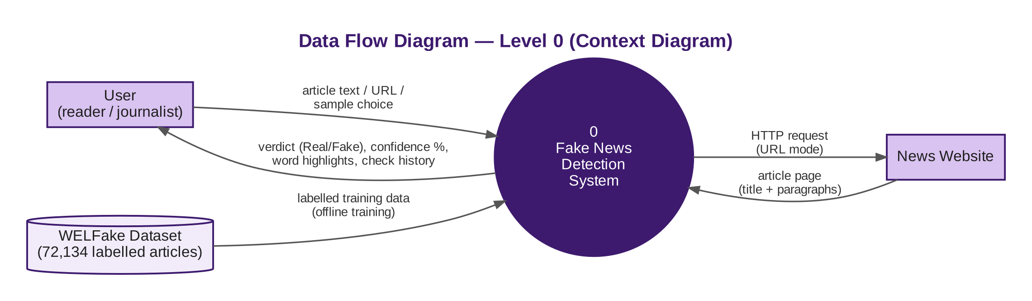
Figure 1: Data Flow Diagram — Level 0
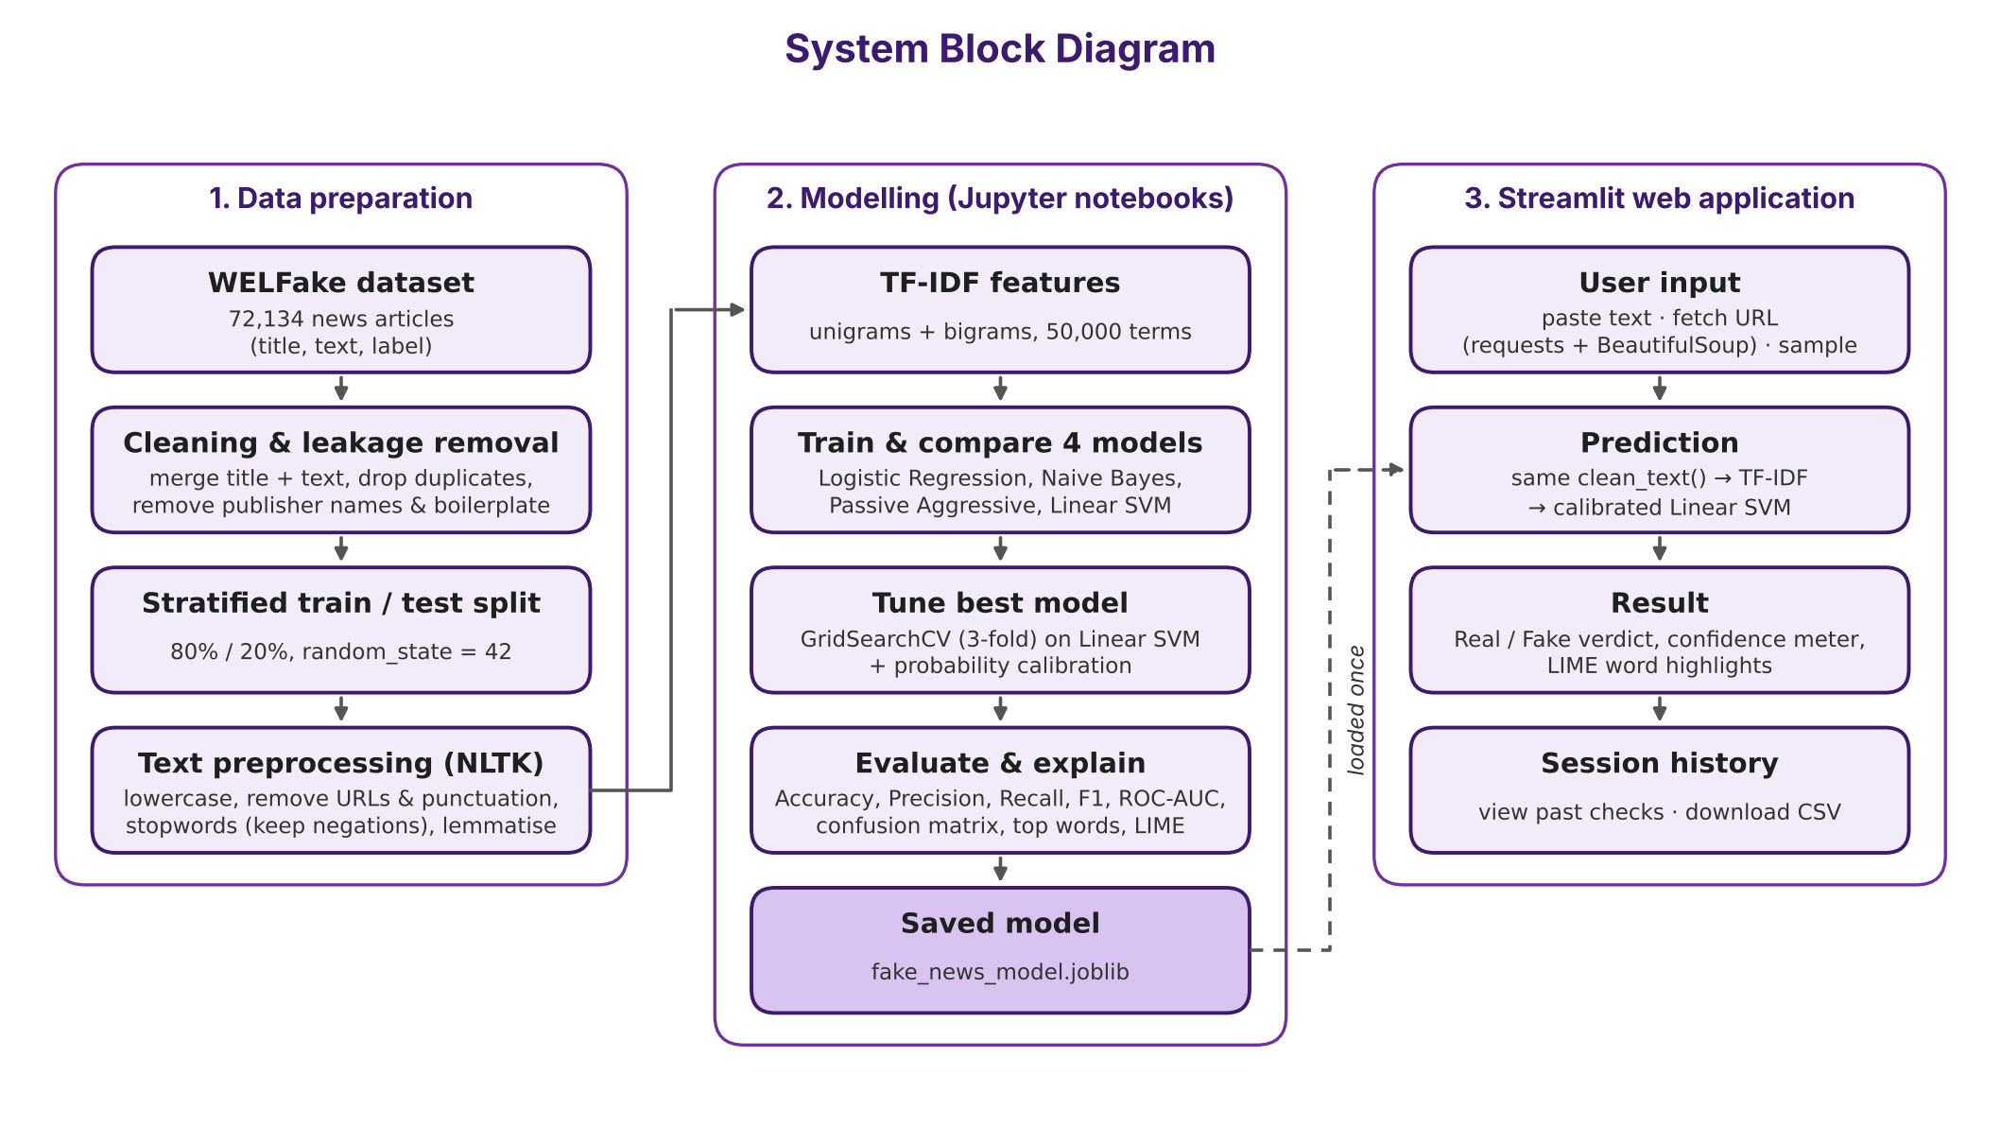
Figure 2: System block diagram (training pipeline and web application)

4. Technology Stack
Frontend / UI: Streamlit web app with a custom CSS theme (Ice Silver, Deep Aubergine, Marigold)
Backend / Logic: Python 3.13; pandas and NumPy for data handling; NLTK for text preprocessing; requests and BeautifulSoup for fetching articles from a URL; joblib for saving the model
Database: None — check history is kept in the user session (st.session_state) and can be downloaded as CSV; no personal data is stored
AI/ML Framework: scikit-learn (TfidfVectorizer, Logistic Regression, MultinomialNB, PassiveAggressiveClassifier, LinearSVC, GridSearchCV, CalibratedClassifierCV) and LIME for explainability
Visualisation: Matplotlib, Seaborn, WordCloud (EDA charts, confusion matrices, model comparison, top-word charts)
Tools: VS Code, Jupyter Notebooks, Git and GitHub
Hardware: Standard laptop (Apple MacBook Air); no GPU required

5. Dataset Used
Dataset file name: WELFake_Dataset.csv (WELFake — Word Embedding over Linguistic Features for Fake News Detection, Kaggle)
Number of rows: 72,134 news articles in the raw file (37,106 fake, 35,028 real); 63,528 unique articles after cleaning and removing duplicates (28,740 fake, 34,788 real)
Number of columns: 4 (index, title, text, label)
Key columns (list 5): title, text, label (0 = real, 1 = fake) from the dataset; content (title + text) and is_fake (verified target) derived during cleaning
Data split: 50,822 training / 12,706 testing articles (80% / 20%), stratified by label, random_state = 42
Any additional data collected: None. Articles fetched from a URL in the app are used only for that prediction and are not stored.

6. Key Results & Metrics
Metric 1: Accuracy (final model, held-out test set) — 94.1%
Metric 2: F1-score (fake class) — 0.935 (Precision 0.932, Recall 0.938, ROC-AUC 0.986)
Metric 3: Response time — under 1 second per article for the prediction; about 3–5 seconds including the LIME explanation
Model comparison (F1): Linear SVM 0.935 > Passive Aggressive 0.929 > Logistic Regression 0.925 > Naive Bayes 0.847
Effect of the leakage fix: F1 fell from 0.952 to 0.935 after website boilerplate was removed — a slightly lower but more honest score, because the model now judges the article text instead of recognising the website.
Business value achieved: readers and moderators can screen a suspicious article in seconds instead of manual checking; the confidence score and word highlights make every decision transparent, so users can see why an article was flagged and verify it with trusted sources before sharing it.

7. Challenges Faced & How Resolved
Challenge 1: Data leakage — the first models learned the source of an article instead of its content, because publisher names (“Reuters”, “The New York Times”, “Breitbart”) and website boilerplate (“Featured image via”, “Factbox”) appeared mostly in one class. → Resolution: found it through word clouds and the model’s top-weighted words, removed these phrases with regular expressions, added a leakage-check step (all counts 0) and re-trained; F1 changed from 0.952 to 0.935, a more honest result.
Challenge 2: Hyperparameter tuning took more than 30 minutes and ran out of memory on a laptop (7 settings × 3 folds, all CPU cores). → Resolution: tuned only the best model from the evaluation step (Linear SVM) and limited parallel jobs, cutting it to about 10 minutes with the same result.
Challenge 3: Linear SVM gives no probabilities, but the app needs a confidence percentage and LIME needs predict_proba. → Resolution: wrapped the tuned model in CalibratedClassifierCV, which adds calibrated probabilities without lowering the F1-score.

8. References
1. P. K. Verma, P. Agrawal, I. Amorim and R. Prodan, “WELFake: Word Embedding Over Linguistic Features for Fake News Detection,” IEEE Transactions on Computational Social Systems, vol. 8, no. 4, pp. 881–893, 2021.
2. K. Shu, A. Sliva, S. Wang, J. Tang and H. Liu, “Fake News Detection on Social Media: A Data Mining Perspective,” ACM SIGKDD Explorations Newsletter, vol. 19, no. 1, pp. 22–36, 2017.
3. H. Ahmed, I. Traore and S. Saad, “Detection of Online Fake News Using N-Gram Analysis and Machine Learning Techniques,” Proc. ISDDC 2017, Lecture Notes in Computer Science, vol. 10618, Springer, 2017.
4. M. T. Ribeiro, S. Singh and C. Guestrin, “‘Why Should I Trust You?’: Explaining the Predictions of Any Classifier,” Proc. 22nd ACM SIGKDD Conference on Knowledge Discovery and Data Mining, 2016.
5. F. Pedregosa et al., “Scikit-learn: Machine Learning in Python,” Journal of Machine Learning Research, vol. 12, pp. 2825–2830, 2011.

9. Ethical Compliance Declaration
I confirm that:
☐ All dataset usage complies with the source licence.
☐ No personally identifiable information (PII) is stored without consent.
☐ AI tools used for code/writing are disclosed in the Appendix.
☐ This project complies with the DPDP Act 2023 where applicable.
Learner Signature: _________________________ Date: ________________

