ACADEMIC PROJECT REPORT

Plan-to-Produce Process in SAP PP
A Case Study of Tata Electronics Manufacturing

Student Name: Tanishq Sahoo
Roll Number: 2305664
Batch / Year: 3rd year
Course: SAP DATA
Institute: KIIT University

Note: Company used for educational case study. All transaction data shown is simulated for academic purposes only.

1. Introduction to Plan-to-Produce (P2P)

1.1 What is the Plan-to-Produce Process?
The Plan-to-Produce (P2P) process is basically the backbone of how manufacturing companies get things done. It covers everything from figuring out what customers will need, to planning production, all the way to making the finished products and storing them.
In plain terms, P2P makes sure the right products get made in the right amounts at the right time — without wasting money or effort. It keeps the factory floor running smoothly and the supply chain from falling apart.
In modern ERP systems like SAP, P2P doesn't work alone — it connects across several modules. The main one is SAP Production Planning (SAP PP), but it also teams up with SAP Materials Management (MM) to handle raw materials and inventory, and SAP Financial Accounting (FI) to keep tabs on production costs and financial records.
The main goals of P2P are pretty straightforward: plan production efficiently, cut down on wasted materials, keep inventory at the right levels, make better use of resources, and track what's happening on the factory floor in real time.
When P2P is set up well, companies can react faster to what the market needs and stay ahead of the competition.

1.2 About Tata Electronics (Case Study Organization)
Tata Electronics is a fast-growing manufacturing company in India and part of the well-known Tata Group. The company makes electronic components and consumer electronics — things like smartphones, semiconductors, and precision devices.
They run large manufacturing plants with modern machinery and follow standard industry processes, backed by enterprise systems like SAP ERP.
For this case study, we're looking at Tata Electronics as the company rolling out SAP PP to manage its production operations. Specifically, the focus is on how smartphones are manufactured at their Hosur plant.
The company gets bulk orders from distributors and retailers, and uses SAP to plan, run, and keep track of the entire production process from start to finish.
This case study gives us a real-world-style scenario to understand how SAP PP actually works on the ground in a manufacturing setup.

1.3 Why SAP PP for Plan-to-Produce?
SAP Production Planning (SAP PP) is one of the key modules in SAP ERP, built specifically to handle everything that goes into manufacturing. It gives companies a clear, structured way to plan and carry out their production activities.
With SAP PP, companies can plan production based on what customers are expected to need, keep track of raw materials and components, create production orders, monitor what's happening on the factory floor in real time, and automatically update inventory and accounting records as things move along.
The benefits of using SAP PP are pretty solid too. It cuts out a lot of manual work, keeps data accurate and consistent, helps different departments stay on the same page, gives you live visibility into what's being produced, and makes it easier to make smart decisions quickly.
And because SAP PP connects with other SAP modules, it makes sure production stays in sync with procurement, inventory, and finance — so nothing falls through the cracks.

1.4 Detailed Case Study: Tata Electronics Smartphone Manufacturing
To get a better feel for how the Plan-to-Produce process actually works, let's walk through a real example using Tata Electronics.
Tata Electronics gets a production request from one of its distributors — TechZone Retail, Bhubaneswar — to manufacture 100 units of Smartphone Model X.

Business Scenario
- Customer: TechZone Retail
- Location: Bhubaneswar, Odisha
- Product: Smartphone Model X
- Quantity: 100 Units
- Production Timeline: 5 Days
- Manufacturing Plant: Hosur

Raw Materials Required
- Display Screens
- Lithium-ion Batteries
- Processors
- Metal Body Frames

Execution of the Process in SAP
The production planning team kicks things off by entering the demand into SAP using MD61, which creates what's called Planned Independent Requirements (PIRs).
From there, the system runs MRP (MD01) to check what stock is available and automatically generates planned orders. If any materials are short, SAP takes care of triggering procurement on its own.
The planned order is then turned into a full Production Order using CO01, which lays out all the details needed for manufacturing.
Once production gets going, raw materials are issued through MB1A (Goods Issue) — this updates the inventory and records exactly what materials were used.
Production progress is kept track of using CO11N (Confirmation), which gives the team real-time visibility into how things are moving on the floor.
Finally, when manufacturing wraps up, the finished smartphones are received into inventory using MIGO (Goods Receipt).

Integration Across Modules
This process integrates multiple SAP modules:
- SAP PP → Production management
- SAP MM → Raw material inventory
- SAP FI → Cost and accounting

Outcome
Using SAP PP, Tata Electronics successfully:
- Manufactured 100 smartphones within 5 days
- Maintained accurate inventory records
- Reduced operational errors
- Ensured efficient production planning

P2P Process Flow in SAP PP

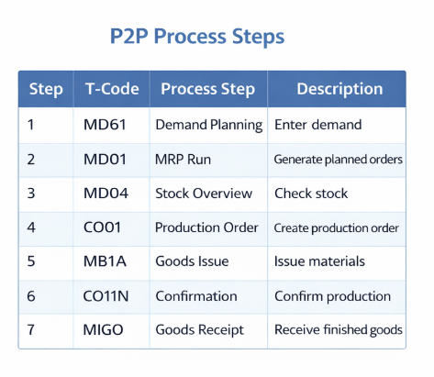

Process Flow Overview
Demand Planning → MRP → Planned Order → Production Order → Goods Issue → Confirmation → Goods Receipt
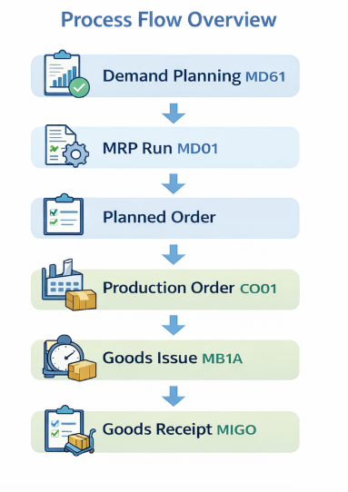

Step-by-Step Process

Step 1: Demand Planning — T-Code: MD61
Demand planning is where the whole P2P process begins. This is the step where the company plugs in its forecasted product demand into the SAP system.
At Tata Electronics, the demand for smartphones is worked out by looking at a few things — market trends, past sales data, and customer orders.
Using transaction code MD61, planners then create what are called Planned Independent Requirements (PIRs), which basically feed into the rest of the production planning process.

Step 2: MRP Run — T-Code: MD01
Material Requirement Planning (MRP) is run using transaction code MD01, and it's one of the most critical steps in the whole SAP PP process.
Here's what MRP actually does — it checks how much stock is currently on hand, spots any shortages, generates planned orders to fill the gaps, and automatically raises purchase requisitions for any raw materials that are needed.
To put it simply with an example: if 100 smartphones need to be built, MRP makes sure there are enough materials to match — so that means 100 displays, 100 batteries, and 100 processors all need to be available and accounted for.

Step 3: Stock Overview — T-Code: MD04
Transaction code MD04 gives you a live, real-time snapshot of your stock and what's needed on the production side.
It shows you everything in one place — what stock is currently available, what materials are coming in, what planned orders are in the pipeline, and where there are any shortages.
This makes it a really handy tool for production planners, helping them make quick, informed decisions without having to dig through multiple screens.

Step 4: Production Order Creation — T-Code: CO01

So once planning is done, the actual production order gets created in CO01. Think of this document as the master instruction sheet for the shop floor — it pulls together everything needed to get production moving: the product details, how many units you're making, the Bill of Materials, the routing (basically the step-by-step production sequence), and which work centers are involved. At Tata Electronics, this is where a production order goes in for 100 smartphones.

Step 5: Goods Issue — T-Code: MB1A

Before anything gets built, the raw materials need to move from the warehouse to the production line. That's what Goods Issue handles, and you do it through MB1A. The moment you post a goods issue, three things happen at once: inventory drops, material consumption gets logged, and the cost shifts over to the production order. For our 100 smartphones, that means 100 screens and 100 batteries walk out of stock and onto the floor.

Step 6: Production Confirmation — T-Code: CO11N

This is the step people sometimes overlook, but it matters. CO11N is where you confirm what actually happened during production — not what was planned, but what was real. Actual labor hours, machine usage, which operations got completed. It keeps the production data honest and current, which downstream processes depend on more than you'd think.

Step 7: Goods Receipt — T-Code: MIGO
The finish line. MIGO is where the completed goods officially enter inventory. The production order gets closed out, finished stock gets updated, and the system generates the corresponding accounting entries automatically.
In our example, those 100 smartphones move from "in production" to finished goods stock — ready to ship.

- Sample Transaction Data

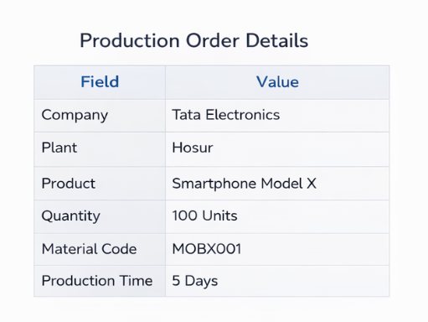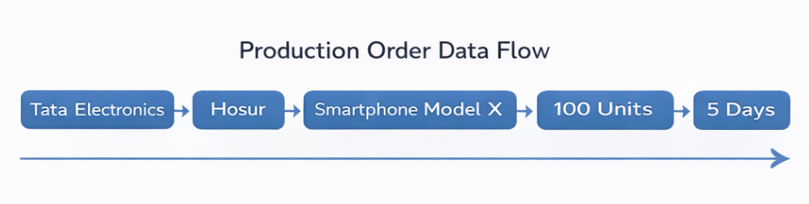

Key Benefits of SAP PP

- Running a factory floor without proper systems in place is a bit like flying blind — and most manufacturers know exactly what that feels like. That's where these capabilities come in.

- Production processes get automated, which means less manual intervention and fewer opportunities for human error to sneak in. And because everything's tracked in real time, you actually know what's happening on the floor *right now*, not three hours ago when someone last updated a spreadsheet.

- Inventory accuracy improves too — and honestly, this one's bigger than it sounds. Bad inventory data creates a ripple effect that messes up everything downstream. Fix it, and your planning and scheduling suddenly become something you can actually rely on. Lead times get more predictable. Bottlenecks become visible before they turn into full-blown delays.

- Speaking of delays — they go down. Not to zero, because nothing's perfect, but enough to matter.

- And then there's the money side. Cost control gets real when you have transparency into where every dollar's going. No more vague overruns that nobody can explain. You can see it, measure it, and actually do something about it.

- Screenshot Placeholders

[ Screenshot 1: MD61 — Demand Planning ]:
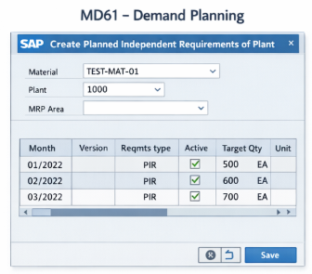
[ Screenshot 2: MD01 — MRP Run ]:
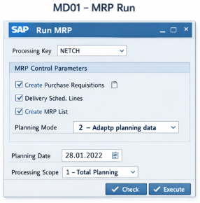
[ Screenshot 3: CO01 — Production Order ]:
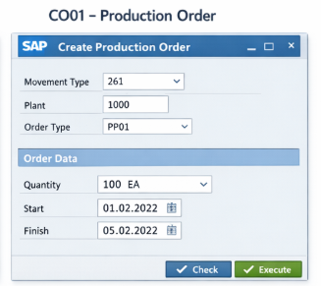

[ Screenshot 4: MB1A — Goods Issue ]:
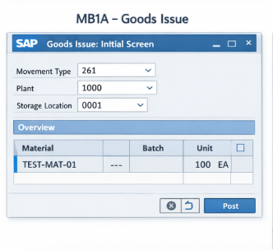
[ Screenshot 5: CO11N — Confirmation ]:
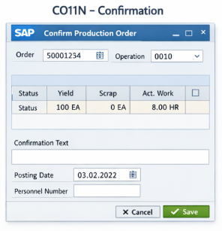

[ Screenshot 6: MIGO — Goods Receipt ]:
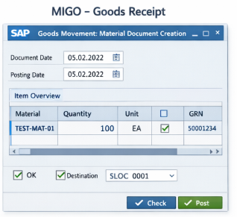

Conclusion

The Plan-to-Produce (P2P) process in SAP PP sits at the heart of how modern manufacturers actually get things done. It's not just a flowchart — it's the backbone that connects demand planning all the way to finished goods landing in inventory.

For this project, we walked through the entire P2P cycle using Tata Electronics as our case study. The goal was to see how a real production requirement — smartphones, in this case — moves through SAP step by step. And honestly, tracing it through transaction codes like MD61, MD01, CO01, MB1A, CO11N, and MIGO makes the whole thing click in a way that theory alone never does.

Every stage matters. Demand planning keeps production tied to what the market actually needs. MRP makes sure the raw materials are there when you need them. Production orders lay out the execution plan. Goods issue tracks material consumption. Confirmation gives you real-time visibility into what's happening on the shop floor. And goods receipt closes the loop — inventory updated, cycle complete.

What makes SAP PP genuinely powerful is how it talks to other modules. The integration with MM and FI means you're not manually reconciling records after the fact. A production activity happens, and it's immediately reflected in inventory and financials. Less manual work, fewer errors. That's a big deal at scale.

The Tata Electronics case made this concrete. Large-scale production is messy — lots of departments, lots of moving parts, lots of room for delays and miscommunication. SAP PP doesn't eliminate that complexity, but it gives you the structure to manage it without losing your mind.

Real-time visibility is another thing worth calling out. Managers can actually see what's happening and respond fast, rather than waiting on reports that are already out of date.

Bottom line: P2P in SAP PP is more than a technical workflow. It's a strategic asset. Whether you're heading into SAP consulting, supply chain, or manufacturing operations, getting your head around this process isn't optional — it's foundational.

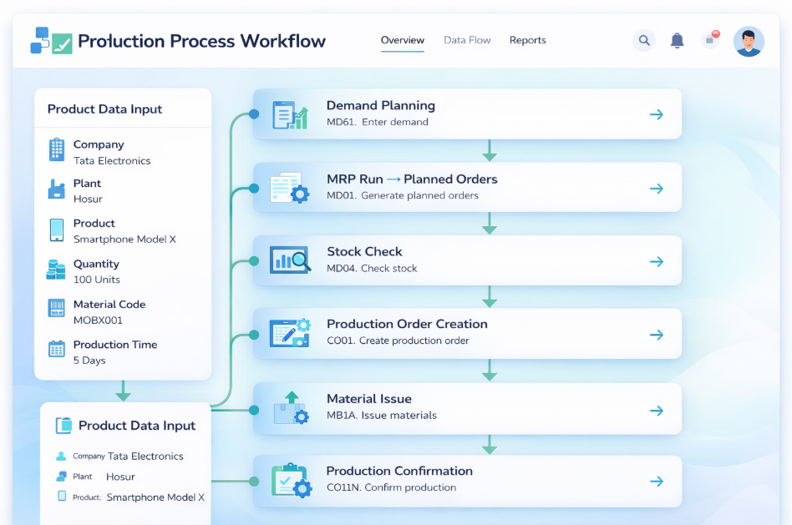

Future Scope

The Plan-to-Produce process in SAP PP is sitting at a genuinely exciting crossroads right now. Manufacturing is changing fast, and the technologies reshaping it aren't just incremental upgrades — they're fundamentally rethinking how production works.
The biggest shift for most organizations is the move to SAP S/4HANA. And honestly, it's a big deal. Faster performance, a much cleaner data model, and the SAP Fiori interface actually make the system pleasant to work with. The P2P process in S/4HANA doesn't just run quicker — it surfaces better analytics, the kind that help planners make smarter calls instead of just reacting to whatever blew up this week. Then there's Industry 4.0. Smart factories aren't a distant concept anymore. Robotics, automation, cyber-physical systems — these are already on shop floors in a serious way. When SAP PP is integrated into that ecosystem, you get real-time visibility into what's actually happening in production, not a lagging snapshot from three hours ago. IoT takes that further. Sensors on machines feeding live data directly into SAP PP means problems get caught early — sometimes before they even become problems. Less downtime, better planning, fewer surprises.
AI and machine learning are changing the calculus on demand forecasting and predictive maintenance. Instead of educated guesses about what's coming, you get models built on actual production history. Scheduling becomes less of an art form and more of a science. On the reporting side, tools like SAP Analytics Cloud let teams dig into production performance in ways that weren't practical before. Bottlenecks become visible. Decisions get grounded in data rather than gut feel. Tighter integration with modules like SAP EWM and APO extends these benefits across the supply chain. And RPA quietly handles the repetitive manual tasks that used to eat up hours — reducing errors and freeing people up for work that actually needs human judgment. The direction is clear: digital transformation, intelligent automation, and deep integration across systems. For manufacturers willing to invest in it, the efficiency gains — and the competitive edge that comes with them — are very real.

