Validation and Controlled Experiments for Reverse Osmosis Membrane Selectivity

Abstract—This report examines machine learning prediction of reverse osmosis membrane water–salt selectivity and develops a reproducible validation framework for the associated project. The work is based on the study by Gao et al. and focuses on Person 4 responsibilities: replication checks, controlled experimentation and final comparison. The revised implementation separates hyperparameter search from evaluation, fits preprocessing within training folds, isolates neural-network early stopping, records out-of-fold predictions and evaluates individual modifications alongside their combination. Random Forest regularization and feature selection form a predeclared ablation study. Published scores are reproduced as reference values, while project-specific performance remains unmeasured pending execution on the membrane dataset. Synthetic execution checks support software correctness but do not establish improved membrane prediction. The contribution is therefore a more auditable evaluation procedure and a testable experimental design; predictive improvement must be demonstrated by subsequent measurements.
Index Terms—Reverse osmosis, machine learning, nested cross-validation, data leakage, Random Forest, reproducibility.

I. Introduction
A membrane prediction study must answer two questions: how accurately a model predicts the target, and whether the evaluation procedure estimates performance on genuinely unseen observations. A high fitted-data score alone cannot answer the second question. Model selection can itself overfit a finite validation sample, making careful separation of development and evaluation necessary [2].
This project reproduces a published membrane modelling workflow and extends its validation. Person 4 coordinates comparisons rather than claiming a new membrane material or a novel learning algorithm. The objective is to compare a baseline, each individual change and their combination under the same evaluation conditions, then explain both improvements and failures. The code-level changes discussed here refer to the revised project notebook [7]. They should not be interpreted as evidence that the original authors used an identical implementation or made the same coding choices.

II. Original Study and Published Reference Results
Gao et al. [1] model reverse osmosis water–salt selectivity, A/B, from Open Membrane Database records. The study considers 1158 membranes, 43 descriptors, an 80/20 split, Bayesian hyperparameter optimization and five-fold cross-validation. Its seven learners are MLP, kNN, SVR, AdaBoost, CatBoost, XGBoost and Random Forest. MAE, RMSE and R² assess prediction, while SHAP relates model outputs to membrane features.
Here, A is the water permeability coefficient and B is the salt permeability coefficient. Their ratio expresses the ability to transport water relative to salt. The original study connects this target to selective-layer chemistry, membrane structure, synthesis and post-treatment modifications, and filtration conditions. It seeks interpretable relationships that can guide membrane design, rather than predicting a single material in isolation [1].
Table I records the five models for which numerical training, validation and pooled overall R² references were transcribed. The paper emphasizes membrane chemistry and modification features; CatBoost and XGBoost perform strongly on validation [1]. Missing numerical references for other models are not estimated from chart heights.
TABLE I
PUBLISHED R² REFERENCES FROM [1]
Model | Train | Validation | Overall
MLP | 0.7174 | 0.6698 | 0.7072
kNN | 0.8047 | 0.6469 | 0.7708
CatBoost | 0.7954 | 0.6986 | 0.7746
XGBoost | 0.7912 | 0.6956 | 0.7706
Random Forest | 0.7420 | 0.6492 | 0.7225

“Overall” combines training and validation predictions [1]. It is retained for descriptive reproduction, but it does not substitute for an independent evaluation score. Comparisons with the paper must use corresponding splits and metrics.
The paper also reports the highest cross-validation score for RF, illustrating why model rankings must identify the evaluation protocol. SHAP analyses of CatBoost, XGBoost and RF rank polyamide as the leading feature. Modification features occupy seven of the top fifteen positions for CatBoost and eight for XGBoost and RF. Additives and surface treatment are also prominent in the MLP feature analysis. These findings concern associations in the collected data; they motivate design hypotheses and do not establish causal effects of a treatment [1].

III. Project Replication Setup

A. Dataset Contract
The notebook expects three processed files: train_data.csv, test_data.csv and preprocessed_full.csv. Its configured dataset description is 976 rows, divided into 780 training and 196 holdout rows. These are project assumptions recorded in the notebook, not independently verified sample counts in this report. The actual CSV files were not executed for the membrane experiments. The difference between 1158 source records and the configured 976 processed rows requires a documented preprocessing history from the data-preparation contributor.
The input contract preserves 43 columns: 21 chemistry indicators, five structure indicators, ten modification indicators, three filtration-mode indicators, three concentration-polarization-mode indicators and one CP variable. The target is A_over_B. Target-derived fields are excluded. The loader checks column order, numeric inputs, target availability and the multiset equality of the combined training/holdout rows with the full file [7].

B. Replication Outputs
The replication stage reports training, cross-validation and supplied-holdout R², MAE and RMSE. Fold means and sample standard deviations are retained. Training–CV and training–holdout gaps reveal discrepancies that a single score can conceal. Paper ranking agreement is calculated over only the five models with comparable reference values. It is kept separate from the seven-model training-CV ranking used for development decisions.
Hyperparameters selected before replication CV can make those CV results optimistic. They are therefore labelled post-selection diagnostics. The new experimental stage retunes parameters independently within each outer training fold rather than reusing the earlier best-parameter dictionaries.

IV. Validation Modifications

A. Data Auditing and Fold Isolation
The modified code rejects non-finite inputs, mismatched feature order, duplicate column names and misaligned target indices. It records exact duplicate rows, feature-profile overlap and cross-split group overlap. An exact training–holdout row overlap or a shared group blocks holdout scoring. Related membranes or records from a common publication can be assigned a group identifier; this identifier is excluded from the predictors and GroupKFold keeps groups separate.
When no group identifier is supplied, shuffled KFold assumes independent rows. That assumption must be checked rather than inferred from the absence of duplicate records. An already processed CSV cannot establish whether earlier imputation, encoding or outlier thresholds were estimated without access to the holdout. Those upstream operations require their own provenance review.

B. Nested Cross Validation
The default experiment procedure uses five outer folds and three inner folds. Inner folds select parameters using mean R²; the outer scoring fold is excluded from that search. The selected pipeline is then fitted on all outer training rows and scored once on the outer fold. Scaling and supervised feature selection are pipeline steps fitted inside each relevant training partition. This structure follows the nested-evaluation principle [3] and fold-isolated preprocessing practice [4].
All variants reuse identical outer and inner splits, random seeds and trial budgets. A mean-prediction model supplies a sanity check. Out-of-fold predictions are retained for every training observation, and coverage checks reject missing or repeated predictions. Fig. 1 shows the separation between tuning, outer evaluation and later holdout diagnostics.
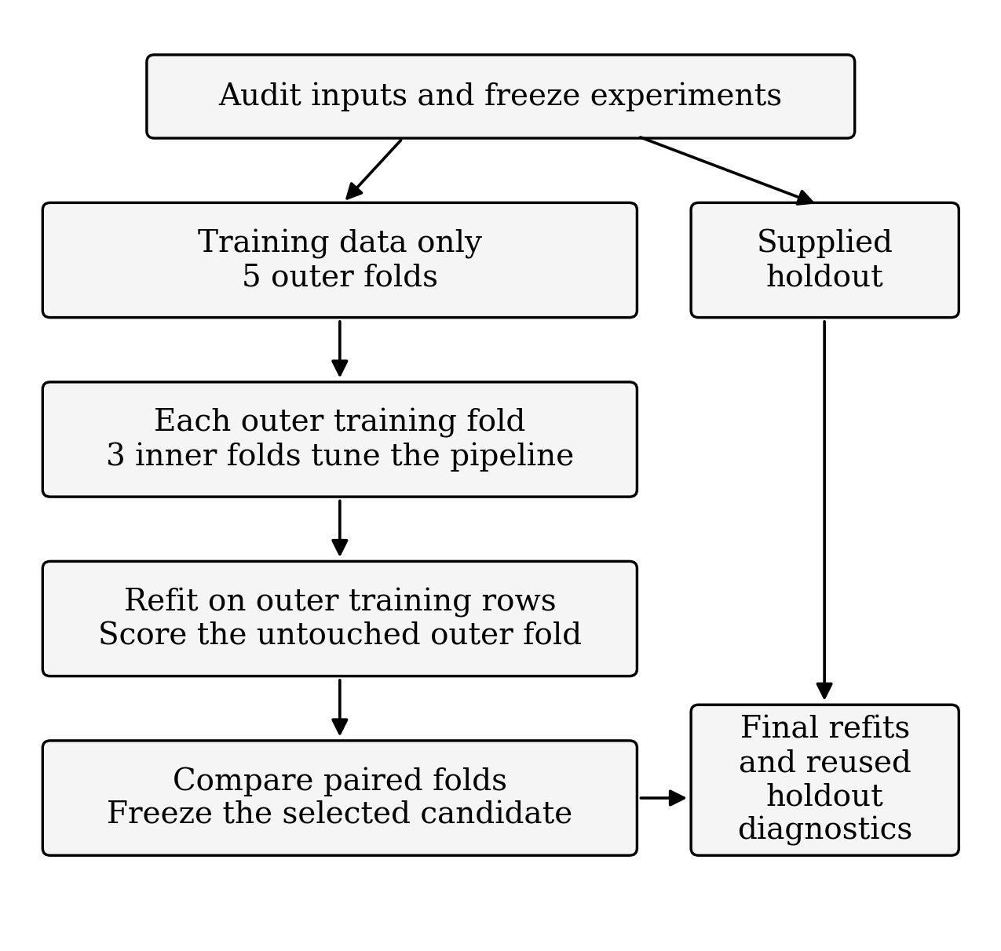
Fig. 1. Evaluation flow. The supplied holdout does not enter model tuning or candidate selection.

C. Neural Network Scaling and Early Stopping
The earlier project implementation scaled the complete training matrix before MLP cross-validation and monitored the scoring fold during early stopping. The revised code fits the scaler within each training fold and takes a separate stopping subset from that fold. It chooses an epoch count on the stopping subset, then rebuilds and refits the network on all available training rows for that epoch count. The outer scoring fold remains unused until prediction. EarlyStopping monitors a specified metric [5]; using it does not itself guarantee that the monitored data are independent of final evaluation.
The original neural architecture ranges are retained. These changes address the evaluation procedure, not a claim that a deeper network has been developed. TensorFlow execution on the membrane data remains pending.

D. Reproducibility and Uncertainty
The experiment registry is frozen before evaluation. Data hashes, software versions, feature names, seeds, fold assignments and per-fold parameters are exported. A guard detects changes to the experiment plan or in-memory dataset. Completed folds are checkpointed so that partial work is visible if a run stops. The framework does not silently exclude an unsuccessful modification from the final comparison.
After candidate selection, paired bootstrap resampling compares the selected model with the baseline on the same holdout observations. The standard profile requests 2000 draws; complete groups are resampled when group labels exist. The resulting 95% percentile intervals are conditional on the fitted models. They do not include uncertainty from retraining or repeated search, and they do not repair reuse of the holdout.

V. Controlled Experimental Design

A. Baseline and Ablations
The default study is a Random Forest ablation experiment. It supports a manageable comparison while the original replication covers seven model families. Table II defines the planned variants. The combined candidate is evaluated regardless of whether either individual modification wins. It is not designated the best version in advance. Team-specific preprocessing, model or feature-engineering changes require additional predeclared variants before their results are inspected.
TABLE II
PREDECLARED RANDOM FOREST EXPERIMENTS
ID | Variant | Change relative to E0
E0 | Baseline | Original RF search, retuned within each fold
E1 | Regularized | Shallower search and larger minimum split/leaf sizes
E2 | Feature selection | Retain 75% using fold-fitted F-regression scores
E3 | Combined | Apply E1 and E2 together
S0 | Sanity check | Predict the training-fold target mean

For E0, maximum depth ranges from 3 to 30, minimum split size from 2 to 20 and minimum leaf size from 1 to 10. E1 changes these ranges to 3–15, 4–20 and 2–10. Every RF variant searches 100–1000 trees and the same maximum-feature choices: square root, logarithm base two, 0.5 and 1.0. E2 uses univariate F-regression selection. It is computationally simple but can miss nonlinear interactions; a worse result is a legitimate experimental outcome.

B. Budget and Selection Rule
The standard configuration uses seed 42, five outer folds, three inner folds and ten trials per non-dummy search. This gives equal trial counts, not equal computation time. The sampler is Optuna TPESampler. Its documented default startup count is ten [6]; consequently, this ten-trial budget consists of startup sampling rather than a sustained adaptive TPE search. A larger, predeclared trial budget is an appropriate follow-up experiment, not a result already obtained.
A candidate passes the practical screen if mean outer-CV R² improves by at least 0.01 and mean RMSE decreases relative to E0. Among passing candidates, the highest mean R² is selected, with lower RMSE and then the experiment name resolving ties. If no candidate passes, E0 is retained. The mean predictor is never eligible. The 0.01 threshold is an absolute R² difference, not a statistical significance level.
Selecting a winner among several outer-CV summaries can itself introduce selection bias [2]. Accordingly, the selected score remains exploratory. A fresh external dataset is needed to confirm generalization after development decisions are complete.

C. Evaluation Metrics
For observations yᵢ, predictions ŷᵢ, mean target ȳ and sample size n, the metrics are defined as follows. Lower MAE and RMSE and higher R² indicate better prediction on the same evaluation set.
$MAE =\frac{∑ᵢ₌₁ⁿ |yᵢ - ŷᵢ|}{n}$ (1)
$RMSE =\sqrt{\frac{∑ᵢ₌₁ⁿ (yᵢ - ŷᵢ)²}{n}}$ (2)
$R² = 1 -\frac{∑ᵢ₌₁ⁿ (yᵢ - ŷᵢ)²}{∑ᵢ₌₁ⁿ (yᵢ - ȳ)²}$ (3)
The reported gap is mean training R² minus mean outer-fold R². A gap above 0.10 triggers a review flag; it is a heuristic and cannot establish overfitting on its own. Fold standard deviations describe dispersion and are not treated as confidence intervals. Pooled out-of-fold R² and the mean of fold R² are both exported because they need not be equal.

VI. Results and Discussion

A. Interpretation of Published Scores
From Table I, the five-model validation ordering is CatBoost, XGBoost, MLP, Random Forest and kNN. Subtracting validation R² from training R² gives gaps of 0.0968, 0.0956, 0.0476, 0.0928 and 0.1578, respectively. These are arithmetic comparisons of the published values, not new experiments. The largest gap belongs to kNN. A small gap alone is insufficient: it must be considered alongside absolute error and validation performance.

B. Implementation Verification
The revised non-neural experiment and reporting path completed a synthetic-data execution check. Checks covered notebook syntax, all registered variants, complete out-of-fold coverage, candidate selection, baseline retention when no change passes, paper-reference joins, result exports and rejection of changed input data. Overlap handling was also exercised: blocked holdout evaluation produced missing holdout scores rather than invented values. These checks verify code behaviour, not membrane-domain accuracy.
No synthetic score is presented as an OMD result. Full membrane experiments and TensorFlow training have not been completed for this report. Table III therefore separates the planned comparison from the published reference table. The default code evaluates all five entries on the supplied holdout only after the selection decision is frozen.
TABLE III
PROJECT PERFORMANCE STATUS
Variant | Train | Validation
MLP | 0.6940 | 0.5534
KNN | 0.9802 | 0.5902
CatBoost | 0.9085 | 0.7941
XGBoost | 0.9638 | 0.7897
Random Forest | 0.8060 | 0.8151

NR means not run on the membrane dataset. It is not zero and is not an unsuccessful measured result. The final selected version and its improvement cannot be assigned until this table is populated by a completed standard run.

C. Reading the Final Comparison
The exported comparison must retain E0–E3 and S0, their train/CV gaps, outer-fold variability, paired baseline differences and holdout diagnostics. A useful conclusion states whether the CV screen was passed, whether the holdout agrees in direction, and whether any error metric worsened. If the combined model loses, the report must show that result. If the baseline wins, retaining it is a valid conclusion.
The supplied holdout has also been used for replication reporting, so it is conservatively labelled reused. Comparing an experimental model with a paper reference is contextual unless sample filtering and split definitions are equivalent. A positive holdout-minus-paper R² difference alone does not prove superiority. Published MAE, RMSE or CV values that were not reliably transcribed remain absent rather than being reconstructed.

VII. Limitations and Future Work
The main unresolved issues are upstream preprocessing provenance, possible dependence among membrane records, the absence of a fresh external test set and the lack of measured project results. Fold isolation cannot undo leakage introduced before CSV creation. F-regression selection may discard features that matter through interactions, while stronger regularization may underfit. The search budget limits optimization depth and should be increased consistently across variants if resources allow.
Next steps are to verify the processed data and group identifiers, run the standard protocol, inspect the full experiment table and repeat promising configurations under a predeclared larger search budget. Optional all-family nested evaluation can assess whether RF findings transfer to other learners. Any SHAP-guided selection must be learned within the training folds rather than from holdout explanations. A new independent evaluation is needed before making a confirmatory improvement claim.

VIII. Conclusion
This report connects the published membrane prediction study with a revised validation and experimentation framework. The implemented contribution is a traceable comparison procedure: separate tuning and scoring, fold-specific preprocessing, isolated neural stopping, controlled ablations, comparable paper metrics and transparent exports. The published scores provide a reference, while the modified project scores remain pending. The present evidence supports the implementation and the experimental design; it does not yet demonstrate a numerical improvement in membrane selectivity prediction.

References
[1] W. Gao, G. Wang, J. Li, H. Li, L. Ren, Y. Wang, and L. Kong, “Insights into synthesis and optimization features of reverse osmosis membrane using machine learning,” Materials, vol. 18, no. 4, Art. no. 840, 2025, doi: 10.3390/ma18040840.
[2] G. C. Cawley and N. L. C. Talbot, “On over-fitting in model selection and subsequent selection bias in performance evaluation,” Journal of Machine Learning Research, vol. 11, pp. 2079–2107, 2010.
[3] scikit-learn developers, “Nested versus non-nested cross-validation.” Accessed: Nov. 7, 2026. [Online]. Available: https://scikit-learn.org/stable/auto_examples/model_selection/plot_nested_cross_validation_iris.html
[4] scikit-learn developers, “Common pitfalls and recommended practices.” Accessed: Nov. 7, 2026. [Online]. Available: https://scikit-learn.org/stable/common_pitfalls.html
[5] Keras team, “EarlyStopping.” Accessed: Nov. 7, 2026. [Online]. Available: https://keras.io/api/callbacks/early_stopping/
[6] Optuna contributors, “optuna.samplers.TPESampler.” Accessed: Nov. 7, 2026. [Online]. Available: https://optuna.readthedocs.io/en/stable/reference/samplers/generated/optuna.samplers.TPESampler.html
[7] Project implementation, “RO_ML_PAPER_FINAL_REPRODUCTION.ipynb,” revised Person 4 validation and experimentation code, unpublished project notebook, Nov. 2026.

