WORKING WITH AI (WAI) REPORT
The Entrepreneurial Manager
PlateWise.
AI-driven food-waste analytics and demand forecasting for institutional canteens and messes
Opportunity identification, market research, idea refinement and business model development with generative AI
Student | Tanish Tyagi
Roll no. / Section | M56D-26 / Section D
Programme | MBA 2026-28, IIM Ranchi
Course / Term | The Entrepreneurial Manager, Term II (25% weight)
Submission | October 2026

AI-use disclosure (summary)
Generative AI (Claude, by Anthropic) was used throughout: to generate and screen venture ideas, to search and summarise sources, to build the financial and simulation models in Python, to draw the charts and to draft this report. Every source is cited, every number comes from the code and assumptions listed in Appendices B and C, and the pilot data in Section 4 is synthetic (simulated) and is labelled as such wherever it appears. I take responsibility for the originality, accuracy and quality of the report. Full disclosure: Section 11 and Appendix A.

Executive summary
Indian hostels, college messes and corporate canteens cook to a fixed norm, not to what students actually eat. A mess that cooks for 89% of residents when only 77% turn up throws away roughly one portion in eight. PlateWise is a software-and-sensor service that forecasts attendance meal by meal, tells the kitchen how much to cook, and measures what comes back on the plate. The client pays a small subscription plus a share of the verified savings.
₹138 cr  TAM, revenue pool per year | 3.1x  LTV : CAC, base case | 12.3 mo  CAC payback per site | ₹2.5 cr  Funding ask incl. 20% buffer

I used generative AI as a working partner across the whole entrepreneurial process: screening five venture ideas against a weighted scorecard, sizing the market two independent ways, designing and running a simulated pilot, building a 48-month financial model with a Monte Carlo risk layer, and stress-testing the result. The main findings:
- The problem is large and measurable. Contract catering in India is about ₹34,188 crore a year in one published estimate; at 35% food cost and 10% waste, ₹1,197 crore of food is wasted, of which about ₹359 crore is reducible at a 30% cut.
- The reachable niche is small but real. Top-down TAM is ₹138 crore a year and bottom-up is ₹122 crore (hostel diners). The serviceable market is ₹36.5 crore and the obtainable share after three years is ₹2.58 crore of annual recurring revenue (7.1% of SAM).
- The unit economics work. A 1,000-diner canteen saves ₹7.3 lakh of food a year; PlateWise earns ₹2.81 lakh (gross margin 70%), the client keeps ₹4.48 lakh (2.6x its spend), payback is 12.3 months and LTV:CAC is 3.1.
- The business is capital-hungry before it is profitable. The base plan reaches 92 customers by month 36, turns cash-positive in month 41 and needs about ₹2.05 crore at its trough, so the ask is ₹2.5 crore including a 20% buffer. In the pessimistic case it does not recover within 48 months.
- The forecast beats today's practice in simulation. On 28 held-out days of a simulated 800-resident mess, a ridge-regression forecast cut error (MAPE) from 6.6% (last-week rule) to 3.7% and waste from 12.1% to 5.7%. That is a simulation, so the model plans on a 30% reduction, not the 53% simulated.

Table 1. Venture at a glance. All figures from the model in Appendix C; pilot evidence is simulated.
Venture at a glance
Customer | Hostel messes, college canteens, corporate cafeterias (contract-caterer or institution-run)
Offer | Measure (plate and prep logging) + Forecast (meal-wise attendance) + Act (cook-to-forecast plan)
Price | ₹15/diner/month for 9 months + 20% of verified savings
Revenue per 1,000-diner site | ₹2.81 lakh/year (₹280/diner/year)
Gross margin / LTV:CAC / payback | 70% / 3.1 / 12.3 months
TAM / SAM / SOM (year 3) | ₹138 cr / ₹36.5 cr / ₹2.58 cr ARR
Funding need (base) | ₹2.05 cr trough; ask ₹2.5 cr
Impact (month 36) | 2.24 million portions saved per year (SDG 12.3)

How this report meets the brief
The brief asks for gen-AI use in opportunity identification, market research, idea refinement and business model development, with full disclosure and student responsibility for quality. The matrix maps each requirement to where it is met, and the second table maps course frameworks to their use.
Table 2. Compliance matrix against the assignment brief.
Requirement | Where met | Evidence in this report
Opportunity identification with gen-AI | Section 1 | Five ideas generated and scored on six weighted criteria; sensitivity of the ranking tested (Table 5)
Market research with gen-AI | Section 2 | Top-down and bottom-up sizing, 3x spread across published estimates reconciled, competitor and price-gap analysis (Figures 1-3)
Idea refinement | Sections 3-4 | Segments, jobs-to-be-done, value proposition, six testable hypotheses, simulated pilot and pivot rules (Figures 4-6)
Business model development | Sections 5-7 | Business Model Canvas, unit economics, 48-month plan, scenarios, funding route (Figures 7-9, Tables 14-17)
Risk and uncertainty | Section 8 | Tornado, Monte Carlo and risk register (Figures 8, 10)
Impact and ethics | Section 9 | SDG 12.3 quantified; data, privacy and fairness considerations
Disclosure and accountability | Section 11, Appendices A-C | Tools, tasks, verification, corrections, limits, ideal prompt log, assumptions register, reproducibility note

Table 3. Course frameworks mapped to sections.
Course framework | Applied in
Effectuation (bird-in-hand, affordable loss, crazy quilt, lemonade) | Section 1.3
Value proposition canvas and jobs-to-be-done | Section 3
Lean start-up: hypotheses, build-measure-learn, pivot rules | Section 4
Business Model Canvas and pricing | Section 5
Financial planning, funding stages and trade-offs | Sections 6-7
Entrepreneurial ecosystem (Ranchi versus the metros) | Section 7.3
Managing uncertainty, scenarios, social entrepreneurship (SDG) | Sections 8-9

1. Opportunity identification

1.1 The problem, with evidence
Food waste is not a fringe problem. The UNEP Food Waste Index 2024 puts India's household food waste at about 55 kg per person per year, roughly 78 million tonnes in total [1][2], and FSSAI's Save Food, Share Food material notes that about a third of food in India is spoiled or wasted [3]. Institutions are the easier place to act because food is cooked in one place, to one plan, by one team.
Campus measurements show how large the gap can be. Amrita's tracking reports 41 g per person per day, while noting that campuses are often at 70-100 g [6]. A Kelaniya University study found 26.4% of served food wasted, or 139.5 g per student [7], and a review of dining studies reports 25-135 g per consumer per meal [8]. Commercial-kitchen vendors report that 5-15% of purchases are wasted [9]. I use 10% of food purchases as the planning figure, the middle of that range, and test 5% and 15% in the sensitivity analysis.
The mechanism is simple. A mess cooks to a fixed norm (in my simulation, 90% of residents at weekday lunch, 80-88% at weekends) while actual attendance varies by weekday, exam weeks, festivals and special menus. The cook cannot see tomorrow's attendance, so he rounds up; the surplus is discarded, and the institution pays for it either directly or through the per-student rate.

1.2 Why now
- Policy is moving. FSSAI's Eat Right Campus programme audits campus food, and the audit includes food-waste management [4][34]. SDG 12.3 sets a halving target for per-capita food waste [5].
- Enrolment is large and hostelised. AISHE 2021-22 records 4.33 crore students in higher education [23]. Even 10% living in hostels is more than 43 lakh diners.
- The tools are cheap. Attendance forecasting needs a few weeks of meal counts and a regression model. What used to need a data-science team now runs on a laptop, and a phone camera or a kitchen scale replaces the expensive hardware.
- Global vendors exist but are priced for hotels. Leanpath is listed at about USD 1,200 a month [11], roughly ₹12.7 lakh a year at ₹88 to the dollar, against ₹2.8 lakh for PlateWise (Section 2.4).

1.3 Effectuation: what I start with
The venture is built from means at hand, not from a forecast of the market, which is the effectuation logic taught in the course.
Table 4. Effectuation lens on the venture.
Principle | Application to PlateWise
Bird-in-hand (who I am, what I know, whom I know) | MBA student with an analytics and operations focus; hands-on use of Python and forecasting; a campus mess and its caterer and committee as the first test-bed (access to be negotiated, not assumed).
Affordable loss | A 90-day pre-pilot capped at a small, self-funded amount (proposed ceiling of about ₹50,000, for a kitchen scale, a tablet and cloud credits). No hardware inventory or hires before a paying customer.
Crazy quilt (partnerships) | Mess committee (data and access), caterer (cooking plan), FSSAI Eat Right Campus auditors (credibility), a campus incubator (grants and mentors), a student volunteer team (logging).
Lemonade (use surprises) | If caterers resist because savings go to the institution, sell the service to the institution as an audit tool; if the kitchen will not weigh waste, use attendance forecasting alone.

1.4 Choosing the idea with an AI-assisted scorecard
I asked the AI for venture ideas rooted in Indian demand and public data; it proposed five, and I scored each from 1 (poor) to 5 (strong) on six weighted criteria: market scale, data and measurability (Data), low capital need, social and SDG impact, lean testability (Lean test) and policy tailwind. The scores are my judgement informed by the AI's reasoning, so they are subjective and I tested how much the ranking depends on the weights. Food-waste analytics leads at 4.20. If market scale is weighted at 40% instead of 20%, it still leads (3.90) but only narrowly over EV battery swapping (3.80), so the choice is a judgement call, not a certainty.
Table 5. Idea screening. Score = weighted total with the weights shown; Alt. = total with market scale weighted 40%. Scores are the author's AI-assisted judgement.
Idea | Market scale  (20%) | Data  (20%) | Low capital  (15%) | Social / SDG  (15%) | Lean test  (20%) | Policy  (10%) | Score | Alt.
EV battery-swapping for delivery riders | 5 | 4 | 1 | 3 | 2 | 5 | 3.30 | 3.80
Millet-based ready-to-eat foods | 3 | 3 | 3 | 4 | 3 | 4 | 3.25 | 3.20
Cold-chain micro-hubs for produce | 4 | 3 | 1 | 5 | 2 | 5 | 3.20 | 3.45
Food-waste analytics for canteens | 3 | 5 | 4 | 4 | 5 | 4 | 4.20 | 3.90
Vernacular placement-readiness platform | 4 | 3 | 4 | 3 | 4 | 2 | 3.45 | 3.55

2. Market research

2.1 What published estimates say, and why they disagree
Published sizes of the Indian catering market differ by about three times, because each report defines scope differently (contract versus event catering, B2B versus total food service):
Table 6. Published catering market estimates. The 3x spread reflects scope, not accuracy.
Source | Metric | Figure
Deep Market Insights [19] | India contract catering, 2025 | USD 3,885 million (to USD 6,661 million by 2034)
The Report Cubes [22] | India B2B catering, 2025 | USD 3.99 billion (contract about 65%)
IMARC [20] | India catering services, 2024 | USD 5.10 billion
Ken Research [21] | India catering services, 2025 | USD 12.45 billion

I chose the narrowest figure, contract catering at USD 3,885 million [19], because PlateWise sells to institutions that outsource or run structured kitchens. Using the narrowest estimate keeps the sizing conservative. This is a judgement, and the report states it so a reader can substitute another figure.

2.2 Top-down sizing
The chain converts the market into rupees at ₹88 per USD, applies food cost at 35% of catering revenue (the industry range for food cost is roughly 28-35% [28]), then waste, then the reducible portion, and finally PlateWise's share of savings:
Table 7. Top-down chain from catering market to PlateWise TAM.
Step | Value | Basis
Contract catering revenue | ₹34,188 cr | USD 3,885 m x ₹88 [19]
Food purchases (35%) | ₹11,966 cr | Food-cost share, upper end of range [28]
Wasted food (10%) | ₹1,197 cr | Mid-range of 5-15% [9]
Reducible waste (30%) | ₹359 cr | Conservative against 33-50%+ in vendor cases [10][12][13]
PlateWise revenue pool (TAM) | ₹138 cr | 38.5% of savings (subscription + 20% gain share)

2.3 Bottom-up check, SAM and SOM
Bottom-up starts from diners. With 4.33 crore students enrolled [23] and 10% assumed to live in a hostel (an assumption, flagged in Appendix B), there are 43.3 lakh hostel diners. At ₹281 revenue per diner per year, bottom-up TAM is ₹122 crore, about 12% below the top-down figure of ₹138 crore. The two methods use different inputs, so their agreement is reassuring but not proof. SAM assumes PlateWise can reach 30% of those diners (13.0 lakh), worth ₹36.5 crore. SOM is the annual recurring revenue at month 36 of the base plan, ₹2.58 crore or 7.1% of SAM.
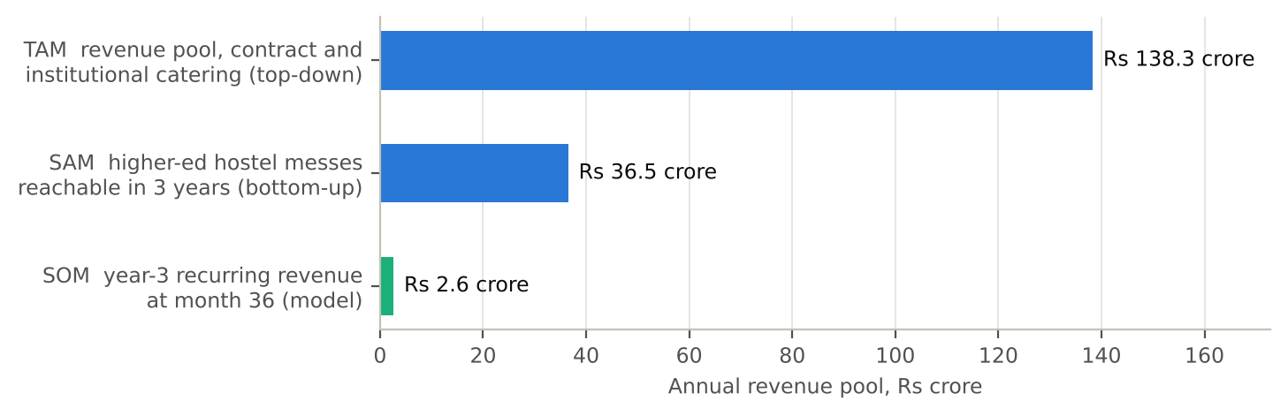
Figure 1. TAM, SAM and SOM (₹ crore per year). TAM top-down 138; bottom-up 122; SAM 36.5; SOM 2.58.
Honest reading of the market
A revenue pool of ₹138 crore is a niche, not a mass market. That suits a focused start-up that wins campuses first, but it caps the outcome unless PlateWise extends to corporate cafeterias, hospitals and hotels. The model does not count that expansion.

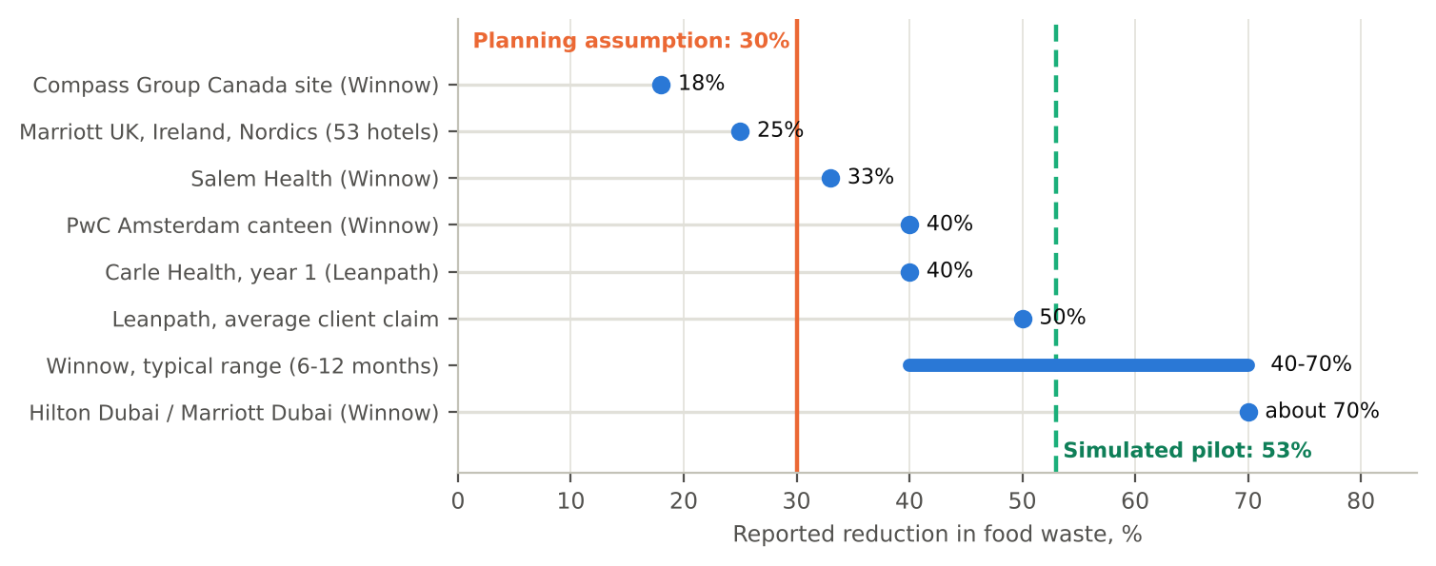
Figure 2. Waste benchmarks from published sources versus the planning assumption used in this model.

2.4 Competitors and the price gap
AI-based kitchen waste tools already exist; the opportunity is price and fit, not novelty.
Table 8. Competitive landscape. PlateWise's positioning is the author's assessment.
Player | Approach | Evidence of effect | Gap for Indian messes (author's assessment)
Winnow | Camera and scale on the bin, AI identifies food | 5-15% of purchases wasted; 40-70% reduction in 6-12 months; PwC Amsterdam 40%, Salem Health 33% [9][12][13] | Built for hotels and corporate kitchens; priced above a typical mess budget
Leanpath | Scale-based tracking with staff engagement | Average 50% reduction, 2-6% of purchase cost saved [10]; about USD 1,200 a month [11] | About ₹12.7 lakh a year; hardware and onboarding heavy
Orbisk and others | AI camera on bins | Reported in trade press [16][17] | Same hardware and price pattern; one study notes difficulty with mixed food [15], common on a thali
Manual audits (Eat Right Campus) | Periodic inspection | Includes food waste management in the audit [4] | Periodic, not continuous; no forecast
PlateWise | Attendance forecast + cooking plan + light measurement | Simulated: waste cut by 53% (planning: 30%) | ₹2.8 lakh a year per 1,000 diners; software-first

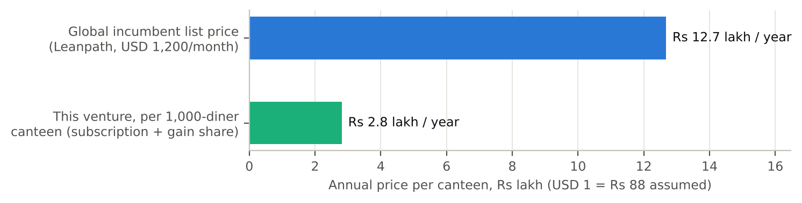
Figure 3. Annual cost to a 1,000-diner site: Leanpath list price versus PlateWise (₹ lakh).

3. Customer and value proposition

3.1 Segments and who pays
The buyer and the beneficiary are often different people, which is the main commercial risk. At IIT Kanpur, raw materials are passed through to the students on a formula basis [27]; at IIT Madras the caterer is paid a per-student-per-day rate that is not allowed to fall below about ₹95 [26]. Student mess fees at institutions range from about ₹3,500 for four meals at AIIMS Delhi [25] to ₹4,200-8,083 a month at a management institute [24]. Under a pass-through contract the institution pockets the savings; under a fixed-rate contract the caterer does.
Table 9. Customer segments and the split-incentive problem. Priority ordering is the author's.
Segment | Contract type | Who gains from savings | Who buys PlateWise | Priority
Institution-run hostel mess | Direct cost, student pays | Students / institution | Mess committee, warden | 1 (start here)
Campus with pass-through caterer | Raw material pass-through | Institution | Institution (with caterer buy-in) | 2
Campus with fixed-rate caterer | Per-student-per-day rate | Caterer | Caterer | 3 (needs gain share)
Corporate cafeteria | Vendor contract | Mixed | Facilities / vendor | 4 (expansion)

3.2 Jobs to be done and value proposition
Table 10. Jobs-to-be-done and value proposition canvas, combined.
Who | Job to be done | Pain today | Gain from PlateWise
Mess manager / cook | Cook the right quantity for every meal | Guesswork; blamed for both shortage and waste | A number to cook and a reason for it
Warden / committee | Keep fees stable and complaints low | Rising food cost; no data to challenge the caterer | Cost per plate trend; waste report
Caterer | Protect margin on a fixed-rate contract | Waste eats margin; shortage risks the contract | Lower waste share and an audit-ready record
Students | Get food of acceptable quality, every time | Stock-outs at the end of service; plain food | Fewer shortages; savings can fund menu quality
Sustainability / audit lead | Show progress on waste for Eat Right Campus | No measured baseline | Dated, auditable waste log [4][34]

3.3 The product: Measure, Forecast, Act
- Measure. A phone or tablet app logs headcount at the counter, food prepared and food left over; a kitchen scale is optional at the start (hardware capex ₹30,000 per site).
- Forecast. A regression model predicts attendance by meal using weekday, exams, festivals, special menus and recent history.
- Act. The cooking plan converts the forecast into quantities with a safety buffer chosen to hold unserved demand below 0.5% and stock-out meals below 10%.

4. Lean validation: hypotheses and a simulated pilot
Important: the pilot below is a simulation
I have not yet run PlateWise in a real mess. The data in this section are synthetic, generated from assumptions I set (weekday patterns, exam week, festivals, noise). They show that the method works if attendance is as predictable as assumed. They do not prove that it is. The planning model therefore uses a lower waste reduction (30%) than the simulation shows (53%).

4.1 Hypotheses and tests
Table 11. Hypothesis register. Only H3 and H4 have simulated evidence; the rest are planned.
# | Hypothesis (riskiest first) | Test | Pass criterion | Status
H1 | Mess managers see food waste as a cost problem and have no measurement | 10 interviews at hostels and canteens | 8 of 10 confirm waste above 8% and no log | Planned
H2 | Institutions will pay about ₹15/diner/month plus a savings share | Pricing conversations; letter of intent | 3 of 10 accept the price band | Planned
H3 | A forecast beats the current cooking rule | 28-day hold-out comparison | MAPE at least 20% below last-week rule | Simulated: 44% lower
H4 | Cooking to the forecast cuts waste without more stock-outs | 8-week live trial at one mess | At least 30% less waste; unserved below 0.5% | Simulated: 53%; live test planned
H5 | Caterers accept a gain-share contract | Caterer meetings | 3 of 10 accept | Planned
H6 | A site can be acquired for no more than ₹2 lakh | Cold outreach and tender watch | CAC at most ₹2.0 lakh over first 5 sites | Planned

4.2 Design of the simulated pilot
The simulation is an 800-resident mess over 56 days with two meals a day. Average attendance is 77% of residents, while the baseline kitchen cooks for about 89%. The first 28 days train the models, and the next 28 are a rolling-origin evaluation, where each day is forecast using only earlier data. Four forecasts are compared: a seasonal-naive rule (same meal last week), a 4-week moving average, gradient boosting and ridge regression.
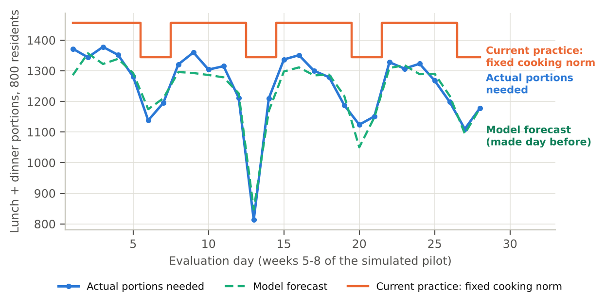
Figure 4. Simulated demand versus the fixed cooking norm and the ridge forecast over the evaluation window (synthetic data).

4.3 Results
Ridge regression was the most accurate model, cutting MAPE from 6.6% for the last-week rule to 3.7% (44% lower) and from 5.3% for the moving average (30% lower). The simpler model won over gradient boosting because the dataset is only 28 training days and the signal is mostly calendar effects, a result worth remembering when real data arrives.
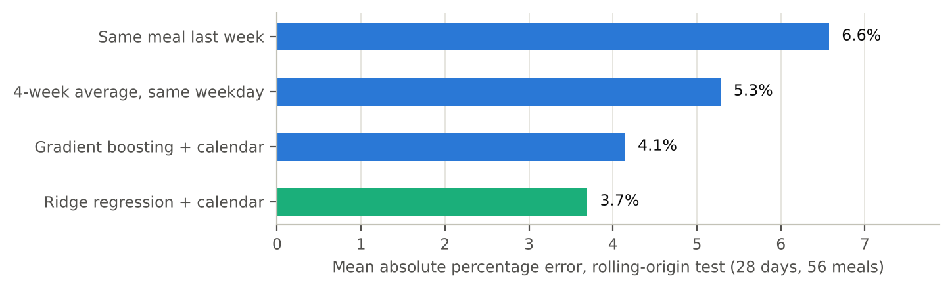
Figure 5. Forecast error on the 28-day evaluation window (MAPE, %; lower is better). Synthetic data.
Table 12. Forecast accuracy on the evaluation window (simulated).
Model | MAPE (%) | MAE (portions)
Seasonal naive (same meal last week) | 6.6 | 37.9
4-week moving average | 5.3 | 30.5
Gradient boosting | 4.1 | 24.2
Ridge regression | 3.7 | 22.7

4.4 From forecast to cooking policy: waste versus shortage
A better forecast only matters if it changes how much is cooked. Adding a buffer to the forecast trades waste against shortage. I chose the smallest buffer that keeps unserved demand under 0.5% and stock-out meals under 10%; for ridge that is +7%. The last-week rule needs a +17% buffer to give similar service and ends up wasting more than the fixed norm.
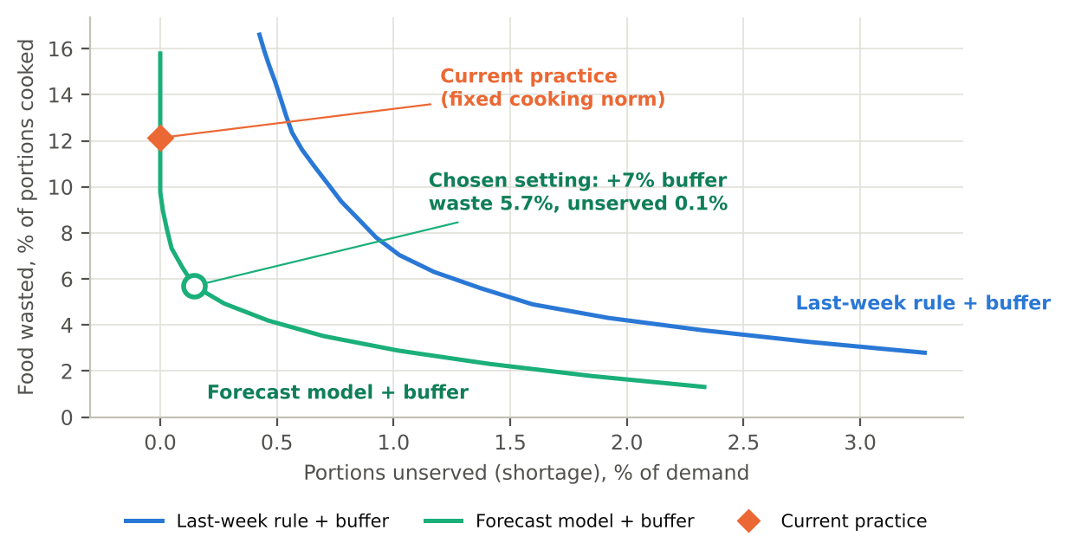
Figure 6. Waste share and unserved demand as the safety buffer grows, ridge forecast versus last-week rule (synthetic data).
Table 13. Cooking policies compared on the same 28 evaluation days (simulated).
Policy | Waste (% of cooked) | Unserved demand | Stock-out meals
Fixed cooking norm (baseline) | 12.1% | 0.00% | 0.0%
Last-week rule +17% | 14.5% | 0.49% | 3.6%
Ridge forecast +7% (PlateWise) | 5.7% | 0.15% | 5.4%

At the operating point waste falls from 12.1% to 5.7%, a 53% reduction, or 97 portions a day. At ₹30 a portion that is ₹7.87 lakh a year for 800 residents (₹984 per diner), against ₹729 per diner in the planning model. The planning figure is therefore 74% of the simulated saving, a deliberate haircut for noisier real data, harder-to-predict attendance and imperfect compliance by the kitchen.

4.5 Limits and pivot rules
- Synthetic data. Real attendance is noisier and may be harder to capture; the 3.7% MAPE should be read as an upper bound on performance.
- One mess, 56 days. No claim about generalisation across campuses.
- Stock-out cost is not priced. The trade-off treats a shortage as a service constraint, not a rupee cost; a real trial must track student complaints.
Pivot rules decided in advance: if H1 fails (managers do not see waste as a problem), pivot to selling the attendance forecast as a cost-control tool for caterers. If H2 or H5 fails, test a flat annual licence per campus. If H4 reaches under 15% waste reduction in live trials, drop the gain-share and sell as a compliance and reporting tool for Eat Right Campus audits.

5. Business model

5.1 Business Model Canvas
Table 14. Business Model Canvas for PlateWise.
Key partners  Mess committees, caterers, FSSAI Eat Right Campus auditors, campus incubators, cloud provider | Key activities  Forecast model upkeep, onboarding, data cleaning, savings verification | Value propositions  Cook the right quantity: waste down about 30% (53% in simulation) with stock-outs held in check; auditable waste log; priced for messes, not hotels | Customer relationships  Onboarding by a field analyst; monthly savings report; shared savings keep us aligned | Customer segments  Hostel messes, college canteens (first); corporate cafeterias (later)
Key resources  Forecasting code, data from each site, small field team, scales and tablets (₹30,000 per site) | Channels  Direct sales to campuses, tenders and empanelment, IIM and IIT alumni, Eat Right Campus network | Cost structure  Fixed ₹24-90 lakh a year (years 1-4); CAC ₹2 lakh per site; cloud and support ₹0.75 lakh per site-year; hardware ₹0.30 lakh | Revenue streams  Subscription ₹15/diner/month over 9 months + 20% of verified savings; renewal annual | Social value  2.2 million portions saved a year at month 36

5.2 Pricing logic
Price has two parts so that both sides share the risk. The subscription (₹15 per diner per month for the 9 months a campus is in session) covers the cost of serving the client; the gain share (20% of savings above the baseline, verified in a monthly report) aligns the incentive. For a 1,000-diner site this is ₹1.35 lakh plus ₹1.458 lakh, a total of ₹2.81 lakh, or 39% of the ₹7.29 lakh gross saving. The client keeps ₹4.48 lakh, which is 2.6 times what it pays.
I raised the subscription from ₹12 to ₹15 during modelling because at ₹12 the base case failed to reach break-even. The new price is a design choice to be tested in H2, not a finding. If institutions reject it, the tornado (Section 8) shows that a ₹10 price takes LTV:CAC down by 0.7.

5.3 Unit economics
Table 15. Unit economics for the base case.
Per 1,000-diner site, per year | Value
Gross food saved for the client | ₹7.29 lakh
PlateWise revenue (subscription + gain share) | ₹2.81 lakh
Cost of service (cloud, support, hardware depreciation) | ₹0.85 lakh
Gross profit / gross margin | ₹1.96 lakh / 69.7%
Customer acquisition cost | ₹2.0 lakh
CAC payback | 12.3 months
Lifetime value (churn 20%, discount 12%) | ₹6.12 lakh
LTV : CAC | 3.06
Client net saving and return | ₹4.48 lakh / 2.6x

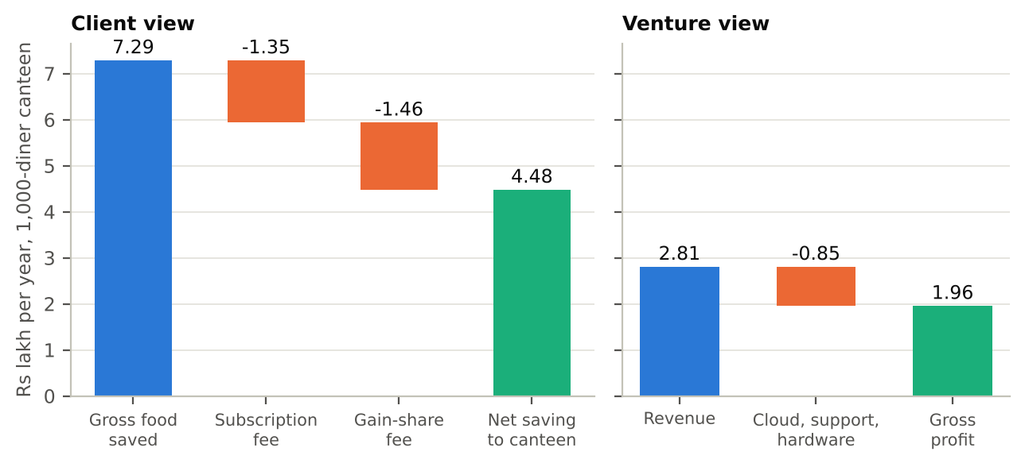
Figure 7. Where the client's gross saving goes, and PlateWise's revenue, cost and profit per site-year.
These economics are in line with Indian B2B SaaS benchmarks: UpGrowth reports CAC of ₹1.2-2.5 lakh, LTV:CAC of 2.5-3x and payback of 14-20 months for companies at ₹10-30 crore ARR, with gross margins of 70-80% [29]. PlateWise is at or inside those bands (LTV:CAC 3.1, payback 12 months, GM 70%), which is a sanity check and not validation, since those benchmarks are for scaled software firms and PlateWise has none of that evidence yet.

5.4 How much will one site really save? Monte Carlo
To see how uncertainty in the inputs spreads, I ran 10,000 draws with triangular distributions (minimum, most likely, maximum) on four inputs: diners per site (600, 1,000, 1,500), raw-food spend per diner per day (₹70, 90, 120), share of food wasted today (3%, 10%, 15%) and reduction achieved (10%, 30%, 45%). The per-site gross saving has a median of ₹6.47 lakh (10th-90th percentile ₹3.43-10.90 lakh). The client's benefit-cost ratio (gross saving divided by fees paid) is above 1 in 99.7% of draws and above 2 in 78.7%; its median is 2.4.
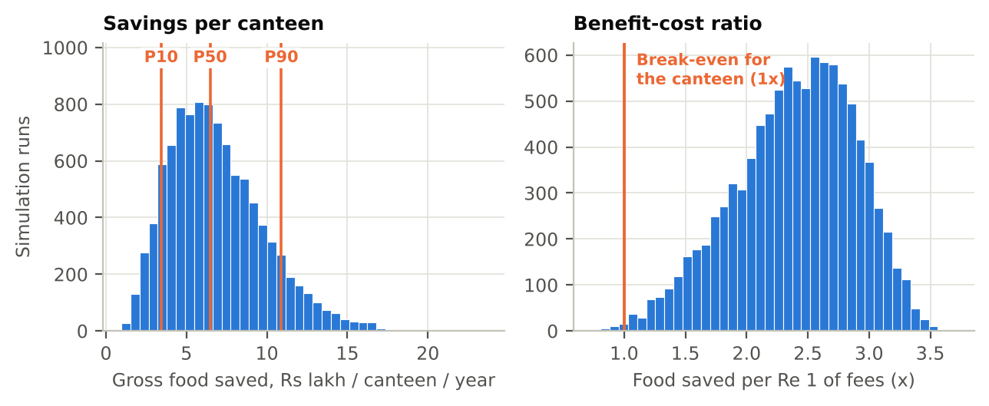
Figure 8. Monte Carlo distribution of the per-site gross saving (₹ lakh per year). P10 = 3.43, P50 = 6.47, P90 = 10.90.

6. Financial plan
The 48-month plan adds 12, 33, 65, 55 customer sites in years 1-4 (a launch ramp in year 1, then interpolated monthly), with fixed operating costs of ₹24, 45, 70, 90 lakh. Customers churn at 20% a year. CAC is paid when a site is won; the subscription is billed over 9 months a year.
Table 16. Annual plan, base case. Operating result uses accrual cost of service (including hardware depreciation); net cash flow uses cash cost and hardware purchases. Brackets are negatives.
₹ lakh | Year 1 | Year 2 | Year 3 | Year 4
Customer sites (end of year) | 11 | 40 | 92 | 125
Revenue | 11.2 | 67.0 | 184.8 | 307.9
Cost of service | (3.4) | (20.3) | (55.9) | (93.2)
Gross profit | 7.8 | 46.7 | 128.8 | 214.7
Customer acquisition | (24.0) | (66.0) | (130.0) | (110.0)
Fixed operating costs | (24.0) | (45.0) | (70.0) | (90.0)
Operating result | (40.2) | (64.3) | (71.2) | 14.7
Hardware capex | (3.6) | (9.9) | (19.5) | (16.5)
Net cash flow (cash COGS) | (43.4) | (71.8) | (84.1) | 9.2

Run-rate profit before growth spend turns positive in month 19, but the cash does not turn positive until month 41 because acquisition spend continues. Break-even needs about 46 sites against year-4 fixed costs. The cash trough is ₹205.4 lakh in month 40; the cumulative cash position at month 48 is still a shortfall of ₹190.1 lakh, which is why the plan is a venture-style bet that pays back after year 4.
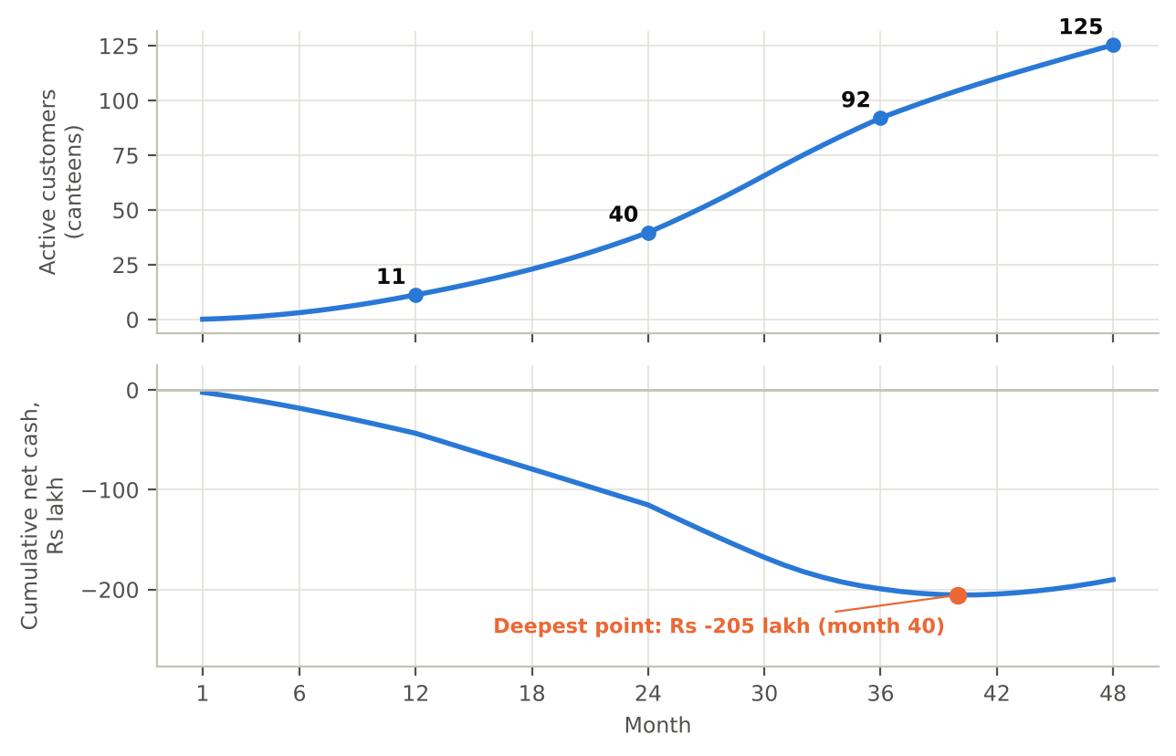
Figure 9. 48-month plan, base case: monthly net cash flow and cumulative cash (the J-curve), with customer sites.

6.1 Scenarios
Scenarios flex five inputs together. Pessimistic: reduction 20%, starting waste 8%, 30% fewer customers won, CAC ₹2.6 lakh, churn 28%. Optimistic: reduction 40%, starting waste 12%, 20% more customers won, CAC ₹1.6 lakh, churn 12%.
Table 17. Scenario analysis. The pessimistic case does not recover within 48 months.
Metric | Pessimistic | Base | Optimistic
LTV : CAC | 1.23 | 3.06 | 7.38
CAC payback (months) | 24.4 | 12.3 | 6.8
Gross margin | 60% | 70% | 77%
Customer sites at month 36 | 60 | 92 | 118
ARR at month 36 (₹ cr) | 1.28 | 2.58 | 4.36
Cash needed at trough (₹ cr) | 3.81 | 2.05 | 0.79
First cash-positive month | none by month 48 | 41 | 30

The spread is wide: funding need ranges from ₹0.79 crore to ₹3.81 crore. A founder who raises ₹2.5 crore on the base plan has no cushion if the pessimistic inputs are close to the truth. That is the reason to stage the funding around the hypotheses H1-H6 rather than raise everything up front.

7. Funding, ecosystem and policy

7.1 Use of funds
The cumulative funding need to the cash trough (months 1-40) is ₹2.05 crore; with a 20% buffer the ask is about ₹2.5 crore. By use, over months 1-40:
Table 18. Use of funds to the cash trough, base case.
Item (months 1-40) | ₹ lakh | Share of outflow
Fixed operating costs (team, tools, travel) | 169.0 | 30%
Customer acquisition | 258.0 | 46%
Hardware | 38.7 | 7%
Cash cost of service | 94.9 | 17%
Total outflow | 560.6 | 100%
Less: revenue collected | (355.2)
Net funding need (trough) | 205.4

7.2 Funding stages and trade-offs
Table 19. Funding path. Scheme terms are from the cited sources and must be re-checked before applying.
Stage | Source | Amount | What it buys | Trade-off
Pre-seed | Founder, student grants, incubator | up to about ₹0.5 lakh | H1-H3 tests, 90-day pre-pilot | No dilution; slow and capped by affordable loss
Seed grant | Startup India Seed Fund Scheme (SISFS) through an incubator [30][31] | Up to ₹20 lakh grant; up to ₹50 lakh convertible | First 5-10 paid sites; team of 3 | Needs DPIIT recognition; company at most 2 years old; incubator controls disbursement
State support | Jharkhand Startup Policy 2023 [32][33] | Stipends, rent, marketing and utilities support (details vary by scheme) | Runway for a Ranchi base | Eligibility and timing to be confirmed with the nodal agency
Seed round | Angels or an impact fund | About ₹1.5-2.5 cr | Growth to 40+ sites (year 2-3) | Dilution; investors will ask for live evidence for H2 and H4

SISFS was launched in April 2021 with an outlay of ₹945 crore; it offers up to ₹20 lakh as a grant for validation and prototyping and up to ₹50 lakh as convertible debentures or debt for market entry, to DPIIT-recognised start-ups no more than two years old [30][31]. The grant alone covers the 90-day pre-pilot and the first few months of the plan, but not the ₹2.05 crore trough, so the scheme is a bridge, not the funding strategy.

7.3 Where to build: Ranchi versus the metros
The Jharkhand Startup Policy 2023, approved in December 2023, offers stipends, rental and marketing support and other incentives to registered start-ups, and an ideas portal opened from 4 February 2025 [32][33]. A Ranchi base would keep fixed costs near the low end of the ₹24 lakh first-year budget, give access to the state scheme and put the team close to a large pool of institutional kitchens (government colleges, universities, hostels). The cost is a thinner network of angels and SaaS talent than Bangalore or Hyderabad. My view is to build and prove in Ranchi, raise in Bangalore: keep operations at Jharkhand cost levels and take seed meetings in the larger ecosystem once H2 and H4 have live evidence. This is a judgement for discussion, not a finding.

7.4 Regulatory tailwind
FSSAI's Eat Right Campus certification covers hygiene, healthy food and waste management on campuses [4][34]. A PlateWise waste log gives a campus dated evidence for that part of the audit, which is an independent reason for an institution to buy, apart from the savings.

8. Risk and sensitivity
The tornado varies one input at a time and shows the change in LTV:CAC from the base of 3.06. Site size matters most: a 700-diner site lowers LTV:CAC by 1.3 and a 1,400-diner site raises it by 1.8. The two inputs that PlateWise cannot control, the starting waste share and the reduction achieved, each swing the ratio by about 1.1 either way. That is why H1 and H4 are tested first.
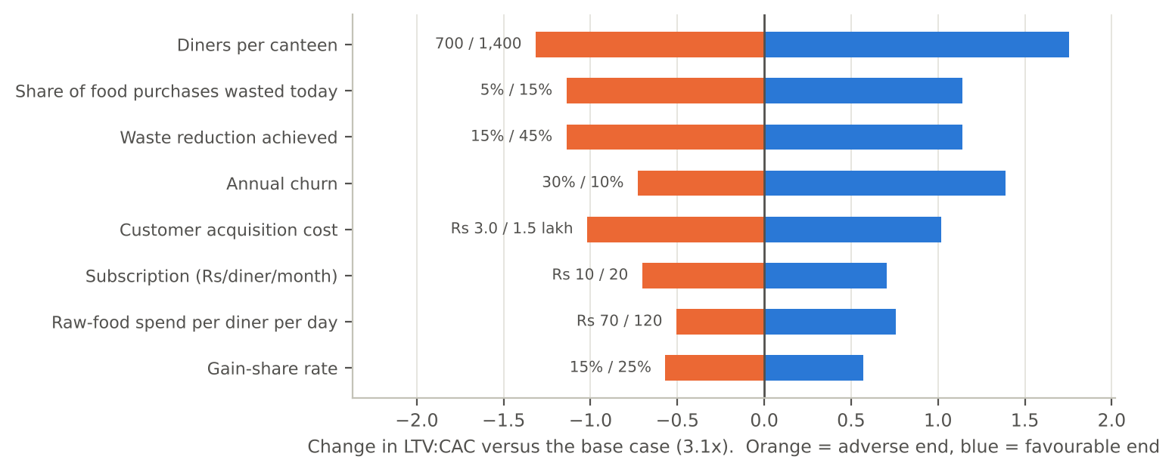
Figure 10. One-at-a-time sensitivity of LTV:CAC. Orange = adverse value, blue = favourable value; labels give the tested range.

8.1 Risk register
Table 20. Risk register.
Risk | Likelihood | Impact | Mitigation | Early signal
Split incentive: caterer or institution does not benefit, so no one buys | High | High | Segment 1 first; gain-share contracts; offer an audit-report tier | Low H2 / H5 pass rate
Real attendance harder to predict than simulated | Medium | High | Plan on 30% reduction; collect 4 weeks of data before pricing gain share | Live MAPE above 8%
Kitchen staff do not follow the cooking plan | Medium | High | Cook-side training; show cost of stock-outs and waste weekly | Compliance below 70%
Long institutional sales cycles and tenders | High | Medium | Pilot first, budgeted CAC ₹2 lakh; target direct-purchase sites | Median sales cycle above 6 months
Seasonality: 9 billing months a year | Certain | Low | Built into pricing (9 months) | n/a
Foreign vendors cut price or enter India | Low | Medium | Local pricing, vernacular support, Indian food coverage | Competitor tender wins
Data privacy: attendance records on identifiable students | Medium | Medium | Use aggregate counts only; no personal data; clear consent in contract | Client data requests
Founder bandwidth: a solo MBA founder | High | Medium | Bring in a technical co-founder and a field analyst at seed | Slipping pilot timeline

9. Social and environmental impact
PlateWise contributes directly to SDG 12.3 (halving per-capita food waste) [5]. Each 1,000-diner site avoids about 24,300 wasted portions a year. At month 36 the base plan covers 92 sites, or about 2.24 million portions a year; at month 48 it covers 125 sites and about 3.04 million portions. Clients' gross savings at month 36 are roughly ₹6.7 crore a year.
Two cautions apply. The portion counts follow from the planning assumptions, not from measured results. Second, savings that stay with a caterer or a committee do not automatically reach students; the contract design in Section 3.1 determines whether lower waste means lower fees, better menus or only higher margins. The measure of success is a trend in cost per plate and in student satisfaction, tracked at each site, not portions alone.

10. Conclusion and next 90 days
PlateWise is a credible, narrow business: a ₹138 crore niche with software-like margins and a clear client return, but with a long J-curve and a funding need of about ₹2.05 crore. The evidence to date is a model and a simulation, not customers. The next 90 days are designed to turn the riskiest assumptions into facts at an affordable loss:
- Weeks 1-3: run 10 interviews (H1) at hostels and canteens, ideally including at least two caterers (H5).
- Weeks 3-6: collect real meal counts from one mess; replicate the forecast comparison on real data (H3).
- Weeks 6-10: run an 8-week cook-to-forecast trial at that mess with a paper cooking plan (H4).
- Weeks 8-12: put the price band to 10 institutions and note the letters of intent (H2, H6).
- Week 12: decide pivot or persevere against the pre-set criteria in Section 4.5; then apply for DPIIT recognition and SISFS through an incubator.

11. AI use disclosure and verification

11.1 What AI was used for
Table 21. AI use by stage. Tool: Claude (Anthropic), with web search and a Python sandbox.
Stage | AI task | Human decision and checking
Opportunity identification | Proposed five venture ideas and the scoring criteria; drafted scores for all five | I set the criteria weights and chose the final venture (food-waste analytics, from the scorecard); scores are my judgement; ranking tested under alternative weights
Market research | Searched the web, summarised sources, proposed the sizing chain | Sources cited and numbers traced; chose the conservative estimate; flagged the 3x spread
Idea refinement | Drafted hypotheses and the simulated pilot design; wrote the forecasting code | Chose to label the pilot synthetic; planning uses 30% not 53%
Business model | Built the unit-economics, 48-month, scenario and Monte Carlo models in Python; drew the charts | Reviewed assumptions and outputs; changed the price after the base case failed (Section 5.2)
Writing | Drafted this report from the model outputs | Re-checked every number against results.json; reviewed text for unsupported claims

11.2 Where AI went wrong and what I changed
- Sensitivity analysis error. The first tornado was run on cumulative cash and gave the wrong sign for customers won (CAC is paid up front). It was rebuilt on LTV:CAC, with plan-level effects shown in a separate scenario table.
- Plan horizon. A 36-month plan cut off the J-curve, so the model was extended to 48 months.
- Weak economics. The first base case did not break even (LTV:CAC 2.6); the subscription was raised from ₹12 to ₹15. That is an assumption I own, not a discovery.
- Stock-outs. An initial operating point had 19.6% stock-out meals; a second service criterion (at most 10%) was added, which changed the buffer to +7%.
- Chart defects. Several label collisions were found by looking at the rendered images and fixed.

11.3 Verification steps
- Every external number carries a citation, and the market figures were re-computed from the stated inputs.
- All model outputs are generated by one script from the assumptions in Appendix B, so the report and figures cannot drift apart.
- The simulated pilot is labelled synthetic in the text, in table captions and in the executive summary.
- Where sources disagree (market size, vendor results), the report states the range and the choice made.

11.4 Limits
Generative AI can produce confident but wrong claims. Vendor results (for example, 40-70% reductions) come from the vendors' own case studies and are not independent. Several sources are secondary summaries of primary reports. Hostel share (10%), reach (30%), CAC and churn are assumptions with low or medium confidence (Appendix B), and the pessimistic scenario shows what happens if they are wrong.

References
[1] Drishti IAS (2024). Food Waste Index Report 2024 (UNEP). Daily news analysis. https://www.drishtiias.com/daily-updates/daily-news-analysis/food-waste-index-report-2024/print_manually
[2] Statista. Total annual household food waste produced in selected countries. https://statista.com/chart/24350/total-annual-household-waste-produced-in-selected-countries
[3] NutritionConnect. FSSAI: guiding the optimisation of surplus food donation (Save Food, Share Food). https://nutritionconnect.org/food-safety-standards-authority-india-fssai-guiding-optimisation-surplus-food-donation
[4] TUV NORD India. Eat Right Campus: audit of campus canteens (leaflet). https://www.tuv-nord.com/fileadmin/Content/TUV_NORD_COM/TUV_INDIA/pdf/Eat_Right_Campus.pdf
[5] Khan Global Studies. Food Waste Index Report 2024 and SDG 12.3. https://currentaffairs.khanglobalstudies.com/food-waste-index-report-2024/
[6] Amrita Vishwa Vidyapeetham. Campus food waste tracking. https://webfiles.amrita.edu/2025/10/campus-food-waste-tracking-at-amrita-vishwa-vidyapeetham.pdf
[7] University of Kelaniya, Faculty of Medicine. Food waste in a university canteen (poster). https://medicine.kln.ac.lk/depts/publichealth/images/PosterPresentations/Posters/B27_B.2.3_Poster.pdf
[8] Canadian Food Studies. Plate waste measured in a university dining setting. https://canadianfoodstudies.uwaterloo.ca/index.php/cfs/article/download/683/635/5610
[9] Food Tank (2020). How Winnow is using artificial intelligence to help kitchens end food waste. https://foodtank.com/news/2020/04/how-winnow-is-using-artificial-intelligence-to-help-kitchens-end-food-waste/
[10] Waste360. Leanpath marries technology and human engagement to cut commercial kitchen food waste. https://www.waste360.com/organic-waste/leanpath-marries-technology-and-human-engagement-to-cut-commercial-kitchen-food-waste
[11] FAO Agritech Observatory. Leanpath. https://agritechobservatory.review.fao.org/ar/leanpath
[12] casestudies.com. PwC Amsterdam cuts food waste by 40% with Winnow. https://www.casestudies.com/company/winnow/case-study/pwc-amsterdam-cuts-food-waste-by-40-with-winnow
[13] casestudies.com. Salem Health cuts food waste 33% with Winnow. https://www.casestudies.com/company/winnow/case-study/salem-health-cuts-food-waste-33-with-winnow
[14] casestudies.com. Compass Group saves $63,000 a year with Winnow. https://www.casestudies.com/company/winnow/case-study/compass-group-saves-63000-a-year-with-winnow
[15] Hong Kong Polytechnic University (PolyU). Study of AI-based food-waste tracking in hotel kitchens. https://ira.lib.polyu.edu.hk/handle/10397/114698
[16] Hotel Dive. AI-assisted kitchen solution to reduce food waste. https://www.hoteldive.com/news/ai-assisted-kitchen-solution-to-reduce-food-waste/649553/
[17] AOL. Chefs taking food waste off the menu (Orbisk, Leanpath). https://www.aol.com/chefs-taking-food-waste-off-153635054.html
[18] MealPe. Catering types in India. https://mealpe.app/catering-types-in-india-best-1
[19] Deep Market Insights. India contract catering market. https://deepmarketinsights.com/vista/insights/contract-catering-market/india
[20] IMARC Group. India catering services market. https://imarcgroup.com/india-catering-services-market
[21] Ken Research. India catering services market. https://www.kenresearch.com/industry-reports/india-catering-services-market.md
[22] The Report Cubes. India B2B catering services market. https://thereportcubes.com/public/report-store/india-b2b-catering-services-market
[23] Ministry of Education, Govt. of India. All India Survey on Higher Education (AISHE) 2021-22. https://education.gov.in/sites/upload_files/mhrd/files/statistics-new/AISHE%20Book_2021-22_4.pdf
[24] Indian Institute of Tourism and Travel Management. Hostel and mess fee notice (MBA). https://iittm.ac.in
[25] AIIMS New Delhi. Hostel accommodation: fees. https://aiims.edu/index.php/en/hostel_accomodation_hos_official/fees
[26] T5E, IIT Madras. Mess operations and per-student-per-day rate. https://www.t5eiitm.org/?p=10093
[27] VoxIITK. How the mess functions at IIT Kanpur, part 1. https://voxiitk.com/how-mess-functions-at-iitk-part-1/
[28] PetPooja. Food cost (glossary). https://blog.petpooja.com/glossary/food-cost/
[29] UpGrowth. CAC benchmarks for Indian B2B SaaS by ARR band, 2026. https://upgrowth.in/cac-benchmarks-indian-b2b-saas-arr-band-2026/
[30] Bajaj Finserv. Startup India Seed Fund Scheme. https://www.bajajfinserv.in/startup-india-seed-fund-scheme
[31] myScheme, Govt. of India. Startup India Seed Fund Scheme (SISFS). https://myscheme.gov.in/schemes/sisfs-fs
[32] Daily Pioneer (2025). Govt to invite startup ideas under new policy from Feb 4. https://www.dailypioneer.com/2025/state-editions/govt-to-invite-startup-ideas-under-new-policy-from-feb-4.html
[33] StartupGrants India. Jharkhand Startup Policy 2023. https://www.startupgrantsindia.com/schemes/jharkhand-startup-policy
[34] FSSAI. Eat Right Campus. https://eastregion.fssai.gov.in/Eat-Right-Campus.php

Appendix A. Prompt log (ideal prompts)
The prompts below are the structured form of how each task was set up. They show the pattern used: role, context, task, constraints and a request to state assumptions and uncertainty.
A1. Idea generation
You are an early-stage venture analyst for the Indian market. Generate five venture ideas that a first-year MBA student could start with under INR 10 lakh, in sectors with measurable demand. For each, give the customer, the problem, the revenue model, and one reason it might fail. Do not repeat generic ideas.
A2. Idea screening
Score these five ideas from 1 to 5 on market scale, data and measurability, low capital need, social/SDG impact, lean testability and policy tailwind. Show your reasoning in one line per score. Then re-score with market scale weighted at 40% and tell me whether the ranking changes.
A3. Market research
Find published estimates of India's contract catering and institutional food-service market. For each, give the source, year, scope definition and figure. Explain why they differ, and identify which is the most conservative for B2B campus catering.
A4. Waste evidence
Collect measured food-waste figures for campus and institutional canteens (grams per person, % of food served). Report only numbers with a named source; flag any that come from vendors.
A5. Competitor scan
List AI-based food-waste tools used in commercial kitchens. For each, state the method, reported results with source, price if public, and a limitation for Indian mass-catering.
A6. Sizing
Build a top-down TAM from the catering market through food-cost share, waste share, reducible share and vendor take rate, and a bottom-up TAM from hostel diners. Keep every assumption in a named variable and state its source or mark it as an assumption.
A7. Hypotheses
Convert the business model into six falsifiable hypotheses ordered by risk. For each give a test, a sample size, a pass criterion and a pivot decision if it fails.
A8. Simulated pilot
Write a Python simulation of an 800-resident mess for 56 days with weekday, exam, festival and special-menu effects. Compare seasonal-naive, moving-average, ridge and gradient-boosting forecasts on a rolling-origin evaluation. Label all output as synthetic.
A9. Financial model
Build a 48-month monthly model with sites won, churn, subscription and gain-share revenue, cost of service, CAC and fixed costs. Output unit economics, annual summary, funding trough and first positive-cash month. Run pessimistic, base and optimistic scenarios, a one-at-a-time tornado on LTV:CAC and a 10,000-draw Monte Carlo.
A10. Critique
Act as a sceptical investor. List the five weakest assumptions in this model, what evidence would change your mind, and which result looks too good to be true.
A11. Report
Draft a report that follows the course's WAI template: executive summary, one section per assignment requirement, figures with captions, a disclosure section that lists what the AI got wrong, and an assumptions register. Use only numbers from the results file.

Appendix B. Assumptions register
Table 22. Assumptions register. Low-confidence items are the first to verify in the 90-day plan.
Assumption | Value | Basis | Confidence
Exchange rate | ₹88 / USD | Working rate | Medium
Diners per site | 1,000 | Typical hostel mess; tornado 700-1,400 | Medium
Operating days per year | 270 | Nine academic months | High
Food spend per diner per day | ₹90 | Mess fees and food-cost share [24][25][28] | Medium
Share of food purchases wasted today | 10% | Mid-range of 5-15% [9] | Medium
Waste reduction achieved | 30% | Haircut against 53% simulated and 33-50% vendor cases [10][12][13] | Low
Cost per wasted portion | ₹30 | Raw food cost per plate (pilot valuation) | Medium
Subscription | ₹15/diner/month, 9 months | Design choice; to test (H2) | Low
Gain share | 20% | Design choice; to test (H5) | Low
Cloud / support / hardware dep. per site-year | ₹0.30 / 0.45 / 0.10 lakh | Author estimate | Medium
Hardware capex per site | ₹0.30 lakh | Author estimate (scale, tablet) | Medium
CAC | ₹2.0 lakh | UpGrowth range ₹1.2-2.5 lakh [29] | Low
Annual churn / discount rate | 20% / 12% | Author assumption | Low
Customer sites added, years 1-4 | 12, 33, 65, 55 | Author plan | Low
Fixed operating costs, years 1-4 | ₹24, 45, 70, 90 lakh | Author plan | Medium
Contract catering market | USD 3,885 m | Deep Market Insights [19]; 3x spread | Low
Food-cost share of catering revenue | 35% | Upper end of 28-35% [28] | Medium
Higher-education enrolment | 4.33 crore | AISHE 2021-22 [23] | High
Hostel share of enrolment | 10% | Assumption; verify with AISHE hostel data | Low
SAM reach | 30% | Assumption | Low

Appendix C. Reproducibility note
All numbers in the report come from a single Python script (model.py) that reads the assumptions in Appendix B, builds the unit economics, 48-month model, scenarios, tornado, Monte Carlo (10,000 triangular draws, fixed seed) and the simulated pilot (fixed seed), and writes results.json, the charts and the CSV files. The report is generated from results.json, so a change in an assumption flows into the text, tables and figures together. Files kept for the dashboard: results.json, plan_48_month.csv, pilot_eval_simulated.csv and pilot_full_simulated.csv.
The pilot data are synthetic: attendance is generated from set weekday, exam-week, festival and holiday patterns plus noise, and the baseline cooking norm is 90% of residents at weekday lunch, 92% at weekday dinner, 80% and 88% at weekends. Forecasts use only earlier days (rolling origin), so there is no look-ahead.

