WORKING WITH AI (WAI) REPORT
The Entrepreneurial Manager
PlateWise.
AI-driven food-waste analytics and demand forecasting for institutional canteens and messes
Opportunity identification, market research, idea refinement and business model development with generative AI
Student | Tanish Tyagi
Roll no. / Section | M56D-26 / Section D
Programme | MBA 2026-28, IIM Ranchi
Course / Term | The Entrepreneurial Manager, Term II (25% weight)
Submission | November 2026

AI-use disclosure (summary)
Generative AI (Claude, by Anthropic) was used throughout: to generate and screen venture ideas, to search and summarise sources, to build the financial and simulation models in Python, to draw the charts and to draft this report. Every source is cited, every number comes from the code and assumptions listed in Appendices B and C, and the pilot data in Section 3.5 and the survey responses in Section 2.6 are synthetic (simulated) and are labelled as such wherever they appear. I take responsibility for the originality, accuracy and quality of the report. Full disclosure: Section 7 and Appendix A.

Executive summary
Indian hostels, college messes and corporate canteens cook to a fixed norm, not to what students actually eat. A mess that cooks for 89% of residents when only 77% turn up throws away roughly one portion in eight. PlateWise is a software-and-sensor service that forecasts attendance meal by meal, tells the kitchen how much to cook, and measures what comes back on the plate. The client pays a small subscription plus a share of the verified savings.
₹138 cr  TAM, revenue pool per year | 3.1x  LTV : CAC, base case | 12.3 mo  CAC payback per site | ₹2.5 cr  Funding ask incl. 20% buffer

The report takes this one opportunity from idea to business model, using generative AI at every stage and checking its output as I went. The five findings that matter most:
- A defined customer with a real problem. The buyer is the mess committee or caterer of an institutional kitchen; the beneficiary is the student who pays the mess fee. Published campus measurements and vendor data put waste at 5-15% of food purchases (Section 1.2).
- One idea chosen from five AI proposals, with reasons. The AI's own favourite (EV battery swapping) was rejected because it scores worst on capital need and testability; food-waste analytics scored highest on a six-criterion scorecard, and I show how the ranking changes under different weights (Section 1.4).
- The market is a niche, sized two ways and cross-checked. Top-down TAM is ₹138 crore and bottom-up ₹122 crore; published catering estimates differ 3x, and a table shows which AI claims were confirmed, adjusted or rejected against sources (Sections 2.1 and 2.4).
- The business model works on paper but needs patient capital. A 1,000-diner site saves ₹7.3 lakh of food a year; PlateWise earns ₹2.81 lakh (gross margin 70%), LTV:CAC is 3.1 and payback 12.3 months. The base plan needs about ₹2.05 crore at its low point, and in the pessimistic case it does not recover within 48 months (Section 4).
- The AI was wrong, biased, generic or outdated in thirteen identified places. Section 6 logs each one with how it was caught and what I changed. The most important: the simulated pilot shows a 53% waste cut, but because the AI generated that data, the model plans on 30%.

Evidence base
The evidence is published data, vendor and campus studies, my own model, a simulated pilot and a simulated survey, not customer data. Section 2.5 tests the opportunity six ways with that evidence and states what each test cannot show; Section 2.6 rehearses the student survey on synthetic respondents and fixes the decision rules for the real one. Three hypotheses that depend on people (H1 managers, H2 payment, H5 caterers) are the first tests in the 90-day plan (Section 8).

Table 1. Venture at a glance. All figures from the model in Appendix C; pilot evidence is simulated.
Venture at a glance
Customer | Buyer: mess committee, warden or caterer of a hostel mess, college canteen or corporate cafeteria. Beneficiary: the student who pays the fee.
Offer | Measure (plate and prep logging) + Forecast (meal-wise attendance) + Act (cook-to-forecast plan)
Price | ₹15/diner/month for 9 months + 20% of verified savings
Revenue per 1,000-diner site | ₹2.81 lakh/year (₹280/diner/year)
Gross margin / LTV:CAC / payback | 70% / 3.1 / 12.3 months
TAM / SAM / SOM (year 3) | ₹138 cr / ₹36.5 cr / ₹2.58 cr ARR
Funding need (base) | ₹2.05 cr trough; ask ₹2.5 cr
Impact (month 36) | 2.24 million portions saved per year (SDG 12.3)

How this report is organised
The report follows the five assessment parameters in order. The table shows what each parameter asks for and where this report answers it.
Table 2. Map from assessment parameters to report sections.
Parameter | What it asks for | Where | Evidence in this report
1. Opportunity identification | Specific problem, defined customer, evidence, timing; why AI-suggested ideas were chosen or rejected | Section 1 | Customer definition; evidence from campus studies and vendors; why now; five AI ideas scored on six criteria, with a chosen/rejected decision and reason for each
2. Market research and validation | Market size, segments, competitors; AI findings cross-checked against credible sources; validation of the opportunity | Section 2 | Top-down and bottom-up sizing; segments and who pays; competitor and price gap; AI-claim cross-check table; six tests of the opportunity; a labelled simulated survey with decision rules
3. Idea refinement and business model | How the idea changed through iterations with AI and with people; coherent canvas, value proposition, revenue, costs, risks | Sections 3 and 4 | Iteration log; value proposition; hypotheses and simulated pilot; Business Model Canvas; pricing; unit economics; 48-month plan; scenarios; funding; risk register
4. Critical use of AI | Where AI was wrong, biased, generic or outdated; how corrected; own judgement | Section 6 | Thirteen-item AI critique log; decisions where my judgement changed the outcome; verification practice
5. Disclosure, originality and presentation | Tools, prompts, how AI was used; sources cited; original; structured | Section 7, References, Appendices A-D | Tool and stage disclosure; 34 numbered sources; ideal prompt log; assumptions register; reproducibility note; survey instrument and simulation assumptions

1. Opportunity identification

1.1 The problem and the customer
The problem. Institutional kitchens decide how much to cook from a fixed norm, not from how many people will actually eat. Attendance changes by weekday, exam week, festival and menu, so the cook rounds up and the surplus is thrown away. In my simulated mess the norm is 90% of residents at weekday lunch while average attendance is 77%, so about one portion in eight is wasted. The cook cannot see tomorrow's attendance; the institution pays for the surplus either directly or through the per-student rate.
The customer. The buyer is a specific person in a specific kitchen, not "the market". The table separates the roles, because the person who pays for the waste is often not the person who can reduce it.
Table 3. Defined customer: buyer, payer, user and beneficiary.
Role | Who | Interest
Buyer (decides to adopt) | Mess committee or warden at an institution-run hostel mess; the caterer at a contract-run canteen | Lower food cost; fewer complaints; audit-ready record
Payer (bears the waste) | Students through the mess fee (pass-through contracts) or the caterer (fixed per-student-per-day rate) | Lower fees or higher margin
User | Mess manager and cook | A clear number to cook and a reason for it
Beneficiary | Students | Fewer stock-outs; savings can fund menu quality

1.2 Evidence that the problem is real
Food waste is not a fringe problem. The UNEP Food Waste Index 2024 puts India's household food waste at about 55 kg per person per year, roughly 78 million tonnes in total [1][2], and FSSAI's Save Food, Share Food material notes that about a third of food in India is spoiled or wasted [3]. Institutions are the easier place to act because food is cooked in one place, to one plan, by one team.
Campus measurements show how large the gap can be. Amrita's tracking reports 41 g per person per day, while noting that campuses are often at 70-100 g [6]. A Kelaniya University study found 26.4% of served food wasted, or 139.5 g per student [7], and a review of dining studies reports 25-135 g per consumer per meal [8]. Commercial-kitchen vendors report that 5-15% of purchases are wasted [9]. I use 10% of food purchases as the planning figure, the middle of that range, and test 5% and 15% in the sensitivity analysis. Most of this evidence is from other countries or from vendors, so I treat the 10% as a planning assumption and test it in Section 2.5.

1.3 Why now
- Policy is moving. FSSAI's Eat Right Campus programme [34] rates campuses on five parameters, and food waste management is one of them [4]. SDG 12.3 sets a halving target for per-capita food waste [5].
- Enrolment is large and hostelised. AISHE 2021-22 records 4.33 crore students in higher education [23]. Even 10% living in hostels is more than 43 lakh diners.
- The tools are cheap. Attendance forecasting needs a few weeks of meal counts and a regression model. What used to need a data-science team now runs on a laptop, and a phone camera or a kitchen scale replaces the expensive hardware.
- Global vendors exist but are priced for hotels. Leanpath is listed at about USD 1,200 a month [11], roughly ₹12.7 lakh a year at ₹88 to the dollar, against ₹2.8 lakh for PlateWise (Section 2.3).

1.4 From five AI ideas to one venture
I asked the AI for venture ideas rooted in Indian demand and public data; it proposed five and named EV battery swapping as its own pick "for chart-heavy scoring". Rather than accept that, I scored each idea from 1 (poor) to 5 (strong) on six weighted criteria: market scale, data and measurability (Data), low capital need, social and SDG impact, lean testability (Lean test) and policy tailwind. The scores are my judgement informed by the AI's reasoning, so they are subjective, and I tested how much the ranking depends on the weights. Food-waste analytics leads at 4.20. If market scale is weighted at 40% instead of 20%, it still leads (3.90) but only narrowly over EV battery swapping (3.80), so the choice is a judgement call, not a certainty.
Table 4. Idea screening. Score = weighted total with the weights shown; Alt. = total with market scale weighted 40%. Scores are the author's AI-assisted judgement.
Idea | Market scale  (20%) | Data  (20%) | Low capital  (15%) | Social / SDG  (15%) | Lean test  (20%) | Policy  (10%) | Score | Alt.
EV battery-swapping for delivery riders | 5 | 4 | 1 | 3 | 2 | 5 | 3.30 | 3.80
Millet-based ready-to-eat foods | 3 | 3 | 3 | 4 | 3 | 4 | 3.25 | 3.20
Cold-chain micro-hubs for produce | 4 | 3 | 1 | 5 | 2 | 5 | 3.20 | 3.45
Food-waste analytics for canteens | 3 | 5 | 4 | 4 | 5 | 4 | 4.20 | 3.90
Vernacular placement-readiness platform | 4 | 3 | 4 | 3 | 4 | 2 | 3.45 | 3.55

Table 5. Why each AI-suggested idea was chosen or rejected. Reasons are the author's reading of the scorecard.
Idea | What the AI said | Decision | Why
EV battery swapping for delivery riders | AI's own pick: strong unit economics, policy tailwind, chart-friendly data | Rejected | Needs battery stock and charging sites before the first customer (capital 1) and is hardest to test cheaply (lean test 2). Good data is not the same as a good first business.
Millet-based ready-to-eat foods | Consumer trend data; Jharkhand sourcing angle | Rejected | Mid scores everywhere and no standout; a consumer brand needs stock and distribution before it learns anything (capital 3, lean test 3).
Cold-chain micro-hubs for produce | Fits ecosystem, policy and social-entrepreneurship themes | Rejected | Strong social value (5) but capex-heavy (capital 1) and slow to test (lean test 2).
Food-waste analytics for canteens | B2B model with measurable savings | Chosen | Highest on data and measurability (5) and lean testability (5), with low capital need (4): a first test needs only meal counts and a few weeks.
Vernacular placement-readiness platform | Data-rich, large student market | Rejected | Weaker policy tailwind (2) and mid on measurability (3): the outcome, a placement, is slow to observe and hard to attribute.

1.5 Effectuation: what I start with
The venture is built from means at hand, not from a forecast of the market, which is the effectuation logic taught in the course.
Table 6. Effectuation lens on the venture.
Principle | Application to PlateWise
Bird-in-hand (who I am, what I know, whom I know) | MBA student with an analytics and operations focus; hands-on use of Python and forecasting; a campus mess and its caterer and committee as the first test-bed (access to be negotiated, not assumed).
Affordable loss | A 90-day pre-pilot capped at a small, self-funded amount (proposed ceiling of about ₹50,000, for a kitchen scale, a tablet and cloud credits). No hardware inventory or hires before a paying customer.
Crazy quilt (partnerships) | Mess committee (data and access), caterer (cooking plan), FSSAI Eat Right Campus auditors (credibility), a campus incubator (grants and mentors), a student volunteer team (logging).
Lemonade (use surprises) | If caterers resist because savings go to the institution, sell the service to the institution as an audit tool; if the kitchen will not weigh waste, use attendance forecasting alone.

2. Market research and validation

2.1 Market size
Published sizes of the Indian catering market differ by about three times, because each report defines scope differently (contract versus event catering, B2B versus total food service):
Table 7. Published catering market estimates. The 3x spread reflects scope, not accuracy.
Source | Metric | Figure
Deep Market Insights [19] | India contract catering, 2025 | USD 3,885 million (to USD 6,661 million by 2034)
The Report Cubes [22] | India B2B catering, 2025 | USD 3.99 billion (contract about 65%)
IMARC [20] | India catering services, 2024 | USD 5.10 billion
Ken Research [21] | India catering services, 2025 | USD 12.45 billion

I chose the narrowest figure, contract catering at USD 3,885 million [19], because PlateWise sells to institutions that outsource or run structured kitchens. Using the narrowest estimate keeps the sizing conservative. This is a judgement, and the report states it so a reader can substitute another figure.

Top-down sizing
The chain converts the market into rupees at ₹88 per USD, applies food cost at 35% of catering revenue (the industry range for food cost is roughly 28-35% [28]), then waste, then the reducible portion, and finally PlateWise's share of savings:
Table 8. Top-down chain from catering market to PlateWise TAM.
Step | Value | Basis
Contract catering revenue | ₹34,188 cr | USD 3,885 m x ₹88 [19]
Food purchases (35%) | ₹11,966 cr | Food-cost share, upper end of range [28]
Wasted food (10%) | ₹1,197 cr | Mid-range of 5-15% [9]
Reducible waste (30%) | ₹359 cr | Conservative against 33-50%+ in vendor cases [10][12][13]
PlateWise revenue pool (TAM) | ₹138 cr | 38.5% of savings (subscription + 20% gain share)

Bottom-up check, SAM and SOM
Bottom-up starts from diners. With 4.33 crore students enrolled [23] and 10% assumed to live in a hostel (an assumption, flagged in Appendix B), there are 43.3 lakh hostel diners. At ₹281 revenue per diner per year, bottom-up TAM is ₹122 crore, about 12% below the top-down figure of ₹138 crore. The two methods use different inputs, so their agreement is reassuring but not proof. SAM assumes PlateWise can reach 30% of those diners (13.0 lakh), worth ₹36.5 crore. SOM is the annual recurring revenue at month 36 of the base plan, ₹2.58 crore or 7.1% of SAM.
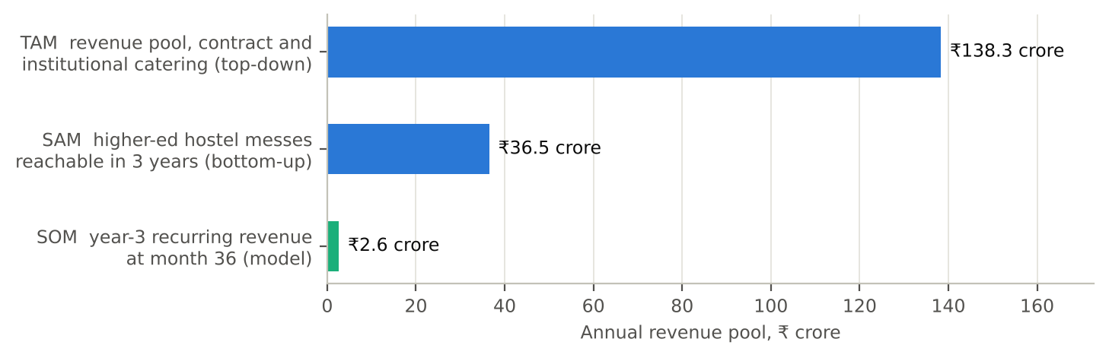
Figure 1. TAM, SAM and SOM (₹ crore per year). TAM top-down 138; bottom-up 122; SAM 36.5; SOM 2.58.
Honest reading of the market
A revenue pool of ₹138 crore is a niche, not a mass market. That suits a focused start-up that wins campuses first, but it caps the outcome unless PlateWise extends to corporate cafeterias, hospitals and hotels. The model does not count that expansion.

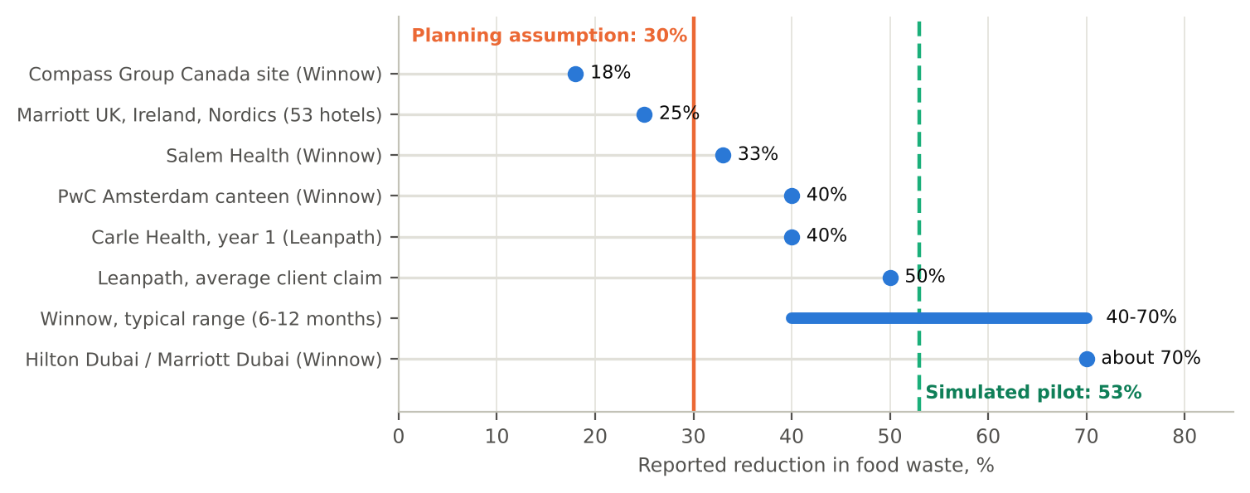
Figure 2. Waste benchmarks from published sources versus the planning assumption used in this model.

2.2 Customer segments and who pays
The buyer and the beneficiary are often different people, which is the main commercial risk. At IIT Kanpur, raw materials are passed through to the students on a formula basis [27]. At IIT Madras, a 2013 letter from the Dean (Students) argued that a per-student-per-day rate below about ₹95 was not plausible for the menu described [26]; this is a dated opinion, not a current contract rate, but it shows how thin a caterer's margin is. Student mess charges are about ₹3,500 a month for four meals in most AIIMS Delhi messes and ₹3,500-4,500 in student-run messes [25]; IIT Mandi lists ₹16,884-24,522 for the 2026-27 odd semester, approximate and paid as per actual [24]. Under a pass-through contract the institution pockets the savings; under a fixed-rate contract the caterer does.
Table 9. Customer segments and the split-incentive problem. Priority ordering is the author's.
Segment | Contract type | Who gains from savings | Who buys PlateWise | Priority
Institution-run hostel mess | Direct cost, student pays | Students / institution | Mess committee, warden | 1 (start here)
Campus with pass-through caterer | Raw material pass-through | Institution | Institution (with caterer buy-in) | 2
Campus with fixed-rate caterer | Per-student-per-day rate | Caterer | Caterer | 3 (needs gain share)
Corporate cafeteria | Vendor contract | Mixed | Facilities / vendor | 4 (expansion)

2.3 Competitors and the price gap
AI-based kitchen waste tools already exist; the opportunity is price and fit, not novelty.
Table 10. Competitive landscape. PlateWise's positioning is the author's assessment.
Player | Approach | Evidence of effect | Gap for Indian messes (author's assessment)
Winnow | Camera and scale on the bin, AI identifies food | 5-15% of purchases wasted; 40-70% reduction in 6-12 months; PwC Amsterdam 40%, Salem Health 33% [9][12][13] | Built for hotels and corporate kitchens; priced above a typical mess budget
Leanpath | Scale-based tracking with staff engagement | Average 50% reduction, 2-6% of purchase cost saved [10]; about USD 1,200 a month [11] | About ₹12.7 lakh a year; hardware and onboarding heavy
Orbisk and others | AI camera on bins | Reported in trade press [16][17] | Same hardware and price pattern; one study notes difficulty with mixed food [15], common on a thali
Manual audits (Eat Right Campus) | Periodic inspection | Includes food waste management in the audit [4] | Periodic, not continuous; no forecast
PlateWise | Attendance forecast + cooking plan + light measurement | Simulated: waste cut by 53% (planning: 30%) | ₹2.8 lakh a year per 1,000 diners; software-first

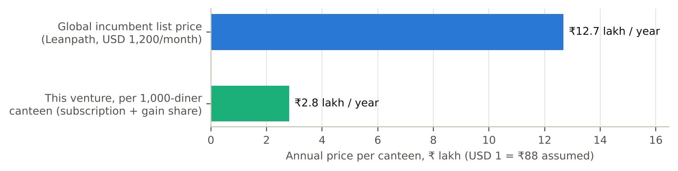
Figure 3. Annual cost to a 1,000-diner site: Leanpath list price versus PlateWise (₹ lakh).

2.4 Cross-checking AI findings against sources
Every number the AI gave me was traced to a source before it went into the model. The table shows what the check found, including where the AI's claim had to be adjusted or was left as an open assumption.
Table 11. AI claims cross-checked against sources. Green = confirmed; amber = adjusted or conflicting; orange = unsupported or unverified.
AI output | Checked against | Result | What I did
India household food waste about 55 kg per person per year | UNEP Food Waste Index coverage [1][2] | Confirmed | Used, but noted it is household waste, not institutional kitchens
Contract catering market size | Four published estimates [19]-[22]: USD 3.9 bn to 12.5 bn | Conflicting (3x spread) | Chose the narrowest (contract catering, USD 3,885 m), stated the spread
Waste cut of 40-70% with AI tools | Vendor case studies and trade press [9][10][12][13] | Adjusted: self-reported by vendors | Planning figure cut to 30%; vendor range shown only as context
Leanpath price of about USD 1,200 a month | One source [11] | Single source, unverified | Used as an indicative list price, flagged in the price-gap chart
SISFS gives up to ₹20 lakh grant and ₹50 lakh convertible | Bajaj Finserv summary [30]; the myScheme page [31] could not be reopened | Confirmed on one source; period stated as 2021-2025 | Added DPIIT recognition and 2-year age conditions; check the scheme is still open before applying
Jharkhand Startup Policy incentives | Secondary sites [32][33]; no official notice found | Unverified detail | Described in general terms; marked to re-check with the nodal agency
Higher-education enrolment 4.33 crore | AISHE 2021-22 [23] | Confirmed, but dated | Used; flagged that a newer survey may exist
10% of students live in hostels | No source found | Unsupported | Kept as a flagged low-confidence assumption, not cited as fact
Gross margins of 70-80% for Indian B2B SaaS | UpGrowth benchmark page [29] | Not found in the source | Dropped the claim; the benchmark is used for CAC, LTV:CAC and payback only
Food cost is 28-35% of catering revenue | PetPooja glossary [28] | Confirmed for restaurants only | Used upper end (35%); institutional kitchens may differ

2.5 Testing the opportunity with the evidence available
The sources in Sections 1 and 2 show that waste is common. They do not show that a particular mess would pay to reduce it. I therefore ran six tests that use only published data and my own model, and for each I state what it can and cannot show. No primary data was collected for this report; where only a field test can answer a question, the table says so. Section 2.6 then adds a clearly labelled simulated survey to rehearse the first-hand test.
Table 12. Six tests of the opportunity using the evidence available, with the limit of each.
Test | What I did | Result | What it cannot show
1. Two-way sizing | Sized the revenue pool top-down (catering market, food spend, waste, reduction, take rate) and bottom-up (hostel diners times revenue per diner) | ₹138 cr against ₹122 cr; the top-down figure is 14% higher | Both chains share the 10% hostel-share assumption, so they are not fully independent
2. Waste benchmark | Compared the 10% planning figure with published measurements | 10% sits inside the 5-15% vendor range [9]; campus studies are higher (26.4% at Kelaniya [7]; 70-100 g per person per day often seen on campuses [6]) | Most evidence is foreign or vendor-reported; waste in an Indian hostel mess is not measured here
3. Price sanity | Compared ₹15 per diner per month with published mess charges | About 0.3-0.4% of ₹3,500-4,500 a month at AIIMS Delhi [25]; about 0.4% of IIT Mandi's ₹16,884 semester charge if a semester is five months [24] | That the fee is small against the bill, not that the buyer values what it buys
4. Unit-economics benchmark | Compared CAC, LTV:CAC and payback with Indian B2B SaaS bands [29] | CAC ₹2.0 lakh is inside the ₹1.2-2.5 lakh band; LTV:CAC 3.1 is at the top of 2.5-3x; payback 12 months is shorter than 14-20 | The benchmarks are for scaled software firms; PlateWise has no customers, so being inside the band flatters it
5. Client value under uncertainty | Ran 10,000 Monte Carlo draws on diners, food spend, waste share and reduction (Section 4.4) | Client benefit-cost ratio above 1 in 99.7% of draws, above 2 in 78.7%, median 2.4 | The result is only as good as the input ranges I set
6. Simulated pilot | Ran an 800-resident, 56-day synthetic mess (Section 3.5) | Forecast error 3.7% against 6.6% for the last-week rule; waste 12.1% to 5.7% in simulation | It is circular: the data came from my assumptions, so it tests the method, not the market

What stays untested
Hypotheses H1 (managers see waste as a cost problem), H2 (institutions will pay) and H5 (caterers accept a gain share) depend on how people behave, so desk evidence cannot settle them. They are the first tests in the 90-day plan (Section 8), with pass criteria fixed in advance (Section 3.4). Where the evidence is thin, the planning figures are deliberately cautious (30% reduction instead of the simulated 53%), and the pessimistic scenario in Section 4.5 shows the cost of being wrong.

2.6 Simulated student survey: a rehearsal of the first-hand test
Simulated data
Every response in this section is synthetic. I generated 60 "respondents" by computer from distributions I assumed (Appendix D.2); none of them is a real student. The results therefore restate my assumptions and are not evidence about real messes. The purpose is to rehearse the survey and its analysis, to size the real survey, and to fix decision rules before any real data exist.

PlateWise depends on two things published data cannot show: whether students notice waste, and whether they would mark attendance. I wrote a 7-question instrument (Appendix D.1), generated synthetic responses from stated assumptions with a fixed random seed, and ran the analysis script on them. This checked that every question maps to a hypothesis (H1 or H2), that the analysis runs from the raw responses to the chart, and how many real responses I would need.
60  Synthetic respondents (SIMULATED) | 63%  See waste often or always (SIMULATED) | 73%  Skip meals unannounced (SIMULATED) | 78%  Would or might mark attendance (SIMULATED)

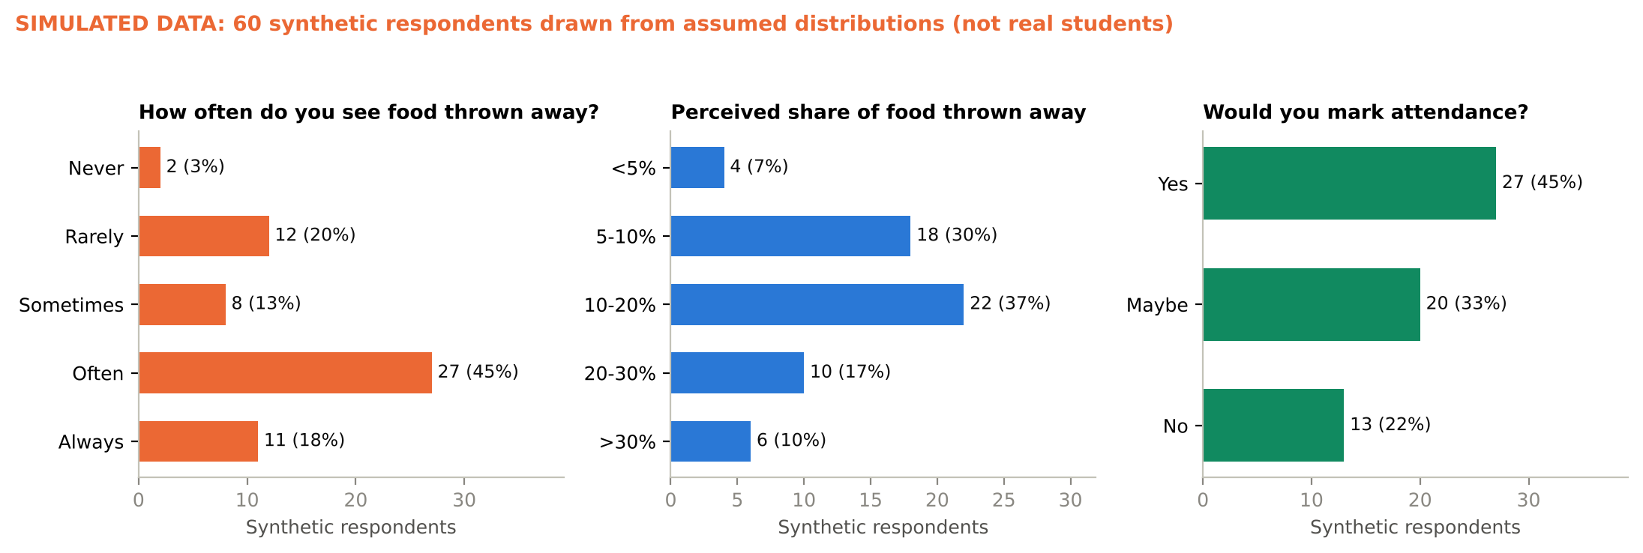
Figure 4. Simulated survey: 60 synthetic respondents (not real students). Shares follow from the assumed distributions in Appendix D.2.
Reading the output. The shares above are what my assumptions say, not findings. The mean perceived waste share (15.6%) is above my 10% planning figure because I assumed students overestimate; perceptions are not measurements. What the rehearsal does show is sample size: with 30 responses the 95% interval around a share is about ±18 points, with 60 it is ±13, so I set 60 as the target for the real survey.
Table 13. Decision rules for the real survey. The thresholds are my judgement from the planning assumptions, set independently of the simulated result; the middle column only shows the rules applied to synthetic data.
Question | Decision rule fixed in advance (real survey) | Simulated reading | Action if the real result is below the rule
Q2 Sees waste (H1) | Supports H1 if at least 50% say often or always; reconsider if under 30% | 63% (rule met) | Under 30%: apply the H1 pivot rule (Section 3.6)
Q3 Perceived share | Supports the 10% planning figure if the mean is at least 8%; if under 5%, rerun the model at 5% waste (LTV:CAC falls by about 1.1, Section 4.7) | 15.6% (rule met) | Cut the waste assumption and restate the funding need
Q4 Food runs out | Keep the +7% buffer if under 50% say sometimes or more; raise it above that | 40% (keep buffer) | Re-run the cooking-policy trade-off with a higher buffer
Q5 Unannounced skipping | Build a per-meal opt-out if at least 50% skip sometimes or more; under 25% means variation is mostly structural | 73% (build opt-out) | Rely on counter headcount and the calendar, not sign-up
Q6 Would mark attendance (H2) | Include sign-up in version 1 if at least 60% say yes or maybe; drop it if under 30% | 78% (include) | Ship counter logging only

What this does and does not show
- It tests the instrument and the analysis, not the market. The questions, the scoring and the chart work end to end on the kind of file a Google Form exports.
- The results are my assumptions in a different form. Changing an assumption changes the result, so none of it supports H1 or H2, and no synthetic number is used as an input anywhere in the model.
- The real survey is the first step of the 90-day plan (Section 8): 60 responses from hostel residents using the form in Appendix D.1, analysed against the rules above.

3. Idea refinement

3.1 How the idea changed: iteration log
The idea was refined in rounds. Some changes were triggered by AI output, some by data or modelling and some by my own critique of the results. The log shows each round and what it changed.
Table 14. Iteration log: how the idea changed, and what triggered each change.
Round | Trigger | What changed | Why
1 | AI + my judgement | Five AI ideas scored; EV battery swapping (AI's pick) set aside for food-waste analytics | Capital need and lean testability decided it (Section 1.4)
2 | AI competitor scan | Positioning set as software-first with an optional ₹30,000 scale, not the hardware-first AI-camera model sold by global vendors | Price gap to hotel-priced tools [11]; one study notes difficulty with mixed food [15], common on a thali
3 | Modelling | Subscription raised from ₹12 to ₹15 per diner per month, plus a 20% gain share | The ₹12 base case did not break even (LTV:CAC 2.6); gain-share aligns the incentive where the caterer or the institution benefits. Still to be tested (H2)
4 | Modelling | Plan horizon extended from 36 to 48 months | The 36-month view cut off the J-curve before cash recovered
5 | Data | Forecast model chosen: ridge regression, not gradient boosting | On only 28 training days the simpler model was more accurate (MAPE 3.7% vs 4.1%)
6 | Data | Service guardrail added: stock-out meals at most 10% (buffer set at +7%) | The first operating point left 19.6% of meals with a stock-out, which a kitchen would not accept
7 | Critique | Planning waste reduction set at 30%, not the 53% simulated | The simulated data came from assumptions I set, so it cannot validate itself (Section 6)
8 | Simulation | Real survey sized at 60 responses, with decision rules fixed in advance | A simulated rehearsal showed that 30 responses leave about ±18 points of uncertainty on a share (Section 2.6)

3.2 Jobs to be done and value proposition
Table 15. Jobs-to-be-done and value proposition canvas, combined.
Who | Job to be done | Pain today | Gain from PlateWise
Mess manager / cook | Cook the right quantity for every meal | Guesswork; blamed for both shortage and waste | A number to cook and a reason for it
Warden / committee | Keep fees stable and complaints low | Rising food cost; no data to challenge the caterer | Cost per plate trend; waste report
Caterer | Protect margin on a fixed-rate contract | Waste eats margin; shortage risks the contract | Lower waste share and an audit-ready record
Students | Get food of acceptable quality, every time | Stock-outs at the end of service; plain food | Fewer shortages; savings can fund menu quality
Sustainability / audit lead | Show progress on waste for Eat Right Campus | No measured baseline | Dated, auditable waste log [4]

3.3 The product: Measure, Forecast, Act
- Measure. A phone or tablet app logs headcount at the counter, food prepared and food left over; a kitchen scale is optional at the start (hardware capex ₹30,000 per site).
- Forecast. A regression model predicts attendance by meal using weekday, exams, festivals, special menus and recent history.
- Act. The cooking plan converts the forecast into quantities with a safety buffer chosen to hold unserved demand below 0.5% and stock-out meals below 10%.

3.4 Hypotheses and tests
Important: the pilot below is a simulation
I have not yet run PlateWise in a real mess. The data in this section are synthetic, generated from assumptions I set (weekday patterns, exam week, festivals, noise). They show that the method works if attendance is as predictable as assumed. They do not prove that it is. The planning model therefore uses a lower waste reduction (30%) than the simulation shows (53%).

Table 16. Hypothesis register. H3 and H4 have simulated evidence only; H2 has a desk price check; the survey in Section 2.6 only rehearses H1 and H2; H1, H5 and H6 are untested.
# | Hypothesis (riskiest first) | Test | Pass criterion | Status
H1 | Mess managers see food waste as a cost problem and have no measurement | 10 interviews at hostels and canteens; 60-response survey | 8 of 10 confirm waste above 8% and no log; survey rule in Section 2.6 | Untested; survey only rehearsed
H2 | Institutions will pay about ₹15/diner/month plus a savings share | Pricing conversations; letter of intent | 3 of 10 accept the price band | Desk check only (Section 2.5)
H3 | A forecast beats the current cooking rule | 28-day hold-out comparison | MAPE at least 20% below last-week rule | Simulated: 44% lower
H4 | Cooking to the forecast cuts waste without more stock-outs | 8-week live trial at one mess | At least 30% less waste; unserved below 0.5% | Simulated: 53%; live test planned
H5 | Caterers accept a gain-share contract | Caterer meetings | 3 of 10 accept | Untested; first 90-day test
H6 | A site can be acquired for no more than ₹2 lakh | Cold outreach and tender watch | CAC at most ₹2.0 lakh over first 5 sites | Planned

3.5 The simulated pilot

Design
The simulation is an 800-resident mess over 56 days with two meals a day. Average attendance is 77% of residents, while the baseline kitchen cooks for about 89%. The first 28 days train the models, and the next 28 are a rolling-origin evaluation, where each day is forecast using only earlier data. Four forecasts are compared: a seasonal-naive rule (same meal last week), a 4-week moving average, gradient boosting and ridge regression.
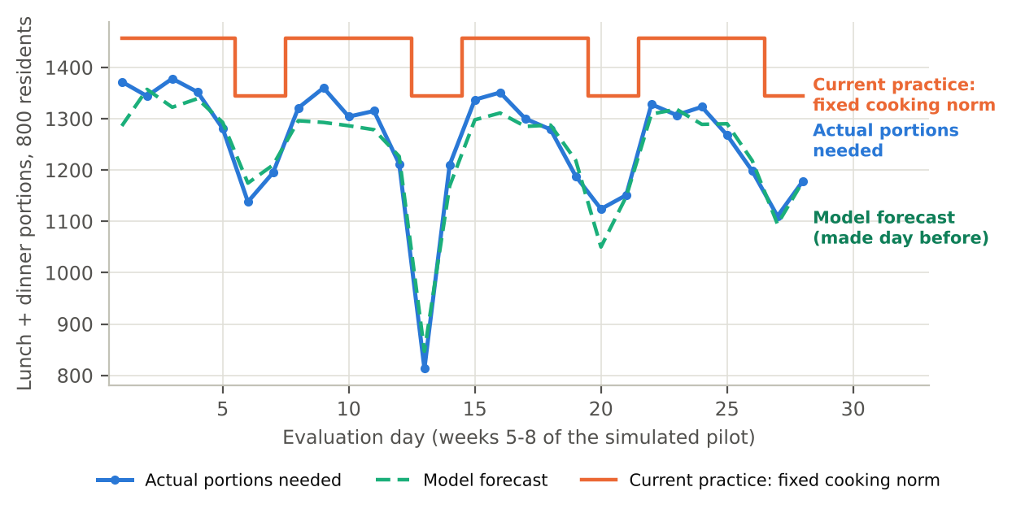
Figure 5. Simulated demand versus the fixed cooking norm and the ridge forecast over the evaluation window (synthetic data).

Results
Ridge regression was the most accurate model, cutting MAPE from 6.6% for the last-week rule to 3.7% (44% lower) and from 5.3% for the moving average (30% lower). The simpler model won over gradient boosting because the dataset is only 28 training days and the signal is mostly calendar effects, a result worth remembering when real data arrives.
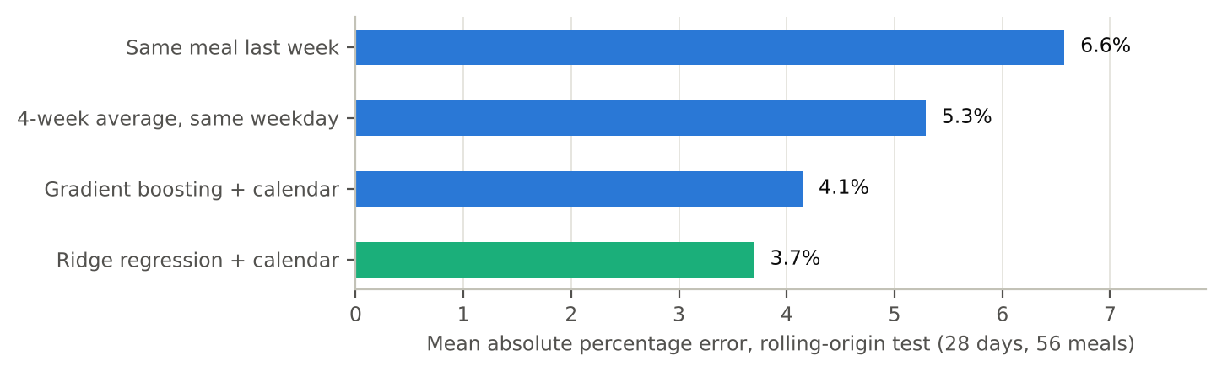
Figure 6. Forecast error on the 28-day evaluation window (MAPE, %; lower is better). Synthetic data.
Table 17. Forecast accuracy on the evaluation window (simulated).
Model | MAPE (%) | MAE (portions)
Seasonal naive (same meal last week) | 6.6 | 37.9
4-week moving average | 5.3 | 30.5
Gradient boosting | 4.1 | 24.2
Ridge regression | 3.7 | 22.7

From forecast to cooking policy: waste versus shortage
A better forecast only matters if it changes how much is cooked. Adding a buffer to the forecast trades waste against shortage. I chose the smallest buffer that keeps unserved demand under 0.5% and stock-out meals under 10%; for ridge that is +7%. The last-week rule needs a +17% buffer to give similar service and ends up wasting more than the fixed norm.
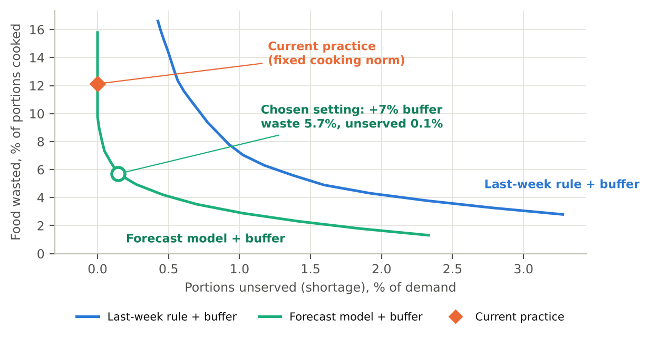
Figure 7. Waste share and unserved demand as the safety buffer grows, ridge forecast versus last-week rule (synthetic data).
Table 18. Cooking policies compared on the same 28 evaluation days (simulated).
Policy | Waste (% of cooked) | Unserved demand | Stock-out meals
Fixed cooking norm (baseline) | 12.1% | 0.00% | 0.0%
Last-week rule +17% | 14.5% | 0.49% | 3.6%
Ridge forecast +7% (PlateWise) | 5.7% | 0.15% | 5.4%

At the operating point waste falls from 12.1% to 5.7%, a 53% reduction, or 97 portions a day. At ₹30 a portion that is ₹7.87 lakh a year for 800 residents (₹984 per diner), against ₹729 per diner in the planning model. The planning figure is therefore 74% of the simulated saving, a deliberate haircut for noisier real data, harder-to-predict attendance and imperfect compliance by the kitchen.

3.6 Limits and pivot rules
- Synthetic data. Real attendance is noisier and may be harder to capture; the 3.7% MAPE should be read as an upper bound on performance.
- One mess, 56 days. No claim about generalisation across campuses.
- Stock-out cost is not priced. The trade-off treats a shortage as a service constraint, not a rupee cost; a real trial must track student complaints.
Pivot rules decided in advance: if H1 fails (managers do not see waste as a problem), pivot to selling the attendance forecast as a cost-control tool for caterers. If H2 or H5 fails, test a flat annual licence per campus. If H4 reaches under 15% waste reduction in live trials, drop the gain-share and sell as a compliance and reporting tool for Eat Right Campus audits.

4. Business model, financials and risks

4.1 Business Model Canvas
Table 19. Business Model Canvas for PlateWise.
Key partners  Mess committees, caterers, FSSAI Eat Right Campus auditors, campus incubators, cloud provider | Key activities  Forecast model upkeep, onboarding, data cleaning, savings verification | Value propositions  Cook the right quantity: waste down about 30% (53% in simulation) with stock-outs held in check; auditable waste log; priced for messes, not hotels | Customer relationships  Onboarding by a field analyst; monthly savings report; shared savings keep us aligned | Customer segments  Hostel messes, college canteens (first); corporate cafeterias (later)
Key resources  Forecasting code, data from each site, small field team, scales and tablets (₹30,000 per site) | Channels  Direct sales to campuses, tenders and empanelment, IIM and IIT alumni, Eat Right Campus network | Cost structure  Fixed ₹24-90 lakh a year (years 1-4); CAC ₹2 lakh per site; cloud and support ₹0.75 lakh per site-year; hardware ₹0.30 lakh | Revenue streams  Subscription ₹15/diner/month over 9 months + 20% of verified savings; renewal annual | Social value  2.2 million portions saved a year at month 36

4.2 Revenue model and pricing
Price has two parts so that both sides share the risk. The subscription (₹15 per diner per month for the 9 months a campus is in session) covers the cost of serving the client; the gain share (20% of savings above the baseline, verified in a monthly report) aligns the incentive. For a 1,000-diner site this is ₹1.35 lakh plus ₹1.458 lakh, a total of ₹2.81 lakh, or 39% of the ₹7.29 lakh gross saving. The client keeps ₹4.48 lakh, which is 2.6 times what it pays.
I raised the subscription from ₹12 to ₹15 during modelling because at ₹12 the base case failed to reach break-even. The new price is a design choice to be tested in H2, not a finding. If institutions reject it, the tornado (Section 4.7) shows that a ₹10 price takes LTV:CAC down by 0.7.

4.3 Unit economics
Table 20. Unit economics for the base case.
Per 1,000-diner site, per year | Value
Gross food saved for the client | ₹7.29 lakh
PlateWise revenue (subscription + gain share) | ₹2.81 lakh
Cost of service (cloud, support, hardware depreciation) | ₹0.85 lakh
Gross profit / gross margin | ₹1.96 lakh / 69.7%
Customer acquisition cost | ₹2.0 lakh
CAC payback | 12.3 months
Lifetime value (churn 20%, discount 12%) | ₹6.12 lakh
LTV : CAC | 3.06
Client net saving and return | ₹4.48 lakh / 2.6x

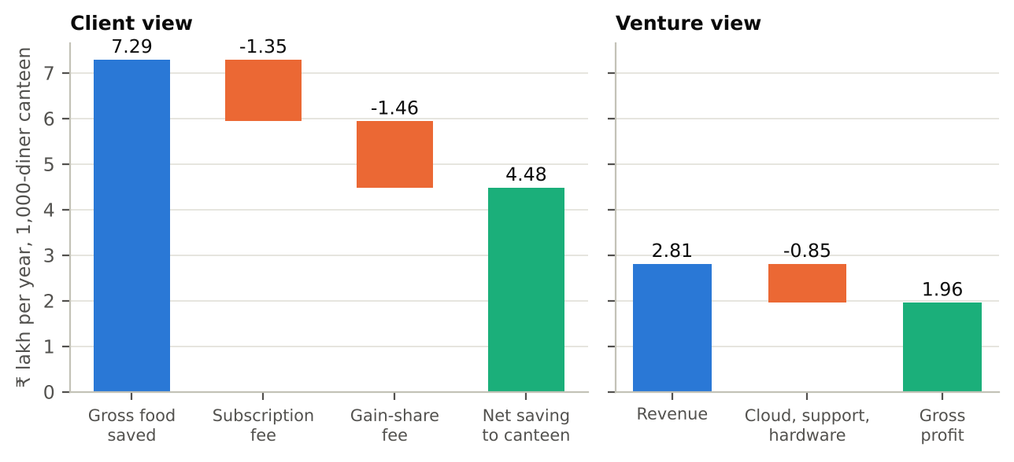
Figure 8. Where the client's gross saving goes, and PlateWise's revenue, cost and profit per site-year.
The economics can be compared with Indian B2B SaaS benchmarks: UpGrowth reports CAC of ₹1.2-2.5 lakh, LTV:CAC of 2.5-3x and payback of 14-20 months for companies at ₹10-30 crore ARR [29]. PlateWise's CAC (₹2.0 lakh) is inside that band, its LTV:CAC (3.1) is at the top of it and its payback (12 months) is shorter. This is a sanity check, not validation: the benchmarks are for scaled software firms and PlateWise has no customers, so a result inside the band flatters it.

4.4 How much will one site really save? Monte Carlo
To see how uncertainty in the inputs spreads, I ran 10,000 draws with triangular distributions (minimum, most likely, maximum) on four inputs: diners per site (600, 1,000, 1,500), raw-food spend per diner per day (₹70, 90, 120), share of food wasted today (3%, 10%, 15%) and reduction achieved (10%, 30%, 45%). The per-site gross saving has a median of ₹6.47 lakh (10th-90th percentile ₹3.43-10.90 lakh). The client's benefit-cost ratio (gross saving divided by fees paid) is above 1 in 99.7% of draws and above 2 in 78.7%; its median is 2.4.
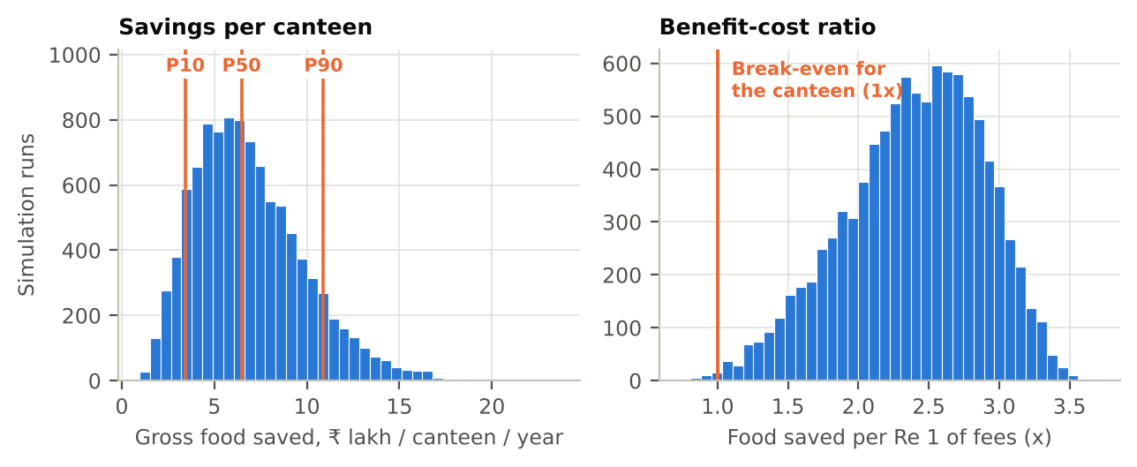
Figure 9. Monte Carlo distribution of the per-site gross saving (₹ lakh per year). P10 = 3.43, P50 = 6.47, P90 = 10.90.

4.5 Financial plan
The 48-month plan adds 12, 33, 65, 55 customer sites in years 1-4 (a launch ramp in year 1, then interpolated monthly), with fixed operating costs of ₹24, 45, 70, 90 lakh. Customers churn at 20% a year. CAC is paid when a site is won; the subscription is billed over 9 months a year.
Table 21. Annual plan, base case. Operating result uses accrual cost of service (including hardware depreciation); net cash flow uses cash cost and hardware purchases. Brackets are negatives.
₹ lakh | Year 1 | Year 2 | Year 3 | Year 4
Customer sites (end of year) | 11 | 40 | 92 | 125
Revenue | 11.2 | 67.0 | 184.8 | 307.9
Cost of service | (3.4) | (20.3) | (55.9) | (93.2)
Gross profit | 7.8 | 46.7 | 128.8 | 214.7
Customer acquisition | (24.0) | (66.0) | (130.0) | (110.0)
Fixed operating costs | (24.0) | (45.0) | (70.0) | (90.0)
Operating result | (40.2) | (64.3) | (71.2) | 14.7
Hardware capex | (3.6) | (9.9) | (19.5) | (16.5)
Net cash flow (cash COGS) | (43.4) | (71.8) | (84.1) | 9.2

Run-rate profit before growth spend turns positive in month 19, but the cash does not turn positive until month 41 because acquisition spend continues. Break-even needs about 46 sites against year-4 fixed costs. The cash trough is ₹205.4 lakh in month 40; the cumulative cash position at month 48 is still a shortfall of ₹190.1 lakh, which is why the plan is a venture-style bet that pays back after year 4.
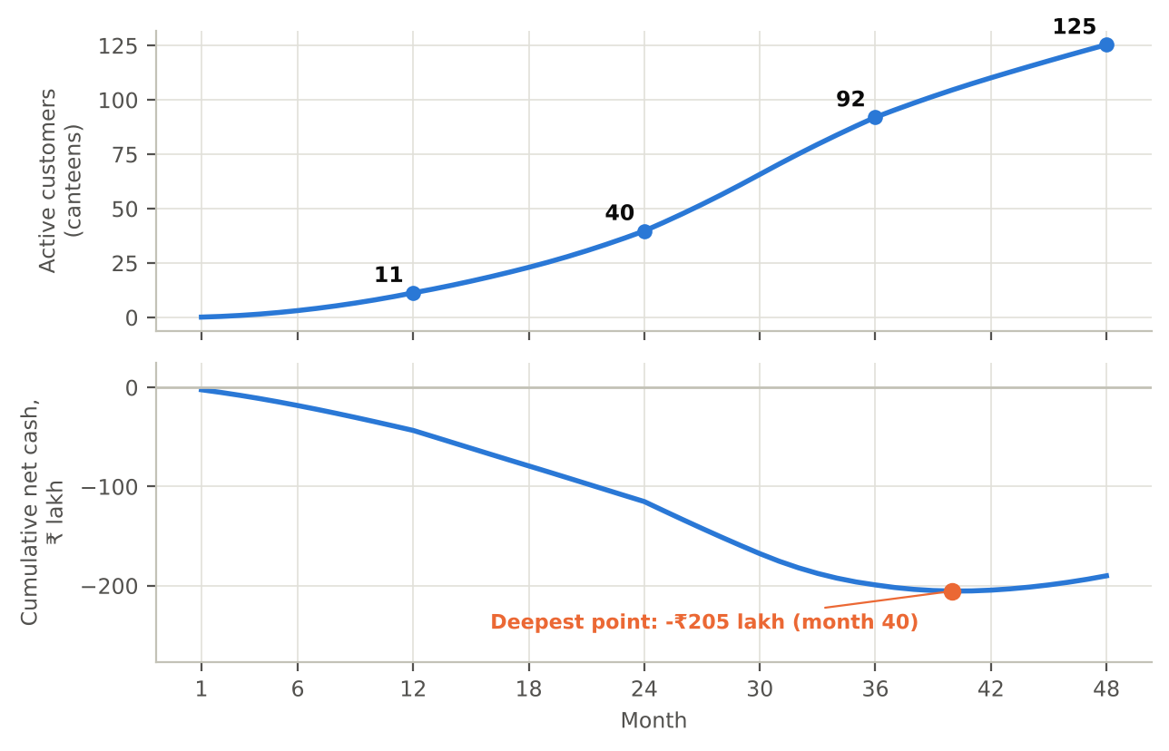
Figure 10. 48-month plan, base case: monthly net cash flow and cumulative cash (the J-curve), with customer sites.

Scenarios
Scenarios flex five inputs together. Pessimistic: reduction 20%, starting waste 8%, 30% fewer customers won, CAC ₹2.6 lakh, churn 28%. Optimistic: reduction 40%, starting waste 12%, 20% more customers won, CAC ₹1.6 lakh, churn 12%.
Table 22. Scenario analysis. The pessimistic case does not recover within 48 months.
Metric | Pessimistic | Base | Optimistic
LTV : CAC | 1.23 | 3.06 | 7.38
CAC payback (months) | 24.4 | 12.3 | 6.8
Gross margin | 60% | 70% | 77%
Customer sites at month 36 | 60 | 92 | 118
ARR at month 36 (₹ cr) | 1.28 | 2.58 | 4.36
Cash needed at trough (₹ cr) | 3.81 | 2.05 | 0.79
First cash-positive month | none by month 48 | 41 | 30

The spread is wide: funding need ranges from ₹0.79 crore to ₹3.81 crore. A founder who raises ₹2.5 crore on the base plan has no cushion if the pessimistic inputs are close to the truth. That is the reason to stage the funding around the hypotheses H1-H6 rather than raise everything up front.

4.6 Funding, ecosystem and policy

Use of funds
The cumulative funding need to the cash trough (months 1-40) is ₹2.05 crore; with a 20% buffer the ask is about ₹2.5 crore. By use, over months 1-40:
Table 23. Use of funds to the cash trough, base case.
Item (months 1-40) | ₹ lakh | Share of outflow
Fixed operating costs (team, tools, travel) | 169.0 | 30%
Customer acquisition | 258.0 | 46%
Hardware | 38.7 | 7%
Cash cost of service | 94.9 | 17%
Total outflow | 560.6 | 100%
Less: revenue collected | (355.2)
Net funding need (trough) | 205.4

Funding stages and trade-offs
Table 24. Funding path. Scheme terms are from the cited sources and must be re-checked before applying.
Stage | Source | Amount | What it buys | Trade-off
Pre-seed | Founder, student grants, incubator | up to about ₹0.5 lakh | H1-H3 tests, 90-day pre-pilot | No dilution; slow and capped by affordable loss
Seed grant | Startup India Seed Fund Scheme (SISFS) through an incubator [30] | Up to ₹20 lakh grant; up to ₹50 lakh convertible | First 5-10 paid sites; team of 3 | Needs DPIIT recognition; company at most 2 years old; incubator controls disbursement
State support | Jharkhand Startup Policy 2023 [32][33] | Stipends, rent, marketing and utilities support (details vary by scheme) | Runway for a Ranchi base | Eligibility and timing to be confirmed with the nodal agency
Seed round | Angels or an impact fund | About ₹1.5-2.5 cr | Growth to 40+ sites (year 2-3) | Dilution; investors will ask for live evidence for H2 and H4

SISFS has an outlay of ₹945 crore and a stated operative period of 2021-2025, so check that it is still open before applying; it offers up to ₹20 lakh as a grant for validation and prototyping and up to ₹50 lakh as convertible debentures or debt for market entry, to DPIIT-recognised start-ups no more than two years old [30]. The grant alone covers the 90-day pre-pilot and the first few months of the plan, but not the ₹2.05 crore trough, so the scheme is a bridge, not the funding strategy.

Where to build: Ranchi versus the metros
The Jharkhand Startup Policy 2023 was approved in December 2023, and an ideas portal opened from 4 February 2025 [32]. A secondary site lists stipends, rental and marketing support for registered start-ups [33], which I have not been able to confirm against an official notice. A Ranchi base would keep fixed costs near the low end of the ₹24 lakh first-year budget, give access to the state scheme and put the team close to a large pool of institutional kitchens (government colleges, universities, hostels). The cost is a thinner network of angels and SaaS talent than Bangalore or Hyderabad. My view is to build and prove in Ranchi, raise in Bangalore: keep operations at Jharkhand cost levels and take seed meetings in the larger ecosystem once H2 and H4 have live evidence. This is a judgement for discussion, not a finding.

Regulatory tailwind
FSSAI's Eat Right Campus programme [34] rates campuses on food safety, healthy diet, local and seasonal food, food waste management and awareness [4]. A PlateWise waste log gives a campus dated evidence for that part of the audit, which is an independent reason for an institution to buy, apart from the savings.

4.7 Key risks and sensitivity
The tornado varies one input at a time and shows the change in LTV:CAC from the base of 3.06. Site size matters most: a 700-diner site lowers LTV:CAC by 1.3 and a 1,400-diner site raises it by 1.8. The two inputs that PlateWise cannot control, the starting waste share and the reduction achieved, each swing the ratio by about 1.1 either way. That is why H1 and H4 are tested first.
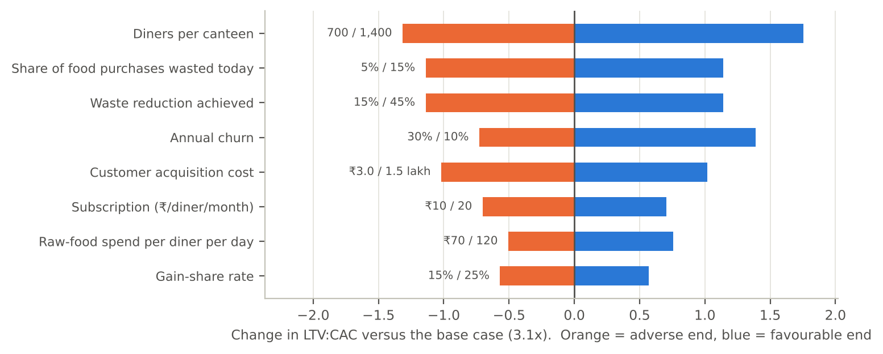
Figure 11. One-at-a-time sensitivity of LTV:CAC. Orange = adverse value, blue = favourable value; labels give the tested range.

Risk register
Table 25. Risk register.
Risk | Likelihood | Impact | Mitigation | Early signal
Split incentive: caterer or institution does not benefit, so no one buys | High | High | Segment 1 first; gain-share contracts; offer an audit-report tier | Low H2 / H5 pass rate
Real attendance harder to predict than simulated | Medium | High | Plan on 30% reduction; collect 4 weeks of data before pricing gain share | Live MAPE above 8%
Kitchen staff do not follow the cooking plan | Medium | High | Cook-side training; show cost of stock-outs and waste weekly | Compliance below 70%
Long institutional sales cycles and tenders | High | Medium | Pilot first, budgeted CAC ₹2 lakh; target direct-purchase sites | Median sales cycle above 6 months
Seasonality: 9 billing months a year | Certain | Low | Built into pricing (9 months) | n/a
Foreign vendors cut price or enter India | Low | Medium | Local pricing, vernacular support, Indian food coverage | Competitor tender wins
Data privacy: attendance records on identifiable students | Medium | Medium | Use aggregate counts only; no personal data; clear consent in contract | Client data requests
Founder bandwidth: a solo MBA founder | High | Medium | Bring in a technical co-founder and a field analyst at seed | Slipping pilot timeline

5. Social and environmental impact
PlateWise contributes directly to SDG 12.3 (halving per-capita food waste) [5]. Each 1,000-diner site avoids about 24,300 wasted portions a year. At month 36 the base plan covers 92 sites, or about 2.24 million portions a year; at month 48 it covers 125 sites and about 3.04 million portions. Clients' gross savings at month 36 are roughly ₹6.7 crore a year.
Two cautions apply. The portion counts follow from the planning assumptions, not from measured results. Second, savings that stay with a caterer or a committee do not automatically reach students; the contract design in Section 2.2 determines whether lower waste means lower fees, better menus or only higher margins. The measure of success is a trend in cost per plate and in student satisfaction, tracked at each site, not portions alone.

6. Critical use of AI
Using AI is only useful if its output is questioned. This section logs thirteen places where the AI's output was wrong, biased, generic or outdated, how each was caught, and what I did about it.

6.1 AI critique log
Table 26. AI critique log. Types: Wrong = factually or logically incorrect; Biased = tilted by source, incentive or method; Generic = a default answer that did not fit; Outdated = old or unverified data.
# | Type | What the AI produced | How it was caught | What I did
1 | Wrong | First sensitivity chart (tornado) run on cumulative cash showed that winning more customers made cash worse | The sign contradicted the plan table: CAC is paid up front, so cash dips before it recovers | Rebuilt on LTV:CAC; plan-level effects moved to the scenario table
2 | Wrong | A 36-month plan that ended before cash recovered | The J-curve was still falling at the last month | Extended to 48 months
3 | Wrong | A first operating buffer that left 19.6% of simulated meals with a stock-out | Checking service level, not just waste | Added a stock-out limit of 10%; buffer moved to +7%
4 | Wrong | A base case that did not break even (LTV:CAC 2.6) | Plan stayed negative through year 4 | Raised the subscription to ₹15, and recorded it as my assumption, not a finding
5 | Biased | Named EV battery swapping as its pick "for chart-heavy scoring" | Data-rich is not the same as a good first business | Scored six criteria incl. capital and testability; chose food-waste analytics (Section 1.4)
6 | Biased | Waste cuts of 40-70% from vendor case studies and trade press | Every positive result was from a seller or its customers [9][10][12][13][16] | Planned on 30%; vendor range used only as context
7 | Biased | A simulated pilot in which the forecast wins by 44% on MAPE | The pilot data was generated from assumptions the AI chose, so the test is circular | Labelled synthetic everywhere; haircut the benefit; a live trial (H4) is the real test
8 | Generic | The default expectation that a gradient-boosting model would beat a linear one | On 28 training days it did not (4.1% vs 3.7% MAPE) | Chose ridge regression; kept gradient boosting as a comparison
9 | Generic | SaaS benchmarks (CAC, LTV:CAC, payback) for scaled Indian B2B software firms [29] | PlateWise has no customers; the benchmark is for firms at ₹10-30 crore ARR | Used only as a sanity check, not as validation
10 | Outdated | Enrolment of 4.33 crore from AISHE 2021-22 [23] | Survey year is several years old | Used with a flag; hostel share left as an explicit assumption
11 | Outdated | Market reports dated 2024 and 2025 with different scopes [19]-[22] | Figures differed 3x and years differed | Chose the narrowest estimate and stated the spread
12 | Outdated | Government scheme details taken from secondary websites [32][33] | No official notice was found | Wrote in general terms and marked for re-check before applying
13 | Biased | A simulated survey whose results read like student opinion | The responses are drawn from distributions I set, so they restate my assumptions | Labelled synthetic on every table and figure; used only to size the real survey and fix decision rules; kept out of all model inputs

6.2 Where my judgement changed the outcome
- I chose against the AI's favourite. The AI preferred EV battery swapping; I chose the idea that could be tested cheaply and has measurable savings.
- I took the smaller market. I used the narrowest of four market estimates, which gives a niche of ₹138 crore, because a conservative size is easier to defend than a flattering one.
- I refused to let the simulation validate itself. The pilot is labelled synthetic and the model plans on 30% instead of 53%.
- I designed the price around who benefits. A flat per-seat fee ignores whether the caterer or the institution gains from lower waste, so the price has a gain-share part.
- I set stopping rules in advance. Pivot rules for each hypothesis (Section 3.6) mean I decide what would change my mind before I see results.
- I staged the funding. Because the pessimistic case does not recover within 48 months, the plan raises money against hypotheses H1-H6, not all up front.

6.3 How I checked AI output
- Each external number was traced to a source, and conflicts were recorded (Section 2.4).
- All model outputs come from one script and one set of assumptions (Appendices B and C), so text, tables and charts cannot drift apart.
- Charts were rendered and inspected for label collisions and misleading scales before use.
- Claims about the future (waste reduction, price acceptance) are written as hypotheses with a test and a pass criterion, not as facts.

7. AI use disclosure

7.1 Tools used
Table 27. AI tools used.
Tool | Used for
Claude (Anthropic), a large language model | Idea generation and scoring support, source summarising, drafting, model and chart code, critique of its own output
Web search and page-fetch tools used by Claude | Finding and reading the 34 sources in the reference list
Python (pandas, scikit-learn, matplotlib), run by Claude | Unit economics, 48-month model, scenarios, sensitivity, Monte Carlo, simulated pilot, charts
docx-js, run by Claude | Building this Word report from the model outputs

7.2 How AI was used, stage by stage
Table 28. AI use by stage, with the human decision at each.
Stage | AI task | Human decision and checking
Opportunity identification | Proposed five venture ideas and the scoring criteria; drafted scores for all five | I set the criteria weights, tested the ranking under alternative weights and chose the final venture against the AI's own pick
Market research | Searched the web, summarised sources, proposed the sizing chain | Sources cited and numbers traced (Table in Section 2.4); chose the conservative estimate; flagged the 3x spread
Validation (desk tests and simulation) | Designed the six tests in Section 2.5; drafted the survey and generated the synthetic responses and analysis in Section 2.6 | Chose which tests to run; set the generating assumptions and the decision thresholds myself; labelled all synthetic output; used none of it as a model input
Idea refinement | Drafted hypotheses and the simulated pilot; wrote the forecasting code | Chose to label the pilot synthetic; planning uses 30%, not 53%
Business model | Built unit-economics, 48-month, scenario and Monte Carlo models; drew the charts | Reviewed assumptions and outputs; changed the price after the base case failed
Writing | Drafted this report from the model outputs | Re-checked every number against results.json; reviewed text for unsupported claims

7.3 Prompts
The key prompts used at each stage are listed in Appendix A, in cleaned and structured form rather than word for word, so that a reader can reproduce the approach.

7.4 Originality and responsibility
This report was produced with AI assistance and is submitted under the APO guidelines on AI use. Sources are paraphrased and cited, not copied; figures are generated from the model in Appendix C; and every simulated or assumed number is labelled as such. I am responsible for the originality, accuracy and quality of the report.

7.5 Limits
Generative AI can produce confident but wrong claims. Vendor results come from the vendors' own case studies and are not independent. Several sources are secondary summaries of primary reports. Hostel share (10%), reach (30%), CAC and churn are assumptions with low or medium confidence (Appendix B), and the pessimistic scenario shows what happens if they are wrong. No primary data (survey, interviews or a live pilot) was collected, so the evidence is secondary and simulated. The survey in Section 2.6 is synthetic, and Section 2.5 says what each test can and cannot show.

8. Conclusion and next 90 days
PlateWise is a credible, narrow business: a ₹138 crore niche with software-like margins and a clear client return, but with a long J-curve and a funding need of about ₹2.05 crore. The evidence to date is a model, a simulation and no customer data yet. The next 90 days are designed to turn the riskiest assumptions into facts at an affordable loss:
- Weeks 1-3: run the real 60-response survey (form in Appendix D.1) and 10 interviews at hostels and canteens, including at least two caterers (H1, H5), and record what each changes in the plan.
- Weeks 3-6: collect real meal counts from one mess; replicate the forecast comparison on real data (H3).
- Weeks 6-10: run an 8-week cook-to-forecast trial at that mess with a paper cooking plan (H4).
- Weeks 8-12: put the price band to 10 institutions and note the letters of intent (H2, H6).
- Week 12: decide pivot or persevere against the pre-set criteria in Section 3.6; then apply for DPIIT recognition and SISFS through an incubator.

References
[1] Drishti IAS (2024). Food Waste Index Report 2024 (UNEP). Daily news analysis. https://www.drishtiias.com/daily-updates/daily-news-analysis/food-waste-index-report-2024/print_manually
[2] Statista. Total annual household food waste produced in selected countries. https://statista.com/chart/24350/total-annual-household-waste-produced-in-selected-countries
[3] NutritionConnect. FSSAI: guiding the optimisation of surplus food donation (Save Food, Share Food). https://nutritionconnect.org/food-safety-standards-authority-india-fssai-guiding-optimisation-surplus-food-donation
[4] TUV NORD India. Eat Right Campus: audit of campus canteens (leaflet). https://www.tuv-nord.com/fileadmin/Content/TUV_NORD_COM/TUV_INDIA/pdf/Eat_Right_Campus.pdf
[5] Khan Global Studies. Food Waste Index Report 2024 and SDG 12.3. https://currentaffairs.khanglobalstudies.com/food-waste-index-report-2024/
[6] Amrita Vishwa Vidyapeetham. Campus food waste tracking. https://webfiles.amrita.edu/2025/10/campus-food-waste-tracking-at-amrita-vishwa-vidyapeetham.pdf
[7] University of Kelaniya, Faculty of Medicine. Food waste in a university canteen (poster). https://medicine.kln.ac.lk/depts/publichealth/images/PosterPresentations/Posters/B27_B.2.3_Poster.pdf
[8] Canadian Food Studies. Plate waste measured in a university dining setting. https://canadianfoodstudies.uwaterloo.ca/index.php/cfs/article/download/683/635/5610
[9] Food Tank (2020). How Winnow is using artificial intelligence to help kitchens end food waste. https://foodtank.com/news/2020/04/how-winnow-is-using-artificial-intelligence-to-help-kitchens-end-food-waste/
[10] Waste360. Leanpath marries technology and human engagement to cut commercial kitchen food waste. https://www.waste360.com/organic-waste/leanpath-marries-technology-and-human-engagement-to-cut-commercial-kitchen-food-waste
[11] FAO Agritech Observatory. Leanpath. https://agritechobservatory.review.fao.org/ar/leanpath
[12] casestudies.com. PwC Amsterdam cuts food waste by 40% with Winnow. https://www.casestudies.com/company/winnow/case-study/pwc-amsterdam-cuts-food-waste-by-40-with-winnow
[13] casestudies.com. Salem Health cuts food waste 33% with Winnow. https://www.casestudies.com/company/winnow/case-study/salem-health-cuts-food-waste-33-with-winnow
[14] casestudies.com. Compass Group saves $63,000 a year with Winnow. https://www.casestudies.com/company/winnow/case-study/compass-group-saves-63000-a-year-with-winnow
[15] Hong Kong Polytechnic University (PolyU). Study of AI-based food-waste tracking in hotel kitchens. https://ira.lib.polyu.edu.hk/handle/10397/114698
[16] Hotel Dive. AI-assisted kitchen solution to reduce food waste. https://www.hoteldive.com/news/ai-assisted-kitchen-solution-to-reduce-food-waste/649553/
[17] AOL. Chefs taking food waste off the menu (Orbisk, Leanpath). https://www.aol.com/chefs-taking-food-waste-off-153635054.html
[18] MealPe. Catering types in India. https://mealpe.app/catering-types-in-india-best-1
[19] Deep Market Insights. India contract catering market. https://deepmarketinsights.com/vista/insights/contract-catering-market/india
[20] IMARC Group. India catering services market. https://imarcgroup.com/india-catering-services-market
[21] Ken Research. India catering services market. https://www.kenresearch.com/industry-reports/india-catering-services-market.md
[22] The Report Cubes. India B2B catering services market. https://thereportcubes.com/public/report-store/india-b2b-catering-services-market
[23] Ministry of Education, Govt. of India. All India Survey on Higher Education (AISHE) 2021-22. https://education.gov.in/sites/upload_files/mhrd/files/statistics-new/AISHE%20Book_2021-22_4.pdf
[24] IIT Mandi. Hostel mess charges 2026-27 (new admissions). https://academics.iitmandi.ac.in/pdf/fees/Hostel_Mess_Charges2026_27_New_admission.pdf
[25] AIIMS New Delhi. Hostel accommodation: fees. https://aiims.edu/index.php/en/hostel_accomodation_hos_official/fees
[26] T5E (The Fifth Estate), IIT Madras. Letter from the Dean (Students) on mess rates, 2013. https://www.t5eiitm.org/?p=10093
[27] VoxIITK. How the mess functions at IIT Kanpur, part 1. https://voxiitk.com/how-mess-functions-at-iitk-part-1/
[28] PetPooja. Food cost (glossary). https://blog.petpooja.com/glossary/food-cost/
[29] UpGrowth. CAC benchmarks for Indian B2B SaaS by ARR band, 2026. https://upgrowth.in/cac-benchmarks-indian-b2b-saas-arr-band-2026/
[30] Bajaj Finserv. Startup India Seed Fund Scheme. https://www.bajajfinserv.in/startup-india-seed-fund-scheme
[31] myScheme, Govt. of India. Startup India Seed Fund Scheme (SISFS). https://myscheme.gov.in/schemes/sisfs-fs
[32] Daily Pioneer (2025). Govt to invite startup ideas under new policy from Feb 4. https://www.dailypioneer.com/2025/state-editions/govt-to-invite-startup-ideas-under-new-policy-from-feb-4.html
[33] StartupGrants India. Jharkhand Startup Policy 2023. https://www.startupgrantsindia.com/schemes/jharkhand-startup-policy
[34] FSSAI. Eat Right Campus. https://eastregion.fssai.gov.in/Eat-Right-Campus.php

Appendix A. Prompt log (ideal prompts)
The key prompts used at each stage, shown in cleaned and structured form rather than word for word. They show the pattern used: role, context, task, constraints and a request to state assumptions and uncertainty.
A1. Idea generation
You are an early-stage venture analyst for the Indian market. Generate five venture ideas that a first-year MBA student could start with under INR 10 lakh, in sectors with measurable demand. For each, give the customer, the problem, the revenue model, and one reason it might fail. Do not repeat generic ideas.
A2. Idea screening
Score these five ideas from 1 to 5 on market scale, data and measurability, low capital need, social/SDG impact, lean testability and policy tailwind. Show your reasoning in one line per score. Then re-score with market scale weighted at 40% and tell me whether the ranking changes.
A3. Market research
Find published estimates of India's contract catering and institutional food-service market. For each, give the source, year, scope definition and figure. Explain why they differ, and identify which is the most conservative for B2B campus catering.
A4. Waste evidence
Collect measured food-waste figures for campus and institutional canteens (grams per person, % of food served). Report only numbers with a named source; flag any that come from vendors.
A5. Competitor scan
List AI-based food-waste tools used in commercial kitchens. For each, state the method, reported results with source, price if public, and a limitation for Indian mass-catering.
A6. Sizing
Build a top-down TAM from the catering market through food-cost share, waste share, reducible share and vendor take rate, and a bottom-up TAM from hostel diners. Keep every assumption in a named variable and state its source or mark it as an assumption.
A7. Hypotheses
Convert the business model into six falsifiable hypotheses ordered by risk. For each give a test, a sample size, a pass criterion and a pivot decision if it fails.
A8. Simulated pilot
Write a Python simulation of an 800-resident mess for 56 days with weekday, exam, festival and special-menu effects. Compare seasonal-naive, moving-average, ridge and gradient-boosting forecasts on a rolling-origin evaluation. Label all output as synthetic.
A9. Financial model
Build a 48-month monthly model with sites won, churn, subscription and gain-share revenue, cost of service, CAC and fixed costs. Output unit economics, annual summary, funding trough and first positive-cash month. Run pessimistic, base and optimistic scenarios, a one-at-a-time tornado on LTV:CAC and a 10,000-draw Monte Carlo.
A10. Critique
Act as a sceptical investor. List the five weakest assumptions in this model, what evidence would change your mind, and which result looks too good to be true.
A11. Validation instruments
Design a 7-question survey for hostel residents. Each question must map to a named hypothesis (H1 or H2), use simple answer scales and avoid leading wording. Then write a script that analyses the exported responses.
A12. Simulated survey rehearsal
Generate synthetic survey responses from explicit, stated distributions with a fixed seed, run the analysis on them, and label every output as synthetic. Use the exercise only to size the real survey and to set decision rules in advance; state that the results restate the assumptions.
A13. Testing without primary data
Without collecting any new data, design tests of whether this opportunity is real: two independent sizing routes, a benchmark of each key assumption against published sources, a price sanity check and a simulation. For each test, state the result and what it cannot show, and list which hypotheses remain untested.
A14. Source cross-check
For every number you gave me, list the source, a second independent source, and whether they agree. Mark each claim as confirmed, adjusted, conflicting or unsupported, and say what you would do with it in the model.
A15. Report
Draft a report that follows the course's WAI template: executive summary, one section per assignment requirement, figures with captions, a disclosure section that lists what the AI got wrong, and an assumptions register. Use only numbers from the results file.

Appendix B. Assumptions register
Table 29. Assumptions register. Low-confidence items are the first to verify in the 90-day plan.
Assumption | Value | Basis | Confidence
Exchange rate | ₹88 / USD | Working rate | Medium
Diners per site | 1,000 | Typical hostel mess; tornado 700-1,400 | Medium
Operating days per year | 270 | Nine academic months | High
Food spend per diner per day | ₹90 | Mess fees and food-cost share [24][25][28] | Medium
Share of food purchases wasted today | 10% | Mid-range of 5-15% [9] | Medium
Waste reduction achieved | 30% | Haircut against 53% simulated and 33-50% vendor cases [10][12][13] | Low
Cost per wasted portion | ₹30 | Raw food cost per plate (pilot valuation) | Medium
Subscription | ₹15/diner/month, 9 months | Design choice; to test (H2) | Low
Gain share | 20% | Design choice; to test (H5) | Low
Cloud / support / hardware dep. per site-year | ₹0.30 / 0.45 / 0.10 lakh | Author estimate | Medium
Hardware capex per site | ₹0.30 lakh | Author estimate (scale, tablet) | Medium
CAC | ₹2.0 lakh | UpGrowth range ₹1.2-2.5 lakh [29] | Low
Annual churn / discount rate | 20% / 12% | Author assumption | Low
Customer sites added, years 1-4 | 12, 33, 65, 55 | Author plan | Low
Fixed operating costs, years 1-4 | ₹24, 45, 70, 90 lakh | Author plan | Medium
Contract catering market | USD 3,885 m | Deep Market Insights [19]; 3x spread | Low
Food-cost share of catering revenue | 35% | Upper end of 28-35% [28] | Medium
Higher-education enrolment | 4.33 crore | AISHE 2021-22 [23] | High
Hostel share of enrolment | 10% | Assumption; verify with AISHE hostel data | Low
SAM reach | 30% | Assumption | Low

Appendix C. Reproducibility note
All numbers in the report come from a single Python script (model.py) that reads the assumptions in Appendix B, builds the unit economics, 48-month model, scenarios, tornado, Monte Carlo (10,000 draws, fixed seed) and the simulated pilot, and writes results.json, the charts and the CSV files, so a change in an assumption flows into the text, tables and figures together. The pilot data are synthetic (weekday, exam-week and festival patterns plus noise; forecasts use only earlier days). The synthetic survey in Section 2.6 comes from a separate script, simulate_survey.py, with a fixed seed; model.py does not read it.

Appendix D. Survey instrument and simulation assumptions

D.1 Student survey (Google Form, 7 questions)
Introduction shown to respondents: "I am an MBA student studying food waste in hostel messes. This is anonymous and takes two minutes."
Table 30. Survey instrument. Question order is the order the analysis script reads columns.
# | Question | Answer options | Tests
1 | Of your last 14 mess meals, how many did you attend? | Number from 0 to 14 | Attendance rate
2 | How often do you see food thrown away at your mess? | Never / Rarely / Sometimes / Often / Always | H1
3 | Of all food served, what share do you think is thrown away? | Less than 5% / 5-10% / 10-20% / 20-30% / More than 30% | 10% planning figure
4 | How often does food run out before you are served? | Never / Rarely / Sometimes / Often | Safety buffer
5 | How often do you skip a mess meal without telling the mess? | Never / Rarely / Sometimes / Often / Always | Forecast error
6 | Would you mark your attendance for the next meal (app or QR) if it helped improve food quality? | Yes / Maybe / No | H2 sign-up
7 | (Optional) What one change would you want in your mess? | Short text | Open feedback

D.2 Assumptions used to generate the synthetic responses
The 60 synthetic respondents (Section 2.6) were drawn with a fixed seed (20261102) from the distributions below. None of these comes from a source: each is my judgement, chosen to be plausible, so the simulated results cannot test them.
Table 31. Generating assumptions for the simulated survey. All synthetic; none is a measured value.
Question | Assumed distribution | Reasoning
Q1 Attendance | Mean 10.8 of 14 meals (77%), standard deviation 2.2 | Matches the attendance in the simulated pilot (Section 3.5)
Q2 Sees waste | Never 3%, Rarely 12%, Sometimes 30%, Often 35%, Always 20% | Surplus is visible at the counter, so most students notice it
Q3 Perceived share | Under 5% 15%, 5-10% 30%, 10-20% 30%, 20-30% 17%, over 30% 8% | Students are assumed to overestimate against the 10% planning figure
Q4 Food runs out | Never 20%, Rarely 35%, Sometimes 30%, Often 15% | Late-serving shortages are common but not the norm
Q5 Unannounced skipping | Never 8%, Rarely 22%, Sometimes 40%, Often 22%, Always 8% | Skipping a meal without telling the mess is assumed to be common
Q6 Would mark attendance | No 20%, Maybe 40%, Yes 40%; correlation 0.4 with Q2 | Students who notice waste are assumed to be more willing to help

