PATTERN PROGRAMMING PRACTICE
C++ + Python | Easy → Medium → Hard
120+ pattern problems covering symbols, numbers, alphabets, pyramids, diamonds, hollow shapes, matrices and advanced logic.
All questions are intentionally language-neutral so the same problem can be implemented in both C++ and Python.

How to Use This Book
- Use n as the main input unless the question specifies rows, columns, or another value.
- First predict the number of rows and columns. Then identify what changes with i and j.
- For every problem, try a clean nested-loop solution before looking for shortcuts.
- Solve each question twice: once in C++ and once in Python.
- For harder patterns, first draw a small case such as n = 3, 4, or 5 on paper.

Pattern Families Covered
1. Basic symbol patterns
2. Half/side pyramids
3. Full pyramids and inverted pyramids
4. Flipped and rotated pyramids
5. Number pyramids
6. Floyd's triangle
7. Palindromic number patterns
8. Alphabet patterns
9. Continuous alphabet patterns
10. Hollow patterns
11. Diamonds and half-diamonds
12. Hourglass / sandglass patterns
13. Butterfly patterns
14. X, plus and cross patterns
15. Square and rectangle patterns
16. Rhombus and parallelogram patterns
17. Concentric / boundary-number patterns
18. Binary and alternating patterns
19. Multiplication/table patterns
20. Pascal's triangle
21. Spiral / matrix-style patterns
22. Mixed and logic-heavy patterns

Reference Patterns From Your Images
These reference sheets are included so you can compare your solutions with the pattern styles you asked to cover.
Reference Sheet 1 – common symbol, number and alphabet patterns
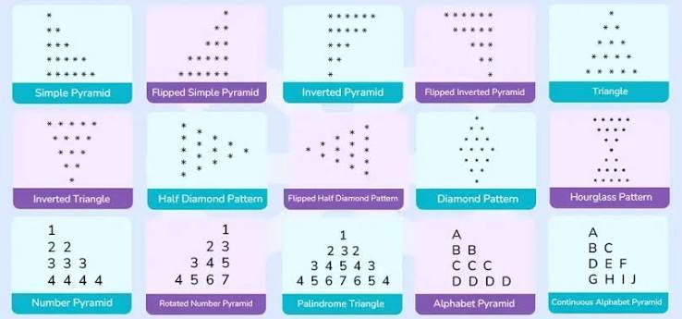
Reference Sheet 2 – square, half-pyramid, inverted half-pyramid and number patterns
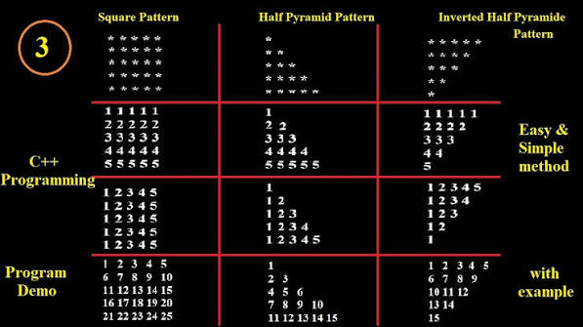
Reference Sheet 3 – symmetric grid / diamond-style pattern
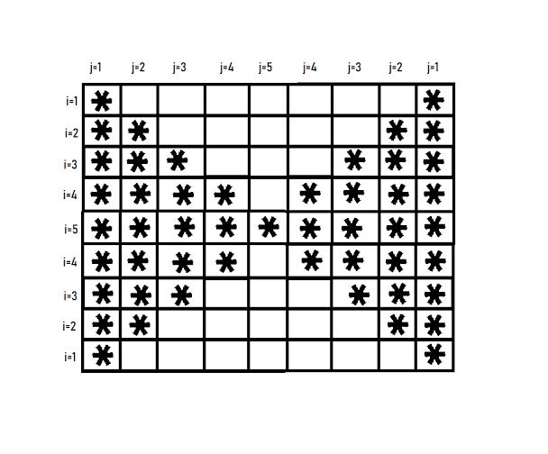
Reference Sheet 4 – additional C++ star and number patterns
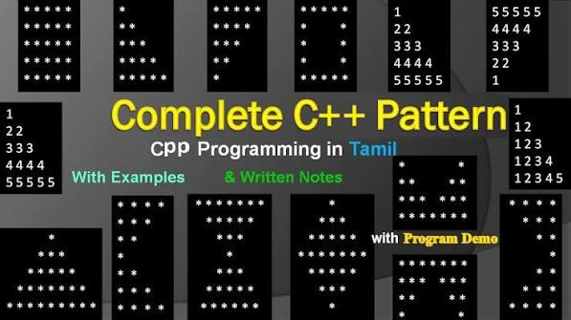
Reference Sheet 5 – hollow / split pattern

Reference Sheet 6 – Java-style number, star and character pattern collection
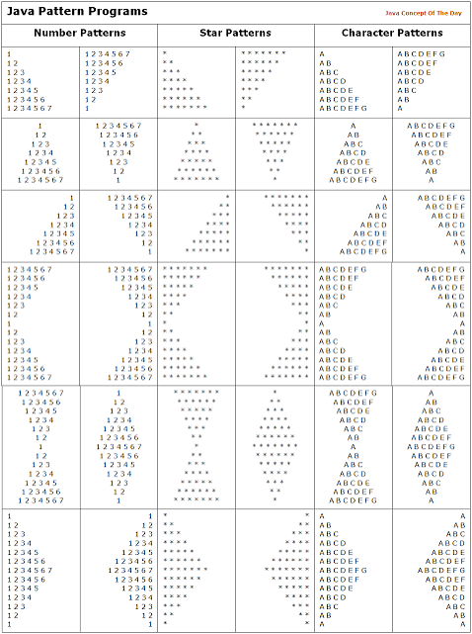
Reference Sheet 7 – number pyramid, number diamond and vertical number pyramid
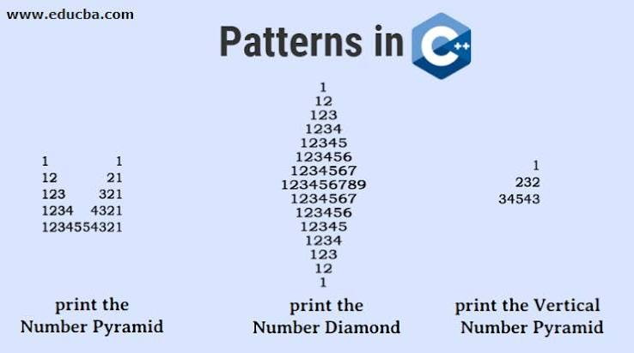

LEVEL 1 — EASY PATTERN QUESTIONS
Start here. Focus on nested loops, row/column control, spaces, and simple sequences.
1. Print an n × n square of * characters. [Easy | Basic Symbols]
2. Print an n × n square where every row contains the row number repeated n times. [Easy | Numbers]
3. Print an n × n square where every row contains the same letter repeated n times. [Easy | Alphabets]
4. Print a left-aligned half pyramid of * with row i containing i stars. [Easy | Half Pyramid]
5. Print an inverted left-aligned half pyramid of *. [Easy | Inverted Half Pyramid]
6. Print a right-aligned half pyramid of *. [Easy | Right Pyramid]
7. Print an inverted right-aligned half pyramid of *. [Easy | Inverted Right Pyramid]
8. Print a left-aligned number triangle: 1 / 1 2 / 1 2 3 / ... [Easy | Number Triangle]
9. Print a repeated-number triangle: 1 / 2 2 / 3 3 3 / ... [Easy | Number Triangle]
10. Print an alphabet triangle: A / A B / A B C / ... [Easy | Alphabet Triangle]
11. Print a repeated-letter triangle: A / B B / C C C / ... [Easy | Alphabet Triangle]
12. Print a full centered star pyramid with n rows. [Easy | Pyramid]
13. Print an inverted centered star pyramid with n rows. [Easy | Inverted Pyramid]
14. Print a centered number pyramid where row i contains 1 through i. [Easy | Number Pyramid]
15. Print a centered pyramid where row i contains the same number i repeated i times. [Easy | Number Pyramid]
16. Print Floyd's triangle for n rows. [Easy | Floyd Triangle]
17. Print a triangle containing consecutive integers starting from 1. [Easy | Continuous Numbers]
18. Print a triangle containing consecutive alphabets starting from A and restarting at A on every row. [Easy | Continuous Alphabets]
19. Print an n × n matrix of alternating 0 and 1, starting with 1. [Easy | Binary]
20. Print an n × n checkerboard pattern using * and space. [Easy | Checkerboard]
21. Print an n × n square with 1 on the main diagonal and 0 elsewhere. [Easy | Matrix Diagonal]
22. Print an n × n square with * on both diagonals and spaces elsewhere. [Easy | X Pattern]
23. Print an n × n square with * on the border and spaces inside. [Easy | Hollow Square]
24. Print a hollow rectangle with r rows and c columns. [Easy | Hollow Rectangle]
25. Print a plus/cross pattern in an odd-sized n × n grid. [Easy | Plus Pattern]
26. Print an n-row right-aligned triangle of numbers 1 to i. [Easy | Right Number Triangle]
27. Print an inverted number triangle: 1 2 3 ... n, then one fewer number per row. [Easy | Inverted Number Triangle]
28. Print an alphabet pyramid using A, B, C... with letters increasing across each row. [Easy | Alphabet Pyramid]
29. Print a triangle of multiplication values: row i contains i, 2i, 3i, ... i*i. [Easy | Multiplication Triangle]
30. Print an n × n table where cell (i,j) contains i*j. [Easy | Multiplication Matrix]
31. Print an n × n matrix where cell (i,j) contains i+j. [Easy | Sum Matrix]
32. Print an n × n matrix where cell (i,j) contains |i-j|. [Easy | Difference Matrix]
33. Print a hollow right triangle of *. [Easy | Hollow Triangle]
34. Print a hollow inverted right triangle of *. [Easy | Hollow Inverted Triangle]
35. Print a hollow centered pyramid of *. [Easy | Hollow Pyramid]
36. Print a hollow inverted centered pyramid of *. [Easy | Hollow Inverted Pyramid]
37. Print a diamond of * with n rows in the upper half. [Easy | Diamond]
38. Print an inverted diamond of *. [Easy | Inverted Diamond]
39. Print a vertical line of * on both sides of an n-row pattern, with a centered filled row at the middle. [Easy | Split / Center Pattern]
40. Print the first n rows of Pascal's triangle. [Easy | Pascal Triangle]

LEVEL 2 — MEDIUM PATTERN QUESTIONS
These require symmetry, reversing, continuous sequences, hollow boundaries, or more careful space handling.
1. Print a number pyramid in which each row is a palindrome: 1 / 121 / 12321 / ... [Medium | Palindromic Numbers]
2. Print a palindromic number pyramid with row i using 1..i..1. [Medium | Number Pyramid]
3. Print an alphabet palindrome pyramid: A / ABA / ABCBA / ... [Medium | Palindromic Alphabets]
4. Print a continuous alphabet triangle where letters continue across rows without restarting. [Medium | Continuous Alphabets]
5. Print a continuous number pyramid where counting continues across every row. [Medium | Continuous Numbers]
6. Print a rotated number pyramid: numbers increase from the left edge toward the right. [Medium | Rotated Pyramid]
7. Print a flipped version of the rotated number pyramid. [Medium | Flipped Pyramid]
8. Print a half-diamond: increasing star rows followed by decreasing star rows. [Medium | Half Diamond]
9. Print a flipped half-diamond. [Medium | Flipped Half Diamond]
10. Print a full diamond with hollow interior. [Medium | Hollow Diamond]
11. Print an hourglass/sandglass pattern of *. [Medium | Hourglass]
12. Print a hollow hourglass pattern. [Medium | Hollow Hourglass]
13. Print a butterfly pattern: two mirrored triangles separated by spaces. [Medium | Butterfly]
14. Print an inverted butterfly pattern. [Medium | Inverted Butterfly]
15. Print a bow-tie pattern using stars and spaces. [Medium | Bow Tie]
16. Print an hourglass made of numbers, with row values increasing from the edges toward the center. [Medium | Number Hourglass]
17. Print a diamond where the numbers increase toward the center and decrease symmetrically. [Medium | Number Diamond]
18. Print a vertical number palindrome pattern such as 1, 232, 34543 with a user-defined n. [Medium | Vertical Number Pyramid]
19. Print an n × n hollow square whose border contains the row number on each side. [Medium | Hollow Number Square]
20. Print a hollow square with 1 on the top border, 2 on the next border, etc., forming layers. [Medium | Concentric Layers]
21. Print a concentric square pattern where the outer layer is n and the center is 1. [Medium | Concentric Numbers]
22. Print a concentric square pattern of alternating * and # layers. [Medium | Concentric Symbols]
23. Print an n × n matrix with 1 on the border and 0 inside. [Medium | Boundary Matrix]
24. Print an n × n matrix with increasing values only on the boundary and blanks inside. [Medium | Boundary Numbers]
25. Print a lower triangular matrix of numbers where cell (i,j)=j. [Medium | Lower Triangle]
26. Print an upper triangular matrix of numbers where cell (i,j)=j. [Medium | Upper Triangle]
27. Print an upper triangular matrix of consecutive numbers. [Medium | Upper Triangle]
28. Print a lower triangular matrix of consecutive numbers. [Medium | Lower Triangle]
29. Print a binary triangle: 1 / 01 / 101 / 0101 / ... [Medium | Binary Triangle]
30. Print a binary triangle where the starting bit alternates every row. [Medium | Binary Triangle]
31. Print a checkerboard triangle using 0 and 1. [Medium | Binary Pattern]
32. Print a right-aligned alphabet triangle with A B C... on each row. [Medium | Right Alphabet Triangle]
33. Print an inverted alphabet triangle where each row starts at A and gets shorter. [Medium | Inverted Alphabet]
34. Print an alphabet diamond with A at the top and increasing letters toward the center. [Medium | Alphabet Diamond]
35. Print a hollow alphabet diamond with letters only on the boundary. [Medium | Hollow Alphabet Diamond]
36. Print an n-row pattern in which row i contains the first i multiples of i. [Medium | Multiplication]
37. Print multiplication tables 1 to n in triangular form. [Medium | Multiplication Pattern]
38. Print a triangle where each row contains i repeated i times, but reverse the row order. [Medium | Repeated Numbers]
39. Print a square in which odd rows contain increasing numbers and even rows contain decreasing numbers. [Medium | Alternating Rows]
40. Print a square in which odd rows contain A B C... and even rows contain Z Y X... as far as needed. [Medium | Alternating Alphabets]
41. Print a hollow rectangle with a diagonal from top-left to bottom-right. [Medium | Mixed Shape]

LEVEL 3 — HARD PATTERN QUESTIONS
These combine multiple loop conditions, symmetry, matrices, transformations, and mathematical logic.
1. Print a butterfly pattern whose upper and lower halves are both hollow. [Hard | Hollow Butterfly]
2. Print a hollow butterfly with stars on both outer boundaries and inner wings. [Hard | Hollow Butterfly]
3. Print a double diamond: two diamonds sharing a center row. [Hard | Double Diamond]
4. Print a mirrored double pyramid joined at the center. [Hard | Double Pyramid]
5. Print a sandglass with a hollow border and a filled center line. [Hard | Hollow Sandglass]
6. Print a diamond in which each row is palindromic numbers and spacing is centered. [Hard | Palindromic Diamond]
7. Print an alphabet diamond where each row is a palindrome and letters continue symmetrically. [Hard | Alphabet Diamond]
8. Print a continuous alphabet diamond using A-Z cyclically when the sequence exceeds Z. [Hard | Continuous Alphabet Diamond]
9. Print a number diamond using consecutive integers, continuing the count across rows. [Hard | Continuous Number Diamond]
10. Print a hollow number diamond whose boundary values follow the row number. [Hard | Hollow Number Diamond]
11. Print a rhombus of * with n rows and n columns. [Hard | Rhombus]
12. Print a hollow rhombus of *. [Hard | Hollow Rhombus]
13. Print a parallelogram of numbers with each row shifted right by one position. [Hard | Parallelogram]
14. Print a hollow parallelogram of *. [Hard | Hollow Parallelogram]
15. Print an X pattern where the two diagonals use increasing numbers instead of stars. [Hard | Number X]
16. Print an X pattern where both diagonals contain the same row-dependent number. [Hard | Number X]
17. Print a plus pattern with increasing numbers on the horizontal and vertical arms. [Hard | Number Plus]
18. Print a plus pattern where the center contains n and values decrease away from it. [Hard | Number Plus]
19. Print a border matrix with clockwise increasing numbers around the perimeter. [Hard | Boundary Traversal]
20. Print a matrix where the outer layer contains n, the next layer n-1, down to 1. [Hard | Concentric Matrix]
21. Print a matrix where each concentric layer contains a different alphabet. [Hard | Concentric Alphabet Matrix]
22. Print a matrix whose top-left quadrant mirrors the top-right and bottom halves mirror the top. [Hard | Symmetric Matrix]
23. Print a square pattern that is horizontally and vertically symmetric using *. [Hard | Symmetric Pattern]
24. Print a pattern where the number of spaces decreases by 2 while the number of stars increases by 2 each row, then reverse it. [Hard | Diamond Logic]
25. Print an hourglass where the number of stars decreases to 1 and then increases, while row numbers remain visible. [Hard | Numbered Hourglass]
26. Print a butterfly whose wings contain consecutive numbers rather than stars. [Hard | Number Butterfly]
27. Print an alphabet butterfly where each wing uses A, B, C... symmetrically. [Hard | Alphabet Butterfly]
28. Print a hollow butterfly with a filled central vertical axis. [Hard | Advanced Butterfly]
29. Print a pattern that alternates between a full row, hollow row, full row, hollow row. [Hard | Alternating Hollow]
30. Print a square where the top-left to bottom-right diagonal contains 1..n and the opposite diagonal contains n..1. [Hard | Dual Diagonal]
31. Print a matrix pattern with values equal to min(i,j,n-i+1,n-j+1). [Hard | Layer Matrix]
32. Print a matrix pattern with values equal to max(i,j,n-i+1,n-j+1). [Hard | Reverse Layer Matrix]
33. Print a matrix whose value at each cell is the Manhattan distance from the center. [Hard | Center Distance]
34. Print a matrix whose value at each cell is the minimum distance to any border. [Hard | Border Distance]
35. Print a spiral matrix containing 1 to n². [Hard | Spiral Matrix]
36. Print an anti-clockwise spiral matrix containing 1 to n². [Hard | Reverse Spiral]
37. Print a matrix filled in a zigzag row-wise pattern with consecutive integers. [Hard | Zigzag Matrix]
38. Print a matrix filled in a zigzag column-wise pattern with consecutive integers. [Hard | Column Zigzag]
39. Print Pascal's triangle centered using proper spacing and n rows. [Hard | Pascal Triangle]
40. Print a Pascal-style triangle but replace each value with '*' whenever it is odd and a space whenever it is even. [Hard | Pascal Parity]
41. Print a pattern combining a hollow diamond with an X inside it. [Hard | Composite Pattern]
42. Print a pattern combining a hollow square, both diagonals and a center plus. [Hard | Composite Pattern]
43. Print a number pyramid in which each row starts from the row number and increases to a peak, then decreases. [Hard | Peak Pyramid]
44. Print a pattern where row i contains i numbers, but the sequence reverses direction on every row. [Hard | Snake Triangle]
45. Print a continuous alphabet pattern that wraps from Z back to A. [Hard | Cyclic Alphabets]
46. Print a cyclic number pattern using digits 1-9 repeatedly. [Hard | Cyclic Numbers]
47. Print a pattern where primes occupy the star positions and composite numbers occupy the blank positions. [Hard | Prime Pattern]
48. Print a pattern where Fibonacci numbers are printed along the rows instead of ordinary counting. [Hard | Fibonacci Pattern]
49. Print a pattern where each row contains the first i Fibonacci numbers. [Hard | Fibonacci Triangle]
50. Print a pattern where each cell contains '*' if i+j is even and '#' otherwise. [Hard | Parity Grid]
51. Print a pattern where each cell contains '*' if i*j is even and '#' otherwise. [Hard | Product Parity Grid]

LEVEL 4 — BONUS CHALLENGES
Use these after completing the main bank. They test reusable functions and generalized pattern logic.
1. For a given n, print all 4 rotations of a half-pyramid in one output: left, right, inverted-left, inverted-right. [Challenge | Rotation Set]
2. For a given odd n, print square, X, plus, hollow square, and border-number patterns one after another. [Challenge | Pattern Set]
3. Given n and a character ch, generate all basic star patterns using ch instead of '*'. [Challenge | Parameterized Patterns]
4. Given n and two characters a and b, generate an alternating checkerboard pattern. [Challenge | Parameterized Grid]
5. Given n, print a diamond, then its 90-degree rotated equivalent using the same number of symbols. [Challenge | Transformations]
6. Given rows and columns, print every possible border-only rectangle variation: top, bottom, left, right, and full border. [Challenge | Boundary Variations]
7. Generate a menu-driven pattern program that lets the user choose among at least 15 patterns. [Challenge | Menu Driven]
8. Build one reusable function per pattern and call the selected function from a menu. [Challenge | Functions + Patterns]
9. Take n and a symbol from the user and generate hollow square, hollow triangle, hollow diamond and hollow rhombus. [Challenge | Reusable Logic]
10. Generate the same 10 selected patterns in both C++ and Python and ensure their outputs match for n=5. [Challenge | Cross-Language Validation]

Pattern-Solving Checklist
- Can I identify the total number of rows?
- For row i, how many spaces are printed?
- For row i, how many symbols/numbers/letters are printed?
- Does the sequence restart on every row or continue globally?
- Is the pattern left-aligned, right-aligned, or centered?
- Is the pattern symmetric?
- If it is hollow, which cells are boundary cells?
- Can I express the condition using i and j?
- Can I test the pattern with n = 3 before n = 5?
- Can I implement the same logic in both C++ and Python?
- Can I convert the repeated logic into a function?
- Can I explain the time complexity in terms of n?

Important Note
The questions are language-neutral. C++ and Python both support the loops, conditions, functions, arithmetic, strings/characters, and output operations needed for this entire set. The goal is to practice the pattern logic rather than memorize language-specific syntax.

ADDITIONAL SECTION — ALL PATTERNS FROM THE PROVIDED IMAGES
This section has been added to the original question bank. It converts the distinct pattern examples visible in the supplied reference images into individual practice questions. Solve these in both C++ and Python.
1. Print a Simple Pyramid of stars: 1, 2, 3, ..., n stars centered on each row. [Image 1]
2. Print a Flipped Simple Pyramid of stars, with the alignment reversed. [Image 1]
3. Print an Inverted Pyramid of stars: n stars down to 1 star. [Image 1]
4. Print a Flipped Inverted Pyramid of stars, with the inverted alignment reversed. [Image 1]
5. Print a centered Triangle pattern of stars with increasing row width. [Image 1]
6. Print an Inverted Triangle pattern of stars with decreasing row width. [Image 1]
7. Print a Half Diamond: increasing stars to n, then decreasing back to 1. [Image 1]
8. Print a Flipped Half Diamond with the opposite alignment. [Image 1]
9. Print a full Diamond of stars with equal upper and lower halves. [Image 1]
10. Print an Hourglass/Sandglass pattern of stars. [Image 1]
11. Print a Number Pyramid where row i contains the number i repeated i times. [Image 1]
12. Print a Rotated Number Pyramid with numbers arranged in the rotated triangular form shown in the reference. [Image 1]
13. Print a Palindrome Triangle where each row reads the same forward and backward, such as 1, 232, 34543. [Image 1]
14. Print an Alphabet Pyramid with A, AB, ABC, ... centered by row. [Image 1]
15. Print a Continuous Alphabet Pyramid where alphabet characters continue counting across rows instead of restarting. [Image 1]

Image 2 — C++ Pattern Collection
1. Print a solid n × n star square. [Image 2]
2. Print a left-aligned star half pyramid. [Image 2]
3. Print an inverted left-aligned star half pyramid. [Image 2]
4. Print an n × n square where row i contains i repeated across the row. [Image 2]
5. Print a half pyramid where row i contains i repeated i times. [Image 2]
6. Print an inverted repeated-number half pyramid. [Image 2]
7. Print a square where every row prints 1 2 3 ... n. [Image 2]
8. Print a number half pyramid where counting restarts from 1 on every row. [Image 2]
9. Print an inverted number half pyramid where each row starts at 1 and becomes shorter. [Image 2]
10. Print a square filled with consecutive numbers row-wise from 1 to n². [Image 2]
11. Print a lower triangular consecutive-number pattern, continuing the count across rows. [Image 2]
12. Print an inverted version of the continuous-number triangle. [Image 2]

Image 3 — Symmetric Grid Pattern
1. Print the symmetric star-grid pattern shown in the reference: for each row, stars extend from both left and right edges toward the center, with the middle row completely filled. [Image 3]
2. Generalize the same pattern for any odd n using row distance from the center. [Image 3]
3. Print the horizontally and vertically symmetric version where the number of stars in row i is determined by min(i, n-i+1) on both sides. [Image 3]

Image 4 — Complete C++ Pattern Collection
1. Print a solid star square. [Image 4]
2. Print a left-aligned star half pyramid. [Image 4]
3. Print an inverted half pyramid. [Image 4]
4. Print a square of repeated row numbers: 1 1 1..., 2 2 2..., etc. [Image 4]
5. Print a repeated-number half pyramid: 1 / 2 2 / 3 3 3 / ... [Image 4]
6. Print an inverted repeated-number half pyramid. [Image 4]
7. Print a square where every row is 1 2 3 ... n. [Image 4]
8. Print a left-aligned increasing number triangle where each row restarts at 1. [Image 4]
9. Print an inverted increasing number triangle. [Image 4]
10. Print a square of continuous numbers from 1 to n². [Image 4]
11. Print a continuous-number lower triangle. [Image 4]
12. Print an inverted continuous-number triangle. [Image 4]
13. Print a centered star pyramid. [Image 4]
14. Print an inverted centered star pyramid. [Image 4]
15. Print a centered number pyramid. [Image 4]
16. Print a centered inverted number pyramid. [Image 4]
17. Print a hollow star rectangle with only the boundary printed. [Image 4]
18. Print a hollow star square. [Image 4]
19. Print a hollow centered pyramid. [Image 4]
20. Print a hollow inverted centered pyramid. [Image 4]
21. Print a diamond of stars. [Image 4]
22. Print an inverted diamond/sandglass. [Image 4]
23. Print a butterfly pattern with two mirrored triangular wings. [Image 4]
24. Print an inverted butterfly pattern. [Image 4]
25. Print a hollow diamond. [Image 4]
26. Print a pattern containing stars only on the outer boundary and a separate central line. [Image 4]

Image 5 — Hollow Split / Mirror Pattern
1. Print the exact hollow split pattern shown: the first and last positions are always stars, while the inner star groups expand toward the middle and contract symmetrically. [Image 5]
2. Generalize the pattern for odd n so the center row is completely filled. [Image 5]
3. Create the same pattern using a user-provided symbol instead of *. [Image 5]

Image 6 — Java Pattern Programs Sheet
1. Print a left-aligned number triangle: 1 / 1 2 / 1 2 3 / ... [Image 6]
2. Print an inverted number triangle. [Image 6]
3. Print a right-aligned number triangle. [Image 6]
4. Print a reversed right-aligned number triangle. [Image 6]
5. Print a number triangle with continuous counting across rows. [Image 6]
6. Print a number triangle whose row length decreases from n to 1. [Image 6]
7. Print a star half pyramid. [Image 6]
8. Print a right-aligned star pyramid. [Image 6]
9. Print an inverted star pyramid. [Image 6]
10. Print an inverted right-aligned star pyramid. [Image 6]
11. Print a centered star pyramid. [Image 6]
12. Print a centered inverted star pyramid. [Image 6]
13. Print a hollow centered pyramid. [Image 6]
14. Print a hollow inverted pyramid. [Image 6]
15. Print an alphabet triangle A / AB / ABC / ... [Image 6]
16. Print an inverted alphabet triangle. [Image 6]
17. Print a right-aligned alphabet triangle. [Image 6]
18. Print a reversed/right-to-left alphabet triangle. [Image 6]
19. Print a continuous alphabet triangle. [Image 6]
20. Print an alphabet pattern where each row decreases from the previous row. [Image 6]
21. Print a centered alphabet pyramid. [Image 6]
22. Print an inverted centered alphabet pyramid. [Image 6]
23. Print a hollow alphabet pyramid. [Image 6]
24. Print a hollow inverted alphabet pyramid. [Image 6]
25. Print a diamond-shaped alphabet pattern. [Image 6]
26. Print an inverted diamond-shaped alphabet pattern. [Image 6]
27. Print a number diamond. [Image 6]
28. Print a palindromic number diamond. [Image 6]
29. Print a star diamond. [Image 6]
30. Print a hollow star diamond. [Image 6]
31. Print a butterfly star pattern. [Image 6]
32. Print an inverted butterfly pattern. [Image 6]
33. Print a number butterfly. [Image 6]
34. Print an alphabet butterfly. [Image 6]
35. Print an hourglass star pattern. [Image 6]
36. Print a hollow hourglass. [Image 6]
37. Print a number hourglass. [Image 6]
38. Print a continuous-number hourglass. [Image 6]
39. Print a square of repeated numbers. [Image 6]
40. Print a square of continuous numbers. [Image 6]
41. Print a hollow number square. [Image 6]
42. Print a square of repeated alphabets. [Image 6]
43. Print a continuous alphabet square. [Image 6]
44. Print a hollow alphabet square. [Image 6]
45. Print a checkerboard using stars and spaces. [Image 6]
46. Print alternating 1 and 0 rows. [Image 6]
47. Print an X-shaped star pattern. [Image 6]
48. Print a plus-shaped star pattern. [Image 6]
49. Print a rhombus of stars. [Image 6]
50. Print a hollow rhombus. [Image 6]
51. Print a parallelogram of stars. [Image 6]
52. Print a hollow parallelogram. [Image 6]
53. Print a Pascal triangle. [Image 6]

Image 7 — Number Pyramid / Diamond / Vertical Pyramid
1. Print the Number Pyramid shown: row i contains 1 through i. [Image 7]
2. Print the Number Diamond shown: rows increase from 1..n and then decrease back to 1. [Image 7]
3. Print the Vertical Number Pyramid shown, where each row is a palindrome such as 1, 232, 34543, and the sequence continues downward. [Image 7]
4. Generalize the vertical number pyramid for arbitrary n. [Image 7]
5. Create a centered version of the same palindrome-number pyramid. [Image 7]

IMAGE PATTERN MASTER CHECKLIST
The following families are now represented in the combined document: simple, inverted, flipped and rotated pyramids; triangles; half diamonds; diamonds; hourglasses; squares; rectangles; hollow shapes; repeated numbers; continuous numbers; palindromic numbers; alphabets; continuous alphabets; butterflies; rhombuses; parallelograms; X and plus patterns; checkerboards; Pascal triangle; number diamonds; vertical number pyramids; and symmetric/mirror patterns.
Practice rule: For each image-based question, first reproduce the exact output shown by the reference, then modify n and verify that the logic still works. After that, implement the same question in the other language.

