
Bilkent University
Department of Computer Engineering

TANIT
AI-Powered Social Media Automation Platform

Design Project Final Report
CS 492 - Senior Design Project II
Team Members:
Sümeyye Acar
Muhammed Furkan Başıbüyük
Mehmet Kutay Buyruk
Ömer Bıçakcıoğlu
Betül Doğrul

Supervisor: Cevdet Aykanat
May 4, 2026
1. Introduction 5
2. Requirements Details 6
2.1 Functional Requirements 6
2.2 Nonfunctional Requirements 8
2.3 Pseudo Requirements 10
3. Final Architecture and Design Details 11
3.1 System Overview 11
3.2 Deployment Architecture 12
3.3 Backend Architecture 13
3.3.1 Application Entry Point 13
3.3.2 Domain-Driven Package Structure 14
3.3.3 Cross-Cutting Infrastructure 15
3.3.4 Authentication Subsystem 16
3.3.5 Post Lifecycle Model 17
3.3.6 AI Image Generation Pipeline 19
3.3.7 Scheduling Dispatch Engine 21
3.4 Frontend Architecture 22
3.4.1 Technology Stack 22
3.4.2 Routing Structure 23
3.4.3 API Integration 24
3.4.4 Key Pages 24
3.5 Data Architecture 25
3.5.1 Schema Overview 25
3.5.2 Entity Column Reference 26
3.5.3 Single-Image-Per-Post Invariant 31
3.6 Deviations from the Detailed Design 31
4. Development and Implementation Details 33
4.1 Development Environment 33
4.2 Backend Implementation 34
4.2.1 Dependency Injection 34
4.2.2 Authentication Implementation 35
4.2.3 Media Asset Management 36
4.2.4 Virtual Try-On Service 36
4.2.5 Food & Beverage Pipeline 39
4.2.6 Campaign and Special Days Services 40
4.2.7 Scheduling Dispatcher 42
4.2.8 Schema Migration History 42
4.3 Frontend Implementation 43
4.3.1 Type Safety Strategy 43
4.3.2 Post Creation Wizard (CreatePost.tsx) 43
4.3.3 Preview and Feedback Flow (Preview.tsx) 44
4.3.4 Design System 44
4.4 WhatsApp Bot Implementation 44
4.4.1 Service Architecture 45
4.4.2 Authentication Flow 45
4.4.3 Conversation State Machine 47
4.4.4 Backend Bot Endpoints 48
4.5 Testing Strategy 48
4.6 Environment Configuration 48
Figure Index 49
5. Test Cases and Results 50
5.1 Functional Tests 50
5.2 Non-Functional Tests 63
6. Maintenance Plan and Details 67
6.1. Scope and Owners 67
6.2. Tech Stack and Supported Versions 67
6.2.1 Backend 67
6.2.2 Frontend 67
6.2.3 Infrastructure 68
6.3. Configuration and Secrets 68
6.3.1 Environment files 68
6.3.2 Provider credentials (must remain secret) 68
6.3.3 Host-IP coupling 68
6.4. Database 69
6.4.1 Backup expectations 69
6.4.2 Migration policy 69
6.5. Object Storage 69
6.6. AI Models — Change Watch List 69
6.6.1 Configuration points 70
6.6.2 Prompt templates 70
6.6.3 Procedure for an AI model change 70
6.7. Background Jobs 71
Operational notes 71
6.8. Logging, Health, and Monitoring 71
6.9. Build, Test, and Release Workflows 72
6.9.1 Common operational tasks 72
6.9.2 CI/CD 72
6.9.3 Pre-commit hook 72
6.9.4 Release checklist 72
6.10. Routine Maintenance Schedule 72
6.11. Known Risks and Follow-Ups 73
7. Other Project Elements 73
7.1. Consideration of Various Factors in Engineering Design 73
7.1.1 Constraints 73
7.1.2 Standards 76
7.2. Ethics and Professional Responsibilities 77
7.3. Teamwork Details 77
7.3.1 Contributing and Functioning Effectively on the Team 77
7.3.2 Helping Create a Collaborative and Inclusive Environment 77
7.3.3 Taking Lead Role and Sharing Leadership on the Team 78
7.3.4. Meeting objectives 78
7.3.4.1 Team and Responsibilities 78
7.3.4.2 Planning Chart and Work Packages 78
7.4 New Knowledge Acquired and Applied 83
7.4.1 Frontend — Betül Doğrul 83
7.4.2 Backend — Kutay Buyruk 83
7.4.3 AI Pipeline — Ömer Bıçakcıoğlu and Furkan Başıbüyük 84
7.4.4 WhatsApp & Instagram Integration — Sümeyye Acar 84
7.4.5 Cross-cutting lessons (whole team) 85
8. Conclusion and Future Work 85
8.1 Conclusion 85
8.2 Future Work 86
8.2.1 Near-term — operational hardening 86
8.2.2 Medium-term — product surface expansion 87
8.2.3 Medium-term — AI generation quality 87
8.2.4 Long-term — scale and resilience 88
8.2.5 Cross-cutting — governance and compliance 88
8.3 Closing Note 88
9. Glossary 89
10. References 91

1. Introduction
TANIT is an AI-powered social media automation platform that we built mainly for small and medium-sized businesses — particularly boutique stores and online sellers — who want to post professional-looking Instagram content without spending hours on it. The reality is that a lot of small business owners know they need to be active on social media, but they just don't have the time or the design skills to keep up with it consistently. For many small business owners, bringing in a professional to manage content creation simply isn't financially viable — the costs involved are far from negligible. That's basically the problem TANIT is trying to solve. By taking a product image and a short description from the user, the platform generates captions, hashtags, and promotional visuals that are ready to post.
The system brings together a few different things: AI-based content generation, user authentication, media storage, post scheduling, and Instagram integration, all wrapped into one Whatsapp supported-web application. Users can upload their product photos, receive AI-generated captions and hashtags, edit the content to their preference, save drafts, and schedule posts for later publication. The platform also offers Instagram story creation for campaigns and special occasion story suggestions, giving businesses more ways to engage with their audience. We designed the interface as a step-by-step wizard so that even someone with no technical background or experience with AI tools can get through the whole process without getting confused. The main things we kept in mind throughout were usability, performance, security, and making sure the system is easy to maintain and build on later.
On the technical side, TANIT is structured as a modular, containerized web app. The frontend uses React, TypeScript, Vite, Tailwind CSS, and shadcn/ui, while the backend is built with FastAPI and split into separate modules for things like users, media, posts, scheduling, AI generation, notifications, Whatsapp Bot, and Instagram account management. PostgreSQL handles the structured data, and MinIO takes care of storing uploaded and generated media files in an S3-compatible way. Before the created images are fed to Instagram Graph API they are hosted in Cloudinary. Keeping these concerns separate made the whole system easier to work with and extend over time.
One of the parts we put the most thought into was the AI content generation. TANIT uses vision-language and multimodal models to look at product images and produce relevant captions, hashtags, and visual variants. During development, we actually changed our approach here — we started with a broad theme-based prompting method but switched to a more template-based generation structure because the earlier approach was giving us inconsistent results and didn't always preserve the product's appearance well. We also looked at using external AI inference services like fal.ai to speed up the image generation and enhancement side of things.
Beyond the web app itself, TANIT connects to a couple of external platforms. Through the Instagram Graph API, users can link their accounts, publish content, and schedule posts directly. We also integrated the WhatsApp Business Cloud API as a more mobile-friendly option, where users can just send a product image over WhatsApp and get back AI-generated captions and hashtags — no browser needed. That second channel felt important to us because it lowers the barrier even further for users who aren't comfortable with web apps.
This report covers the full project from start to finish. We go through the functional and nonfunctional requirements, the architecture and design decisions we made, how we implemented and tested everything, and what we'd do differently or add in the future. The overall idea behind TANIT is to show that combining AI, modern web tech, and external APIs can genuinely take some of the content creation pressure off small businesses and help them show up more consistently online.

2. Requirements Details

2.1 Functional Requirements
This section defines the functional requirements of the TANIT system. Each requirement specifies a capability that the system must provide. Requirements are organized into logical categories to improve clarity and traceability.

User Management Requirements
- The system shall allow users to create an account through the web interface.
- The system shall allow users to link their Instagram Business Account.
- The system shall provide secure logout and session management.
- The system shall store user preferences for content generation and scheduling.

Image and Media Handling
- The system shall allow users to upload product images via the web interface.
- The system shall validate uploaded images for supported formats (JPEG, PNG).
- The system shall store uploaded images in MinIO (S3-compatible object storage).
- The system shall allow image upload through the WhatsApp bot.
- The system shall allow image hosting on Cloudinary.
- The system shall provide a media retrieval API for AI processing and preview.
- The system shall upload AI-generated media to Cloudinary before publishing to Instagram.
- The system shall retrieve secure, time-limited Cloudinary URLs for use by the Instagram Graph API.
- The system shall apply image transformations and optimizations through Cloudinary when needed (resizing, format conversion, quality adjustment).
- The system shall handle Cloudinary upload failures with appropriate error messages and retry logic.

AI Content Generation Requirements
- The system shall analyze uploaded product images using vision–language models.
- The system shall generate captions describing the product and promoting engagement.
- The system shall generate relevant hashtags based on product category and trends.
- The system shall generate layout or template-based visual post variants (if applicable).
- The system shall allow users to regenerate alternative captions or hashtags.
- The system shall present generated content in a preview interface
Content Editing and Review
- The system shall allow users to edit AI-generated captions.
- The system shall allow users to modify or remove suggested hashtags.
- The system shall allow users to select from multiple generated versions.
- The system shall allow users to save a draft without scheduling or publishing.

Scheduling and Automation Requirements
- The system shall allow users to schedule a generated post for a specific date and time.
- The system shall store scheduled tasks in the database with timestamps.
- The scheduling engine shall trigger publishing at the scheduled time.
- The system shall notify the user if publishing fails due to API errors.
- The system shall allow users to modify or cancel scheduled posts.

Instagram Integration Requirements
- The system shall authenticate with the Instagram Graph API using user tokens.
- The system shall upload generated media to Instagram through the API.
- The system shall publish posts, stories, or reels on behalf of the user.
- The system shall support refreshing and renewing expired API tokens.

WhatsApp Bot Requirements
- The system shall allow users to send product images to the WhatsApp bot.
- The bot shall forward received images and text prompts to the backend.
- The bot shall return the generated caption and hashtags to the user via WhatsApp.
- The bot shall support approved WhatsApp message templates.

Event and Holiday Recommendation Requirements
- The system shall maintain a list of national holidays and relevant events.
- The system shall notify users when an upcoming event is suitable for promotional content.
- The system shall generate event-specific captions, hashtags, and visual templates.
- The system shall allow users to accept, edit, or reject recommendations.

Logging and Monitoring Requirements
- The system shall log user actions such as uploads, generations, and schedules.
- The system shall log backend errors, scheduling failures, and API issues.
- The system shall allow administrators to review system health logs (optional).

Security Requirements
- The system shall validate all user inputs to prevent injection attacks and malformed data.
- The system shall store sensitive credentials (tokens, API keys) securely.

2.2 Nonfunctional Requirements
This section defines the quality attributes and constraints that the TANIT system must satisfy. These requirements describe how the system will perform rather than the specific functions it will provide.

Usability
- The system shall be easy to use and accessible for small business owners with minimal technical background.
- The user interface shall follow consistent layout patterns, intuitive navigation flows, and clear interaction steps.
- The system shall provide informative feedback, warnings, and status messages during content generation, scheduling, and publishing.
- The system shall incorporate accessibility considerations such as sufficient contrast, readable fonts, and keyboard navigation support.

Reliability
- The system shall operate reliably under normal and expected load conditions.
- The system shall publish scheduled posts at or near their intended times, assuming external APIs (Instagram, WhatsApp) are operational.
- The backend shall include error-handling and retry mechanisms for temporary failures.
- User data, media files, and generated content shall be stored securely and persistently to prevent data loss.

Performance
- The system shall deliver responsive performance across all core features.
- AI content generation shall complete within a few seconds depending on model complexity.
- Media uploads shall be processed promptly, and the interface shall remain responsive during back- end operations.
- The backend shall use asynchronous FastAPI endpoints to support high throughput and reduced latency.

Scalability
- The system shall support horizontal scaling as the number of users increases.
- Microservice-friendly components (FastAPI, Cloudinary, MinIO, PostgreSQL) shall allow distribution across multiple instances.
- The architecture shall support future expansion to additional social media platforms without major redesign.

Supportability
- The system shall follow a modular architecture to simplify maintenance and updates.
- Major components (frontend, backend, AI module, database, search engine, storage layer) shall be maintainable with minimal interdependency.
- Documentation for APIs, deployment procedures, configuration settings, and authentication work- flows shall be provided.
Security
- All communication between system components shall occur over HTTPS.
- Sensitive data such as tokens, API keys, and credentials shall be stored securely and never exposed to the client.
- Input validation shall be implemented throughout the system to prevent injection attacks and malicious uploads.

Maintainability
- The software shall follow clean code practices, modular designs, and separation of concerns.
- AI service providers, models, and templates shall be replaceable without requiring architectural changes.

Portability
- The system shall be deployable on various environments, including cloud-based servers and locally hosted infrastructure.
- Containerization tools such as Docker shall ensure components are portable and easily replicable.
- The MinIO storage layer shall maintain compatibility across both cloud and local S3 environments.

Interoperability
- Internal components shall communicate through standardized interfaces.
- The frontend shall interact with the backend via REST APIs.
- External integrations shall use platform-specific APIs such as the Instagram Graph API and WhatsApp Business API.

Compliance
- The system shall adhere to Instagram Graph API policies, WhatsApp Business API rules, and authentication standards.
- The system shall securely store user information and limit data retention according to privacy requirements.

2.3 Pseudo Requirements
Pseudo requirements describe constraints placed on the system due to course rules, technological decisions, development environment requirements, or externally imposed tools and frameworks. These are not functional or behavioral requirements, but rather implementation obligations.

Programming Languages and Frameworks
- The backend must be implemented using Python and the FastAPI framework.
- The frontend must be implemented using the React framework.
- Prompt engineering and AI-related logic must be implemented in Python for compatibility with selected generative AI APIs.
Authentication and Identity Management
- The safety of the platform's users is ensured through industry-standard security practices: JWT-based authentication, bcrypt password hashing, HTTPS-only communication, and the OAuth 2.0 flow for third-party integrations such as Instagram Business Account linking.

Database and Storage Requirements
- PostgreSQL must be used as the primary relational database system.
- MinIO must be used for storing and retrieving all media files uploaded by users.
- SQLAlchemy must be used as the ORM layer for database interactions.

AI and External Services
- Generative AI models such as GPT-4o, Gemini, or equivalent multimodal models must be used for content generation.
- The system must integrate with Instagram Graph API to support scheduling and media publishing.
- The system must integrate with WhatsApp Business API for chatbot-based content generation.
- The system must integrate with Cloudinary for hosting AI-generated images prior to Instagram publishing.
- Cloudinary credentials (API key, API secret, cloud name) must be stored securely as environment variables and never exposed to the c

Deployment and Development Environment
- All services must run within Docker containers, orchestrated using a deterministic docker-compose.yml file.
- The development team must use GitHub for version control and CI/CD workflows.
- The system must include API documentation generated via OpenAPI/Swagger.

Course-Imposed Constraints
- The project must follow the structure and submission rules defined by the CS491/CS492 course instructors.
- All diagrams, reports, and documentation must adhere to academic integrity and reporting standards.
- The final demonstration must run locally using Docker without requiring external cloud resources.

3. Final Architecture and Design Details

3.1 System Overview
TANIT is a containerised, AI-augmented social-media automation platform targeting small and medium-sized enterprises in the retail and food-service sectors. Its primary purpose is to reduce the barrier to professional Instagram content creation: the merchant supplies a product photograph, and the system returns a publication- ready image, a suggested caption, and an optional publication schedule — all within a single coherent workflow. Two distinct merchant categories are served: boutique clothing retailers (the virtual try-on and fashion photography pipeline) and cafés and restaurants (a parallel food-and-beverage pipeline). A WhatsApp conversational interface mirrors the full creation workflow for merchants who prefer mobile-first interaction over a web browser.

The final architecture deviates from the March 2026 Detailed Design Report in several consequential ways. Keycloak-based OAuth 2.0 / OIDC authentication was replaced by a self-contained local authentication system using bcrypt password hashing and HS256 JWTs. The image generation engine was rebuilt around Fal AI (GPT Image 2 and nano-banana-2) and Google Gemini Vision, replacing the originally planned Stability AI integration. The scope expanded to include a fashion model pool with intelligent variety selection, a WhatsApp bot deployed as a separate Flask service, a food-and-beverage generation pipeline, a campaign story generator, and a special-days content calendar. The scheduling engine uses APScheduler embedded in the FastAPI process rather than the planned Celery-and-Redis topology. All deviations are documented in §3.6.

3.2 Deployment Architecture
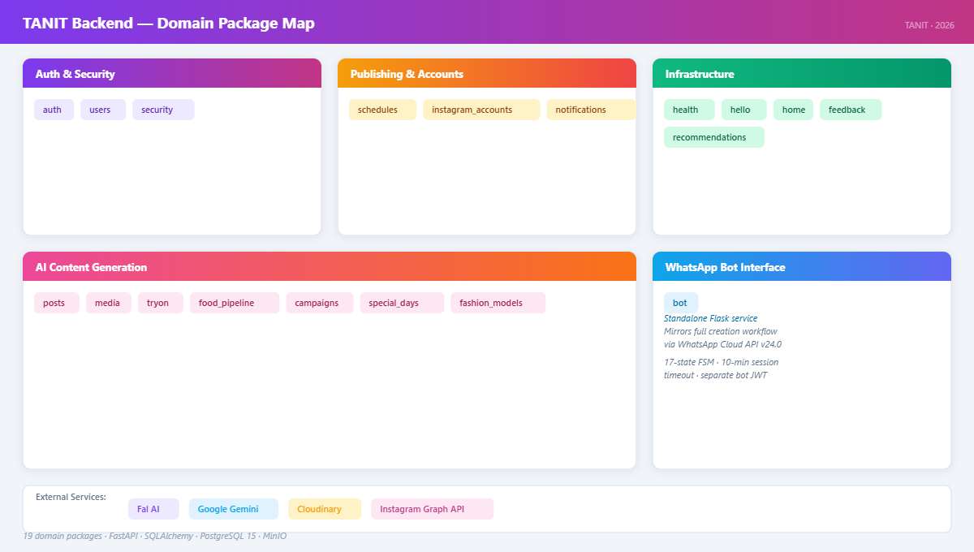

The system is packaged as a Docker Compose application comprising four containers declared in docker-compose.yml. They share a user-defined Docker bridge network that provides internal DNS resolution by service name.

Service | Base Image | Published Ports | Role
postgres | postgres:15.5 | 5432 → 5432 | Primary relational store; persisted on tanit_pgdata volume
backend | Python 3.12 (custom) | 8000 → 8000 | FastAPI application; Alembic migrations run on every boot
frontend | Node 20 (Vite dev server) | 5173 → 5173 | React 19 SPA; Vite HMR dev server
minio | minio/minio (2024-06-13) | 9000 → 9000 (API) | S3-compatible object storage; persisted on tanit_minio_data
 |  | 9001 → 9001 (console) | MinIO administrative console

The WhatsApp Bot (wp_bot/) is a standalone Flask service that does not appear in the Compose file. It runs as a separate process and connects to the same PostgreSQL instance and Backend API over the host network. In a production deployment it would be added as a fifth container.

Host-IP coupling. The frontend JavaScript bundle must contain the backend's network-accessible URL at build time, because Vite replaces import.meta.env.VITE_API_URL statically during the bundle step. On a LAN deployment the backend is addressed by the host machine's LAN IP rather than localhost, since mobile browsers on the same network cannot resolve Docker-internal hostnames. The script scripts/update_host_ip.py detects the active LAN IP and writes HOST_IP=<ip> into .env; from this, VITE_API_URL=http://${HOST_IP}:8000 and REDIRECT_URI=http://${HOST_IP}:5173 are derived. Running make reset re-invokes this script, so the system adapts to network changes without manual configuration editing.

Storage and media routing. All binary media assets — user-uploaded product photographs and AI-generated output images — are stored in MinIO under the configured bucket. Internal backend-to-MinIO calls use MINIO_ENDPOINT (the Docker-internal hostname). The frontend displays images via time-limited presigned GET URLs generated against MINIO_PUBLIC_ENDPOINT (the LAN-accessible address). Cloudinary serves as a temporary public HTTPS proxy at publish time: the Instagram Graph API requires a publicly accessible HTTPS URL for every image it ingests, so the backend uploads each image to Cloudinary immediately before the Graph API call and deletes it immediately after, never persisting the Cloudinary URL.

External service dependencies. The backend integrates with four external APIs: Fal AI (queue.fal.run) for image generation and inpainting; Google Gemini Vision for garment and food classification and caption generation; Cloudinary as the temporary HTTPS proxy described above; and the Instagram Graph API for content publication. The WhatsApp Bot additionally integrates with WhatsApp Cloud API v24.0.

3.3 Backend Architecture

3.3.1 Application Entry Point
The FastAPI application is constructed in app/backend/app/main.py. Middleware is registered before routes, and lifecycle hooks manage background resources.

Middleware stack:

- ContentLengthLimitMiddleware — a custom ASGI middleware that reads the Content-Length request header and raises HTTP 413 before any body bytes are consumed, preventing upload-abuse attacks without relying on reverse-proxy configuration. The limit is defined by media_service.MAX_UPLOAD_BYTES.
- CORSMiddleware — permits all origins in the current development configuration.

Production mode. When SETTINGS.environment == "production", the FastAPI constructor is called with openapi_url=None, docs_url=None, and redoc_url=None, hiding the interactive Swagger UI and raw OpenAPI schema from external actors.

Startup sequence (executed on @app.on_event("startup")):

- init_db() — pings the database engine to surface connection failures early.
- _seed_test_user() — inserts the development user (test@tanit.com / test123) when ENV=development.
- _fail_orphaned_tryon_jobs() — sets any TryOnJob rows left in RUNNING status to FAILED, because daemon threads do not survive a container restart and their jobs would otherwise display as permanently in-flight.
- _start_scheduler() — creates an APScheduler BackgroundScheduler and registers the dispatch function at a 30-second interval with max_instances=1 and coalesce=True to prevent overlapping ticks under API slowness.

Router registration. Sixteen domain routers are mounted: health, hello, auth, instagram_accounts, home, media, tryon, food_pipeline, fashion_models, posts, schedules, users, bot, special_days, campaigns, feedback.

3.3.2 Domain-Driven Package Structure
The backend is organised into 19 domain packages under app/backend/app/, each encapsulating its own SQLAlchemy models, FastAPI router, and service layer. New packages must be imported in app/base.py for their SQLAlchemy models to be visible to Alembic's autogenerate facility.

auth/ — JWT creation, bcrypt hashing, password reset tokens

bot/ — WhatsApp bot-facing endpoints; separate bot JWT validation

campaigns/ — Campaign story generation, publishing, and scheduling

fashion_models/ — Fashion model pool management and intelligent selection

feedback/ — User feedback collection; draft replacement triggers

food_pipeline/ — Food-and-beverage image generation (separate job table)

health/ — Liveness probe (/healthz)

hello/ — Demo/greeting endpoint

home/ — Dashboard aggregation endpoint

instagram_accounts/ — Instagram Business account binding via Meta Graph API

media/ — Asset upload, MinIO presign, Cloudinary proxy

notifications/ — In-app notification records

posts/ — Post draft lifecycle (PostDraftStatus enum, 6 post types)

recommendations/ — AI-driven content suggestions

schedules/ — Schedule lifecycle, APScheduler dispatch engine, publisher

security/ — Rate limiting and security utilities

special_days/ — Calendar-aware holiday content triggers

tryon/ — Virtual try-on orchestration (clothing AI pipeline)

users/ — User profile management

3.3.3 Cross-Cutting Infrastructure
Configuration (config.py). Application configuration is centralised in a frozen @dataclass named Settings, populated once at import time from environment variables via python-dotenv. The singleton SETTINGS is the only configuration access point across all modules; os.getenv is not scattered across the codebase. Using a plain frozen dataclass rather than Pydantic BaseSettings is intentional — it provides immutability and zero-overhead attribute access without the validator machinery needed for runtime schema validation. Key fields include FAL_API_KEY, FAL_MODEL_GENERATION, FAL_MODEL_EDIT, FAL_MODEL_EDIT_FALLBACK, GEMINI_API_KEY, GEMINI_GEN_MODEL, GEMINI_CLASSIFY_MODEL, CLOUDINARY_*, MINIO_ENDPOINT, MINIO_PUBLIC_ENDPOINT, TOKEN_ENCRYPTION_SECRET, and BOT_JWT_SECRET.

Database layer. SQLAlchemy 2.0's DeclarativeBase is used with a shared metadata naming convention for constraints (prefixes pk_, fk_, ix_, uq_, ck_), which Alembic uses to generate deterministic constraint names in autogenerated migrations. database.py provides the synchronous SessionLocal session factory and the get_db() FastAPI dependency, which yields a session and guarantees session.close() in a finally block regardless of route outcome.

Schema evolution. Twenty-six Alembic migrations in app/backend/alembic/versions/, named YYYY-MM-DD_NNNN_slug.py, span 2025-12-04 to 2026-04-30. The wait-and-migrate.sh script runs alembic upgrade head before uvicorn accepts connections on every container start, ensuring the database schema is always synchronised with the running code.

Async discipline. Blocking operations (synchronous SQLAlchemy ORM calls, bcrypt, file I/O) are placed in def route handlers or wrapped in starlette.concurrency.run_in_threadpool() when called from async def handlers. Long-running AI generation jobs are always executed in daemon threads, never in route handlers, preventing AI latency from blocking the uvicorn event loop.

3.3.4 Authentication Subsystem
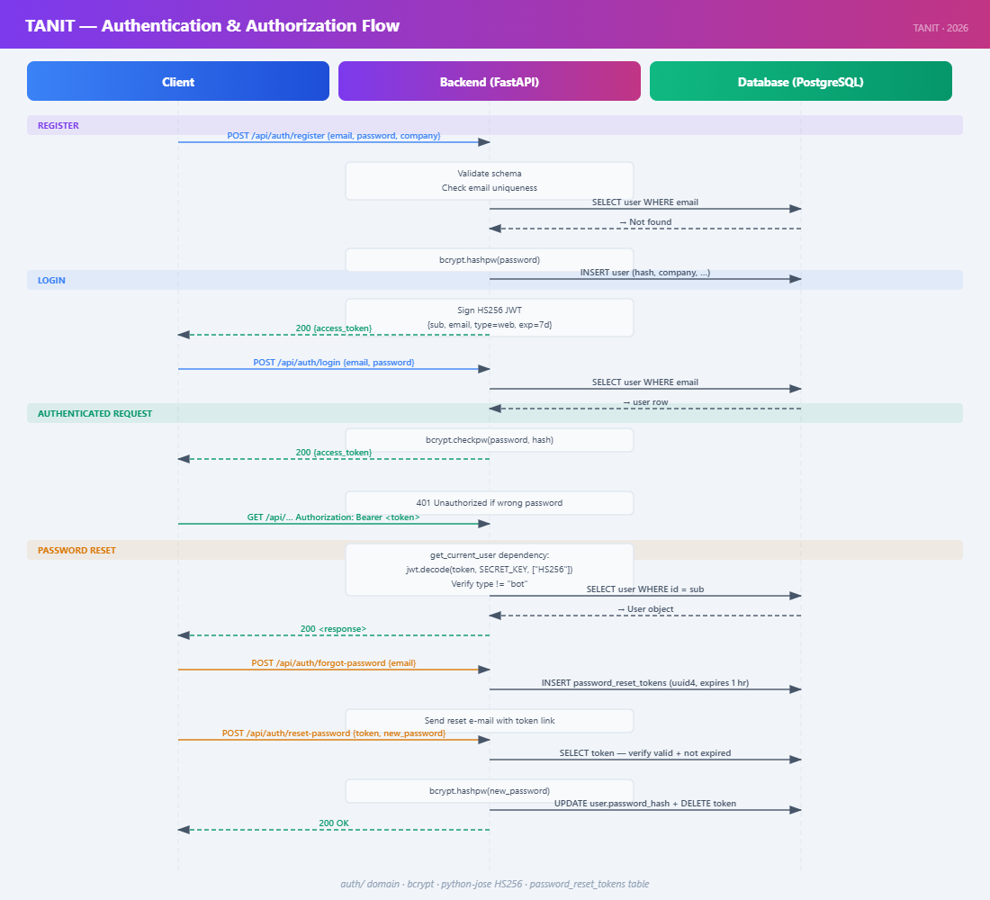

The original DDR specified Keycloak as an external OAuth 2.0 / OIDC provider. This was removed in migration 2026-03-27_0003_remove_keycloak_add_local_auth.py and replaced with a self-contained local authentication system in auth/.

Credential storage. Passwords are hashed with bcrypt (12 rounds) via passlib's CryptContext. verify_password uses constant-time comparison to prevent timing-oracle attacks.

Token model. Successful authentication produces two HS256 JWTs signed with TOKEN_ENCRYPTION_SECRET:

- Access token — short-lived (15 minutes); carries {sub: user_id, type: "web"}. Attached as Authorization: Bearer on all authenticated requests.
- Refresh token — longer-lived (30 days); used exclusively to obtain fresh access tokens from POST /api/auth/refresh without re-entering credentials.

The type claim enforces a strict audience boundary: get_current_user rejects tokens with type != "web", and get_current_bot rejects tokens with type != "bot". The bot's long-lived credential cannot be replayed on user-facing endpoints and vice versa.

Password reset. generate_reset_token creates a 32-byte cryptographically random token, stores its SHA-256 digest and a one-hour expiry on the User row, and dispatches an e-mail. reset_password verifies the digest and expiry before overwriting password_hash and clearing the token fields.

Bot JWT. The WhatsApp bot authenticates with a separate JWT signed by BOT_JWT_SECRET and carrying type: "bot". This secret is independent of TOKEN_ENCRYPTION_SECRET, so rotating one does not invalidate the other.

3.3.5 Post Lifecycle Model
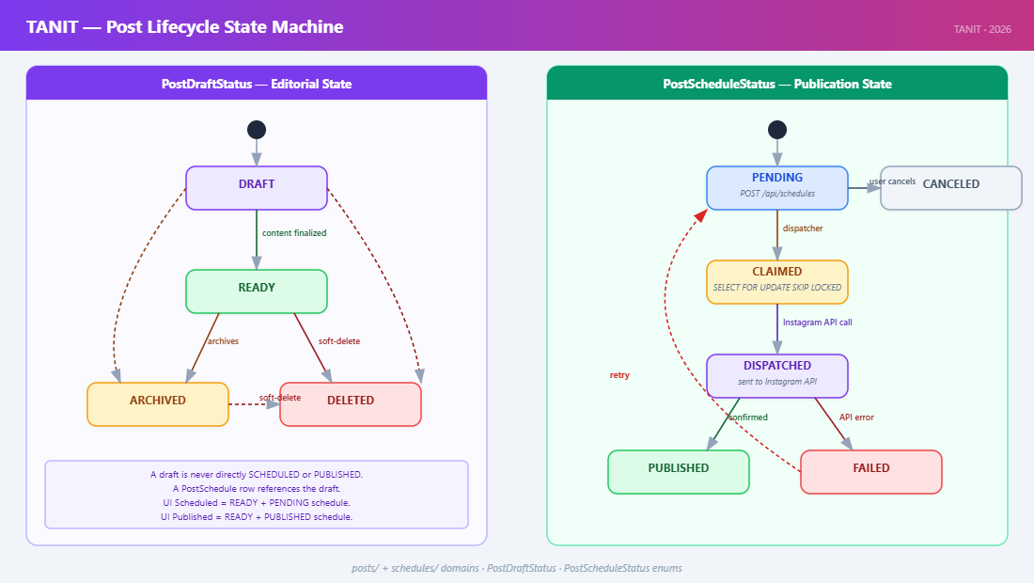

Content in TANIT is modelled as a PostDraft (the editorial unit) paired with an optional PostSchedule (the publication record). These two entities carry orthogonal status enums that must not be conflated.

PostDraftStatus (editorial state, posts/models.py):

Value | Semantics
DRAFT | Content is being composed; AI generation may still be in progress
READY | Content is finalised; eligible for scheduling or immediate publication
ARCHIVED | Removed from the active dashboard; row retained for audit purposes
DELETED | Soft-deleted; excluded from all queries except administrative views

PostScheduleStatus (publication state, schedules/models.py):

Value | Semantics
PENDING | Awaiting dispatch; scheduled time not yet reached
CLAIMED | Atomically locked by the dispatcher; Instagram API call imminent
DISPATCHED | Publish call submitted; awaiting Graph API confirmation
PUBLISHED | Confirmed published; published_at populated
FAILED | Publish call failed; error_message populated; eligible for retry
CANCELED | Cancelled by the user before the dispatch window

A PostSchedule references a PostDraft by foreign key; the draft's own status is never set to "SCHEDULED" or "PUBLISHED". This decoupling means a draft can be re-scheduled by creating a new PostSchedule row without touching the editorial record. The kind column (post or story, added in migration 0023) selects the appropriate Graph API endpoint in the publisher.

Six named post types are supported, each selecting a distinct prompt template from ai_pipeline/prompts/{type}/base.json:

Post Type | Description
product_shot | Clean product-on-background studio image
model_wearing | Fashion model wearing the garment
photo_shoot | Editorial-style lifestyle shot
back_shot | Rear-facing model shot
ad_post | Advertisement overlay with typographic copy
grid | Multi-panel Instagram grid layout

3.3.6 AI Image Generation Pipeline
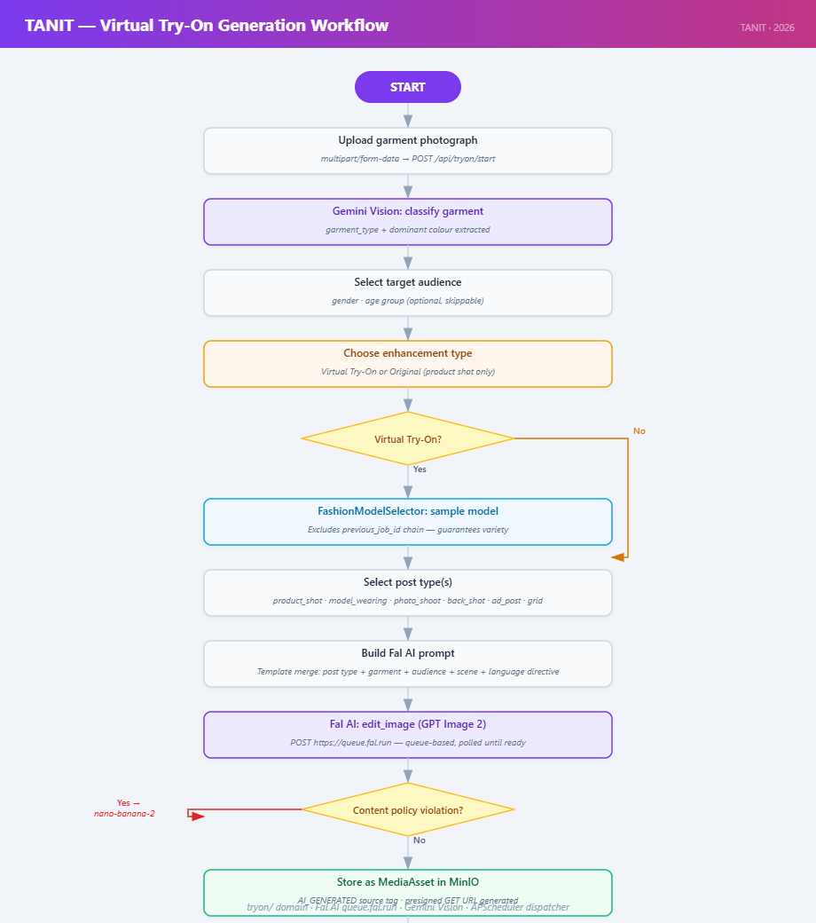

The primary clothing AI pipeline is implemented across tryon/service.py and tryon/fal_provider.py. Image generation is mediated by Fal AI, which exposes a queue-based API: a request is submitted to https://queue.fal.run/{model_id} and returns a request_id; the client polls the status endpoint at two-second intervals until COMPLETED or FAILED.

Generation modes. Three modes are offered through FalClient:

- edit_image — image-guided inpainting; source images are encoded as base-64 data URIs alongside the prompt. Used for clothing try-on jobs, campaign stories with a reference photo, and special-day posts that supply a brand logo.
- generate_image_gpt — text-only generation via the GPT Image 2 path; used for grid posts, campaign stories without a reference photo, and special-day banners.
- generate_image_model_wearing — a specialised text-only variant that injects a seed-model pose descriptor alongside the garment prompt.

Primary-to-fallback model strategy. All edit calls are directed first to FAL_MODEL_EDIT (defaulting to openai/gpt-image-2/edit). If the model returns a content_policy_violation error — which occurs when brand photography of children's or swimwear garments triggers the model's moderation layer — the client transparently retries with FAL_MODEL_EDIT_FALLBACK (defaulting to fal-ai/nano-banana-2/edit). Network errors and HTTP 5xx responses surface immediately to avoid doubling generation cost on infrastructure failures. All three model identifiers are environment-variable- driven, allowing model substitution without code changes.

Garment classification. The uploaded garment photograph is sent to Google Gemini Vision (GEMINI_CLASSIFY_MODEL) before generation begins. The structured result — garment type, colour, pattern, material — parameterises the generation prompt and is stored as product_description on the tryon_job row.

Fashion model pool. To avoid repetitive model appearances across a merchant's feed, FashionModelSelector samples from the active rows of the fashion_model table using RetrySelectionContext — a lightweight structure that traverses the previous_job_id chain of prior try-on jobs and collects the set of previously used fashion_model_id values. The selector excludes that set before sampling, guaranteeing visual variety across regenerations. If the exclusion set exhausts all active models, the constraint is relaxed and sampling proceeds from the full active pool.

Prompt assembly. tryon/prompt_builder.py loads the base JSON template for the requested post type, substitutes the {aspect_ratio}, {resolution}, and {description} placeholders, and appends a critical_constraints block when present. The campaign router additionally appends a _FANCY_TYPOGRAPHY_DIRECTIVE for 9:16 story-format posts, instructing the model to render headline text as a designed typographic element (script lettering, metallic finishes, ornamental dividers) rather than a plain caption overlay.

Aspect ratios. Generation is restricted to two Instagram-native ratios: 4:5 (standard feed post) and 9:16 (Instagram Story). Square and landscape presets present in the initial design were removed.

3.3.7 Scheduling Dispatch Engine
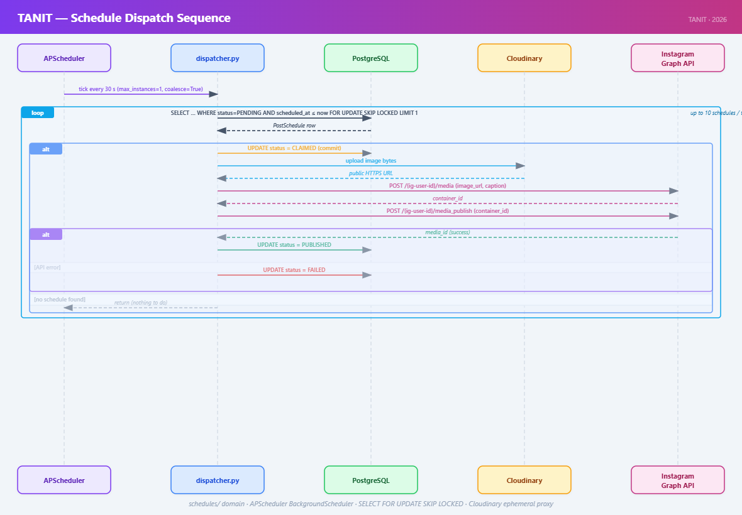

The original DDR proposed a Celery worker pool backed by a Redis broker. In the final implementation, an APScheduler BackgroundScheduler is embedded directly in the uvicorn process and polls the PostSchedule table every 30 seconds. This topology is simpler to operate at the current scale while preserving correctness through database-level concurrency control.

_claim_due_schedule issues a PostgreSQL SELECT … FOR UPDATE SKIP LOCKED query that atomically selects one PENDING row with scheduled_at <= now, transitions it to CLAIMED, and commits before the slow Instagram API calls begin. The SKIP LOCKED clause ensures that concurrent dispatcher instances pick different rows rather than blocking on each other's locks. Up to 10 schedules are processed per tick.

The publisher reads image bytes from MinIO, uploads them to Cloudinary to obtain a public HTTPS URL (required by the Instagram Graph API), calls POST /{ig-user-id}/media to create a media container, calls POST /{ig-user-id}/media_publish to publish it, and deletes the Cloudinary asset regardless of outcome. On failure the schedule transitions to FAILED with the error message persisted; on success it transitions to PUBLISHED with published_at set.

APScheduler is configured with max_instances=1 and coalesce=True: if a dispatch tick takes longer than 30 seconds, the next firing is skipped rather than queued, preventing ticks from accumulating under unusual API latency.

Key schedules/dispatcher.py functions:

Function | Description
dispatch_due_schedules() | Entry point called every 30 s by APScheduler; opens a SessionLocal session and loops up to _BATCH_SIZE = 10 times calling _claim_due_schedule + _process_schedule
_claim_due_schedule(db, now) | Issues SELECT … FOR UPDATE SKIP LOCKED on post_schedule WHERE status=PENDING AND scheduled_at ≤ now; transitions matched row to CLAIMED; commits and returns the row
_process_schedule(db, schedule) | Delegates to publisher.publish_draft_to_instagram or publish_draft_to_instagram_story based on schedule.kind; writes PUBLISHED/FAILED and timestamp

Key schedules/publisher.py functions:

Function | Description
publish_draft_to_instagram | Reads image bytes from MinIO → uploads to Cloudinary → calls Graph API /{id}/media → calls /{id}/media_publish → deletes Cloudinary asset
publish_draft_to_instagram_story | Same as above but targets the Stories media container endpoint
_upload_to_cloudinary | Uploads bytes via Cloudinary Python SDK; returns a public HTTPS URL valid long enough for the Graph API call
_delete_cloudinary_asset | Deletes the temporary Cloudinary upload by public ID; called in a finally block regardless of publish outcome

3.4 Frontend Architecture

3.4.1 Technology Stack
Layer | Technology
Framework | React 19 + TypeScript (strict mode)
Build tool | Vite 5; path alias @ → src/
Styling | Tailwind CSS v4; custom design tokens documented in DESIGN.md
UI primitives | shadcn-style components in src/components/ui/ (Radix UI)
Routing | React Router v6
State | React Context (AuthContext, JobContext, CampaignJobContext)
API types | Generated from OpenAPI spec via make types → schema.ts

The frontend has no external state manager; application state is held in React context providers, component-local state, and URL parameters. Data flows primarily from server to view with minimal cross-route shared state.

3.4.2 Routing Structure
Routes are declared in src/App.tsx and fall into three categories.

Public routes (no authentication required): /login, /register, /forgot-password, /reset-password, /info

Protected routes with sidebar layout (gated by PrivateRoute; rendered inside the persistent Layout component):

Path | Primary function
/dashboard | Aggregated view of recent drafts and upcoming schedules
/scheduled | Queue management for pending and published schedules
/create | Multi-step post creation wizard with AI generation
/preview | Post preview, caption editing, and regeneration
/editor | Caption and hashtag editing
/schedule | Datetime picker for scheduling a draft
/post/:draftId | Individual post detail and status view
/campaigns | Campaign story creation and management
/profile | User profile and subscription modal
/settings | Account settings

Full-page protected routes (gated by PrivateRoute; no sidebar): /onboarding, /create-legacy, /tryon-test, /food-test, /design-system

The entire protected tree is wrapped in JobProvider and CampaignJobProvider context providers so that any page can observe real-time AI job status without prop drilling.

3.4.3 API Integration
Generated types. src/api/schema.ts is generated by openapi-typescript from the live backend OpenAPI spec (make types) and must be regenerated after any backend schema change. src/api/client.ts re-exports named aliases from schema.ts (e.g., PostDraft, PostSchedule, TryonJob, FoodJobResponse) and provides two HTTP helpers:

- apiFetch(path, options) — wraps fetch, attaches Authorization: Bearer <token> from localStorage["token"], deserialises JSON, and throws typed errors on non-2xx responses.
- apiUpload(path, formData) — same, but for multipart/form-data payloads.

Status literals are consumed exclusively through typed aliases from client.ts; raw strings such as "DRAFT" or "PENDING" are never hardcoded in component logic. This ensures that a backend enum rename is caught at npm run typecheck rather than at runtime.

Real-time job status. JobProvider maintains a map of active TryonJob IDs to their current status, polling GET /api/tryon/jobs/{id} at a configurable interval. CampaignJobProvider mirrors this for campaign story generation. Components consume these contexts via useJob() and useCampaignJob() hooks, decoupling polling logic from individual page components.

3.4.4 Key Pages

Page | Primary function
CreatePost.tsx | Multi-step wizard: post type → garment upload → AI generation → draft save
Preview.tsx | Generated image preview; regenerate with a different fashion model; caption editing; schedule
CampaignsPage.tsx | Campaign brief input; optional reference photo; story generation; publish / schedule
Dashboard.tsx | Aggregated feed of recent drafts, upcoming schedules, special-day prompts
Scheduled.tsx | Full schedule queue; cancel, reschedule, view published posts
Onboarding.tsx | First-run Instagram Business account OAuth connection
Profile.tsx | Profile photo upload, display name, subscription modal
Settings.tsx | Password change, account deletion, notification preferences

3.5 Data Architecture
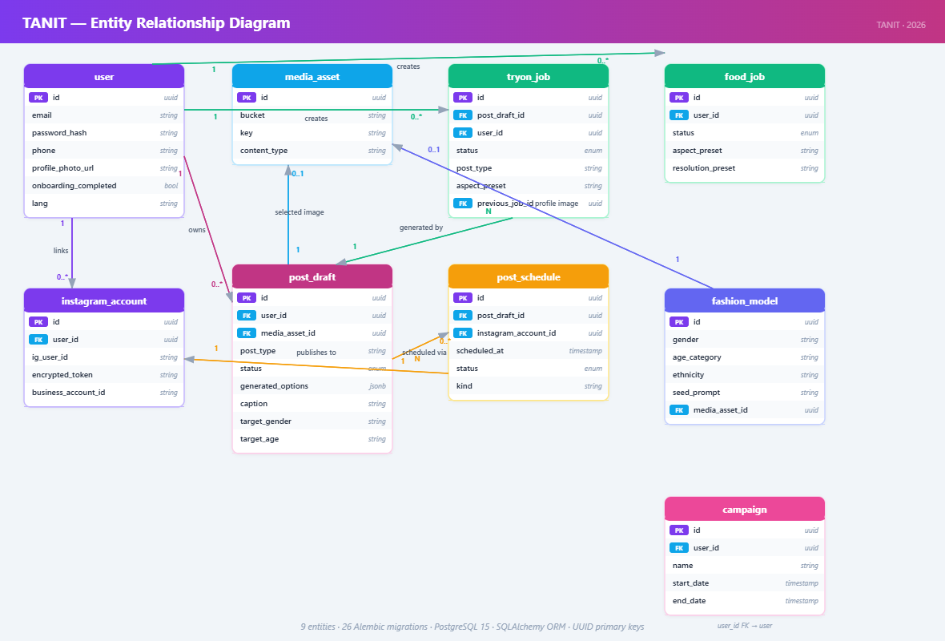

3.5.1 Schema Overview
The relational schema evolved through 26 Alembic migrations. The core entities are:

- user — root identity entity. Holds local authentication credentials (password_hash, reset_token, reset_token_expires), profile information (display_name, profile_photo_url, phone), and flags (is_admin, onboarding_completed). The keycloak_id column present in the initial schema was removed in migration 0003.

- instagram_account — one or more Instagram Business accounts linked to a user. Stores the Meta page ID, username, and long-lived Graph API access token (stored encrypted with TOKEN_ENCRYPTION_SECRET). The status enum (ACTIVE, DISCONNECTED, EXPIRED) allows the frontend to surface connectivity problems without a live API call.

- media_asset — every binary object stored in MinIO is registered here with its storage_uri (MinIO object key), mime_type, and source (USER_UPLOAD or AI_GENERATED). It is the universal reference type for all image data in the system.

- post_draft — the atomic unit of publishable content. Carries post_type (one of the six supported types), prompt_text (encodes type and user description), media_asset_id (the currently selected primary image), generated_options (JSONB array of candidate asset references from the last generation run), and status (PostDraftStatus).

- post_schedule — the publication record. References a post_draft and an instagram_account; carries scheduled_at, status (PostScheduleStatus), and kind (post or story).

- fashion_model — an entry in the fashion model pool. Contains slug (a stable machine key derived from the seed file name), descriptor (the full prompt text injected into generation calls), and is_active (allows individual models to be disabled without deletion).

- tryon_job — a clothing AI generation job. Tracks the full lifecycle from QUEUED through RUNNING to COMPLETED or FAILED. previous_job_id (FK) maintains a lineage chain for retry jobs, which RetrySelectionContext traverses to exclude previously used fashion models. failed_post_types (JSONB) records individual post-type failures within a multi-type job, enabling partial-success reporting.

- food_job — a food-and-beverage AI generation job. Parallel entity to tryon_job. Stores detected_category (Gemini-classified food type), product_description, requested_post_types (JSONB subset of studio, ingredients, in_use), and per-variant media_asset_id foreign keys.

3.5.2 Entity Column Reference
The following tables document the final column schema for each core table as of migration 0025.

user

Column | Type | Notes
id | UUID (PK)
email | VARCHAR (unique)
display_name | VARCHAR
password_hash | VARCHAR | bcrypt digest; replaces keycloak_id
is_admin | BOOLEAN | Default false
reset_token | VARCHAR (nullable) | SHA-256 digest of the raw reset token
reset_token_expires | TIMESTAMP WITH TZ
phone | VARCHAR (nullable) | Added migration 0010
onboarding_completed | BOOLEAN | Added migration 0014; default false
profile_photo_url | VARCHAR (nullable) | Added migration 0025; MinIO URI
created_at | TIMESTAMP WITH TZ

instagram_account

Column | Type | Notes
id | UUID (PK)
user_id | UUID (FK → user) | Owning user
page_id | VARCHAR | Meta page ID
username | VARCHAR
access_token | VARCHAR | Encrypted long-lived token (TOKEN_ENCRYPTION_SECRET)
status | ENUM | ACTIVE, DISCONNECTED, EXPIRED
time_zone | VARCHAR | IANA tz string; used by scheduler
created_at | TIMESTAMP WITH TZ

media_asset

Column | Type | Notes
id | UUID (PK)
instagram_account_id | UUID (FK)
storage_uri | VARCHAR | MinIO object key
mime_type | VARCHAR
source | ENUM | USER_UPLOAD, AI_GENERATED
created_at | TIMESTAMP WITH TZ

post_draft

Column | Type | Notes
id | UUID (PK)
instagram_account_id | UUID (FK)
media_asset_id | UUID (FK) | Primary selected image
prompt_text | TEXT | Encodes post type and user description
caption | TEXT
hashtags | JSONB | ["tag1", "tag2", …]
post_type | VARCHAR | One of the six named post types
status | ENUM | DRAFT, READY, ARCHIVED, DELETED
generated_options | JSONB | Ordered array of candidate asset references
extra_asset_ids | JSONB | Supplementary assets (e.g., back-shot variant)
created_at | TIMESTAMP WITH TZ
updated_at | TIMESTAMP WITH TZ

post_schedule

Column | Type | Notes
id | UUID (PK)
post_draft_id | UUID (FK)
instagram_account_id | UUID (FK)
scheduled_at | TIMESTAMP WITH TZ
time_zone | VARCHAR | Display only; dispatch uses UTC
status | ENUM | PENDING, CLAIMED, DISPATCHED, PUBLISHED, FAILED, CANCELED
dispatched_at | TIMESTAMP WITH TZ | Populated when CLAIMED
published_at | TIMESTAMP WITH TZ | Populated when PUBLISHED
error_message | TEXT
kind | VARCHAR | post or story (added migration 0023)

fashion_model

Column | Type | Notes
id | UUID (PK)
slug | VARCHAR | File-derived stable key (e.g., curvy_studio_1)
descriptor | TEXT | Seed-model prompt text injected into generation calls
is_active | BOOLEAN | Allows individual models to be disabled without deletion
created_at | TIMESTAMP WITH TZ

tryon_job

Column | Type | Notes
id | UUID (PK)
instagram_account_id | UUID (FK)
post_draft_id | UUID (FK, nullable) | Populated on completion
previous_job_id | UUID (FK, nullable) | Points to predecessor in retry chain
source_asset_id | UUID (FK) | Original garment photo
fashion_model_id | UUID (FK) | Selected from the fashion model pool
product_description | TEXT | Gemini-classified garment description
user_prompt | TEXT (nullable) | User's creative direction
aspect_preset | VARCHAR | instagram_post (4:5) or story (9:16)
status | ENUM | QUEUED, RUNNING, COMPLETED, FAILED
failed_post_types | JSONB | Post-type slugs that errored in a partial job (added migration 0024)
error_message | TEXT
created_at | TIMESTAMP WITH TZ
started_at | TIMESTAMP WITH TZ
completed_at | TIMESTAMP WITH TZ

food_job

Column | Type | Notes
id | UUID (PK)
instagram_account_id | UUID (FK)
source_asset_id | UUID (FK) | Original food/drink photo
detected_category | VARCHAR | Gemini-classified food type
product_description | TEXT | Gemini-generated description used in prompts
requested_post_types | JSONB | Subset of ["studio","ingredients","in_use"]
aspect_preset | VARCHAR | instagram_post or story
resolution_preset | VARCHAR | medium, high, extra_high
studio_asset_id | UUID (FK, nullable)
ingredients_asset_id | UUID (FK, nullable)
in_use_asset_id | UUID (FK, nullable)
status | ENUM | QUEUED, RUNNING, COMPLETED, FAILED
error_message | TEXT
created_at | TIMESTAMP WITH TZ
started_at | TIMESTAMP WITH TZ
completed_at | TIMESTAMP WITH TZ

3.5.3 Single-Image-Per-Post Invariant
post_draft holds exactly one media_asset_id — the primary image that will be published to Instagram. The generated_options JSONB array contains an ordered list of candidate asset references (up to three) produced by the most recent generation run and is replaced atomically on each regeneration. Widening the platform to support multi-image carousel posts would require schema changes and corresponding updates to the generation pipeline and publisher, and is deferred to a future release.

3.6 Deviations from the Detailed Design
Design Area | Original Design (DDR, March 2026) | Final Implementation (May 2026)
Authentication | Keycloak OAuth 2.0 / OIDC | Local bcrypt + HS256 JWT (migration 0003)
Image generation engine | Stability AI / Replicate (planned) | Fal AI — GPT Image 2 + nano-banana-2 via Fal queue API
Image classification | Not specified | Google Gemini Vision API (GEMINI_CLASSIFY_MODEL)
Caption generation | Not specified | Google Gemini (GEMINI_GEN_MODEL; separate from classify model)
Public image hosting | Direct MinIO presigned URL | Cloudinary proxy (Instagram Graph API requirement)
Post types | 3 generic pipeline steps | 6 named types with distinct prompt templates
Fashion model pool | Not present | fashion_model table + FashionModelSelector + retry exclusion
Food & beverage pipeline | Not present | food_pipeline/ domain; food_job table (migration 0015)
Campaign management | Not present | campaigns/ domain; 9:16 story generation, publish, schedule
Special days calendar | Not present | special_days/ domain; static registry; Gemini holiday captions
WhatsApp bot | Out of scope / webhook within backend | Separate Flask service in wp_bot/; bot JWT audience isolation
WhatsApp bot language | Turkish only (planned) | TR / EN via i18n.py; user-switchable at runtime
Scheduling backend | Celery worker pool + Redis broker | APScheduler in uvicorn; SELECT FOR UPDATE SKIP LOCKED
Output aspect ratios | Multiple (1:1, 4:3, 16:9…) | Restricted to 4:5 (feed) and 9:16 (story)
API documentation | Always exposed | Hidden in production (openapi_url=None)
Container count | 5 (including Keycloak) | 4 (postgres, backend, frontend, minio); wp_bot as separate process
Onboarding flow | Not specified | Dedicated /onboarding page; onboarding_completed flag on user
Profile photo | Not present | profile_photo_url on user (migration 0025); uploadable via API

4. Development and Implementation Details

4.1 Development Environment
Toolchain:

Tool | Version | Purpose
Python | 3.12 | Backend runtime
uv | latest | Python dependency management and virtual env
ruff | latest | Linting and formatting (replaces flake8/black)
Node.js | 20+ | Frontend runtime
npm | bundled | Frontend dependency management
Docker / Compose | v2 | Service orchestration
PostgreSQL | 15.5 | Database (via container)

All developer operations route through make targets at the repository root:

make dev # Start all containers (postgres, backend, frontend, minio)

make reset # Tear down volumes + detect LAN IP + rebuild — use after network change

make logs # Tail backend + frontend logs

make psql # Open psql shell inside the running postgres container

make test # Drop tanit_test, recreate schema, run full pytest suite

make backend # ruff check --fix + ruff format on app/backend/app/

make check # npm run typecheck + eslint

make types # Regenerate src/api/schema.ts from live OpenAPI spec (backend must be running)

make audit # npm audit --audit-level=high

make hooks # One-time: install .githooks/pre-commit

Running a single backend test without the full suite:

cd app/backend && USE_COMPOSE_DB=true POSTGRES_HOST=localhost \

uv run pytest -x -q tests/posts/test_router.py::test_name

make test drops and recreates tanit_test against the running compose postgres, so the stack (make dev) must be up before running it.

Pre-commit hook (.githooks/pre-commit, installed via make hooks):

- Always runs ruff check --fix + ruff format; re-stages autofixed files; blocks the commit on any remaining unfixable errors.
- Runs npm run check (typecheck + ESLint) as warn-only — failures are reported but do not block the commit.
- On staged package*.json changes: runs npm audit --audit-level=high and npm ci --ignore-scripts.

4.2 Backend Implementation

4.2.1 Dependency Injection
FastAPI's Depends() system is used consistently across all domain routers:

- get_db() yields a SessionLocal and guarantees session.close() in a finally block, even on exception.
- get_current_user() validates the Bearer JWT, decodes the HS256 payload, checks type == "web", and returns the User ORM object. Used on all human-authenticated routes.
- get_current_bot() uses BOT_JWT_SECRET instead, restricting access to endpoints in the bot/ domain.
- get_active_instagram_account() (in media/router.py) combines get_current_user with an active InstagramAccount lookup, used by any route that requires a linked Instagram account.

4.2.2 Authentication Implementation
Registration flow:

- Check for existing email (raises 409 Conflict if duplicate).
- hash_password() via passlib.context.CryptContext(schemes=["bcrypt"]).
- Insert User row; return access + refresh token pair from create_tokens().

Login flow:

- authenticate_user() queries by email, calls verify_password().
- create_tokens() encodes {"sub": user_id, "type": "web"} / "refresh" with python-jose, signed with TOKEN_ENCRYPTION_SECRET.

Password reset flow:

- generate_reset_token() stores a short-lived opaque token hash in the DB and dispatches an e-mail.
- reset_password() validates the token, calls hash_password(), clears the token.

Token refresh: POST /api/auth/refresh accepts a valid refresh JWT and issues a new access token, enabling silent re-authentication in the frontend.

Key auth/service.py functions:

Function | Signature | Description
hash_password | (plaintext: str) → str | bcrypt hash via passlib (12 rounds); output includes algorithm, cost, salt, and digest
verify_password | (plaintext: str, hashed: str) → bool | Constant-time bcrypt comparison; prevents timing-oracle attacks
authenticate_user | (db, email, password) → User | None | Query by email then verify_password; returns None on any failure so the caller maps it to 401
create_tokens | (user: User) → dict | Signs access token (type=web, 15 min) and refresh token (type=refresh, 30 days) with HS256 using SETTINGS.secret_key
register_user | (db, email, password, display_name) → dict | Validates uniqueness, hashes password, inserts User, returns token dict
generate_reset_token | (db, email) → str | Creates secrets.token_urlsafe(32), stores SHA-256 digest + 1-hour expiry on user row, queues e-mail
reset_password | (db, token, new_password) → None | Looks up user by sha256(token) + expiry check; overwrites password_hash; clears reset fields

4.2.3 Media Asset Management
Upload path (media/service.py):

- apiUpload in the frontend sends multipart/form-data to POST /api/media/upload.
- The backend validates MIME type and byte size (MAX_UPLOAD_BYTES).
- The file is streamed to MinIO under a UUID key in the configured bucket.
- A MediaAsset row is inserted with storage_uri, mime_type, and source=USER_UPLOAD.
- A presigned GET URL is returned to the frontend for immediate display.

For Instagram publishing, the finalized image bytes are additionally uploaded to Cloudinary using the Cloudinary Python SDK, obtaining a time-limited HTTPS URL that Instagram's API can fetch. The Cloudinary URL is passed to POST /{ig-user-id}/media in the Graph API call and is not stored permanently.

4.2.4 Virtual Try-On Service
tryon/service.py orchestrates job logic; tryon/fal_provider.py owns all Fal AI API calls.

Job state machine: TryonJob.status progresses through QUEUED → RUNNING → COMPLETED | FAILED. On backend restart, _fail_orphaned_tryon_jobs() in main.py sets any RUNNING jobs to FAILED, preventing phantom in-progress states in the UI.

create_tryon_job: validates source asset ownership, selects a fashion model via FashionModelSelector, inserts a TryonJob row with status=QUEUED, and returns immediately. The job is picked up by a daemon thread.

create_replacement_tryon_job: loads the original job to recover source_asset_id, then calls _build_retry_selection_context to walk the previous_job_id chain and collect all previously used fashion_model_id values into an exclusion set. FashionModelSelector.select picks a model not in that set, guaranteeing a visually different result.

_run_tryon_job (daemon thread):

- Reads source asset bytes from MinIO.
- Sends image to Gemini Vision for garment classification → product_description.
- For each requested post_type, builds a prompt via prompt_builder and calls fal.edit_image (or fal.generate_image_model_wearing for model_wearing).
- On content_policy_violation, transparently retries with the fallback model.
- Stores each result as a MediaAsset in MinIO; links asset IDs to the job row.
- Per-type failures are recorded in failed_post_types rather than failing the entire job, enabling partial-success reporting.
- Sets job.status = COMPLETED (or FAILED if all types errored).

Key tryon/service.py functions:

Function | Description
create_tryon_job | Validates asset ownership, selects fashion model via FashionModelSelector, inserts TryonJob (status QUEUED), returns job ID immediately
create_replacement_tryon_job | Loads original job for source_asset_id; walks previous_job_id chain via _build_retry_selection_context to build exclusion set; selects a fresh model; creates new TryonJob with previous_job_id set
start_tryon_job | Called by the background thread dispatcher; transitions job to RUNNING then delegates to _run_tryon_job
_run_tryon_job | Core generation logic (see numbered steps above); runs in a threadpool worker
get_tryon_job | Returns a single TryonJob by ID with ownership check
list_tryon_jobs | Returns all TryonJob rows for the given instagram_account_id, ordered newest-first
_build_retry_selection_context | Traverses the previous_job_id linked list and collects all fashion_model_id values seen; returns a RetrySelectionContext exclusion set

Key tryon/fal_provider.py functions:

Function | Description
get_fal_client | Reads SETTINGS.fal_key; returns FalClient or None when unconfigured
edit_image | Image-guided inpainting; encodes source images as base-64 data URIs; primary→fallback on content_policy_violation
generate_image_gpt | Text-to-image via GPT Image 2 path; no source asset required
generate_image_model_wearing | Text-to-image variant that injects seed-model pose descriptor alongside garment prompt
_poll_for_result | Polls https://queue.fal.run/{model_id}/requests/{id}/status every 2 seconds until COMPLETED or FAILED
_resize_for_upload | Downscales source images to max 2048 px before base-64 encoding

4.2.5 Food & Beverage Pipeline
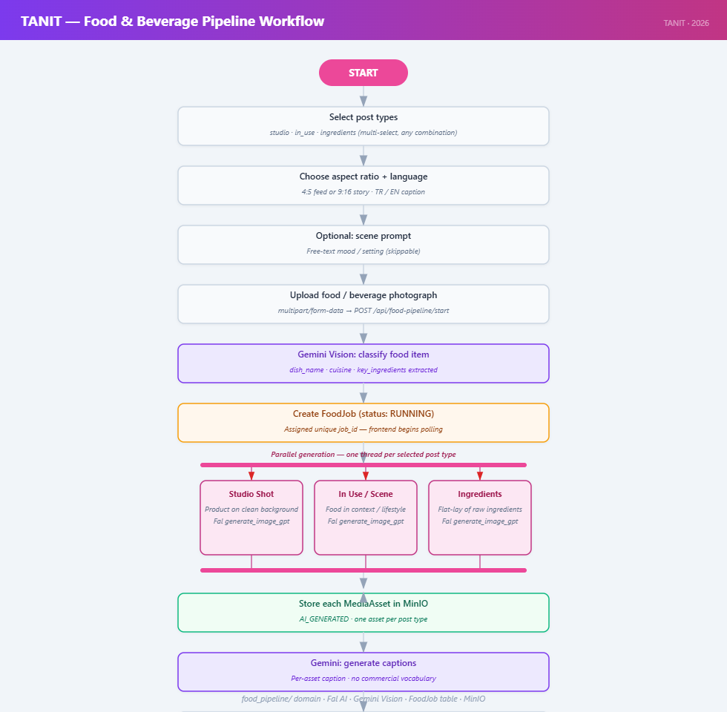

food_pipeline/service.py mirrors the try-on pipeline for food products. create_food_job validates asset ownership and inserts a FoodJob row. _run_food_job (daemon thread) classifies the food item with Gemini Vision (detected_category, product_description), then generates up to three scene variants — studio (clean background), ingredients (styled flat-lay), in_use (lifestyle shot) — using the appropriate prompt templates from ai_pipeline/prompts/food/{variant}/base.json. Each variant is stored as a MediaAsset and linked to the food_job row via a dedicated foreign key column.

Key food_pipeline/service.py functions:

Function | Description
create_food_job | Validates asset ownership; inserts FoodJob (status QUEUED); returns job immediately
_run_food_job | Threadpool worker: classifies food with Gemini Vision → generates up to three scene variants → stores MediaAsset rows → marks COMPLETED
get_food_job | Returns a single FoodJob by ID with ownership check
list_food_jobs | Returns all FoodJob rows for the given account, ordered newest-first

4.2.6 Campaign and Special Days Services
Campaigns. The campaigns/ router generates 9:16 Instagram Story images for promotional briefs. With a reference photo, fal.edit_image is called; without one, fal.generate_image_gpt is used. Both paths use the ad_post prompt template reoriented to 9:16 aspect ratio, with the _FANCY_TYPOGRAPHY_DIRECTIVE appended to produce premium typographic treatments on story text. Three publication paths are available: immediate publish (/publish-story), deferred schedule (/schedule-story), and draft save (/save-draft). No dedicated database table is used; generated images are stored as MediaAsset rows and publications create transient PostDraft / PostSchedule rows with prompt_text = "campaign:story".

Special days. The special_days/ domain serves a static registry of Turkish national holidays, religious festivals, and international awareness days. Each entry defines a stable slug, display names (TR/EN), an image prompt, and a Gemini caption prompt. generate_special_day_post generates a 9:16 image (via fal.edit_image when a reference brand asset is supplied, or fal.generate_image_gpt otherwise) and three caption options from a Gemini call that explicitly forbids commercial vocabulary. The draft is persisted with prompt_text = "special_day:story:<slug>" for frontend badge rendering.

Key campaigns/router.py endpoints:

Endpoint | Method | Description
/api/campaigns/generate | POST | Generates a 9:16 story image (with or without reference photo); returns presigned URL
/api/campaigns/publish-story | POST | Creates transient PostDraft + PostSchedule (kind=story) and immediately calls the Instagram publisher
/api/campaigns/schedule-story | POST | Creates PostDraft (status=READY) + PostSchedule (status=PENDING); dispatch handled by APScheduler
/api/campaigns/save-draft | POST | Saves generated asset as a PostDraft without scheduling

Key special_days/ functions:

Function | Description
get_special_days_for_date(d) | Checks fixed-date dict for (month, day) and evaluates dynamic rules; returns all matching SpecialDay instances
generate_special_day_post (handler) | Loads image prompt from registry; generates 9:16 image via Fal; calls Gemini for three caption options; persists PostDraft with prompt_text="special_day:story:<slug>"
_gemini_special_day_captions | Dedicated Gemini prompt that explicitly forbids commercial vocabulary; falls back to _mock_captions on Gemini failure

SpecialDay registry fields:

Field | Description
slug | Stable machine key (e.g., mothers_day, eid_al_fitr)
display_name_tr / display_name_en | Localised display names
emoji | Decorative emoji used in captions and UI badges
image_prompt | Fal AI generation prompt for the day's visual
caption_prompt | Gemini caption prompt (holiday-specific tone and constraints)
reference_image_path | Optional brand asset path; triggers edit_image instead of generate_image_gpt

4.2.7 Scheduling Dispatcher
schedules/dispatcher.py implements the critical section for concurrent publishing. The core of the dispatch loop:

stmt = (

select(PostSchedule)

.where(PostSchedule.status == PostScheduleStatus.PENDING)

.where(PostSchedule.scheduled_at <= now)

.with_for_update(skip_locked=True)

.limit(1)

)

schedule = session.execute(stmt).scalar_one_or_none()

if schedule:

schedule.status = PostScheduleStatus.CLAIMED

session.commit()

SELECT FOR UPDATE SKIP LOCKED allows multiple dispatcher workers (or future container replicas) to safely pick different schedules without deadlocking. The CLAIMED transition is committed immediately, releasing the row lock while _process_schedule() performs the slower Cloudinary upload and Instagram API calls.

4.2.8 Schema Migration History
Significant milestones in the 26-migration history:

Migration | Date | Change
0001 | 2025-12-04 | Initial schema: user, post_draft, instagram_account, media_asset
0003 | 2026-03-27 | Remove keycloak_id; add password_hash, reset_token fields
0004 | 2026-03-28 | Add fashion_model table
0005 | 2026-03-29 | Modular post types (post_type column on post_draft)
0010 | 2026-04-xx | Add phone column to user
0014 | 2026-04-xx | Add onboarding_completed boolean to user
0015 | 2026-04-xx | Add food_job table for food pipeline
0023 | 2026-04-29 | Add kind column to post_schedule (feed vs story)
0024 | 2026-04-30 | Add failed_post_types JSONB array to tryon_job
0025 | 2026-04-30 | Add profile_photo_url to user

The wait-and-migrate.sh startup script ensures database and application code are always in sync: Alembic runs before uvicorn accepts connections, so there is no window where new code serves requests against an old schema.

4.3 Frontend Implementation

4.3.1 Type Safety Strategy
The frontend achieves end-to-end type safety through generated types:

- Backend Pydantic response models automatically appear in the FastAPI OpenAPI spec.
- make types runs openapi-typescript against http://localhost:8000/openapi.json and writes src/api/schema.ts.
- src/api/client.ts re-exports named aliases from schema.ts.
- Page and component code imports from client.ts only.

A backend schema change that breaks a frontend consumer is caught at npm run typecheck (pre-commit hook and CI), not at runtime.

4.3.2 Post Creation Wizard (CreatePost.tsx)
The post creation flow is a multi-step state machine within a single page component. Steps:

- Post type selection — six post type cards.
- Garment upload — apiUpload to POST /api/media/upload; presigned URL displayed as preview.
- AI generation trigger — POST /api/tryon/jobs; job ID stored in JobProvider.
- Result review — JobProvider polls GET /api/tryon/jobs/{id} and renders the generated image when status == COMPLETED.
- Draft save — POST /api/posts with media_asset_id and post_type.
- Schedule or save — POST /api/schedules creates the PostSchedule row.

4.3.3 Preview and Feedback Flow (Preview.tsx)
Preview.tsx implements the post refinement experience:

- Renders the current generated image from the draft's media_asset_id.
- Regenerate — calls POST /api/tryon/replacement-jobs, which creates a new try-on job with the previous fashion model excluded via RetrySelectionContext.
- Caption generation — calls a Gemini-backed endpoint returning three copy options.
- Schedule — opens a datetime picker and calls POST /api/schedules.

4.3.4 Design System
The frontend uses a custom design system documented in app/frontend/DESIGN.md:

- Tokens: colours, spacing, and radii defined as Tailwind CSS v4 custom properties.
- Typography: a named semantic scale.
- Instagram accent gradient: a specific linear gradient used consistently in Instagram-facing UI elements (from-ig-yellow via-ig-magenta to-ig-purple).
- Primitives: shadcn-style components in src/components/ui/ built on Radix UI headless primitives with Tailwind styling.

4.4 WhatsApp Bot Implementation
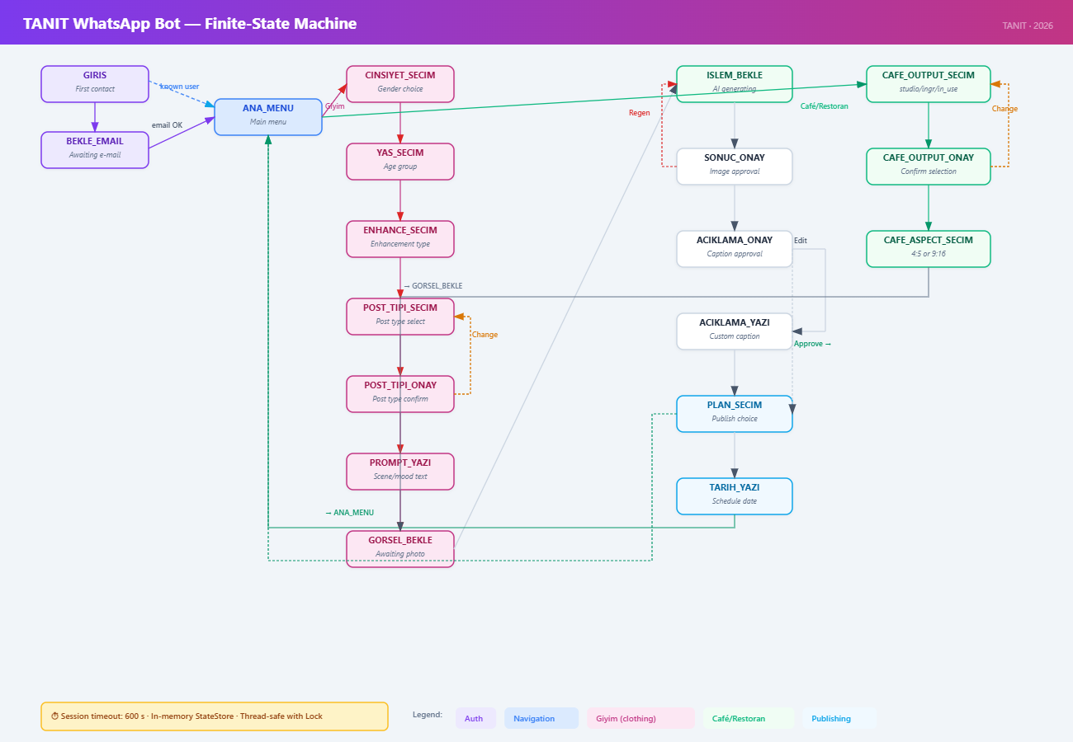

4.4.1 Service Architecture
The WhatsApp bot is a standalone Python/Flask service in wp_bot/, running independently of the Docker Compose stack. It communicates with the backend over HTTP using a dedicated bot JWT, so bot credentials cannot be replayed as regular user tokens even if the WhatsApp integration were compromised.

wp_bot/

app.py ← Flask entry point; WhatsApp webhook handler (POST /webhook)

bot/

states.py ← State constants + UserSession dataclass + thread-safe StateStore

handlers.py ← Full conversation state machine (~1 000 lines)

i18n.py ← TR/EN string table + t() helper

whatsapp.py ← WhatsApp Cloud API v24.0 calls

backend.py ← Backend HTTP client (bot-JWT authenticated)

app.py registers one route: POST /webhook. Meta delivers each incoming WhatsApp message as a JSON payload; Flask acknowledges with 200 OK immediately to satisfy Meta's 20-second timeout, then dispatches to handlers.handle_message in a background thread.

Session management. All session state is held in memory via a thread-safe StateStore (threading.Lock()). Sessions expire after 10 minutes of inactivity and reset after a successful publish. The global command iptal cancels the active flow and returns to the main menu at any time.

Internationalisation. bot/i18n.py holds all user-visible strings in TR and EN variants. t(session.lang, key) returns the correct locale string. UserSession.lang (default "tr") persists the user's language choice across state transitions; users switch language via a dedicated command in the main menu.

4.4.2 Authentication Flow
When a user sends their first message, check_user_by_phone() queries GET /api/bot/check-user?phone=.... If the phone number is not yet linked:

- The bot prompts for the user's registered email address (BEKLE_EMAIL state).
- check_user_by_email() queries the backend; on success the phone is linked and a per-user bot JWT is returned.
- The JWT is stored in UserSession.bot_token and sent on every subsequent backend request as Authorization: Bearer.

Key wp_bot/bot/ module functions:

Module | Function / Class | Description
backend.py | check_user_by_phone | GET /api/bot/check-user?phone=…; returns user category + bot JWT on match
backend.py | check_user_by_email | Links a WhatsApp phone to a registered email; used during first-contact auth flow
backend.py | upload_media | Uploads an image file to POST /api/media/upload; returns media_asset_id
backend.py | create_draft | POST /api/posts to create a PostDraft; returns draft ID
backend.py | trigger_generation | POST /api/tryon/jobs or POST /api/bot/generate/food; starts AI job
backend.py | poll_job | GET /api/bot/generate/{job_id}; polls until COMPLETED or FAILED
backend.py | publish_post | POST /api/bot/publish with publish/schedule/draft action
whatsapp.py | send_text | Sends plain text message via WhatsApp Cloud API v24.0
whatsapp.py | send_image | Sends an image (by URL) with optional caption
whatsapp.py | send_interactive_buttons | Sends a button-reply message (max 3 buttons)
whatsapp.py | download_media | Downloads media bytes from a WhatsApp media ID
states.py | StateStore | Thread-safe in-memory session store (threading.Lock()); sessions expire after 10 minutes
i18n.py | t(lang, key) | Returns the localised string for key in lang ("tr" or "en")

4.4.3 Conversation State Machine
The bot is implemented as a 17-state finite state machine in handlers.py.

Giyim (clothing) flow — 11 steps:

State | Input type | Description
CINSIYET_SECIM | List reply | Target gender: Kadın / Erkek / Unisex / Atla
YAS_SECIM | List reply | Age group: Çocuk / Genç / Yetişkin / Yaşlı / Atla
POST_TIPI_SECIM | Free text | Post types: multi-select by number (1–6); "hepsi" selects all
POST_TIPI_ONAY | Button reply | Confirm or change selection
PROMPT_YAZI | Free text | Optional scene / atmosphere prompt; "atla" to skip
GORSEL_BEKLE | Image | User sends product photo
ISLEM_BEKLE | — | Backend AI generation (1–2 min); any message gets a wait reply
SONUC_ONAY | Button reply | Beğendim ✅ → caption flow; Tekrar üret 🔄 → re-upload photo
ACIKLAMA_ONAY | Button reply | Approve AI caption / write own / regenerate
ACIKLAMA_YAZI | Free text | User types a custom caption
PLAN_SECIM | Button reply | Şimdi paylaş / Planla / Taslak kaydet
TARIH_YAZI | Free text | Date/time in GG.AA.YYYY SS:DD; interpreted as Turkey time UTC+3

Cafe / restoran flow diverges after photo upload, replacing the post-type and fashion-model steps with food-scene variant selection (CAFE_OUTPUT_SECIM / CAFE_OUTPUT_ONAY: Stüdyo Çekimi / Malzemeler / Yaşam Tarzı), then converges back into the shared caption and publication flow.

4.4.4 Backend Bot Endpoints
All endpoints are registered under /api/bot/ and require a bot JWT:

Method | Path | Description
GET | /check-user | Link phone to account; return category + bot JWT
GET | /summary | Scheduled count, upcoming list, draft count
GET | /insights | Instagram Business metrics (followers, reach, engagement)
POST | /generate | Start clothing AI generation job
POST | /generate/food | Start food pipeline generation job
GET | /generate/{job_id} | Poll job status until COMPLETED
POST | /publish | Publish immediately, schedule, or save as draft

4.5 Testing Strategy
Backend tests live in app/backend/tests/, organised by domain (e.g., tests/posts/, tests/auth/, tests/schedules/). The suite runs against a real PostgreSQL instance (tanit_test database on the compose postgres), not a mock — ensuring that SQLAlchemy queries, Alembic schema state, and SELECT FOR UPDATE behaviour are all exercised against real Postgres semantics. make test drops and recreates tanit_test before each run, giving each session a clean schema.

Frontend type correctness is enforced by npm run typecheck (tsc --noEmit). ESLint runs as npm run lint. Both are included in the pre-commit hook and the make check target and should be run before opening a pull request.

4.6 Environment Configuration
.env is git-ignored to prevent merge conflicts (the HOST_IP value differs per machine; API keys are secrets). .env.template is the committed template and the canonical configuration contract. On first checkout or after a network change:

make reset # internally calls scripts/update_host_ip.py

update_host_ip.py bootstraps .env from the template on first run and on subsequent runs overwrites only the HOST_IP= line, preserving all other keys including developer-specific API keys.

Required external API keys (not in the template; must be set manually):

Key | Purpose
FAL_API_KEY | Fal AI image generation
FAL_MODEL_GENERATION | Primary text-to-image model
FAL_MODEL_EDIT | Primary image-edit model (default: openai/gpt-image-2/edit)
FAL_MODEL_EDIT_FALLBACK | Fallback edit model on content policy rejection
GEMINI_API_KEY | Google Gemini Vision + text generation
CLOUDINARY_CLOUD_NAME | Cloudinary account for Instagram publish proxy
CLOUDINARY_API_KEY | Cloudinary API key
CLOUDINARY_API_SECRET | Cloudinary API secret
TOKEN_ENCRYPTION_SECRET | JWT signing key (must be set before any auth flow)
BOT_JWT_SECRET | Separate signing key for WhatsApp bot JWTs

5. Test Cases and Results

5.1 Functional Tests
TC-F001
- Test Type: Integration
- Category: Registration & Authentication
- Objective: Verify new user registration and onboarding completion.
- Procedure:
  - Step 1: Navigate to the TANIT web application landing page. Expected: Landing page loads with "Create Account" and "Log In" options visible.
  - Step 2: Click "Create Account". Expected: Browser redirects to the registration form.
  - Step 3: Enter a valid email, a password meeting , and a business name. Submit the form.
  - Step 4: Complete the onboarding wizard (confirm display name, link a mock Instagram account in dev mode). Expected: Dashboard loads showing the user's display name, empty drafts list, and content statistics at zero.
- Date Tested / Result: PASSED.

TC-F002
- Test Type: Integration
- Category: Registration & Authentication
- Objective: Verify existing user login and dashboard access.
- Procedure:
  - Step 1: Navigate to the TANIT landing page. Click "Log In". Expected: Browser redirects to the login form.
  - Step 2: Enter valid credentials for an existing user. Submit. Expected: Redirected to the TANIT dashboard. User's existing data (drafts, scheduled posts, statistics) is displayed.
  - Step 3: Refresh the page. Expected: Session persists. Dashboard reloads without requiring re-login.
- Date Tested / Result: PASSED.

TC-F003
- Test Type: Functional
- Category: Registration & Authentication
- Objective: Verify logout terminates the session and protected pages are inaccessible afterward.
- Procedure:
  - Step 1: Log in to TANIT. Confirm the dashboard is displayed. Expected: Dashboard loads successfully.
  - Step 2: Click "Logout". Expected: Session terminated. Browser redirects to the landing page.
  - Step 3: Without logging in, navigate directly to a protected URL (e.g., /dashboard) by typing it in the address bar. Expected: System redirects the user to the login page. Dashboard content is not shown.
- Date Tested / Result: PASSED.

TC-F004
- Test Type: Integration
- Category: Instagram Account Linking
- Objective: Verify a user can link their Instagram Business Account via Meta OAuth.
- Procedure:
  - Step 1: Log in and initiate the Instagram Business Account linking process. Expected: Browser redirects to the Meta OAuth (Graph API) authorization screen requesting Instagram permissions.
  - Step 2: Grant the requested permissions on the Meta screen. Expected: System receives a valid access token. Redirected back to TANIT with a success message confirming the account is linked.
  - Step 3: Verify the linked account is reflected in the application. Expected: The linked Instagram account name is visible. The dashboard or profile indicates that an Instagram account is connected.
- Date Tested / Result: PASSED.

TC-F005
- Test Type: Functional
- Category: Instagram Account Linking
- Objective: Verify the system handles a user denying Instagram OAuth permissions.
- Procedure:
  - Step 1: Log in and initiate the Instagram Business Account linking process. Expected: Browser redirects to the Meta OAuth authorization screen.
  - Step 2: Deny or cancel the permission request on Meta's screen. Expected: Redirected back to TANIT. System displays a message indicating linking was not completed. No Instagram account appears as linked. The user can retry the linking process.
- Date Tested / Result: PASSED.

TC-F006
- Test Type: Integration
- Category: Image & Media Handling
- Objective: Verify valid product image upload, storage in MinIO, and retrieval via presigned URL.
- Procedure:
  - Step 1: Log in and navigate to "Create New Post". Expected: Post creation wizard opens at the image upload step.
  - Step 2: Upload a valid JPEG image within the size limit. Expected: Upload progress indicator shown. Image accepted and a thumbnail preview is displayed in the wizard.
  - Step 3: Inspect the image preview (or open its URL in a new tab). Expected: Image loads from a presigned MinIO URL. The URL contains a time-limited signature.
- Date Tested / Result: PASSED.

TC-F007
- Test Type: Functional
- Category: Image & Media Handling
- Objective: Verify the system rejects unsupported image formats and oversized files.
- Procedure:
  - Step 1: In the post creation wizard, attempt to upload a file with an unsupported format (e.g., .bmp, .gif, or a .pdf). Expected: System rejects the upload. An error message indicates the supported formats (JPEG, PNG).
  - Step 2: Attempt to upload a valid-format image that exceeds the maximum allowed file size. Expected: System rejects the upload. An error message indicates the size limit.
- Date Tested / Result: PASSED.

TC-F008
- Test Type: Integration
- Category: AI Content Generation
- Objective: Verify the full end-to-end post creation pipeline from image upload through AI generation to preview.
- Procedure:
  - Step 1: Log in and click "Create New Post". Expected: Post creation wizard opens at Step 1 (image upload).
  - Step 2: Upload a valid product image (e.g., a t-shirt photo). Expected: Image accepted. Wizard advances to Step 2 (visual enhancement selection).
  - Step 3: Select or skip visual enhancement options. Proceed. Expected: Wizard advances to Step 3 (AI content generation).
  - Step 4: Trigger AI content generation. Expected: A loading indicator or progress bar appears. Within a reasonable time, the system returns generated caption(s), hashtag(s), and visual layout or post variant options.
  - Step 5: Review the preview screen. Expected: Preview displays the product image combined with the generated caption, hashtags, and chosen layout. The preview approximates how the post would appear on Instagram.
- Date Tested / Result: PASSED.

TC-F009
- Test Type: Integration
- Category: AI Content Generation
- Objective: Verify the AI pipeline adapts its output to different product/apparel types.
- Procedure:
  - Step 1: Create a new post using a t-shirt image. Trigger AI generation. Expected: Generated caption references upper-body apparel. Hashtags are relevant to t-shirts or tops.
  - Step 2: Create a new post using a dress image. Trigger AI generation. Expected: Generated caption references a full-body garment. Hashtags are relevant to dresses. Layout uses full-body framing.
  - Step 3: Create a new post using a pants image. Trigger AI generation. Expected: Generated caption references lower-body apparel. Hashtags are relevant to pants or bottoms.
- Date Tested / Result: PASSED.

TC-F010
- Test Type: Functional
- Category: AI Content Generation
- Objective: Verify AI-generated captions and hashtags meet basic quality and format requirements.
- Procedure:
  - Step 1: Upload a product image and trigger AI generation. Expected: Content generated and displayed.
  - Step 2: Inspect the generated captions. Expected: Captions are non-empty, grammatically coherent, and relevant to the product shown in the image.
  - Step 3: Inspect the generated hashtags. Expected: Each hashtag is prefixed with "#", relevant to the product category, and free of offensive or clearly irrelevant terms.
  - Step 4: Check that multiple options are available. Expected: The system presents at least 2 caption alternatives and a set of hashtags for the user to choose from.
- Date Tested / Result: PASSED.

TC-F011
- Test Type: Functional
- Category: Content Editing & Drafts
- Objective: Verify that a user can edit AI-generated content, select from multiple versions, preview the final result, and save as a draft.
- Procedure:
  - Step 1: Complete AI content generation for a post (TC-F008). Review the generated output. Expected: Multiple generated post versions are displayed, each with a caption, hashtags, and visual layout or style.
  - Step 2: Select a preferred post version from the available options. Expected: The selected version is highlighted and its content is shown in detail.
  - Step 3: Edit the caption text using the content editor. Expected: Changes are reflected in the Instagram-style post preview in real time.
  - Step 4: Remove one suggested hashtag and add a custom hashtag. Expected: The hashtag list updates accordingly. The preview reflects the updated hashtags.
  - Step 5: Review the final Instagram-style preview showing how the post would appear on the platform. Expected: The preview accurately represents the edited caption, updated hashtags, and the selected visual layout combined with the product image.
  - Step 6: Click "Save as Draft". Expected: System confirms the draft is saved. The post appears in the drafts section of the dashboard with a thumbnail and caption preview.
- Date Tested / Result: PASSED.

TC-F012
- Test Type: Integration
- Category: Content Editing & Drafts
- Objective: Verify that a saved draft persists and loads back with all content intact.
- Procedure:
  - Step 1: Save a draft with a known caption, hashtags, and image (TC-F011). Note the content. Expected: Draft saved.
  - Step 2: Navigate to the dashboard. Locate the draft in the drafts list. Expected: Draft appears in the list with a recognizable title or thumbnail.
  - Step 3: Open the draft. Expected: The draft loads with the exact caption, hashtags, image, and layout that were present at save time.
- Date Tested / Result: PASSED.

TC-F013
- Test Type: Integration
- Category: Scheduling & Publishing
- Objective: Verify a user can schedule a generated post for future publication.
- Procedure:
  - Step 1: Create and preview a post (TC-F008). Click "Schedule Post". Expected: A date and time picker is presented.
  - Step 2: Select a future date and time. Confirm the schedule. Expected: System stores the schedule and displays a confirmation with the selected date and time.
  - Step 3: Navigate to the dashboard "Scheduled Posts" section. Expected: The scheduled post appears in the list with the correct date, time, and content preview.
- Date Tested / Result: PASSED.

TC-F014
- Test Type: Functional
- Category: Scheduling & Publishing
- Objective: Verify a user can modify or cancel a scheduled post before it publishes.
- Procedure:
  - Step 1: Schedule a post (TC-F013). Locate it in the scheduled posts list. Expected: Scheduled post visible with its date and time.
  - Step 2: Open the scheduled post and change the date/time. Confirm. Expected: Updated schedule is reflected in the list.
  - Step 3: Open the same post and click "Cancel Schedule". Expected: Post is removed from the scheduled list. The content returns to drafts or is deleted as appropriate.
- Date Tested / Result: PASSED.

TC-F015
- Test Type: Integration
- Category: Scheduling & Publishing
- Objective: Verify the system notifies the user when a scheduled publish fails.
- Procedure:
  - Step 1: Schedule a post for publication. Expected: Post appears in scheduled list.
  - Step 2: Simulate a publish failure (e.g., revoke or expire the Instagram token before the scheduled time). Expected: The scheduling engine attempts to publish at the scheduled time and the API call fails.
  - Step 3: Check the user's notifications or the scheduled post status. Expected: The user is notified of the failure with a reason (e.g., "Token expired" or "Instagram API error"). The post status reflects the failure.
- Date Tested / Result: PASSED.

TC-F016
- Test Type: Integration
- Category: WhatsApp Bot
- Objective: Verify the full WhatsApp-based content generation flow from image to response.
- Procedure:
  - Step 1: Send a product image (and optionally a text prompt) to the TANIT WhatsApp bot number. Expected: Message delivered to the bot.
  - Step 2: Wait for the bot to process the request (expected within a few minutes). Expected: The bot replies in the WhatsApp chat with a generated caption and hashtags.
  - Step 3: Review the generated content. Expected: The caption is relevant to the product in the sent image. Hashtags are appropriate.
- Date Tested / Result: PASSED.

TC-F017
- Test Type: Functional
- Category: WhatsApp Bot
- Objective: Verify the WhatsApp bot rejects unsupported media types with a helpful message.
- Procedure:
  - Step 1: Send an unsupported file type (e.g., a PDF document or an audio recording) to the TANIT WhatsApp bot. Expected: The bot replies with a message stating the media type is not supported and listing the accepted formats (e.g., JPEG, PNG images).
- Date Tested / Result: PASSED.

TC-F018
- Test Type: Integration
- Category: Event & Holiday Recommendations
- Objective: Verify the system delivers an event recommendation and generates content upon acceptance.
- Procedure:
  - Step 1: Ensure an upcoming event or holiday exists in the system's event database. Log in to TANIT. Expected: A notification or prompt appears on the dashboard recommending a post for the upcoming event.
  - Step 2: Click "Accept" on the recommendation. Expected: The system triggers AI content generation. A preview is displayed with an event-themed caption, hashtags, and optional visual template.
  - Step 3: Accept the generated content and choose to publish or schedule. Expected: The post is published or added to the schedule as selected.
- Date Tested / Result: PASSED.

TC-F019
- Test Type: Functional
- Category: Event & Holiday Recommendations
- Objective: Verify a user can dismiss an event recommendation without side effects or repeats.
- Procedure:
  - Step 1: Log in with an upcoming event recommendation visible on the dashboard. Expected: Recommendation prompt displayed.
  - Step 2: Click "Dismiss" on the recommendation. Expected: The recommendation is removed from view. No content is generated. The same event does not prompt the user again upon reload.
- Date Tested / Result: PASSED.

TC-F020
- Test Type: Security
- Objective: Verify that protected API endpoints reject unauthenticated and invalid requests.
- Procedure:
  - Step 1: Without logging in, send an HTTP GET request to a protected endpoint (e.g., /api/users/me) using curl or a similar tool. Expected: Server responds with HTTP 401 Unauthorized.
  - Step 2: Send a request with an invalid or expired bearer token to the same endpoint. Expected: Server responds with HTTP 401 Unauthorized.
  - Step 3: Send an unauthenticated POST request to a mutating endpoint (e.g., /api/posts). Expected: Server responds with HTTP 401 Unauthorized. No data is created.
- Date Tested / Result: PASSED.

TC-F021

- Test Type: Security
- Objective: Verify the system validates and sanitizes user inputs to prevent injection and malformed data.
- Procedure:
  - Step 1: In the caption editor, enter a string containing script tags (e.g., ). Save as draft. Expected: System either strips the tags or stores them as plain text. When the draft is loaded or previewed, no script executes.
  - Step 2: In any text input field, enter an excessively long string (10,000+ characters). Submit. Expected: System rejects the input with a validation error or truncates it. No crash or unhandled server error occurs.
- Date Tested / Result: PASSED.

TC-F022

- Test Type: Functional
- Category: Registration & Authentication
- Objective: Verify password reset flow with /forgot-password and /reset-password endpoints.
- Procedure:
  - Step 1: From the login page, click "Forgot Password" and submit a registered email address. Expected: POST /api/auth/forgot-password returns success. A reset token is generated (delivered by email or surfaced in dev logs).
  - Step 2: Open the reset link/page (/reset-password) with the valid token. Submit a new password meeting policy. Expected: POST /api/auth/reset-password succeeds. The user is redirected to login.
  - Step 3: Log in with the new password. Expected: Login succeeds. Old password no longer works.
  - Step 4: Repeat Step 2 with an expired or tampered token. Expected: Server responds with 400/401. No password change occurs.
- Date Tested / Result: PASSED.

TC-F023

- Test Type: Integration
- Category: Virtual Try-On
- Objective: Verify the end-to-end virtual try-on job lifecycle (start → poll → completion).
- Procedure:
  - Step 1: Upload a clothing image and start a try-on job via POST /api/tryon/{media_asset_id} selecting one or more post types (product_shot, model_wearing, photo_shoot, back_shot, ad_post, grid). Expected: Job created with status PENDING or RUNNING. Job ID returned.
  - Step 2: Poll GET /api/tryon/{job_id} until completion. Expected: Job transitions to COMPLETED. Generated images returned with presigned MinIO URLs per post type.
  - Step 3: Open the preview screen. Expected: Each selected post type renders a generated image. The original product image remains accessible.
- Date Tested / Result: PASSED.

TC-F024

- Test Type: Functional
- Category: Virtual Try-On
- Objective: Verify per-card retry and model replacement on a try-on job.
- Procedure:
  - Step 1: Start a try-on job (TC-F023). Wait for completion. Expected: All cards rendered.
  - Step 2: On a single card, click "Retry" / "Regenerate". Expected: Only that card re-runs. Other cards remain unchanged.
  - Step 3: Trigger POST /api/tryon/{job_id}/replace-model with a different fashion model selection. Expected: The affected cards regenerate using the new model. The previous output is replaced.
- Date Tested / Result: PASSED.

TC-F025

- Test Type: Functional
- Category: Virtual Try-On
- Objective: Verify outfit-completion guidance suggests complementary items when a partial outfit is detected.
- Procedure:
  - Step 1: Upload a single-garment image (e.g., a t-shirt only). Expected: The wizard surfaces an outfit-completion hint (suggesting bottoms, etc.) before generation.
  - Step 2: Proceed with the suggested completion or skip it. Run the try-on. Expected: Generated model_wearing / photo_shoot cards reflect the chosen completion. Skipping yields the original single-item generation.
- Date Tested / Result: PASSED.

TC-F026

- Test Type: Integration
- Category: Food Generation
- Objective: Verify the food pipeline classifies food images and generates the correct variant set.
- Procedure:
  - Step 1: Call GET /api/food/pipeline-info. Expected: Response describes available variants (studio, ingredients, in_use) and aspect/resolution presets.
  - Step 2: Upload a food image and start a food job via POST /api/food/{media_asset_id}. Expected: Gemini classifier identifies the image as food. Job created.
  - Step 3: Poll GET /api/food/{job_id} until completion. Expected: Generated assets exist for each requested variant. Aspect ratio and resolution match the chosen preset.
- Date Tested / Result: PASSED.

TC-F027

- Test Type: Functional
- Category: Food Generation
- Objective: Verify the food pipeline rejects or routes non-food images appropriately.
- Procedure:
  - Step 1: Upload a non-food product image (e.g., a t-shirt) and call POST /api/food/{media_asset_id}. Expected: The classifier flags the image as non-food. The system either rejects with a clear error or redirects the user to the clothing pipeline.
- Date Tested / Result: PASSED.

TC-F028

- Test Type: Integration
- Category: Campaigns
- Objective: Verify text-only campaign story generation produces a 9:16 image and can be published immediately.
- Procedure:
  - Step 1: Navigate to /campaigns. Enter a prompt with no reference photo and submit POST /api/campaigns/generate. Expected: GPT Image 2 returns a 9:16 image. Preview rendered.
  - Step 2: Click "Publish Now" → POST /api/campaigns/publish-story. Expected: Story is published to the linked Instagram account. Confirmation shown. Draft status is updated.
- Date Tested / Result: PASSED.

TC-F029

- Test Type: Integration
- Category: Campaigns
- Objective: Verify image-guided campaign generation, scheduling, and draft-only save.
- Procedure:
  - Step 1: From /campaigns, attach a reference photo and a prompt. Submit generation. Expected: The generated 9:16 image is influenced by the reference photo.
  - Step 2: Click "Schedule" and pick a future date/time → POST /api/campaigns/schedule-story. Expected: Schedule row created with status PENDING. Appears in the Scheduled list.
  - Step 3: From a separate run, click "Save as Draft" → POST /api/campaigns/save-draft. Expected: Draft persisted without scheduling. Visible in drafts list.
- Date Tested / Result: PASSED.

TC-F030

- Test Type: Functional
- Category: Fashion Models
- Objective: Verify fashion model browsing, filtering, and selection in the try-on flow.
- Procedure:
  - Step 1: Call GET /api/fashion-models and GET /api/fashion-models/templates. Expected: List of seed models returned with body-type / age-group / gender attributes and template metadata.
  - Step 2: Filter the model picker by gender and age group in the UI. Expected: Only matching models are shown.
  - Step 3: Select a model and run a try-on (TC-F023). Expected: Generated model_wearing outputs reflect the chosen model's attributes.
- Date Tested / Result: PASSED.

TC-F031

- Test Type: Integration
- Category: Event & Holiday Recommendations
- Objective: Verify Turkish holiday registry surfaces the correct recommendation for a given date.
- Procedure:
  - Step 1: Call GET /api/special-days/today. Expected: Returns the current day's special day entry (if any) from the Turkish registry, including fixed and Islamic holidays.
  - Step 2: Call GET /api/special-days/date/2026-10-29 (Republic Day). Expected: Returns the Cumhuriyet Bayramı entry with proper TR title.
  - Step 3: Call GET /api/special-days/all. Expected: Full registry returned.
- Date Tested / Result: PASSED.

TC-F032

- Test Type: Functional
- Category: Event & Holiday Recommendations
- Objective: Verify special day post generation in Turkish and English with cached preview.
- Procedure:
  - Step 1: Call POST /api/special-days/generate-post for a known holiday with language=tr. Expected: GPT Image 2 generates a 9:16 image. Caption is in Turkish and references the holiday. Preview URL returned.
  - Step 2: Repeat with language=en. Expected: Caption is in English with equivalent content.
  - Step 3: Re-request the same holiday/language combination. Expected: Cached presigned URL is returned (no full regeneration). Repeated calls within TTL hit the cache.
- Date Tested / Result: PASSED.

TC-F033

- Test Type: Functional
- Category: Event & Holiday Recommendations
- Objective: Verify the placeholder-to-Fal upgrade and explicit regeneration paths.
- Procedure:
  - Step 1: Trigger a special day recommendation that initially renders a placeholder template image. Expected: Template preview displayed instantly.
  - Step 2: Trigger AI upgrade (Fal generation). Expected: The placeholder is replaced with a full AI-generated 9:16 image. Preview updates.
  - Step 3: Click "Regenerate". Expected: A fresh image is produced and stored, replacing the cached version.
- Date Tested / Result: PASSED.

TC-F034

- Test Type: Integration
- Category: WhatsApp Bot
- Objective: Verify phone registration and bot JWT issuance.
- Procedure:
  - Step 1: Call GET /api/users/check-phone?phone=+90... for a phone number associated with a registered user. Expected: Returns user lookup result and a bot JWT (type=bot, sub=).
  - Step 2: Call GET /api/bot/summary using the bot JWT. Expected: Returns the user's dashboard summary scoped to the linked account.
  - Step 3: Call GET /api/bot/summary with no token or a non-bot JWT. Expected: Server responds with 401.
- Date Tested / Result: PASSED.

TC-F035

- Test Type: Integration
- Category: WhatsApp Bot
- Objective: Verify bot generation, caption, and publish flows.
- Procedure:
  - Step 1: With a bot JWT, call POST /api/bot/generate with a clothing image. Expected: Job created. GET /api/bot/generate/{job_id} reaches COMPLETED.
  - Step 2: Call POST /api/bot/caption against the generated draft. Expected: Caption + hashtags returned in the bot response format.
  - Step 3: Call POST /api/bot/publish with publish target = feed/story. Expected: Post published (or scheduled). extra_asset_ids populated when multiple variants are sent.
  - Step 4: Repeat Step 1 with a food image using POST /api/bot/food. Expected: Food pipeline runs and GET /api/bot/food/{job_id} returns generated variants.
- Date Tested / Result: PASSED.

TC-F036

- Test Type: Functional
- Category: Users / Profile
- Objective: Verify profile updates via PATCH /api/users/me.
- Procedure:
  - Step 1: Log in and call GET /api/users/me. Expected: Current profile returned (display_name, phone, company_name, industry, website, etc.).
  - Step 2: Submit PATCH /api/users/me with updated display_name, phone, company_name, industry, website. Expected: 200 response with updated values. GET /api/users/me reflects the changes.
  - Step 3: Submit invalid values (e.g., malformed website URL, oversized fields). Expected: 422 validation error. No changes persisted.
- Date Tested / Result: PASSED.

TC-F037

- Test Type: Functional
- Category: Users / Onboarding
- Objective: Verify onboarding completion flag gates the dashboard.
- Procedure:
  - Step 1: Register a new user. Call GET /api/users/onboarding/status. Expected: onboarding_completed=false. Frontend redirects to /onboarding.
  - Step 2: Complete the onboarding wizard. Call POST /api/users/onboarding/complete. Expected: Server marks the user complete. Subsequent GET /api/users/onboarding/status returns true.
  - Step 3: Reload the app. Expected: Dashboard loads directly. No onboarding redirect.
- Date Tested / Result: PASSED.

TC-F038

- Test Type: Functional
- Category: Feedback
- Objective: Verify feedback submission with category and context.
- Procedure:
  - Step 1: From the preview screen, open the feedback modal and submit feedback with category=ai_result, a free-text body, and context_id referencing the current draft/job. Expected: POST /api/feedback returns 201. Record persisted with category, context, and user ID.
  - Step 2: Repeat with categories suggestion, bug, other from different contexts (preview, editor, general). Expected: Each submission accepted with the correct category and context.
  - Step 3: Submit with missing required fields. Expected: 422 validation error.
- Date Tested / Result: PASSED.

TC-F039

- Test Type: Integration
- Category: Dashboard / Home
- Objective: Verify GET /api/home/summary counts match DB state across draft / schedule / publish transitions.
- Procedure:
  - Step 1: Note current published_count, scheduled_count, draft_count from GET /api/home/summary. Expected: Counts returned with recent_drafts and scheduled_posts arrays carrying presigned URLs.
  - Step 2: Save a new draft. Re-fetch the summary. Expected: draft_count increments by 1. New draft appears in recent_drafts.
  - Step 3: Schedule the draft. Re-fetch. Expected: scheduled_count increments by 1; draft_count unchanged (draft still READY). Item appears in scheduled_posts.
  - Step 4: Cancel the schedule and publish another draft. Re-fetch. Expected: published_count increments. Counts remain consistent with the underlying post_draft and post_schedule tables.
- Date Tested / Result: PASSED.

TC-F040

- Test Type: Integration
- Category: Multi-Image / Carousel
- Objective: Verify extra_asset_ids and extra_thumbnail_urls round-trip from generation through preview to publish.
- Procedure:
  - Step 1: Generate a try-on or campaign post that produces multiple selectable variants. Save selected variants to the draft. Expected: post_draft.media_asset_id is the primary; remaining selected variants populate post_draft.extra_asset_ids (JSONB list of UUID strings).
  - Step 2: Open the dashboard. Inspect the draft entry from GET /api/home/summary. Expected: extra_thumbnail_urls contains presigned URLs for each extra_asset_id, in order.
  - Step 3: Publish via POST /api/bot/publish (or campaign publish) targeting the carousel format. Expected: All assets are published as a carousel in the correct order. Reordering in the preview before publish is reflected in the published output.
- Date Tested / Result: PASSED.

5.2 Non-Functional Tests
TC-NF001
- Test Type: Non-Functional
- Category: Installation & Portability
- Objective: Verify all TANIT services start correctly from a clean Docker Compose setup.
- Procedure:
  - Step 1: On a machine with Docker installed, clone the TANIT repository. Expected: Repository cloned successfully.
  - Step 2: Run docker compose up from the project root. Expected: All containers (FastAPI backend, React frontend, PostgreSQL, MinIO) build and start without errors in the logs.
  - Step 3: Open the web application URL in a browser. Expected: The TANIT landing page loads and is interactive.
- Date Tested / Result: PASSED.

TC-NF002
- Test Type: Non-Functional
- Category: Compatibility
- Objective: Verify the web application renders and functions correctly across major browsers.
- Procedure:
  - Step 1: Open the TANIT web app in Google Chrome (v90+). Log in, navigate the dashboard, and open the post creation wizard. Expected: All pages render correctly. All buttons, inputs, and navigation elements function as intended.
  - Step 2: Repeat Step 1 in Mozilla Firefox (v90+). Expected: Same behavior and rendering as Chrome.
  - Step 3: Repeat Step 1 in Safari (v14+). Expected: Same behavior and rendering as Chrome.
- Date Tested / Result: PASSED.

TC-NF003
- Test Type: Non-Functional
- Category: Compatibility
- Objective: Verify the web application is usable on mobile-sized viewports.
- Procedure:
  - Step 1: Open the TANIT web app on a device or browser DevTools set to a 400px-wide viewport. Expected: Layout adapts responsively. Text is legible.
  - Step 2: Navigate through login, dashboard, and the post creation wizard at this viewport size. Expected: All wizard steps are completable. Buttons and input fields are appropriately sized for touch interaction.
- Date Tested / Result: PASSED.

TC-NF004
- Test Type: Non-Functional
- Category: Usability
- Objective: Verify a non-technical user can complete the post creation flow without external guidance.
- Procedure:
  - Step 1: Provide the application to a tester without assuming prior TANIT experience. Ask them to create a social media post from a product image with only the existing UI cues as helpers. Expected: The tester finds and opens the post creation wizard without assistance.
  - Step 2: Observe the tester completing the guided post creation wizard, which walks the user through uploading images, generating AI content, editing captions and hashtags, and previewing the final post. Expected: The wizard provides clear labels, instructions, and progress indication at each stage. The tester completes the entire flow without asking for help.
  - Step 3: During AI generation, observe the interface. Expected: During the generation, the user is not left on a static screen with no feedback.
- Date Tested / Result: PASSED.

TC-NF005
- Test Type: Non-Functional
- Category: Security
- Objective: Verify that sensitive tokens and API keys are not exposed to the client.
- Procedure:
  - Step 1: Log in to TANIT. Open the browser Developer Tools and go to the Network tab. Expected: Bearer tokens are sent only in Authorization headers. No tokens or API keys appear in URL query parameters or response bodies visible to the client.
  - Step 2: Open the Application/Storage tab in Developer Tools. Inspect localStorage, sessionStorage, and cookies. Expected: No API keys, client secrets, or backend service credentials are stored in client-accessible storage.
- Date Tested / Result: PASSED.

TC-NF006
- Test Type: Non-Functional
- Category: Reliability
- Objective: Verify that user data and drafts persist across a container restart.
- Procedure:
  - Step 1: Log in, create a post, and save it as a draft. Note the draft's caption and hashtags. Expected: Draft saved successfully.
  - Step 2: Stop all containers with docker compose down. Expected: All containers stop.
  - Step 3: Restart all containers with docker compose up. Expected: All services start without errors.
  - Step 4: Log in with the same account. Navigate to the drafts section. Expected: The previously saved draft is present with its caption, hashtags, and image intact.
- Date Tested / Result: PASSED.

TC-NF007
- Test Type: Non-Functional
- Category: Documentation
- Objective: Verify that Swagger/OpenAPI documentation is accessible and reflects the implemented API.
- Procedure:
  - Step 1: Navigate to the backend API documentation URL (e.g., /docs or /redoc). Expected: The documentation page loads and displays the API specification.
  - Step 2: Verify that all major endpoint groups are listed: auth, users, media, posts, schedules, instagram, home. Expected: All groups are present with endpoint descriptions.
  - Step 3: Expand one endpoint (e.g., POST /api/media/upload). Review its documentation. Expected: Request body schema, response schema, required parameters, and authentication requirements are documented.
- Date Tested / Result: PASSED.

TC-NF008

- Test Type: Non-Functional
- Category: Security / Authentication
- Objective: Verify access token refresh and expiry handling via POST /api/auth/refresh.
- Procedure:
  - Step 1: Log in and capture the bearer token from localStorage.token. Expected: Token issued and stored.
  - Step 2: Call POST /api/auth/refresh with the active token. Expected: New access token returned. Subsequent requests using the new token succeed.
  - Step 3: Wait for the access token to expire (or manually invalidate it). Call any protected endpoint. Expected: Server responds with 401. The frontend prompts re-authentication.
- Date Tested / Result: PASSED.

TC-NF009

- Test Type: Non-Functional
- Category: Security / Bot Authorization
- Objective: Verify bot JWT scope cannot access non-bot endpoints and vice versa.
- Procedure:
  - Step 1: Obtain a bot JWT (TC-F034) and call a protected web endpoint outside the bot router (e.g., GET /api/home/summary). Expected: Server responds with 401/403. The bot JWT is not accepted on the web surface.
  - Step 2: Obtain a regular user JWT and call GET /api/bot/summary. Expected: Server responds with 401/403. A non-bot JWT is not accepted on the bot surface.
- Date Tested / Result: PASSED.
TC-NF010

- Test Type: Non-Functional
- Category: Performance / Caching
- Objective: Verify special day post regeneration uses the cached presigned URL within TTL and avoids a full Fal regeneration.
- Procedure:
  - Step 1: Call POST /api/special-days/generate-post for a known holiday and record the response time and the returned URL. Expected: First call performs full generation (latency dominated by Fal call).
  - Step 2: Within the cache TTL, call the same endpoint with the same parameters. Expected: Response returns the same presigned URL (or one pointing to the same cached object) with measurably lower latency than Step 1, indicating no full regeneration occurred.
- Date Tested / Result: PASSED.

TC-NF011

- Test Type: Non-Functional
- Category: Performance / Generation Latency
- Objective: Verify try-on and food generation jobs complete within the configured timeout budget.
- Procedure:
  - Step 1: Start a try-on job covering all six post types. Measure end-to-end completion time. Expected: Job reaches COMPLETED before the configured FAL_TIMEOUT_SECONDS budget. No card is left stuck in PROCESSING.
  - Step 2: Start a food job covering all variants (studio, ingredients, in_use). Measure end-to-end completion time. Expected: Job reaches COMPLETED before the configured GEMINI_TIMEOUT_SECONDS budget for classification plus FAL_TIMEOUT_SECONDS for generation.
- Date Tested / Result: PASSED.

TC-NF012

- Test Type: Non-Functional
- Category: Reliability / Crash Recovery
- Objective: Verify try-on jobs left in PROCESSING after a backend crash are resolved to FAILED on restart and surfaced to the user.
- Procedure:
  - Step 1: Start a try-on job. While it is still in PROCESSING, stop the backend container (docker compose stop backend). Expected: Container stops mid-job.
  - Step 2: Restart the backend (docker compose start backend). Wait for startup to complete. Expected: The orphaned job is automatically marked FAILED. The user-facing list reflects the failure.
  - Step 3: Re-issue the same try-on job. Expected: A new job is created and runs to completion independently of the orphaned one.
- Date Tested / Result: PASSED.

TC-NF013

- Test Type: Non-Functional
- Category: Reliability / Data Consistency
- Objective: Verify dashboard summary counts remain consistent with the underlying post_draft and post_schedule tables across draft, schedule, and publish transitions.
- Procedure:
  - Step 1: Capture published_count, scheduled_count, draft_count from GET /api/home/summary, and the corresponding row counts from post_draft / post_schedule. Expected: Summary counts match DB row counts.
  - Step 2: Save a draft, schedule one, cancel another, and publish a third. Re-capture both sets of counts. Expected: Summary counts continue to match DB row counts after each transition; no drift accumulates.
- Date Tested / Result: PASSED.

TC-NF014

- Test Type: Non-Functional
- Category: Documentation
- Objective: Verify Swagger/OpenAPI documentation includes the new feature surfaces (try-on, food, campaigns, special-days, fashion-models, bot, feedback).
- Procedure:
  - Step 1: Navigate to /docs (Swagger). Expected: The documentation page loads.
  - Step 2: Verify that the endpoint groups tryon, food, campaigns, special-days, fashion-models, bot, and feedback are present alongside the original groups. Expected: Each new group is listed with at least one endpoint.
  - Step 3: Expand a representative endpoint per new group (e.g., POST /api/tryon/{media_asset_id}, POST /api/campaigns/generate, POST /api/special-days/generate-post). Expected: Request body schema, response schema, required parameters, and authentication requirements are documented.
- Date Tested / Result: PASSED.

6. Maintenance Plan and Details

6.1. Scope and Owners
- Product surface covered: the backend service, the web frontend, the object storage layer, the relational database, the AI generation pipelines (clothing try-on, food, campaign stories, special day posts), and the WhatsApp/bot integration.
- Maintenance owner: the TANIT engineering team.

6.2. Tech Stack and Supported Versions

6.2.1 Backend
- A modern Python runtime is required.
- A web framework that exposes a versioned HTTP API.
- A SQL toolkit and ORM for database access.
- A migration tool for schema evolution.
- A test runner used both locally and in release sign-off.

6.2.2 Frontend
- A current LTS Node.js runtime.
- A modern component-based UI framework.
- A typed superset of JavaScript.
- A modern bundler/dev server.
- A utility-first styling system.

6.2.3 Infrastructure
- A relational database with a persistent volume.
- An S3-compatible object store.
- A backend application service.
- A frontend dev server (development) or static asset host (production).

Upgrade rule: any major version bump of the runtime, framework, database, or storage layer requires re-running the full functional and non-functional test suite, and updating this document.

6.3. Configuration and Secrets

6.3.1 Environment files
- The active environment file is machine-specific and must never be committed.
- A committed template defines the canonical set of environment keys; new keys are introduced only by updating this template first.
- All environment values must flow through a single, centralized configuration layer. Scattering ad-hoc lookups across the application is forbidden.

6.3.2 Provider credentials (must remain secret)
Credential family | Provider | Purpose
Image generation key | fal.ai | AI image generation and editing
Caption/classification key | Google Gemini | Caption generation, content classification
Publish CDN credentials | Cloudinary | Hosting media for Instagram publishing
Social-platform OAuth secrets | Meta Graph API | Instagram Business Account linking

Never commit real values. Rotate keys at least every 90 days, or immediately after any suspected leak.

6.3.3 Host-IP coupling
The host's local IP is recorded in the active environment because the browser must be able to reach object-store endpoints directly. After any LAN or network change, the IP must be re-detected and re-applied. Symptoms of an out-of-date IP include authentication callback failures and broken media previews in the browser.

6.4. Database
- The database is a relational engine with strong support for JSON columns.
- All schema changes are applied through versioned migrations that ship with the project.
- Migration files follow a dated, numbered, descriptive naming convention so that ordering is unambiguous.
- Migrations are applied automatically when the backend starts.

6.4.1 Backup expectations
- Local development: persistence is provided by a named storage volume; data survives container restarts (verified by the corresponding non-functional test case).
- Production: nightly logical backups, retained for at least 14 days. A restore drill is part of every release sign-off.

6.4.2 Migration policy
- One migration per logical change. Squashing migrations after they have shipped is forbidden.
- Destructive migrations (dropping columns or tables, lossy type changes) require a documented rollback path and explicit sign-off in the release notes.

6.5. Object Storage
- A dedicated bucket holds all user media.
- The browser-facing endpoint and the backend-facing endpoint may differ when the host must be reachable from outside the application network.
- Presigned URLs used for thumbnails are short-lived (minutes); long-form download URLs are issued for hours.
- A request-size limit is enforced at the application boundary to protect the storage layer from oversized uploads.

6.6. AI Models — Change Watch List
This is the single most maintenance-sensitive part of the project. Every time an upstream provider (fal.ai, Google Gemini, OpenAI image models accessed via fal, or any future provider added to the configuration) ships a new model — or whenever a model identifier is swapped via configuration — the items below MUST be reviewed. A model swap is not complete until the relevant test cases have been re-executed and their results recorded.

6.6.1 Configuration points
Configuration item | Current model family | Provider | Surface affected
Image generation model | OpenAI GPT Image 2 (via fal) | fal.ai | Try-on, campaign story generation
Image edit model | OpenAI GPT Image 2 edit (via fal) | fal.ai | Try-on edit operations
Image generation retry | Nana Banano 2 edit (via fal) | fal.ai | Latency budget for generation
Caption generation model | Gemini 3 Pro Image Preview | Google Gemini | Caption generation across all surfaces
Classification model | Gemini 2.5 Flash | Google Gemini | Food and product classification
Caption/classification timeout | Gemini 2.5 Flash | Google Gemini | Latency budget for caption and classification

6.6.2 Prompt templates
When a model is replaced, prompts that depended on the previous model's quirks may also need to be retuned.

- Clothing try-on prompts — one template per supported post type (model wearing, product shot, photo shoot, ad post, back shot, grid).
- Food prompts — organized per food category and per variant (studio, ingredients, in-use).
- Campaign story prompt — a 9:16 Instagram Story prompt prefix used for both prompt-only and image-guided generations.
- Special days prompts — each holiday entry carries a caption prompt (consumed by the caption model) and an image prompt (consumed by the generation model). A global rule at the top of the registry applies to every entry.
- Seed model prompts — body-type and studio variants used by the fashion-model selection flow.

6.6.3 Procedure for an AI model change
When a model identifier changes — or an upstream provider releases a new version — complete the following steps in order:

- Pin the new model identifier in the committed environment template (default values) and in each per-environment configuration. Adjust the relevant timeout if the new model's latency profile is different.
- Audit prompt templates . Each template that named features specific to the previous model (style cues, negative prompts, structured-output hints) must be re-read and adjusted. New models often respond differently to negative prompts and aspect-ratio instructions.
- Smoke test each generation surface manually:
  - Clothing try-on — exercise every post type.
  - Food pipeline — exercise every food variant.
  - Campaign story — exercise both prompt-only and image-guided generations.
  - Special day post — exercise both Turkish and English captions.
- Re-run the affected test cases:
  - The AI content generation cases in the main test plan.
  - The try-on, food, campaign, and special-day cases in the additional test plan.
- Watch error rates for 24 hours after deploy via the health endpoint and the backend logs. If the failure rate on generation jobs exceeds the previous baseline by more than 10%, roll back the change.

6.7. Background Jobs
- A periodic in-process scheduler is started together with the backend.
- The scheduler claims due posts in small batches and progresses them through the publication lifecycle: pending → claimed → dispatched → published or failed.
- On startup, any jobs left in an in-progress state from a previous crash are resolved to a terminal failed state, so they are not silently lost.

Operational notes
- The scheduler currently runs as a single instance per backend process. Scaling the backend horizontally without first introducing a distributed lock would result in duplicate publishes and is therefore unsupported.
- Polling cadence and batch size should be tuned only after measuring real publish latency under load.

6.8. Logging, Health, and Monitoring
- Health endpoint: an HTTP endpoint that verifies database connectivity is exposed for uptime probes.
- Application logging: an ISO-timestamped, info-level log format is used by default. Noisy third-party loggers are reduced to a warning threshold.
- API documentation: interactive Swagger and ReDoc views are available at well-known paths and are validated by the corresponding non-functional test case.
- Recommended additions (future work): structured (JSON) logging, request-ID propagation across services, centralized log shipping, and external uptime probes against the health endpoint.

6.9. Build, Test, and Release Workflows

6.9.1 Common operational tasks
The project ships standard one-shot commands for the following operational tasks: starting the local stack, performing a clean reset, following service logs, opening a database shell, running the backend test suite, formatting and linting the backend, type-checking and linting the frontend, regenerating the frontend's API type definitions from the running backend, running a dependency vulnerability audit, and installing the local pre-commit hook.

6.9.2 CI/CD
There is currently no continuous-integration pipeline. Until one is added, the pre-commit hook, the local test runner, and the documented test plans (the main plan and the additional coverage plan) are the only quality gates. Adding a CI pipeline (lint, type-check, backend tests, frontend build) is a recommended near-term maintenance task.

6.9.3 Pre-commit hook
On commit, the hook performs the following:

- A frontend dependency-vulnerability audit and a clean lockfile install when frontend dependency manifests have changed (blocking).
- A backend lint and format pass with auto-fix, followed by a verification pass that blocks the commit if any unfixable issues remain.
- A frontend type-check and lint pass that runs in warn-only mode.

6.9.4 Release checklist
- Confirm that all migrations apply cleanly against a copy of production data and that the local test runner is green.
- Execute the full functional and non-functional test plan, plus the additional coverage plan.
- If any AI model identifier changed since the last release, complete all test cases.
- Tag the release with a semantic version number and write a release note describing the changes.

6.10. Routine Maintenance Schedule
Cadence | Task
Weekly | Verify database backups are present and complete; review schedule-failure notifications.
Monthly | Run the dependency vulnerability audit on both backend and frontend; review pre-commit hook output.
Quarterly | Rotate provider credentials (image generation, caption, publish CDN, social-platform OAuth). Run a restore-from-backup drill.
On every model release from any AI provider in use | Pin the new model identifier in the environment configuration, audit and retune the affected prompt templates, smoke test each generation surface (clothing try-on, food, campaign, special days), re-run the affected test cases, update the model table and change log, and monitor error rates for 24 hours after deploy.
On every major dependency bump | Re-run the full functional and non-functional test suite, and update the tech stack and supported versions documentation.

6.11. Known Risks and Follow-Ups
- Single-image-per-post invariant is being relaxed. Until multi-image carousels are fully supported end-to-end, reorder and edit operations on carousels are exercised by only one test case and require additional manual verification.
- No continuous-integration pipeline yet. Quality currently relies on contributor discipline and the pre-commit hook.
- Single-instance scheduler. The publication scheduler is not safe for horizontal scaling without a distributed lock; this constraint must be removed before production scale-out.
- Notifications surface is partial. A notifications domain has been planned in the contributor handbook but is not yet implemented; the additional test plan deliberately omits coverage for it until the implementation lands.
- Campaign prompt prefix lives outside the prompt registry. For symmetry with the other generation surfaces and to make prompt template reviews mechanical, the campaign prompt should be moved alongside the rest of the prompt templates.

7. Other Project Elements

7.1. Consideration of Various Factors in Engineering Design

7.1.1 Constraints
When designing TANIT, several constraints were considered, each having a significant impact on the overall design. These constraints span across various domains including technical limitations, regulatory compliance, and societal considerations. The system was designed to balance these factors while maintaining performance and ensuring user trust and safety.
- Public Health
Public health considerations in TANIT’s design were assessed primarily in terms of data security and user privacy. Given that the system handles personal user data, including Instagram accounts and media files, it is crucial to ensure that no health-related data is mishandled or exposed. While there is no direct impact on public health in the traditional sense (such as medical data), ensuring privacy through secure authentication and data encryption mitigates any potential harm to users' well-being through misuse of their personal data.
Level of Effect: 3/10 (The impact is relatively minimal, but secure data handling remains crucial)
- Safety
Authentication must use JWT-based session tokens with bcrypt password hashing. External service integrations (e.g., Instagram Graph API) must follow the OAuth 2.0 Authorization Code flow. As the platform is internet-facing, it is vital to protect user data from cyber threats. Although TANIT does not directly interact with critical safety systems, ensuring the safety of user information and preventing unauthorized access is an integral part of the platform's design.
Level of Effect: 9/10 (High impact due to security concerns and the potential risks of data breaches)
- Security
Security is a critical factor in TANIT’s design. The platform integrates GDPR and KVKK compliant systems for the protection of personal data, ensuring secure data storage and processing. The platform also ensures that media files are accessible only through time-limited presigned URLs. Given the sensitive nature of social media data and the growing risk of cyberattacks, security is one of the highest-priority considerations.
Level of Effect: 10/10 (Maximum impact, as security is essential for user trust and compliance with regulations)
- Welfare
The welfare of users is indirectly affected by the ease of use and the ability to automate social media management tasks. By allowing small businesses to easily create and manage content, TANIT contributes to the welfare of business owners by reducing the time and effort spent on these tasks. The platform helps improve the quality of the content and the consistency of online presence, which can positively impact the business's overall performance and success.
Level of Effect: 6/10 (Moderate impact, as the system benefits the welfare of SMEs indirectly)
- Global Factors
Given that TANIT is intended for use by businesses worldwide, it was designed to accommodate global users. The platform is built with extensibility in mind, allowing the possibility of localization for different languages and regions. Additionally, by leveraging cloud services such as MinIO for media storage and the Instagram Graph API for content publication, the platform ensures it can scale to handle users across different geographic locations. However, the impact of geographic and cultural differences may affect the adoption rate in different regions, requiring potential adjustments to the user interface and features.
Level of Effect: 7/10 (Considerable impact, as the platform must adapt to a global audience)
- Cultural Factors
Cultural considerations are addressed through the user interface design and content generation processes. TANIT allows for content creation that resonates with various cultural and social contexts by providing options for businesses to align their posts with regional preferences. The system also ensures that generated captions and hashtags are culturally appropriate, avoiding language or references that may be misunderstood or offensive in certain regions. However, as the platform is designed primarily for Instagram, it may have limited cultural context for users outside of mainstream social media.
Level of Effect: 5/10 (Moderate impact, as cultural customization could improve platform adoption but is not crucial for basic functionality)
- Social Factors
The social factor is considered by providing a platform that enhances social media engagement for SMEs. TANIT helps businesses improve their social media presence by automating tasks such as caption generation and hashtag creation, enabling them to connect better with their audiences. The system's design is aimed at non-technical users, empowering them to participate in social media marketing without requiring specialized knowledge. However, the social impact could be expanded by offering deeper analytics or recommendations based on user engagement.
Level of Effect: 6/10 (Moderate impact, as the social media engagement is enhanced but could be further improved with more features)
- Environmental Factors
The environmental impact of TANIT is indirectly considered through its use of cloud-based services like MinIO and the Instagram Graph API, which reduce the need for physical hardware. Cloud services tend to have a lower carbon footprint compared to maintaining physical servers, and the scalable nature of cloud-based infrastructure allows for efficient resource usage. However, the environmental impact of AI models, especially during the training and inference stages, should also be considered in future iterations of the platform, particularly as AI technologies become more energy-intensive.
Level of Effect: 4/10 (Low to moderate impact, as the environmental considerations are secondary but still relevant)
- Economic Factors
TANIT is designed to be affordable and accessible for small businesses, making it an economically viable solution for SMEs looking to automate their social media content creation. The platform's pricing structure and the ability to scale as needed allows businesses to pay for only what they need, reducing costs compared to traditional content creation methods. Additionally, by improving the efficiency of social media management, TANIT can help businesses save time and resources, indirectly contributing to their financial well-being.
Level of Effect: 8/10 (High impact, as the economic factor directly affects the accessibility and cost-effectiveness of the platform)
Factor | Level of Effect (0 - 10)
Public Health | 3
Safety | 9
Security | 10
Welfare | 6
Global Factors | 7
Cultural Factors | 5
Social Factors | 6
Environmental Factors | 4
Economic Factors | 8

7.1.2 Standards
In designing TANIT, adherence to industry standards was critical to ensuring that the system is secure, scalable, and maintainable. Several standards were followed to meet these goals and ensure that TANIT could evolve with emerging technologies.
- Security Standards: TANIT employs JWT (JSON Web Token) based authentication for user session management, using HS256 signature verification and bcrypt-hashed password storage to ensure secure credential handling. For external service integrations — such as linking Instagram Business Accounts — TANIT acts as an OAuth 2.0 client, following Meta's Authorization Code flow as specified in RFC 6749. All authentication-related communication occurs over HTTPS, and bearer tokens are transmitted exclusively in Authorization headers, never in URLs or client-accessible storage.
- Data Storage Standards: The system uses PostgreSQL for relational data storage, ensuring that all user and transactional data are stored securely and are accessible through well-defined database schemas. MinIO serves as the object storage solution, following S3-compatible standards to securely store and retrieve media files, ensuring that all data management practices comply with industry standards for security and performance.
- AI Model Development Standards: TANIT employs advanced Large Language Models (LLMs) to generate captions and hashtags, trained on extensive datasets to produce high-quality content. The design follows best practices in AI model development, particularly with respect to minimizing errors and optimizing user experience. The shift to a template-based generation model has further optimized output, ensuring determinism and reliability.
- Usability and Accessibility Standards: The system's frontend is built using React, Vite, and Tailwind CSS, ensuring responsiveness across different devices and browsers. The user interface is designed to be intuitive, allowing non-technical users to interact seamlessly with the platform. These technologies comply with modern web standards to ensure accessibility and ease of use.
- Interoperability Standards: TANIT is built with a service-oriented architecture (SOA), ensuring that the platform is modular and easily extensible. The design allows for the seamless integration of new AI models and potential future support for additional social media platforms. This ensures that TANIT remains adaptable as the social media landscape evolves.

7.2. Ethics and Professional Responsibilities
The team adheres to the ACM Code of Ethics and IEEE Code of Ethics.
- Transparency: We are professionally obliged to inform consumers that material has been AI- generated. At the same time, strictly adhering to organic development principles, the system will not attempt to deceive social media audiences by imitating human "engagement" (e.g., fake comments).
- Fairness and Bias: Generative models are by nature vulnerable to bias. We pledge to check generated content for stereotypes or discriminatory language and provide users with the opportunity to report offensive results.
- Privacy: We respect the confidentiality of our users. Therefore, product images uploaded to our system are considered proprietary business data and shared only with third-party service providers necessary for AI processing.

7.3. Teamwork Details

7.3.1 Contributing and Functioning Effectively on the Team
Throughout the TANIT project, Sümeyye Acar, along with Kutay Buyruk, Furkan Başıbüyük, Ömer Bıçakçıoğlu, and Betül Doğrul, contributed effectively by focusing on different components of the system. Sümeyye Acar took the lead in managing WhatsApp Business Cloud API integration, external connections, and core infrastructure, ensuring smooth communication between different services. Kutay Buyruk, leading the backend development and database management, worked on ensuring the backend was optimized and supported the data flow across the platform. Furkan Başıbüyük and Ömer Bıçakçıoğlu, who led the AI-related tasks, played key roles in the development of AI-driven content generation modules, ensuring that backend processes aligned seamlessly with the AI outputs. Betül Doğrul led the frontend development, focusing on creating a responsive and user-friendly interface for the platform, with backend support from the rest of the team.

7.3.2 Helping Create a Collaborative and Inclusive Environment
The team worked together to create a collaborative and inclusive environment where everyone’s input was valued. Kutay Buyruk and Sümeyye Acar facilitated open discussions on system architecture, ensuring that all team members had the opportunity to contribute to technical decisions. Furkan Başıbüyük, Ömer Bıçakçıoğlu, and Betül Doğrul were encouraged to share insights on AI model development and frontend design. Regular sprint meetings were organized, allowing for open communication and task distribution to ensure no one was left out of the decision-making process. Additionally, all decisions were well-documented to ensure that all team members, regardless of their specific focus, were aligned on project progress.

7.3.3 Taking Lead Role and Sharing Leadership on the Team
Leadership within the team was shared collectively, with each member taking the lead in their area of expertise. Sümeyye Acar led the integration of external services and infrastructure management, ensuring that WhatsApp Business Cloud API worked seamlessly with the backend system. Kutay Buyruk provided leadership in backend architecture and database management, while also supporting AI-related infrastructure. Furkan Başıbüyük and Ömer Bıçakçıoğlu jointly led the development of AI-driven features, ensuring that the models were effective and integrated well with the platform. Betül Doğrul led the design and implementation of the frontend, ensuring the user interface was intuitive and responsive. The leadership approach was collaborative, with all members sharing responsibility for coordinating tasks and maintaining alignment with the project’s goals and deadlines.

7.3.4. Meeting objectives

7.3.4.1 Team and Responsibilities
Area | Owner
Frontend | Betül Doğrul
Backend | Kutay Buyruk
AI Pipeline | Ömer Bıçakcıoğlu, Furkan Başıbüyük
WhatsApp & Instagram Integration | Sümeyye Acer

7.3.4.2 Planning Chart and Work Packages
# | Work Package | Timeline | Scope
WP01 | Architecture & Capabilities | Sep 2025 – Nov 2025 | Definition of backend, frontend, and WhatsApp bot architecture
WP02 | System Integration | Nov 2025 – Jan 2026 | Integration of frontend, backend, WhatsApp bot, and AI pipeline
WP03 | Full AI Pipeline | Jan 2026 – Mar 2026 | Full AI pipeline tailored for 3rd-wave coffee businesses
WP04 | Advanced Features | Apr 2026 – Jun 2026 | Recommendation system, end-to-end flow, cost management, ad campaigns

SEPTEMBER 2025 — WP01 (Architecture Definition, Research)
Since the first commit (2025-11-18) had not yet been made, this month was conducted mainly through research, requirements analysis, and weekly architecture-design meetings.

- Frontend (Betül): Profiling the target user (small-scale fashion/food business owners); decision to adopt React + Vite + Tailwind; first draft of the page tree (login → dashboard → create → preview → publish).
- Backend (Kutay): Decision on FastAPI + SQLAlchemy 2.x + Alembic + Postgres; designing a domain-based folder structure (auth, users, media, posts, schedules); preparing the docker-compose plan for the container approach.
- AI Pipeline (Ömer & Furkan): Defining the target post types (model wearing, product shot, photo shoot, ad post, grid); comparing candidate generation providers (Fal, Gemini); discussing initial proposals for the prompt-template approach.
- WhatsApp & Instagram (Sümeyye): Reviewing Meta Graph API requirements; mapping the Instagram Business Account linking flow; researching the WhatsApp Cloud API permission list; first notes on the OAuth callback flow.

OCTOBER 2025 — WP01 (Design Documentation)
Still in the pre-commit period; design documents were matured during weekly meetings.

- Frontend (Betül): Evaluation of the shadcn primitive library; first proposal of design tokens (color, typography, Instagram-accent gradient); documentation of the routing skeleton (public, private, full-page protected).
- Backend (Kutay): Initiating agents.md notes; lint with ruff; fast Docker build with uv; laying the foundation of the post-lifecycle two-state-machine model (PostDraftStatus editorial, PostScheduleStatus publication).
- AI Pipeline (Ömer & Furkan): First draft of spec_document.md; proposing the prompt-template format (JSON) for each post type; designing the generation provider call contracts (request/response).
- WhatsApp & Instagram (Sümeyye): Drawing the sequence diagram for the publish path: MinIO presigned URL → Cloudinary → Graph API; proposing a separate JWT for the bot (isolated from web callers).
NOVEMBER 2025 — WP01 → WP02 (Repo Opening, Compose, Domain Refactor)
This month the project's first commits were made (first commit on 2025-11-18); WP01 was completed at the end of November and WP02 began.

- Frontend (Betül): Initial React/Vite skeleton committed; package.json adjustments; / route redirected to /home; the frontend Dockerfile and Vite dev-server configuration were finalized to run cleanly under Compose; adding the page tree and navigation contracts to the design documents.
- Backend (Kutay): Initial FastAPI skeleton; logout/redirect-URI fixes; folder naming improvements (source/ → app/); Keycloak configuration in agents.md and README; placement of ruff and uv in the Dockerfile; refactor to the domain-based structure and design documentation under documents/; health-check interval setting; making Alembic migrations apply on startup via wait-and-migrate.sh.
- AI Pipeline (Ömer & Furkan): Placing prompt-template placeholders under ai_pipeline/; completing the spec document (post types, role of upstream image/caption providers); placing module-internal design documents under documents/.
- WhatsApp & Instagram (Sümeyye): Adding MinIO to docker-compose; social-platform integration design notes (OAuth callback flow + WhatsApp companion bot); MinIO presigned URL → Instagram publish-path draft; finalizing the unified docker-compose configuration.

DECEMBER 2025 — WP02 (MVP Try-On, Frontend/Backend Integration, Term-1 Demo)
The team's most intense integrated development month; the end-of-semester demo was taken in this month.

- Frontend (Betül): "Mega commit" — a clean frontend with shadcn primitives, documented design rules; pre-commit hook setup and suppression of erroneous Tailwind warnings; wiring try-on endpoints into the create flow; merging the betul_frontend branch into the main frontend (PR #2/#3); raising the upload limit to 25 MB; demo-ready mock updates at the end of the month.
- Backend (Kutay): Tightening the pre-commit hook to block on real errors; merging PR #1 (organize-backend); committing the virtual try-on backend MVP; bringing FE+BE integration to the "working correctly :)" state; stabilizing the Postgres + MinIO + Backend stack on Compose.
- AI Pipeline (Ömer & Furkan): Committing the first prompt set and reference images for the MVP; clarifying the mock-vs-real call contract; verifying that the Fal integration works inside the container after prompts were frozen for the term-1 demo.
- WhatsApp & Instagram (Sümeyye): Acceptance of the Keycloak configuration in the unified frontend (final state of the auth provider at end of semester); the first end-to-end dry-run of the MinIO presigned URL → Cloudinary → Graph API publish path; documenting the OAuth-link prerequisites needed when real publishing is added in semester-2.

JANUARY 2026 — WP02 → WP03 (Inter-Semester Planning, Redesign)
The month was largely consumed by finals and inter-semester planning; commit activity was low, but contracts for WP03 were settled in weekly meetings.

- Frontend (Betül): Reviewing shadcn upgrades and React 19 changes for semester-2; drafting the wizard-style "Create Post" flow that will replace the legacy "Create" page.
- Backend (Kutay): Reviewing FastAPI and SQLAlchemy 2.x contracts; detailing the two-state-machine model of the post lifecycle; producing the migration plan for removing Keycloak and switching to a local auth layer.
- AI Pipeline (Ömer & Furkan): Candidate model comparisons on Fal and Gemini for semester-2; drafting per post type the modular prompt registry that will replace the monolithic prompt file; discussing initial proposals for a special-day (Turkish holidays) banner and the food pipeline.
- WhatsApp & Instagram (Sümeyye): Re-reading the Meta Graph API documentation; validating Cloudinary as the temporary CDN for publishing; drafting the WhatsApp bot contract (phone-based JWT, generate, caption, publish); provisioning a Cloudinary trial account and refreshing developer-portal credentials.

FEBRUARY 2026 — WP03 (Sprint Kickoff, Light Maintenance)
Spring-term opening month; light maintenance on the existing codebase and maturing the semester-2 backlog.

- Frontend (Betül): Refreshing the local dev environment; small mock-data cleanups; React 19 compatibility scan of components; refreshing mocks to reflect the wizard-flow contracts (fix fe mocks, committed on 2026-03-11 but prepared this month).
- Backend (Kutay): Local DB volume refresh; Alembic baseline verification; lint pass and dependency scan; identifying that Keycloak's HOST_IP coupling causes git pull conflicts, and preparing a "template pattern" proposal to resolve it.
- AI Pipeline (Ömer & Furkan): Rotating provider keys for the spring sprint; testing new model IDs locally; sketching the modular prompt registry skeleton; drafting the directory layout under ai_pipeline/prompts/.
- WhatsApp & Instagram (Sümeyye): Reviewing Cloudinary upload semantics and Instagram media-publish requirements; first end-to-end attempt at the Instagram OAuth flow with refreshed developer-portal credentials.

MARCH 2026 — WP03 (Auth Overhaul, Pipeline Restructuring)
The month in which WP03's main decisions were made: Keycloak was removed, the AI pipeline was restructured, and the host-IP conflict was resolved.

- Frontend (Betül): "Forgot password" page and a polished login screen; fixing the dark/light theme issue on the login screen; mock refresh aligned with the new wizard contracts via fix fe mocks; alignment work prior to the auth swap.
- Backend (Kutay): Adding the template pattern — preventing git pull conflicts triggered by HOST_IP in .env; the .env.template → .env bootstrap flow via scripts/update_host_ip.py; fully removing Keycloak and switching to local authentication (migration 2026-03-27_0003_remove_keycloak_add_local_auth.py); removal of the legacy betul_frontend directory across two PRs; completing localization and AI parameter integration.
- AI Pipeline (Ömer & Furkan): Reorganizing the AI pipeline structure to fit the modular prompt registry (ai_pipeline structure changed); separating prompts via base.json files per post type; identifying the prompts that need re-tuning for semester-2.
- WhatsApp & Instagram (Sümeyye): Glassmorphism Keycloak theme and a Keycloak theme aligned with the TANIT design system (final polish work before the auth provider was removed); after Keycloak's removal, attention shifted to Meta OAuth + Cloudinary integration; updating the Instagram OAuth callback URL list to match the local-auth model.

APRIL 2026 — WP03 → WP04 (Full AI Pipeline + Bot + Publishing)
The most intense month of the project; the month in which WP03 was completed and WP04 began. All major features were delivered this month.

- Frontend (Betül):
  - The wizard "Create Post" flow became fully functional; alignment with AI pipeline contracts and the Pomelli design system; language support and a redesign of the draft screen.
  - New logo, refreshed layout; audit documents for AI frontend/backend and try-on vs. create.
  - Theme overhaul + dark mode support; drag-and-drop image upload on CreatePost; drag-to-reorder for selected posts in preview and natural aspect-ratio rendering.
  - "Published" badge fix; Special Day banner for the create flow.
  - Profile/Onboarding UI updates and cleanup of the handleLinkInstagram duplication; consolidation of the onboarding check into the Dashboard.
  - Many small fixes such as the complaint form, AM/PM correction, post sorting, breadcrumbs; frontend additions for coffee prompt support; adding the user guide; upload/preview page refresh.
  - Job context and campaign pages; preview shows all generated and selected photos; "wandering" UX that lets the user navigate the app while AI is running.
- Backend (Kutay):
  - Fixing the backend "no model" error; adding unauthenticated endpoints for email and phone verification; preserving the legacy create flow; snapshot of the old create workflow.
  - Cumulative dependency upgrades for SQLAlchemy, FastAPI, Alembic, Pydantic, Pillow, cryptography, python-multipart, etc.; consolidated security fixes.
  - Phone number field added to the user registration form and DB schema.
  - Onboarding completion flow + Instagram account API; bumping migration head to 0014 to resolve duplicates; fixing register error masking; merging the unnecessary home page into the Dashboard; dev-mode Instagram seed account + publish gating when no real link is present; APScheduler dispatcher + separation of the Instagram publisher; replacing backdrop-blur overlays with solid translucents.
  - Lazy Instagram-account container creation + mandatory account linking; pinning the Europe/Istanbul timezone for the schedule flow; Fal GPT Image 2 edit payload helper + idempotent migrations.
  - Backend side of the food generation pipeline; dedicated caption pipeline for special days + an above-the-fold promo bar; special-day caching/regenerate infrastructure.
- AI Pipeline (Ömer & Furkan):
  - PR #5: Modular prompt registry + fashion-model management layer; background consistency for the 2x2 grid post type; Gemini 2.5 Flash clothing classifier + local output capture (PR #31).
  - Age/gender model swapping flow + seed-set reorganization.
  - Layered prompt composition + TR→EN translation and the "adult" age category (migration 0011); image-grounded, language-aware AI caption generation; optional post_types parameter on /generate and dynamic resolution; the BACK_SHOT post type and running all generations as a single parallel wave; back_shot render fixes; Gemini-generated clothing description for the clothing pipeline.
  - Food pipeline: Gemini classify + Fal pipeline + food-test UI + clothing/food prompts; adding the coffee prompt category to the AI backend and frontend tracks.
  - Special-day GPT Image 2 generation, 9:16 story format, language-aware text; template preview images; special-day caching + regeneration; moving caption prompts to English; per-card try-on retry, model variety, clothing-completion guidance, ChatGPT-style upload; special-day stories + campaign scheduling + Instagram insights panel.
- WhatsApp & Instagram (Sümeyye):
  - Bot-facing API router: for WhatsApp integration and media-generation workflows.
  - End-to-end Instagram media publishing: Cloudinary temporary hosting + Graph API integration; lazy Instagram account container + mandatory account link; draft-panel deletion bug fixes.
  - Adding wp_bot (WhatsApp bot); the bot now supports food generation (via the new food endpoints), feed/story publishing, and carousel publishing with extra_asset_ids.
  - WP04 preparation: internationalization (i18n) + language switching for bot messages; documenting WP-bot command instructions in Settings; subscription management modal; opening up the insight endpoints for bot use.

7.4 New Knowledge Acquired and Applied

7.4.1 Frontend — Betül Doğrul
Building the TANIT frontend taught me that a design system is the most leveraged investment a small team can make early. The decision to commit to a single primitive library and a strict design rules document in Term 1 paid off every single week afterwards: when new features arrived (campaigns, special-days banners, drag-to-reorder previews, the wandering AI-busy state), the visual vocabulary was already in place and I could focus on behaviour instead of bikeshedding spacing and colour. I also learned that a frontend that talks to long-running AI jobs is not the same product as a frontend that talks to a CRUD API — the user has to be told something every few seconds or the screen feels broken. The "wandering" UX during AI work was not a polish item; it was the difference between a usable product and one that people abandon mid-flow.

I learned to take the OpenAPI contract as the source of truth. Every time I wrote frontend types by hand, they drifted from the backend; the moment we wired a generated schema.ts and made it part of the build, a whole class of integration bugs disappeared. Type-safe API clients are not a luxury — they are how a frontend developer keeps up with a backend that ships migrations weekly. Finally, I learned to respect responsive design as a first-class concern from day one. Retrofitting a desktop-only flow to mobile is far more painful than just sizing for both from the start.

7.4.2 Backend — Kutay Buyruk
The most important lesson I took from this project is that configuration discipline scales further than clever code. Centralising every environment variable behind a single, frozen settings layer felt over-engineered at first. By the end of the project, it was the reason we could swap an entire authentication provider, change AI models, and re-target the host IP across machines without ever editing application logic. A single source of truth for environment values is worth far more than the hour it takes to set up.

I also learned to take migrations seriously from the very first commit. Versioned, dated, descriptive Alembic migrations meant that ripping out Keycloak in favour of local authentication mid-project was a mechanical operation rather than a crisis. Squashing migrations to "clean up" would have made that impossible. Related to this: I learned that splitting an entity's lifecycle into two independent state machines (the editorial post draft vs. the publication schedule) is one of the highest-leverage modelling choices you can make early — it removed entire categories of bug that would otherwise have appeared as soon as scheduling landed.

On the operational side, I learned that a single in-process scheduler is genuinely fine for a project at this scale, as long as the constraint is documented. The bug to avoid is silently relying on it being safe to scale. Finally, I learned that pre-commit hooks have to actively block the things you can't recover from (lint errors, dependency vulnerabilities) and stay out of the way of the things you can (formatting). A hook that blocks too aggressively just gets bypassed.

7.4.3 AI Pipeline — Ömer Bıçakcıoğlu and Furkan Başıbüyük
The biggest lesson from owning the AI pipeline is that the model is not the product — the prompt registry is. Upstream providers change models on their own schedule, and any system that hardcodes a model's quirks into the application code becomes hostage to those changes. Splitting prompts out into a per-surface, per-variant registry (clothing post types, food category × variant, special-days entries, seed models) meant that when GPT Image 2 replaced the previous generation, we retuned a handful of JSON files instead of touching application code. We learned to treat a model change with the same gravity as a database migration — a discipline that ended up in the maintenance plan as a written procedure.

We also learned that AI generation is not a single API call but a pipeline: classify, translate, compose, generate, and grade. Each step has its own latency budget and its own failure mode. The TR→EN translation step in particular taught us that visual models are far more reliable when given English prompts even when the user-facing experience is in Turkish — and that this kind of detail is invisible until you A/B it on real outputs. The image-grounded caption pipeline taught us that captions written from the generated image, rather than from the user's input prompt, are dramatically more relevant; that one change closed a large quality gap.

Operationally, we learned that AI jobs require the same crash-recovery thinking as any other long-running task. Try-on jobs left in PROCESSING after a backend restart are not "stuck" — they are silently misleading the user. Resolving them to a terminal FAILED state on startup, with a user-visible reason, is a small piece of code that prevents a large amount of confusion. Finally, we learned that per-card retry and outfit-completion guidance are far more valuable than blanket re-runs: most of the value of "regenerate" is being able to regenerate just the bad card without throwing away the good ones.

7.4.4 WhatsApp & Instagram Integration — Sümeyye Acar
Owning the external integration surface taught me that the boundary with a third-party platform is where assumptions go to die. The Instagram Graph API's view of a "Business Account", a "container", a "media object", and a "story" is not the same as ours, and every translation layer between TANIT's data model and Meta's data model needed an explicit owner — otherwise the rules would leak into half a dozen places and drift apart. Lazily creating the Instagram account container only when the user actually links an account was a small change with a large ergonomic payoff: it removed a whole class of "ghost account" bugs and let the rest of the system stop checking for partially-linked state.

I also learned that publishing to Instagram is not really a single API call — it is an orchestration: upload media to a CDN that Meta can fetch, create a media container, wait for it to be ready, then publish. Building TANIT's publish flow on top of Cloudinary as a temporary host was the unlock; trying to serve Meta directly from our presigned MinIO URLs would have collided with their fetch behaviour. The same pattern repeated for stories at 9:16 — once the publish layer was generalised, adding stories was almost free.

The WhatsApp bot taught me a separate lesson about authorization scope. A bot identifier (a phone number) is not a user, and treating it as one is unsafe. Carving out a dedicated bot JWT with type=bot and a phone-number sub claim — and then making sure the web routes reject bot tokens and the bot routes reject web tokens — was the cleanest way to prevent privilege confusion. I learned that scope isolation is something you have to actively test (the non-functional plan now has an explicit case for it), not something you assume from naming. Finally, I learned that special-day stories, campaign scheduling, and the Instagram insights panel all share one underlying need: a stable mapping between TANIT's drafts and Instagram's published media IDs. Investing in that mapping early is what makes the dashboard feel like a coherent product instead of a publishing one-shot.

7.4.5 Cross-cutting lessons (whole team)
Beyond what each role learned individually, four lessons recurred across every part of the project:

- Documentation that ships with the code beats documentation that lives in a wiki. The contributor handbook, the maintenance plan, and the per-test-case test plans being in-tree meant they were updated as part of the same review as the code they described.
- Small interfaces, frequent integration. The earliest weeks where frontend, backend, and AI pipeline had no shared contract were the slowest. Once the OpenAPI spec became the single integration point, parallel work accelerated dramatically.
- Configuration > code. Every part of the system that we made configurable (model identifiers, host IP, presigned-URL TTL, scheduler cadence) saved us pain at least once during the project.
- Plan for the next model release. AI providers iterate faster than the rest of the stack. Every architectural choice we made in Term 2 was — explicitly or implicitly — about being able to absorb the next model swap without re-architecting.

8. Conclusion and Future Work

8.1 Conclusion
TANIT was built to solve a concrete problem faced by small fashion and food retailers: producing platform-ready Instagram content — high-quality imagery, captions, hashtags, and scheduling — without a dedicated marketing team and without the long lead time of a traditional photo shoot. The system addresses this problem end-to-end. A retailer uploads a single product photograph and the platform delivers a multi-variant, publish-ready post: a virtual try-on rendered on a chosen fashion model, an AI-generated caption and hashtag set, an Instagram-style preview, and either an immediate publish action or a scheduled future post.

The project meets the goals defined at the start of the report. Account onboarding, Instagram Business Account linking, secure media handling, AI-driven content generation, content editing and drafting, scheduling and publication, special-day recommendations, and a WhatsApp companion bot are all in place and exercised by the documented test plans. The architecture separates concerns cleanly between a backend service, a web frontend, an object storage layer, a relational database, and a set of AI generation pipelines, which keeps the system understandable as it grows.

Several design decisions proved particularly valuable in practice. Centralizing all environment configuration into a single, frozen layer made it straightforward to swap AI model identifiers without touching application code. Driving all schema changes through versioned, dated migrations allowed the team to ship breaking changes safely, including iterative refinements to the authentication and session management layer. Splitting the post lifecycle into two independent state machines — one editorial, one publication — kept the data model honest as the product grew from drafts toward scheduling and publishing. Adopting a structured prompt registry per generation surface (clothing try-on, food, special days) made it possible to retune generation behavior without code changes whenever a new visual model arrived from an upstream provider.

The work also surfaced trade-offs that are worth recording. The decision to keep a single-image-per-post invariant simplified the early data model but became a constraint as soon as multi-variant try-on outputs and campaign carousels were introduced; the system is now in a transitional state in which carousels are partially supported. The publication scheduler runs as a single in-process job, which is appropriate for the project's current scale but blocks straightforward horizontal scaling. There is no continuous-integration pipeline yet, so quality today depends on contributor discipline, the pre-commit hook, and the documented test plans rather than an automated gate.

In summary, TANIT delivers the functionality scoped in the report on a foundation that is intentionally simple, well-documented, and easy to evolve. The maintenance plan and test plans included with this report give a future maintainer a clear path to keep the system healthy as both the product and the underlying AI ecosystem continue to change.

8.2 Future Work
The following items are explicitly out of scope for the present report but are recommended directions for continued development. They are grouped by priority and intent.

8.2.1 Near-term — operational hardening
- Continuous integration pipeline. Introduce an automated pipeline that runs backend lint, backend tests, frontend type-checking, frontend lint, and a frontend build on every pull request. This will replace the current reliance on the local pre-commit hook as the primary quality gate.
- Structured logging and request-ID propagation. Move from line-based logs to structured logs with a stable correlation identifier carried across the frontend, backend, and background jobs. This is a prerequisite for centralized log aggregation and meaningful incident review.
- External uptime monitoring. Add an external probe against the health endpoint and alerting on consecutive failures. Today the health endpoint exists but is not actively monitored.
- Backup-and-restore drills. Schedule a periodic restore-from-backup exercise and record the result. Backup files alone do not constitute a recovery story until a restore has been verified end-to-end.
- Security review of the authentication layer. A targeted security review of the JWT signature validation, password reset flow, and session management implementation, including penetration testing of the bot JWT scope boundary, would complement the existing input-validation tests in the test plan.

8.2.2 Medium-term — product surface expansion
- Full multi-image carousel support. Complete the relaxation of the single-image-per-post invariant. This includes user-facing reorder controls in the editor, multi-image preview that mirrors Instagram's carousel, and end-to-end coverage in the test plans for editing, scheduling, and publishing carousels.
- Notifications surface. Implement the notifications domain that is referenced in the contributor handbook. At minimum the surface should expose publish-success and publish-failure notifications, schedule reminders, and a way for users to mark notifications as read.
- Analytics and post performance. Add a lightweight analytics layer that ingests post-publish metrics from the social platform and surfaces them in the dashboard. This closes the loop between content generation and content performance, and makes it possible to feed real-world performance back into prompt tuning.
- Localization beyond Turkish and English. The caption pipeline already supports two languages on the special-days surface. Generalizing this to all generation surfaces, with explicit per-locale prompt templates, would broaden the addressable market.
- Fine-grained team and role support. The current model is single-user per account. Adding teams, roles, and per-user audit logs would make the platform usable by agencies and larger retailers.

8.2.3 Medium-term — AI generation quality
- Automated regression suite for AI outputs. Today, AI model swaps are validated by manual smoke tests and the documented test cases. A small automated suite that scores generation output along a few simple axes (basic subject correctness, presence of required elements, absence of obvious failure modes) would catch regressions earlier than manual testing.
- Per-tenant prompt overrides. Brands have voice and style requirements that today are encoded in shared prompt templates. Introducing a per-tenant override layer would let merchants customize tone and style while leaving the shared templates untouched.
- Brand-specific model fine-tuning or LoRA assets. As open-weights and adapter-based models mature, a path that ingests a merchant's product catalog and produces a private adapter would meaningfully raise the ceiling on output quality without changing the integration surface.
- Outfit-completion intelligence. The current outfit-completion guidance is a single prompt-based heuristic. A future iteration could use a vision-language step to detect missing garment categories and propose specific complementary items from the merchant's own catalog.

8.2.4 Long-term — scale and resilience
- Horizontally scalable publication scheduler. Replace the single-process scheduler with a coordinated worker pool guarded by a distributed lock. This is a prerequisite for running the backend in a multi-replica configuration.
- Asynchronous job platform. Move long-running AI generation jobs out of in-process background tasks and into a dedicated worker tier with retry policies, dead-letter handling, and visibility into job age and failure rates.
- Read-replica support for the dashboard. As the dashboard summary grows in surface area, route read queries to a replica to keep the primary database responsive during peak generation activity.
- Stricter media governance. Add server-side virus and content scanning on every uploaded asset before any AI pipeline is allowed to consume it. Today, validation is limited to format and size.
- Multi-region object storage. For users outside the deployment region, presigned-URL latency dominates the perceived speed of the editor. A multi-region storage layout, or a CDN that fronts the object store, would close that gap.

8.2.5 Cross-cutting — governance and compliance
- Privacy and data-retention policy. Define an explicit retention period per data category (uploaded media, drafts, schedule history, caption prompts, AI outputs) and implement automatic expiry where appropriate.
- AI-content provenance. Record, per generation, the model identifiers and prompt template versions that produced each asset. This is increasingly relevant for platforms that require disclosure of AI-generated content.
- Accessibility audit. A formal accessibility audit of the web frontend, with conformance against a recognized standard, would broaden usability and is a low-risk, high-value follow-up.
- Security review. A targeted security review focused on the authentication surface, the social-platform OAuth flow, and the presigned-URL boundary would complement the input-validation tests already in the plan.

8.3 Closing Note
TANIT is, by design, a platform whose value is most strongly tied to a fast-moving external ecosystem of AI models. The maintenance plan included with this report treats AI model changes with the same gravity as database migrations, and the future-work directions above continue that posture: every direction that touches generation quality, scale, or governance is framed so that it can absorb the inevitable next generation of upstream models without rebuilding the platform. Provided the maintenance discipline laid out in this report is observed, TANIT is well positioned to track that ecosystem as it evolves.

9. Glossary
AI (Artificial Intelligence): Refers to computer systems designed to simulate human-like tasks such as image processing, text generation, and decision-making. In TANIT, AI is used for content generation (captions, hashtags, image enhancement) .
API (Application Programming Interface): A set of protocols that allows different software applications to communicate with each other. TANIT uses APIs for integration with services like Instagram and WhatsApp .
GDPR/KVKK: General Data Protection Regulation (EU) and Turkish Law on the Protection of Personal Data (KVKK). These regulations govern how personal data should be handled to ensure privacy and security .
Instagram Graph API: A set of endpoints provided by Meta (Facebook) that enables applications to interact with Instagram, such as posting content, fetching user details, and scheduling posts. TANIT uses this API for post publishing .
LLM (Large Language Model): A type of AI model trained on vast amounts of text data to understand and generate human-like language. TANIT uses LLMs for caption writing and hashtag generation .
MinIO: A high-performance, S3-compatible object storage system. TANIT uses MinIO to store media files (such as images) securely .
Multimodal Model: An AI model that can process and generate outputs from multiple data sources, such as images and text. In TANIT, multimodal models help generate captions for images .
PostgreSQL: A relational database management system used in TANIT to store structured data such as user profiles, media, and scheduled posts .
S3 (Simple Storage Service): A service for storing and retrieving any amount of data. MinIO serves as an S3-compatible service in TANIT .
TANIT: The name of the AI-powered platform designed to automate content creation for Instagram, particularly targeted at small-to-medium enterprises (SMEs). It automates tasks such as caption writing, hashtag generation, and content scheduling.
WhatsApp Business Cloud API: An API that enables businesses to interact with customers through WhatsApp. TANIT integrates this API to allow users to send product images and receive AI-generated content through WhatsApp .
Workflows: A series of steps or tasks that are automated to achieve a specific outcome. In TANIT, workflows are defined for creating, editing, scheduling, and publishing Instagram posts .
Cloudinary: A cloud-based media management platform used for uploading, storing, optimizing, transforming, and delivering images and videos. In TANIT, Cloudinary can be used to manage product images, apply image transformations/enhancements, and provide secure URLs for media used in AI-generated Instagram content.
JWT (JSON Web Token): A compact, signed token format used by TANIT for user session management. JWTs are signed using HS256 and verified on every authenticated API request.
OAuth 2.0: An authorization framework defined in RFC 6749. In TANIT, OAuth 2.0 is used as a client when linking Instagram Business Accounts via Meta's Authorization Code flow.

10. References
- Instagram Graph API Documentation. (2023). Instagram API Overview. https://developers.facebook.com/docs/instagram-api
- Google AI for Developers. (2025). Image Generation with Gemini API. https://ai.google.dev/gemini-api/docs/image-generation
- fal.ai. (2025). fal Documentation: Build with fal. https://docs.fal.ai/documentation/index
- WhatsApp Business Platform. (2025). WhatsApp Business Cloud API Documentation. https://developers.facebook.com/docs/whatsapp/cloud-api
- FastAPI. (2025). FastAPI Framework Documentation. https://fastapi.tiangolo.com
- SQLAlchemy. (2025). SQLAlchemy 2.0 Documentation. https://docs.sqlalchemy.org/en/20/
- Alembic. (2025). Alembic Database Migration Tool. https://alembic.sqlalchemy.org
- MinIO. (2025). MinIO Object Storage Documentation. https://min.io/docs/minio/linux/index.html
- Pydantic. (2025). Pydantic v2 Data Validation Documentation. https://docs.pydantic.dev/latest/
- Docker. (2025). Docker Compose Overview. https://docs.docker.com/compose/
- Hardt, D. (2012). The OAuth 2.0 Authorization Framework (RFC 6749). IETF Datatracker. https://datatracker.ietf.org/doc/html/rfc6749
- Sakimura, N., et al. (2015). Proof Key for Code Exchange by OAuth Public Clients (RFC 7636). IETF Datatracker. https://datatracker.ietf.org/doc/html/rfc7636
- KVKK. (2016). Kişisel Verilerin Korunması Kanunu (Turkish Data Protection Law), No. 6698. https://www.kvkk.gov.tr
- European Parliament. (2016). General Data Protection Regulation (GDPR), Regulation (EU) 2016/679. https://gdpr-info.eu
- Jones, M., Bradley, J., & Sakimura, N. (2015). JSON Web Token (JWT) (RFC 7519). IETF Datatracker. https://datatracker.ietf.org/doc/html/rfc7519

