Sequence Diagram

DB

**Files**

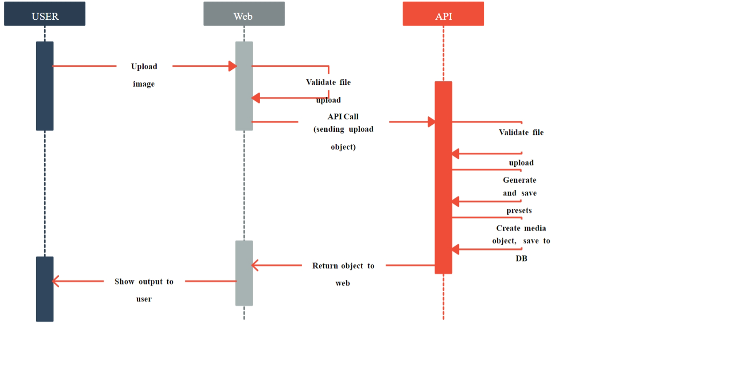

FileMapping



Validatefile(.jpg,.GIF,.bmp,.pdf,.docx,.doc,.xlsx,xls & .csv)

API Call(FileController)