PROJECT AND TEAM INFORMATION

Project Title
LightMeter: Measuring Ambient Light with Precision

Student / Team Information
Group number:  Team | G2
Team member 1 (Team Lead)  NAME: Akanksha Katiyar  STUDENT ID: 2510378334  EMAIL: akankshakatiyar04@gmail.com | 
Team member 2  NAME: Pragya Anand  STUDENT ID:2510011890  EMAIL: anandpragya66@gmail.com | 
Team member 3  NAME: Akshat Dobhal  STUDENT ID:2510370353  EMAIL: akshatdobhal017@gmail.com | 
Team member 4  NAME: Ashmit Nautiyal  STUDENT ID:2510370208  EMAIL: ashmitnautiyal06@gmail.com | 

PROPOSAL DESCRIPTION

Motivation
Light intensity plays a crucial role in our daily lives. It affects human comfort, energy consumption, plant growth, photography, and industrial processes. Many lighting systems operate manually, which may lead to unnecessary electricity consumption during daytime or insufficient lighting at night.
The aim of this project is to design and develop a Light Meter system that accurately measures ambient light intensity and displays the values. This system can also be used to automatically control lighting based on surrounding brightness.
This project demonstrates the practical application of electronic components like sensors, resistors, and microcontrollers in real-world automation systems. It also helps in understanding analog-to-digital conversion and sensor interfacing.

State of the Art / Current solution

Traditional light measurement devices use analog light meters with needle indicators. Modern systems use digital light sensors integrated with microcontrollers for precise measurement.
Advanced systems use IoT-based smart lighting control with cloud monitoring, but they are expensive and complex.
Our project proposes a simple, cost-effective electronic LightMeter using LDR (Light Dependent Resistor) or Light Sensor Module with a microcontroller to measure and display ambient light intensity.

Project Goals and Milestones
Main Goal
To design and implement a system that measures ambient light intensity and displays it accurately.

Initial Milestones
- Study working principle of LDR
- Understand voltage divider circuit
- Learn microcontroller programming
- Design basic circuit diagram

Intermediate Milestones
- Interface LDR with microcontroller (Arduino)
- Convert analog signal to digital value
- Display light intensity on LCD/Serial Monitor
- Calibrate sensor readings

Final Milestones
- Test system under different lighting conditions
- Improve accuracy and stability
- Prepare final report and demonstration

Project Approach
The system will use an LDR (Light Dependent Resistor) to detect ambient light.
When light intensity increases → LDR resistance decreases.
When light intensity decreases → LDR resistance increases.

The LDR will be connected in a voltage divider circuit. The output voltage will vary according to light intensity.
An Arduino microcontroller will read this analog voltage using its ADC (Analog to Digital Converter). The processed data will then be displayed on:
- Serial Monitor
- LCD Display

The system can also be extended to automatically turn ON/OFF a light bulb based on a threshold value.

System Architecture (High Level Diagram)
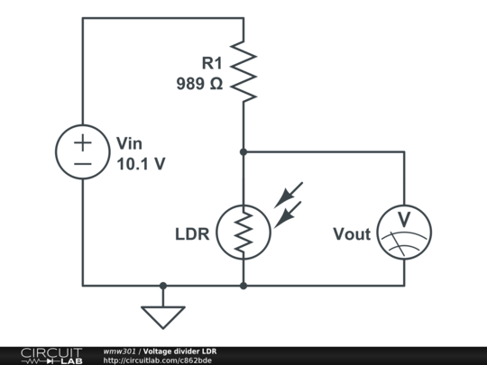
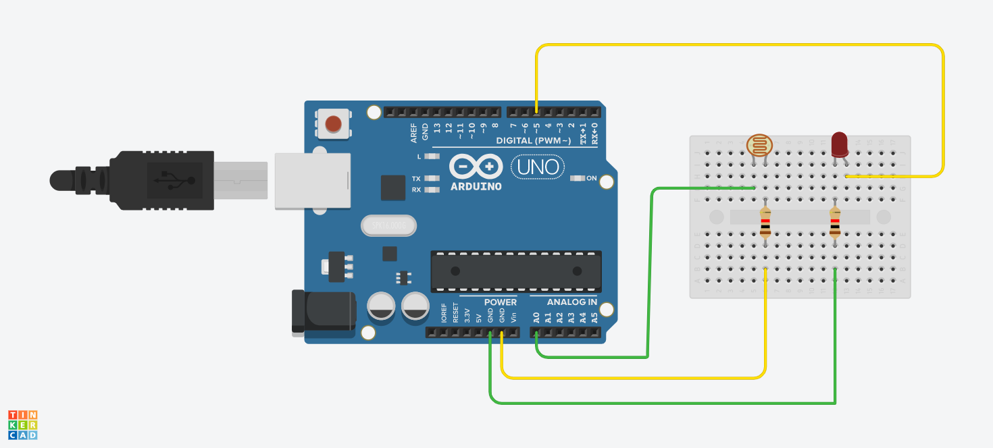

Project Outcome / Deliverables
- Working Light Meter prototype
- Circuit diagram and block diagram
- Arduino code for light measurement
- Demonstration of light intensity reading
- Final project report and presentation

Assumptions
- The LDR responds accurately to changes in light intensity.
- Power supply remains stable.
- System is tested in controlled indoor lighting conditions.
- ADC conversion provides consistent readings.

References
- Arduino Official Website – https://www.arduino.cc
- Basic Electronics Engineering Textbooks
- Research articles on light sensing systems
- Tinkercad Simulation Platform – https://www.tinkercad.com

