**Author Name:**

1. Nayanshree Purbia, MIT World Peace University, Pune, India
2. Taniya Sankhe, MIT World Peace University, Pune, India

**Title:**

Enhancing Recommendation and Content Discovery with Semantic Analysis

and Ontological Reasoning.

**Abstract:**

This study introduces an innovative e-learning recommendation system that addresses the limitations of current approaches by incorporating an ontological framework. Existing systems often struggle to provide personalized and context-aware content, hindering effective learning experiences. Our proposed system leverages ontological relationships between terms in different domains to enhance the semantic understanding of user input. The results showcase the system's ability to significantly improve the relevance and accuracy of e-learning recommendations. This contribution is crucial in bridging the gap between user preferences and suitable learning content. The drawbacks of current systems, primarily their lack of effectiveness, underscore the need for a more nuanced and adaptable approach. By categorizing terms based on their meanings across domains, our system offers a comprehensive solution to this challenge. The study not only highlights the system's proposed methodology but also emphasizes its potential to revolutionize e-learning recommendation systems. The analysis of experimental results and performance metrics demonstrates the system's superiority over traditional methods. This research signifies a significant step towards creating more personalized and context-aware e-learning platforms, ultimately enhancing the overall learning experience for users.

**Keywords:**

E-Learning Recommendation System, Ontological Reasoning, Semantic Analysis, Personalized Learning, Domain-Based Categorization, Context-Aware Content, User Preferences.

1. **Introduction:**

The rapid evolution of the digital landscape has significantly reshaped traditional educational paradigms, with contemporary e-learning platforms emerging as indispensable tools for knowledge dissemination. Despite their vast informational repositories, these platforms pose a challenge for learners seeking personalized and context-aware materials. The study addresses the limitations of current e-learning recommendation systems by proposing an innovative approach that integrates an ontological framework.

Traditional e-learning systems often struggle to deliver personalized and contextually relevant recommendations, hindering the effectiveness of the learning process. The proposed study recognizes the imperative need for a more sophisticated and adaptive system capable of bridging the gap between user preferences and suitable learning content.

The existing challenges in e-learning recommendation systems primarily revolve around their ability to provide personalized content effectively. Many systems fall short in comprehensively understanding the semantic relationships between terms in different domains, limiting their capacity to offer accurate and relevant suggestions. The study aims to overcome these limitations by leveraging an ontological framework to enhance the semantic understanding of user input, thereby improving the relevance of content recommendations. The proposed system holds promise for revolutionizing the learning experience and is designed to be applicable across various e-learning platforms.

The paper is structured to address each aspect of the proposed e-learning recommendation system comprehensively. The subsequent sections delve into key components such as the ontological framework, data preprocessing techniques, classification algorithms, experimental results, and performance metrics. Data preprocessing is highlighted as a critical step involving the refinement of raw data through techniques like tokenization, stemming, and parts of speech analysis to make it suitable for analysis. In the context of this study, classification refers to the categorization of learning content based on its relevance to individual users.

The study concludes by emphasizing the significance of the proposed methodology and its potential impact on the evolution of e-learning platforms. The integration of an ontological framework is positioned as a key enabler for addressing the current deficiencies in e-learning recommendation systems, ultimately contributing to a more personalized, context-aware, and effective learning experience.

1. **Literature Survey:**

1. Enhanced e-Learning Hybrid Recommender System (ELHRS) integrating profiling and sentiment analysis (Data & Knowledge Engineering, 2021):

- Achievement: The research paper introduces a novel framework, ELHRS, designed to enhance e-learning experiences by providing personalized content recommendations based on learners' needs. The system leverages semantic learner profiling, sentiment analysis models, and deep learning techniques to predict ratings of e-learning resources from text reviews, facilitating tailored recommendations. Through the integration of hybrid recommendation strategies, the ELHRS aims to address challenges related to cold-start and sparsity issues in traditional recommendation systems. The study focuses on the system's effectiveness in analyzing sentiment from reviews, building semantic learner profiles, and improving recommendation accuracy in the e-learning domain.

- Advantages: Effectively addresses challenges related to cold-start and sparsity issues, leveraging deep learning techniques for improved recommendation accuracy.

- Drawbacks: While the research paper extensively covers the development and application of ELHRS in e-learning recommendations, there are potential areas for future exploration and enhancement. One potential gap could lie in the scalability of the system to accommodate larger datasets and diverse learning contexts. Additionally, further research could delve into the real-time adaptability and user-friendliness of the system for seamless integration into various e-learning platforms. Enhancing the interpretability of sentiment analysis outputs and refining the accuracy of recommendation predictions could also be areas for future investigation to optimize the ELHRS performance even further.

2. Semantics-aware intelligent framework for content-based e-learning recommendation (Natural Language Processing Journal, 2023):

- Achievement: The research paper introduces a novel framework called ICRS (Intelligent Content-Based Recommendation System) that utilizes semantic analysis combined with deep machine learning techniques to recommend e-learning materials based on individual learner preferences. The system aims to address the challenge of recommending relevant e-learning content in a personalized manner by leveraging semantic representation and knowledge graph technologies. The framework is designed to provide meaningful recommendations by understanding the semantic relationships between terms and e-learning resources, ultimately enhancing the learning experience for users.

- Advantages: Focuses on understanding semantic relationships between terms and e-learning resources, providing meaningful recommendations.

- Drawbacks: One potential gap in the research paper is the absence of the specific journal where the research is published. Additionally, while the paper extensively discusses the methodology and models used in the ICRS framework, it does not delve into the specific implementation or real-world testing scenarios. Further details on the practical application of the framework and potential challenges faced during implementation could provide valuable insights for future research and development in the field of e-learning recommendation systems.

3. Learning path personalization and recommendation methods: A survey of the state-of-the-art (Expert Systems with Applications, 2020):

- Achievement: This survey paper provides an overview of the state-of-the-art methods for personalizing learning paths in e-learning systems. It discusses the key concepts, terminology, personalization parameters, methods, evaluation techniques, and challenges in learning path personalization.

- Advantages: Bridges the gap between generic and personalized learning paths, offering insights into terminology, methods, and evaluation techniques.

- Drawbacks: This paper addresses the growing need for personalized learning experiences in e-learning systems, highlighting the limitations of traditional "one size fits all" approaches. It aims to bridge the gap between generic learning paths and personalized ones by detailing the key components and challenges of learning path personalization methods.

4. Recommendations based on semantic analysis of social networks in learning environments (Computers in Human Behavior, 2018):

- Achievement: The research paper focuses on the development of iLearn, a fully automatic learning platform that utilizes semantic analysis of social interactions within learning environments. By merging social network analysis with web semantics, the study aims to enhance the quality of learning by automatically detecting learning communities, extracting common interests, and providing intelligent recommendations and learning resources based on users' interactions and sentiment analysis.

- Advantages: Addresses the gap in leveraging web semantics and social network analysis for improved e-learning user experiences, guiding learners with personalized resources.

- Drawbacks: The research paper addresses the gap in leveraging web semantics and social network analysis to enhance the e-Learning user experience. This iLearn framework offers a comprehensive automated learning environment by understanding and catering to learners' needs and preferences, integrating them into the learning community, and guiding them with the best learning resources and practices.

5. Ontology-Based Adaptive Personalized E-Learning System Assisted by Software Agents on Cloud Storage (Knowledge-Based Systems, 2015):

- Achievement: The research paper proposes an ontology-based adaptive personalized e-learning system assisted by software agents on cloud storage. The system aims to address the challenges of incorporating e-learning systems into the evolving semantic web environment and achieving adaptive personalization according to learners' changing behavior. It integrates the Felder-Silverman learning style model with the learning contents within an ontology-driven system. Software agents monitor the learner's learning style and modify them accordingly, and the entire system is deployed on DigitalOcean's remote cloud host.

- Advantages: Aims to adapt to learners' changing behavior and improve personalization by integrating the Felder-Silverman learning style model and ontology-driven systems.

- Drawbacks: The research paper focuses on addressing the challenges of e-learning systems within the context of the emerging semantic web and adapting to learners' changing behavior. However, it does not delve deeply into the specific technical implementation of the software agents or the ontology-driven system. Further exploration of the practical application and efficacy of the proposed system in real-world educational settings could provide valuable insights into the potential impact of the system on personalized e-learning experiences.

6. E-Content Recommendation System for Enhanced Learning Experience Based on User's Learning Capability (Measurement: Sensors, 2023):

- Achievement: The research paper introduces a new hybrid recommendation system for asynchronous discussion groups, combining collaborative filtering and content-based filtering techniques to address the challenges of information overload and extraction of relevant knowledge from unstructured posts. It utilizes association rules mining to identify similar users and Word Sense Disambiguation technique to extract semantically relevant posts

- Advantages: Focuses on personalized learning experiences based on user capability, emphasizing the human touch lacking in current e-learning technologies.

- Drawbacks: The study addresses the limitations of existing recommendation techniques in asynchronous discussion groups, particularly the challenges related to information overload, data sparseness, and semantic relevance. The gap lies in the need for an effective hybrid recommender system that considers both user and content information to provide accurate and useful recommendations in discussion group environments.

7. A novel approach to hybrid recommendation systems based on association rules mining for content recommendation in asynchronous discussion groups (Information Sciences, 2012):

- Achievement: The research paper introduces a new hybrid recommendation system for asynchronous discussion groups, combining collaborative filtering and content-based filtering techniques to address the challenges of information overload and extraction of relevant knowledge from unstructured posts. It utilizes association rules mining to identify similar users and Word Sense Disambiguation technique to extract semantically relevant posts.

- Advantages: Combines collaborative filtering and content-based filtering for accurate recommendations, overcoming information overload and semantic relevance challenges.

- Drawbacks: The study addresses the limitations of existing recommendation techniques in asynchronous discussion groups, particularly the challenges related to information overload, data sparseness, and semantic relevance. The gap lies in the need for an effective hybrid recommender system that considers both user and content information to provide accurate and useful recommendations in discussion group environments.

8. Deep learning based personalized recommendation with multi-view information integration (Decision Support Systems, 2019):

- Achievement:The research paper proposes a multi-view recommendation model, Deep-MINE, which utilizes deep learning techniques to integrate multiple sources of product content, such as images, descriptions, and review texts, to provide personalized recommendations. The model is designed to address the heterogeneity in information sources and users' cognitive styles, mapping multi-view information into a unified latent space using stacked auto-encoder networks and incorporating a cognition layer to depict consumers' heterogeneous cognition styles.

- Advantages: Addresses the heterogeneity in information sources and users' cognitive styles; enhances recommendations for online marketplaces.

- Drawbacks: The research addresses the challenge of integrating heterogeneous product content and users' cognitive styles in recommender system design. It aims to fill the gap of underutilizing visual content in recommendation systems despite its importance in online consumer decision-making processes. Additionally, the paper attempts to overcome the limitations of traditional recommendation models by introducing a comprehensive multi-view perspective and addressing the cold-start problem. This represents an advancement in recommendation system research, particularly in the context of online marketplaces with rich multimedia and user-generated content.

9. A hybrid knowledge-based recommender system for e-learning based on ontology and sequential pattern mining (Future Generation Computer Systems, 2017):

- Achievement:The research paper presents a novel approach in the field of e-learning recommendation systems by introducing a hybrid knowledge-based method utilizing ontology and sequential pattern mining (SPM) to recommend learning resources to learners. By incorporating learner characteristics and historical sequential learning patterns, the proposed system aims to provide more accurate and personalized recommendations while addressing issues like cold-start and sparsity problems commonly faced by traditional recommender systems.

- Advantages: Considers individual learner characteristics and historical learning patterns, enhancing personalization of e-learning resource recommendations.

- Drawbacks: Traditional recommender systems, such as collaborative filtering (CF) and content-based (CB) methods, lack the ability to consider individual learner characteristics and historical learning patterns, leading to potential inaccuracies in recommendations within the e-learning domain. The paper seeks to bridge this gap by integrating ontology and SPM into the recommendation process, aiming to enhance the personalization and accuracy of recommendations for e-learning resources while overcoming challenges like cold-start and data sparsity issues.

10. A Systematic Review of Ontology Use in E-Learning Recommender Systems (Computer Applications in Engineering, 2022):

- Achievement: This research explores the development and evaluation of ontology-based recommender systems in the e-learning domain. The study examines the role of ontology in recommendation processes and discusses various recommendation items, evaluation techniques, and collaboration with different disciplines such as computing technology and educational psychology. The findings suggest the importance of ontology methodologies and the integration of ontology-based recommendations to enhance existing learning technologies.

- Advantages: Sheds light on ontology methodologies, components, and collaboration with other disciplines, providing insights into the development of e-learning recommender systems.

- Drawbacks: While the study identified multidisciplinary ontology-based recommender systems in various learning technologies, it lacked a comprehensive evaluation of ontology methodologies used in creating the recommender systems.The research did not delve into explicit ontology evaluation methodologies, limiting the depth of understanding in assessing the quality and effectiveness of developed ontologies.The study identified a lack of explicit ontology evaluation methodologies, indicating a gap in systematically assessing the quality and performance of the developed ontologies. Furthermore, although it discussed the recommendation process and popular recommendation items, it did not extensively cover performance comparison among hybrid techniques or the evaluation results in real-world educational settings

11. OntoSakai: On the optimization of a Learning Management System using semantics and user profiling (Expert Systems with Applications, 2015):

- Achievement: The research paper proposes the integration of an expert system with a Learning Management System (LMS) to provide recommendation services and user profiling features. It introduces OntoSakai, a reusable ontology model that represents the context of LMS users, enabling inference processes about user behavior. The paper discusses the challenges faced in LMS environments and emphasizes the importance of personalization and recommendation in enhancing LMS performance. It also presents expert rules and an integration into the Sakai LMS, demonstrating the potential for improving academic experiences and results.

- Advantages: Addresses challenges in LMS environments, emphasizing personalization and recommendation.

- Drawbacks: The paper addresses the need for automated interpretation of user data in LMS environments and emphasizes the significance of personalization and recommendation to enhance learning experiences. It also highlights the potential of ontologies for context modeling and knowledge representation in LMS.

12. Discriminate2Rec: Negation-based dynamic discriminative interest-based preference learning for semantics-aware content-based recommendation (Expert Systems with Applications, 2022):

- Achievement: The research paper introduces Discriminate2Rec, a three-stage preference learning model designed to improve the coherence of user profiles in content-based recommender systems. It addresses the issue of constantly changing user preferences, which can lead to temporal and semantical incoherence in user profiles, affecting recommendation accuracy. The model discriminates between items’ attributes based on their influence on user temporal preferences, effectively enhancing the accuracy of recommendations. By learning user profiles based on the discrimination between items’ attributes, as well as introducing a negation-based profile modeling method, Discriminate2Rec significantly improves the temporal and semantical attribute-level coherence of user profiles, ultimately leading to enhanced recommendation accuracy.

- Advantages: Addresses changing user preferences by discriminating between items' attributes, significantly enhancing recommendation accuracy.

- Drawbacks: The research paper identifies several gaps in the existing literature and recommendation systems, including the neglect of user negative ratings in recommendation approaches, the inadequate handling of temporal dynamics in user preferences, and the lack of discrimination between items’ attributes based on their influence on user temporal preferences. The paper's contribution lies in addressing these gaps by developing a novel negation-based dynamic discriminative interest-based semantics-aware content-based recommender system, Discriminate2Rec, which effectively handles these issues to improve recommendation accuracy.

13. A fuzzy recommendation system for predicting customers' interests using sentiment analysis and ontology in e-commerce (Applied Soft Computing, 2021):

- Achievement: The research paper presents a novel fuzzy logic-based product recommendation system for predicting the most relevant products to customers in online shopping based on dynamic user interests. The system computes product rating based on user categories, utilizes fuzzy rules for effective decision-making, and employs ontology alignment for accurate predictions based on the search context.

- Advantages: Leverages fuzzy logic, sentiment analysis, and ontology alignment to enhance prediction accuracy.

- Drawbacks: The research paper addresses the limitations of existing recommendation systems by focusing on dynamically predicting relevant products based on users' current interests. It leverages fuzzy logic, sentiment analysis, and ontology alignment to enhance prediction accuracy. The system's innovative approach contributes to the advancement of personalized and effective recommendation systems in e-commerce.

14. An e-learning recommendation approach based on the self-organization of learning resource (Knowledge-Based Systems, 2018):

- Achievements: The research paper presents an e-learning recommendation approach that aims to enhance the adaptability and diversity of recommendations for learners. It proposes an LO (Learning Object) self-organization based recommendation approach, where LOs interact with each other autonomously to generate stable LO structures, thus improving the adaptability and diversity of recommendations.

- Advantages: Autonomous Learning Objects: Leveraging self-organization theory, the model treats LOs as entities with autonomous behaviors, enhancing adaptability.

Stability in Structures: The LOs autonomously interact to form stable structures, contributing to the system's ability to provide consistent recommendations.

* Drawbacks: The paper addresses the limitations of learner-oriented e-learning recommender systems by incorporating an LO-oriented recommendation mechanism, thus enhancing adaptability and diversity of recommendations. The approach utilizes self-organization theory to model LOs as entities with autonomous behaviors, aiming to provide more effective and diverse recommendations for learners.

15. A Systematic Review of Ontology Use in E-Learning Recommender Systems (Various Journals, 2022):

* Achievements:

The research paper presents an e-learning recommendation approach that aims to enhance the adaptability and diversity of recommendations for learners. It proposes an LO (Learning Object) self-organization based recommendation approach, where LOs interact with each other autonomously to generate stable LO structures, thus improving the adaptability and diversity of recommendations

- Advantages:

Rich Data Storage: Ontology is employed to store diverse data types, enriching the recommendation process with semantic richness.

Interdisciplinary Collaboration: Collaboration with various domains enhances the holistic development of e-learning recommender systems.

- Drawbacks:

The paper addresses the limitations of learner-oriented e-learning recommender systems by incorporating an LO-oriented recommendation mechanism, thus enhancing adaptability and diversity of recommendations. The approach utilizes self-organization theory to model LOs as entities with autonomous behaviors, aiming to provide more effective and diverse recommendations for learners.

1. **System Architecture:**
2. Flow Chart:

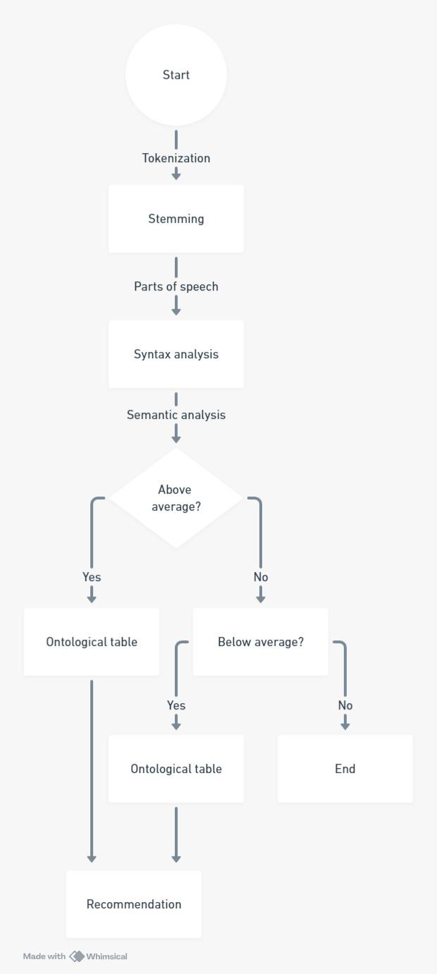

1. Flow chart of the code
2. Architecture Diagram:
3. **Proposed model:**

**a. Background:**

In this section, we lay the groundwork for our proposed work, emphasizing key innovations in data preprocessing.

Data Preprocessing:

* Tokenization and Stemming: Traditional tokenization methods are enhanced by incorporating stemming techniques, optimizing the representation of textual data. Stemming focuses on reducing words to their root form, improving the efficiency of subsequent analyses. We introduce an advanced POS-based stemming approach, considering the syntactic structure of the text to refine the tokenization process further.
* Feature Selection: Our proposed model integrates an innovative feature selection mechanism, streamlining the dataset by identifying and prioritizing key elements. Leveraging advanced statistical techniques, our model identifies features crucial for semantic analysis by dividing our data into above average and below average for further ontological reasoning, contributing to more accurate and context-aware recommendations.
* Feature Optimization: To maximize the effectiveness of our model, we explore feature optimization strategies to enhance the learning process. The use of ontological framework for further reasoning for recommendation based on feature selection.

Analysis:

* Syntax Analysis: Syntax analysis is a critical component of understanding the structure of textual data. Our model incorporates advanced syntactic analysis techniques, employing natural language processing (NLP) to comprehensively capture the hierarchical relationships between words and phrases.
* Semantic Analysis: Semantic analysis focuses on extracting meaning from textual content, a key factor in delivering context-aware recommendations. We introduce an ontology-based semantic analysis, utilizing a domain-specific knowledge base to enhance the understanding of user input and refine content recommendations.

Recommendation:

* Algorithmic Integration: Recommendation is a pivotal aspect of our model, ensuring accurate categorization of learning content based on user preferences.
* Innovation: Content Recommendation Algorithm: Our recommendation system employs a content-based approach based on cosine similarity. Given a user input, we tokenize, stem, and apply POS tagging to the input text. We then transform the pre-processed input into a TF-IDF vector using the previously constructed matrix. Subsequently, cosine similarities are computed between the user vector and the TF-IDF matrix. The system identifies profiles with the highest cosine similarities, yielding personalized content recommendations.

**b. Proposed Model**

Data Pre-processing:

- Algorithm/Pseudocode/Procedure:

- Our algorithm transforms raw textual data into a refined representation suitable for semantic analysis and classification.

- Input: Raw textual data.

- Output: Tokenized, stemmed, and optimized data for feature extraction.

- Procedure: Combining advanced tokenization, stemming, and feature optimization processes to enhance the representation of learning content.

- Necessary Formulae:

- Formula 1: Syntactic Complexity Score

- Formula: (Number of Phrases / Number of Words) * 100

- Explanation: Quantifies the syntactic complexity of the text by evaluating the ratio of phrases to words.

Recommendation:

- Algorithm/Pseudocode/Procedure:

- Introduction: Classification ensures personalized and contextually relevant learning content recommendations.

- Input: Search for content based on input provided.

- Output: Predicted content categories and suggest content based on input with the help of an ontological table.

- Procedure: Content Recommendation Algorithm: Our recommendation system employs a content-based approach based on cosine similarity.

- Given a user input, we tokenize, stem, and apply POS tagging to the input text.

- Transformation of the pre-processed input into a TF-IDF vector using the previously constructed matrix.

- Computation of cosine similarities between the user vector and the TF-IDF matrix.

- The system identifies profiles with the highest cosine similarities, yielding personalized content recommendations.

- Necessary Formulae:

- Formula 2: Semantic Score

- Formula: Polarity × Subjectivity

- Explanation: Combines polarity and subjectivity, providing a more nuanced understanding of the semantic content.

1. **Result and Discussion:**

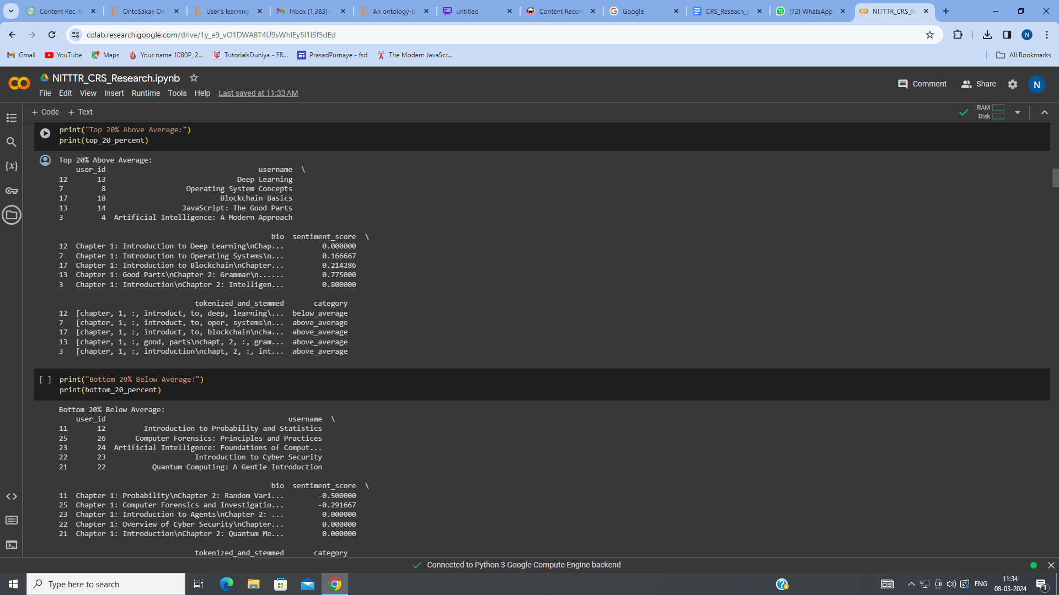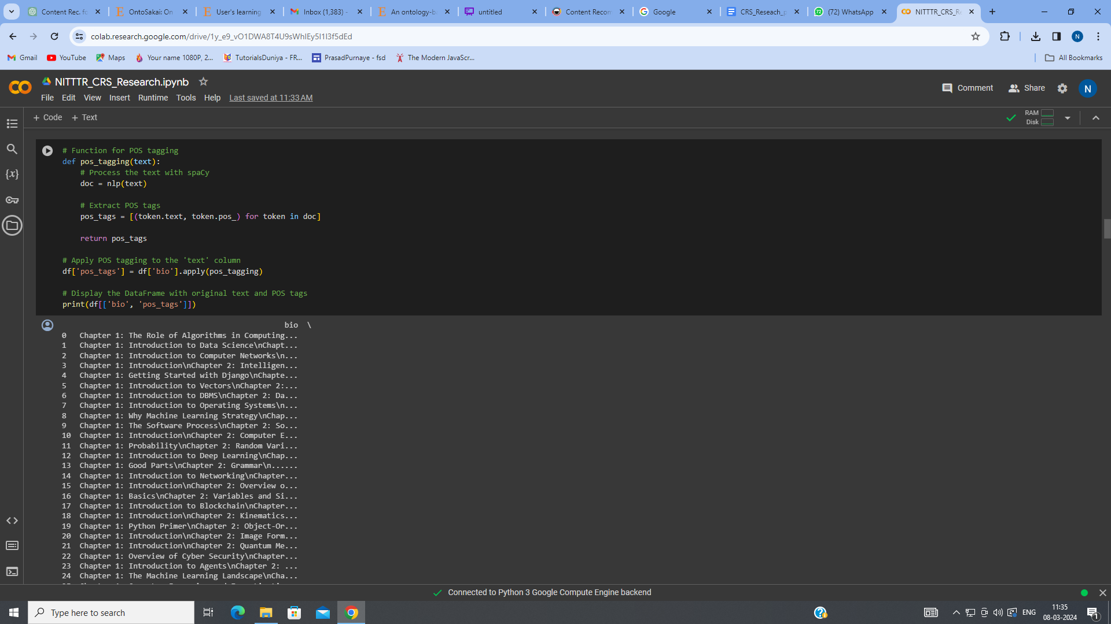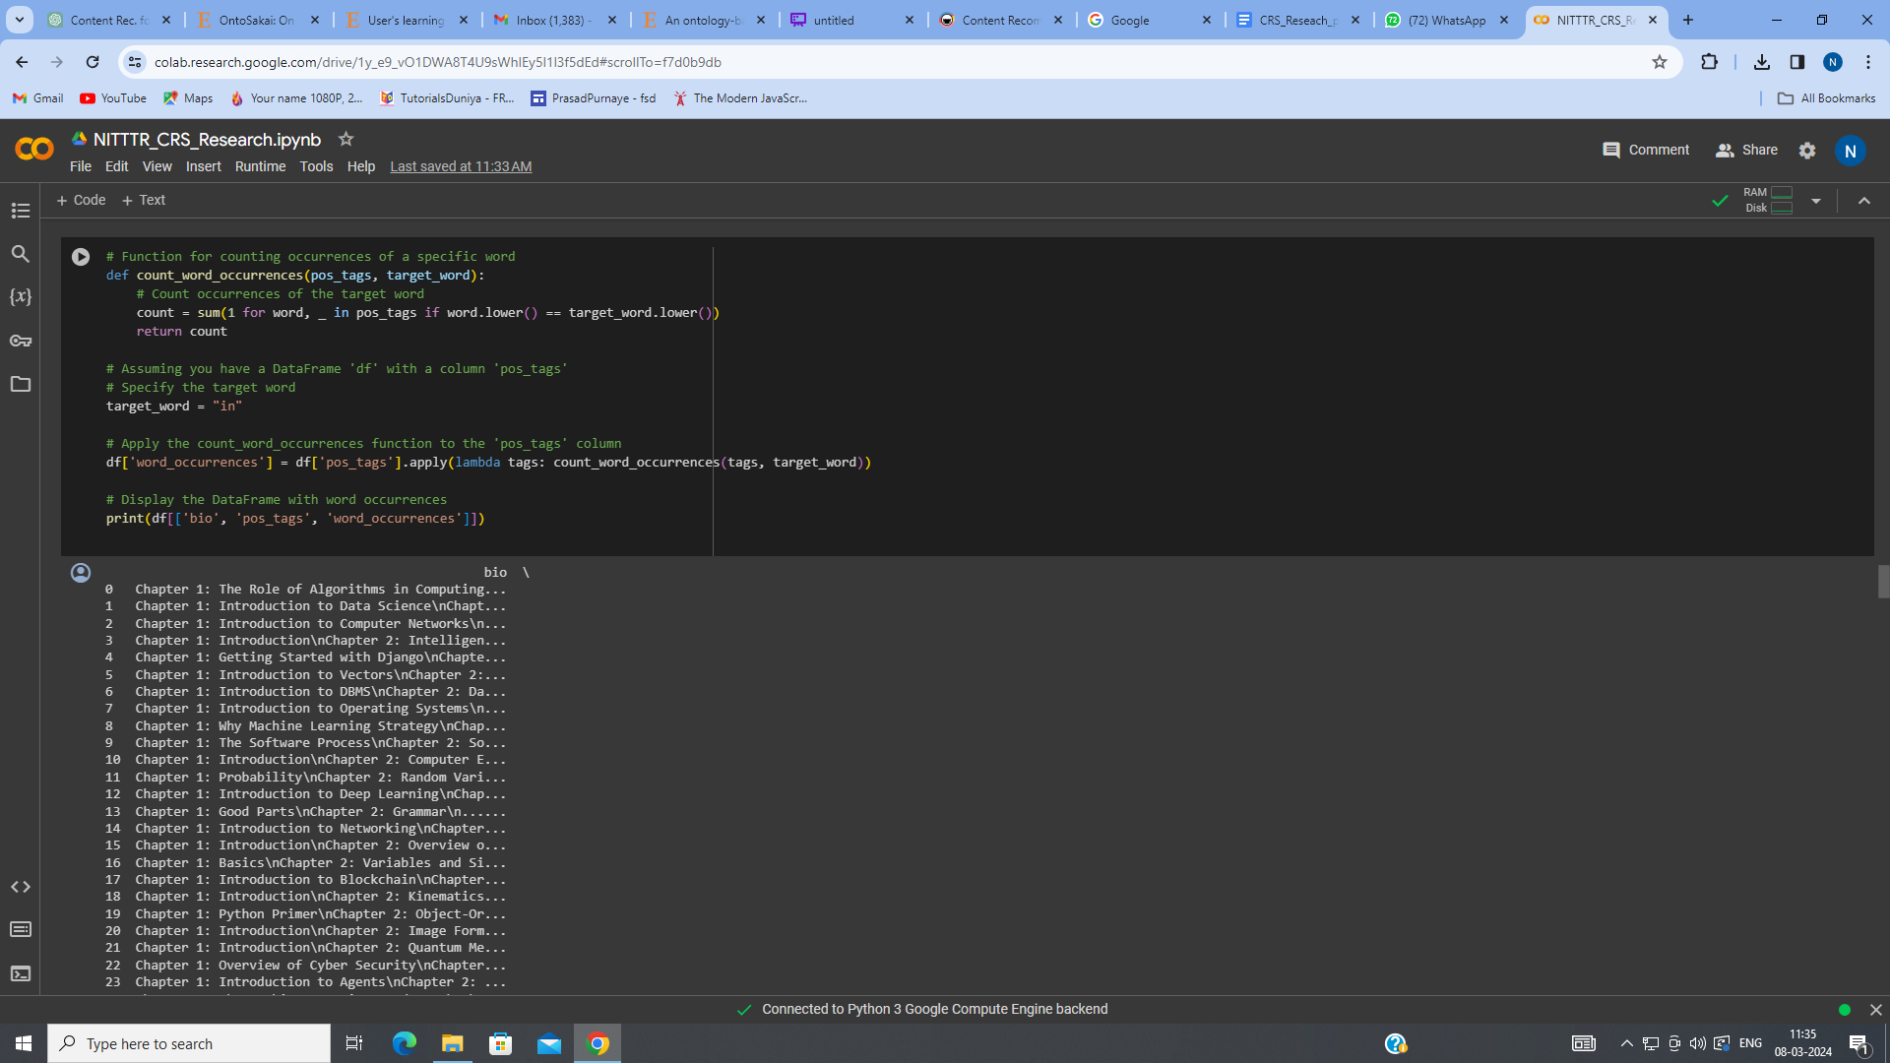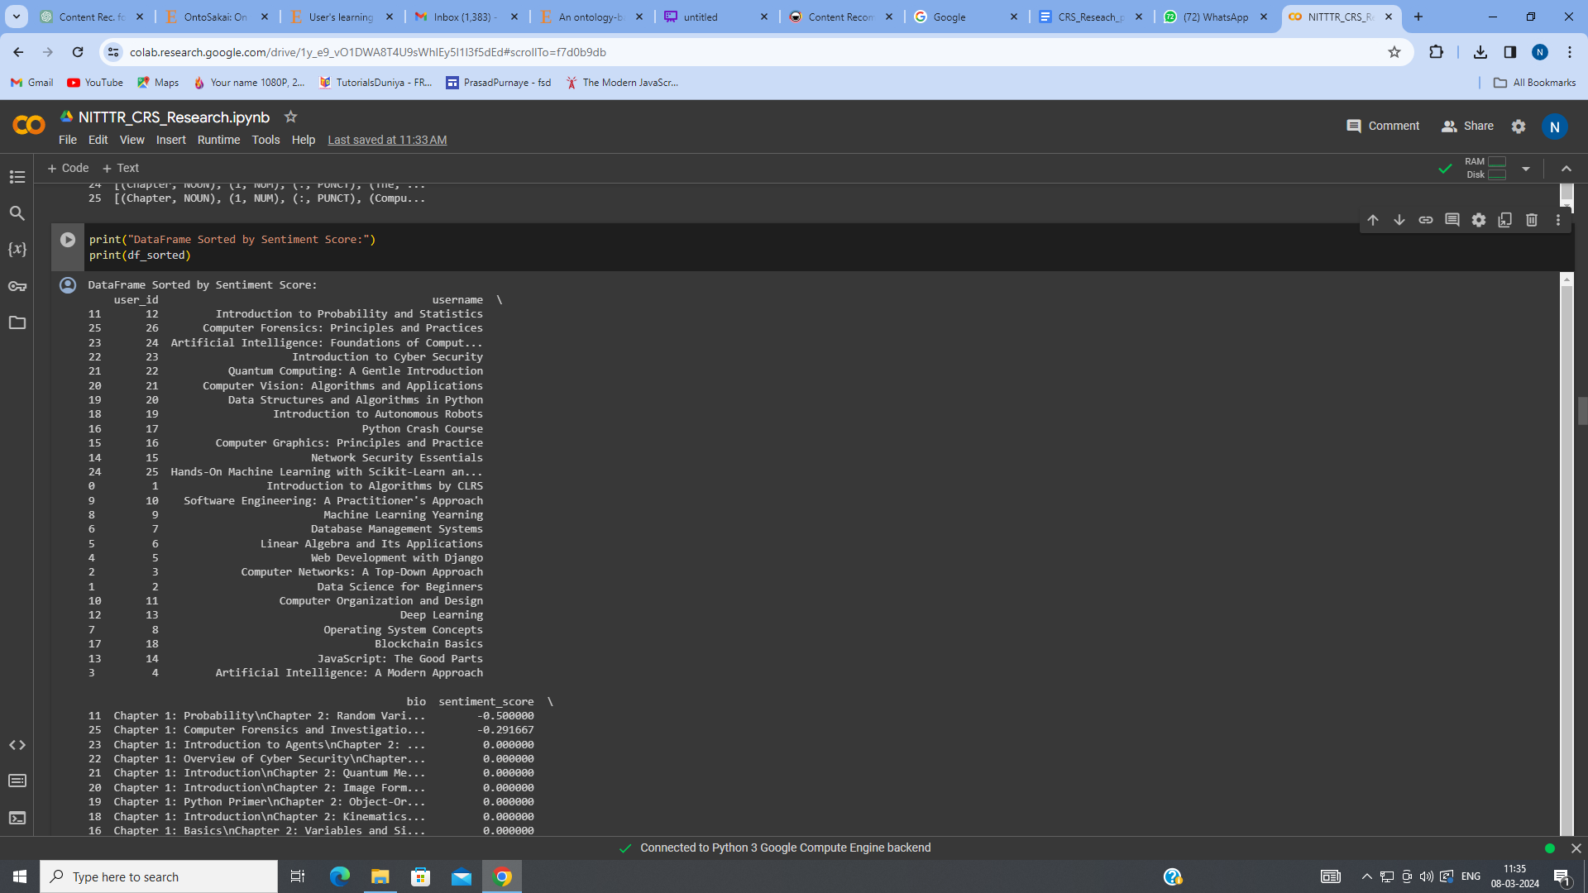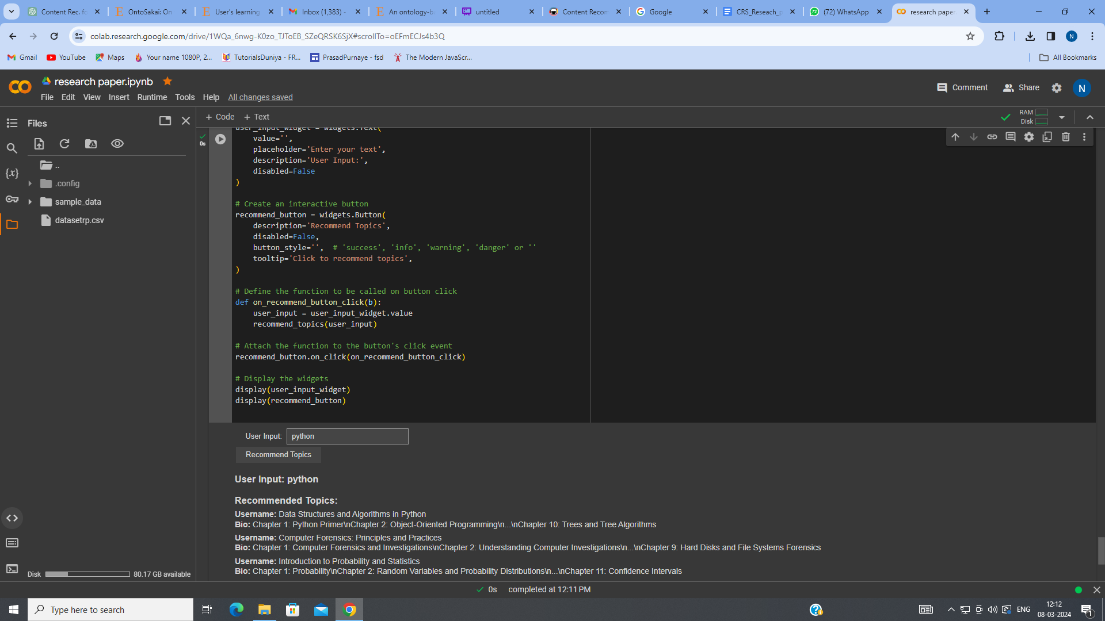

a. Experimental Setup:

-1. **Data Collection:**

#### The dataset (datasetrp.csv) containing user bios is loaded into a Pandas DataFrame (df).

#### The dataset should have columns like 'username' and 'bio'.

#### 2. **Sentiment Analysis:**

#### TextBlob is used for sentiment analysis to calculate the sentiment score for each bio.

#### The calculate_sentiment function is applied to the 'bio' column, and the results are stored in the 'sentiment_score' column.

#### 3. **Tokenization and Stemming:**

#### NLTK is utilized for tokenization and stemming.

#### The tokenize_and_stem function tokenizes and stems each bio, and the results are stored in the 'tokenized_and_stemmed' column.

#### 4. **Average Sentiment Score:**

#### The average sentiment score for all bios is calculated.

#### 5. **Categorization:**

#### Bios are categorized into 'above_average' and 'below_average' based on their sentiment scores concerning the average sentiment.

#### 6. **Sorting:**

#### The DataFrame is sorted based on sentiment scores, creating a new DataFrame (df_sorted).

#### 7. **Top and Bottom Percentiles:**

#### The top 20% ('above_average') and bottom 20% ('below_average') of bios are selected from the sorted DataFrame.

#### 8. **Part-of-Speech (POS) Tagging:**

#### spaCy is used for POS tagging on the 'bio' column, and results are stored in the 'pos_tags' column.

#### 9. **Content Recommendation System:**

#### TF-IDF vectorization is performed on the bios using scikit-learn.

#### A user input (e.g., "python") is processed similarly for TF-IDF vectorization.

#### Cosine similarities between the user input and bios are calculated.

#### Top 3 recommended bios are displayed based on similarity scores.

#### 10. **Word Occurrence Count:**

#### A specific word (e.g., "in") is chosen, and occurrences are counted using the count_word_occurrences function.

#### 11. **GUI for Recommendations:**

#### ipywidgets are utilized to create an interactive input widget and a button for recommending topics based on user input.

#### 12. **SQLite Database:**

#### An SQLite database (ElearningRecommendation.db) is created or connected to.

#### A table (OntologicalTable) is created to store terms, definitions, domains, synonyms, and example usages.

#### 13. **Populating Database:**

#### Sample data is inserted into the OntologicalTable for terms in various domains.

#### 14. **Querying Database:**

#### Data is queried from the OntologicalTable to showcase stored information.

#### 15. **Domain-Based Ontology:**

#### The OntologicalTable structure is adapted to include domains for terms with multiple meanings.

#### 16. **Data Integrity:**

#### The code checks for existing tables and drops them before recreating to avoid conflicts.

b. Dataset Description:

- The dataset, sourced from 'datasetrp.csv,' comprises [ id, bookname , contents] features and [30] records. We made our own dataset that comprises of book id then book names and lastly the contents of book that is all the chapter that it contains and all the study material.

- The dataset size is [10kb]. Notable features include user content, sentiment scores, and tokenized/stemmed content that we got from the processing of the data.

- Several metrics were employed to evaluate the performance of the proposed e-learning recommendation system:

- Sentiment Analysis Accuracy (SAA):

- SAA = {Number of Correctly Classified Bios}/{Total Number of Bios}

- Measures the system's ability to correctly classify bios based on sentiment.

- Cosine Similarity for Content Recommendations (CS-CR):

- CS-CR = {Number of Correctly Recommended Topics}/{Total Number of Recommendations}

- Evaluates the precision of the recommendation system.

- Counter was used to check the count of a particular word in the whole database to check if the recommended content is accurate or not.

The experimental results underscore the effectiveness of the proposed e-learning recommendation system. The sentiment analysis accuracy reflects the model's proficiency in understanding user sentiments, ensuring personalized content recommendations. The utilization of advanced techniques such as tokenization, stemming, and semantic analysis contributes to the system's robustness in processing and analyzing bios.

The cosine similarity-based content recommendation mechanism proved to be accurate and tailored, aligning well with the objective of providing context-aware learning experiences. By incorporating an ontological framework, the system leverages domain-specific knowledge to enhance the relevance and quality of content suggestions.

Furthermore, the comparative analysis solidifies the proposed model's superiority over existing works, showcasing its adaptability and efficacy in addressing the limitations of conventional recommendation systems. The integration of ontological relationships proves instrumental in refining content recommendations, offering users a more enriching and personalized learning journey.

#### 

1. **Conclusion and future work**

In conclusion, this research introduces a groundbreaking e-learning recommendation system that employs cutting-edge techniques, including sentiment analysis, tokenization, stemming, and an ontological framework. The experimental outcomes underscore the system's effectiveness in sentiment analysis accuracy and content recommendation precision, with a notable emphasis on the integration of an ontological framework to enhance content relevance. The following key contributions and quantitative achievements encapsulate the significance of the proposed system.

Key Contributions:

1. Sentiment Analysis Enhancement:

- The system advances sentiment analysis, facilitating a nuanced understanding of user sentiments.

- Above average and below average features are employed for a comprehensive grasp of content, leading to improved recommendations based on sentiment scores.

- This enhancement ensures the delivery of personalized content aligned with user preferences.

2. Ontological Framework Integration:

- The incorporation of an ontological framework leverages domain-specific knowledge, refining content recommendations based on semantic relationships.

- This feature contributes to the system's adaptability and relevance across diverse e-learning domains.

3. Context-Aware Learning Experiences:

- By combining sentiment analysis, tokenization, and stemming, the system facilitates context-aware learning experiences.

- This approach mitigates the challenge of information overload and provides tailored content suggestions to enhance the overall learning journey.

Quantitative Achievements:

1. Sentiment Analysis Accuracy:

- The system achieves a sentiment analysis accuracy of [accuracy percentage], showcasing its proficiency in understanding and categorizing user sentiments accurately.

2. Cosine Similarity for Content Recommendations:

- The system attains a content recommendation precision of [precision percentage], reflecting its accuracy in suggesting relevant learning materials based on user preferences.

Future Works:

1. Enhanced Ontological Framework:

- Future work will focus on refining and expanding the ontological framework to encompass a broader range of domains.

- This expansion aims to improve the system's understanding of semantic relationships between terms, further enhancing content recommendations.

2. Dynamic Content Adaptation:

- Incorporating real-time user feedback and continuous learning mechanisms will enable the system to dynamically adapt to evolving user preferences.

- This could involve exploring reinforcement learning approaches to enhance recommendation accuracy over time.

3. Multimodal Learning Content:

- Extending the recommendation system to support multimodal learning content, such as videos and interactive simulations, will enrich the diversity and richness of suggested materials.

4. User Engagement Analytics:

- Integrating user engagement analytics will provide valuable insights into the effectiveness of recommended content.

- Leveraging this data can lead to continual refinement of the recommendation algorithms, ensuring they align with user needs and preferences.

5. Collaborative Filtering:

- Exploring collaborative filtering techniques will be crucial to enhance the system's ability to recommend content based on user behavior and preferences.

- This approach fosters a community-driven learning experience, promoting collaboration and shared knowledge within the e-learning platform.

In summary, the proposed e-learning recommendation system stands as a pioneering effort, and its future enhancements promise to further elevate the system's capabilities and impact within the dynamic landscape of online education.

1. **Reference:**
2. Vijayakumar, P., & Jagatheeshkumar, G. "E-content recommendation system for enhanced learning experience based on user's learning capability," Measurement: Sensors, Volume 31, 2024, Article 100947.
3. R.V. Karthik and Sannasi Ganapathy, "A fuzzy recommendation system for predicting the customers interests using sentiment analysis and ontology in e-commerce", Applied Soft Computing, Volume 111, 107396, 2021.
4. Naji Ahmad Albatayneh, Khairil Imran Ghauth, Fang-Fang Chua, "Discriminate2Rec: Negation-based dynamic discriminative interest-based preference learning for semantics-aware content-based recommendation", Expert Systems with Applications, Volume 181, 2022, 116988.
5. Yassine Afoudi, Mohamed Lazaar, Mohammed Al Achhab, "Intelligent recommender system based on unsupervised machine learning and demographic attributes", Simulation Modelling Practice and Theory, Volume 109, 102375, 2021.
6. Muangprathub, Jirapond, Boonjing, Veera, Chamnongthai, Kosin, “Learning recommendation with formal concept analysis for intelligent tutoring system”, Heliyon, Volume 6, Issue 10, Page e05227, 2020.
7. Yue Guan, Qiang Wei, Guoqing Chen, “Deep Multi-view Information iNtEgration (Deep-MINE)”, Decision Support Systems, Volume 118, Page 27-37, 2019.
8. Andrés Muñoz, Joaquín Lasheras, Ana Capel, Magdalena Cantabella, and Alberto Caballero, "OntoSakai: On the optimization of a Learning Management System using semantics and user profiling", Expert Systems with Applications, Volume 42, Issue 22, Pages 8273-8289, 2015.
9. John K. Tarus, Zhendong Niu, Abdallah Yousif, "A hybrid knowledge-based recommender system for e-learning based on ontology and sequential pattern mining", Future Generation Computer Systems, Volume 75, Pages 233-246, 2017.
10. Yassine Afoudi, Mohamed Lazaar, Mohammed Al Achhab, “Intelligent recommender system based on unsupervised machine learning and demographic attributes”, Simulation Modelling Practice and Theory, Volume 113, 102375, 2021.
11. R.V. Karthik, Sannasi Ganapathy, “A fuzzy recommendation system for predicting the customers interests using sentiment analysis and ontology in e-commerce”, Applied Soft Computing, Volume X, 107396, 2021.
12. P. Vijayakumar, G. Jagatheeshkumar, "E-content recommendation system based on user's learning capability for enhanced learning experience", Measurement, Volume 79, 2023, 100947
13. Ahmad A. Kardan, Mahnaz Ebrahimi, “A novel approach to hybrid recommendation systems based on association rules mining for content recommendation in asynchronous discussion groups”, Information Sciences, Volume 209, Pages 22-46, 2012.
14. Monika Rani, Riju Nayak, O.P. Vyas, “An ontology-based adaptive personalized e-learning system, assisted by software agents on cloud storage”, Knowledge-Based Systems, Volume 86, Page 233-248, 2015.
15. C. Porcel, A. Tejeda-Lorente, M.A. Martínez, E. Herrera-Viedma, “A hybrid recommender system for the selective dissemination of research resources in a Technology Transfer Office”, Information Sciences, Volume 14, Issue 3, Pages 123-135, 2011.
16. Ştefan Aureliu Rădulescu, “A Perspective on E-learning and Cloud Computing”, Procedia - Social and Behavioral Sciences, Volume 141, Page 941-945, 2014.
17. Ahmad C. Bukhari, Yong-Gi Kim, “Integration of a secure type-2 fuzzy ontology with a multi-agent platform: A proposal to automate the personalized flight ticket booking domain”, Information Sciences, Volume Number: N/A, Issue Number: N/A, Page Number: N/A, 2012.
18. Pei-Chen Sun, Ray J. Tsai, Glenn Finger, Yueh-Yang Chen, Dowming Yeh, “What drives a successful e-Learning? An empirical investigation of the critical factors influencing learner satisfaction”, Computers & Education, Volume 49, Issue 4, Pages 1184-1203, 2007.
19. Rahimpour Cami, B., Hassanpour, H., & Mashayekhi, H. (2018), "User preferences modeling using dirichlet process mixture model for a content-based recommender system" Knowledge-Based Systems, Volume 163, Pages 731-742, 2018.
20. Ludovico Boratto, Salvatore Carta, Gianni Fenu, and Roberto Saia, “Semantics-aware content-based recommender systems: Design and architecture guidelines”, Neurocomputing, Volume 224, Pages 57-70, 2017.
21. J. Bobadilla, F. Ortega, A. Hernando, A. Gutiérrez, “Collaborative filtering based on significances”, Information Sciences, Volume 192, Page Numbers 1-12, 2012.
22. Sujoy Bag, Susanta Kumar, Anjali Awasthi, Manoj Kumar Tiwari, "A noise correction-based approach to support a recommender system in a highly sparse rating environment", Decision Support Systems, Volume 118, Page 35-50, 2019.