
Session-2025-26
Experiential Learning Activity in Lab [10 Marks]
Lab: - Engineering Graphics ; Design Lab (N-ESE103P)
Name of Activity: From Sketch to Solid – Reverse Engineering of a Real Object
The purpose of this activity is to help students understand engineering visualization, measurement, sketching, manual drafting and CAD modelling by selecting an everyday object and converting it into orthographic and isometric drawings.
----------------------------------------------------------------------------------------------------------------------
- Group No- 6 Year/Semester-First/First Section:-_C__
- Name of Student -______Sakshi Sandel___________ USN No-__CS25169____
_______Taniya Sinha__________USN No-___CS25179______
________Twinkle Pawar________USN No-___CS25183___
- Name of object- ________Spanner_______________________
- Material: -_________Iron___________________________
- Date of Submission:- 12th Dec 2025_

- Photograph of product-

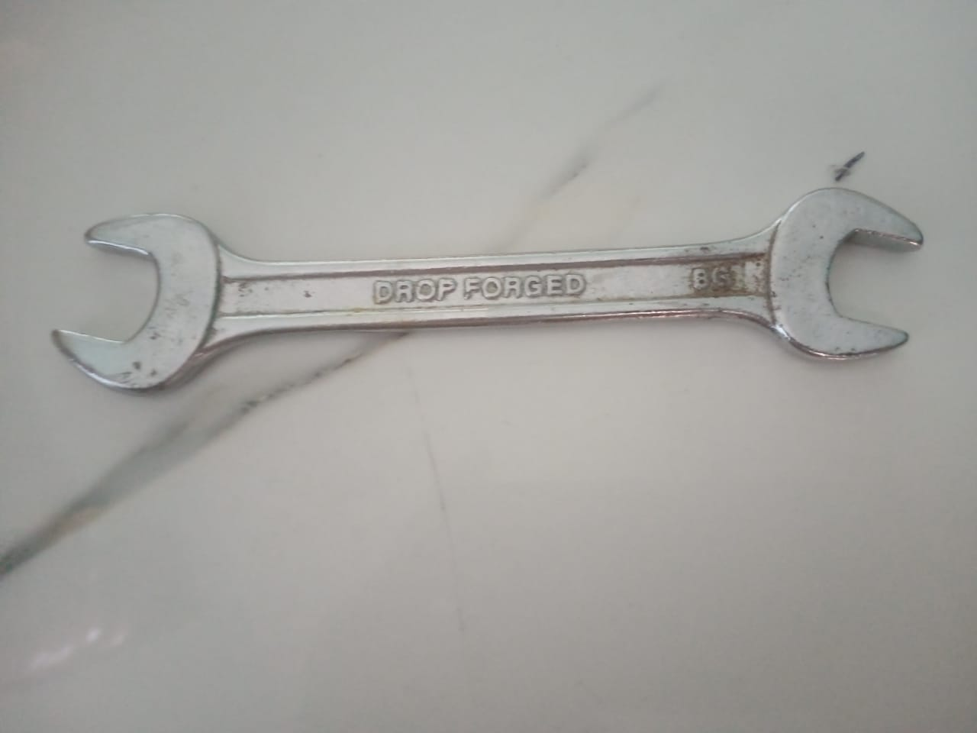

5.Orthographic view:-

6.isometric view:-

7.CAD Drawing:-

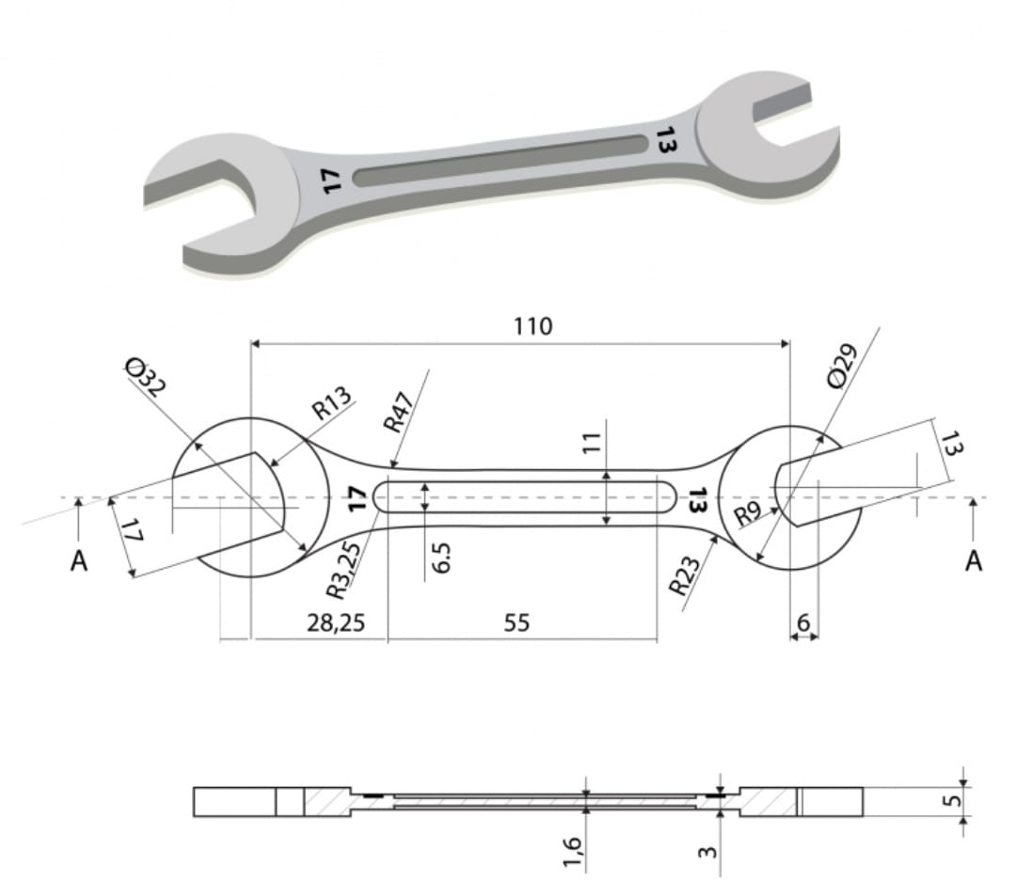

- Peer review :- Reviewed by Group No:17
The drawing clearly shows good technical understanding and is easy to read.
Important dimensions are correctly included making the design functional .With
Cleaner dimensioning and clearer jaw and section details, it would look fully
professional.
- Conclusion - This activity helped in understanding real-world engineering drawings by starting from a physical object and completing the full workflow , measurement, drafting orthographic and Isometric view, CAD modeling, and evaluation. The experience improved technical communication and visualization skills crucial for future engineering design.
(This is sample conclusion . Student need to write outcome /understanding of the activity in their own words)

Description of Activity- Students will work in small groups (3–4 members) :

    - Step-1. Select an Everyday Object [Examples: a smartphone stand, door handle, nut & bolt, spanner, or a small mechanical bracket.
    - Step-2. Measurement [Take measurements using scales, and other tools.]
    - Step-3. Take Photo of the object (colour) and paste it in the report at space defined.
    - Step-4.Manual Drawing 2D & 3D [Draw manual Orthographic projections and Isometric views in the separate sheet and attached its it to the report]
    - Step-5. CAD Modelling [Convert manual drawings into a 2D & 3D CAD model using Auto-CAD or other approved software and attached it to the report in separate sheet.
    - Step 7: Peer Review Exchange work with another group for review. Note suggestions and make improvements accordingly and write it in the report.
    - Step 8: Presentation & Submission [Present your work with action taken on the feedback and submit it to the teacher for evaluation.]
- Learning Outcomes - By the end of the activity, students will be able to:
      - Remember: Recall BIS conventions, symbols, and dimensioning rules.

      - Understand: Explain the link between 2D drawings and 3D objects.
      - Apply: Create orthographic projections and isometric drawings of real objects.
      - Analyze: Identify drawing errors and suggest corrections through peer review.
      - Evaluate: Compare manual and CAD drawings for accuracy and presentation.
      - Create: Develop complete set of engineering drawings & CAD models for selected object.
- Conclusion
This activity helped in understanding real-world engineering drawings by starting from a physical object and completing the full workflow , measurement, drafting orthographic and Isometric view, CAD modeling, and evaluation. The experience improved technical communication and visualization skills crucial for future engineering design.

- Assessment Rubric (Total: 10 Marks)

- Group No:- _6__ Year/Semester-First/First Section:-___C____
- Name of Student/Roll No-___Sakshi Sandel____ USN No-___CS25169__
___Taniya Sinha____ USN No-____CS25179___
___Twinkle Pawar__ USN No-___CS25183__

- Name of object- ___Spanner___

Component | Criteria | Marks | Marks Awarded
 |  |  | USN 1 | USN 2 | USN 3
Manual Drawings  (2D & 3D) | Correctness of views, line conventions, dimensioning, Quality , neatness | 3
CAD Drawings | Completeness, correct features, proper dimensioning, line conventions | 3
Peer Review comments | Comments correctness (line conventions, dimensioning, proportion, missing features). | 1
Presentation/  Viva | Clarity of explanation, understanding of process | 3
Total Marks |  | 10

Faculty Signature: ____________________________
Date: ____________________________

