 | Daffodil International University | 
Department of Computer Science & Engineering (CSE)
CSE222 · Object Oriented Programming Lab · Mini Project
Software Requirements Specification
BorrowBox
Peer-to-Peer University Product Sharing & Rental System (Android App + Java Server)
Document Reference | SRS_BORROWBOX_DIU_CSE222_V2.0
Version | 2.0 — Short Version
Target Platform | Android Native (Java) · API 24 – 34 · Multi-threaded Java Socket Server · SQLite
Institution | Daffodil International University (DIU)
Department | Computer Science & Engineering (CSE)
Campus | Daffodil Smart City (DSC), Birulia, Savar, Dhaka-1216
Date | October 23, 2026

PROJECT TEAM
No. | Full Name | Student ID | Module / Role
01 | Muhammad Tanjeem | 252-15-817 | User Auth & Trust
02 | Md. Sabbir Hossain Shamim | 252-15-825 | Product Catalog & Search
03 | Chandan Acharjee Himel | 252-15-891 | Server & Rental Lifecycle
04 | Mst Tasnim Binty Ekram | 252-15-074 | Timer, QR & Payment
05 | Md. Rafiul Islam Rafi | 252-15-105 | Safety, Dispute & Alerts

1. Introduction

1.1 Project Overview
BorrowBox is a native Android app (written in Java) where university students can borrow things they need for a short time (charger, calculator, cable, lab tool) from other students for a small hourly fee. Many students use the system at the same time through a client–server setup: a multi-threaded Java socket server handles all requests and every student uses the Android app on their phone.
The system covers the full rental cycle: listing, search, request, owner approval, QR handover, timer, late fee, deposit, payment, rating and dispute.

1.2 Real-World Scenario
Student A’s laptop charger stops working 30 minutes before a lab exam. A searches “charger”, finds Student B nearby (20 BDT/hour) and books it for 2 hours. At the same moment Student C also tries to book it, but the server allows only one booking. A and B meet, scan the QR code, the timer starts, A returns the charger on time, gets the deposit back, and both rate each other.

1.3 Problem Statement
- High cost: students buy items for just one exam or project.
- Emergencies: no quick way to get gear before a class or lab.
- No trust: informal borrowing has no time tracking, deposit or proof.
- Double booking: two students can be promised the same item at the same time.

1.4 Main Goals
- Give students cheap and fast access to campus tools.
- Let owners earn from unused items safely.
- Stop booking conflicts using thread synchronization.
- Build trust with QR handover, deposit and Trust Score.
- Apply OOP, UML, multi-threading, sockets and exception handling.

1.5 Stakeholders
Who | What they do
Borrower (Student) | Searches, requests, pays, returns items
Owner (Student) | Lists items, accepts or declines requests
Administrator | Manages users, solves disputes, sees reports
Guest | Only browses the catalog
Faculty | Evaluates the project

1.6 Project Scope
Included | Excluded (Future)
• Native Android app in Java (API 24–34)  • Multi-threaded Java socket server  • Login with role-based access  • Product listing, search, filter  • Rental request and approval  • QR handover using phone camera  • Live countdown timer and reminders  • Late fee and security deposit  • Simulated payment (bKash/Nagad)  • Rating, Trust Score, reports | • iOS app  • Real payment gateway  • Delivery service  • AI damage detection  • Multi-university support  • Web dashboard

2. Feature List & Technical Description

2.1 Feature List

User Management
- Register with name, university email, student ID, phone and password
- Login/logout; passwords stored as salted hash
- Roles: Guest, Borrower, Owner, Admin (different screens and permissions)
- Profile with Trust Score and rating

Product Catalog
- Add, edit, delete product with title, category, condition, hourly price and deposit
- Status: Available / Reserved / Rented / Hidden
- Product cannot be edited while it is in a rental

Search & Filter
- Keyword search from the server
- Filter by category, price, condition, availability
- Sort by price, newest or Trust Score

Rental Booking (Concurrency)
- Choose 1h, 2h, 3h, 6h or 1 day and see cost: Fee + Deposit
- Only one student can book a product at a time (lock per product)
- Owner accepts or declines within 30 minutes
- Emergency SOS request sent to nearby owners

QR Handover, Timer & Late Fee
- QR token for pickup and return (single-use, expires in 10 minutes)
- Countdown timer runs on the server and shows live on the phone; reminders at 15 and 5 minutes as phone notifications
- Scan QR with the phone camera (CameraX + ZXing)
- After time ends, status becomes Overdue and late fee is added per hour

Deposit & Payment
- Deposit held until return is checked
- Clean return: full refund; damage report: deposit frozen
- Itemised invoice and receipt after every rental

Rating, Reports & Admin
- Both users rate each other (1–5 stars)
- Trust Score = 80 + 1.5×Completed + 2×AvgRating − 4×Late − 10×Disputes
- Report damage or fake listing; admin gives the final decision
- Real-time notifications on the phone for all important events

Error Handling
- Wrong input, wrong password, expired QR or lost connection never crash the system
- Custom exceptions show clear messages to the user

2.2 Technical Description

Development Stack
Component | Technology | Purpose
Language | Java | All logic and OOP
Platform | Android (API 24–34) | Mobile app for students
UI | XML Layouts + Material Design 3 | Role-based user screens
Networking | Socket (app, background thread) / ServerSocket (server) | App–server communication
Multi-threading | ExecutorService, ReentrantLock (server); Handler/WorkManager (app) | Many clients, safe booking, no UI freeze
Database | SQLite + JDBC (server); Room (app cache) | Store data
QR & Camera | ZXing + CameraX | Create and scan QR codes
Testing | JUnit 5 | Unit and stress tests
Tools | Android Studio, Gradle, Git/GitHub | Build and teamwork

OOP Principles Applied
Principle | Use in BorrowBox
Encapsulation | All fields are private; access only through getters/setters with validation
Inheritance | Student and Admin extend abstract User; DamageReport extends abstract Report
Polymorphism | BkashSimulator and NagadSimulator implement Payable; used the same way
Abstraction | Abstract classes and DAO interfaces hide details
Interface | Payable and Verifiable allow easy change and testing

Client–Server Design
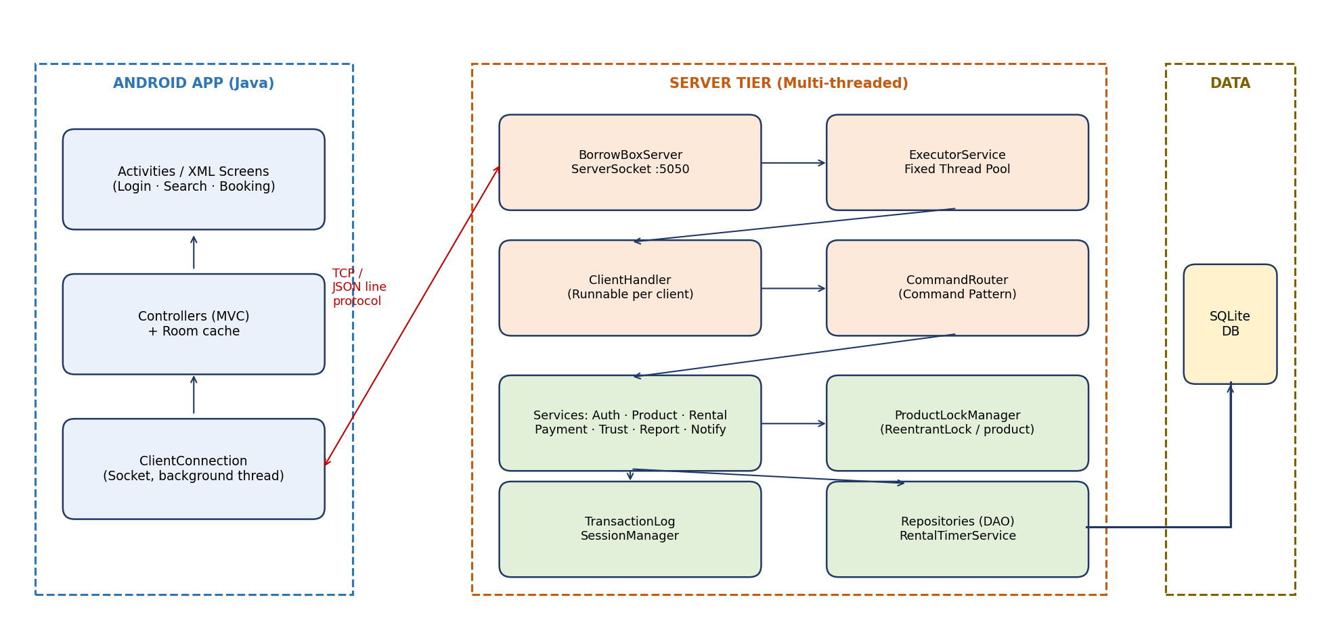
Figure 1 — System architecture (Android app + Java server)
The server listens on a port. The Android app connects using a Socket on a background thread (never on the main UI thread). Each connected client gets its own thread from a thread pool. Before booking, the thread takes the product’s lock, checks availability, saves the booking, then releases the lock. This avoids double booking.

Core Classes (UML)
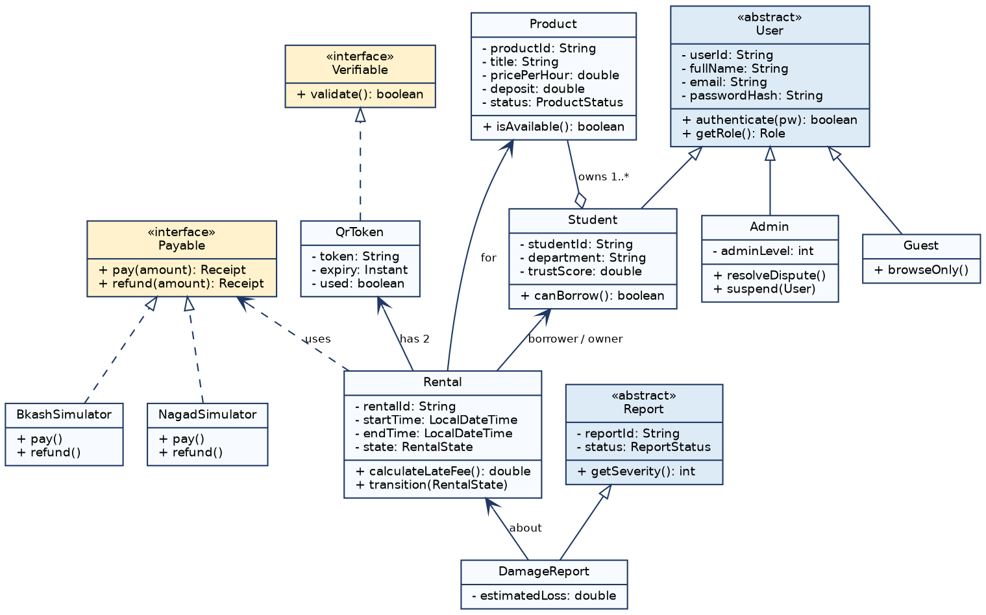
Figure 2 — UML class diagram
Class | Type | Key Attributes & Methods
User | Abstract | userId, fullName, email, passwordHash, authenticate()
Student / Admin | Extends User | studentId, trustScore / suspend(), resolveDispute()
Product | Concrete | productId, title, pricePerHour, deposit, status, isAvailable()
Rental | Concrete | rentalId, startTime, endTime, state, calculateLateFee()
QrToken | Implements Verifiable | token, expiry, used, validate()
Payment | Implements Payable | amount, deposit, status, pay(), refund()
Report / DamageReport | Abstract / Extends | reportId, status, estimatedLoss

Exception Handling
Exception | When
InvalidInputException | Wrong or empty input
AuthenticationException | Wrong password / locked account
SlotUnavailableException | Product already booked
TokenInvalidException | QR expired or already used
PaymentFailedException | Payment failed
IOException / SocketException | Client disconnects

3. Team Task Distribution
The work is divided equally among 5 members. Each member owns one module.
Member 01 · Muhammad Tanjeem · ID: 252-15-817
Module: User Authentication & Trust
• Registration, login, logout, password hashing
• User, Student, Admin class hierarchy (Encapsulation, Inheritance)
• Role-based access control
• Rating and Trust Score
• Unit tests for this module

Member 02 · Md. Sabbir Hossain Shamim · ID: 252-15-825
Module: Product Catalog & Search
• Add, edit, delete product
• Keyword search, filter and sort
• Android screens for catalog and product details (RecyclerView, Material cards)
• Search speed test

Member 03 · Chandan Acharjee Himel · ID: 252-15-891
Module: Server & Rental Lifecycle
• ServerSocket, ClientHandler and thread pool
• Rental request, approval and state flow
• Lock for double-booking prevention
• Emergency SOS
• Concurrency stress test

Member 04 · Mst Tasnim Binty Ekram · ID: 252-15-074
Module: Timer, QR & Payment
• QR code create (ZXing) and scan (CameraX) screens
• Countdown timer, WorkManager reminders, overdue
• Late-fee calculation
• Payable interface with bKash/Nagad simulators
• Deposit, invoice and receipt

Member 05 · Md. Rafiul Islam Rafi · ID: 252-15-105
Module: Safety, Dispute & Alerts
• Damage and misconduct reports
• Admin panel: verdict, suspend, warning
• Android notifications and notification centre
• Custom exceptions and error handling
• Integration tests, GitHub README

3.1 Shared Team Responsibilities
# | Shared Work | All
1 | Common data model, message protocol and app/server package structure | ✔
2 | GitHub with branches and README.md | ✔
3 | Testing and bug fixing | ✔
4 | Report, presentation and live demo | ✔
5 | Viva preparation (design pattern, synchronization, UML) | ✔

3.2 Rental Flow
Step | Stage | Who | What Happens
1 | Listing | Owner | Adds product with price and deposit
2 | Search | Borrower | Searches product or sends SOS
3 | Booking | Borrower | Selects time and sees total cost
4 | Approval | Owner | Accepts or declines; server locks the slot
5 | Payment | Borrower | Pays fee + deposit (simulated)
6 | Pickup | Both | Scan QR; timer starts
7 | Reminder | System | Alerts at 15 and 5 minutes left
8 | Return | Both | Scan return QR; timer stops
9 | Settlement | System | Late fee if any; refund deposit; receipt
10 | Rating | Both | Rate each other; Trust Score updates

3.3 Deliverables
- GitHub repository with README.md
- Project report
- Demo APK
- Presentation and live demo on Android phone/emulator (concurrent borrowing, socket search, exception recovery)

