 | Daffodil International University | 
Department of Computer Science & Engineering (CSE)
CSE222 · Object Oriented Programming Lab
Mini Project (Complex Engineering Problem) · Group-based · 40 Marks
Software Requirements Specification
BorrowBox
Android App with Multi-threaded Java Client–Server Backend · Peer-to-Peer University Product Sharing & Rental System
Document Reference | SRS_BORROWBOX_DIU_CSE222_V2.0
Version | 2.0 — Aligned with CSE222 Mini Project Guideline
Course | CSE222 · Object Oriented Programming Lab
Target Platform | Android Native (Java) · API 24 – 34 · Multi-threaded Java Socket Server · SQLite
Institution | Daffodil International University (DIU)
Department | Computer Science & Engineering (CSE)
Campus | Daffodil Smart City (DSC), Birulia, Savar, Dhaka-1216
Date | October 23, 2026
Targeted Attributes | EP1 Depth of Knowledge · EP2 Conflicting Requirements · EP3 Depth of Analysis · EP6 Stakeholder Involvement

PROJECT TEAM
No. | Full Name | Student ID | Module / Role
01 | Muhammad Tanjeem | 252-15-817 | User Auth, RBAC & Trust Engine
02 | Md. Sabbir Hossain Shamim | 252-15-825 | Product Catalog, Search & Android UI
03 | Chandan Acharjee Himel | 252-15-891 | Server Core, Rental Lifecycle & Concurrency
04 | Mst Tasnim Binty Ekram | 252-15-074 | Timer, QR & Payment
05 | Md. Rafiul Islam Rafi | 252-15-105 | Reports, Admin, Notifications & Testing
Team Lead: ______________________ (to be designated by the group)

Table of Contents
1. Introduction
2. Overall Description
3. Functional Requirements
4. Non-Functional Requirements
5. System Architecture & OOP Design
6. Concurrency, Networking & Trade-off Analysis
7. Exception Handling & Input Validation
8. User Interface & Stakeholder Feedback
9. Testing & Performance Evaluation
10. Engineering Standards, Ethics & Impact
11. Team Task Distribution
12. Deliverables, Timeline & Guideline Compliance Matrix
Appendix A — Requirement Traceability

1. Introduction

1.1 Purpose of this Document
This Software Requirements Specification (SRS) defines the functional, non-functional, architectural and quality requirements of BorrowBox, the group mini project for CSE222 Object Oriented Programming Lab. It follows the course Lab Mini Project Guideline (Complex Engineering Problem) and is structured so that every report component (Introduction, System Architecture, Implementation & Results, Engineering Standards & Mapping) and every assessment tool (Demonstration, Viva Voce, Followup) can be traced directly to a section of this document.

1.2 Project Overview
BorrowBox is a Java-based, multi-user Android client–server application that lets verified university students borrow essential equipment (chargers, calculators, HDMI cables, lab tools, books) from peers on campus for a low hourly or daily fee. A central multi-threaded server, built on the Java Socket API, serves many Android app clients simultaneously. It manages the complete micro-rental lifecycle: product listing, search, request and approval, QR-verified handover, countdown timer, late-fee calculation, security deposit escrow, simulated payment, peer rating, and dispute resolution.
The system is deliberately designed as a Complex Engineering Problem: many students may try to borrow the same item at the same instant, roles have different permissions, and performance must be balanced against thread-safety, security and usability.

1.3 Real-World Campus Scenario
Student A is in the DIU Library 30 minutes before a lab exam and the laptop charger has stopped working; buying a new one costs about 1,500 BDT. Using the BorrowBox client, Student A searches “charger”, finds Student B near YKSG-1 Hall offering a compatible charger at 20 BDT/hour, and requests it for two hours. At the same moment Student C requests the same charger. The server processes both requests through a per-product lock: exactly one succeeds, the other receives a clear “slot already taken” message. After the owner accepts, both meet at Kathal Tola, scan the pickup QR token, the timer starts, and on time-out reminders are pushed. The charger is returned, the deposit is refunded and both students rate each other.

1.4 Problem Statement
- High temporary ownership cost: students buy items needed only for one exam or project at full retail price.
- Campus gear emergencies: hardware failures just before lectures or labs have no reliable real-time on-campus solution.
- No accountability in informal sharing: WhatsApp-based borrowing has no time tracking, deposit protection, condition evidence or enforcement.
- Concurrent demand conflicts: without a central authority, two students can be promised the same item at the same time (race condition / double-booking).

1.5 Objectives
- Provide fast, affordable and organised access to campus tools without purchase.
- Let owners earn from idle items while keeping deposit and condition protection.
- Guarantee data integrity under real-time concurrent borrowing using synchronization and resource locking.
- Apply encapsulation, inheritance, abstraction, polymorphism, interfaces and design patterns in a modular Java code base.
- Deliver role-based interfaces (Guest, Borrower, Owner, Administrator) with clear feedback and error recovery.
- Provide UML-driven analysis and design, unit tests, and performance profiling as engineering evidence.

1.6 Project Scope
Included — Academic Release | Excluded — Future Phases
• Native Android app (Java, API 24–34) and standalone multi-threaded Java server  • Multi-client TCP socket communication with a JSON-line protocol  • Registration, login, salted password hashing, role-based access control  • Product listing, search, filter, sort and detail views  • Rental request, owner approval, double-booking prevention  • QR token generation (ZXing) and verification for pickup/return  • Server-side countdown timer, reminders and automated late fee  • Security deposit escrow and simulated payment (bKash/Nagad simulators)  • Condition notes/photo references, damage report and admin dispute resolution  • Trust Score (0–100), ratings and reviews  • Emergency SOS broadcast to connected owners  • Activity log, activity summary report, exception recovery | • iOS application  • Real payment gateway integration (live bKash/Nagad/SSLCommerz)  • Off-campus delivery or courier  • Rentals longer than 7 continuous days  • AI-based automated damage detection  • Multi-university network  • GPS hardware tracking  • End-to-end encrypted chat (planned extension)  • Web-based analytics portal

1.7 Stakeholders (EP6)
Stakeholder involvement is a targeted attribute. The following stakeholders were identified; each has distinct goals, permissions and conflicting interests that shape the requirements.
Stakeholder | Role in System | Primary Needs | Potential Conflict
Student Borrower | Searches, requests, pays, returns | Cheap, fast access; clear cost; fair deposit rules | Wants low deposit; owner wants high protection
Student Owner | Lists items, approves requests | Earn income; protect item; quick decisions | Wants strict approval; borrower wants instant booking
System Administrator | Moderates users, resolves disputes, views reports | Visibility, control, audit trail, fair verdicts | Needs full data access vs. user privacy
Faculty / Lab Instructor | Evaluates project; may recommend lab equipment pooling | Demonstrable OOP quality, documentation | Wants rich features vs. limited lab time
University Administration | Campus policy owner | Safe, rule-abiding sharing; no misuse of student data | Policy strictness vs. student convenience
Guest Visitor | Browses catalog only | See availability before registering | Open browsing vs. account-only transactions

1.8 Constraints
- Technology: Java, Android SDK (API 24–34), Java Socket API, JUnit 5; no external web framework for the core server.
- Time: semester lab schedule; report and presentation by the guideline deadline.
- Team: five members with equal workload and individual viva accountability.
- Infrastructure: LAN/localhost demonstration; SQLite single-file database; payment is simulated.
- Ethics & policy: only university-verified students; passwords never stored or transmitted in plaintext.

1.9 Definitions and Acronyms
Term | Meaning
SRS | Software Requirements Specification
CEP | Complex Engineering Problem
OOP | Object Oriented Programming
RBAC | Role-Based Access Control
DAO | Data Access Object
QR token | Time-limited, single-use handover code generated with ZXing
Escrow | Deposit held by the system until return is verified
Trust Score | Algorithmic 0–100 reliability value of a student
PO / CO | Program Outcome / Course Outcome
EP | Engineering Problem attribute (EP1–EP7)

1.10 References
- CSE222 Lab Mini Project — Guideline & Instruction (Complex Engineering Problem).
- IEEE Std 830-1998 / ISO/IEC/IEEE 29148 — Requirements Engineering.
- OMG UML 2.5.1 Specification.
- ISO/IEC 25010 — Software Product Quality Model.
- Oracle Java SE 17 Documentation (java.net, java.util.concurrent).
- Gamma, Helm, Johnson, Vlissides — Design Patterns.

2. Overall Description

2.1 Product Perspective
BorrowBox is a self-contained two-tier application. The client tier is the Android app (Activities with XML layouts) that never touches the database directly. The server tier listens on a TCP port, creates a worker task for each connected client using a fixed thread pool, validates every command, and performs all business logic and persistence. All shared state is protected against concurrent modification.
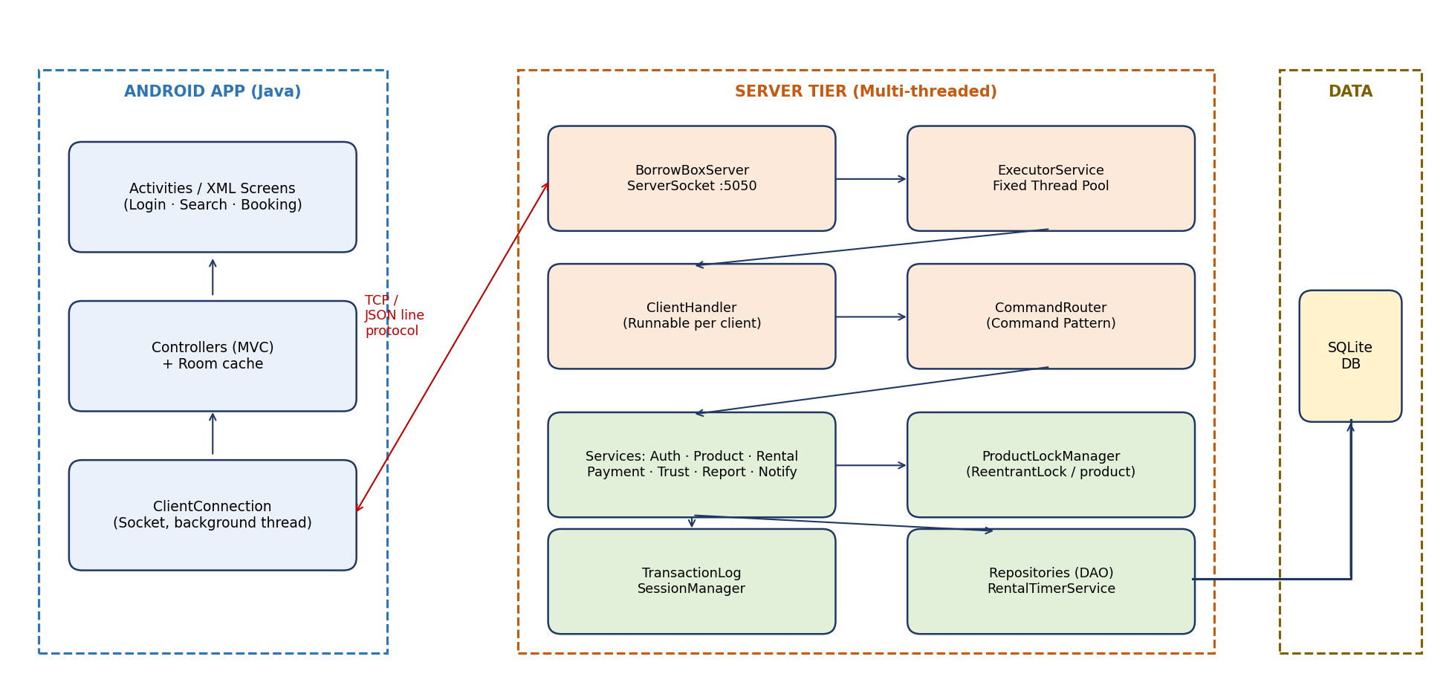
Figure 2.1 — High-level client–server architecture

2.2 User Classes and Role-Based Access Control
Function | Guest | Borrower | Owner | Admin
Browse / search catalog | ✔ | ✔ | ✔ | ✔
Register / log in | ✔ | — | — | —
Request rental, pay, return | — | ✔ | — | —
List / edit own product | — | — | ✔ | —
Accept / decline request | — | — | ✔ | —
Scan pickup / return QR | — | ✔ | ✔ | —
Rate and review | — | ✔ | ✔ | —
File damage / misconduct report | — | ✔ | ✔ | —
Send Emergency SOS | — | ✔ | — | —
Suspend users, resolve disputes | — | — | — | ✔
View activity summary & audit log | — | — | — | ✔
A student account may act as both Borrower and Owner; permissions are checked per action by the server, not only hidden in the app screens.

2.3 Operating Environment
Item | Specification
Language / JDK | Java (Android SDK API 24–34; server JDK 17)
Client App | Android Native (Java), XML layouts + Material Design 3, CameraX for QR scanning; network calls on background threads only
Server | Java standalone process using java.net.ServerSocket, java.util.concurrent
Database | SQLite via JDBC, accessed only by the server through DAO classes
Libraries | Gson (JSON), ZXing (QR), CameraX, Room (local cache), WorkManager, JUnit 5, Gradle build
IDE / VCS | Android Studio; Git + GitHub with customised README.md
Mobile OS | Android 7.0 (API 24) to Android 14 (API 34); server runs on any OS with JDK 17
Network | TCP/IP over campus Wi-Fi/LAN (emulator: 10.0.2.2), default port 5050

2.4 Assumptions and Dependencies
- All users have a valid university e-mail (e.g., @diu.edu.bd) and student ID.
- Server machine clock is the single source of truth for time (timers, QR expiry).
- Clients can reach the server host and port during the demonstration.
- Payment gateways are replaced by simulators implementing the same Payable interface.

3. Functional Requirements
Priority: M = Mandatory, S = Should have, C = Could have. Each requirement is uniquely identified for traceability (Appendix A).

3.1 User Management & Authentication
ID | Requirement | Pri.
FR-01 | The system shall register a student with full name, university e-mail, student ID, mobile number and password. | M
FR-02 | The system shall validate e-mail domain, unique student ID and password strength (≥ 8 chars, letter + digit). | M
FR-03 | Passwords shall be stored only as salted hashes (PBKDF2/SHA-256); plaintext shall never be stored or logged. | M
FR-04 | The system shall authenticate users and create a server-side session bound to the client connection. | M
FR-05 | The system shall enforce role-based permissions on every command at the server (Guest, Student, Admin). | M
FR-06 | Users shall view and edit their profile and toggle phone-number visibility. | S
FR-07 | The system shall lock an account for 5 minutes after 5 consecutive failed logins. | S
FR-08 | The system shall record login, registration and profile changes in an audit log. | S

3.2 Product Catalog
ID | Requirement | Pri.
FR-09 | An owner shall create a listing with title, brand, model, category, description, condition grade, hourly rate, optional daily cap and optional deposit. | M
FR-10 | Categories: Electronics, Chargers & Cables, Calculators, Books & Notes, Lab Equipment, Adapters & Connectors. | M
FR-11 | Status values: Available, Reserved, Rented, Hidden. Only the server may change Reserved/Rented. | M
FR-12 | The system shall prevent edit or delete of a product that has an active or pending rental (listing lock). | M
FR-13 | Owners shall attach up to 4 image references (file path/URL) per product. | C

3.3 Search, Filter & Sort
ID | Requirement | Pri.
FR-14 | Keyword search over title, brand, model and tags, performed on the server using an in-memory index. | M
FR-15 | Filters: category, min/max price, condition grade, availability. | M
FR-16 | Sorting by price, newest, owner Trust Score and campus zone using Comparator implementations. | M
FR-17 | Wishlist: a student can bookmark products and list bookmarks. | C
FR-18 | Campus zone labels (DIU Library, YKSG-1 Hall, Kathal Tola, Food Village, AB-4 Building) shown as suggested meetup spots. | S

3.4 Rental Booking & Concurrency
ID | Requirement | Pri.
FR-19 | A borrower shall select duration (1h, 2h, 3h, 6h, 1 day) and see Base Fee + Deposit = Total before submitting. | M
FR-20 | The server shall process borrow requests for the same product atomically; exactly one concurrent request shall succeed. | M
FR-21 | The owner shall accept or decline within 30 minutes; otherwise the request auto-expires and the slot is released. | M
FR-22 | The rental shall follow the state machine Requested → Accepted → HandoverPending → Active → ReturnPending → Returned → Completed (plus Declined, Expired, Cancelled, Overdue, Disputed). | M
FR-23 | A borrower may cancel before handover without penalty. | S
FR-24 | Borrowers with Trust Score < 50 shall be blocked from borrowing deposit-required items. | S
FR-25 | Emergency SOS: a borrower broadcasts a category request; matching online owners receive a push message and may accept with one action; SOS expires after 30 minutes. | S

3.5 QR Handover, Timer & Late Fee
ID | Requirement | Pri.
FR-26 | The server shall generate a Pickup token (rendered as QR via ZXing) for the owner and a Return token for the borrower. | M
FR-27 | Tokens shall be single-use, expire after 10 minutes, and be rejected if malformed, expired or reused. | M
FR-28 | A valid Pickup scan shall start the rental timer on the server (ScheduledExecutorService). | M
FR-29 | The server shall push reminders to both parties at 15 and 5 minutes before expiry. | M
FR-30 | At expiry without Return scan, state becomes Overdue and late fee = ceil(extra hours) × hourly rate, capped at deposit or configured maximum. | M
FR-31 | A valid Return scan shall stop the timer, close the rental and trigger settlement. | M
FR-32 | Each scan event shall be logged with server timestamp and zone label. | S

3.6 Payment & Deposit Escrow (Simulated)
ID | Requirement | Pri.
FR-33 | The Payable interface shall define pay() and refund(); BkashSimulator, NagadSimulator and CashRecord implement it polymorphically. | M
FR-34 | Rental fee and deposit shall be debited into escrow when the owner accepts; failed payments release the slot lock. | M
FR-35 | Settlement shall generate an itemised invoice: Base Fee + Late Fee ± Deposit = Final Amount, with a unique Transaction ID. | M
FR-36 | Deposit shall be refunded automatically on a clean return, or frozen if a damage report is filed within 2 hours. | M
FR-37 | Each student shall have a ledger of earnings, expenses and deposits. | S

3.7 Ratings, Trust Score, Reports & Administration
ID | Requirement | Pri.
FR-38 | After completion both parties shall submit a 1–5 rating and optional review; reviews are revealed only after both submit (blind review). | M
FR-39 | Trust Score = 80 + 1.5 × Completed + 2.0 × AvgRating − 4.0 × LateReturns − 10.0 × DisputePenalties, clamped to 0–100. | M
FR-40 | “Trusted Campus Peer” badge at Trust Score ≥ 90 with ≥ 10 completed rentals. | C
FR-41 | Users shall file reports (Damaged, Lost, Fake Listing, Misconduct) with description and evidence references. | M
FR-42 | Report lifecycle: Submitted → Under Review → Resolved / Dismissed. | M
FR-43 | Admin shall adjust deposit release, apply Trust penalties, warn, suspend or ban accounts. | M
FR-44 | Admin shall view an activity summary: active rentals, connected clients, rentals per day, overdue count, disputes. | S
FR-45 | Users shall receive real-time notifications for request, acceptance, reminders, overdue, settlement and verdict. | M

4. Non-Functional Requirements
ID | Category | Requirement (measurable)
NFR-01 | Performance | Search over 10,000 products shall respond in < 300 ms; a borrow request shall complete in < 500 ms with 50 concurrent clients.
NFR-02 | Concurrency / Thread-safety | No lost update, duplicate booking or negative balance under 100 simultaneous borrow attempts on one product (verified by stress test).
NFR-03 | Scalability | Server shall support at least 50 simultaneous client connections using a bounded thread pool.
NFR-04 | Reliability | Server shall survive malformed input and abrupt client disconnects without crashing; resources (sockets, statements) always closed.
NFR-05 | Security | Salted password hashing, server-side authorisation, input sanitisation (prepared statements), token expiry, no sensitive data in logs.
NFR-06 | Data Integrity | Money-affecting operations run in database transactions with rollback on exception.
NFR-07 | Usability | A new user shall complete a borrow request in ≤ 6 clicks; every error shows a plain-language message.
NFR-08 | Maintainability | Layered packages, ≤ 300 lines per class (guideline), Javadoc on public API, ≥ 70% unit-test coverage of services.
NFR-09 | Portability | Runs on any OS with JDK 17 without code change.
NFR-10 | Accessibility | Keyboard navigation, readable contrast, dark/light CSS theme.
NFR-11 | Privacy | Phone numbers hidden by default; personal data access limited by role; chat/report data retained ≤ 30 days where applicable.

5. System Architecture & OOP Design
This chapter supports EP1 (Depth of Knowledge) and EP3 (Depth of Analysis) and corresponds to Report Part B.

5.1 Layered Modular Design
Layer | Package | Responsibility
Presentation | com.borrowbox.client.ui / controller | Activities/Fragments, XML layouts, role-specific screens, user feedback
Client Network | com.borrowbox.client.net | ClientConnection, request/response correlation, listener thread for pushed notifications
Protocol | com.borrowbox.common.protocol | Command, Request, Response, MessageCodec (shared by client and server)
Server Core | com.borrowbox.server.core | BorrowBoxServer, ClientHandler, CommandRouter, SessionManager
Service | com.borrowbox.server.service | AuthService, ProductService, RentalService, PaymentService, TrustService, ReportService, NotificationService
Concurrency | com.borrowbox.server.concurrent | ProductLockManager, RentalTimerService, TransactionLog
Persistence | com.borrowbox.server.dao | DAO interfaces and SQLite implementations
Domain Model | com.borrowbox.common.model | User, Student, Admin, Product, Rental, Payment, Report, QrToken …
Exceptions & Utils | com.borrowbox.common.exception / util | Custom checked/unchecked exceptions, PasswordHasher, Validator

5.2 Technology Stack
Component | Technology | Purpose
Language | Java | All business logic; OOP features
Mobile UI | Android XML + Material Design 3 | Role-based user interface
Networking | java.net.Socket / ServerSocket | Client–server communication
Concurrency | ExecutorService, ReentrantLock, ConcurrentHashMap, ScheduledExecutorService | Thread pool, locking, timers
Persistence | SQLite + JDBC (PreparedStatement) | Durable data store
Serialization | Gson | JSON-line message protocol
QR | ZXing core | QR image generation and decoding
Testing | JUnit 5, custom stress harness | Unit, concurrency and performance tests
Build / VCS | Android Studio, Gradle, Git, GitHub | Reproducible build, collaboration

5.3 Use-Case Model
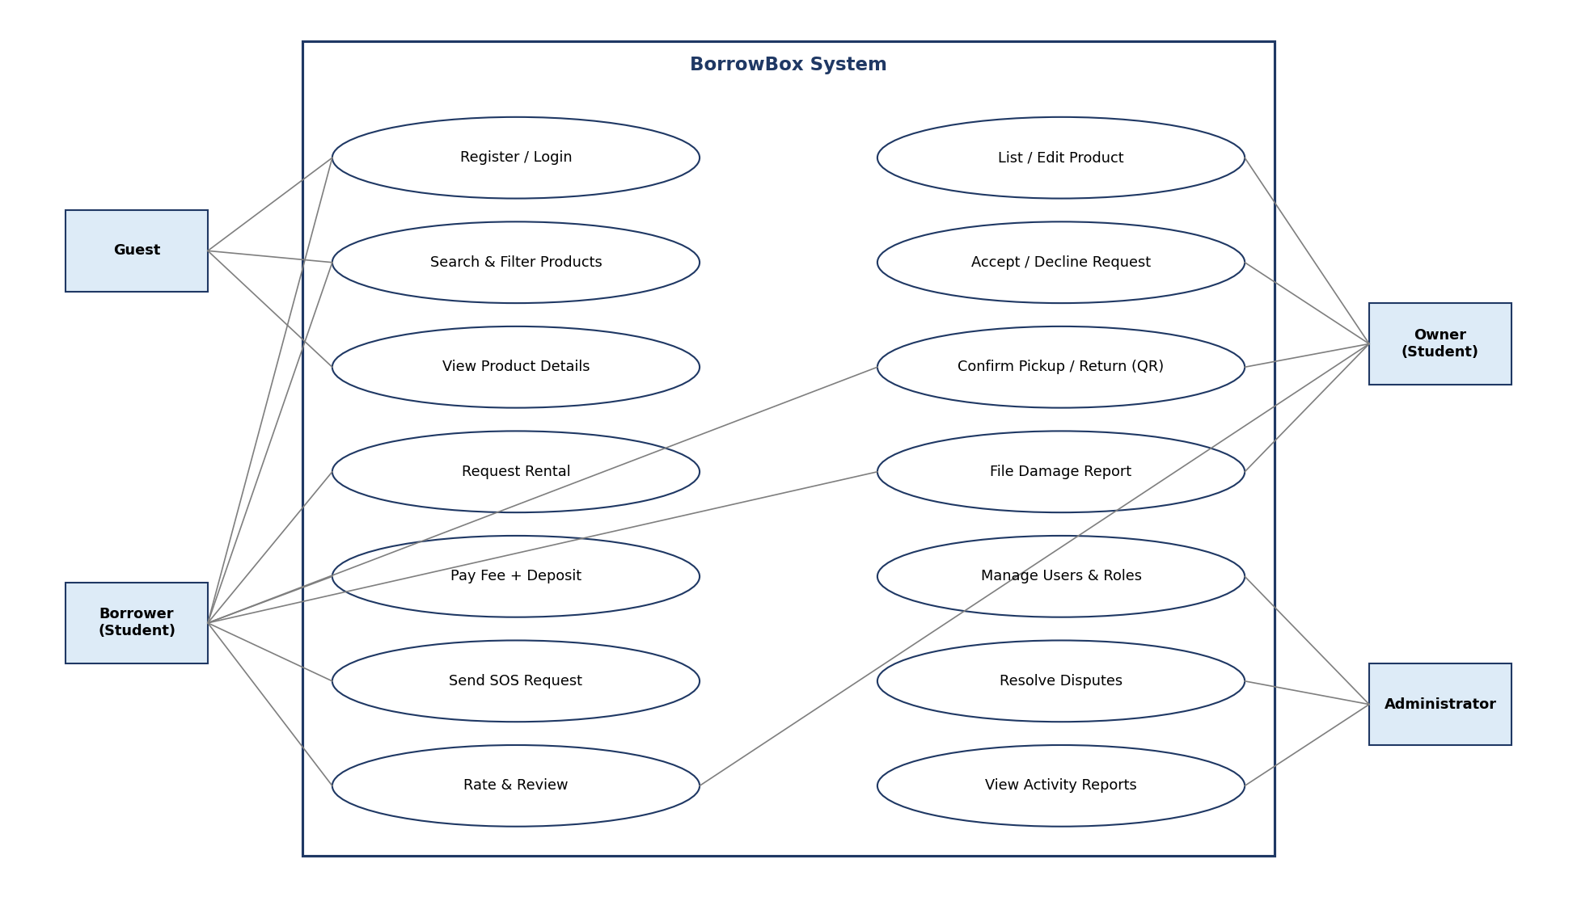
Figure 5.1 — Use-case diagram for Guest, Borrower, Owner and Administrator

5.4 UML Class Diagram
The class diagram shows the inheritance hierarchies (User → Student/Admin/Guest, Report → DamageReport), interface realisation (Payable, Verifiable) and the key associations between Rental, Student, Product and QrToken.
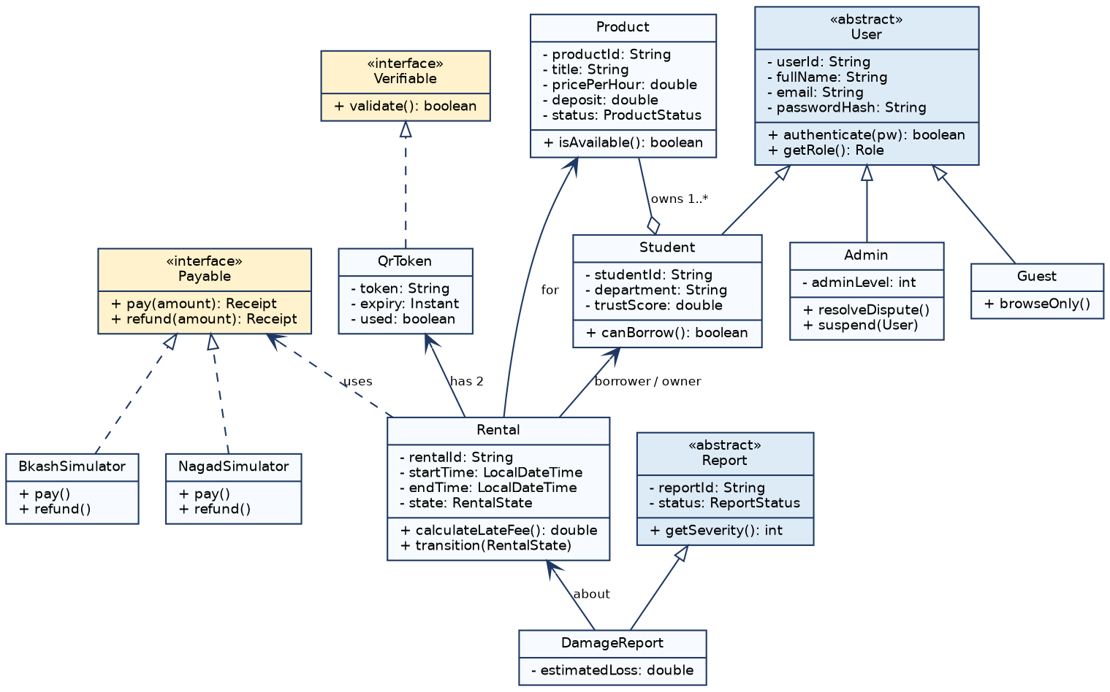
Figure 5.2 — UML class diagram (core domain)

5.5 OOP Principles Applied
Principle | Application in BorrowBox
Encapsulation | All domain fields are private; mutation only via validated setters or domain methods (e.g., Rental.transition()). Immutable value objects (Money, QrToken) expose no setters.
Inheritance | Student, Admin, Guest extend abstract User; DamageReport, MisconductReport extend abstract Report; custom exceptions extend BorrowBoxException.
Polymorphism | Payable (BkashSimulator, NagadSimulator, CashRecord) and Command implementations are invoked through the interface; Comparator strategies for sorting.
Abstraction | Abstract User.getPermissions() and Report.getSeverity(); DAO interfaces hide SQLite details; services hide locking from controllers.
Interfaces | Payable, Verifiable, Notifiable, ProductRepository, RentalRepository enable mocking and swapping implementations.
Association / Aggregation / Composition | Rental associates Borrower, Owner, Product; Student aggregates Products; Rental composes two QrTokens and one Payment.

5.6 Design Patterns
Pattern | Where Used | Reason
Singleton | ProductLockManager, ServerConfig | Single shared lock registry and configuration
Factory Method | UserFactory, PaymentFactory | Create Student/Admin or a Payable by type
Strategy | SortStrategy, LateFeePolicy, Payable | Swap algorithms without changing callers
Command | CommandRouter + Command classes | Each protocol command handled by one class; easy to extend
Observer | NotificationService / listeners | Push events to subscribed client handlers
State | RentalState transitions | Enforce legal lifecycle transitions
DAO | *Repository interfaces | Separate persistence from business logic
MVC | Client controllers and views | Separate UI from logic

5.7 Rental Lifecycle State Machine
From | Event | To | Guard / Action
Requested | Owner accepts | Accepted | Lock acquired; escrow debit
Requested | Owner declines / 30 min timeout | Declined / Expired | Release slot
Accepted | Both at meetup; tokens issued | HandoverPending | Generate Pickup QR
HandoverPending | Valid Pickup scan | Active | Start timer; product = Rented
Active | Return initiated | ReturnPending | Generate Return QR
Active | Timer reaches zero | Overdue | Start late-fee accrual
ReturnPending / Overdue | Valid Return scan | Returned | Stop timer; product = Available
Returned | Clean / damage report within 2 h | Completed / Disputed | Refund / freeze deposit
Accepted / Requested | Borrower cancels | Cancelled | No penalty before handover

5.8 UML Sequence Diagram — Concurrent Borrowing
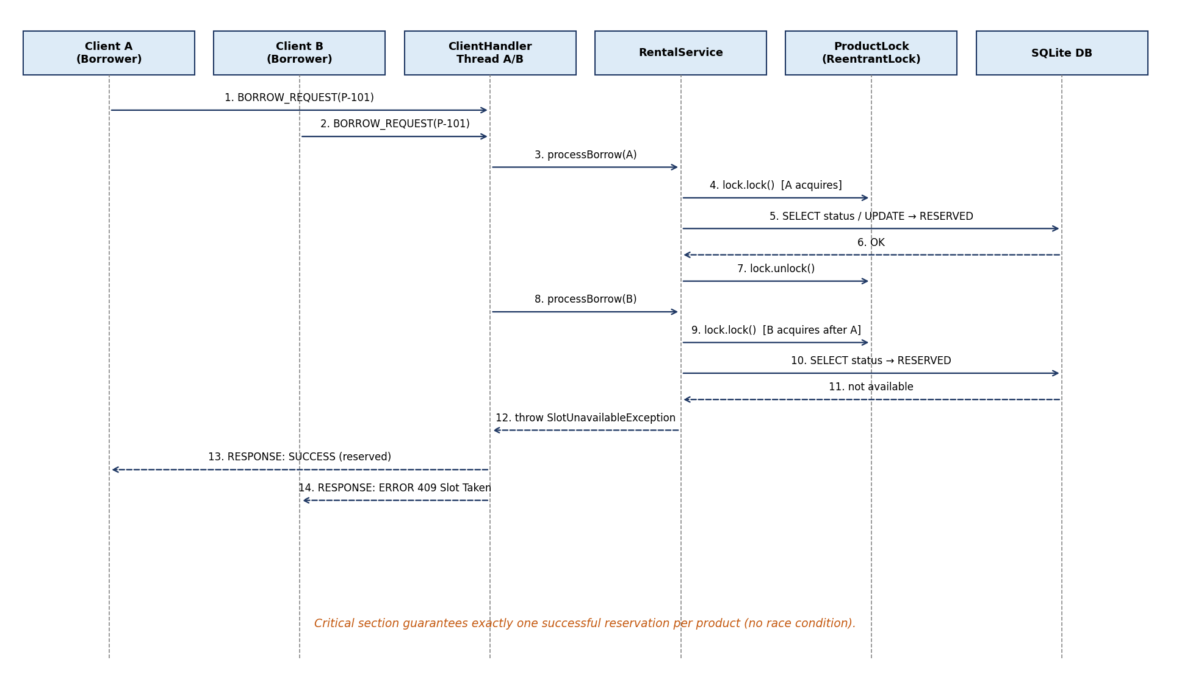
Figure 5.3 — Sequence diagram of two simultaneous borrow requests

5.9 UML Activity Diagram — Rental Workflow
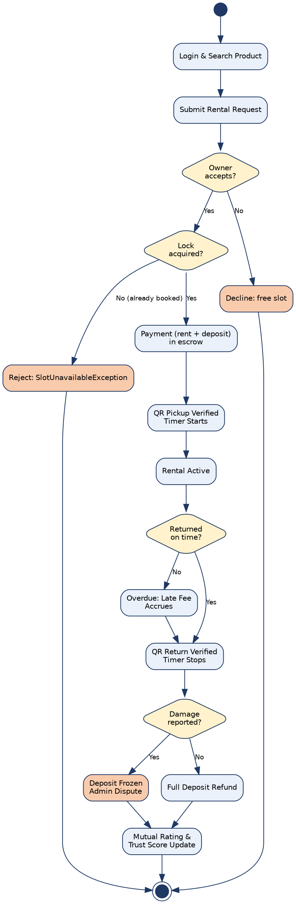
Figure 5.4 — Activity diagram of the end-to-end rental workflow

5.10 Client–Server Protocol
Messages are single-line JSON objects terminated by a newline. Every request has a requestId, command, authentication token and payload; the server replies with the same requestId, a status (OK / ERROR) and either data or an error code. Server-initiated pushes use requestId = 0.
Command | Allowed Roles | Description | Possible Errors
REGISTER / LOGIN / LOGOUT | Guest / any | Account creation and session control | INVALID_INPUT, AUTH_FAILED, ACCOUNT_LOCKED
SEARCH | All | Keyword, filter and sort query | INVALID_INPUT
LIST_PRODUCT / EDIT / DELETE | Owner | Manage listings | FORBIDDEN, LISTING_LOCKED
BORROW_REQUEST | Borrower | Atomic reservation attempt | SLOT_TAKEN, LOW_TRUST
ACCEPT / DECLINE | Owner | Respond to request | REQUEST_EXPIRED, FORBIDDEN
PAY | Borrower | Pay fee + deposit via Payable | PAYMENT_FAILED
PICKUP_SCAN / RETURN_SCAN | Borrower, Owner | Validate QR token | TOKEN_EXPIRED, TOKEN_USED, TOKEN_INVALID
RATE | Borrower, Owner | Submit rating/review | NOT_COMPLETED
REPORT | Borrower, Owner | File incident report | INVALID_INPUT
SOS_BROADCAST / SOS_ACCEPT | Borrower / Owner | Emergency request flow | SOS_EXPIRED
ADMIN_RESOLVE / SUSPEND / SUMMARY | Admin | Moderation and reporting | FORBIDDEN

5.11 Java Source Code Structure & Access Modifiers
Directory / Package | Content | Access Rules
common/model | User, Student, Admin, Product, Rental, Payment, Report… | private fields; public getters; package-private constructors via factories where needed
common/protocol | Request, Response, Command enum, MessageCodec | public final immutable classes
server/core | BorrowBoxServer, ClientHandler, CommandRouter | ClientHandler package-private; entry class public
server/service | Service interfaces + *Impl classes | interfaces public, implementations package-private
server/concurrent | ProductLockManager, RentalTimerService | private lock maps; synchronized access only through public methods
server/dao | Repository interfaces + SQLite implementations | SQL only here; PreparedStatement mandatory
client/ui, client/net | Activities/controllers, ClientConnection | controllers package-private; no direct DB access
test | JUnit tests, ConcurrencyStressTest | —

5.12 Data Model
Table | Key Columns | Owner (Module)
users | user_id PK, full_name, email UNIQUE, password_hash, salt, role, status, failed_logins | Tanjeem
students | user_id FK, student_id UNIQUE, department, batch, trust_score | Tanjeem
reviews / audit_logs | review_id, rental_id, rater_id, stars, text / log_id, user_id, action, ts | Tanjeem
products / favourites | product_id PK, owner_id FK, title, category, price_hour, deposit, condition, status / user_id, product_id | Sabbir
rental_requests / rentals | request_id, borrower_id, product_id, hours, state, start_ts, end_ts, late_fee | Himel
emergency_requests | sos_id, requester_id, category, expires_at, status | Himel
qr_tokens / payments / receipts | token, rental_id, type, expiry, used / txn_id, amount, deposit, status | Tasnim
reports / notifications / admin_actions | report_id, type, status / notif_id, recipient_id, body, read / action_id, admin_id | Rafi

5.13 Algorithms and Data Structures (EP3)
Task | Data Structure / Algorithm | Complexity & Justification
Active sessions | ConcurrentHashMap<String, ClientHandler> | O(1) lookup, thread-safe without global lock
Per-product locking | ConcurrentHashMap<productId, ReentrantLock> | Fine-grained locking: unrelated products never block each other
Keyword search | Inverted index HashMap<token, Set<productId>> | O(k) per token vs. O(n) full scan; rebuilt incrementally on listing changes
Sorting results | List.sort with Comparator (Strategy) | O(n log n); stable ordering
Timers | ScheduledExecutorService (priority-queue based) | Efficient scheduling of many rental timers
Pending requests | PriorityQueue by expiry time | O(log n) insertion; efficient auto-expiry

6. Concurrency, Networking & Trade-off Analysis
This chapter supports EP2 (Range of Conflicting Requirements) and corresponds to Report Part C.

6.1 Server Threading Model
- BorrowBoxServer accepts connections in a dedicated accept-loop thread.
- Each accepted Socket is wrapped in a ClientHandler (Runnable) and submitted to a fixed-size ExecutorService (default 50 threads).
- A ClientHandler reads one JSON line at a time, passes it to CommandRouter, and writes the response; pushed notifications use a synchronized writer queue per client.
- RentalTimerService uses a ScheduledExecutorService for countdowns, reminders and request expiry.
- Graceful shutdown: server stops accepting, drains the pool and closes sockets.

6.2 Synchronization Design
A ProductLockManager provides one ReentrantLock per product ID. RentalService acquires the lock, re-reads the product status from the database inside a transaction, performs the reservation, commits, and releases the lock in a finally block. This guarantees that availability status, transaction log and user balance are updated consistently without data conflicts.
Critical-section rule: lock → verify status → update status + create rental + write transaction log (single DB transaction) → commit → unlock (finally). Locks are always acquired in a fixed order (product, then user wallet) to avoid deadlock; tryLock with a timeout prevents indefinite waiting.

6.3 Conflicting Requirements and Trade-off Resolution
Conflict | Requirement A | Requirement B | Resolution
Thread-safety vs. response time | No double-booking (global lock is safest) | Fast response for 50 clients | Per-product ReentrantLock (fine-grained) with short critical section; global lock rejected after stress test comparison
Security vs. usability | Strong passwords, account lock-out | Quick login for students | Strength rule with inline hints; lock-out only after 5 failures for 5 minutes
Deposit protection vs. affordability | Owner wants high deposit | Borrower wants low cost | Deposit is optional, owner-set within 200–1,000 BDT, scaled by Trust Score
Privacy vs. accountability | Hide phone numbers, minimal data | Admin needs evidence for disputes | Role-based visibility; evidence visible to admin only for reported rentals; audit log
Real-time updates vs. server load | Instant push notifications | Limited threads and bandwidth | Push over existing socket; batch non-urgent updates; bounded queues
Strict approval vs. speed | Owner approves each request | Emergency need within minutes | Emergency SOS flow with one-tap acceptance and 30-minute expiry
Persistence vs. performance | Every action stored durably | Low latency | In-memory search index and cache; write-through to SQLite for money/state changes only

6.4 Hypotheses and Exploratory Analysis
The team will test the following hypotheses and report results in Part C of the report:
- H1: Without locking, concurrent borrow attempts on one product produce duplicate bookings (demonstrated by a deliberately unsafe baseline).
- H2: Per-product locking yields lower average latency than a single global lock at 50 concurrent clients.
- H3: The inverted index reduces search time at least 5× compared with linear scan at 10,000 products.
- H4: Fixed thread pool sustains throughput better than thread-per-connection beyond 100 connections.

6.5 Rental Fee and Late-Fee Algorithms
Base Fee = hours × hourly rate (capped by daily maximum when duration is 1 day). Late Fee = ceil(overdueMinutes / 60) × hourly rate, capped at min(deposit, configured ceiling). Final Amount = Base Fee + Late Fee − refunded deposit. All amounts use BigDecimal to avoid floating-point errors.

7. Exception Handling & Input Validation
The system shall remain stable under invalid inputs and network faults (guideline requirement for the demonstration). A custom exception hierarchy provides precise error codes that map to protocol errors and GUI messages.
Exception | Extends | Thrown When | Recovery
BorrowBoxException | Exception | Base class of all application errors | Logged, converted to ERROR response
InvalidInputException | BorrowBoxException | Empty field, bad e-mail/ID, negative price, malformed JSON | Show field-level message; request not processed
AuthenticationException | BorrowBoxException | Wrong credentials, locked account | Retry counter, lock-out message
AuthorizationException | BorrowBoxException | Role not permitted for command | FORBIDDEN response; audit entry
SlotUnavailableException | BorrowBoxException | Product already reserved/rented | Suggest similar available products
InsufficientTrustException | BorrowBoxException | Trust Score below threshold | Explain how to improve score
PaymentFailedException | BorrowBoxException | Simulated gateway failure | Release lock, notify both parties within 5 s
TokenInvalidException | BorrowBoxException | Expired, reused or malformed QR token | Regenerate token; log attempt
IllegalStateTransitionException | RuntimeException | Illegal rental state change | Reject; rollback transaction
PersistenceException | RuntimeException | SQL/IO failure | Rollback; generic message to client
java.net.SocketException / IOException | — | Client disconnect, timeout | Close resources, remove session, release held locks
Rules: (1) try-with-resources for all sockets and JDBC objects; (2) no empty catch blocks; (3) stack traces only in server logs, never in client messages; (4) every public service method validates its arguments; (5) the server’s accept loop and handlers catch Throwable at the boundary so one failing client cannot stop the server.

8. User Interface & Stakeholder Feedback
This chapter supports EP6 (Extent of Stakeholder Involvement). The Android app presents role-specific views; the server enforces the same permissions independently.
Screen | Role | Main Elements | Feedback Provided
Login / Register | Guest | Form fields, password strength meter | Inline validation, lock-out countdown
Catalog / Search | All | Search bar, filters, sort, product cards | Result count, empty-state message
Product Detail | All | Photos, price, owner Trust Score, Book button | Cost preview; Book disabled for Guest
My Rentals | Borrower | Active timer HH:MM:SS, QR scan/enter, return button | Status badges, reminder pop-ups
Owner Dashboard | Owner | My listings, incoming requests, accept/decline | Request expiry countdown
Payment & Receipt | Borrower | Itemised cost, gateway selector, receipt | Success/failure dialog with transaction ID
Report & Rating | Borrower, Owner | Report form, star rating | Confirmation and status tracking
Admin Panel | Admin | User table, dispute queue, evidence viewer, activity summary | Verdict notification to all parties

8.1 Stakeholder Feedback Integration
- Paper/Figma wireframes reviewed with 5–10 student volunteers (borrowers and owners) and one faculty reviewer before coding.
- A short usability questionnaire (task completion, clarity of error messages, 1–5 satisfaction) is administered after the pilot demo.
- Feedback is logged in the report, prioritised using MoSCoW, and the resulting UI changes are listed in Part D.
- Administrator view is validated against the dispute-handling workflow with the course instructor acting as campus staff.

9. Testing & Performance Evaluation

9.1 Test Strategy
- Unit tests (JUnit 5): PasswordHasher, Validator, fee/late-fee calculators, Trust Score engine, state machine, QR token validation.
- Integration tests: client ↔ server over loopback for each protocol command.
- Concurrency tests: 100 threads attempt to borrow the same product; assert exactly one success and consistent database state.
- Fault-injection tests: malformed JSON, abrupt socket close, expired token, duplicate payment reference.
- Performance profiling: measure search latency and borrow throughput with 10, 25, 50 and 100 clients; record averages and 95th percentile.

9.2 Key Test Cases
ID | Scenario | Expected Result
TC-01 | Register with non-university e-mail | InvalidInputException; clear message
TC-02 | Login with wrong password 5 times | Account locked 5 minutes
TC-03 | 100 simultaneous borrow requests for one product | Exactly 1 success, 99 SLOT_TAKEN, no DB inconsistency
TC-04 | Guest attempts BORROW_REQUEST | AuthorizationException / FORBIDDEN
TC-05 | Scan expired QR token (> 10 min) | TOKEN_EXPIRED; token regenerated on request
TC-06 | Scan used QR token again | TOKEN_USED; no state change
TC-07 | Rental passes expiry without return (2 h late, 20 BDT/h) | State Overdue; late fee 40 BDT (≤ deposit cap)
TC-08 | Client process killed mid-request | Server releases lock, session removed, no crash
TC-09 | Damage report filed within 2 hours | Deposit frozen; admin queue entry; notifications sent
TC-10 | Delete product with pending rental | LISTING_LOCKED error
TC-11 | Send malformed JSON line | INVALID_INPUT; connection remains alive
TC-12 | Search 10,000 products by keyword | Response < 300 ms

9.3 Demonstration Plan (10 Marks)
- Start server; connect at least three Android clients (phones/emulators: Borrower A, Borrower B, Owner) plus an Admin client.
- Show real-time concurrent borrowing: A and B request the same item; one succeeds, one is rejected.
- Show client–server search with filters and sorting.
- Show QR pickup, live timer, reminder, overdue late fee, QR return and settlement.
- Show exception recovery: invalid input, wrong password, expired token, client disconnect.
- Show admin dispute resolution and Trust Score update.

10. Engineering Standards, Ethics & Impact
This chapter supports EP3 and corresponds to Report Part D.

10.1 Applicable Standards
Standard / Guideline | Application
IEEE 830 / ISO/IEC/IEEE 29148 | Structure and quality of this SRS (unambiguous, verifiable, traceable requirements)
UML 2.5.1 (OMG) | Use-case, class, sequence, activity and state modelling
ISO/IEC 25010 | Quality attributes: performance, security, reliability, usability, maintainability, portability
Java Code Conventions / Javadoc | Naming, formatting, documentation of public API
OWASP Top 10 principles | Prepared statements, secure password storage, access control, input validation
Bangladesh Digital Security Act principles & DIU IT policy | Responsible handling of student personal data

10.2 Ethical Handling of User Data and Passwords
- Passwords are salted and hashed (PBKDF2WithHmacSHA256); the plaintext password is never saved, logged or echoed.
- Only the minimum personal data is collected; phone numbers are hidden unless the owner opts in.
- Access to evidence photos and reports is limited to involved parties and the administrator; every admin action is audit-logged.
- Data retention: temporary tokens and notifications are purged after use or 30 days.
- Fair-use of Trust Score: scoring formula is transparent and visible to users; penalties can be appealed through the dispute process.
- Academic honesty: all external libraries are credited; code is the team’s own work with Git history as evidence.

10.3 Socio-technical, Operational and Sustainability Impact
Dimension | Impact
Social | Builds peer trust culture, reduces financial pressure on students, helps students in emergencies
Economic | Lets students earn from idle items; avoids one-time purchases of short-use gear
Environmental | Reuse of equipment reduces e-waste and unnecessary manufacturing
Operational | Requires admin moderation; server availability matters during exam periods
Risks | Misuse, disputes, privacy leaks — mitigated by verification, escrow, audit logs and RBAC

10.4 Mapping to Engineering Attributes (EP)
Attribute | How BorrowBox Addresses It | SRS Section
EP1 Depth of Knowledge | UML modelling, encapsulation/inheritance/polymorphism/abstraction/interfaces, multi-threading, socket networking, custom exceptions | 5, 6, 7
EP2 Conflicting Requirements | Thread-safety vs. performance, security vs. usability, privacy vs. accountability trade-offs with evidence from stress tests | 6.3, 6.4
EP3 Depth of Analysis | Sequence/activity diagrams, algorithm and data-structure selection, performance profiling, unit tests | 5.8–5.13, 9
EP6 Stakeholder Involvement | Six stakeholder groups, RBAC views for admin/user/guest, feedback loops, simulated stakeholder review | 1.7, 2.2, 8

10.5 Indicative PO / CO Mapping
The Course Outcomes below are project-level statements. The team shall align the CO numbering with the official CSE222 course outline before final submission.
Project Activity | CO (project-level) | PO
Requirement analysis, stakeholder mapping | CO1: Analyse a complex problem and specify requirements | PO1, PO2
UML modelling and architecture | CO2: Design object-oriented solutions using UML and design principles | PO3
Java implementation with threads and sockets | CO3: Implement multi-threaded networked Java applications with exception handling | PO3, PO5
Testing, profiling, trade-off analysis | CO4: Evaluate and test solutions against conflicting requirements | PO4
Ethics, data protection, impact analysis | CO5: Apply professional ethics and assess societal impact | PO6, PO7, PO8
Teamwork, report, presentation, viva | CO6: Work in teams and communicate effectively | PO9, PO10, PO12

11. Team Task Distribution
Workload is distributed equally. Each member owns a subsystem, its classes, tests and one UML artefact, and must be able to explain it in the individual viva.
Member 01 · Muhammad Tanjeem · ID: 252-15-817
Module: User Authentication, RBAC & Trust Engine
• Abstract User and Student/Admin/Guest hierarchy with full encapsulation
• Registration, login, logout, account lock-out and server-side sessions
• PBKDF2 password hashing (PasswordHasher) and input Validator utility
• Role-based permission checks on every command (RBAC)
• Ratings, blind reviews and Trust Score algorithm, badge logic, audit log
• Unit tests: hashing, validation, Trust Score
UML / Report ownership: Class diagram of user hierarchy; Report Part D (ethics, password handling)

Member 02 · Md. Sabbir Hossain Shamim · ID: 252-15-825
Module: Product Catalog, Search & Android Screens
• Product, Category and listing CRUD with listing lock
• Inverted-index keyword search, filters and Comparator-based sorting
• Wishlist, product detail view, catalog card UI and CSS theme
• Catalog DAO and SQLite implementation
• Android screens (RecyclerView) for catalog, owner dashboard and wireframe user testing
• Search performance profiling (H3)
UML / Report ownership: Use-case diagram; Report Part C (search algorithms and results)

Member 03 · Chandan Acharjee Himel · ID: 252-15-891
Module: Server Core, Rental Lifecycle & Concurrency
• BorrowBoxServer, ClientHandler, ExecutorService thread pool, CommandRouter
• JSON-line protocol, ClientConnection and push-notification channel
• RentalService with state machine, owner approval and request expiry
• ProductLockManager and atomic double-booking prevention
• Emergency SOS broadcast and acceptance
• Concurrency stress tests (H1, H2, H4)
UML / Report ownership: Sequence diagram of concurrent borrowing; Report Part C (synchronization and trade-offs)

Member 04 · Mst Tasnim Binty Ekram · ID: 252-15-074
Module: Timer, QR Verification & Payment
• QR token generation/validation with ZXing, expiry and single-use rules
• RentalTimerService: countdown, 15/5-minute reminders, overdue transition
• Late-fee engine with LateFeePolicy strategy and BigDecimal money handling
• Payable interface with BkashSimulator, NagadSimulator, CashRecord
• Deposit escrow, itemised invoice, receipts and ledger
• Unit tests: fee calculation, token validation
UML / Report ownership: Activity diagram of rental workflow; Report Part B (design patterns)

Member 05 · Md. Rafiul Islam Rafi · ID: 252-15-105
Module: Reports, Admin Panel, Notifications & Testing
• Abstract Report with DamageReport/MisconductReport and lifecycle states
• Admin dispute resolution, deposit adjustment, warnings, suspension
• NotificationService (Observer) and in-app notification centre
• Custom exception hierarchy and global error handling
• Integration and fault-injection tests; activity summary report
• GitHub README.md, presentation assembly
UML / Report ownership: Exception-handling design; Report Part A (stakeholders) and Part D (impact)

11.1 Shared Team Responsibilities
# | Shared Deliverable | All Members
1 | Shared domain model, protocol definition and package structure | ✔
2 | Git workflow on GitHub: feature branches, pull-request reviews, meaningful commits | ✔
3 | JUnit tests and bug fixing; each member tests own module | ✔
4 | Final report (Parts A–D), presentation slides, live demonstration | ✔
5 | Viva preparation: every member can explain design patterns, synchronization and UML | ✔

12. Deliverables, Timeline & Guideline Compliance Matrix

12.1 Deliverables
- GitHub repository containing source code, SQL schema, unit tests and a customised README.md (project description, setup, run instructions, screenshots, team).
- Project Report following the provided template (Parts A–D).
- Presentation slides for demonstration and viva.

12.2 Timeline
Phase | Activities | Output
Phase 1 | Requirement analysis, stakeholder mapping, SRS | This SRS
Phase 2 | UML design: class, sequence, activity, state | Design chapter / diagrams
Phase 3 | Server core, protocol, authentication, catalog | Working skeleton, followup demo
Phase 4 | Rental, concurrency, timer, QR, payment simulator | Feature-complete system
Phase 5 | Android UI polish, testing, profiling, exception recovery | Test report and results
Phase 6 | Report, presentation, README, viva rehearsal | Final submission by 15.08.2026 (as per guideline)

12.3 Guideline Compliance Matrix
Guideline Component | Marks | EP | Covered In (SRS) | Evidence
A. Introduction | 5 | EP1, EP6 | 1, 2, 8 | Stakeholder table, constraints, real-world scenario
B. System Architecture | 5 | EP3 | 5 | Class, sequence, activity diagrams; patterns; code structure; access modifiers
C. Implementation and Results | 5 | EP1, EP2 | 3, 6, 7, 9 | Java classes, threads, sockets, trade-offs, hypotheses, test results
D. Engineering Standards and Mapping | 5 | EP2, EP3 | 10 | Ethics, impact, standards, PO/CO/EP mapping
E. Project Demonstration | 10 | EP1, EP2 | 9.3 | Concurrent borrowing, socket search, exception recovery
F. Viva Voce | 5 | EP1, EP3 | 5, 6, 11 | Design pattern choices, synchronization, UML defence
G. Project Followup | 5 | — | 12.2 | Progress checkpoints and understanding

Appendix A — Requirement Traceability
Requirement Group | IDs | Module Owner | Design Artefact | Test Cases
Authentication & RBAC | FR-01 – FR-08 | Tanjeem | Class diagram (user hierarchy) | TC-01, TC-02, TC-04
Product Catalog | FR-09 – FR-13 | Sabbir | Use-case diagram, DAO | TC-10
Search, Filter, Sort | FR-14 – FR-18 | Sabbir | Algorithm table 5.13 | TC-12
Booking & Concurrency | FR-19 – FR-25 | Himel | Sequence diagram 5.3 | TC-03, TC-08
QR, Timer, Late Fee | FR-26 – FR-32 | Tasnim | Activity diagram 5.4, state machine | TC-05, TC-06, TC-07
Payment & Escrow | FR-33 – FR-37 | Tasnim | Payable interface | TC-09
Trust, Reports, Admin | FR-38 – FR-45 | Tanjeem / Rafi | Class diagram (Report) | TC-09, TC-11
Non-functional | NFR-01 – NFR-11 | All | Sections 4, 6, 9 | TC-03, TC-08, TC-11, TC-12

— End of Document —

