**Hands-On Test – Week 7, Oct. 27, 2021**

Be sure to read the following general instructions carefully:

- This test must be completed individually by all the students.

- See the naming and **submission rules** at the end of this document

- You will have to upload the solution on **eCentennial** through the assignment link.

**Exercise 1: Backpropagation**

Write a Python program to **train the given banknote authentication dataset using backpropagation algorithm** as in BackPropEx1 example.

Attribute Information:

1. variance of Wavelet Transformed image (continuous)

2. skewness of Wavelet Transformed image (continuous)

3. curtosis of Wavelet Transformed image (continuous)

4. entropy of image (continuous)

5. **class** (integer)

Use the net architecture (**4-6-1**) shown below:

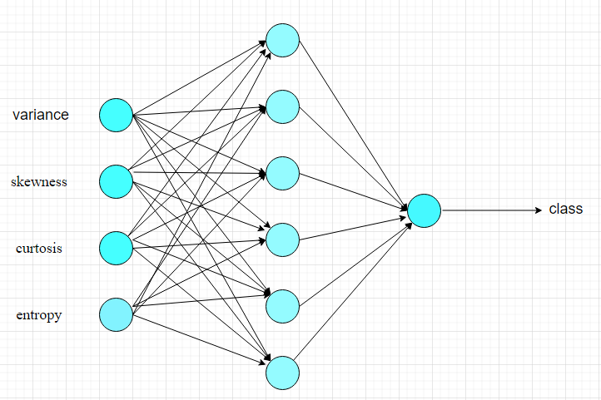

Download the **dataset** from the course shell (Assessment/Assignments/Hands-On Test folder.

Make the **necessary modifications** (the shape of delta1, x, y1) to *backprop* function from BackPropEx1 example. Use **sigmoid activation function** and its derivative where needed.

**Load** the banknote_authentication.csv file and store it in a data frame.

**Extract** input matrix X and output column y from the data frame.

**Split** the dataset into train and test datasets using train_test_split method.

**Initialize** the weights and call backprop function to compute the final weights W1, W2.

**Calculate** the output of the network with final weights for a few inputs from testing set.

**Print** the input, actual output, and predicted output in a friendly format (see sample output below):

x= [-2.3142 2.0838 -0.46813 -1.6767 ] ,y= 1.0 , predicted value= [0.99994195]

x= [ 2.9856 7.2673 -0.409 -2.2431] ,y= 0.0 , predicted value= [0.00214389]

x= [ 2.994 7.2011 -1.2153 0.3211] ,y= 0.0 , predicted value= [0.00230119]

……

(**3 marks**)

**Exercise 2**: **Using MLPs in /Prediction/Classification problems**

Write a Python program to **train the given hepatitis dataset** using **TensorFlow**.

Attribute information:

1. Pregnancies: Number of previous pregnancies
2. Glucose: Plasma glucose concentration
3. BloodPressure: Diastolic blood pressure
4. SkinThickness: Skin fold thickness measured from the triceps
5. Insulin : Blood serum insulin concentration
6. BMI: Body mass index
7. DiabetesPedigreeFunction: A summarized score that indicates the genetic predisposition of the patient for diabetes, as extrapolated from the patient's family record for diabetes
8. Age: Age in years
9. **Class**: The target variable we are trying to predict, **1** for patients that developed diabetes within five years of the initial measurement, and **0** otherwise

Download the **dataset** from the course shell (Assessment/Assignments/Hands-On Test folder.

Load the *diabetes_noheaders.csv* file and store it in a data frame.

You will design an MLP network using the sequential API. Start with an **8-32-16-1** net. Use ReLU activation function for hidden layers and sigmoid for the output layer. Build a classifier. Compile, train, and evaluate the model. You may use *‘binary_crossentropy’* as loss function. Make the necessary adjustments (number of hidden layers, number of neurons per hidden layer) to the net architecture to achieve a high accuracy. Use the model to make predictions (use some test set data for this). Don’t expect to get a high accuracy.

**Print** the input, actual output, and predicted output in a friendly format.

(**7 marks**)

**Evaluation:**

|  |  |
| --- | --- |
| **Functionality:**   * Correct implementation of requirements as specified in exercises | 70% |
| **Design**:   * correct design of classes and methods similarly to class examples * Correct use of naming guidelines for classes, variables, methods. Good use of comments. | 20%  10% |
| **Total** | 100% |

You must name your Jupyter notebook files according to the following rule:

**YourFullName_COMP-258_MidTermTest_F2021_ExerciseNumber**.

Example: **JohnSmith_ COMP-258_MidTermTest_F2021_Ex1**

**Submission rules:**

Submit your solution as a **zip file that includes both Jupyter notebooks and** is named as **YourFullName_COMP-258_MidTermTest_F2021.zip**.