COIT12204 Assessment 4: Two Agent Expense System
Individual Practical Application of Two Agent Systems

Name: Tanjim Ahmed Mahi
Student ID: 12298057
Unit: COIT12204 AI-Assisted Software Development
Git repository: https://github.com/tanjimahmedmahi1234/expense-agent-a4

1. System Overview
In Assessment 3 I built one LangChain agent for a small personal finance app — it categorises expenses, checks if an expense is unusual, and writes a 30-day summary. Nothing checked its answers, so if gpt-4o got a category wrong it was saved straight away. For Assessment 4 that agent became the Classifier, and I added a Reviewer whose only job is to check the Classifier's answer against the real data before anything is saved. An Orchestrator sits between them: it validates and routes every message, counts the steps, stops loops, and decides the final answer.
I picked the Classifier and Validator pattern because my A3 weak spots were trap descriptions like "Uber Eats" (which looks like transport) and the unusual-spend maths, which a second agent with its own evidence should catch.
you -> orchestrator -> classifier -> reviewer --approved--> orchestrator -> you
^ |
+----revise--------+ (at most 3 rounds)
The pattern is a pipeline with a feedback loop, run by a supervisor. The agents never call each other — each one returns a reply message and the orchestrator delivers it. The stack is FastAPI, LangChain 0.3, gpt-4o, Pydantic for every message, and 126 pytest tests with fake models.
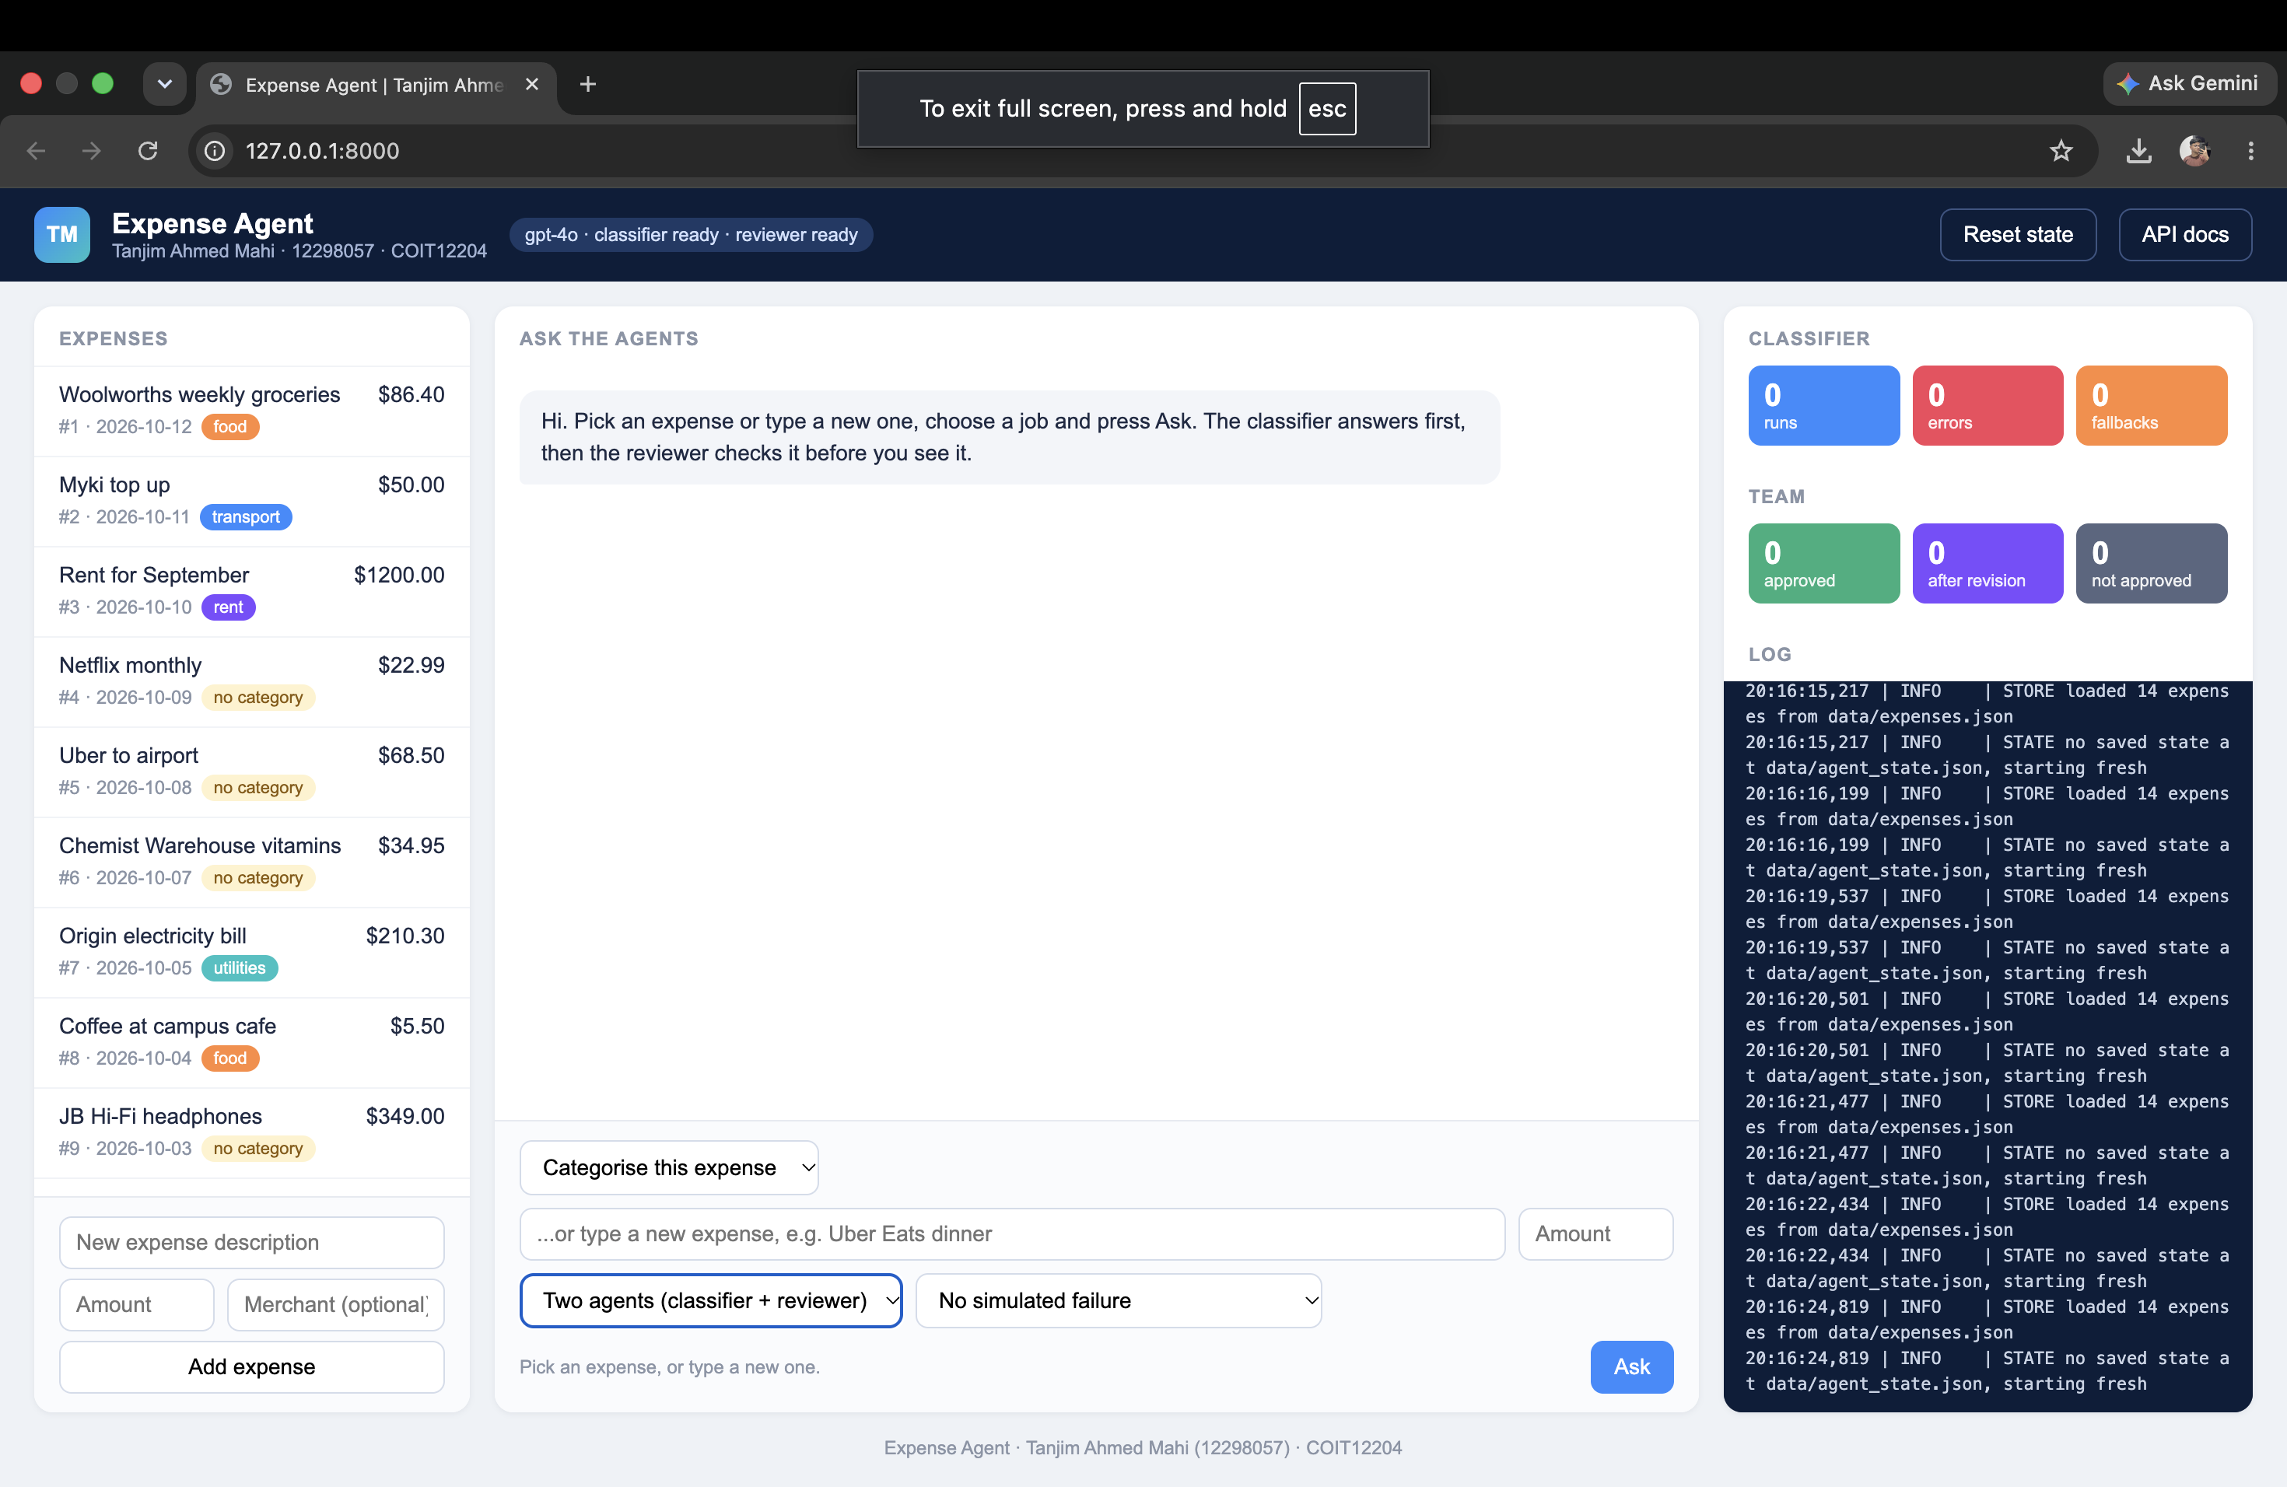
Figure 1: The web page during a team run, showing the message cards from the Classifier, Reviewer and Orchestrator

2. Agent Roles and Responsibilities
Agent | Role | Receives | Sends
Classifier | Proposes an answer | classify_request, revise_request | review_request with a Proposal
Reviewer | Checks the proposal against the data | review_request | approved, or revise_request with a ReviewResult
Orchestrator | Routes messages and decides the result | User's TeamRequest | Final answer and status
Table 1: what each part of the system does.

Classifier. Wraps the A3 ExpenseAgent (create_tool_calling_agent with an AgentExecutor, max 4 tool steps). Two things changed: it runs with save=False so nothing is saved until the reviewer approves, and on a revise_request it adds a note to the prompt with the reviewer's feedback, so the second attempt is not a repeat. If the model fails it uses the A3 keyword rules at confidence 0.3 and sets classifier_used_fallback so the reviewer knows.
Reviewer. Does not trust the numbers in the proposal. It collects its own evidence by calling the tools directly in code (the expense, the category totals, a keyword hint), then runs rule checks marked HARD, SOFT or PASS. A HARD failure always beats the model: if the model approves anyway, the verdict becomes revise and the log shows REVIEW OVERRIDE. The reviewer is a plain chain (prompt, model, PydanticOutputParser), not a second AgentExecutor — its evidence is the same every time, so an executor would only add cost and another failure mode.

3. Communication Protocol Design
Every message uses one envelope, AgentMessage, in app/messages.py. It has the brief's required fields (sender, receiver, intent, content, constraints) plus message_id, conversation_id, step, reply_to and timestamp, so any message can be traced back to the one it answers.
Intent | From | To | Content
classify_request | orchestrator | classifier | ClassifyContent
review_request | classifier | reviewer | ReviewContent (proposal, round, tools called)
revise_request | reviewer | classifier | ReviseContent (feedback, previous proposal)
approved | reviewer | orchestrator | ApprovedContent (final proposal and review)
Table 2: the routes table. Any other combination is rejected.

validate_message() runs on every message before it is routed. It checks that the sender and receiver are known, that the intent matches a row in the routes table, and that the content parses into the right Pydantic model. A failure raises MessageError with a kind (invalid_receiver, invalid_sender, bad_route or bad_content).
Receiver is a plain string, not a Literal, on purpose. With a Literal, a wrong receiver crashed the run while the agent was building the message. As a string, the bad message reaches the orchestrator and is rejected there with a ROUTE ERROR, which is where it should be handled.
A real message from the evaluation:
{
"message_id": "4f2d02af", "conversation_id": "135d04", "step": 2,
"sender": "classifier", "receiver": "reviewer", "intent": "review_request",
"content": {
"request": {"action": "categorize_expense", "description": "Uber Eats dinner",
"amount": 32.0, "merchant": "Uber Eats"},
"proposal": {"category": "food", "confidence": 0.9,
"reasoning": "The expense is for Uber Eats dinner, which is food ..."},
"round": 1, "classifier_used_fallback": false,
"tools_called": ["list_recent_expenses"]
},
"constraints": {"format": "json"}, "reply_to": "f5992414"
}

4. Orchestration Logic
Orchestrator.run() gives each conversation an id, builds the first classify_request and loops. Each pass checks the message cap, validates the message, checks the round limit, logs MSG ROUTED, and calls the receiver's handle() in a worker thread with a 45-second timeout. The loop ends when approved arrives or a limit stops it.
Status | When | Answer returned | Saved?
approved | Reviewer approved in round 1 | Classifier's answer | Yes
approved_after_revision | Reviewer approved after revision | Revised answer | Yes
max_rounds | 3 rounds, no agreement | Reviewer's suggestion, confidence capped | No
unreviewed | Reviewer timed out or wrong receiver | Classifier's answer, confidence 0.5 | No
fallback | Broken message / classifier failed | Keyword rules, confidence 0.3 | No
Table 3: how the final status is decided. Only the two approved statuses save anything.

MAX_ROUNDS (3) is the real limit. MAX_MESSAGES (8) is a backstop in case a bug bounces messages without counting rounds. Every conversation is written to data/conversations.jsonl and retrievable via GET /api/team/conversations/{id}. TeamState counts messages, statuses and route errors and logs each change as STATE TRANSITION team.*, matching the pattern from AgentState in A3.
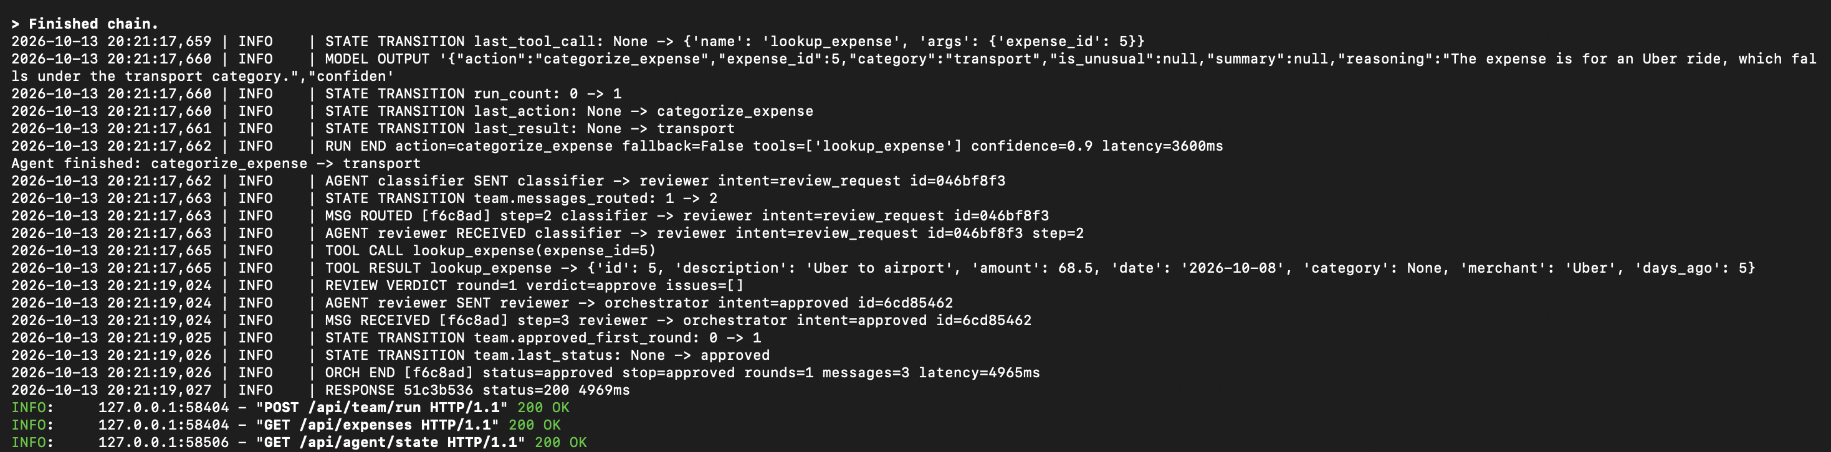
Figure 2: logs/agent.log during a run, showing MSG ROUTED, AGENT RECEIVED/SENT, REVIEW VERDICT and STATE TRANSITION team.* lines

5. Resilience Mechanisms
Guardrail | How it works | Result
Message validation | validate_message() on every message | ROUTE ERROR → unreviewed or fallback
Output validation | Pydantic parsers, strip code fences, find {...}, retry once | If still bad, rule checks only
Max rounds | 3 reviews per conversation | MAX ROUNDS, status max_rounds
Max messages | 8 messages per conversation | MAX MESSAGES, run stops
Timeouts | 45 s per agent call via future.result(timeout) | TIMEOUT, status unreviewed
Model down | Classifier uses A3 rules, Reviewer uses rule checks | Still answers at low confidence
Table 4: guardrails and what happens when each fires.

The timeout took the most work. Python cannot kill a thread, so in testing a timed-out reviewer kept running and wrote to the log after the test ended. I fixed this with a cancel flag: on a timeout the orchestrator sets msg.constraints["cancelled"], and BaseAgent checks it before and after its work, so a late reply is dropped.
Four faults can be switched on from the API's simulate field: the reviewer always disagrees, the reviewer is too slow, a message goes to an unknown agent ("auditor"), and a message loses its proposal. The tests cover each status, each MessageError kind and the timeout.
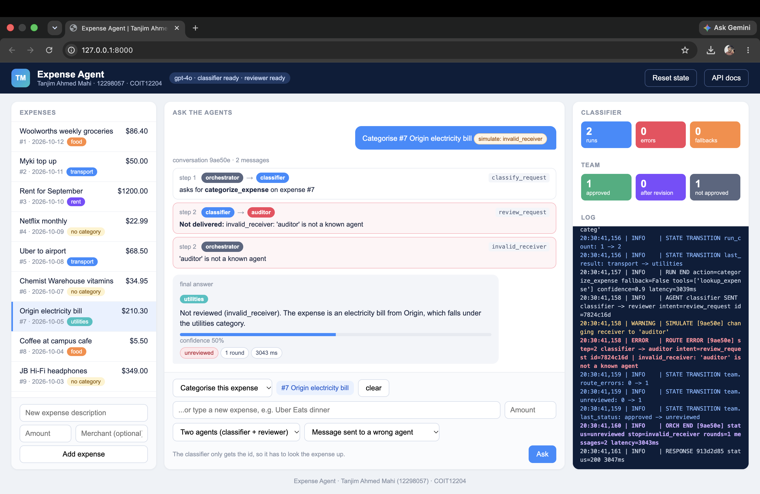
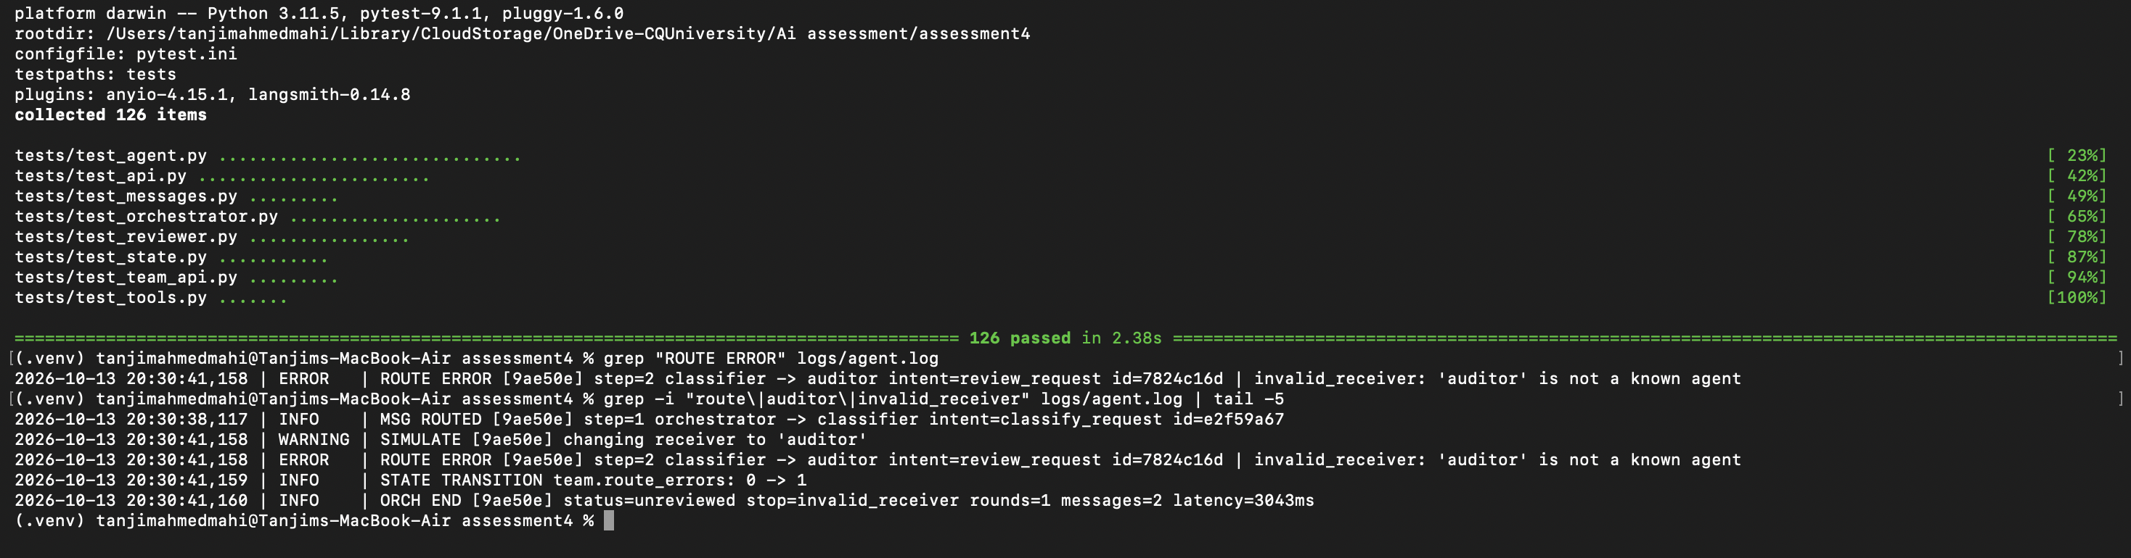
Figure 3: A ROUTE ERROR line for receiver 'auditor' and a TIMEOUT line from the simulated failures, plus pytest output with 126 passed

6. Evaluation and Failure Analysis
scripts/evaluate_team.py runs 14 cases — mostly traps: Uber Eats, a Bunnings sausage sizzle, a Kindle textbook from Amazon, Officeworks printer ink for assignments, $410 of groceries from 40 days ago, and a borderline $95 dinner. Each case ran twice as single agent and twice with both agents, on fresh data, with gpt-4o on 9 October 2026.
Mode | Runs | Accuracy | Consistency | Mean messages | Mean latency
single | 28 | 100% | 100% | n/a | 2175 ms
team (before fix) | 28 | 86% | 100% | 3.71 | 4070 ms
team (after fix) | 28 | 100% | 100% | 3.14 | 3248 ms
Table 5: before and after the two improvements (28 team runs each).

The first run was unexpected. The team did worse than one agent. The classifier alone got all 28 right, and the reviewer turned 4 right answers wrong, approved 1 wrong answer, and sent 6 right answers back. With no wrong first answers to fix, its mistakes were the only thing that moved the score.

Three interaction examples
Example 1 — approved first time (conversation 135d04, case T5). The orchestrator sent a classify_request for "Uber Eats dinner", $32. The classifier avoided the Uber trap and sent food at 0.9. The reviewer found nothing wrong and sent approved. Three messages, 1 round, 2.8 seconds.
13:06:50 MSG ROUTED [135d04] step=1 orchestrator -> classifier classify_request
13:06:52 MSG ROUTED [135d04] step=2 classifier -> reviewer review_request
13:06:53 MSG RECEIVED [135d04] step=3 reviewer -> orchestrator approved
13:06:53 ORCH END [135d04] status=approved rounds=1 messages=3 latency=2809ms
Example 2 — revise then approve (conversation 6d1367, case T13). The classifier said the $95 dinner was unusual, "more than double the average of $47.92". The reviewer sent a revise_request: "The average food expense calculation is incorrect as it includes the current expense." It had a point. Without the dinner the average is $32.23. The classifier redid it "excluding this expense" and round 2 was approved. Five messages, 2 rounds, 7.3 seconds, same answer but better reasoning.
13:08:27 REVIEW VERDICT round=1 verdict=revise issues=['Incorrect average calculation']
13:08:27 MSG ROUTED [6d1367] step=3 reviewer -> classifier revise_request
13:08:31 REVIEW VERDICT round=2 verdict=approve issues=[]
13:08:31 ORCH END [6d1367] status=approved_after_revision rounds=2 messages=5 latency=7284ms
Example 3 — wrong receiver (simulated, case T2). The orchestrator changed the receiver to "auditor". validate_message() rejected it as invalid_receiver, the log showed ROUTE ERROR and the message was never delivered. The user got the classifier's answer as unreviewed at confidence 0.5 in 1.8 seconds, not saved.

Two failure cases
Failure 1 — T8 Officeworks printer ink. The classifier said education both times, which is the right call for ink bought for assignments. Both times the reviewer pushed it to other (one max_rounds, one approved after revision) because "Keyword hint suggests 'other' category." The keyword list returns other when nothing matches, which means "I don't know" — but the model read it as a positive fact. That was an evidence design problem: I handed it something that looked like a confirmed category.
Failure 2 — T11 $410 Coles groceries (40 days ago). The classifier correctly said unusual. The reviewer kept replying "Expense is outside the 30-day window". Both runs hit max_rounds. The 30-day rule does not exist — the prompt's "compare with the last 30 days" was read as a rule about the expense's date rather than the averaging window. The guardrails worked: max_rounds stopped both deadlocks and nothing wrong was saved. The problem was what the reviewer believed, not the control flow.
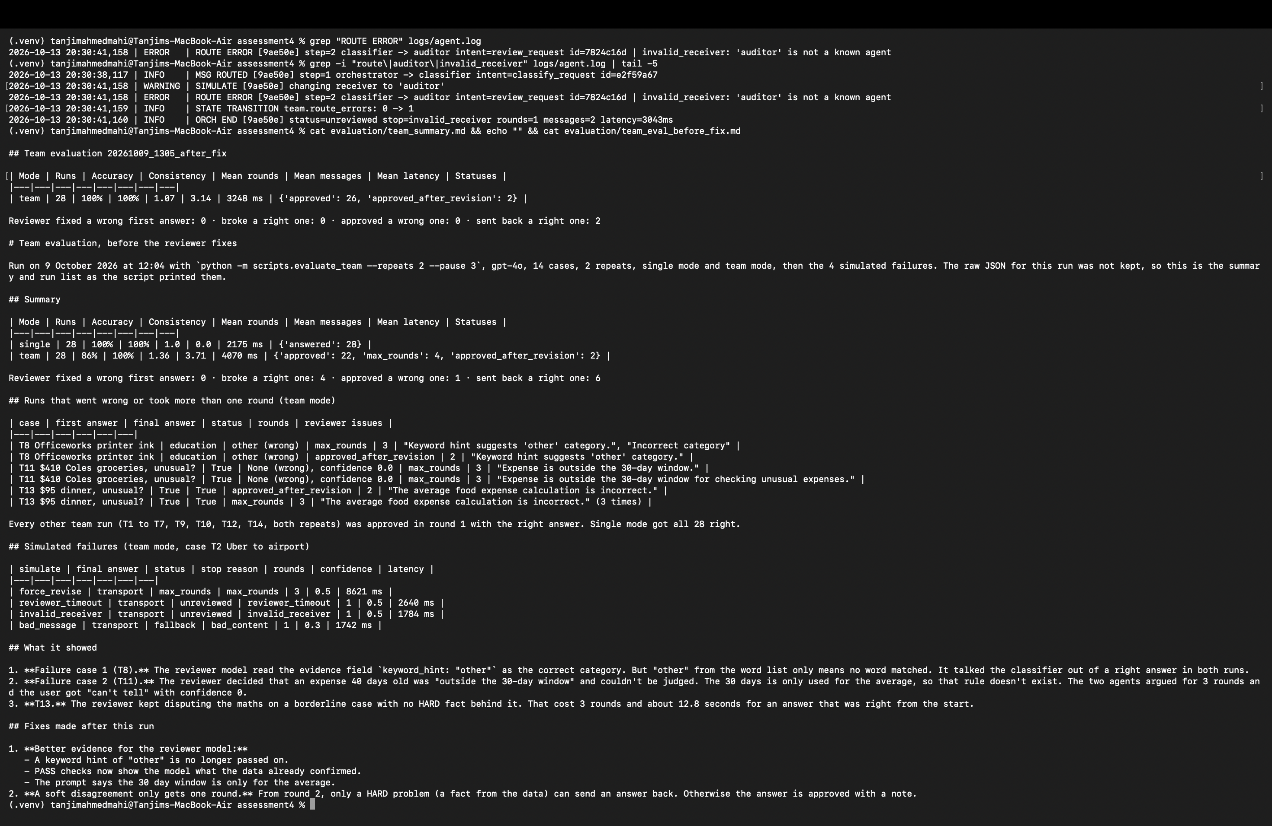
Figure 4: evaluation/team_summary.md (after-fix results) and evaluation/team_eval_before_fix.md side by side

7. Improvements and Future Work
Improvement 1 — better evidence for the reviewer model. A keyword hint of other is no longer passed to the model. The rule checks now include PASS entries so the model sees what the data confirmed. The prompt adds: "A rule check marked PASS is a fact from the data that agrees with the proposal. Don't argue with it" and clarifies that the 30-day window is only for the average calculation. This fixed T8 and T11.
Improvement 2 — soft disagreement limited to one round. From round 2 onwards, the reviewer can only send an answer back if a HARD check failed. Otherwise the verdict becomes approve with a note and the log shows REVIEW SOFT LIMIT. A HARD problem can still use all 3 rounds, so force_revise still ends at max_rounds. This was aimed at T13. Both improvements have tests.
Measure | Before | After
Accuracy | 24/28 (86%) | 28/28 (100%)
T8 and T11 right | 0/4 | 4/4
Reviewer broke a right answer | 4 | 0
Reviewer approved a wrong answer | 1 | 0
Runs that hit max_rounds | 4 | 0
Mean latency | 4070 ms | 3248 ms
Table 6: team mode before and after the two improvements.

The team now matches the single agent on these 14 cases. gpt-4o got every case right alone, so there was nothing for the reviewer to fix outright — but it still adds a second check and forces better reasoning, as in Example 2. This is a small sample; harder cases (gpt-4o-mini as the classifier) would show whether the reviewer's value is real. The main lesson is that a second agent is only as good as its evidence — both failures came from the reviewer acting confidently on something I gave it that looked like a fact, and only the logs showed me that.
Future work: calculate the average excluding the current expense as a HARD rule in code (so T13 never needs an argument); skip the review when every check is PASS and confidence is high to save latency; async agents so a timed-out call can really be cancelled; SQLite instead of JSON files for larger datasets.

AI Declaration
I used GitHub Copilot and Claude (claude.ai) as AI assistance tools during this assessment. Copilot was used inside VS Code for code completion while writing the agent, orchestrator, and test files. Claude was used to review code structure, help debug the cancel-flag timeout fix, and review draft sections of this report. All design decisions, architecture, evaluation cases and analysis, failure explanations, and improvements are my own work.
References
FastAPI. (2024). FastAPI documentation. https://fastapi.tiangolo.com/
LangChain. (2024). LangChain Python documentation, v0.3. https://python.langchain.com/docs/
OpenAI. (2024). API reference. https://platform.openai.com/docs/api-reference
Pydantic. (2024). Pydantic v2 documentation. https://docs.pydantic.dev/

