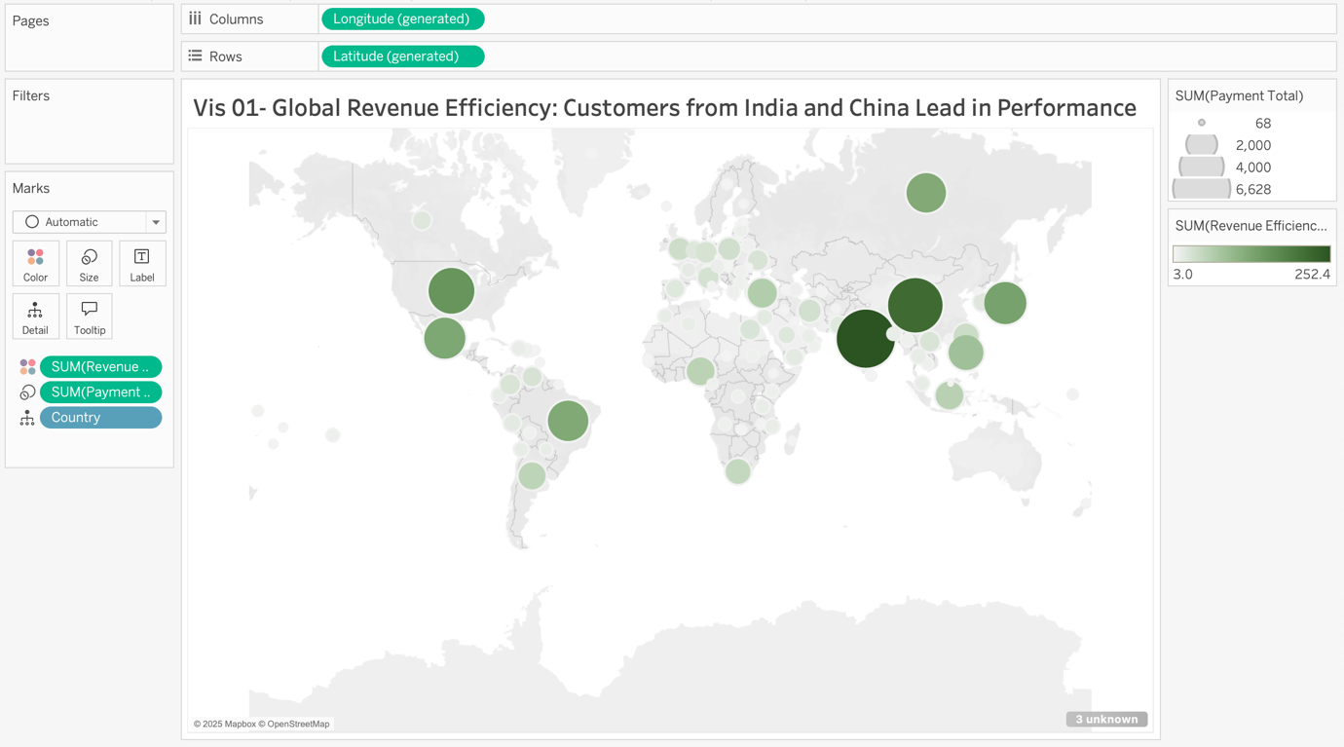

This map shows Payment Total and Revenue Efficiency Score across different countries. Larger circles represent higher total payments, while darker green colors indicate a higher Revenue Efficiency Score, which measures how much revenue is generated per rental.
India has the highest Revenue Efficiency Score of 252.4 and the highest Payment Total of 6,628. China follows with 216.1 and 5,799, while the USA has 151.8 and 4,110.
Businesses can use this to focus on highly efficient markets like India and China, ensuring they maintain strong revenue streams. Meanwhile, they can analyze why some regions have high payments but lower efficiency and adjust pricing or marketing efforts accordingly.

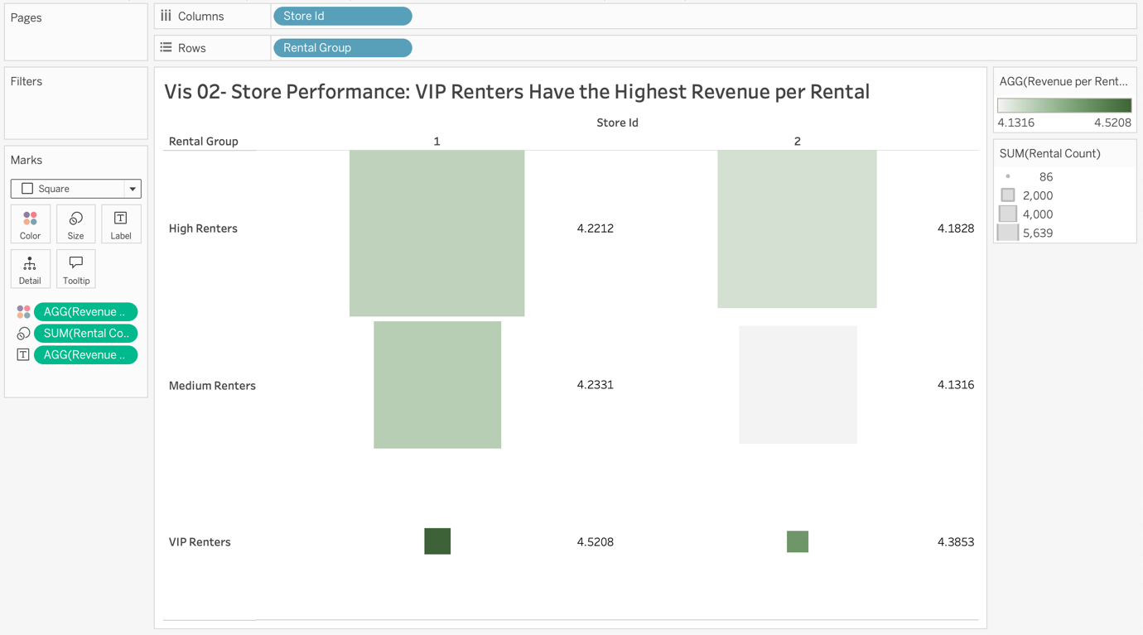

This heatmap shows Revenue per Rental across different rental groups in two stores. The color represents revenue per rental, and the size represents the number of rentals. It helps compare how rental groups contribute to store revenue.
In Store 1, High Renters generate a revenue per rental of 4.22, and Medium Renters have 4.23. In Store 2, High Renters have 4.18, and Medium Renters have 4.13. VIP Renters have the highest revenue per rental, with 4.52 in Store 1 and 4.38 in Store 2, despite having the fewest rentals.
The business can use this to identify which rental groups bring the most value and adjust pricing or promotions. Encouraging more rentals from profitable groups like VIP Renters and offering incentives to lower-revenue renters can optimize overall revenue.

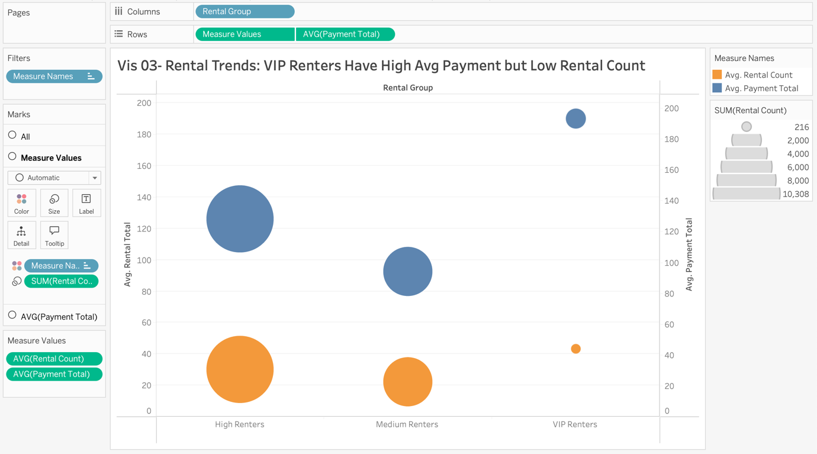

This bubble chart compares the average rental count and payment total across rental groups. Orange bubbles show rental count, blue bubbles show payment total, and bubble size represents total rentals.
High renters have an average rental count of around 40 and an average payment total of about 130. Medium renters have an average rental count of about 25 and an average payment total of 100. VIP renters have the highest average payment total at 200, but they have the lowest rental count since there are only 5 VIP renters.
Businesses can use this to identify which customer segments bring more value and adjust their marketing strategies. Since VIP renters pay more per rental but are very few, the company could introduce exclusive offers to attract similar customers. If high renters generate the most rentals but lower payments, the company could explore subscription-based pricing or bundled offers to increase revenue.

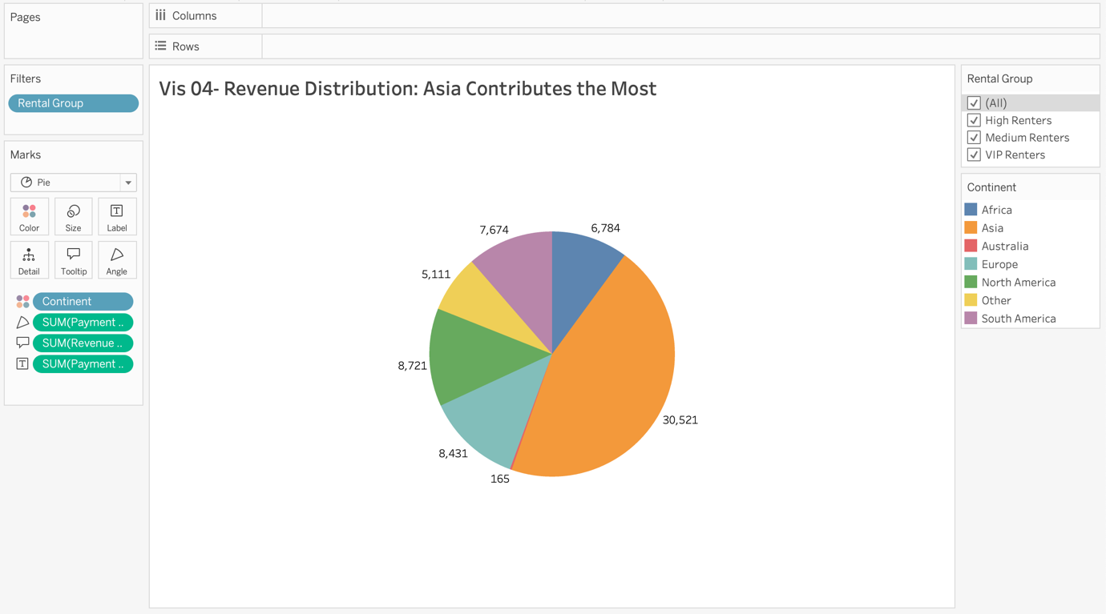

These pie charts show the distribution of payment totals across different continents for different rental groups. We created a calculated column named "Continent" to categorize the countries into regions.
- In the overall chart, Asia has the highest total payments at 30,521, followed by North America at 8,721 and Europe at 8,431.
- The continents that have VIP Renters are Asia, Europe, North America, and Other.
- VIP Renters and High Renters are not present in Australia.

Businesses can use this insight to target high-revenue regions with tailored marketing and pricing strategies while exploring ways to increase engagement in lower-performing areas.

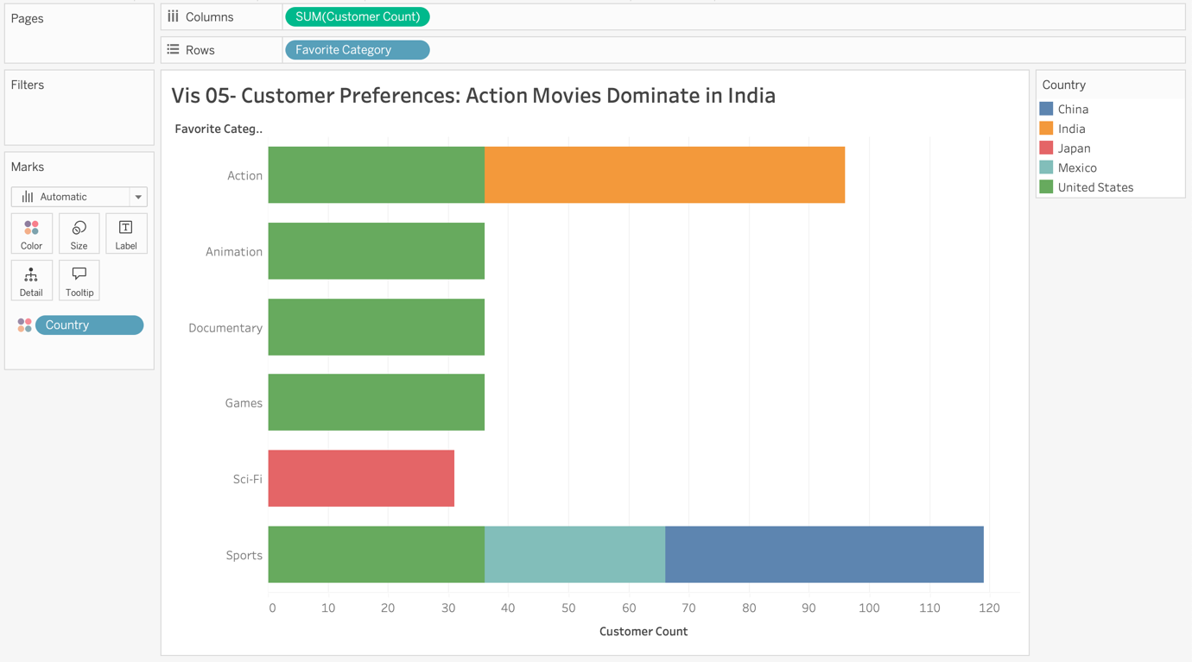

This bar chart shows the most preferred movie categories among customers in the top countries. The length of each bar represents the number of customers who prefer that category, while colors indicate different countries.
- Action movies are the most popular in India, with the highest customer count.
- In the United States and Mexico, Sports and Documentary categories are highly preferred.
- Japan shows a preference for Sci-Fi, while Animation is popular in Mexico.
Businesses can use this insight to tailor content selection and marketing efforts based on regional preferences. By promoting the most popular categories in each country, they can increase customer engagement and maximize revenue.

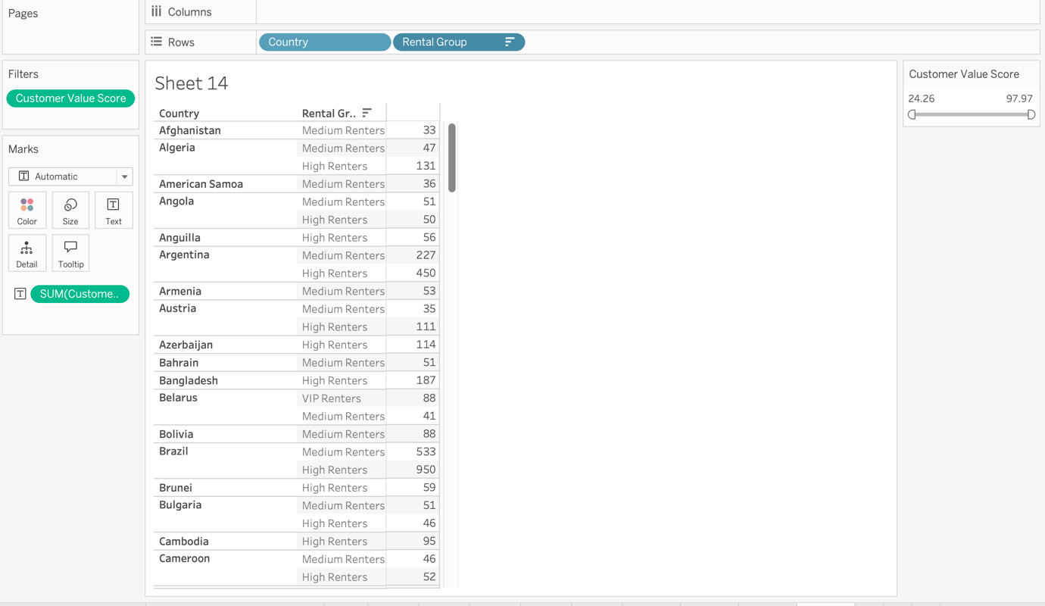

This table shows the Customer Value Score for different rental groups across countries. It helps compare how rental groups contribute based on their activity and payments.
Argentina has 450 high renters and 227 medium renters. Brazil has 950 high renters and 533 medium renters. Bangladesh has 187 high renters, while Belarus has 88 VIP renters and 41 medium renters. The slider on the right lets you filter the table by Customer Value Score.
Businesses can use this to identify high-value customer groups in different countries and create targeted promotions. They can offer discounts or loyalty programs to medium renters to increase spending or focus on high renters to maintain engagement. If a country has low VIP renter activity, they can introduce premium content or exclusive benefits to attract more high-paying customers.

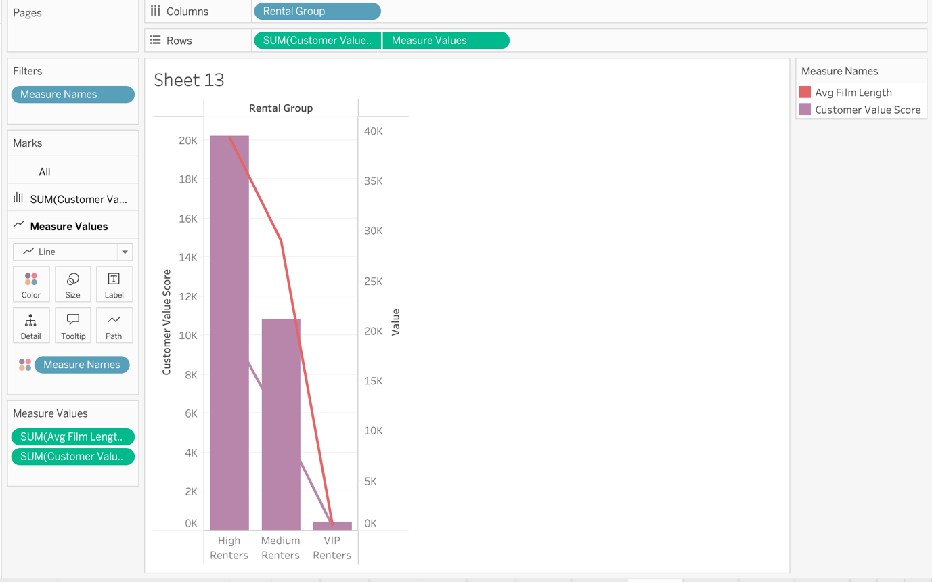

This graph shows the Customer Value Score and Average Film Length across different rental groups. The bars represent the Customer Value Score, while the line represents the Average Film Length.
High renters have the highest Customer Value Score at around 20K, followed by medium renters with 10K, and VIP renters with almost 0. The Average Film Length decreases from nearly 40K for high renters to below 5K for VIP renters.
Businesses can use this to identify which rental groups bring the most value and see if film length affects customer spending. They can recommend longer movies to high-value customers, offer promotions to medium renters, and find ways to engage VIP renters more effectively.

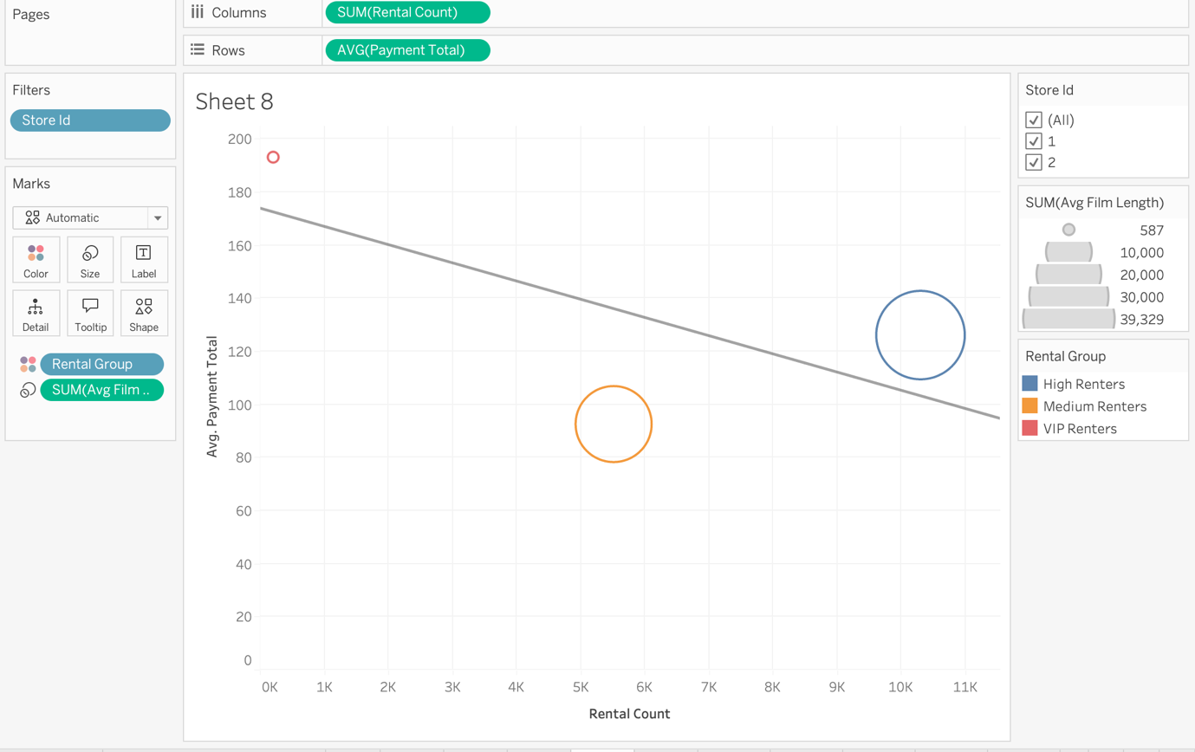

This scatter plot shows the relationship between rental count and average payment total for different rental groups. The bubbles represent rental groups, with their size indicating average film length, and the trend line shows the overall pattern between rental count and average payment total.
High renters have the highest rental count of around 10K but an average payment total of about 120. Medium renters have around 6K rentals and an average payment of 140, while VIP renters have the highest average payment, close to 200, but very few rentals as they are only 5 in number.
Businesses can use this to understand customer spending behavior and adjust pricing strategies. Since VIP renters pay more per rental but are very few, the company could introduce premium content or exclusive deals to attract more similar customers. If high renters generate the most rentals but lower payments, the business could explore upselling strategies or subscription-based pricing to increase revenue.

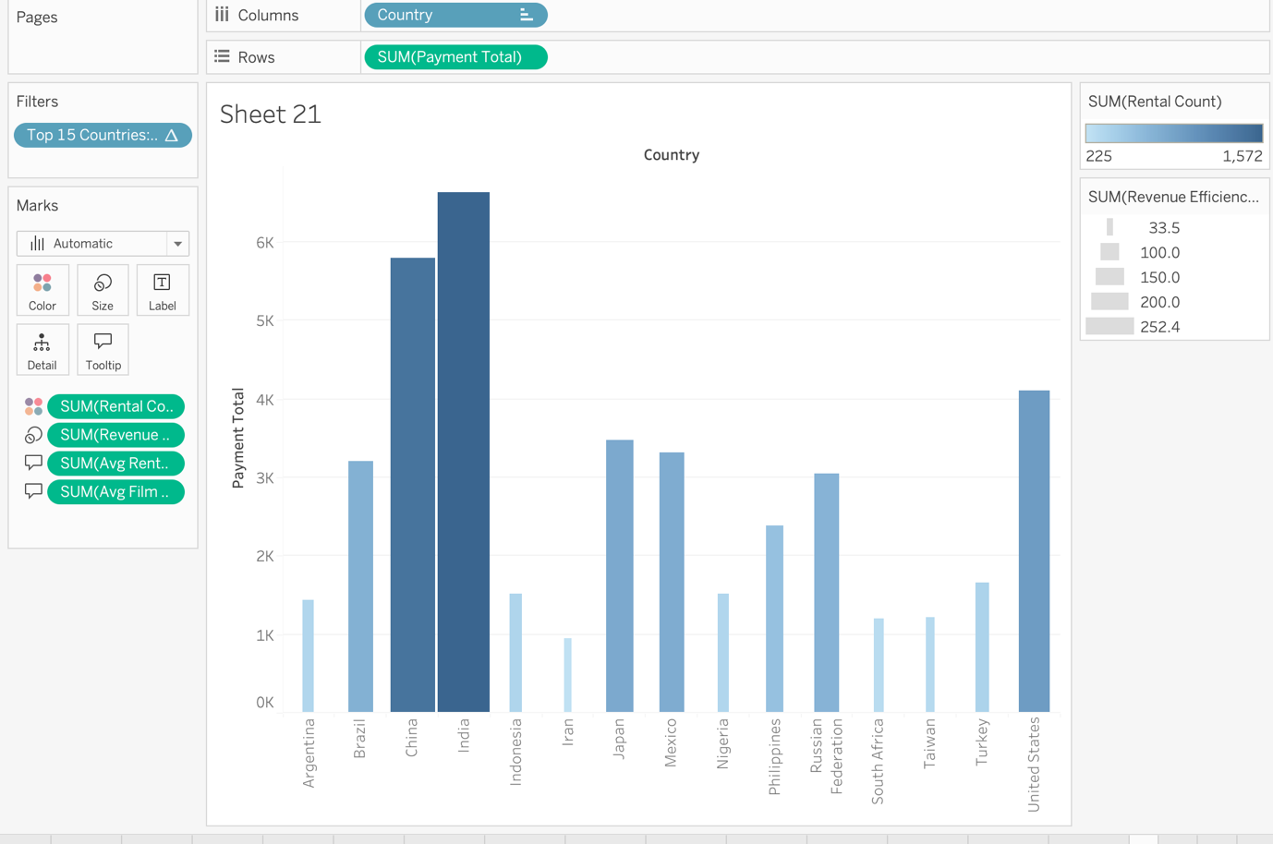

This graph shows the payment total for the top 15 countries, with rental count represented by color intensity and revenue efficiency score represented by size. Darker bars indicate a higher number of rentals, while larger bars represent higher efficiency in generating revenue per rental.
India has the highest payment total of 6,628, followed by China with 5,799, and the United States with 4,110. Brazil and Japan also have high payment totals of 3,170 and 3,074, respectively. India has the highest revenue efficiency score of 252.4, meaning it generates more revenue per rental than other countries.
Businesses can use this data to focus on high-performing markets, identify regions with high rental volume but low efficiency, and optimize pricing strategies. They can also explore why some countries have lower efficiency scores and adjust marketing efforts to maximize revenue.

