Workspace_241124-14_09: FT-SRL
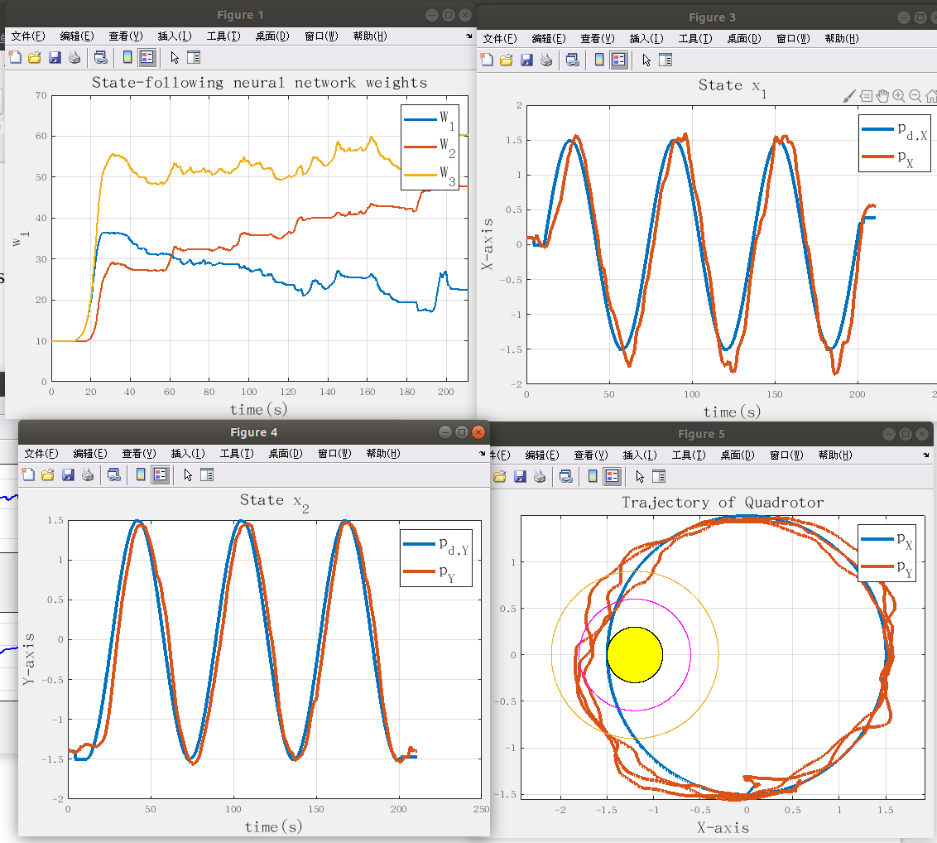
workspace_241124-14_38: FT-NZS
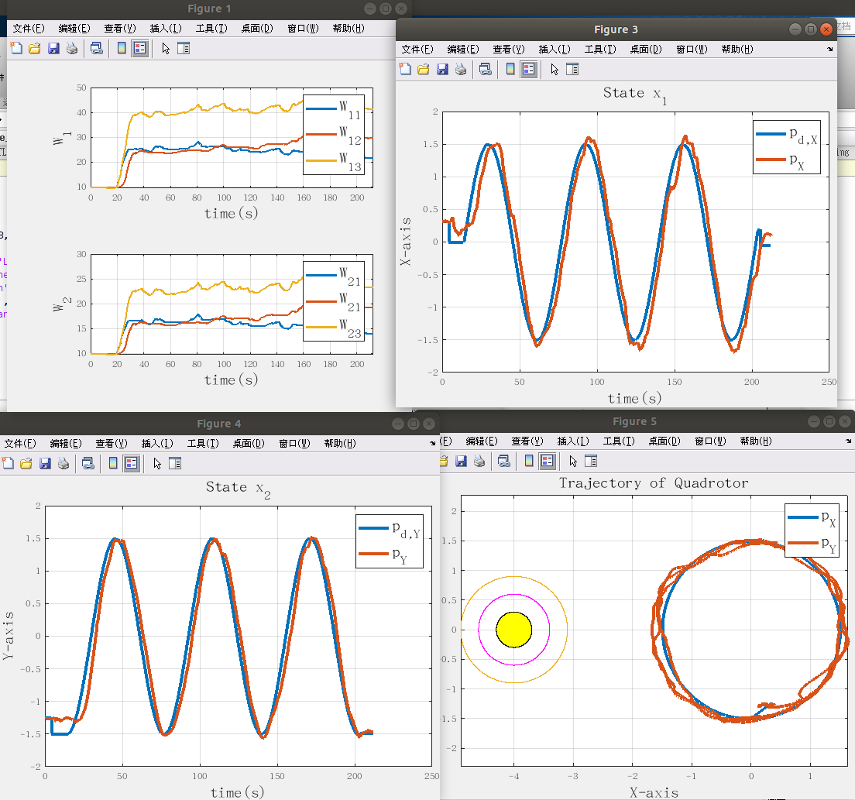
workspace_241124-14_45：FT-SRL-NZS
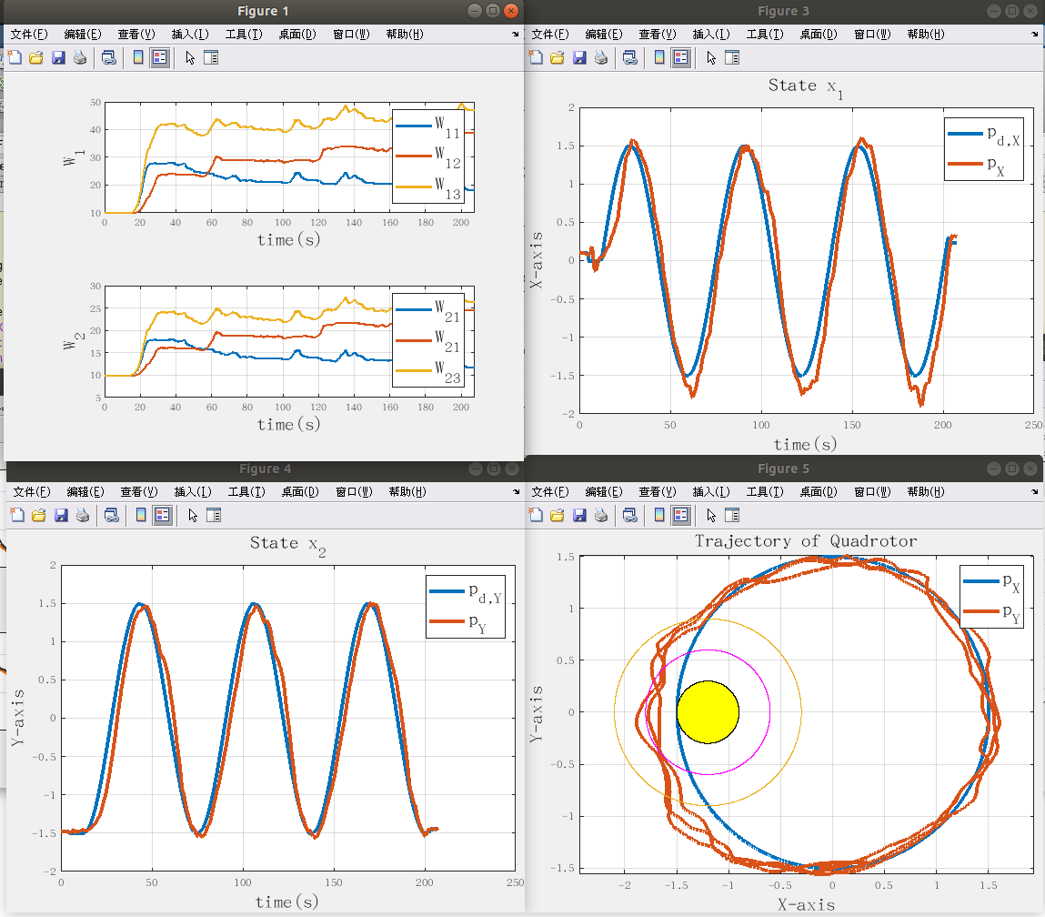
workspace_241124-14_55: StaF-SRL-NZS
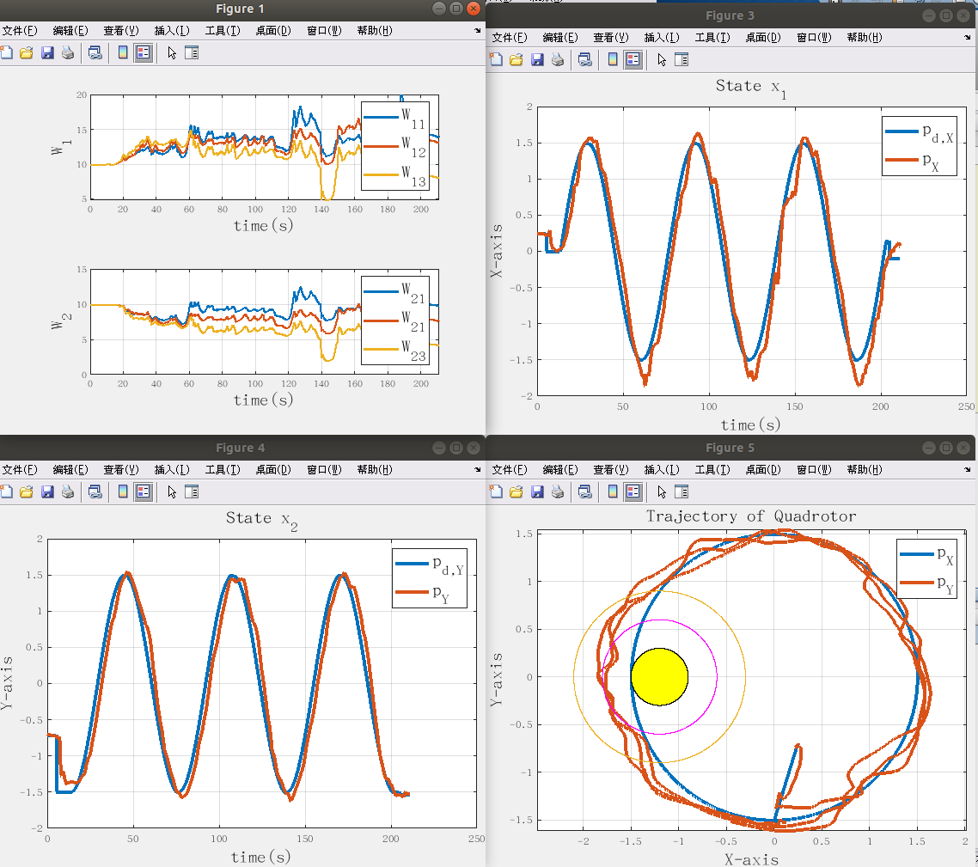
workspace_241124-15_05: NN-SRL-NZS
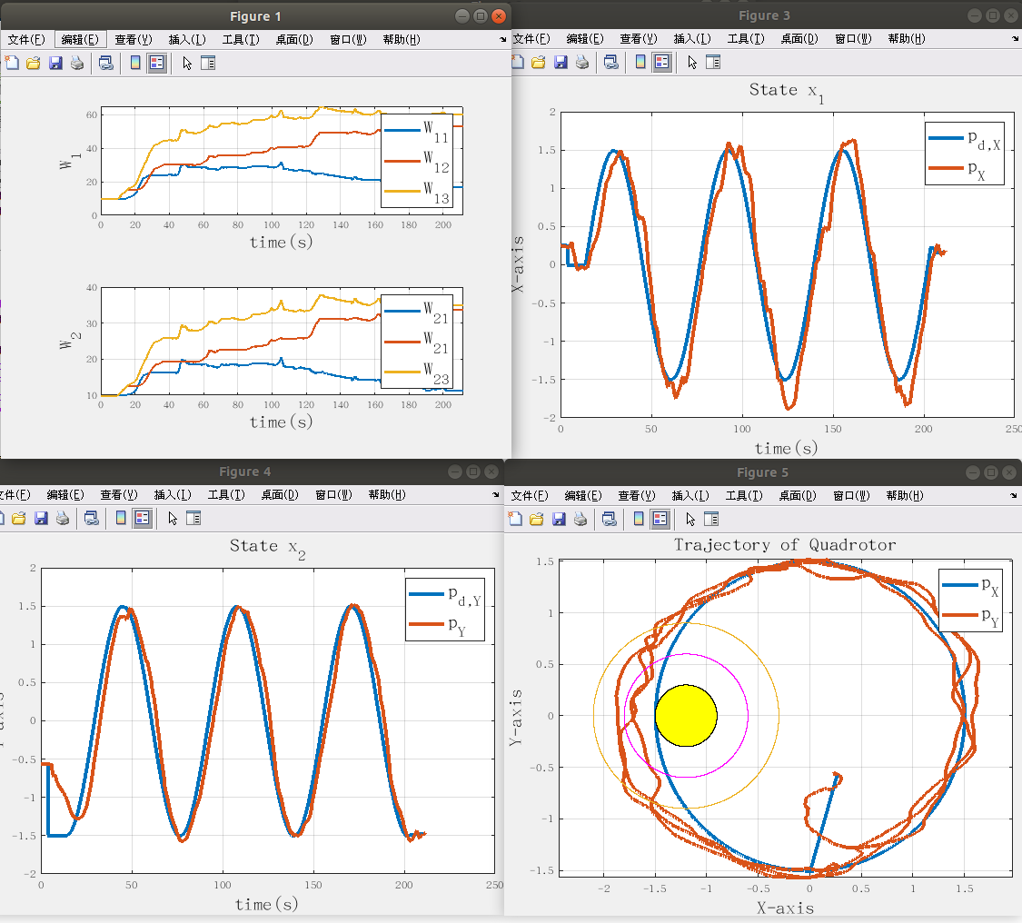
workspace_241124-15_12: NN-NZS
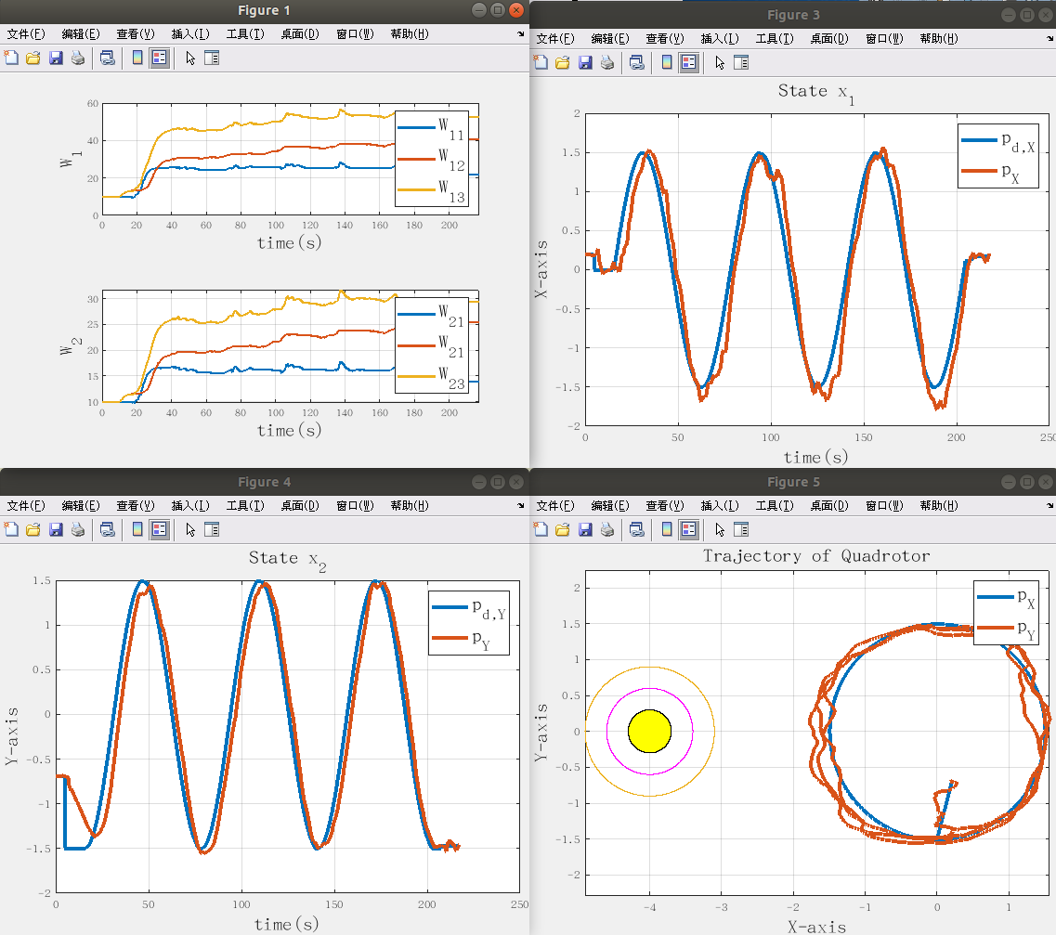
workspace_241124-15_19: StaF-NZS
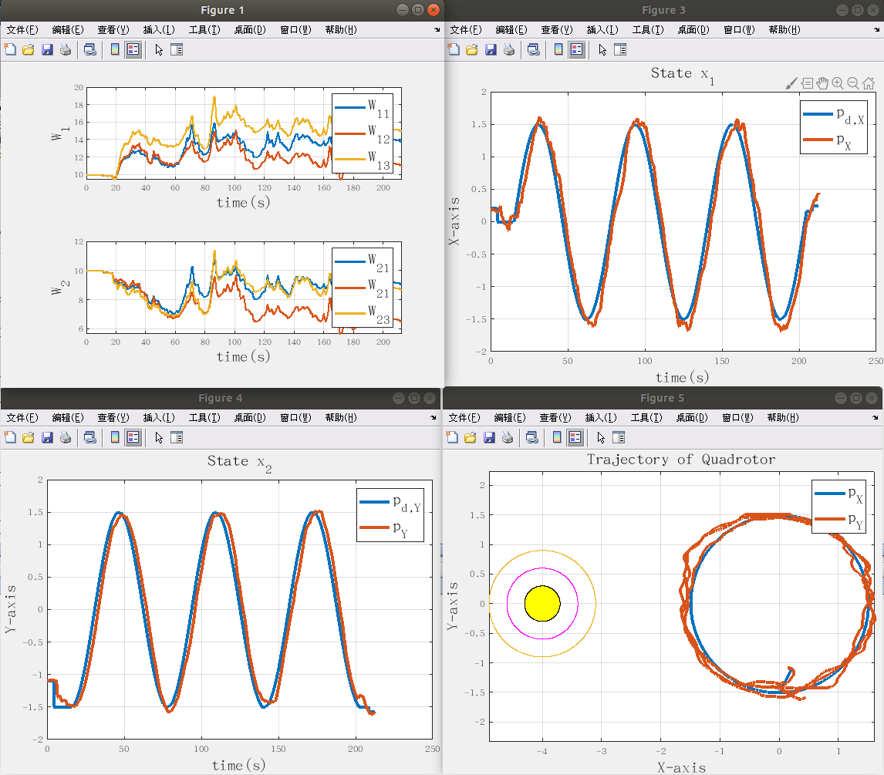
workspace_241124-15_36: 四叶草形状 FT-NZS
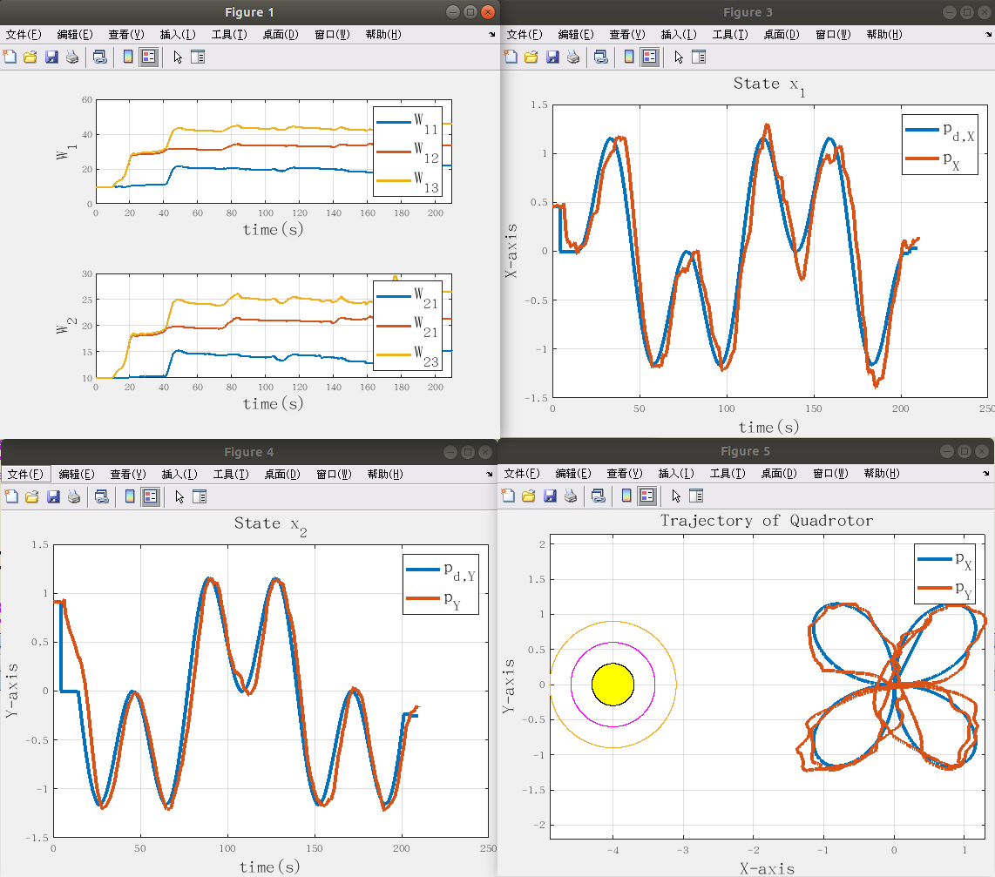

workspace_241124-15_58：FT-SRL-NZS
