准备要打包的资源
使用资源包（AssetBundle）时，可以将任意一个资源打入任意一个资源包。但是在正式打包之前，还是要考虑清楚打包的策略。打包策略就是将资源分组的规则，关键是要适合于具体的游戏。打包策略没有唯一标准，最合适的就是最好的。

按照逻辑功能分组
按逻辑功能分组，意思是根据资源在项目中被用于的功能模块来分组。包括UI系统的、角色的、环境的或是其他系统中。

举例
- 将UI中所用到的所有贴图和布局文件分为一组。
- 将一个或一组角色的模型和动画分为一组。
- Bundling the textures and models for pieces of the scenery shared across multiple levels
Logical Entity Grouping is ideal for downloadable content (DLC) for the fact that, with everything separated in this way, you’re able to make a change to a single entity and not require the download of additional, unchanged, assets.
The biggest trick to being able to properly implement this strategy is that the developer assigning assets to their respective bundles must be familiar with precisely when and where each asset will be used by the project.
按照类型分组
For this strategy you’ll assign assets that are of similar type, such as audio tracks or language localization files, to a single AssetBundle.
Type grouping is one of the better strategies for building AssetBundles to be used by multiple platforms. For example if your audio compression settings are identical between windows and mac platforms, you can pack all audio data into AssetBundles by themselves and reuse those bundles, whereas shaders tend to get compiled with more platform specific options so a shader bundle you build for mac may not be reused on windows. In addition, this method is great for making your AssetBundles compatible with more unity player versions as textures compression formats and settings change less frequently than something like your code scripts or prefabs.

Concurrent Content Grouping
Concurrent Content Grouping is the idea that you will bundle assets together that will be loaded and used at the same time. You could think of these types of bundles as being used for a level based game where each level contains totally unique characters, textures, music, etc. You would want to be absolutely certain that an asset in one of these AssetBundles is only used at the same time the rest of the assets in that bundle are going to be used. Having a dependency on a single asset inside a Concurrent Content Grouping bundle would result in significant increased load times. You would be forced to download the entire bundle for that single asset.
The most common use-case for Concurrent Content Grouping bundles is for bundles that are based on scenes. In this assignment strategy, each scene bundle should contain most or all of that scenes dependencies.
Note that a project absolutely can and should mix these strategies as your needs require. Using the optimal asset assignment strategy for any given scenario greatly increases efficiency for any project.
For example, a project may decide to group its User-Interface (UI) elements for different platforms into their own Platform-UI specific bundle but group its interactive content by level/scene.
Regardless of the strategy you follow, here are some additional tips that are good to keep in mind across the board:
- Split frequently updated objects into AssetBundles separate from objects that rarely change
- Group objects that are likely to be loaded simultaneously. Such as a model, its textures, and its animations
- If you notice multiple objects across multiple AssetBundles are dependant on a single asset from a completely different AssetBundle, move the dependency to a separate AssetBundle. If several AssetBundles are referencing the same group of assets in other AssetBundles, it may be worth pulling those dependencies into a shared AssetBundle to reduce duplication.
- If two sets of objects are unlikely to ever be loaded at the same time, such as Standard and High Definition assets, be sure they are in their own AssetBundles.
- Consider splitting apart an AssetBundle if less that 50% of that bundle is ever frequently loaded at the same time
- Consider combining AssetBundles that are small (less that 5 to 10 assets) but whose content is frequently loaded simultaneously
- If a group of objects are simply different versions of the same object, consider AssetBundle Variants

Building AssetBundles
In the documentation on the AssetBundle Workflow, we have a code sample which passes three arguments to the BuildPipeline.BuildAssetBundles function. Let’s dive a little deeper into what we’re actually saying.
Assets/AssetBundles: This is the directory that the AssetBundles will be output to. You can change this to any output directory you desire, just ensure that the folder actually exists before you attempt a build.

BuildAssetBundleOptions
There are several different BuildAssetBundleOptions that you can specify that have a variety of effects. See Scripting API Reference on BuildAssetBundleOptions for a table of all the options.
While you’re free to combine BuildAssetBundleOptions as needs change and arise, there are three specific BuildAssetBundleOptions that deal with AssetBundle Compression:

BuildAssetBundleOptions.None: This bundle option uses LZMA Format compression, which is a single compressed LZMA stream of serialized data files. LZMA compression requires that the entire bundle is decompressed before it’s used. This results in the smallest possible file size but a slightly longer load time due to the decompression. It is worth noting that when using this BuildAssetBundleOptions, in order to use any assets from the bundle the entire bundle must be uncompressed initially.
Once the bundle has been decompressed, it will be recompressed on disk using LZ4 compression which doesn’t require the entire bundle be decompressed before using assets from the bundle. This is best used when a bundle contains assets such that to use one asset from the bundle would mean all assets are going to be loaded. Packaging all assets for a character or scene are some examples of bundles that might use this.
Using LZMA compression is only recommended for the initial download of an AssetBundle from an off-site host due to the smaller file size. Once the file has been downloaded, it will be cached as a LZ4 compressed bundle.

BuildAssetBundleOptions.UncompressedAssetBundle: This bundle option builds the bundles in such a way that the data is completely uncompressed. The downside to being uncompressed is the larger file download size. However, the load times once downloaded will be much faster.

BuildAssetBundleOptions.ChunkBasedCompression: This bundle option uses a compression method known as LZ4, which results in larger compressed file sizes than LZMA but does not require that entire bundle is decompressed, unlike LZMA, before it can be used. LZ4 uses a chunk based algorithm which allows the AssetBundle be loaded in pieces or “chunks.” Decompressing a single chunk allows the contained assets to be used even if the other chunks of the AssetBundle are not decompressed.

Using ChunkBasedCompression has comparable loading times to uncompressed bundles with the added benefit of reduced size on disk.

BuildTarget
BuildTarget.Standalone: Here we’re telling the build pipeline which target platform we are going to be using these AssetBundles for. You can find a list of the available explicit build targets in the Scripting API Reference for BuildTarget. However, if you’d rather not hardcode in your build target, feel free to take advantage ofEditorUserBuildSettings.activeBuildTarget which will automatically find the platform you’re currently setup to build for and build your AssetBundles based on that target.
Once you’ve properly set up your build script, it’s finally time to build your bundles. If you followed the script example above, click Assets > Build AssetBundles to kick off the process.
Now that you’ve successfully built your AssetBundles, you may notice that your AssetBundles directory has more files than you might have originally expected. 2*(n+1) more files, to be exact. Let’s take a minute and go over exactly what the BuildPipeline.BuildAssetBundles yields.
For every AssetBundle you specified in the editor, you’ll notice a file with your AssetBundle name and your AssetBundle name + “.manifest”.
There will be an additional bundle and manifest that doesn’t share a name with any AssetBundle you created. It, instead, is named after the directory that it’s located in (where the AssetBundles were built to). This is the Manifest Bundle. We’ll discuss more about this and how to use it in the future.

The AssetBundle File
This is the file that lacks the .manifest extension and what you’ll be loading in at runtime in order to load your Assets.
The AssetBundle file is an archive that contains multiple files internally. The structure of this archive can change slightly depending on if it is an AssetBundle or a Scene AssetBundle. This is the structure of a normal AssetBundle:
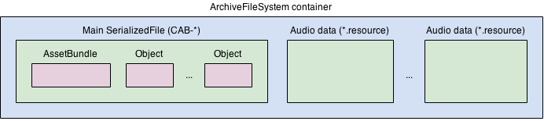
The Scene AssetBundle is different to normal AssetBundles, in that it is optimized for stream loading of a Scene and its content.

The Manifest File
For every bundle generated, including the additional Manifest Bundle, an associated manifest file is generated. The manifest file can be opened with any text editor and contains information such as the cyclic redundancy check (CRC) data and dependency data for the bundle. For the normal AssetBundles their manifest file will look something like this:
ManifestFileVersion: 0
CRC: 2422268106
Hashes:
AssetFileHash:
serializedVersion: 2
Hash: 8b6db55a2344f068cf8a9be0a662ba15
TypeTreeHash:
serializedVersion: 2
Hash: 37ad974993dbaa77485dd2a0c38f347a
HashAppended: 0
ClassTypes:
- Class: 91
Script: {instanceID: 0}
Assets:
Asset_0: Assets/Mecanim/StateMachine.controller
Dependencies: {}
Which shows the contained assets, dependencies, and other information.
The Manifest Bundle that was generated will have a manifest, but it’ll look more like this:
ManifestFileVersion: 0
AssetBundleManifest:
AssetBundleInfos:
Info_0:
Name: scene1assetbundle
Dependencies: {}
This will show how AssetBundles relate and what their dependencies are. For now, just understand that this bundle contains the AssetBundleManifest object which will be incredibly useful for figuring out which bundle dependencies to load at runtime. To learn more about how to use this bundle and the manifest object, see documentation on Using AssetBundles Natively.

AssetBundle Dependencies
AssetBundles can become dependent on other AssetBundles if one or more of the UnityEngine.Objects contains a reference to a UnityEngine.Object located in another bundle. A dependency does not occur if the UnityEngine.Object contains a reference to a UnityEngine.Object that is not contained in any AssetBundle. In this case, a copy of the object that the bundle would be dependent on is copied into the bundle when you build the AssetBundles. If multiple objects in multiple bundles contain a reference to the same object that isn’t assigned to a bundle, every bundle that would have a dependency on that object will make its own copy of the object and package it into the built AssetBundle.
Should an AssetBundle contain a dependency, it is important that the bundles that contain those dependencies are loaded before the object you’re attempting to instantiate is loaded. Unity will not attempt to automatically load dependencies.
Consider the following example, a Material in Bundle 1 references a Texture in Bundle 2:
In this example, before loading the Material from Bundle 1, you would need to load Bundle 2 into memory. It does not matter which order you load Bundle 1 andBundle 2, the important takeaway is that Bundle 2 is loaded before loading the Material from Bundle 1. In the next section, we’ll discuss how you can use theAssetBundleManifest objects we touched on in the previous section to determine, and load, dependencies at runtime.

Using AssetBundles Natively
In Unity 5 there are four different APIs that we can use to load AssetBundles. Their behavior varies based on the platform the bundle is being loaded and the compression method used when the AssetBundles were built (uncompressed, LZMA, LZ4).
The four APIs we have to work with are:
- AssetBundle.LoadFromMemoryAsync
- AssetBundle.LoadFromFile
- WWW.LoadfromCacheOrDownload
- UnityWebRequest’s DownloadHandlerAssetBundle (Unity 5.3 or newer)

AssetBundle.LoadFromMemoryAsync
AssetBundle.LoadFromMemoryAsync
This function takes an array of bytes that contains AssetBundle data. Optionally you can also pass in a CRC value if you desire. If the bundle is LZMA compressed it will decompress the AssetBundle while it’s loading. LZ4 compressed bundles are loaded in their compressed state.
Here’s one example of how to use this method:
IEnumerator LoadFromMemoryAsync(string path)

{

AssetBundleCreateRequest createRequest = AssetBundle.LoadFromMemoryAsync(File.ReadAllBytes(path));

yield return createRequest;

AssetBundle bundle = createRequest.assetBundle;

var prefab = bundle.LoadAsset.<GameObject>("MyObject");
Instantiate(prefab);

}
However, this is not the only strategy that makes using LoadFromMemoryAsync possible. File.ReadAllBytes(path) could be replaced with any desired procedure of obtaining a byte array.

AssetBundle.LoadFromFile
AssetBundle.LoadFromFile
This API is highly-efficient when loading uncompressed bundles from local storage. LoadFromFile will load the bundle directly from disk if the bundle is uncompressed or chunk (LZ4) compressed. Loading a fully compressed (LZMA) bundle with this method will first decompress the bundle before loading it into memory.
One example of how to use LoadFromFile:
public class LoadFromFileExample extends MonoBehaviour {
function Start() {
var myLoadedAssetBundle = AssetBundle.LoadFromFile(Path.Combine(Application.streamingAssetsPath, "myassetBundle"));
if (myLoadedAssetBundle == null) {
Debug.Log("Failed to load AssetBundle!");
return;
}
var prefab = myLoadedAssetBundle.LoadAsset.<GameObject>("MyObject");
Instantiate(prefab);
}
}
Note: On Android devices with Unity 5.3 or older, this API will fail when trying to load AssetBundles from the Streaming Assets path. This is because the contents of that path will reside inside a compressed .jar file. Unity 5.4 and newer can use this API call with Streaming Assets just fine.

WWW.LoadFromCacheOrDownload
WWW.LoadFromCacheOrDownload
TO BE DEPRECATED (Use UnityWebRequest)
This API is useful for downloading AssetBundles from a remote server or loading local AssetBundles. It is the older, and less desirable version of the UnityWebRequest API.
Loading an AssetBundle from a remote location will automatically cache the AssetBundle. If the AssetBundle is compressed, a worker thread will spin up to decompress the bundle and write it to the cache. Once a bundle has been decompressed and cached, it will load exactly like AssetBundle.LoadFromFile.
One example of how to use LoadFromCacheOrDownload:
using UnityEngine;
using System.Collections;

public class LoadFromCacheOrDownloadExample : MonoBehaviour
{
IEnumerator Start ()
{
while (!Caching.ready)
yield return null;

var www = WWW.LoadFromCacheOrDownload("http://myserver.com/myassetBundle", 5);
yield return www;
if(!string.IsNullOrEmpty(www.error))
{
Debug.Log(www.error);
yield return;
}
var myLoadedAssetBundle = www.assetBundle;

var asset = myLoadedAssetBundle.mainAsset;
}
}
Due to the memory overhead of caching an AssetBundle’s bytes in the WWW object, it is recommended that all developers using WWW.LoadFromCacheOrDownload ensure that their AssetBundles remain small - a few megabytes, at most. It is also recommended that developers operating on limited-memory platforms, such as mobile devices, ensure that their code downloads only a single AssetBundle at a time, in order to avoid memory spikes.
If the cache folder does not have any space for caching additional files, LoadFromCacheOrDownload will iteratively delete the least-recently-used AssetBundles from the Cache until sufficient space is available to store the new AssetBundle. If making space is not possible (because the hard disk is full, or all files in the cache are currently in use), LoadFromCacheOrDownload() will bypass Caching and stream the file into memory
In order to force LoadFromCacheOrDownload the version parameter (the second parameter) will need to change. The AssetBundle will only be loaded from cache if the version passed to the function matches the version of the currently cached AssetBundle.

UnityWebRequest
UnityWebRequest
The UnityWebRequest has a specific API call to deal with AssetBundles. To begin, you’ll need to create your web request using UnityWebRequest.GetAssetBundle. After returning the request, pass the request object into DownloadHandlerAssetBundle.GetContent(UnityWebRequest). This GetContent call will return your AssetBundle object.
You can also use the assetBundle property on the DownloadHandlerAssetBundle class after downloading the bundle to load the AssetBundle with the efficiency ofAssetBundle.LoadFromFile.
Here’s an example of how to load an AssetBundle that contains two GameObjects and Instantiate them. To begin this process, we’d just need to callStartCoroutine(InstantiateObject());
IEnumerator InstantiateObject()

{
string uri = "file:///" + Application.dataPath + "/AssetBundles/" + assetBundleName; UnityEngine.Networking.UnityWebRequest request = UnityEngine.Networking.UnityWebRequest.GetAssetBundle(uri, 0);
yield return request.Send();
AssetBundle bundle = DownloadHandlerAssetBundle.GetContent(request);
GameObject cube = bundle.LoadAsset<GameObject>("Cube");
GameObject sprite = bundle.LoadAsset<GameObject>("Sprite");
Instantiate(cube);
Instantiate(sprite);
}
The advantages of using UnityWebRequest is that it allows developers to handle the downloaded data in a more flexible manner and potentially eliminate unnecessary memory usage. This is the more current and preferred API over the UnityEngine.WWW class.

Loading Assets from AssetBundles
Now that you’ve successfully downloaded your AssetBundle, it’s time to finally load in some Assets.
Generic code snippet:
T objectFromBundle = bundleObject.LoadAsset<T>(assetName);
T is the type of the Asset you’re attempting to load.
There are a couple options when deciding how to load Assets. We have LoadAsset, LoadAllAssets, and their Async counterparts LoadAssetAsync and LoadAllAssetsAsyncrespectively.
This is how to load an asset from an AssetBundles synchronously:
To load a single GameObject:
GameObject gameObject = loadedAssetBundle.LoadAsset<GameObject>(assetName);
To load all Assets:
Unity.Object[] objectArray = loadedAssetBundle.LoadAllAssets();
Now, where as the previously shown methods return either the type of object you’re loading or an array of objects, the asynchronous methods return anAssetBundleRequest. You’ll need to wait for this operation to complete before accessing the asset. To load an asset:
AssetBundleRequest request = loadedAssetBundleObject.LoadAssetAsync<GameObject>(assetName);
yield return request;
var loadedAsset = request.asset;
And
AssetBundleRequest request = loadedAssetBundle.LoadAllAssetsAsync();
yield return request;
var loadedAssets = request.allAssets;
Once you have loaded your Assets you’re good to go! You’re able to use the loaded objects as you would any Object in Unity.

Loading AssetBundle Manifests
Loading AssetBundle manifests can be incredibly useful. Especially when dealing with AssetBundle dependencies.
To get a useable AssetBundleManifest object, you’ll need to load that additional AssetBundle (the one that’s named the same thing as the folder it’s in) and load an object of type AssetBundleManifest from it.
Loading the manifest itself is done exactly the same as any other Asset from an AssetBundle:
AssetBundle assetBundle = AssetBundle.LoadFromFile(manifestFilePath);
AssetBundleManifest manifest = assetBundle.LoadAsset<AssetBundleManifest>("AssetBundleManifest");
Now you have access to the AssetBundleManifest API calls through the manifest object from the above example. From here you can use the manifest to get information about the AssetBundles you built. This information includes dependency data, hash data, and variant data for the AssetBundles.
Remember in the earlier section when we discussed AssetBundle Dependencies and how, if a bundle had a dependency on another bundle, those bundles would need to be loaded in before loading any Assets from the original bundle? The manifest object makes dynamically finding a loading dependencies possible. Let’s say we want to load all the dependencies for an AssetBundle named “assetBundle”.
AssetBundle assetBundle = AssetBundle.LoadFromFile(manifestFilePath);
AssetBundleManifest manifest = assetBundle.LoadAsset<AssetBundleManifest>("AssetBundleManifest");
string[] dependencies = manifest.GetAllDependencies("assetBundle"); //Pass the name of the bundle you want the dependencies for.
foreach(string dependency in dependencies)
{
AssetBundle.LoadFromFile(Path.Combine(assetBundlePath, dependency));
}
Now that you’re loading AssetBundles, AssetBundle dependencies, and Assets, it’s time to talk about managing all of these loaded AssetBundles.

Managing Loaded AssetBundles
See also: Unity Learn tutorial on Managing Loaded AssetBundles
Unity does not automatically unload Objects when they are removed from the active scene. Asset cleanup is triggered at specific times, and it can also be triggered manually.
It is important to know when to load and unload an AssetBundle. Improperly unloading an AssetBundle can lead to duplicating objects in memory or other undesirable circumstances, such as missing textures.
The biggest thing to understand about AssetBundle management is when to call
AssetBundle.Unload(bool); and if you should pass true or false into the function call. Unload is a non-static function that will unload your AssetBundle. This API unloads the header information of the AssetBundle being called. The argument indicates whether to also unload all Objects instantiated from this AssetBundle.
AssetBundle.Unload(true) unloads all GameObjects (and their dependencies) that were loaded from the AssetBundle. This does not include copied GameObjects (such as Instantiated GameObjects), because they no longer belong to the AssetBundle. When this happens, Textures that are loaded from that AssetBundle (and still belong to it) disappear from GameObjects in the Scene, and Unity treats them as missing Textures.
Let’s assume Material M is loaded from AssetBundle AB as shown below.
If AB.Unload(true) is called. Any instance of M in the active scene will also be unload and destroyed.
If you were instead to call AB.Unload(false) it would break the chain of the current instances of M and AB.
If AB is loaded again later and AB.LoadAsset() is called, Unity will not re-link the existing copies of M to the newly loaded Material. There will instead be two copies of M loaded.
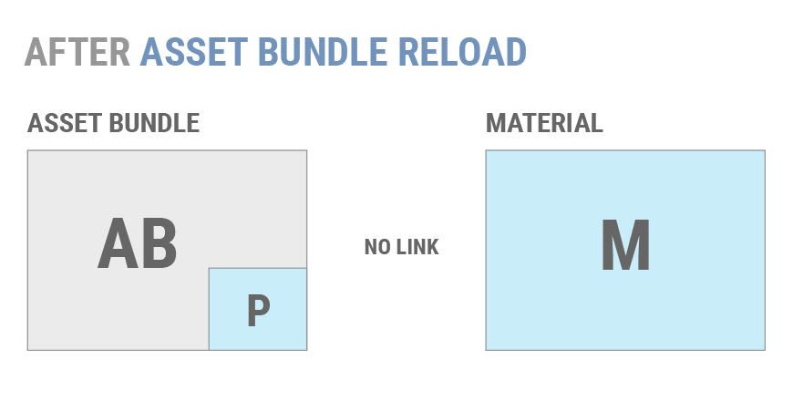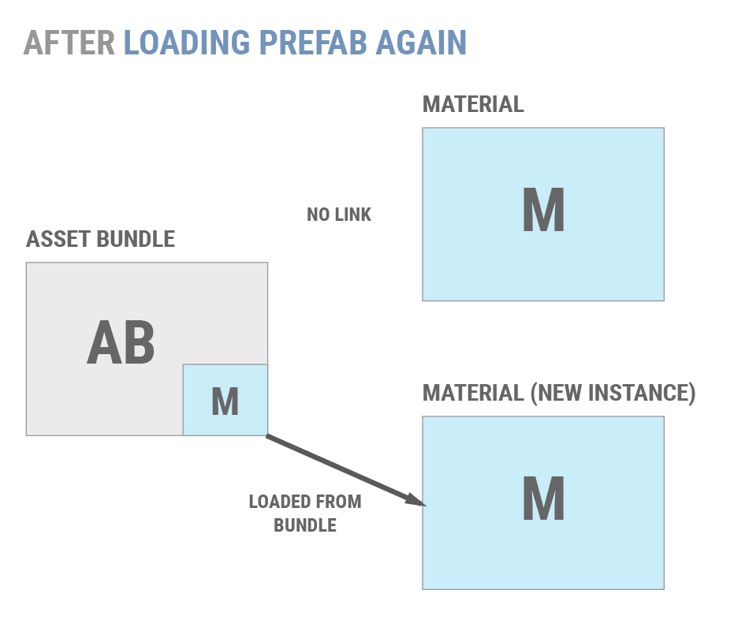
Generally, using AssetBundle.Unload(false) does not lead to an ideal situation. Most projects should use AssetBundle.Unload(true) to keep from duplicating objects in memory.
Most projects should use AssetBundle.Unload(true) and adopt a method to ensure that Objects are not duplicated. Two common methods are:

Having well-defined points during the application’s lifetime at which transient AssetBundles are unloaded, such as between levels or during a loading screen.

Maintaining reference-counts for individual Objects and unload AssetBundles only when all of their constituent Objects are unused. This permits an application to unload & reload individual Objects without duplicating memory.

If an application must use AssetBundle.Unload(false), then individual Objects can only be unloaded in two ways:

Eliminate all references to an unwanted Object, both in the scene and in code. After this is done, call Resources.UnloadUnusedAssets.

Load a scene non-additively. This will destroy all Objects in the current scene and invoke Resources.UnloadUnusedAssets automatically.

If you’d rather not manage loading Asset Bundes, dependencies, and Assets yourself, you might find yourself in need of the AssetBundle Manager.

AssetBundle Manager
The AssetBundle Manager, which can be downloaded here, is a tool made by Unity to make using AssetBundles more streamlined.
Downloading and importing the AssetBundle Manager package not only adds a new API calls for loading and using AssetBundles but it adds some Editor functionality to streamline the workflow as well. This functionality can be found under the Assets menu option.
This new section will contain the following options:

Simulation Mode
Enabling Simulation Mode allows the AssetBundle Manager to work with AssetBundles but does not require the bundles themselves actually be built. The editor looks to see what Assets have been assigned to AssetBundles and uses the Assets directly, instead of actually pulling them from an AssetBundle.
The main advantage of using Simulation Mode is that Assets can be modified, updated, added, and deleted without the need to re-build and deploy the AssetBundles every time.
It is worth noting that AssetBundle Variants do not work with Simulation Mode. If you need to use variants, Local AssetBundle Server is the option you need.

Local AssetBundle Server
The AssetBundle Manager can also start a Local AssetBundle Server which can be used to test AssetBundles in the editor or in local builds (including Mobile).
The stipulation to getting the Local AssetBundle Server to work is that you must create a folder called AssetBundles in the root directory of your project which is the same level as the Assets folder. Such as:
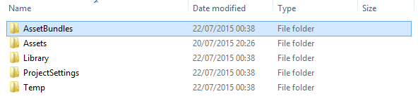
After you create the folder you’ll need to build your AssetBundles to this folder. To do this, select Build AssetBundles from the new menu options. This will build them to that directory for you.
Now you have your AssetBundles built (or have decided to use Simulation Mode) and are ready to start loading AssetBundles. Let’s look at the new API calls available to us through the AssetBundle Manager.

AssetBundleManager.Initialize()
This function loads the AssetBundleManifest object. You’ll need to call this before you start loading in Assets using the AssetBundle Manager. In a very simplified example, initializing the AssetBundle Manager could look like this:
IEnumerator Start()

{
yield return StartCoroutine(Initialize());
}
IEnumerator Initialize()
{
var request = AssetBundleManager.Initialize();
if (request != null)
yield return StartCoroutine(request);
}
The AssetBundle Manager uses this manifest you load during the Initialize() to help with a number of features behind the scenes, including dependency management.

Loading Assets
Let’s get right down to it. You’re using the AssetBundle Manager, you’ve initialized it, and now you’re ready to load some Assets. Let’s take a look at how to load the AssetBundle and instantiate an object from that bundle:
IEnumerator InstantiateGameObjectAsync (string assetBundleName, string assetName)

{
// Load asset from assetBundle.
AssetBundleLoadAssetOperation request = AssetBundleManager.LoadAssetAsync(assetBundleName, assetName, typeof(GameObject) );
if (request == null)
yield break;
yield return StartCoroutine(request);
// Get the asset.
GameObject prefab = request.GetAsset<GameObject> ();
if (prefab != null)
GameObject.Instantiate(prefab);
}
The AssetBundle Manager performs all of it’s load operation asynchronously so it returns a load operation request that loads the bundle upon calling yield return StartCoroutine(request); From there all we need to do is call the GetAsset<T>() to load a game object from the AssetBundle.

Loading Scenes
If you’ve got an AssetBundle name assigned to a scene and you need to load that scene in you’ll need to follow a slightly different code path. The pattern is relatively the same, but with slight differences. Here’s how to load a scene from an AssetBundle:
IEnumerator InitializeLevelAsync (string levelName, bool isAdditive)

{
// Load level from assetBundle.
AssetBundleLoadOperation request = AssetBundleManager.LoadLevelAsync(sceneAssetBundle, levelName, isAdditive);
if (request == null)
yield break;
yield return StartCoroutine(request);
}
As you can see, loading scenes is also an asynchronous and LoadLevelAsync returns a load operation request which will need to be passed to a StartCoroutine in order to load the scene.

Load Variants
Loading variants using the AssetBundle Manager doesn’t actually change the code need to load in the scenes or assets. All that needs to be done is set the ActiveVariants property of the AssetBundleManager.
The ActiveVariants property is an array of strings. Simply build an array of strings containing the names of the variants you created during assigning them to the Assets. Here’s how to load a scene AssetBundle with the hd variant.
IEnumerator InitializeLevelAsync (string levelName, bool isAdditive, string[] variants)

{
//Set the activeVariants.
AssetBundleManager.ActiveVariants = variants;
// Load level from assetBundle.
AssetBundleLoadOperation request = AssetBundleManager.LoadLevelAsync(variantSceneAssetBundle, levelName, isAdditive);
if (request == null)
yield break;
yield return StartCoroutine(request);
}
Where you’d pass in the string array you built up elsewhere in your code (perhaps from a button click or some other circumstances). This will load the bundles that match the set active variants if it is available.

Patching with AssetBundles
Patching AssetBundles is as simple as downloading a new AssetBundle and replacing the existing one. If WWW.LoadFromCacheOrDownload or UnityWebRequest are used to manage an application’s cached AssetBundles, passing a different version parameter to the chosen API will trigger a download of the new AssetBundles.
The more difficult problem to solve in the patching system is detecting which AssetBundles to replace. A patching system requires two lists of information:
- A list of the currently downloaded AssetBundles, and their versioning information
- A list of the AssetBundles on the server, and their versioning information
The patcher should download the list of server-side AssetBundles and compare the AssetBundle lists. Missing AssetBundles, or AssetBundles whose versioning information has changed, should be re-downloaded.
It is also possible to write a custom system for detecting changes to AssetBundles. Most developers who write their own system choose to use an industry-standard data format for their AssetBundle file lists, such as JSON, and a standard C# class for computing checksums, such as MD5.
Unity builds AssetBundles with data ordered in a deterministic manner. This allows applications with custom downloaders to implement differential patching.
Unity does not provide any built-in mechanism for differential patching and neither WWW.LoadFromCacheOrDownload nor UnityWebRequest perform differential patching when using the built-in caching system. If differential patching is a requirement, then a custom downloader must be written.

Troubleshooting
This section describes several problems that commonly appear in projects using AssetBundles.

Asset Duplication
Unity 5’s AssetBundle system will discover all dependencies of an Object when the Object is built into an AssetBundle. This is done using the Asset Database. This dependency information is used to determine the set of Objects that will be included in an AssetBundle.
Objects that are explicitly assigned to an AssetBundle will only be built into that AssetBundle. An Object is “explicitly assigned” when that Object’s AssetImporter has its assetBundleName property set to a non-empty string.
Any Object that is not explicitly assigned in an AssetBundle will be included in all AssetBundles that contain 1 or more Objects that reference the untagged Object.
If two different Objects are assigned to two different AssetBundles, but both have references to a common dependency Object, then that dependency Object will be copied into both AssetBundles. The duplicated dependency will also be instanced, meaning that the two copies of the dependency Object will be considered different Objects with a different identifiers. This will increase the total size of the application’s AssetBundles. This will also cause two different copies of the Object to be loaded into memory if the application loads both of its parents.
There are several ways to address this problem:

Ensure that Objects built into different AssetBundles do not share dependencies. Any Objects which do share dependencies can be placed into the same AssetBundle without duplicating their dependencies.

  - This method usually is not viable for projects with many shared dependencies. It can produce monolithic AssetBundles that must be rebuilt and re-downloaded too frequently to be convenient or efficient.

Segment AssetBundles so that no two AssetBundles that share a dependency will be loaded at the same time.

  - This method may work for certain types of projects, such as level-based games. However, it still unnecessarily increases the size of the project’s AssetBundles, and increases both build times and loading times.

Ensure that all dependency assets are built into their own AssetBundles. This entirely eliminates the risk of duplicated assets, but also introduces complexity. The application must track dependencies between AssetBundles, and ensure that the right AssetBundles are loaded before calling any AssetBundle.LoadAsset APIs.

In Unity 5, Object dependencies are tracked via the AssetDatabase API, located in the UnityEditor namespace. As the namespace implies, this API is only available in the Unity Editor and not at runtime. AssetDatabase.GetDependencies can be used to locate all of the immediate dependencies of a specific Object or Asset. Note that these dependencies may have their own dependencies. Additionally, the AssetImporter API can be used to query the AssetBundle to which any specific Object is assigned.
By combining the AssetDatabase and AssetImporter APIs, it is possible to write an Editor script that ensures that all of an AssetBundle’s direct or indirect dependencies are assigned to AssetBundles, or that no two AssetBundles share dependencies that have not been assigned to an AssetBundle. Due to the memory cost of duplicating assets, it is recommended that all projects have such a script.

Sprite Atlas Duplication
The following sections describe a quirk of Unity 5’s asset dependency calculation code when used in conjunction with automatically-generated sprite atlases.
Any automatically-generated sprite atlas will be assigned to the AssetBundle containing the Sprite Objects from which the sprite atlas was generated. If the sprite Objects are assigned to multiple AssetBundles, then the sprite atlas will not be assigned to an AssetBundle and will be duplicated. If the Sprite Objects are not assigned to an AssetBundle, then the sprite atlas will also not be assigned to an AssetBundle.
To ensure that sprite atlases are not duplicated, check that all sprites tagged into the same sprite atlas are assigned to the same AssetBundle.
Unity 5.2.2p3 and older
Automatically-generated sprite atlases will never be assigned to an AssetBundle. Because of this, they will be included in any AssetBundles containing their constituent sprites and also any AssetBundles referencing their constituent sprites.
Because of this problem, it is strongly recommended that all Unity 5 projects using Unity’s sprite packer upgrade to Unity 5.2.2p4, 5.3 or any newer version of Unity.
For projects that cannot upgrade, there are two workarounds for this problem:

Easy: Avoid using Unity’s built-in sprite packer. Sprite atlases generated by external tools will be normal Assets, and can be properly assigned to an AssetBundle.

Hard: Assign all Objects that use automatically atlased sprites to the same AssetBundle as the sprites.

This will ensure that the generated sprite atlas is not seen as the indirect dependency of any other AssetBundles and will not be duplicated.

This solution preserves the workflow of using Unity’s sprite packer, but it degrades developers’ ability to separate Assets into different AssetBundles, and forces the re-download of an entire sprite atlas when any data changes on any component referencing the atlas, even if the atlas itself is unchanged.

Android Textures
Due to heavy device fragmentation in the Android ecosystem, it is often necessary to compress textures into several different formats. While all Android devices support ETC1, ETC1 does not support textures with alpha channels. Should an application not require OpenGL ES 2 support, the cleanest way to solve the problem is to use ETC2, which is supported by all Android OpenGL ES 3 devices.
Most applications need to ship on older devices where ETC2 support is unavailable. One way to solve this problem is with Unity 5’s AssetBundle Variants. (Please see Unity’s Android optimization guide for details on other options.)
To use AssetBundle Variants, all textures that cannot be cleanly compressed using ETC1 must be isolated into texture-only AssetBundles. Next, create sufficient variants of these AssetBundles to support the non-ETC2-capable slices of the Android ecosystem, using vendor-specific texture compression formats such as DXT5, PVRTC and ATITC. For each AssetBundle Variant, change the included textures’ TextureImporter settings to the compression format appropriate to the Variant.
At runtime, support for the different texture compression formats can be detected using the SystemInfo.SupportsTextureFormat API. This information should be used to select and load the AssetBundle Variant containing textures compressed in a supported format.
More information on Android texture compression formats can be found here.

iOS File Handle Overuse
The issue described in the following section was fixed in Unity 5.3.2p2. Current versions of Unity are not affected by this issue.
In versions prior to Unity 5.3.2p2, Unity would hold an open file handle to an AssetBundle the entire time that the AssetBundle is loaded. This is not a problem on most platforms. However, iOS limits the number of file handles a process may simultaneously have open to 255. If loading an AssetBundle causes this limit to be exceeded, the loading call will fail with a “Too Many Open File Handles” error.
This was a common problem for projects trying to divide their content across many hundreds or thousands of AssetBundles.
For projects unable to upgrade to a patched version of Unity, temporary solutions are:
- Reducing the number of AssetBundles in use by merging related AssetBundles
- Using AssetBundle.Unload(false) to close an AssetBundle’s file handle, and managing the loaded Objects’ lifecycles manually

Unity Asset Bundle Browser tool
NOTE: This tool is extra functionality to Unity’s standard functionality. To access it, you have to download it from GitHub and install it separately from the standard Unity Editor’s download and install.
This tool enables the user to view and edit the configuration of asset bundles for their Unity project. It will block editing that would create invalid bundles, and inform you of any issues with existing bundles. It also provides basic build functionality.
Use this tool as an alternative to selecting assets and setting their asset bundle manually in the inspector. It can be dropped into any Unity project with a version of 5.6 or greater. It will create a new menu item in Window > AssetBundle Browser. The bundle configuration and build functionality are split into two tabs within the new window.

Requires Unity 5.6+

Usage - Configure
Note: this utility is in a pre-release state, and accordingly we recommend creating a backup of your project before using it.
This window provides an explorer like interface to managing and modifying asset bundles in your project. When first opened, the tool will parse all bundle data in the background, slowly marking warnings or errors it detects. It does what it can to stay in sync with the project, but cannot always be aware of activity outside the tool. To force a quick pass at error detection, or to update the tool with changes made externally, hit the Refresh button in the upper left.
The window is broken into four sections: Bundle List, Bundle Details, Asset List, and Asset Details. 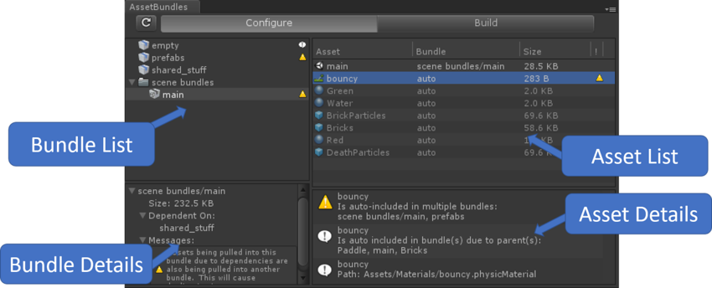

Bundle List
Left hand pane showing a list of all bundles in the project. Available functionality:

Select a bundle or set of bundles to see a list of the assets that will be in the bundle in the Asset List pane.

Bundles with variants are a darker grey and can be expanded to show the list of variants.

Right-click or slow-double-click to rename bundle or bundle folder.

If a bundle has any error, warning, or info message, an icon will appear on the right side. Mouse over the icon for more information.

If a bundle has at least one scene in it (making it a scene bundle) and non-scene assets explicitly included, it will be marked as having an error. This bundle will not build until fixed.

Bundles with duplicated assets will be marked with a warning (more information on duplication in Asset List section below)

Empty bundles will be marked with an info message. For a number of reasons, empty bundles are not very stable and can dissapear from this list at times.

Folders of bundles will be marked with the highest message from the contained bundles.

To fix the duplicated inclusion of assets in bundles, you can:

Right click on a single bundle to move all assets determined to be duplicates into a new bundle.

Right click on multiple bundles to either move the assets from all selected bundles that are duplicates into a new bundle, or only those that are shared within the selection.

You can also drag duplicate assets out of the Asset List pane into the Bundle List to explicitly include them in a bundle. More info on this in the Asset List feature set below.

Right click or hit DEL to delete bundles.

Drag bundles around to move them into and out of folders, or merge them.

Drag assets from the Project Explorer onto bundels to add them.

Drag assets onto empty space to create a new bundle.

Right click to create new bundles or bundle folders.

Right click to “Convert to Variant”

This will add a variant (initially called “newvariant”) to the selected bundle.

All assets currently in selected bundle will be moved into the new variant

ComingSoon: Mismatch detection between variants.

Icons indicate if the bundle is a standard or a scene bundle.
Icon for standard bundleIcon for scene bundle

Bundle Details
Lower left hand pane showing details of the bundles(s) selected in the Bundle List pane. This pane will show the following information if it is available:

Total bundle size. This is a sum of the on-disk size of all assets.

Bundles that the current bundle depends on

Any messages (error/warning/info) associated with the current bundle.

Asset List
Upper right hand pane providing a list of assets contained in whichever bundles are selected in the Bundle List. Available functionality:

View all assets anticipated to be included in bundle. Sort asset list by any column header.

View assets explicitly included in bundle. These are assets that have been assigned a bundle explicitly. The inspector will reflect the bundle inclusion, and in this view they will say the bundle name next to the asset name.

View assets implicitly included in bundle. These assets will say auto as the name of the bundle next to the asset name. If looking at these assets in the inspector they will say None as the assigned bundle.

These assets have been added to the selected bundle(s) due to a dependency on another included asset. Only assets that are not explicitly assigned to a bundle will be implicitly included in any bundles.

Note that this list of implicit includes can be incomplete. There are known issues with materials and textures not always showing up correctly.

As multiple assets can share dependencies, it is common for a given asset to be implicitly included in multiple bundles. If the tool detects this case, it will mark both the bundle and the asset in question with a warning icon.

To fix the duplicate-inclusion warnings, you can manually move assets into a new bundle or right click the bundle and selecting one of the “Move duplicate” options.

Drag assets from the Project Explorer into this view to add them to the selected bundle. This is only valid if only one bundle is selected, and the asset type is compatable (scenes onto scene bundles, etc.)

Drag assets (explicit or implicit) from the Asset List into the Bundle List (to add them to different bundles, or a newly created bundle).

Right click or hit DEL to remove assets from bundles (does not remove assets from project).

Select or double-click assets to reveal them in the Project Explorer.

A note on including folders in bundles. It is possible to assign an asset folder (from the Project Explorer) to a bundle. When viewing this in the browser, the folder itself will be listed as explicit and the contents implicit. This reflects the priority system used to assign assets to bundles. For example, say your game had five prefabs in Assets/Prefabs, and you marked the folder “Prefabs” as being in one bundle, and one of the actual prefabs (“PrefabA”) as being in another. Once built, “PrefabA” would be in one bundle, and the other four prefabs would be in the other.

Asset Details
Lower right hand pane showing details of the asset(s) selected in the Asset List pane. This pane cannot be interacted with, but will show the following information if it is available:

Full path of asset

Reason for implicit inclusion in bundles if it is implicit.

Reason for warning if any.

Reason for error if any.

Troubleshooting
- Can’t rename or delet a specific bundle. This is occasionally caused when first adding this tool to an existing project. Please force a reimport of your assets through the Unity menu system to refresh the data.

External Tool Integration
Other tools that generate asset bundle data can choose to integrate with the browser. Currently the primary example is the Asset Bundle Graph Tool. If integrations are detected, then a selection bar will appear near the top of the browser. It will allow you to select the Default data source (Unity’s AssetDatabase) or an integrated tool. If none are detected, the selector is not present, though you can add it by right-clicking on the tab header and selecting “Custom Sources”.

Usage - Build
The Build tab provides basic build functionality to get you started using asset bundles. In most profressional scenarios, users will end up needing a more advanced build setup. All are welcome to use the build code in this tool as a starting point for writing their own once this no longer meets their needs. Interface:

Build Target - Platform the bundles will be built for

Output Path - Path for saving built bundles. By default this is AssetBundles/. You can edit the path manually, or by selecting “Browse”. To return to the default naming convention, hit “Reset”.

Clear Folders - This will delete all data from the build path folder prior to building.

Copy to StreamingAssets - After the build is complete, this will copy the results to Assets/StreamingAssets. This can be useful for testing, but would not be used in production.

Advanced Settings

Compression - Choose between no compression, standard LZMA, or chunk-based LZ4 compression.

Exclude Type Information - Do not include type information within the asset bundle

Force Rebuild - Rebuild bundles needing to be built. This is different than “Clear Folders” as this option will not delete bundles that no longer exist.

Ignore Type Tree Changes - Ignore the type tree changes when doing the incremental build check.

Append Hash - Append the hash to the asset bundle name.

Strict Mode - Do not allow the build to succeed if any errors are reporting during it.

Dry Run Build - Do a dry run build.

Build - Executes build.

Reducing the file size of your build
Keeping the file size of the built app to a minimum is important, especially for mobile devices or for app stores that impose a size limit. The first step in reducing the size is to determine which Assets contribute most to it, because these Assets are the most likely candidates for optimization. This information is available in the Editor Log just after you have performed the build. Go to the Console window (menu: Window < Console), click the small drop-down panel in the top right, and select Open Editor Log.
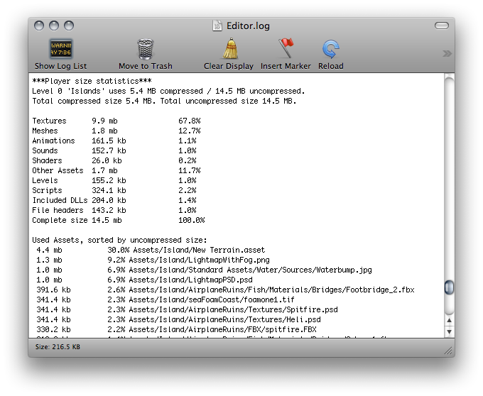The Editor Log just after a build
The Editor Log provides a summary of Assets broken down by type, and then lists all the individual Assets in order of size contribution. Typically, things like Textures, Sounds and Animations take up the most storage, while Scripts, Levels and Shaders usually have the smallest impact. The File headers mentioned in the list are not Assets - they are actually the extra data that is added to “raw” Asset files to store references and settings. The headers normally make very little difference to Asset size, but the value might be large if you have numerous large Assets in the Resources folder.
The Editor Log helps you identify Assets that you might want to remove or optimize, but you should consider the following before you start:

Unity re-codes imported Assets into its own internal formats, so the choice of source Asset type is not relevant. For example, if you have a multi-layer Photoshop Texture in the Project, it is flattened and compressed before building. Exporting the Texture as a .png file does not make any difference to build size, so you should stick to the format that is most convenient for you during development.

Unity strips most unused Assets during the build, so you don’t gain anything by manually removing Assets from the Project. The only Assets that are not removed are scripts (which are generally very small anyway) and Assets in the Resources folder (because Unity can’t determine which of these are needed and which are not). With this in mind, you should make sure that the only Assets in the Resources folder are the ones you need for the game. You might be able to replace Assets in the Resources folder with AssetBundles - this means that Unity loads Assets dynamically, thereby reducing the player size.

Suggestions for reducing build size

Textures
Textures usually take up the most space in the build. The first solution to this is to use compressed Texture formats. See documentation on platform-specific Texture compression for more information.
If that doesn’t reduce the file size enough, try to reduce the physical size (in pixels) of the Texture images. To do this without modifying the actual source content, select the Texture in the Project view, and in the Inspector window reduce the Max Size. To see how this looks in-game, zoom in on a GameObject that uses the Texture, then adjust the Max Size until it starts looking worse in the Scene view. Changing the maximum Texture size does not affect your Texture Asset, just its resolution in the game.
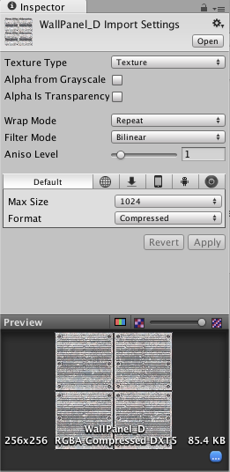Changing the Maximum Texture Size does not affect your Texture Asset, just its resolution in the game
By default, Unity compresses all Textures when importing. For faster workflow in the Editor, go to Unity < Preferences and untick the checkbox for Compress Assets on Import. All Textures are compressed in the build, regardless of this setting.

Meshes and Animations
You can compress Meshes and imported Animation Clips so that they take up less space in your game file. To enable Mesh compression, select the Mesh, then in the Inspector window set the Mesh Compression to Low, Medium or High. Mesh and Animation compression uses quantization, which means it takes less space, but the compression can introduce some inaccuracies. Experiment with what level of compression is acceptable for your models.
Note that Mesh compression only produces smaller data files, and does not use less memory at run time. Animation keyframe reduction produces smaller data files and uses less memory at run time; generally you should always have it enabled. See documentation on Animation Clips for more information about this.

DLLs
By default, Unity includes only the following DLLs in the built player:

mscorlib.dll

Boo.Lang.dll

UnityScript.Lang.dll

UnityEngine.dll

When building a player, you should avoid any dependencies on System.dll or System.Xml.dll. Unity does not include these in the built player by default, but if you use their classes, they are included. These DLLs add about a megabyte to the player’s storage size. If you need to parse XML in your game, you can use a library like Mono.Xml.zipas a smaller alternative to the system libraries. While most Generic containers are contained in mscorlib, Stack and few others are in System.dll, so you should avoid these if possible.
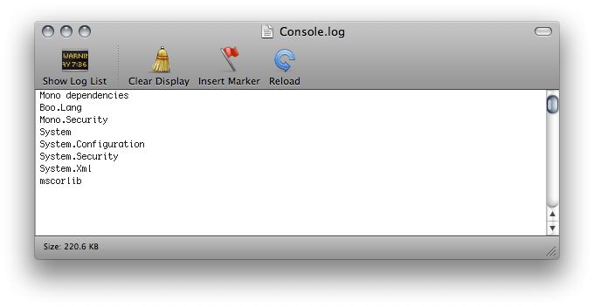Unity includes System.Xml.dll and System.dll when building a player

Reducing mobile .NET library size
Unity supports two .NET API compatibility levels for some mobile devices: .NET 2.0 and a subset of .NET 2.0. Select the appropriate level for your build in the Player Settings.
The .NET 2.0 API profile is similar to the full .NET 2.0 API. Most library routines are fully implemented, so this option offers the best compatibility with pre-existing .NET code. However, for many games, the full library is not needed and the superfluous code takes up valuable memory space.
To avoid wasted memory, Unity also supports the .NET 2.0 Subset API profile. This is very similar to the Mono “monotouch” profile, so many limitations of the “monotouch” profile also apply to Unity’s .NET 2.0 Subset profile. See the Mono Project’s documentation on MonoTouch limitations for more information. Many library routines that are not commonly needed in games are left out of this profile in order to save memory. However, this also means that code with dependencies on those routines do not work correctly. This option can be a useful optimization, but you should check that existing code still works after it is applied.

