SAM Evergreen Advocacy Layer
Household Readiness Check — Concept, Architecture & Requirements
Working draft for review · MASA / SAM (AccessNow) · synthesized from exploratory discussion. Figures and decisions are directional; requirements are split into Initial (v1) and Follow-up (v2+).
1. Purpose of this document
This document captures the concept, logic, architecture, and requirements for an evergreen advocacy layer for SAM, using the Household Readiness Check as the first build. It is a synthesis of a design discussion, intended to give reviewers the reasoning behind what we are considering — not only a feature list. Requirements are organized as Initial (v1) and Follow-up (v2+), followed by non-functional requirements and the open decisions that reviewers should weigh in on.
2. Why we are building this (reasoning)
2.1 The gap in today's SAM
SAM's two live experiences — Post-ER guidance and Medical Bill Advocacy — are both trigger-based: they activate off a transport claim or an existing bill. That means a member first meets the benefit during a crisis, which is the worst moment to discover value. The SAM/AccessNow strategy already names this "timing problem" and raises an open question about whether there should be a "test drive" experience that demonstrates value before a member needs it. The evergreen advocacy layer is that pre-trigger front door. It is not a new product so much as the missing top of the funnel the strategy has already flagged.
2.2 Advocacy as the product, membership as the monetization
In the direct-to-consumer model this inverts the seminar logic: the advocacy experience is the product that earns trust and engagement, and MASA membership coverage is the monetization layer revealed at the natural moment. This is the strategic differentiator versus a coverage-first pitch.
2.3 Why Household Readiness first
Household Readiness is a universal entry point with almost no emotional barrier — "would your family know what to do in an emergency?" applies to everyone, unlike a narrower, more emotionally loaded aging-parent tool. It is also the most natural place to surface MASA's actual coverage gap, because emergency readiness and emergency transport are the same conversation.
2.4 The three-sided value
- Direct-to-consumer: an engaging, repeatable experience that builds a household profile and warms a lead before any sale.
- Seminar channel: readiness content that anchors the value of coverage and pre-qualifies interest.
- Group / broker: an enrollment and engagement asset that differentiates the offering.
3. Product concept
- Household Readiness Check. A guided, personalized experience (~5 minutes) that scores a household's emergency readiness, returns the three most important next steps, and generates a usable artifact.
- The Family Readiness File (the spine). Every interaction quietly writes to a shared household profile. This profile — not any single checklist — is the durable product and data asset: it makes the next session smarter, warms the funnel, and can later feed MASA's event-trigger work.
- Readiness meter that never reaches 100%. Open loops over closure. There is always a visible next step, which is the return-visit mechanic.
- Coverage-gap reveal as the monetization seam. The moment a household sees what its existing coverage does not cover is the natural, honest place to introduce MASA transport benefits.
- Mayo Clinic as the evidence layer. Trusted clinical content appears at the point of need and is cited — not offered as a browsable library. This provides credibility, supports the GEO/citability strategy, and protects the health-adjacent (YMYL) surface.
- YMYL guardrails from day one. Health-adjacent guidance requires safety guardrails designed in from the start, not retrofitted.
A working interactive prototype of this flow has been produced as a companion deliverable (SAM_Household_Readiness_Check.html) and demonstrates the branching intake, the readiness meter, the generated artifact, the follow-up loops, and the coverage seam.
4. Design principles (the logic distilled)
- Intelligence comes from relevance, not length: a short flow that adapts feels smarter than a long static checklist.
- Organize around the user's job ("help me prepare"), not the medical condition.
- Every interaction should produce a tangible artifact and open exactly one new loop.
- The profile is the product; tools are how it gets filled in.
- Every flow needs a live seam to a MASA service and to a human tier — that closed loop is the moat versus a generic AI assistant.
- Authored content is bounded and maintainable; the experienced product is combinatorially large. Keep the gap wide with personalization and (later) the LLM layer.
- Safe by construction on the rails; spend the safety budget where free text enters.
5. Architecture overview
The stance is hybrid, not either/or: an LLM orchestrator as the connective tissue and router, deterministic guided flows as the rails, a shared profile as the spine, and a governed knowledge layer (Mayo + MASA) as the evidence — with defined seams where free text hands into a guided flow and back out. Tapped options run straight down the deterministic rails; free text is the only thing that touches the LLM.
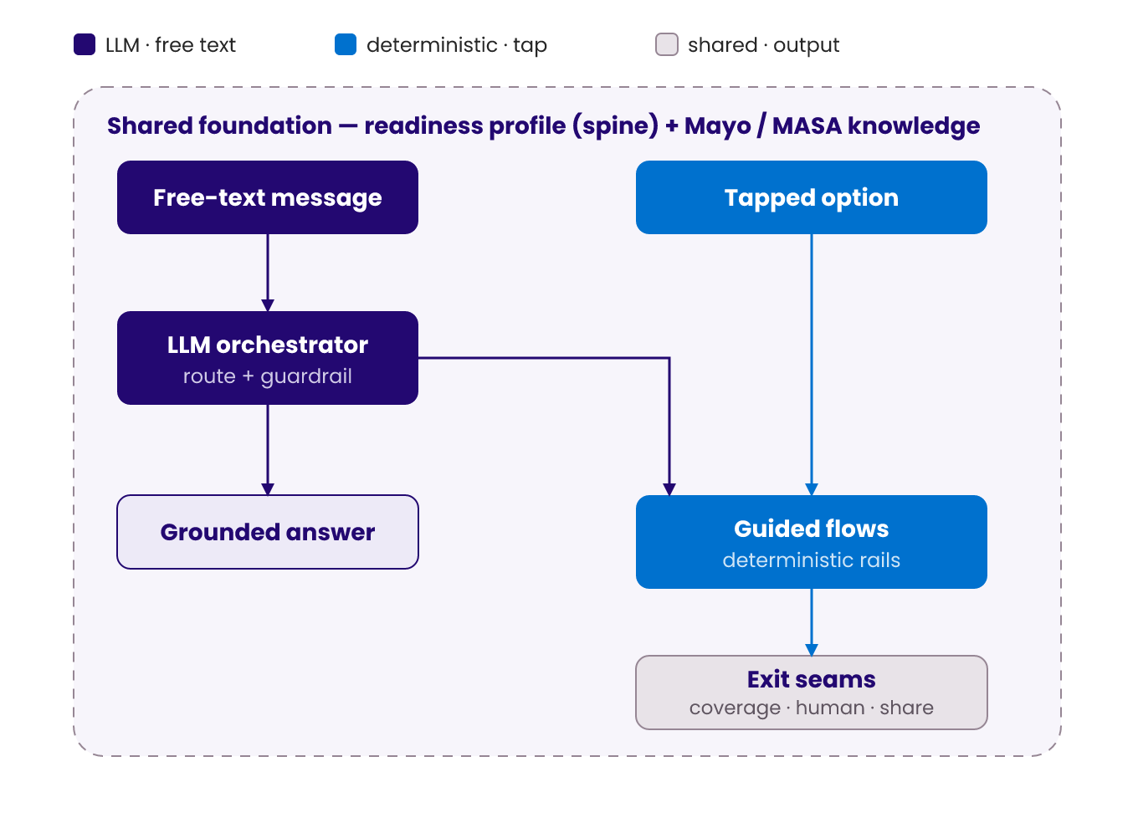
Figure 1. Hybrid architecture — free text is routed by the LLM orchestrator to a grounded answer or a guided flow; tapped options bypass the LLM; everything sits on the shared profile + knowledge foundation.
5.1 The reusable node-type library
Every flow is composed from the same eight node types, which is what keeps the library maintainable as it grows:
Node type | What it does
Content | SAM says something; may pull a knowledge block.
Question | Deterministic options, with an optional free-text escape hatch.
Free-text | Open box; routed through the LLM orchestrator.
Decision | Pure logic over the profile; no user input.
Compute | Scoring and derived values.
Artifact | Renders a template from the profile.
Seam | Coverage reveal, human handoff, share, or cross-flow jump.
Return | Change-detection for repeat visits.

5.2 The profile schema (the spine)
A single shared object that every node in every flow reads and writes: household / identity; health & vulnerability; geo & environmental risk; readiness inventory; top worry; artifacts built; coverage status (member vs. prospect); an event log (for change detection); and consent flags.
5.3 Scale — authored vs. experienced
The number that matters is authored vs. experienced content. A launch library might be ~10 flows, a shared bank of ~50 questions, ~200 knowledge blocks, and ~20 artifact templates — a few hundred authored objects a small team can own. But the experienced surface is combinatorial: flows × branching × six personalization axes × longitudinal state, plus free text, makes the number of distinct sessions effectively unbounded. The goal is to keep authored content bounded while the experienced product feels bespoke.
6. The content flow — Household Readiness (expanded)
The prototype showed an abbreviated five-question slice. Fully authored, the flow is ~9 stages and ~30 nodes with branching most users never fully see. Markers: [FT] free-text slot · [PERS] personalization fork · [MAYO]/[MASA] knowledge or coverage hook · [ART] artifact · [SEAM] jump out.
Stage 0 · Open
- Welcome (content) [PERS: new vs. returning]. Returning sessions open on change-detection instead of intake.
- Cold-open box — "What's on your mind about being prepared?" [FT → router]. Can pre-fill the profile and skip stages.
Stage 1 · Household framing
- Household type — solo / couple / kids / multi-gen / caregiver [PERS: the biggest fork] + [FT: "it's complicated"].
- Branches: caregiver → nearby vs. long-distance (unlocks a remote-coordination track); multi-gen → who lives under the roof.
- Health / vulnerability status [PERS] + [FT: "tell me about their health"] [MAYO: normal-aging vs. warning-signs].
- Branch (condition/mobility): medication count, mobility aids, cognitive changes → risk weighting.
Stage 2 · Context & environmental risk
- Geo / situational risk — disaster-prone / rural / frequent travel / none [PERS], with auto-detect option.
- Branches: disaster → hazard type (seasonal content set); travel → domestic vs. international [SEAM → Travel Readiness].
Stage 3 · Current-state inventory (drives the score)
- What's already in place — meds list / contacts / decision-maker / cost plan / go-bag (multi-select).
- Per-gap deepeners (conditional), e.g. proxy vs. POA [MAYO]. + [FT: partial-state resolution].
Stage 4 · Worry / prioritization
- Top worry [PERS: reorders everything downstream] + [FT: free-form worry → classifier].
Stage 5 · Compute & reveal
- Scoring (deterministic) → five dimensions + overall band; reveal opener changes by band [PERS].
Stage 6 · Next steps
- A selector: top three chosen from a ~15-step candidate library, ranked by gaps × worry × vulnerability × geo; each step = content + [MAYO] + optional [SEAM].
Stage 7 · Artifact generation
- A selector: default Emergency Medical Card; conditionally adds Contact Tree, Go-Bag/Medication-Supply, Remote-Access checklist, or Evacuation plan. [FT fields normalized by LLM] [ART].
Stage 8 · Open loops
- Follow-up chips [PERS: which appear]; "Ask SAM anything" box [FT → router]; save / six-month check-in / share [SEAM].
Stage 9 · Longitudinal return
- Replays the stored profile, asks only what changed, re-scores, regenerates artifacts. The evergreen engine — only possible because Stages 1–4 wrote to a profile.
7. Free-text & LLM design
7.1 The six free-text ingress slots
Slot | Purpose | Risk
Cold open | Blank box at the start; often contains half the intake. | Medium
Mid-flow escape | "…or just tell me" on any question; maps back to a branch. | Medium
Post-artifact Q&A | "Ask SAM anything"; where a question becomes a flow. | Medium–High
Elaboration | "Why does this matter?" — answered from knowledge. | Low
Artifact fields | Free text inside the card; LLM only normalizes. | Low
Emotional / venting | "I'm overwhelmed" — acknowledge, then route gently. | High

7.2 The router
An LLM classifier over a fixed intent taxonomy; every intent maps to a flow, a knowledge answer, or an escalation. Confidence-band behavior: a confident match offers or launches the flow; a medium match asks one clarifying question; a low match answers directly and surfaces two or three flow cards rather than guessing.
7.3 Slot pre-fill (the highest-leverage feature)
When someone types "my mom lives alone and just fell," the LLM does not only route — it extracts household type, vulnerability, and a recent fall event and writes them to the profile before the flow starts. The guided flow then skips the questions it already knows. So free text does not just open a flow; it makes the flow shorter. This is the thing a purely deterministic bot cannot do and a purely free-form LLM will not do reliably — and it is why the hybrid beats either alone.
7.4 The reverse seam
A guided flow hands back to free text at its natural exits: the "other" option, the end-of-flow open box, and the post-artifact "ask me anything."
7.5 Guardrails (before any routing)
- Safety classifier: emergency / self-harm / crisis routes to 911 or a human — never to a flow.
- Scope classifier: in-domain vs. "SAM can't help with that."
- No-diagnosis constraint and a persistent "guidance, not medical advice" disclaimer.
- Grounding requirement: substantive claims trace to a Mayo or MASA block, not the model's open weights.
8. Personalization dimensions
Axis | What it mutates
Profile facets | Which questions, the score, the steps, the artifact (household, vulnerability, geo, worry, coverage).
Role | Framing and pronouns for patient vs. caregiver vs. remote sibling; the artifact shifts.
Longitudinal state | First visit (intake) vs. return (change-detection open).
Entry context | Organic page vs. in-app vs. post-seminar vs. shared link ("merge second member" mode).
Member vs. prospect | Coverage referenced vs. revealed as a gap — flips the tone of the coverage seam.
Free-text signal | Anything the LLM harvested that no deterministic question asked.

9. Requirements
9.1 Initial (v1)
ID | Requirement | Rationale
HR-I-01 | Deliver the Household Readiness Check as a guided, branching flow (~9 stages) that adapts questions, score, steps, and artifact to answers. | Dynamic, not static, is the core engagement premise.
HR-I-02 | Build the flow from the reusable 8-type node library so later flows reuse the same primitives. | Bounded authoring; maintainability.
HR-I-03 | Persist a Family Readiness File (household profile) that every node reads and writes. | The profile is the durable asset; enables personalization and re-engagement.
HR-I-04 | Compute a category-based readiness score across ≥5 dimensions; never present 100%. | Open-loops engagement mechanic.
HR-I-05 | Generate at least one artifact (Emergency Medical Card) rendered from the profile; saveable / downloadable. | Tangible utility; seeds the Emergency Health Wallet.
HR-I-06 | Select top-3 next steps dynamically from a candidate library, ordered by gaps × worry × vulnerability × geo. | Relevance is what makes it feel intelligent.
HR-I-07 | Surface Mayo-sourced evidence at point-of-need, cited; not a browsable library. | Credibility, GEO/citability, YMYL protection.
HR-I-08 | Present post-artifact follow-up chips, each doing one job: deepen profile, reveal gap, go multi-user, re-engage, or escalate. | The engagement engine.
HR-I-09 | Implement the coverage-gap reveal seam using pre-approved MASA stats, routing to a coverage / plan / seminar CTA. | Monetization seam; MASA differentiation.
HR-I-10 | Implement a human-handoff seam that passes the profile as context. | Closed loop to real advocacy — the moat vs. generic AI.
HR-I-11 | Apply MASA voice and "membership (not insurance)" terminology throughout. | Brand compliance.
HR-I-12 | Enforce day-one guardrails: 911 / crisis routing, no-diagnosis, in-scope-only, persistent disclaimer. | YMYL requirement.
HR-I-13 | Support prospect (anonymous / lightweight) sessions entered from an organic content page. | Top-of-funnel acquisition surface.
HR-I-14 | Capture analytics: completion, drop-off by node, artifact creation, follow-up engagement, seam conversion. | Learn what to widen before enabling more.
HR-I-15 | Optional cold-open free-text box mapped to the flow behind guardrails (pending the launch decision in §10). | User expectation vs. risk trade-off.

9.2 Follow-up (v2+)
ID | Requirement | Rationale
HR-F-01 | LLM orchestrator / router over a fixed intent taxonomy with confidence-band behavior. | Meets free-text expectation while staying controllable.
HR-F-02 | Slot pre-fill: extract entities from free text and pre-populate the profile so flows skip known questions. | Makes guided flows shorter; hybrid's signature advantage.
HR-F-03 | Mid-flow free-text escape hatch on every question. | Flexibility without abandoning the rails.
HR-F-04 | Post-artifact open Q&A grounded in the knowledge layer, able to offer a guided flow. | Retention surface; free text → guided flow.
HR-F-05 | Change-detection re-engagement: returning sessions open on "what changed," re-score, regenerate; scheduled check-ins. | The evergreen relationship engine.
HR-F-06 | Share / merge: a second household member opens a shared link, contributes, and merges into the file. | Multi-user growth loop; richer profile.
HR-F-07 | Member variant: coverage-aware flow that references actual benefits instead of a generic gap. | Serves existing members, not just prospects.
HR-F-08 | Additional flows from the catalog (Aging Parent Check-In, Doctor Visit Builder, Emergency Health Wallet, Home Safety, Caregiver Load), reusing the node library and shared profile. | Expands the product without new primitives.
HR-F-09 | Cross-flow seams (e.g., travel branch → Travel Readiness). | One continuous assistant, many tools.
HR-F-10 | Expanded artifact set (Contact Tree, Go-Bag / medication-supply, Remote-Access checklist, Evacuation plan). | Broader tangible value.
HR-F-11 | Knowledge layer as governed RAG (Mayo + MASA MSAs → markdown) with retrieval for free-text answers. | Grounding at scale for the LLM layer.
HR-F-12 | Full account / identity and a longitudinal profile across sessions and channels. | Durable re-engagement and funnel attribution.

9.3 Non-functional / cross-cutting
ID | Requirement | Rationale
NF-01 | Pre-routing guardrail gate (crisis / self-harm / emergency; no-diagnosis; scope) runs before any free-text routing. | Safety is non-negotiable on a health surface.
NF-02 | Grounding: substantive claims trace to a Mayo / MASA block; no open-weight medical claims. | Trust and liability.
NF-03 | Content governance: versioned authored library; Mayo usage within partnership terms; review workflow. | Maintainability and legal.
NF-04 | Privacy / consent: health-data handling and consent capture (reusable by the ADT/HIE authorization track); clarify it is not a medical record. | Compliance; leverage across workstreams.
NF-05 | Single shared profile schema across flows, with an event log for change detection. | Enables the spine and re-engagement.
NF-06 | Deterministic reproducibility: rails produce consistent output for identical inputs. | Consistent experience; testability.
NF-07 | Funnel analytics plus safety monitoring of free-text inputs when enabled. | Measurement and safe expansion.
NF-08 | Mobile-first, accessible, performant. | Reach and inclusion.

10. Open decisions for reviewers
Decision | Recommendation & why it matters
Rails-only vs. free-text at launch. | Launch on rails with an optional cold-open box that logs inputs; widen the free-text aperture after observing what people type. Balances user expectation against YMYL risk and speed.
Authored-content scope before the router is reliable. | Quantify a minimum library (flows + knowledge blocks) that routing and grounding need before enabling the LLM router. This is a quality gate on the free-text experience.
Anonymous session → account / conversion event. | Create a lightweight profile from the first anonymous session; resolve alongside the still-open AccessNow conversion-event decision. Required for re-engagement and funnel attribution.
Coverage-reveal directness on prospect surfaces. | A/B a softer, content-embedded reveal against the direct version used in the prototype. Trades trust on organic surfaces against conversion.
Mayo dependency and positioning. | Keep Mayo as the evidence layer only, avoid becoming a thin wrapper, and confirm content-usage terms. Protects differentiation and manages legal exposure.
11. Recommended first build & sequencing
Build the Household Readiness Check on deterministic rails, with the Family Readiness File, the readiness meter, the generated Emergency Medical Card, the follow-up loops, the coverage-gap seam, Mayo evidence, and the guardrails — plus a single, guardrailed cold-open free-text box used primarily to observe intent. Once the authored library is deep enough to route and ground against, layer in the LLM orchestrator, slot pre-fill, and open Q&A, then expand to the next flows from the catalog on the same primitives.

Appendix A. Candidate flow catalog
Flows that reuse the same node library and shared profile. Household Readiness is v1; the rest are follow-up candidates.
- Household Emergency Readiness — Universal entry point; the v1 build.
- Aging Parent Check-In — Emotionally resonant; the caregiver anchor; recurring.
- Doctor Visit Question Builder — Highest raw frequency; habit-forming.
- Emergency Health Wallet — Persistent asset that pulls users back; shareable.
- Home Safety Walkthrough — Concrete, completable with a parent.
- Caregiver Load Check — Surfaces a hidden, emotionally significant need.
- Procedure & Recovery Readiness — Predictable planning moment with clear MASA adjacency.
- Travel Health Readiness — Connects to travel benefits; cross-flow seam target.
- New Diagnosis Starter Plan — Where Mayo content is especially powerful.
- Annual Health & Coverage Reset — Natural annual re-engagement.
Appendix B. Household Readiness — candidate next-step library
The selector picks three of these per session, ranked by gaps × worry × vulnerability × geo.
- Close the emergency-transport gap (coverage seam)
- Create an emergency medical card
- Name who can make medical decisions (proxy / advance directive)
- Build a shared emergency contact tree
- Build a medication + evacuation go-bag
- Set up remote access to a parent's care
- Turn this into a written household plan
- Confirm several days of medication supply
- Identify the nearest appropriate hospital / transport plan
- Assign roles across the household
Appendix C. Pre-approved MASA statistics (coverage seam)
- Average ground ambulance cost: $2,000
- Average air ambulance cost: $69,000
- Out-of-pocket bill probability even with insurance: 79% (Consumer Reports, 2021)
- Members served: 2 million+ · In business: 50+ years (founded 1974)
Always cite the source when using these figures in external-facing content.

