INDR 252 CLASS EXERCISE, December 08, 2025
A certain factory has two types of workers who choose from three different pension plans. Do different kinds of workers choose certain pension plans? Are the two classifications independent?

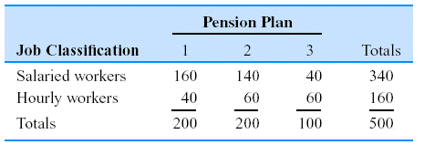
- State the corresponding hypothesis test.
- Define the necessary probabilities and estimate them using the above table.
- Carry out the test to decide whether the worker type affects the chosen pension plans.

H₀ : Two classifications are independent.
H_{a} : Two classifications are not independent.

i | 1 |  | 2
$${\hat{u}}_{i}$$ | 340/500=0.68 |  | 160/500=0.32
i |  | 1 |  | 2 | 3
$${\hat{v}}_{j}$$ |  | 200/500=0.40 |  | 200/500=0.40 | 100/500=0.20

Expected frequencies | 1 | 2 | 3 | Total
Salaried | 136 | 136 | 68 | 340
Hourly | 64 | 64 | 32 | 160
Total | 200 | 200 | 100 | 500

$$χ^{2}=\sum_{i=1}^{r}{\sum_{j=1}^{c}{\frac{(O_{ij}-E_{ij})^{2}}{E_{ij}}}}$$
$$=\frac{(160-136)^{2}}{136}+\frac{(160-136)^{2}}{136}+\frac{(40-68)^{2}}{68}+\frac{(40-64)^{2}}{64}+\frac{(60-64)^{2}}{64}+\frac{(60-32)^{2}}{32}=49.63$$

Compare with the critical value: $χ_{\left(r-1\right)\left(c-1\right),0.05}^{2}= χ_{\left(2-1\right)\left(3-1\right),0.05}^{2}=χ_{2,0.05}^{2}=5.99.$
Comparing $χ^{2}=49.63$ with the critical value $χ_{2,0.05}^{2}=5.99,$ we reject H0. We conclude that the two classifications are not independent at α=5%. We also note that the corresponding p-value is lower than 0.5%. Hence, the worker type affects the choice of pension plans.

