INDR 252 CLASS EXERCISE 2
- In a small city, the green environment supporters claim that the air is heavily polluted, and the authorities should take necessary action to clean the air. The authorities reported the monthly PM10 levels for the last 10 years (January 2013-December 2023), and they claim that the mean of PM10 level is less than 50mg, which is the highest allowed mean level. The descriptive statistics and several plots of the data are given below.
Descriptive Statistics: PM10
Total
Variable Count Mean StDev Minimum Q1 Median Q3 Maximum Skewness
PM10 132 47.909 6.338 33.000 43.000 48.000 53.000 61.000 -0.04
Stem-and-Leaf Display: PM10
Stem-and-leaf of PM10 N = 132
Leaf Unit = 1.0

1 3 3
2 3 4
7 3 66777
15 3 88999999
21 4 000111
36 4 222333333333333
46 4 4444444555
64 4 666666666677777777
(15) 4 888888888889999
53 5 00000000111111
39 5 22233333
31 5 44444445555
20 5 66666777777
9 5 8888899
2 6 01

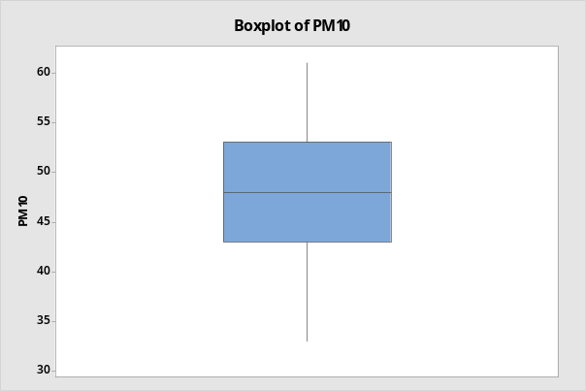 | 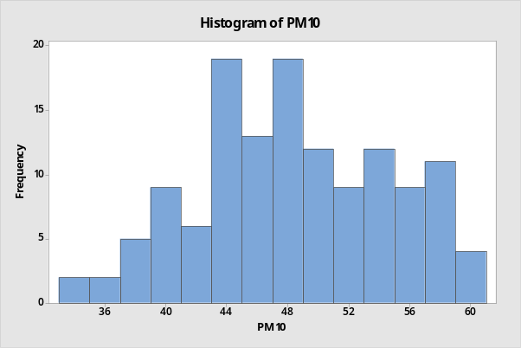

Answer the following questions and explain your answers with the corresponding reasons:
Is the data skewed? Are there any outliers? Is it possible to assume that the data is coming from a normal distribution? Can we assume that the data set constitutes a random sample?

The data does not seem very skewed. There is a short left-tail, but in general the stem-and-leaf diagram, boxplot and histogram look symmetric. The skewness value is -0.04, which is very close to 0, confirming our observations from the plots.
There are no outliers, the tails cover all observations in the sample.
The data can be assumed to be coming from a normal distribution since it looks symmetric.
With the above information, we cannot assess whether the data constitutes a random sample or not. We need to know how the sample is collected, what does a monthly PM10 level mean exactly?
- The green environment supporters provided the following time series plot of the same data set given above. They also pointed out that a new thermal plant started its operations in the city in June 2020 (time period 90), and it has been fully operated since December 2021 (time period 108).

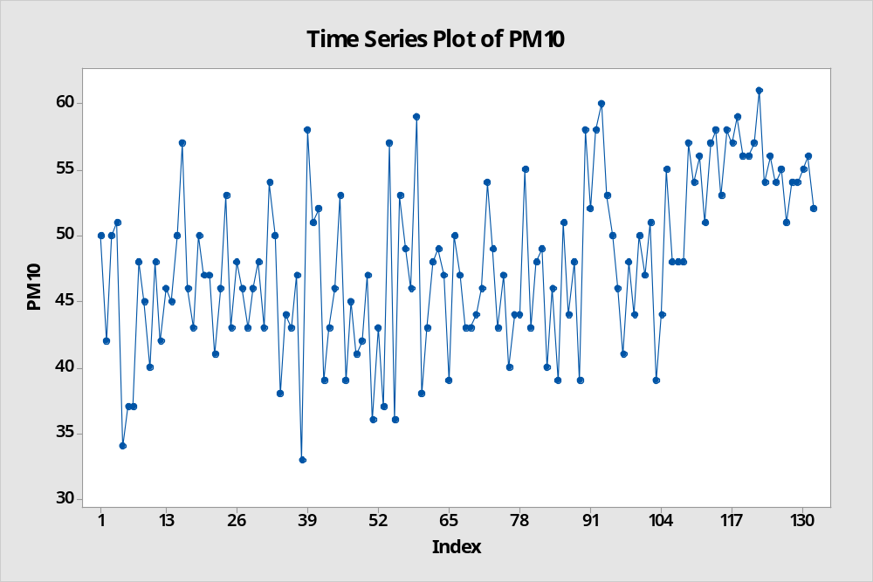

Now answer the following questions, and explain your answers with the corresponding reasons:
Can we assume that this sample of 132 months is a random sample? If not, can we use some parts of this sample and claim that these parts constitute random samples? If yes, specify the indices of the data points to be included in the random sample(s)?

We observe that the data prior to the 90th period seem to be random, since there are random fluctuations. The data after period 108 also seem to constitute a random sample; however, these two samples are not similar to each other. The observations between periods 91-107 seem to reflect a transition period. Hence, we cannot assume that the data from all periods constitutes a random sample.

This observation changes our earlier assumption on the normality of the data points as well. since there are three data sets with different distributions, we can only claim these three data sets can be normal within themselves.

