INDR 252 CLASS EXERCISE 7
In the small city, where green environment supporters claim that the air is heavily polluted, daily PM10 levels for the last two months (January and February 2018) have been recorded. Here is a summary of the collected data:

N Mean SE Mean StDev Min Q1 Median Q3 Max Skewness
59 51.59 0.495 3.802 44 49 52 55 59 -0.10

Stem-and-Leaf Display: PM10  Stem-and-leaf of PM10 N = 59  Leaf Unit = 0.10  1 44 0  4 45 000  7 46 000  10 47 000  14 48 0000  18 49 0000  21 50 000  28 51 0000000  (7) 52 0000000  24 53 00000  19 54 0000  15 55 00000  10 56 000  7 57 0000  3 58 00  1 59 0 | 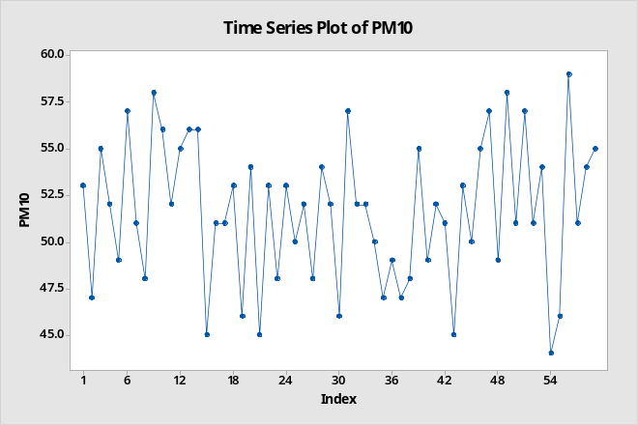

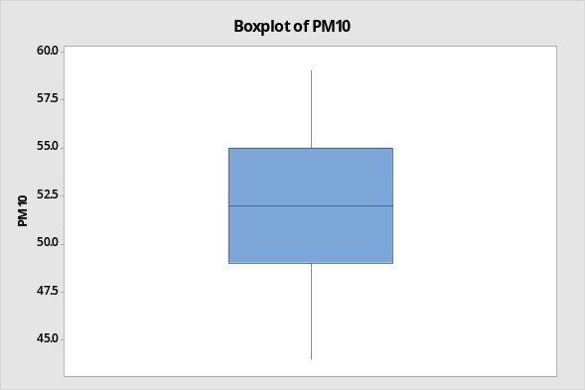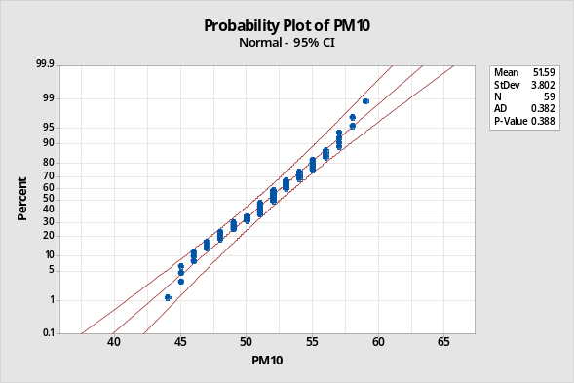

Note that z_{0.005}=2.576, z_{0.01}=2.33, z_{0.025}=1.96, z_{0.05}=1.645, z_{0.1}=1.28.

Green environment supporters claim that the average daily PM10 level is more than the upper limit of 50mg. Evaluate this claim using appropriate confidence intervals or bounds using the data above.

Assumptions:
- When the time series plot is checked, we see nothing but random fluctuations. Therefore, we can assume that the data is a random sample.
- Both the stem-and-leaf diagram and the boxplot show that the data look symmetric. Moreover, the data is around the 45⁰ line in the probability plot, indicating that the data may indeed come from a normal distribution. Hence, we can assume that the PM levels follow a normal distribution.
- If the data didn’t look like normal, we could still construct confidence intervals: Since the sample size is 59, much larger than 40, the sample mean, $\overline{X}$, is approximately normal due to the Central Limit Theorem.

Computations: We can calculate the confidence bounds (one-sided confidence intervals (CIs) and regular CIs (two-sided CIs) as follows:

 | Confidence bounds |  | Confidence Intervals
α | LB | UB | LL | UL
0.01 | 50.43851 | 52.74149 | 50.31502 | 52.86498
0.05 | 50.77583 | 52.40417 | 50.61986 | 52.56014
0.1 | 50.95566 | 52.22434 | 50.77583 | 52.40417

Conclusions: Since we are interested in whether the average daily PM10 level exceeds the upper limit of 50 ppm, we need to consider the confidence bounds (CBs). The upper CBs do not yield a clear conclusion, as all are greater than 50. However, all LBs are greater than 50. Hence, we can claim that the average daily PM10 level exceeds the upper limit of 50 ppm at the 99%, 95%, and 90% confidence levels. We will use 99% because it is the highest confidence level (if we claim this at 99%, we claim it at all confidence levels below 99%).

