INDR 252 CLASS EXERCISE 14
A certain factory has two types of workers, each of whom can choose from three pension plans. Do different kinds of workers choose certain pension plans? Are the two classifications independent?

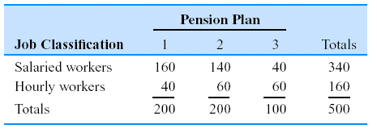
- State the corresponding hypothesis test.
- Define the necessary probabilities and estimate them using the above table.
- Carry out the test to decide whether the worker type affects the chosen pension plans.

Expected frequencies | 1 | 2 | 3 | Total
Salaried
Hourly
Total

