INDR 252 CLASS EXERCISE 2
Look at the back of the page as well.
In a small city, supporters of green environments claim the air is heavily polluted and that the authorities should take necessary action to clean it. The authorities reported monthly PM10 levels for the last 10 years (January 2013-December 2023), and they claim that the mean PM10 level is below 50mg, the highest allowed mean level. The descriptive statistics and several plots of the data are given below.
Descriptive Statistics: PM10
Total
Variable Count Mean StDev Minimum Q1 Median Q3 Maximum Skewness
PM10 132 47.909 6.338 33.000 43.000 48.000 53.000 61.000 -0.04

Stem-and-Leaf Display: PM10
Stem-and-leaf of PM10 N = 132
Leaf Unit = 1.0

1 3 3
2 3 4
7 3 66777
15 3 88999999
21 4 000111
36 4 222333333333333
46 4 4444444555
64 4 666666666677777777
(15) 4 888888888889999
53 5 00000000111111
39 5 22233333
31 5 44444445555
20 5 66666777777
9 5 8888899
2 6 01

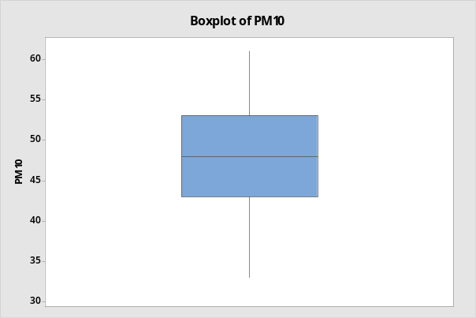 | 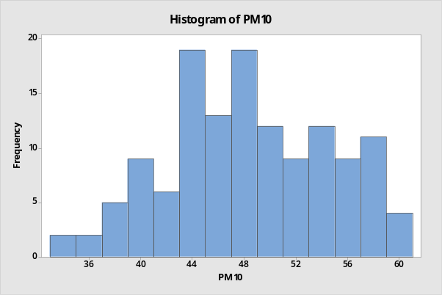

Answer the following questions and explain your answers with the corresponding reasons:

- Is the data skewed? Are there any outliers? Is it possible to assume that the data comes from a normal distribution, i.e., bell-shaped? Can we assume that the dataset is a random sample?
The green environment supporters provided the following time series plot of the same data set given above. They also pointed out that a new thermal plant began operations in the city in June 2020 (time period 90) and has been fully operational since December 2021 (time period 108).

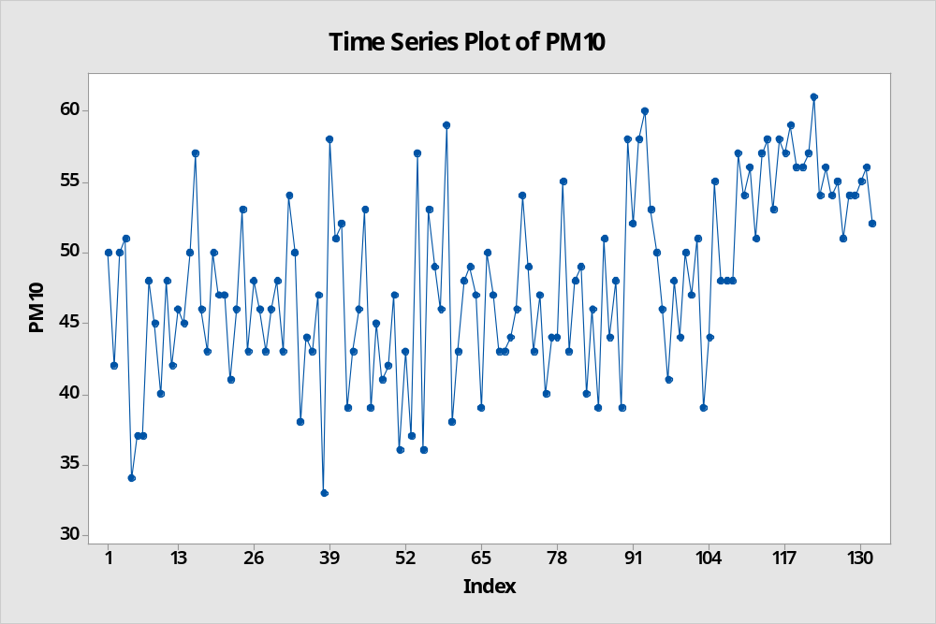

- Can we assume that this sample of 132 months is a random sample? If not, can we use some parts of this sample and claim that these parts constitute random samples? If yes, specify the indices of the data points to be included in the random sample(s)?

