INDR 252 CLASS EXERCISE 7
In the small city, where green environment supporters claim that the air is heavily polluted, daily PM10 levels for the last two months (January and February 2018) have been recorded. Here is a summary of the collected data:

N Mean SE Mean StDev Min Q1 Median Q3 Max Skewness
59 51.59 0.495 3.802 44 49 52 55 59 -0.10

Stem-and-Leaf Display: PM10  Stem-and-leaf of PM10 N = 59  Leaf Unit = 0.10  1 44 0  4 45 000  7 46 000  10 47 000  14 48 0000  18 49 0000  21 50 000  28 51 0000000  (7) 52 0000000  24 53 00000  19 54 0000  15 55 00000  10 56 000  7 57 0000  3 58 00  1 59 0 | 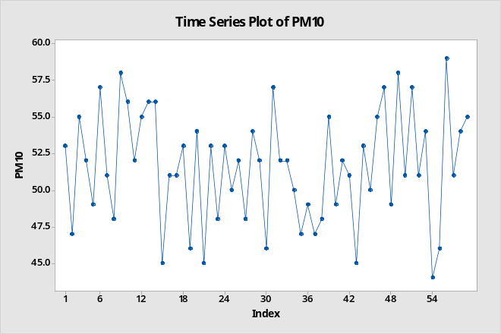

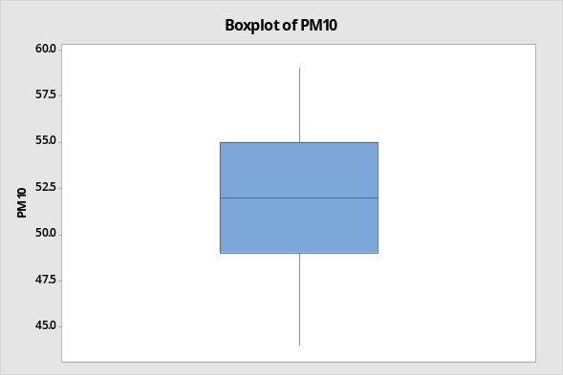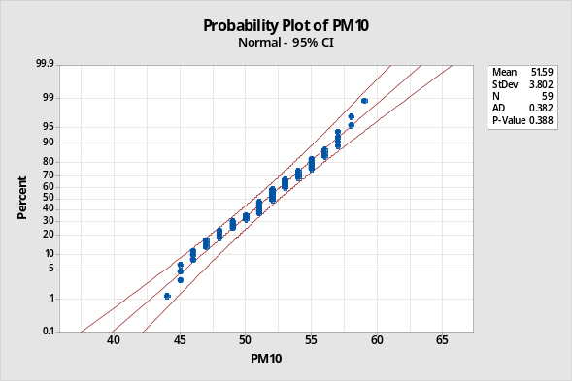

Note that z_{0.005}=2.576, z_{0.01}=2.33, z_{0.025}=1.96, z_{0.05}=1.645, z_{0.1}=1.28.

Green environment supporters claim that the average daily PM10 level is more than the upper limit of 50mg. Evaluate this claim using appropriate confidence intervals or bounds using the data above.

