**Features-Extractor**

Work inspired by E. Viegas, A. Santin and V. Abreu's paper:  
"Enabling Anomaly-based Intrusion Detection Through Model Generalization".

## About the project

The goal is to recreate an Intrusion Detection System (IDS) by training a Machine Learning model based on the traffic recreated within a virtual environment. The traffic generated is difficult to use to train machine learning models as it is scenario dependent, so it would lead to models trained for that specific scenario. To solve this problem it is necessary to treat the traffic generated in a way that is independent of the simulated session (virtual or real environment).

## Workflow

The traffic generated (HTTP, SMTP, SMNP, SSH) is listened to by tcpdump; The generated .dump file is converted into a file called totaltraffic.c containing array C using wireshark; Featuresextractor.py is launched; In the end, 50 features independent of the scenario are obtained and can be used for model training.

50 Features + Target:

1. IP_TYPE
2. IP_LEN
3. FR_LENGHT
4. IP_ID
5. IP_RESERVED
6. IP_DF
7. IP_MF
8. IP_OFFSET
9. IP_PROTO
10. IP_CHECKSUM
11. UDP_SPORT
12. UDP_DPORT
13. UDP_LEN
14. UDP_CHK
15. ICMP_TYPE
16. ICMP_CODE
17. ICMP_CHK
18. TCP_SPORT
19. TCP_DPORT
20. TCP_SEQ
21. TCP_ACK
22. TCP_FFIN
23. TCP_FSYN
24. TCP_FRST
25. TCP_FPUSH
26. TCP_FACK
27. TCP_FURG
28. COUNT_FR_SRC_DST
29. COUNT_FR_DST_SRC
30. NUM_BYTES_SRC_DST
31. NUM_BYTES_DST_SRC
32. NUM_PUSHED_SRC_DST
33. NUM_PUSHED_DST_SRC
34. NUM_SYN_FIN_SRC_DST
35. NUM_SYN_FIN_DST_SRC
36. NUM_FIN_SRC_DST
37. NUM_FIN_DST_SRC
38. NUM_ACK_SRC_DST
39. NUM_ACK_DST_SRC
40. NUM_SYN_SRC_DST
41. NUM_SYN_DST_SRC
42. NUM_RST_SRC_DST
43. NUM_RST_DST_SRC
44. COUNT_SERV_SRC_DST
45. COUNT_SERV_DST_SRC
46. NUM_BYTES_SERV_SRC_DST
47. NUM_BYTES_SERV_DST_SRC
48. FIRST_PACKET
49. FIRST_SERV_PACKET
50. CONN_STATUS
51. TYPE

NOTE:

SRC_DST and DST_SRC indicate the direction of the transmission which will be sent and received respectively. The target variable can take on two values: Attack: if the packet comes from the client; Normal: if the packet comes from the server;

You need to create a virtual environment like the one shown in the figure:

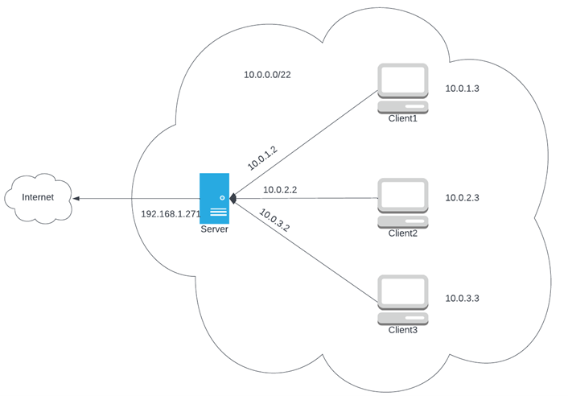

You can use any virtualizer, the important thing is that the client machines can only communicate with the server. The server is the only access point to the internet and takes care of providing connectivity to clients. The goal is to create an environment that is as isolated as possible.

Client and server implement different types of services:

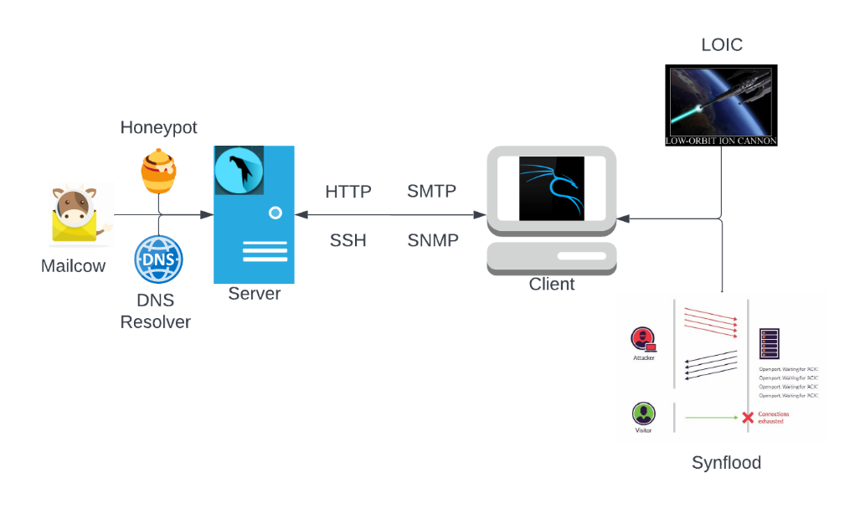

To implement the described scenario, Debian-based distributions (ParrotOS and Kali Linux) were used. The following configuration in \ etc \ network \ interfaces can be used for each client

#Client1 configuration (dhcp or static)

auto eth0

iface eth0 inet dhcp

#Default gateway

post-up route add default gw 10.0.1.2

To automate the traffic acquisition process, the clients have been synchronized with the server following the scheme shown here:

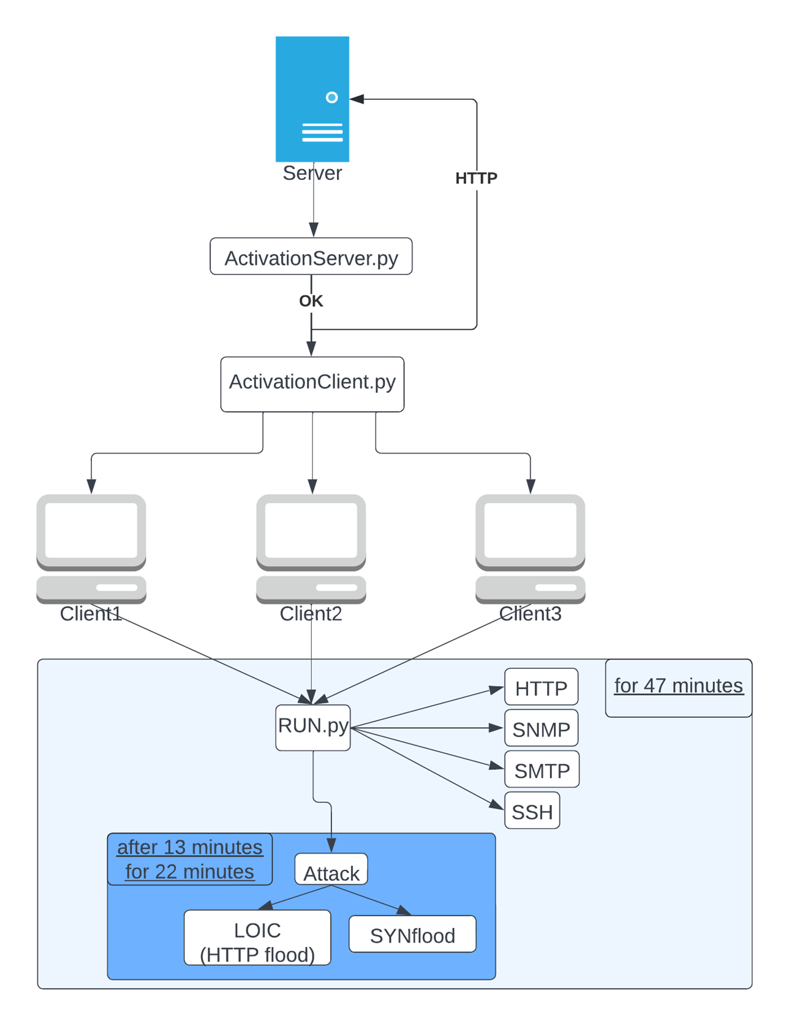

ote: RUN.py is a script that runs one of the 4 scripts shown and after a certain period starts both the LOIC and SYNflood attack.

LOIC is required to generate the HTTPflood attack (downloadable from the link: <https://sourceforge.net/projects/loic/>).

To use it you can use mono:

sudo apt install apt-transport-https dirmngr gnupg ca-certificates

sudo apt-key adv --keyserver hkp://keyserver.ubuntu.com:80 --recv-keys 3FA7E0328081BFF6A14DA29AA6A19B38D3D831EF

echo "deb https://download.mono-project.com/repo/debian stable-buster main" | sudo tee /etc/apt/sources.list.d/mono-official-stable.list

sudo apt update

sudo apt install mono-devel

For synflood use the metasploit suite

To use featuresExtractor you need to convert packages to C array. You can use Wireshark for this purpose:

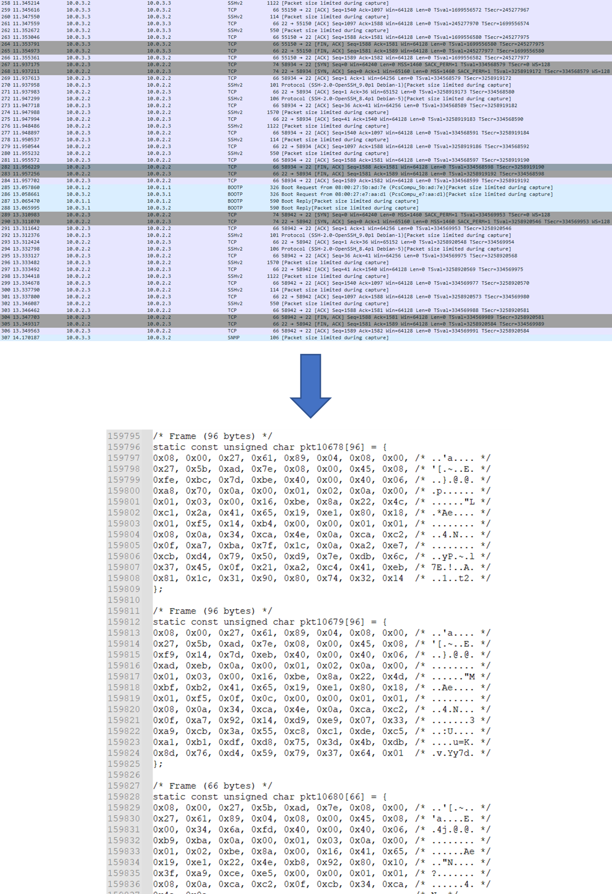

The file to be obtained must have the structure shown, featuresextractor will take care of extracting the information and creating the dataset.

To the featuresExtractor.py it is necessary to pass first the list of IPs of the Server interfaces and then that of the Client. Order is important.

Here is an example to understand how to use featuresextractor. The files used (downloadable from example) must be present in the same folder where the script is launched.

First of all we extract the file:

tar -xvf example.tar.gz

We run the script:

sudo python featuresExtractor.py [10.0.1.2,10.0.2.2,10.0.3.2] [10.0.1.3,10.0.2.3,10.0. 3.3]