CS4433 – SOFTWARE ENGINEERING
Individual Final Project

FINAL INTEGRATED PROJECT REPORT
Moderated Learning Management System (LMS)

Development model | Waterfall, with V-Model verification and validation
Project duration | 7 weeks
Technology | C++; CMake; SQlite; Git
Scope | Offline desktop LMS
Versions reported | Release v1.0 and maintenance update v1.1

1. Abstract
This report documents an individual software engineering project for a secondary-school Moderated Learning Management System. The project follows Waterfall with V-Model verification and validation, using C++17, CMake, SQLite and an offline console interface. Four school roles share the core application while role checks, department scope, database constraints, audit records and HoD-controlled release protect assessment workflows. The implementation was evaluated using local automated workflow and boundary tests, performance sampling and code coverage. A later whole-class deadline-extension request was implemented as version 1.1 with a schema migration and regression tests. The report separates locally executed evidence from hosted CI, Windows deployment and stakeholder acceptance checks that still require actual external execution.

Table of Content
2. Introduction 4
3. Project management plan 4
4. Requirements engineering (stakeholder analysis, SRS, use case model) 6
5. Software design document (architecture, UML, design patterns, database) 7
6. Implementation (structure, key design decisions, security, persistence) 9
7. Verification and validation 10
8. Configuration management and quality assurance 11
9. Deployment 12
10. Maintenance (change request CR1) 12
11. Professional, legal and ethical issues 14
12. Conclusion 15
13. References 16
14. Appendices 17

2. Introduction
A school must control the full lifecycle of continuous assessment rather than merely store assignment files. Its system must distinguish student, lecturer, Head of Department and administrator responsibilities, preserve submissions, apply consistent deadline rules and prevent marks from being visible before departmental review. The case study also requires reliable use in a setting with old school computers and unreliable internet. A small, offline C++17 application with a SQLite database was therefore selected for its low operational burden, modest hardware needs and straightforward installation.
The assessed baseline excludes video conferencing, automated grading, plagiarism detection, online payments, websites and mobile or USSD interfaces. Keeping these outside the examined release avoids introducing infrastructure and data-flow risks beyond the brief. The main value provided is a consistent, auditable process: administrators maintain people and courses, lecturers publish work and enter feedback, students submit or resubmit while allowed, and HoDs make approval and release decisions. The design also retains database history needed to investigate changes after a dispute.
The report is organised around the Waterfall phases and the corresponding V-Model test levels, with the later maintenance change treated separately. Its evidence is traceable to the 16 Must functional requirements and the supporting non-functional requirements identified during requirements engineering. Local CMake and CTest execution, gcov and clang analyzer results are documented. Where the evidence depends on a school computer, a hosted Git service, an institutional decision or a human user, that dependency is reported as outstanding rather than represented as complete.
The project is not a generic learning portal: its defining control is moderated assessment. A submission can be received, marked and reviewed without becoming visible as a result. Only an authorised Head of Department (HoD) may release an approved mark. Keeping these transitions separate is necessary both for the principal’s requirement and for auditability. The report therefore treats release permission, history preservation and database integrity as design invariants rather than optional interface features. The aim is an implementable school workflow that remains usable when internet connectivity is unreliable (National University of Lesotho, 2026).

3. Project management plan
The project is a Moderated Learning Management System (LMS) for a secondary school. The system manages courses, assignments, submissions and assessment for four user types: students, lecturers, Heads of Department (HoDs), and a system administrator. Each user logs in with a username and password and can perform only the actions allowed by their role.
The required application is a C++17 application using SQLite for persistent storage. It may be a console application or a simple desktop GUI and is intended to run on a single school computer or local network. Web and mobile interfaces are explicitly out of scope for this assignment.
The development model is Waterfall, with V-Model verification and validation. The seven-week project progresses through planning, requirements engineering, system design, implementation, verification and validation, deployment, maintenance and completion.
Phase 1 covers feasibility, work breakdown and scheduling, and risk management. These are the three assessed components of the Project Management Plan.
The feasibility study assesses whether the proposed LMS can reasonably be developed and deployed within the seven-week individual project using the technologies and constraints specified in the brief.
Feasibility recommendation: The project is feasible within the stated scope and seven-week schedule. The strongest constraints are schedule pressure and the need to maintain consistency between requirements, UML design, database design, implementation and tests. The project should therefore use strict scope control, complete the design before implementation, and maintain traceability throughout the lifecycle.
The WBS decomposes the project into the major work packages required by the assignment brief. The numbering is used consistently in the schedule.
The schedule follows the assignment's mandated phase structure. Phase gates are treated as milestones. The schedule below also allocates time for CI, testing, deployment and maintenance rather than leaving them until the final days.
The main dependency chain is driven by the Waterfall model: requirements must be sufficiently complete before design; design must pass Gate 2 before implementation; implementation must provide the system needed for full verification; and Gate 3 precedes deployment. Therefore, delays in the following chain directly threaten the seven-week completion date:
This is the principal critical path. Requirements activities C and D are parallel after stakeholder analysis, but both must be complete for Gate 1. Likewise, the main design streams converge at Gate 2. CI and code reviews run alongside implementation and are treated as supporting activities rather than a separate path to the final release.
Key milestones are Gate 1 at the end of requirements engineering, Gate 2 at the end of system design, Gate 3 after verification and validation, release v1.0 during deployment, and release v1.1 after the maintenance change request.
Risk exposure is assessed qualitatively as Likelihood × Impact. A 1–5 scale is used: 1 = very low and 5 = very high. Exposure is therefore from 1 to 25. The owner is the individual responsible for monitoring and implementing the mitigation because this is an individual project.
Risk monitoring: the risk register will be reviewed and updated at each phase gate, as required by the assignment. New risks, changed likelihood/impact, completed mitigations and residual exposure will be recorded.
The feasibility study indicates that the moderated LMS is feasible within the assignment's technical, operational, economic, legal and schedule constraints. The principal management concern is schedule pressure, particularly because implementation is gated by requirements and design approval and the project must still complete automated testing, CI, static analysis, deployment and a maintenance release.
The WBS and schedule therefore prioritise requirements and design early, enforce Gate 2 before implementation, introduce testing and CI during development, and reserve Week 7 for the specified maintenance change and final completion activities. The risk register identifies schedule, traceability, persistence, security, business-rule correctness, usability, testing, quality assurance, configuration management and change-impact risks.
The critical-path activities are requirements approval, architecture and database approval, core implementation, integrated testing, and release preparation. Some tasks, particularly risk review, version control and test planning, run in parallel but cannot eliminate those dependencies. The plan identifies password compromise, database corruption, unauthorised mark release, ambiguous late penalties, timetable slippage and incompatible Windows libraries as threats. Mitigations include salted password hashes, transactional writes, role checks, boundary tests, backups, incremental commits and clean-build verification.

Seven-week phase milestones
Week(s) | Phase / milestone | Required output
1 | Planning | Feasibility, WBS, Gantt and risk register
1–2 | Requirements / Gate 1 | Stakeholder analysis, SRS, use cases
2–3 | Design / Gate 2 | Architecture, class/behavioural UML, 3NF ERD
4–5 | Implementation | C++17 source, SQLite, CMake, unit checks
5–6 | Verification / Gate 3 | Unit, integration, system and acceptance evidence
6 | Deployment v1.0 | Build guide, manuals, deployment evidence
7 | Maintenance / completion | CR1 v1.1, regression tests, final report

4. Requirements engineering (stakeholder analysis, SRS, use case model)
The requirements for the Moderated Learning Management System (LMS) are defined before detailed design begins. The system supports students, lecturers, Heads of Department (HoDs) and a system administrator. It manages courses, assignments, submissions, marking, moderation and release of marks.
The solution is a C++ application with SQLite persistent storage, operating on a single school computer or local network. Core workflows must work offline. Web/mobile interfaces, online payment, video conferencing, automated grading and plagiarism detection are out of scope.

Stakeholder interests and conflict resolution
The Principal makes protection of marks until HoD checking a non-negotiable safeguard, whereas the Lecturer prefers immediate feedback after marking. These positions conflict on timing but not on the need to give students useful assessment information. The agreed engineering resolution is to store marked feedback privately first and publish it to students only after HoD approval and a separate release operation. This is enforced in SQL rather than left to a menu display preference, and it can therefore be tested even if different front ends are used.
The Lecturer requests flexible deadlines for good reasons, while the student representative requests resubmissions and late-work consideration. The initial release supports an extension for a particular enrolled student, preserves every submitted attempt with timestamp, accepts an initial late attempt under an explicitly documented penalty rule and blocks late resubmissions. The later whole-class extension request is deferred to CR1 as required by the project structure. The HoD’s 10% of maximum mark per late day, up to three days, is selected for v1.0 while recognising the need to confirm rounding and exceptions with school stakeholders.
The IT officer’s constraints motivate an offline database, parameterised SQLite statements, CMake, bounded file attachments and clear installation guidance. Role scope is not simply a presentation concern: an authenticated student may see only their enrolments, a lecturer must be assigned to a course, and a HoD can moderate only records in the matching department. A single users table stores role identity while the object model retains derived C++ role classes for polymorphism and responsibility separation.
Three fully dressed use cases organise the behavioural tests. Submit Assignment requires an authenticated, enrolled student and a published assignment; it records the applicable due date and all attempts. Mark Submission requires a course-assigned lecturer, written feedback and mark within bounds. Moderate and Release Marks requires a department-scoped HoD, a current mark and an explicit approval before student-facing results can appear. Exception flows include wrong credentials, inactive accounts, missing enrolments, invalid input, out-of-range marks, superseded attempts and unauthorised moderation.
Stakeholder analysis was used to distinguish what each role wants from what the system must guarantee. The principal’s confidentiality rule prevails over the lecturer’s preference for immediate publication: lecturers may record feedback after marking, but student-facing result queries return nothing until HoD approval and an explicit release operation. The student representative’s request for corrections is satisfied through a sequence of immutable submission attempts, with the resubmission cut-off evaluated against the applicable deadline. Individual extensions are stored with their granting lecturer and reason, so exceptions remain traceable rather than relying on informal verbal agreements.
The SRS uses uniquely identified and testable requirements, consistent with ISO/IEC/IEEE 29148:2018. FR-01 to FR-16 describe authentication, authorisation, account management, course allocation, assignments, individual extensions, student views, submission and resubmission, marking, lateness, moderation, audit, validation, persistence and offline operation. Ten non-functional requirements specify measurable targets for performance with 800 students, login latency, password security, integrity, reliability, usability, maintainability and access control. The detailed statement-to-test mapping is retained in Appendix A.
Three fully dressed use cases establish behavioural acceptance criteria. “Submit assignment” begins with authenticated enrolment and a published task; it resolves an original or authorised individual deadline, stores the attempt with a timestamp, and reports a late status where applicable. Its alternatives include a missing enrolment, an invalid file and a second attempt after the resubmission cut-off. “Mark submission” requires a lecturer assigned to the course and a mark within the maximum. “Moderate and release marks” requires the correct departmental HoD and records approval or a return for correction before a separate release step.

5. Software design document (architecture, UML, design patterns, database)
Core invariants: students cannot view marks before HoD release; every change to a mark is audited; lecturer extensions apply to individual students in v1.0; a submission attempt retains its timestamp; access is role- and department-scoped. CR1 whole-class extensions belong to later maintenance release v1.1, not this baseline.
A layered modular monolith is selected: presentation (console or simple desktop UI), application services, domain model, repositories and SQLite. Services orchestrate use cases; domain entities enforce invariants; repositories isolate SQL and return domain objects. This is practical for offline deployment and C++17, while allowing unit tests without a database.
Layering supports separation of concerns, independent business-rule testing, controlled database access, and low deployment overhead. A distributed microservices architecture was rejected because offline operation, small scale, limited IT support and deployment on older school computers do not justify network orchestration or multiple services. A monolithic class containing UI, rules and SQL was also rejected due to tight coupling and poor testability.
Presentation depends on service interfaces; services depend on domain contracts and repository interfaces; SQLite implementations depend on SQLite C API. Domain rules never call SQL directly. All writes use parameterised statements and transactions where multiple records must change atomically.
Strategy: ILatePenaltyPolicy separates the late penalty calculation from SubmissionService. The DailyTenPercentPenalty policy can be tested or changed without altering submission handling. Repository/DAO: interfaces such as ISubmissionRepository abstract SQLite and support in-memory fakes during unit testing. Both patterns are part of the v1.0 implementation design.
SRP: separate authentication, submission, moderation and persistence. OCP: new penalty strategies implement ILatePenaltyPolicy. LSP: User subtypes preserve common identity and permission contracts. ISP: repositories are split by aggregate rather than one giant interface. DIP: services accept repository and penalty-policy abstractions through constructor injection.
The authoritative, executable SQLite v1.0 schema is provided separately as CS4433_Moderated_LMS_SQLite_Schema.sql. It includes twelve CREATE TABLE statements, 21 foreign-key relationships, CHECK and UNIQUE constraints, indexes, role checks, moderation/release triggers, and student-only result views. The complete CREATE TABLE definitions are reproduced below; triggers and views are preserved in the accompanying SQL source.
1NF: values are atomic; many-to-many relationships use lecturer_courses and enrolments. Submission attempts are separate immutable rows in submissions rather than overwritten. 2NF: composite-key join tables contain attributes dependent on their full key. 3NF: department details are stored once; courses and users refer to departments by foreign key, and submissions, marks, moderation history, releases and audit details are stored in separate tables.
Offline file storage: the SQLite database stores relative file paths and submission metadata, while submission files are kept in a protected local directory. File access must be checked against enrolment and role permissions. Backups should include both the database and submission directory.
The class model includes an abstract User type and Administrator, Lecturer, HeadOfDepartment and Student derivatives. User::can(Action) demonstrates polymorphic permissions, while create-user logic supplies role-specific instances through a factory helper. The penalty calculation is placed behind ILatePenaltyPolicy and implemented by DailyTenPercentPenalty. An ISubmissionRepository abstraction separates database lookups from marking and moderation. These Strategy and Repository/DAO patterns directly support the Open/Closed, Interface Segregation and Dependency Inversion principles needed to change policy or persistence without rewriting each use case.
The normalised database preserves relationships through foreign keys and composite keys. Version 1.0 uses departments, users, courses, lecturer_courses, enrolments, assignments, individual_extensions, submissions, marks, moderation_decisions, mark_releases and mark_audit. Views such as student_released_results and latest_submissions are derived queries and are not represented as stored ERD entities. The SQL schema is the authoritative physical model; it includes foreign-key validation, unique attempt numbering and an explicit release record. The Week 3 editable diagram sources show these tables and their cardinalities.
The submission and marking state models distinguish attempt status from mark visibility. A student may submit an attempt while the assignment is active; a lecturer may mark the latest eligible attempt; a HoD may return it for correction or approve it; and a later release changes student visibility. There is no direct transition from an unmoderated mark to a student-visible result. Every mark revision creates an audit record inside the same transaction as the mark update so a successful business operation does not silently omit its history.
The UML component diagram shows a controlled dependency direction from the console presentation to service interfaces, domain rules and persistence adapters. The class model captures the abstract User contract and its Administrator, Lecturer, Student and HoD specialisations, together with Assignment, Submission, Mark and policy/repository abstractions. The state machine represents submission receipt, marking, moderation and release; a swimlane activity model allocates responsibility to Student, System, Lecturer and HoD. Two sequence diagrams show the on-time/late/resubmission paths and the moderation-to-release conversation. Each diagram uses explicit relationships rather than implying that every user may perform every operation.
The Strategy interface ILatePenaltyPolicy encapsulates the school’s ten-percent rule; the Repository/DAO pattern isolates SQLite statements from the service API. These choices support substitution during tests and limit changes when assessment policy or storage mechanisms evolve. At the relational level, composite keys in lecturer_courses and enrolments represent many-to-many membership without repeating course or user attributes. A separate mark_releases table prevents a provisional mark from being mistaken for a published result. SQLite foreign keys are enabled per connection, as required by SQLite documentation (SQLite Project, n.d.).

6. Implementation (structure, key design decisions, security, persistence)
Included in v1.0: login, authorisation, school and account administration, lecturer-course assignment, enrolment, assignment creation, individual deadline extensions, timestamped submission attempts, resubmissions, late penalties, written feedback, mark moderation, release restrictions and mark-change auditing. Payments, video conferencing, plagiarism checks, automatic grading, and web/mobile interfaces are excluded.
A layered modular monolith follows the Phase 3 architecture. The console presentation delegates use cases to LmsService. Domain role classes and the late penalty policy encapsulate core rules. Db and SQLiteSubmissionRepository provide data access using prepared statements. SQLite stores the relational records; local submission files are copied into a managed directory.
User is an abstract class specialized by Administrator, Lecturer, HeadOfDepartment and Student. A role-specific virtual can(action) method is invoked through polymorphism in service authorisation. The Strategy pattern is implemented by ILatePenaltyPolicy and DailyTenPercentPenalty. Repository/DAO is represented by ISubmissionRepository and SQLiteSubmissionRepository. Statements and transactions use RAII to close resources and roll back incomplete writes.
Every protected service first checks that the authenticated account remains active and the stored role and department match the session. Queries for lecturers, students and HoDs apply course or department filters. UI menu visibility is not treated as the security boundary.
The default deadline is assignments.due_at. An individual extension in individual_extensions overrides the applicable deadline for that student only. A fresh submission is stored even if late, with an immutable attempt number, timestamp, deadline, status and late-day count. Subsequent attempts are allowed only on or before the applicable deadline. The latest attempt is used for assessment and moderation.
The lecturer records a raw mark and compulsory feedback; the penalty strategy calculates the final score. The initial mark and every application-originated revision produce a mark_audit row containing actor, old value, new value, reason and timestamp. The mark write and audit insertion occur within one SQLite transaction. Only a department-scoped HoD can approve a mark, and release requires a current approval decision. Results appear to students only through the student_released_results view once a release record exists.
OpenSSL is the recognised cryptographic library. User passwords are never stored as plain text; a random 16-byte salt and PBKDF2-HMAC-SHA256 with 310,000 iterations derive a 32-byte verifier. The stored value contains the algorithm, work factor, salt and derived key. Constant-time comparison verifies login attempts. Interactive terminals suppress password echo.
Application-controlled values are always supplied through parameterised SQLite statements and typed bindings, not string-concatenated SQL. The Db wrapper enables PRAGMA foreign_keys=ON on every connection. Schema constraints validate unique accounts/enrolments, mark ranges, required reasons, role-specific lecturer/enrolment records and release permissions. Transactions keep related changes atomic.
On Windows UCRT64, use ./build/lms.exe instead. First-run bootstrap is permitted only while the users table is empty. The console creates the local SQLite database as data/lms.db and loads sql/schema.sql. The full Windows and Linux build guide is in README.md inside the project package.
In the source tree, main.cpp provides role-specific console menus while service.cpp centralises permissions and business workflows. Database initialisation and prepared-statement handling are separated from assessment policy so that tests can call services without driving the console interactively. The SQL schema creates the twelve v1.0 LMS tables used for departments, accounts, courses, assignments, extensions, attempts, marks, HoD decisions, releases and audit rows. The same field names are carried through the ERD, schema and repository queries to prevent accidental mismatch between the design document and the running program.
The mark workflow uses a transaction when a score changes and its audit entry is written, preventing an accepted change from losing its reason. Release is a second restricted action checked against an HoD approval decision. A student result retrieval joins the release record rather than displaying all rows in marks. Parameter binding prevents user input from being interpreted as SQL syntax. The password-hash implementation uses a per-user salt and an adaptive derivation cost; the actual chosen cost must be periodically reviewed against contemporary security recommendations (OWASP Foundation, n.d.).

7. Verification and validation
This phase verifies the offline moderated LMS against the Phase 2 functional requirements FR-01 to FR-16 and the Phase 3 design. The V-Model links detailed design decisions to unit tests, component/database design to integration tests, the SRS to system tests, and stakeholder needs to acceptance tests. The goal is to establish traceable evidence rather than assume the presence of functionality because a menu or class exists.
The late-work rule is determined by the applicable deadline, including an approved individual extension. The tests include an exact deadline, one second late, exactly 24 hours late, 24 hours and one second late, exactly 72 hours late, and 72 hours and one second late. For an initially submitted assignment, one to three late days deduct 10%, 20% or 30% of the assignment maximum from the raw mark; more than three late days gives zero. A resubmission after the applicable deadline is blocked. These cases exercise both equivalence classes and boundary values.
The project was built locally with C++17, CMake, SQLite and OpenSSL. Three CTest executables passed: the workflow suite (39 assertions), boundary/security suite (46 assertions), and the representative 800-student performance suite. There are 85 explicit behavioural assertions in the two functional test suites; the performance test contains its own success conditions.
The 800-student test reported 100/100 successful logins and 100/100 ordinary user-list retrievals under two seconds. The sampled 95th-percentile login time was 56.55 ms, and retrieval was 1.41 ms in this container. These measurements are evidence of a representative environment, not a claim that the target school computers have been tested. Performance on older physical hardware must be established separately.
System cases mirror the fully dressed “Submit assignment” and “Moderate and release marks” use cases. A student must be enrolled, may save an on-time attempt, and can resubmit before the effective deadline; the lecturer marks the latest attempt, supplies feedback, and the HoD makes a departmental decision. Approval alone cannot reveal the mark. A separate release creates the record that permits the student results view to display the final mark and written feedback. Negative flows include a student trying to create an assignment, a cross-department HoD attempting review, an unassigned lecturer marking a course and a released mark being edited.
Formal acceptance requires real school representatives to perform the prescribed tasks and confirm suitability. That step is not claimed as completed. Similarly, the two-hour reliability run and disconnected-network acceptance walk-through were not carried out in this environment. The automation supports those checks but does not substitute for observed approval.
Catch2 v3 source tests are included with a conditional CMake option, LMS_FETCH_CATCH2=ON. They were not executed here because the framework was not installed and the environment had no outbound download access. Existing offline CTest suites are fully executed. A GitHub Actions workflow is configured to fetch Catch2 and run it; its hosted result must be verified after publication.
Configure a Debug build with GNU gcov flags, build, run ctest --output-on-failure and inspect docs/evidence. The package contains the complete executable test source, the actual saved logs, the coverage outputs, the test plan and a CSV defect log. Completion of these local steps does not establish a real hosted CI run.
Test evidence is distinguished by provenance. The recorded local CTest workflow and boundary suites passed; coverage was measured with gcov on the service source. The representative 800-student benchmark is a synthetic workload on the development host and should not be presented as proof of school-device performance. The Catch2 test source was configured but not executed in the original local evidence, and formal end-user acceptance remains pending. This limitation is important when reviewing readiness against the V-Model: automated tests support the engineering case, but institutional sign-off requires real stakeholders.

Recorded local test evidence
Evidence | Recorded result | Limitation
Workflow suite | 39 assertions passed | Local executable tests
Boundary and access suite | 46 assertions passed | Local executable tests
Coverage | 88.46% service-source line coverage | GNU gcov on development host
Representative load | 100/100 sampled logins and retrievals under 2 s | Synthetic 800-student data, not target school PC
Framework and sign-off | Catch2 source included; hosted run and acceptance pending | Do not claim external approval

8. Configuration management and quality assurance
The project uses Git to control the Phase 4 C++17/SQLite source, test cases, SQL schema, design references and release documentation. The strategy maintains a reviewed main branch and short-lived feature branches. Merges are preserved as commits; releases have annotated version tags. A real local Git repository was created for the submission evidence and exported as an importable bundle. It is not represented as a hosted school or GitHub repository.
The included workflow installs SQLite and OpenSSL development libraries on Ubuntu, configures CMake, compiles, and executes CTest. The configured hosted workflow requests Catch2 v3 using CMake FetchContent, so it requires network access during the run. The locally executed offline test configuration leaves this option OFF. CI configuration was checked as a file, while an actual GitHub Actions run and pull request approval must still be demonstrated on the student’s own hosted repository.
Clang static analyser was executed locally with clang++ --analyze on db.cpp, security.cpp, repository.cpp, service.cpp and main.cpp. It emitted no diagnostic messages in those runs. The exact raw output is retained under docs/qa/clang_static_analysis.txt. This is not a security certification or a substitute for independent review.
A clang static analyzer pass was run across five source translation units. It produced no warnings in the local execution, but static analysis does not prove correctness and cannot replace testing or manual review. The self-review checklist covers permission boundaries, released-result visibility, password handling, prepared SQL, validation, audit writes, consistent build instructions and known gaps. Conditional-token counts were generated as an inspection aid, not as a substitute for a verified per-function cyclomatic complexity measurement.
Quality checks include a clean CMake build, automated regression execution, static analysis and a manual review of high-risk functions. The locally run Clang analysis found no diagnostics in the selected translation units, although this does not prove absence of vulnerabilities. Review questions focus on a deactivated user retaining permissions, marks leaking before release, a penalty exceeding a raw mark, missing audit reasons, SQL exceptions leaving partial writes, and backup procedures that omit stored attachments. The review and defect evidence are indexed in Appendix B.

9. Deployment
The proposed deployment is a single school computer running the C++ console executable. The SQLite database and stored submission attachments reside on protected local storage; an encrypted removable device provides an IT-managed backup. It is deliberately not a distributed web application or a USSD service. The diagram and its editable diagrams.net source are supplied separately in the deployment directory.
Figure 1. LMS v1.0 deployment view (offline school computer, SQLite and protected backups).
A school technician installs MSYS2 UCRT64 development tools on Windows 11, confirms a C++17 compiler, CMake, Ninja, SQLite and OpenSSL, then configures and builds the executable from source. The technician runs CTest, initialises the administrator account once with --init-admin, and establishes a secure database and attachment directory. Only the first administrator can create the initial account; later school accounts are created through the protected administrator menu.
On Windows, runtime DLL dependencies must be checked using the UCRT64 environment and the executable must be validated on the actual target computer. The CMake/Linux build has been tested locally; a packaged Windows installer and school technician acceptance have not been demonstrated here. This distinction is documented in the installation guide.
Individual manuals are provided for each role in docs/manuals. Every manual explains the actual menu choices from src/main.cpp. User accounts and demonstration passwords should be created locally and not included in the public repository. Technicians should schedule database backup/restore drills and keep the submission directory in the same backup set as SQLite.
At handover the technician should create the first administrator securely, set storage permissions, validate the four role menus, make a backup and perform a documented restore rehearsal. End users receive task-oriented manuals describing the Admin, Lecturer, Student and HoD workflows. The v1.0 release is a locally tested candidate: live school installation, actual user acceptance and technician signatures are separate activities that must be recorded before calling the system operationally accepted.

10. Maintenance (change request CR1)
After the v1.0 release baseline, the school requests CR1: “A lecturer should be able to extend the deadline for a whole class, not just an individual student, and extensions should be shown on the student’s assignment list.” This adds user-visible capability rather than merely repairing a defect. Its primary classification is perfective maintenance; changes to the relational schema and legacy-record handling introduce an associated compatibility concern.
The new LmsService::grantClassExtension method checks that the actor is an assigned active lecturer for the relevant course, requires a reason and a revised UTC deadline after the original, and inserts or advances a whole-class extension. Existing individual-extension methods remain unchanged. Lecturer menu option 8 exposes the new operation. The student assignment list and submit() both calculate a consistent effective due date.
The 3NF schema adds class_extensions with class_extension_id as primary key, assignment_id as a unique foreign key and granted_by as lecturer foreign key, plus revised_due_at, reason and granted_at. The change grows the baseline from 12 to 13 tables and from 21 to 23 foreign keys. Existing individual extensions, submission attempts, marks and audit records are retained.
Both the normal v1.1 schema and a separate v1.0-to-v1.1 SQL migration are supplied. The migration creates the table, enforces lecturer eligibility, revises the applicable_due_at trigger and records schema user_version=11. Before applying it on a school PC, stop the LMS and back up the SQLite database and managed submission files. An old v1.0 executable must not be mixed with a v1.1 database for normal production use because it does not display class-level extensions.
The effective deadline is the latest of the original assignment due time, any approved individual deadline for the student and the current whole-class deadline. This choice means a new class-wide policy never cancels a more generous individual accommodation. It is explicitly identified as an implementation assumption requiring school confirmation. Once the student submits, the attempt stores the applicable effective due date so that later policy changes do not silently rewrite historical attempts.
The existing submitted, marked, moderated and released state machine needs no new states. Instead, the submission sequence and the swimlane decision now resolve effectiveDeadline(student,assignment) before classifying a late attempt or checking resubmission eligibility. The UML/ERD delta source files are editable in diagrams.net and the updated full ERD is also supplied as a vector PDF.
The v1.1 code and SQL migration have been compiled and exercised locally. The original 39 assertion workflows, 46 boundary/negative-security assertions and 50 new CR1 assertions all passed. Four CTest executables completed successfully, including the representative 800-student test. The new suite runs its main cases against a fresh v1.1 schema and against an actual v1.0 schema upgraded by the supplied migration file.
Service-level line coverage was 89.37% of 254 executable lines. This is a local GNU gcov figure and not a claim about hosted CI or the school’s Windows computers. The released-mark privacy rule and mark audit workflow remain covered by the original regression suites.
The LMS handles minors’ account data, submissions and assessment records. A live school rollout should review current Lesotho data-protection obligations and school records policy, define lawful processing and retention periods, restrict staff access by role and department, and protect backups. The assignment provides no jurisdictional legal opinion, and this work does not claim legal certification. Passwords are stored as salted OpenSSL PBKDF2 hashes, while parameterised SQL queries and database constraints reduce unsafe persistence paths.
The console interface requires accessibility evaluation with students and staff who use assistive technology; a clean-looking menu is not proof of accessible use. Screen-reader behaviour, keyboard navigation, font scaling and alternative accessible instructions should be checked. The 10% daily late penalty up to three days, followed by zero, may disproportionately affect students facing disability, illness or common disruptions. The school should publish the rule, provide transparent individual and whole-class extension procedures, and keep an appeal record. HoD release remains a safeguard against premature publication of marks.
Database migration is tested from the prior v1.0 schema and does not require deleting existing student submissions or marks. The correct procedure on a real system is still to close the application and back up both SQLite and file attachments before applying the migration, verify PRAGMA user_version and the new table, then run the regression suite and inspect representative assignment listings. Reverting requires restoration of the v1.0 database and code together; blindly running the old executable against the migrated database can display outdated deadlines.
For a student with more than one applicable deadline, the design uses the latest of the original, individual and whole-class dates. That rule avoids reducing an individual accommodation when the class receives a shorter extension; because it is a policy choice rather than an explicit instruction in the case study, stakeholder confirmation remains necessary. The migration is supported by fresh-install and upgrade tests, with a backup and rollback plan. The new database table and foreign keys are displayed in the updated v1.1 ERD, not retroactively inserted into the v1.0 baseline.

Database version comparison
Area | Release v1.0 | Maintenance v1.1
Database tables | 12 | 13 (adds class_extensions)
Foreign-key relationships | 21 | 23
Extension scope | Individual student | Individual and whole class
Effective deadline | Original or individual | Latest of original, individual, class
Regression evidence | 3 local test executables | 4 local test executables

11. Professional, legal and ethical issues
Privacy and data protection: student identity, submissions, marks and passwords are personal records. The school must identify the applicable Lesotho data-protection rules and institution policy before live use; a legal officer should verify lawful basis, retention, access, corrections and breach notifications. This project does not claim formal legal compliance or certification. Only administrators may manage accounts; HoDs are department-scoped; students see only their released results. Daily backups should be encrypted and access logged.
Security and integrity: plain-text passwords are forbidden. The implementation uses salted OpenSSL PBKDF2 and constant-time verification, SQLite parameter binding, integrity constraints, audit entries and approval-before-release. Strengthen real deployment with operating-system permissions, staff password procedures, periodic patching, threat modelling, disaster recovery drills and independent penetration review. SQLite access-control ultimately relies on file permissions on the offline PC.
Accessibility and usability: a console interface cannot guarantee accessibility for blind/low-vision users. Provide screen-reader testing, keyboard-only use, consistent text prompts, adjustable terminal font/contrast and alternative accessible guidance; engage affected users before claiming conformance. Any future GUI should apply applicable WCAG principles where appropriate.
Fairness and transparency: 10% of available marks per late day and zero after three days may disproportionately affect learners with disabilities or limited resources. Staff should clearly communicate UTC-based deadlines, offer documented extensions and an appeal procedure, avoid secret adjustments, and audit all mark corrections. CR1 supports a whole-class response to common disruptions while preserving individual accommodations. The precedence rule must be agreed by school decision makers.
Professional duty: report unverified performance claims and limitations honestly, avoid real student data in the repository, demonstrate the code in viva, obtain consent for testing, and maintain traceability across SRS, design, code and tests. The locally run test evidence does not substitute for external acceptance approval or production risk assessment.
Responsible engineering requires being explicit about what evidence does and does not show. A locally passing test suite, an empty static-analysis log and a version tag are not equivalent to a security audit, a legally compliant records system or school acceptance. The ACM Code of Ethics asks computing professionals to avoid harm, respect privacy, provide trustworthy evaluations and give due attention to systems that affect other people (Association for Computing Machinery, 2018). A school LMS directly affects learners’ grades and academic opportunities, so these obligations have practical consequences for account security, traceability and correction procedures.
Fairness should be evaluated alongside consistent rule enforcement. A 10% daily late deduction can be transparent while still disadvantaging a learner facing illness, disability-related barriers or community disruptions. Written reasons for individual and class extensions, accurate submission timestamps and an accessible appeal route make exceptions accountable. Because the prototype has not been assessed by learners who use assistive technology, its keyboard-only console interface must not be described as proven accessible.

12. Conclusion
The project establishes a coherent offline LMS from project planning and requirements through design, implementation, testing, configuration control, deployment preparation and maintenance. The main engineering commitments are role-scoped access, preserved submission attempts, transparent lateness calculations, auditable mark corrections and HoD-controlled publication of results. The v1.1 change demonstrates maintainability by adding class-wide deadline extensions while preserving individual arrangements. Local evidence confirms successful compilation, automated workflow and regression execution and measured line coverage above the stated target. The remaining work for production acceptance is external: publish and verify hosted CI, perform a clean target-Windows installation, validate backups, observe representative users and obtain supervisor and stakeholder sign-off.
The most important contribution is the controlled movement from submitted work to a released academic result: every actor has a bounded responsibility, changes remain attributable, and a new maintenance request can be implemented without rewriting the original data model. The submitted artefacts support a technical demonstration, while genuine production use still depends on school approvals, verified backup/restore procedures and acceptance testing on the target machines.

13. References
Association for Computing Machinery. (2018). ACM code of ethics and professional conduct. https://www.acm.org/code-of-ethics
International Organization for Standardization, International Electrotechnical Commission, & Institute of Electrical and Electronics Engineers. (2018). ISO/IEC/IEEE 29148:2018: Systems and software engineering—Life cycle processes—Requirements engineering. https://www.iso.org/standard/72089.html
National University of Lesotho, Department of Mathematics and Computer Science. (2026). CS4433 Software Engineering: Individual final project [Assignment brief].

14. Appendices

Appendix A: Requirements traceability matrix
Requirement | Capability | Primary verification
FR-01 | Authentication | Login and negative access tests
FR-02 | Role authorisation | Cross-role denial tests
FR-03 | Account and department management | Administrator CRUD persistence
FR-04 | Lecturer assignment and enrolment | Course association tests
FR-05 | Create assignment | Assigned lecturer, valid due date and maximum
FR-06 | Individual deadline extension | Permission and applicable due date
FR-07 | Student course and assignment view | Enrolment-scope test
FR-08 | Submission and timestamp | On-time/late test cases
FR-09 | Resubmission | Attempt history and deadline boundary
FR-10 | Mark and feedback | Bounds, required feedback
FR-11 | Late penalty | 0, 1, 2, 3, >3 days
FR-12 | HoD moderation and release | Hidden before release, visible afterwards
FR-13 | Mark audit | Actor, prior/new value, reason, time
FR-14 | Validation and error handling | Invalid-input/database-error tests
FR-15 | SQLite persistence | Restart and FK constraint checks
FR-16 | Offline operation | Offline execution workflow

Selected non-functional requirements
ID | Testable target
NFR-01 | 95% of ordinary retrievals <= 2 s with 800 student records
NFR-02 | At least 95 of 100 logins <= 2 s
NFR-03 | Salted, non-plaintext password hashing
NFR-04 | Committed data survives restart; foreign keys checked
NFR-05 | Every test mark change creates an audit record
NFR-06 | Zero unhandled crashes in planned two-hour run
NFR-07 | Four representative users complete key tasks
NFR-08 | Clean CMake build, no compile errors
NFR-09 | Core workflows run with internet disconnected
NFR-10 | All explicit forbidden cross-role tests denied

Appendix B: Full test-result summary and evidence index
Suite or check | Evidence | Status
Full workflow tests | 39 assertions; administrator, lecturer, student, HoD | Passed locally
Boundary and authorisation | 46 assertions; invalid values, deadline and role cases | Passed locally
Representative 800-user performance | 100 sampled login + 100 retrieval; p95 56.55 ms / 1.41 ms | Passed locally; host-specific
Line coverage, v1.0 service | 88.46% measured by GNU gcov | Measured locally
CR1 extension regression | 50 new assertions; fresh + migrated v1.1 DB | Passed locally
Line coverage, v1.1 service | 89.37% of 254 executable lines | Measured locally
CI workflow | Workflow file configured for CMake/CTest/Catch2 | Hosted run not verified
School user acceptance | Technician and role sign-off | Pending
Disconnected-network walk-through | School equipment offline observation | Pending
Two-hour reliability trial | Observed continuous school-system run | Pending

Evidence locations: Week 5 and Week 7 packages contain source tests, CTest output, gcov reports, SQL migration evidence, and defect records. The local Git bundle and v1.0/v1.1 tags are supplied with the Week 6 and Week 7 releases. A hosted repository URL, external acceptance signatures and hardware validation have to be added after those activities take place.

Appendix C: Condensed role-specific user manuals
Role | Typical sequence | Control / expected outcome
Administrator | Sign in; create department and accounts; create course; assign lecturer; enrol student. | Account is role-scoped; enrolments persist in SQLite.
Lecturer | Open assigned course; publish assignment; grant student/class extension; review attempts; enter mark and feedback. | Cannot mark an unassigned course; amendments require an audit reason.
Student | Sign in; view enrolled courses and assignments; submit or resubmit before effective deadline; view released results. | Cannot see another student’s work or unreleased marks.
HoD | Sign in; inspect departmental marks; approve or return; release approved marks. | Department scope enforced; release must follow approval.

Appendix D: Updated risk register (review baseline)
ID | Risk | L | I | Exposure | Mitigation | Owner
R01 | Unauthorised results disclosure | 4 | 5 | 20 | Role and department checks; release table; negative-access tests | Developer / school IT
R02 | Database or attachment loss | 3 | 5 | 15 | Atomic transactions; full database-and-file backup; restore drill | School IT
R03 | Compromised passwords | 3 | 5 | 15 | Salted adaptive hashes; account security policy | Developer / school IT
R04 | Incorrect late-penalty boundaries | 3 | 4 | 12 | Time-boundary tests; Gate 1 interpretation record | Developer / HoD
R05 | Windows packaging/DDL mismatch | 4 | 4 | 16 | MSYS2 clean build; DLL check; target-PC smoke test | Developer / technician
R06 | Schedule slippage / approval delay | 4 | 4 | 16 | Critical-path monitoring; phase gates; early escalation | Project manager
R07 | Inaccessible console interface | 3 | 4 | 12 | Screen-reader and keyboard testing; adjustable display | School / developer
R08 | Schema migration failure | 3 | 5 | 15 | Pre-migration backup; upgrade test; rollback procedure | Developer / technician

Scale: likelihood and impact from 1 (very low) to 5 (very high); exposure equals L × I. These are planning and review values, not a claim that school gate owners have formally accepted the residual exposure. Priorities must be revised after the real installation and acceptance review.

Appendix E: Selected UML and database diagrams
E1 — LMS component diagram (layered architecture)
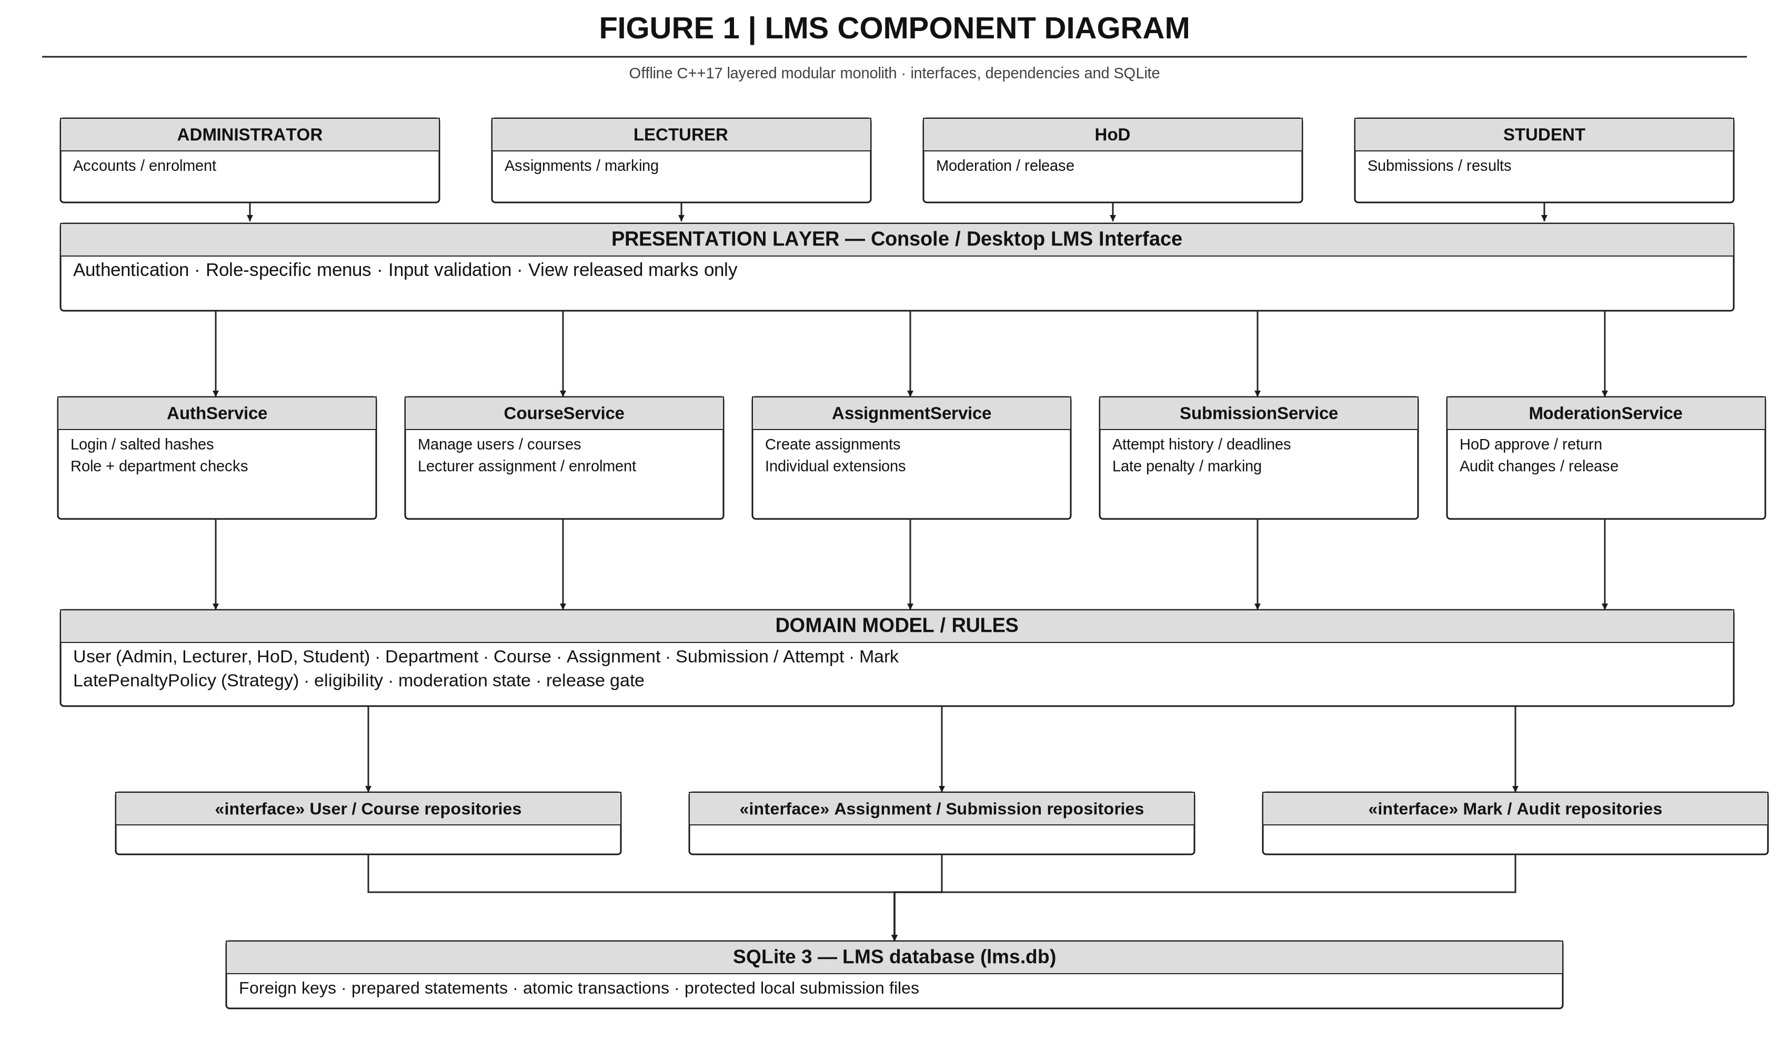

E2 — Design-level UML class diagram
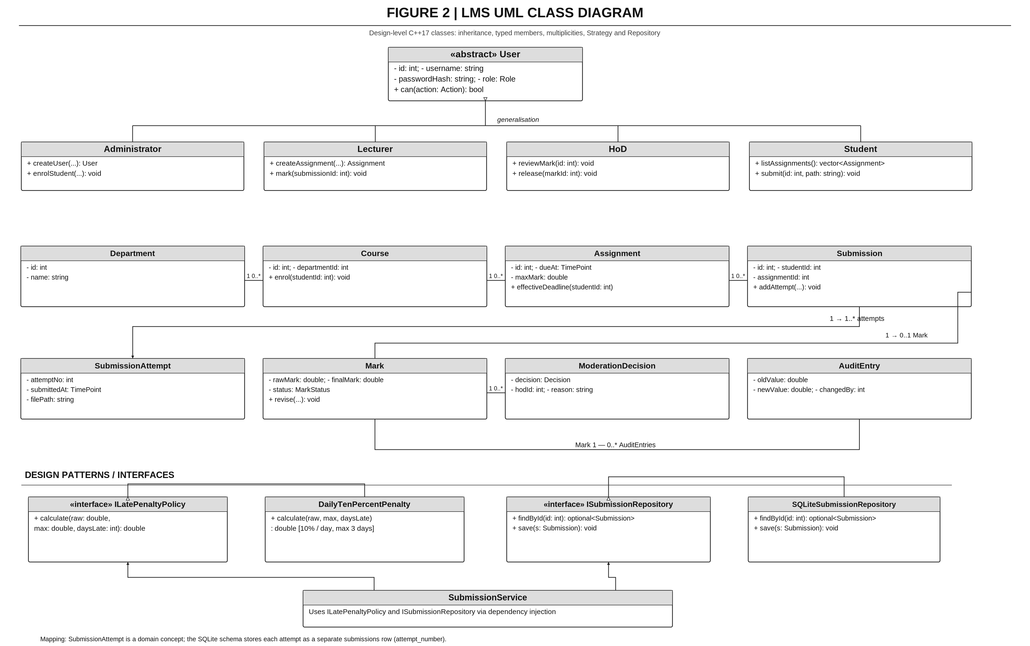

E3 — Submission state machine
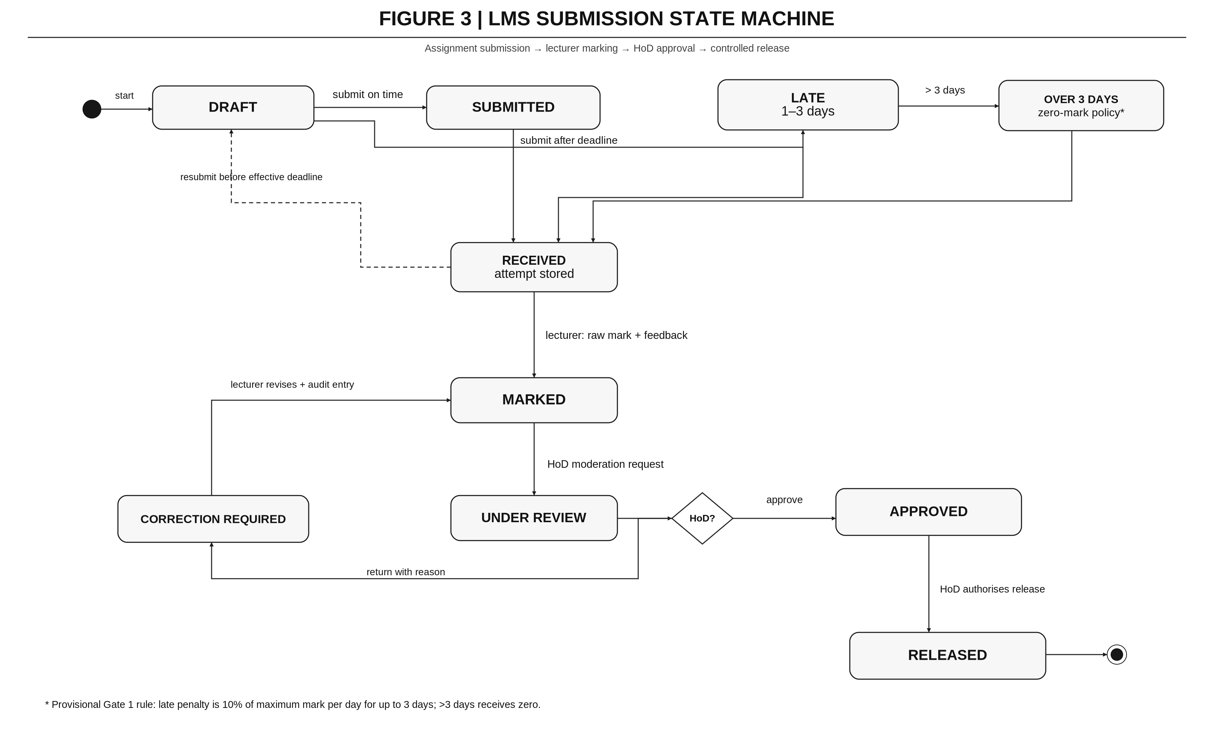

E4 — Submission-to-release swimlane activity diagram
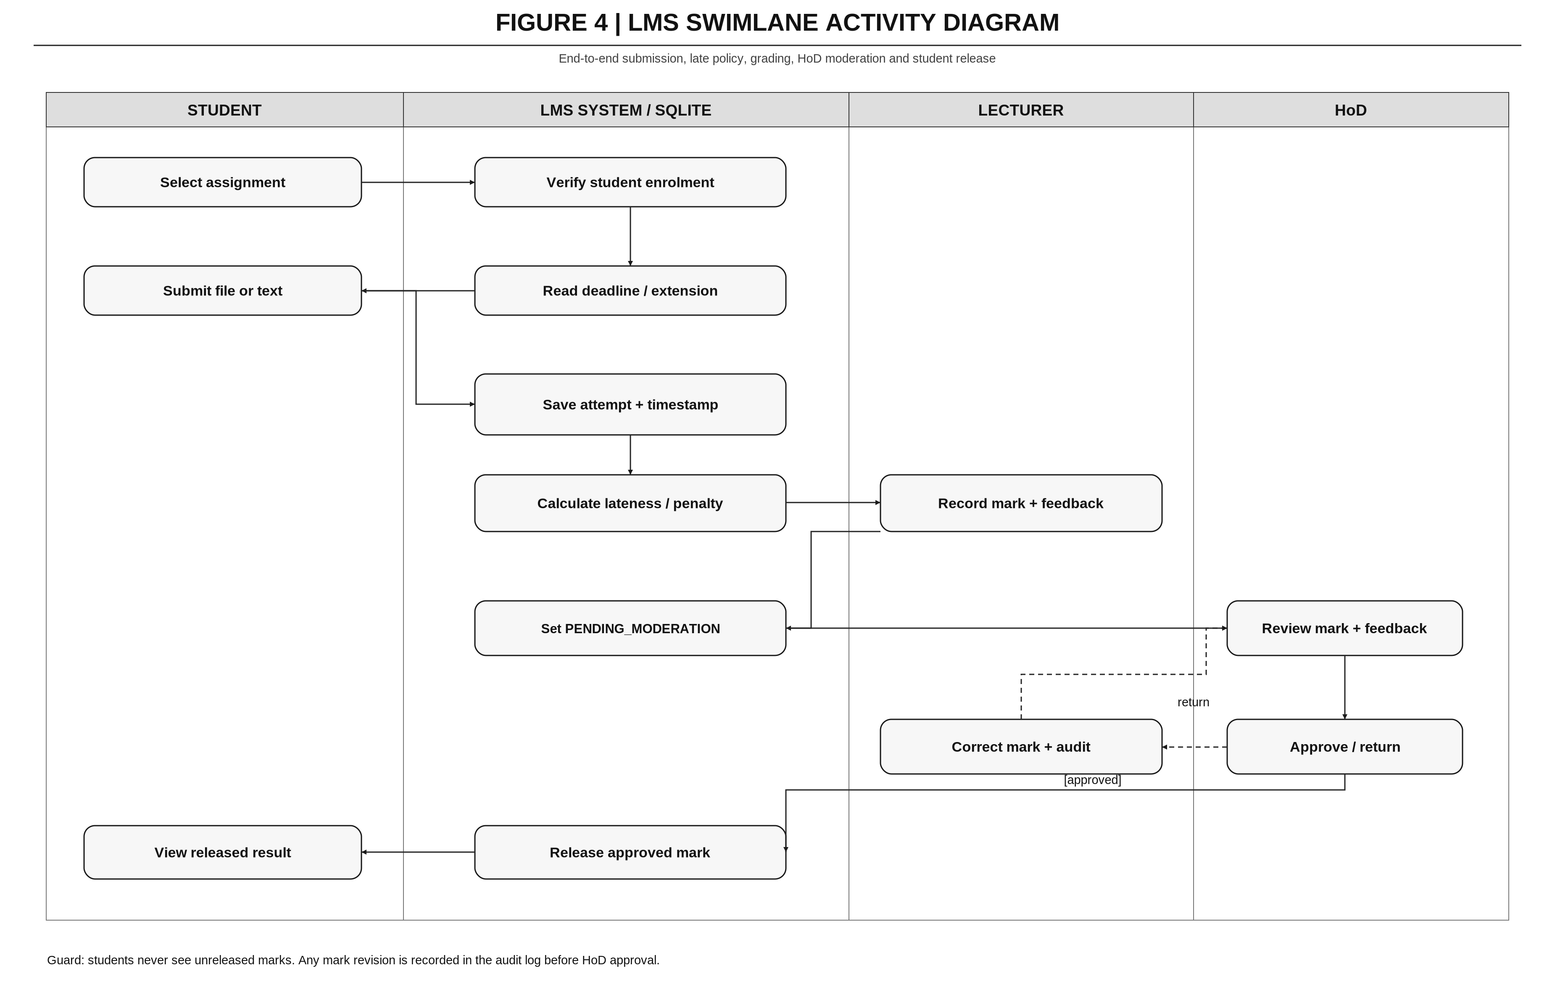

E5 — Submit assignment sequence diagram
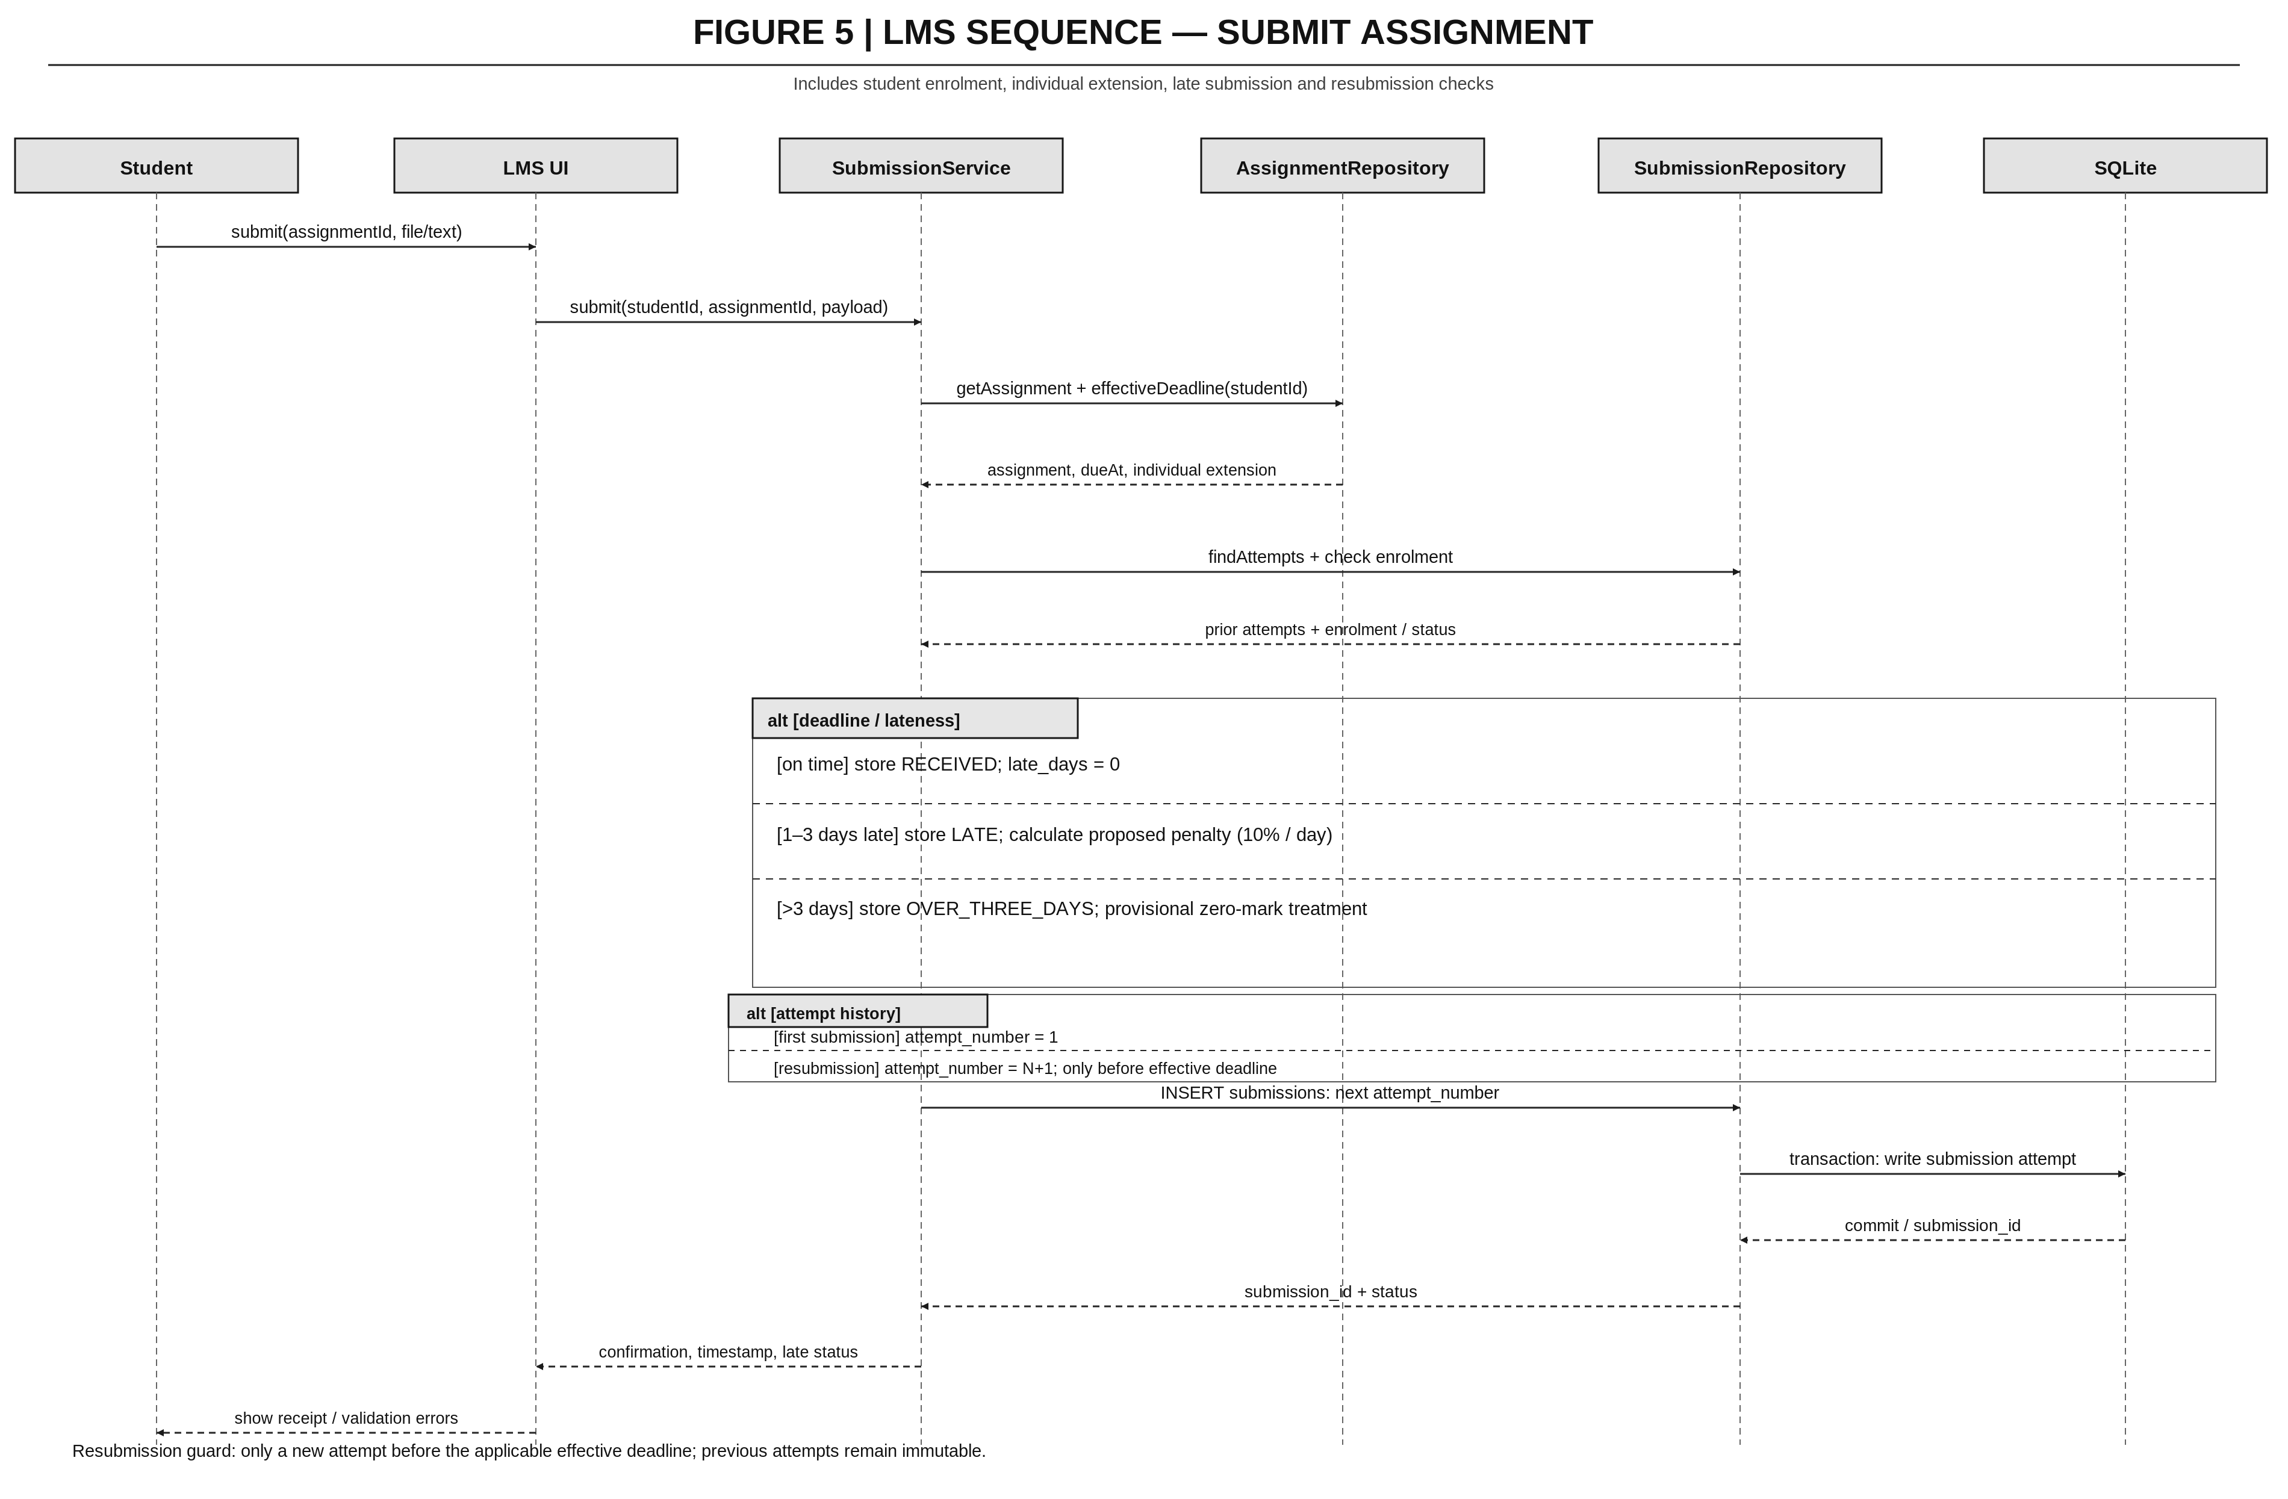

E6 — Moderate and release marks sequence diagram
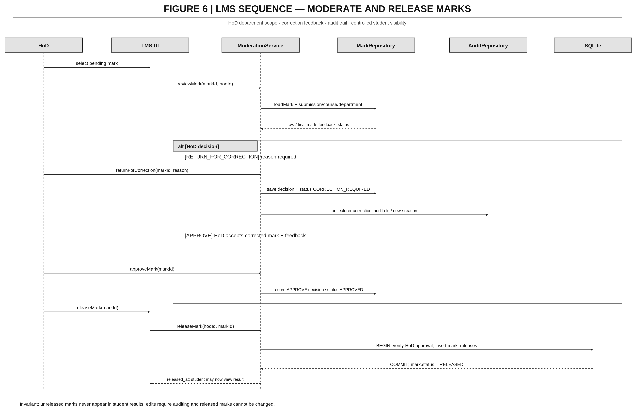

E7 — LMS database ERD


