CS4433 – SOFTWARE ENGINEERING
Individual Final Project

PHASES 6 & 7: QA and Deployment
Moderated Learning Management System (LMS)

Development model | Waterfall, with V-Model verification and validation
Project duration | 7 weeks
Phase 6&7 deliverable | Git configuration control; static analysis; installation manuals; release v1.0

1. Configuration management
The project uses Git to control the Phase 4 C++17/SQLite source, test cases, SQL schema, design references and release documentation. The strategy maintains a reviewed main branch and short-lived feature branches. Merges are preserved as commits; releases have annotated version tags. A real local Git repository was created for the submission evidence and exported as an importable bundle. It is not represented as a hosted school or GitHub repository.
Policy element | Defined rule / available evidence
Branching | main, feature/verification-validation, feature/qa-deployment, release/v1.0.
Changes | Meaningful commits; feature branch merges preserve integration history.
Release tag | Annotated v1.0 tag; verified Git bundle in this package.
CI | GitHub Actions YAML on push and pull_request; local CTest run verified.
Access / backups | No actual learner credentials in Git; protect SQLite database and attachments.

2. Continuous integration and tested build
The included workflow installs SQLite and OpenSSL development libraries on Ubuntu, configures CMake, compiles, and executes CTest. The configured hosted workflow requests Catch2 v3 using CMake FetchContent, so it requires network access during the run. The locally executed offline test configuration leaves this option OFF. CI configuration was checked as a file, while an actual GitHub Actions run and pull request approval must still be demonstrated on the student’s own hosted repository.

3. Static analysis and quality metrics
Clang static analyser was executed locally with clang++ --analyze on db.cpp, security.cpp, repository.cpp, service.cpp and main.cpp. It emitted no diagnostic messages in those runs. The exact raw output is retained under docs/qa/clang_static_analysis.txt. This is not a security certification or a substitute for independent review.
The five implementation files and four public headers contain 665 physical lines in this compact source snapshot. The line count is a code-size measure and not a complexity measure. A separate inspection aid counts conditional lexical tokens by source file, but its figures are explicitly not per-function cyclomatic complexity. Identified review hotspots include LmsService::list, LmsService::submit and LmsService::mark. A proper lizard or clang-tidy McCabe scan is recommended before final sign-off.

4. Self-review and corrective work
Review item | Outcome | Action
Credential storage | Salted OpenSSL PBKDF2 hashes; test verifies no plaintext. | Retained.
Role and department access | Cross-role and cross-department attempts rejected. | Added negative tests.
Audit and release visibility | Mark revisions audited; students see only released marks. | Added regression assertions.
Boundary values | Original suite lacked focused deadline edges. | Added 46 boundary/security assertions.
Performance | No previous representative 800-record sample. | Added reproducible 800-record test.
Catch2 and live CI | Source/config provided; local framework absent. | Hosted execution pending.

5. Phase 7 deployment architecture
The proposed deployment is a single school computer running the C++ console executable. The SQLite database and stored submission attachments reside on protected local storage; an encrypted removable device provides an IT-managed backup. It is deliberately not a distributed web application or a USSD service. The diagram and its editable diagrams.net source are supplied separately in the deployment directory.
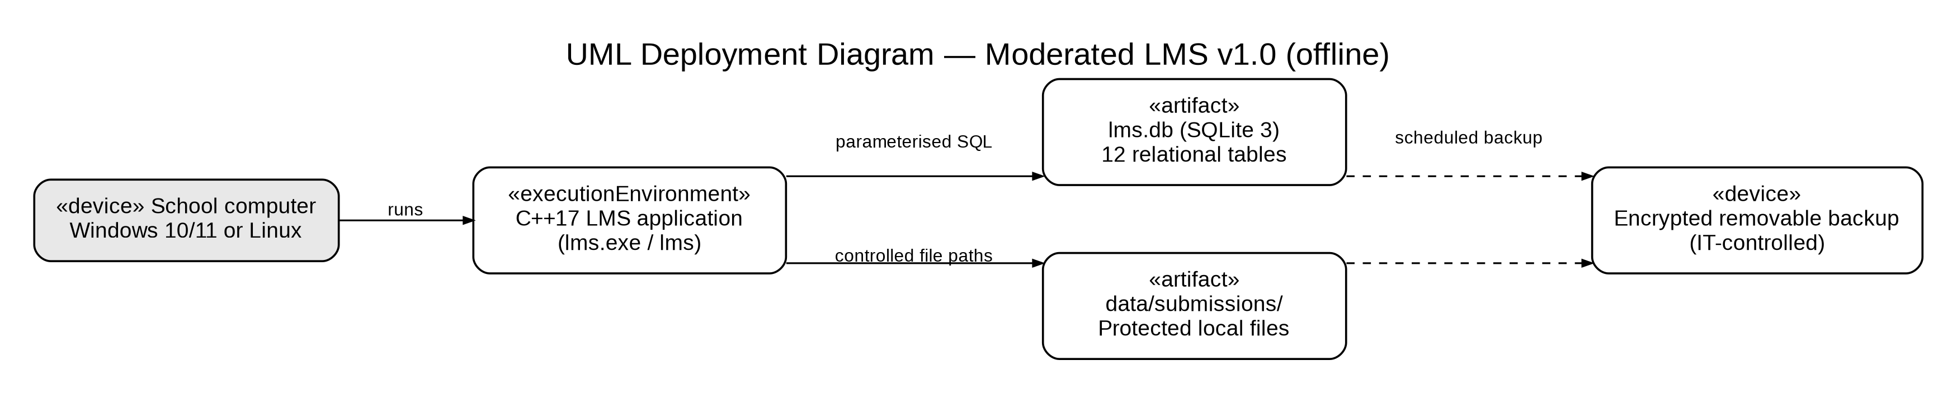
Figure 1. LMS v1.0 deployment view (offline school computer, SQLite and protected backups).

6. Installation and administrator handover
A school technician installs MSYS2 UCRT64 development tools on Windows 10/11, confirms a C++17 compiler, CMake, Ninja, SQLite and OpenSSL, then configures and builds the executable from source. The technician runs CTest, initialises the administrator account once with --init-admin, and establishes a secure database and attachment directory. Only the first administrator can create the initial account; later school accounts are created through the protected administrator menu.
On Windows, runtime DLL dependencies must be checked using the UCRT64 environment and the executable must be validated on the actual target computer. The CMake/Linux build has been tested locally; a packaged Windows installer and school technician acceptance have not been demonstrated here. This distinction is documented in the installation guide.

7. Role-specific user manuals
Role | Key tasks documented
Administrator | Manage departments, accounts, courses, lecturer assignments and enrolments.
Lecturer | Create assignments, grant individual extension, view attempts, mark and revise with audit reason.
Student | View enrolled courses and assignments, submit/resubmit, view own attempts and released feedback.
HoD | Review departmental marks, return for correction, approve, release and inspect decisions.

Individual manuals are provided for each role in docs/manuals. Every manual explains the actual menu choices from src/main.cpp. User accounts and demonstration passwords should be created locally and not included in the public repository. Technicians should schedule database backup/restore drills and keep the submission directory in the same backup set as SQLite.

8. v1.0 release notes and gate evidence
Version v1.0 is tagged in the local Git repository and includes the offline four-role LMS, a 12-table SQLite schema, individual extensions, controlled resubmission, penalty calculation, moderated release and audit logging. The release notes identify known limitations: UTC-only deadlines, locally stored attachments, unverified Windows packaging and pending external acceptance.

