CS4433 – SOFTWARE ENGINEERING
Individual Final Project

PHASE 8: Maintenance and Completion
Moderated Learning Management System (LMS)

Development model | Waterfall, with V-Model verification and validation
Project duration | 7 weeks
Phase 8 deliverable | CR1 impact analysis actual v1.1 implementation regression testing professional issues

1. Change request and maintenance classification
After the v1.0 release baseline, the school requests CR1: “A lecturer should be able to extend the deadline for a whole class, not just an individual student, and extensions should be shown on the student’s assignment list.” This adds user-visible capability rather than merely repairing a defect. Its primary classification is perfective maintenance; changes to the relational schema and legacy-record handling introduce an associated compatibility concern.

2. Requirements, architecture and class impact
Baseline requirement | CR1 effect
FR-06 | Add whole-class extension grant while retaining individual extensions.
FR-07 | Display effective deadline on every enrolled student assignment list.
FR-08/FR-09 | Submission and resubmission compare against updated effective deadline.
FR-11 | Lateness derives from the effective deadline stored with the attempt.
FR-14/FR-15 | Validate new extension and persist it in SQLite; migrate old data safely.

The new LmsService::grantClassExtension method checks that the actor is an assigned active lecturer for the relevant course, requires a reason and a revised UTC deadline after the original, and inserts or advances a whole-class extension. Existing individual-extension methods remain unchanged. Lecturer menu option 8 exposes the new operation. The student assignment list and submit() both calculate a consistent effective due date.
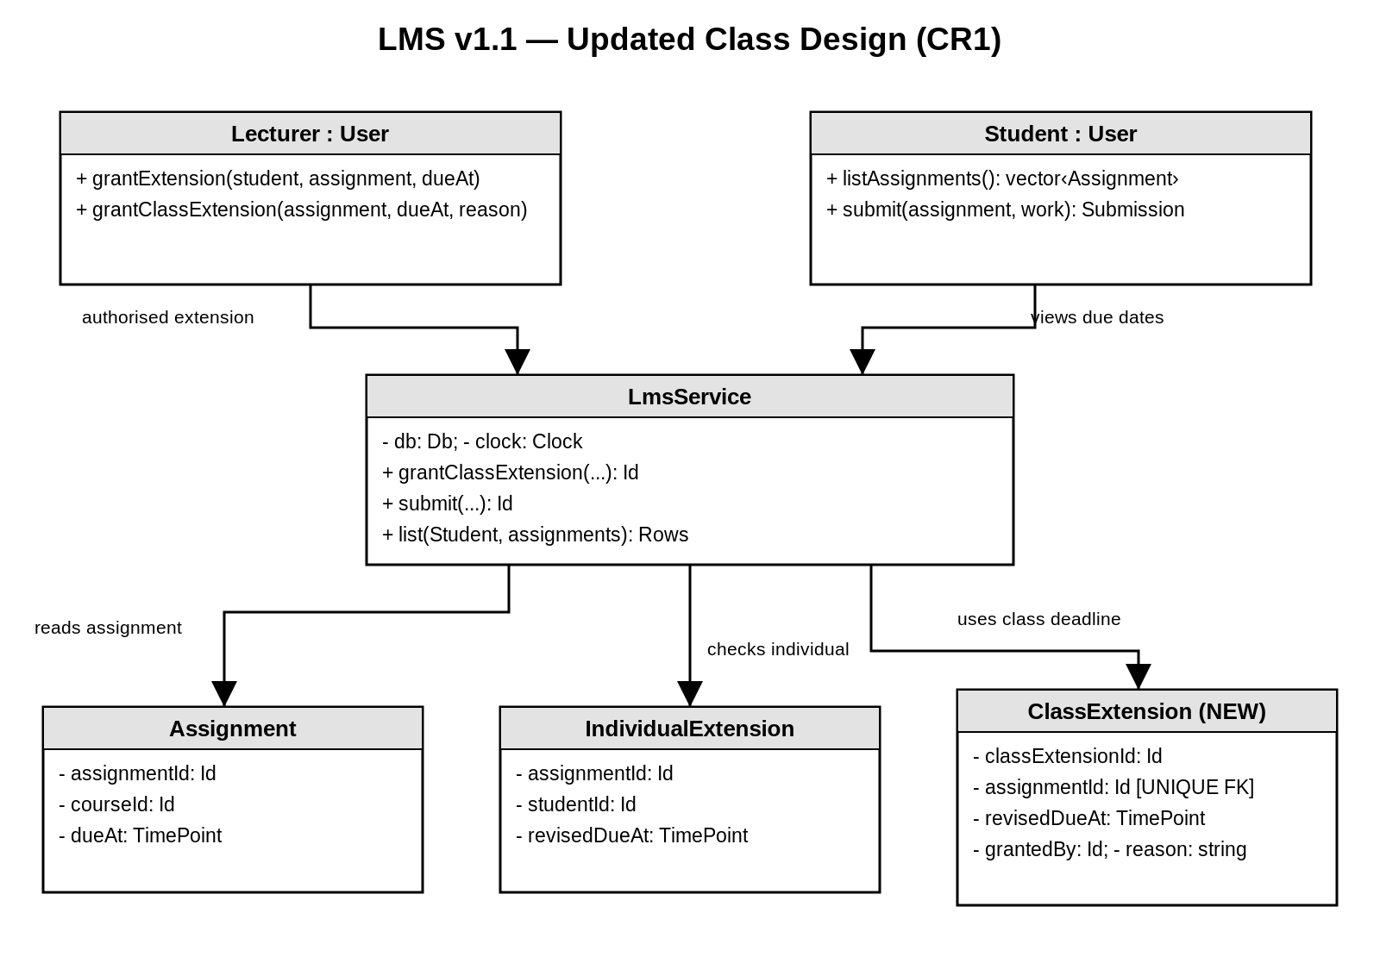
Figure 1. v1.1 design delta: Lecturer/Student operations, LmsService and extension models.

3. Schema update, migration and backward compatibility
The 3NF schema adds class_extensions with class_extension_id as primary key, assignment_id as a unique foreign key and granted_by as lecturer foreign key, plus revised_due_at, reason and granted_at. The change grows the baseline from 12 to 13 tables and from 21 to 23 foreign keys. Existing individual extensions, submission attempts, marks and audit records are retained.
Both the normal v1.1 schema and a separate v1.0-to-v1.1 SQL migration are supplied. The migration creates the table, enforces lecturer eligibility, revises the applicable_due_at trigger and records schema user_version=11. Before applying it on a school PC, stop the LMS and back up the SQLite database and managed submission files. An old v1.0 executable must not be mixed with a v1.1 database for normal production use because it does not display class-level extensions.
Relationship | Cardinality | Reason
assignments → class_extensions | 1 to 0..1 | At most one current whole-class revised deadline per assignment.
users (Lecturer) → class_extensions | 1 to many | Lecturer may grant many class extensions.
assignments → individual_extensions | 1 to many | Existing individual grant path remains supported.

4. Deadline precedence and behavioural model
The effective deadline is the latest of the original assignment due time, any approved individual deadline for the student and the current whole-class deadline. This choice means a new class-wide policy never cancels a more generous individual accommodation. It is explicitly identified as an implementation assumption requiring school confirmation. Once the student submits, the attempt stores the applicable effective due date so that later policy changes do not silently rewrite historical attempts.
The existing submitted, marked, moderated and released state machine needs no new states. Instead, the submission sequence and the swimlane decision now resolve effectiveDeadline(student,assignment) before classifying a late attempt or checking resubmission eligibility. The UML/ERD delta source files are editable in diagrams.net and the updated full ERD is also supplied as a vector PDF.

5. Regression test execution and results
The v1.1 code and SQL migration have been compiled and exercised locally. The original 39 assertion workflows, 46 boundary/negative-security assertions and 50 new CR1 assertions all passed. Four CTest executables completed successfully, including the representative 800-student test. The new suite runs its main cases against a fresh v1.1 schema and against an actual v1.0 schema upgraded by the supplied migration file.
Scenario | Expected outcome | Local result
Lecturer grants class extension | Both enrolled students show revised deadline. | Pass
Wrong-role or wrong-course grant | Controlled denial. | Pass
Individual deadline later than class | Later individual due time wins. | Pass
Class deadline later than individual | Later class due time wins. | Pass
Submit/resubmit after original but before revised | Accepted without late penalty. | Pass
Resubmit after revised deadline | Rejected. | Pass
Upgrade existing v1.0 SQLite schema | Migration retains existing data model and enables CR1. | Pass

Service-level line coverage was 89.37% of 254 executable lines. This is a local GNU gcov figure and not a claim about hosted CI or the school’s Windows computers. The released-mark privacy rule and mark audit workflow remain covered by the original regression suites.

6. Professional, legal and ethical issues
The LMS handles minors’ account data, submissions and assessment records. A live school rollout should review current Lesotho data-protection obligations and school records policy, define lawful processing and retention periods, restrict staff access by role and department, and protect backups. The assignment provides no jurisdictional legal opinion, and this work does not claim legal certification. Passwords are stored as salted OpenSSL PBKDF2 hashes, while parameterised SQL queries and database constraints reduce unsafe persistence paths.
The console interface requires accessibility evaluation with students and staff who use assistive technology; a clean-looking menu is not proof of accessible use. Screen-reader behaviour, keyboard navigation, font scaling and alternative accessible instructions should be checked. The 10% daily late penalty up to three days, followed by zero, may disproportionately affect students facing disability, illness or common disruptions. The school should publish the rule, provide transparent individual and whole-class extension procedures, and keep an appeal record. HoD release remains a safeguard against premature publication of marks.

7. Final handover, viva readiness and outstanding conditions
The Week 7 package contains v1.1 source, migration scripts, updated editable UML/ERD design files, the Git bundle with v1.0/v1.1 tags, regression test evidence, release notes, professional issues discussion and a consolidated final-report draft. For the viva, demonstrate login as all four roles; create an assignment; grant both an individual and class extension; resubmit; mark; show the hidden student result; obtain HoD approval and release; and inspect mark_audit and class_extensions records.

