CS4433 – SOFTWARE ENGINEERING
Individual Final Project

PHASE 1: PROJECT MANAGEMENT PLAN
Moderated Learning Management System (LMS)

Development model | Waterfall, with V-Model verification and validation
Project duration | 7 weeks
Phase 1 deliverable | Project Management Plan

1. Project Overview
The project is a Moderated Learning Management System (LMS) for a secondary school. The system manages courses, assignments, submissions and assessment for four user types: students, lecturers, Heads of Department, and a system administrator. Each user logs in with a username and password and can perform only the actions allowed by their role.
The required application shall be implemented using C++17 with SQLite for persistent storage. It should be a console application or a simple desktop GUI and it should run on a single school computer or local network.
The development model shall be the Waterfall model, with V-Model verification and validation. The seven-week project progresses through planning, requirements engineering, system design, implementation, verification and validation, deployment, maintenance and completion.
In his phase we shall cover feasibility, work breakdown and scheduling, and risk management.

- Feasibility Study

Dimension | Assessment | Evidence / consideration | Conclusion
Technical | The system shall technically be feasible using C++17, SQLite, CMake, Git, a unit-testing framework and a static analyzer. | The brief explicitly specifies C++17, SQLite, CMake, Git, GoogleTest or Catch2, and cppcheck or clang-tidy. The system shall provide role-based access, persistent storage, password hashing, audit logging, validation and exception handling. | Feasible, if the design is kept within the required desktop/local-network environment.
Operational | The LMS addresses the school's stated operational needs and can work without relying on the Internet. | The IT officer states that school computers are old and Internet access is unreliable, so the system shall work offline. The principal also requires simplicity for teachers. The four roles and their responsibilities are clearly defined. | Feasible. A simple console or desktop GUI with clear role-based workflows is appropriate.
Economic | The specified technology stack can be implemented using software tools that are available for development without requiring an online service architecture. | The brief specifies open development tools/technologies such as C++, SQLite, CMake, Git, GoogleTest/Catch2 and cppcheck/clang-tidy. The target is a local application rather than a hosted web service. | Feasible for the academic project, with no major infrastructure cost assumed in the brief.
Legal | The system shall protect learner personal information and assessment records. | The brief explicitly requires discussion of data protection, security of assessment records, accessibility and fairness. It also requires salted password hashes rather than plain-text passwords and an audit log for mark changes. | Feasible if security and data-protection requirements are incorporated into design and implementation.
Schedule | The project has a fixed seven-week schedule and multiple assessed artifacts. | Implementation cannot begin until the design passes Gate 2. Testing, CI, static analysis, deployment, maintenance and the final report must all be completed within the remaining weeks. | Feasible but high schedule pressure exists; strict scope control and early completion of design artefacts are necessary.

Feasibility recommendation: The project is feasible within the stated scope and seven-week schedule. The strongest constraints are schedule pressure and the need to maintain consistency between requirements, UML design, database design, implementation and tests. The project shall therefore use strict scope control, complete the design before implementation, and maintain traceability throughout the lifecycle.

3. Work Breakdown Structure (WBS)
3.2 Class/Design Pattens - 1 Week
3.1 Architecture - 1 Week
3.3Behavioural Models - 1 Week
2.3 Use Case Model - 1 Week
1.3 Risk Management - 1 Week
1.2 Work Breakdown & Schedulling - 1 Week
1.1 Feasibility Study - 1 Week
2.2 SRS - 1 Week
2.1 Stakeholder Analysis - 1 Week
2.0 Requirements Engineering
2 Weeks
3.0 System Design
1 Week
4.0 Implementation - 2 Weeks
5.0 Verification & Validation - 2 Weeks
6.0 Configuration & QA - 2 Weeks
7.0 Deployment - 1 Week
9.0 Completion - 1 Week
8.0 Maintainance
9.0 Completion
1 Week
7.0 Deployment
1 Week
6.0 Configuration & QA
2 Weeks
5.0 Verification & Validation
2 Weeks
4.0 Implementation
2 Weeks
1.0 Project Management
1 Week
Moderated Learning Management System (LMS)
7 Weeks

4. Seven-Week Schedule and Gantt Plan
The schedule follows the mandated phase structure. Phase gates are treated as milestones.
ID | Activity | Duration | Predecessor | Week(s) | Milestone / output
A | Planning & feasibility | 1 week | — | 1 | Project management plan
B | Stakeholder analysis & conflict resolution | 1 week | A | 1–2 | Stakeholder analysis
C | SRS | 1 week | B | 2 | SRS
D | Use case model | 1 week | B | 2 | Use case diagram + specifications
E | Gate 1 review | Milestone | C, D | 2 | Requirements gate
F | Architecture & component design | 1 week | E | 2–3 | Architecture + component diagram
G | Class & design patterns | 1 week | F | 3 | Class diagram + pattern rationale
H | Behavioural models | 1 week | G | 3 | State/activity/sequence diagrams
I | Database design | 1 week | F | 3 | ERD + dictionary + SQL schema
J | Gate 2 review | Milestone | G, H, I | 3 | Design approval
K | C++ implementation + SQLite | 2 weeks | J | 4–5 | Working application
L | CI + code reviews | 2 weeks | J | 4–5 | Automated build/test pipeline
M | Unit & integration testing | 2 weeks | K | 5–6 | Automated tests + coverage
N | System & acceptance testing | 1 week | M | 6 | Test results + defect log
O | Gate 3 review | Milestone | N | 6 | V&V gate
P | Deployment packaging & manuals | 1 week | O | 6 | v1.0 package
Q | CR1 analysis & implementation | 1 week | P | 7 | v1.1
R | Regression testing | 1 week | Q | 7 | Regression results
S | Professional issues + final report + viva | 1 week | P | 7 | Final submission

4.1 Gantt Chart
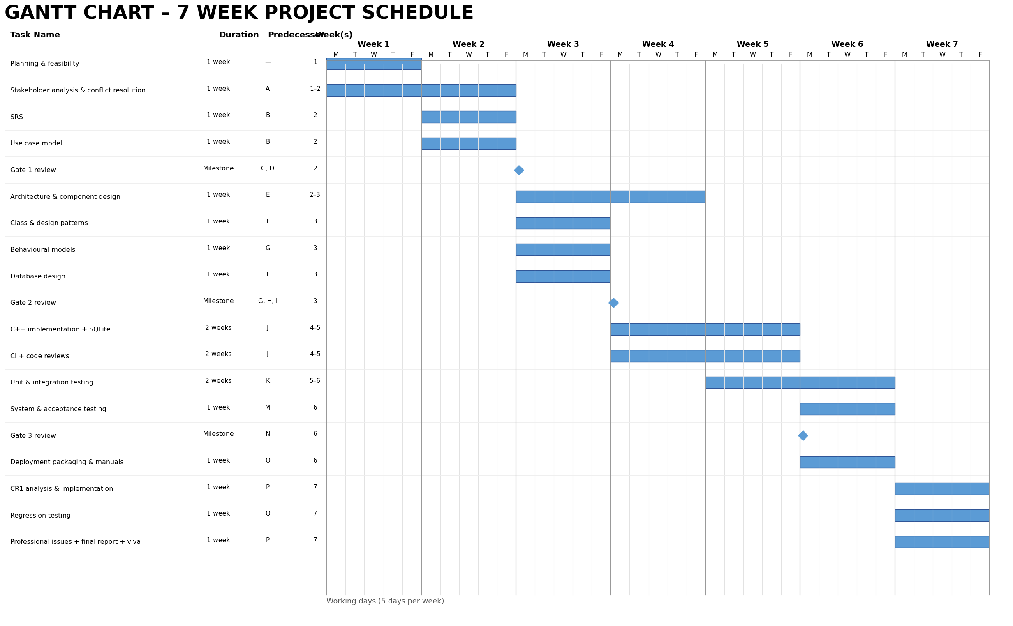
Legend: ■ = active work; ◆ = phase-gate milestone.

4.2 Dependencies and Critical Path
The main dependency chain is follows the Waterfall model: requirements must be sufficiently complete before design; design must pass Gate 2 before implementation; implementation must provide the system needed for full verification; and Gate 3 precedes deployment. Therefore, delays in the following chain directly threaten the seven-week completion date:
A → B → C/D → E → F → G/H/I → J → K → M → N → O → P → Q → R
This is the principal critical path. Requirements activities C and D are parallel after stakeholder analysis, but both must be complete for Gate 1. Likewise, the main design streams converge at Gate 2. CI and code reviews run alongside implementation and are treated as supporting activities rather than a separate path to the final release.
Key milestones are Gate 1 at the end of requirements engineering, Gate 2 at the end of system design, Gate 3 after verification and validation, release v1.0 during deployment, and release v1.1 after the maintenance change request.

5. Risk Management
Risk exposure is assessed qualitatively as Likelihood × Impact. A 1–5 scale is used: 1 = very low and 5 = very high. Exposure is therefore from 1 to 25. My individual responsible as the project overseer is monitoring and implementing the mitigation
ID | Risk | Type | L | I | Exp. | Mitigation / response | Owner
R1 | The seven-week schedule is insufficient because requirements, UML, implementation, testing and documentation are all assessed. | Project | 4 | 5 | 20 | Follow the WBS and critical path; complete phase deliverables incrementally; avoid starting implementation before Gate 2; reserve time for testing and maintenance. | Student / Project Manager
R2 | Design artefacts and implementation become inconsistent, reducing traceability marks. | Technical | 4 | 5 | 20 | Maintain a requirements traceability matrix from requirement → use case → class/table/source/test; update artefacts when design changes. | Student / Project Manager
R3 | SQLite/data-access defects cause data loss or incorrect persistent behaviour. | Technical | 3 | 5 | 15 | Use a Repository/DAO layer, parameterised queries, constraints, transactions where appropriate, backups during development, and database integration tests. | Student / Developer
R4 | Password storage or access-control implementation is insecure. | Technical / Security | 3 | 5 | 15 | Use salted password hashes with a recognised library; never store plain-text passwords; centralise role checks and test authorisation boundaries. | Student / Developer
R5 | Late-penalty, extension or resubmission rules are implemented incorrectly. | Technical / Requirements | 3 | 5 | 15 | Define business rules precisely in the SRS and design; use boundary-value tests around deadlines, one/three-day lateness, extensions and resubmissions. | Student / Developer
R6 | The system becomes too complex for teachers or users to operate easily. | People / Operational | 3 | 4 | 12 | Keep workflows simple; use clear role-specific menus/screens; validate inputs; include user acceptance tests based on the stakeholder needs. | Student / UX & QA
R7 | Automated tests do not reach the required coverage or fail in CI. | Project / Technical | 3 | 4 | 12 | Set up CI during implementation, not at the end; run tests on every push; monitor coverage and add tests alongside business logic. | Student / QA
R8 | Static analysis identifies significant code-quality defects late in the project. | Technical | 3 | 3 | 9 | Run cppcheck or clang-tidy during implementation; fix findings incrementally and record the resulting QA evidence. | Student / QA
R9 | Git/version-control problems cause loss of work or make project history unclear. | Project | 2 | 4 | 8 | Use meaningful commits, regular pushes, a documented branching strategy and tagged releases; keep the hosted repository current. | Student / Configuration Manager
R10 | A requirement change during maintenance affects more artefacts than expected. | Project | 3 | 4 | 12 | Use impact analysis and the traceability matrix; identify affected requirements, diagrams, classes, tables and tests before implementing CR1. | Student / Project Manager
Risk monitoring: the risk register will be reviewed and updated at each phase gate. New risks, changed likelihood/impact, completed mitigations and residual exposure will be recorded.

6. Conclusion
The feasibility study indicates that the moderated LMS is feasible within the Project's technical, operational, economic, legal and schedule constraints. The principal management concern is schedule pressure, particularly because implementation is gated by requirements and design approval and the project must still complete automated testing, CI, static analysis, deployment and a maintenance release.
The WBS and schedule therefore prioritise requirements and design early, enforce Gate 2 before implementation, introduce testing and CI during development, and reserve Week 7 for the specified maintenance change and final completion activities. The risk register identifies schedule, traceability, persistence, security, business-rule correctness, usability, testing, quality assurance, configuration management and change-impact risks.

