CS4433 – SOFTWARE ENGINEERING
Individual Final Project

PHASE 3: Software Design
Moderated Learning Management System (LMS)

Development model | Waterfall, with V-Model verification and validation
Project duration | 7 weeks
Phase 3 deliverable | Software design

1. Purpose, Scope and Design Baseline
This document translates the Week 2 SRS into an implementable architecture, object model, behavioural specification and relational database. It covers Administrator, Lecturer, HoD and Student roles. The system operates offline on a school computer or LAN and stores persistent records in SQLite. Web/mobile interfaces, payments, video meetings, automatic grading and plagiarism detection are excluded.
Core invariants: students cannot view marks before HoD release; every change to a mark is audited; lecturer extensions apply to individual students in v1.0; a submission attempt retains its timestamp; access is role- and department-scoped. CR1 whole-class extensions belong to later maintenance release v1.1, not this baseline.

2. Architectural Design

2.1 Selected style: layered architecture
A layered modular monolith is selected: presentation (console or simple desktop UI), application services, domain model, repositories and SQLite. Services orchestrate use cases; domain entities enforce invariants; repositories isolate SQL and return domain objects. This is practical for offline deployment and C++17, while allowing unit tests without a database.

Figure 1. UML Component Diagram — Layered Architecture
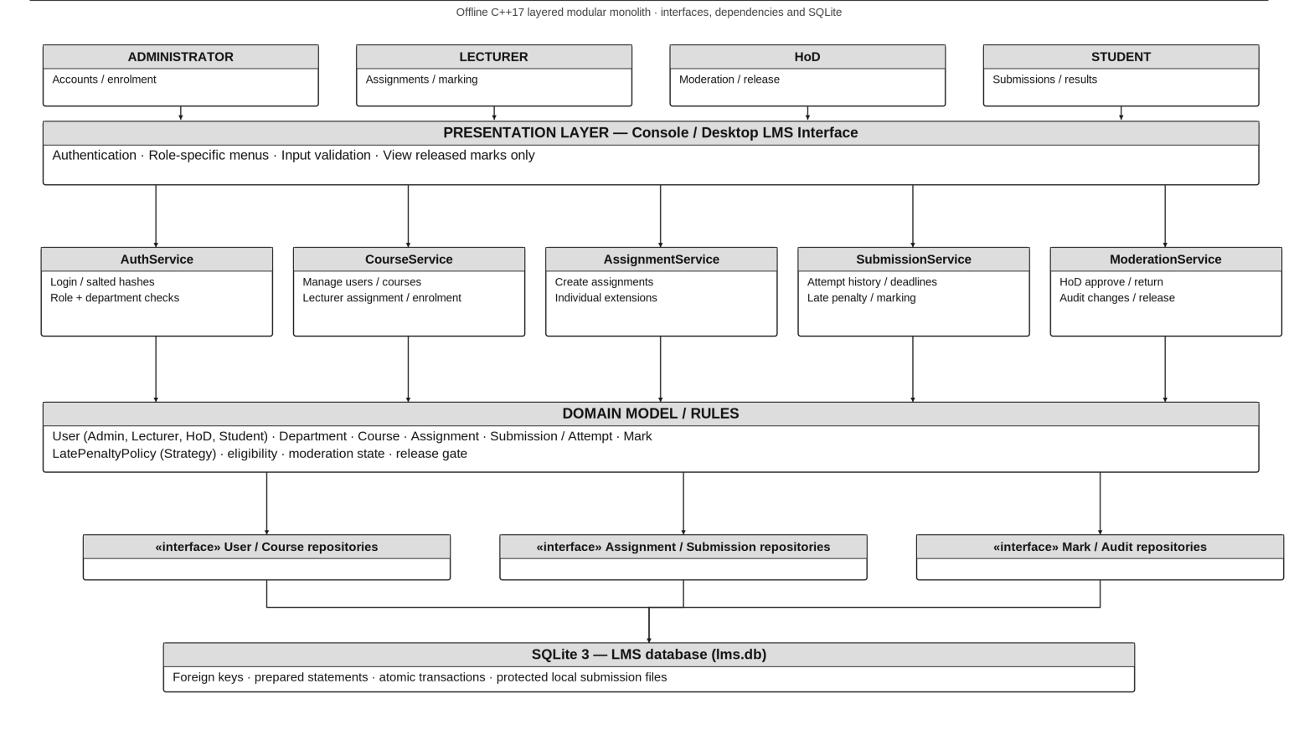

2.2 Rationale and rejected alternative
Layering supports separation of concerns, independent business-rule testing, controlled database access, and low deployment overhead. A distributed microservices architecture was rejected because offline operation, small scale, limited IT support and deployment on older school computers do not justify network orchestration or multiple services. A monolithic class containing UI, rules and SQL was also rejected due to tight coupling and poor testability.

2.3 Interfaces and dependency direction
Presentation depends on service interfaces; services depend on domain contracts and repository interfaces; SQLite implementations depend on SQLite C API. Domain rules never call SQL directly. All writes use parameterised statements and transactions where multiple records must change atomically.

3. Detailed Object-Oriented Design

UML Class Diagram — Design Level
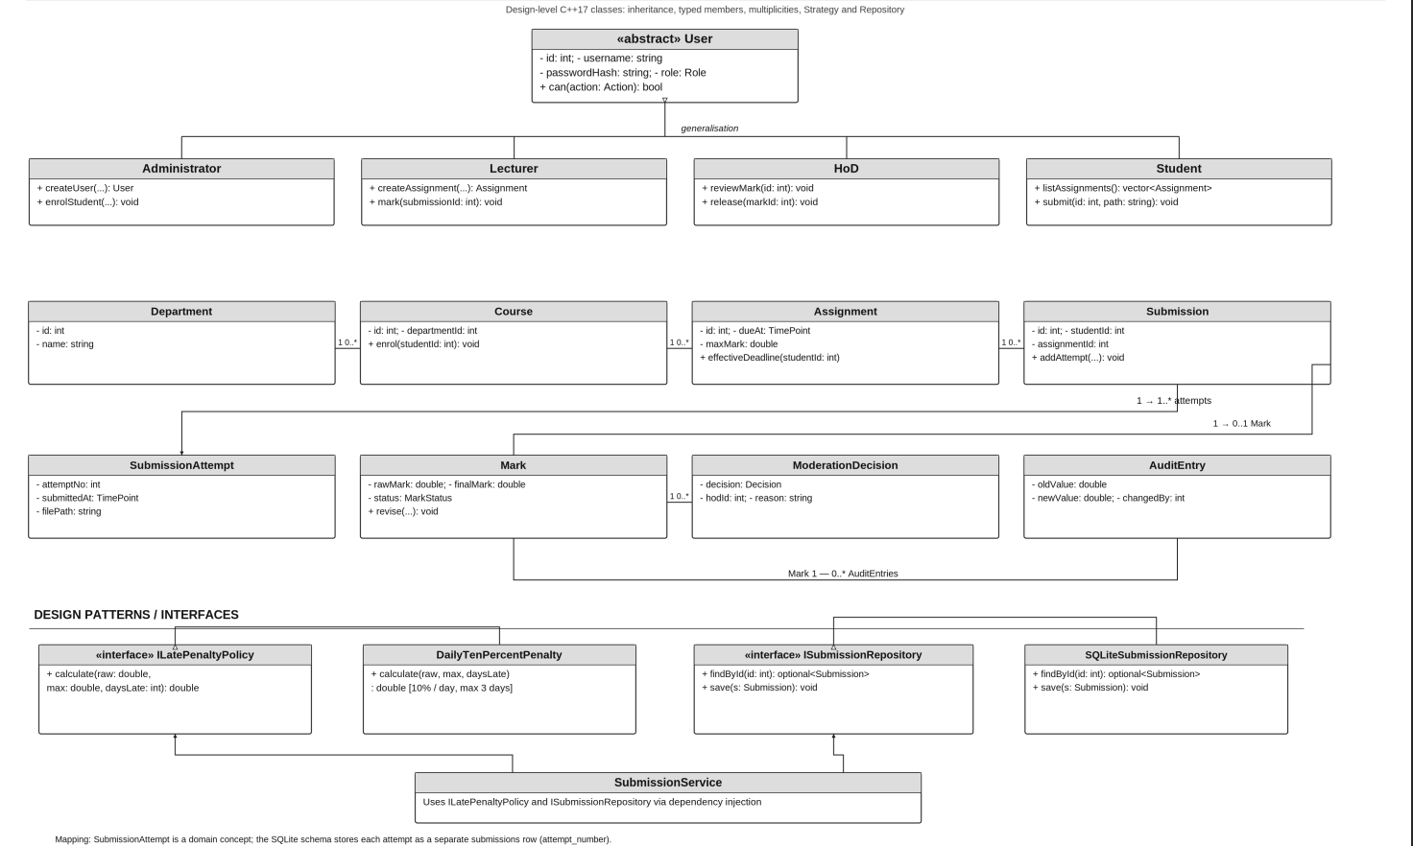

3.2 Key class responsibilities, visibility and types
Class / interface | Representative members and operations
User (abstract) | -id:int; -username:string; -passwordHash:string; -role:Role; +can(Action):bool; virtual destructor
Student : User | +listAssignments():vector<Assignment>; +submit(assignmentId:int, path:string):SubmissionAttempt
Lecturer : User | +createAssignment(...):Assignment; +grantExtension(studentId:int, assignmentId:int, dueAt:TimePoint):void; +mark(submissionId:int, raw:double, feedback:string):void
HoD : User | +reviewMark(markId:int):void; +moderate(markId:int, approvedValue:double, reason:string):void; +release(markId:int):void
Administrator : User | +createUser(...):User; +assignLecturer(...):void; +enrolStudent(...):void
Assignment | -id:int; -courseId:int; -dueAt:TimePoint; -maxMark:double; +effectiveDeadline(studentId:int):TimePoint
Submission | -id:int; -assignmentId:int; -studentId:int; -status:SubmissionStatus; +addAttempt(...):void; +transition(...):void
Mark | -id:int; -rawMark:double; -finalMark:double; -releasedAt:optional<TimePoint>; +revise(...):void
ILatePenaltyPolicy | +calculate(rawMark:double,maxMark:double,daysLate:int):double [pure virtual]
ISubmissionRepository | +findById(id:int):optional<Submission>; +save(s:Submission):void [pure virtual]

3.3 Multiplicities and constraints
One Department has zero or more Courses; each Course belongs to exactly one Department. One Course has zero or more Assignments and enrolments. Each Assignment has zero or more Submissions; a Student has at most one logical Submission per Assignment, with one or more SubmissionAttempts to preserve resubmissions. A Submission has zero or one current Mark; a Mark has zero or more AuditEntries and moderation decisions. A Lecturer may teach multiple Courses; a Course may have multiple assigned lecturers. A HoD may oversee a Department, subject to approved policy.

3.4 Design patterns
Strategy: ILatePenaltyPolicy separates the late penalty calculation from SubmissionService. The DailyTenPercentPenalty policy can be tested or changed without altering submission handling. Repository/DAO: interfaces such as ISubmissionRepository abstract SQLite and support in-memory fakes during unit testing. Both patterns are part of the v1.0 implementation design.

3.5 SOLID application
SRP: separate authentication, submission, moderation and persistence. OCP: new penalty strategies implement ILatePenaltyPolicy. LSP: User subtypes preserve common identity and permission contracts. ISP: repositories are split by aggregate rather than one giant interface. DIP: services accept repository and penalty-policy abstractions through constructor injection.

4. Behavioural Models

Submission State Machine
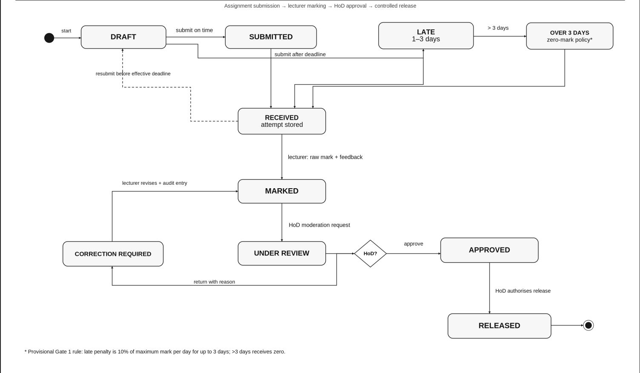
State guards: submission/resubmission requires enrolled Student and an active assignment; resubmission eligibility is checked against the effective deadline; marking requires an eligible lecturer; moderation requires a department-scoped HoD; release requires approved moderation. Audit entries accompany any change to a mark. Late policy and the precise treatment of >3-day submissions remain Gate 1 clarification items.

Swimlane Activity Diagram — Submission to Release
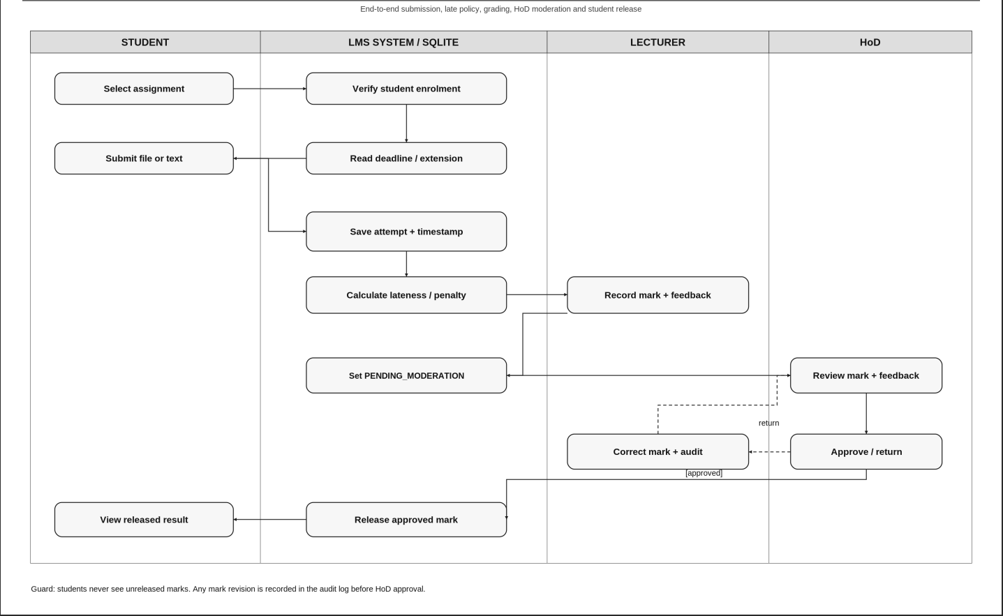

Sequence Diagram — Submit Assignment (late + resubmission)
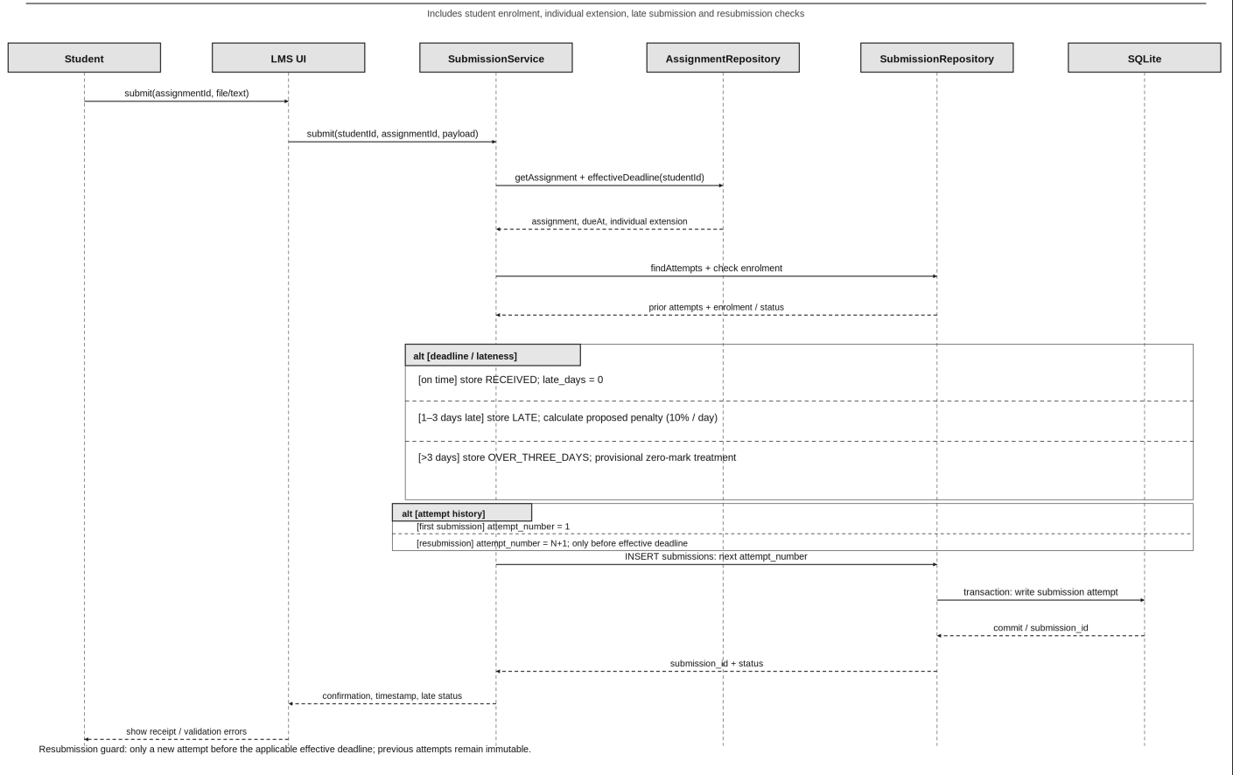

Figure 6. Sequence Diagram — Moderate and Release Marks
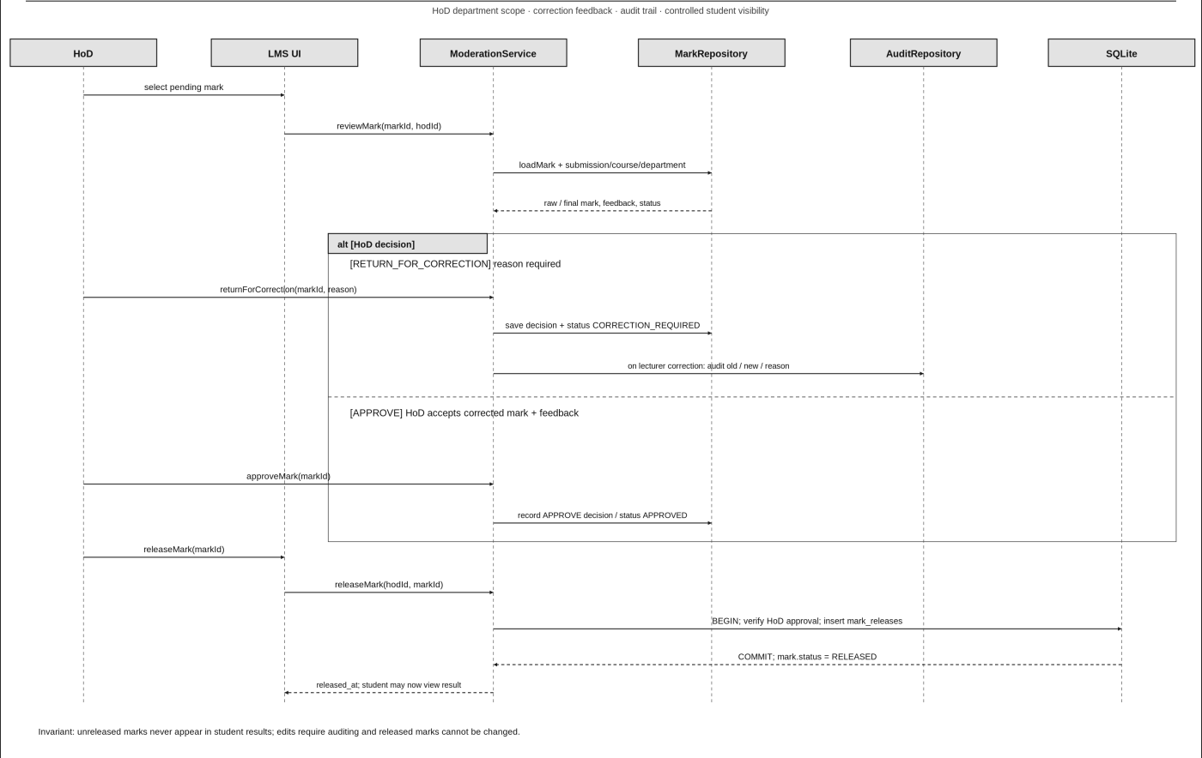

Database Design

ERD — entities and cardinalities (3NF)
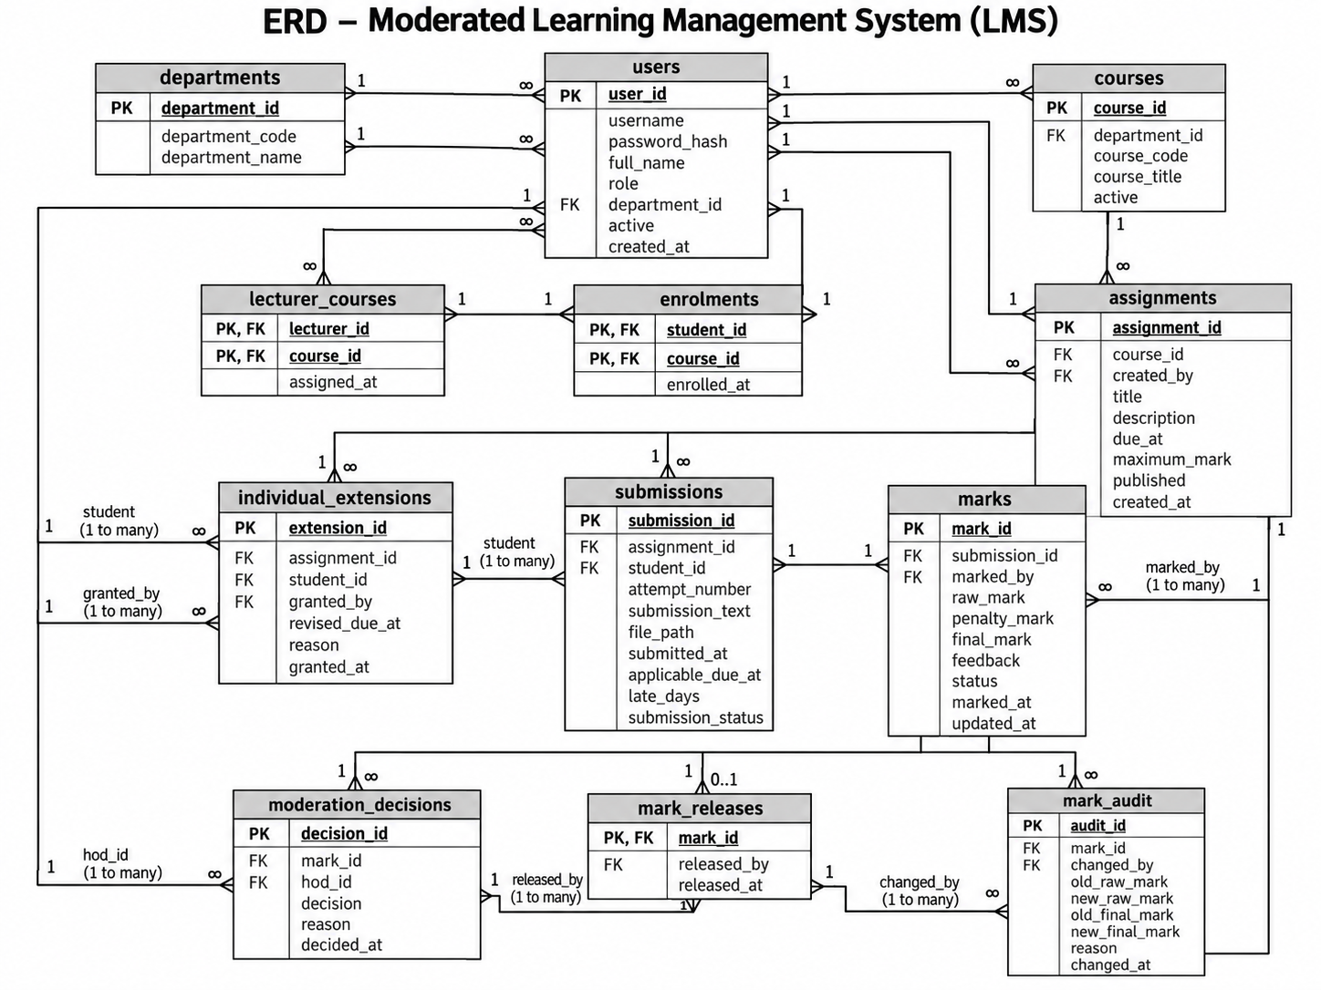

5.2 Data dictionary
Table | Primary key | Selected columns / constraints | Purpose
departments | department_id | name TEXT UNIQUE NOT NULL | School departments
users | user_id | username UNIQUE; role CHECK; password_hash NOT NULL; department_id FK nullable | All four roles, one identity table
courses | course_id | department_id FK; code UNIQUE; title NOT NULL | Course catalogue
course_lecturers | (course_id,lecturer_id) | Both FKs | Lecturer-course assignment
enrolments | (course_id,student_id) | Both FKs | Student-course enrolment
assignments | assignment_id | course_id FK; due_at TEXT; max_mark REAL >0 | Assignment rules
individual_extensions | (assignment_id,student_id) | extended_due_at TEXT; lecturer_id FK; reason | Individual extension only (v1.0)
submissions | submission_id | assignment_id FK; student_id FK; UNIQUE pair; status | One logical submission
submission_attempts | attempt_id | submission_id FK; submitted_at; file_path; attempt_no | Preserved attempts
marks | mark_id | submission_id UNIQUE FK; raw_mark; final_mark; feedback; released_at nullable | Mark and visibility
moderation_decisions | decision_id | mark_id FK; hod_id FK; decision; reason; created_at | HoD review history
mark_audit | audit_id | mark_id FK; actor_id FK; old_value; new_value; reason; changed_at | Mandatory audit trail

5.3 SQL schema (SQLite)
PRAGMA foreign_keys = ON;
CREATE TABLE departments (department_id INTEGER PRIMARY KEY, name TEXT NOT NULL UNIQUE);
CREATE TABLE users (user_id INTEGER PRIMARY KEY, username TEXT NOT NULL UNIQUE,
password_hash TEXT NOT NULL, role TEXT NOT NULL CHECK(role IN ('ADMIN','LECTURER','HOD','STUDENT')),
department_id INTEGER REFERENCES departments(department_id));
CREATE TABLE courses (course_id INTEGER PRIMARY KEY, department_id INTEGER NOT NULL REFERENCES departments,
code TEXT NOT NULL UNIQUE, title TEXT NOT NULL);
CREATE TABLE course_lecturers (course_id INTEGER NOT NULL REFERENCES courses,
lecturer_id INTEGER NOT NULL REFERENCES users, PRIMARY KEY(course_id,lecturer_id));
CREATE TABLE enrolments (course_id INTEGER NOT NULL REFERENCES courses,
student_id INTEGER NOT NULL REFERENCES users, PRIMARY KEY(course_id,student_id));
CREATE TABLE assignments (assignment_id INTEGER PRIMARY KEY, course_id INTEGER NOT NULL REFERENCES courses,
title TEXT NOT NULL, due_at TEXT NOT NULL, max_mark REAL NOT NULL CHECK(max_mark>0));
CREATE TABLE individual_extensions (assignment_id INTEGER NOT NULL REFERENCES assignments,
student_id INTEGER NOT NULL REFERENCES users, extended_due_at TEXT NOT NULL,
lecturer_id INTEGER NOT NULL REFERENCES users, reason TEXT NOT NULL,
PRIMARY KEY(assignment_id,student_id));
CREATE TABLE submissions (submission_id INTEGER PRIMARY KEY, assignment_id INTEGER NOT NULL REFERENCES assignments,
student_id INTEGER NOT NULL REFERENCES users, status TEXT NOT NULL,
UNIQUE(assignment_id,student_id));
CREATE TABLE submission_attempts (attempt_id INTEGER PRIMARY KEY,
submission_id INTEGER NOT NULL REFERENCES submissions, attempt_no INTEGER NOT NULL CHECK(attempt_no>0),
submitted_at TEXT NOT NULL, file_path TEXT NOT NULL,
UNIQUE(submission_id,attempt_no));
CREATE TABLE marks (mark_id INTEGER PRIMARY KEY, submission_id INTEGER NOT NULL UNIQUE REFERENCES submissions,
raw_mark REAL NOT NULL CHECK(raw_mark>=0), final_mark REAL NOT NULL CHECK(final_mark>=0),
feedback TEXT NOT NULL, released_at TEXT);
CREATE TABLE moderation_decisions (decision_id INTEGER PRIMARY KEY,
mark_id INTEGER NOT NULL REFERENCES marks, hod_id INTEGER NOT NULL REFERENCES users,
decision TEXT NOT NULL CHECK(decision IN ('APPROVED','RETURNED','ADJUSTED')),
reason TEXT NOT NULL, created_at TEXT NOT NULL);
CREATE TABLE mark_audit (audit_id INTEGER PRIMARY KEY, mark_id INTEGER NOT NULL REFERENCES marks,
actor_id INTEGER NOT NULL REFERENCES users, old_value REAL, new_value REAL,
reason TEXT NOT NULL, changed_at TEXT NOT NULL);
CREATE INDEX idx_submissions_student ON submissions(student_id);
CREATE INDEX idx_attempts_submission ON submission_attempts(submission_id);
CREATE INDEX idx_marks_release ON marks(released_at);

5.4 Normalisation and object-relational mapping
1NF: all columns are atomic; multiple attempts, lecturers and enrolments are stored in separate rows.
2NF: composite-key tables have no attributes dependent on only part of their key.
3NF: department details are stored only in departments; course details only in courses; users are referenced by foreign keys instead of duplicated. Calculated late days and penalty are derived by the domain service rather than stored redundantly.
Domain class / association | SQLite representation | Justification
User / Admin / Lecturer / HoD / Student | users.role discriminator | Single-table inheritance avoids repeated credentials; C++ retains abstract User and derived classes
Department / Course / Assignment | departments / courses / assignments | One-to-many relations via foreign keys
Student enrolment; lecturer assignment | enrolments; course_lecturers | Normalised many-to-many join tables
Submission; SubmissionAttempt | submissions; submission_attempts | One aggregate with immutable attempt history
Mark; ModerationDecision; AuditEntry | marks; moderation_decisions; mark_audit | Separates current state, approvals and immutable change history
ILatePenaltyPolicy | No dedicated table in v1.0 | Algorithmic strategy injected in code; no persistent entity required

6. Key Design Decisions, Risks and Gate 2 Review
Security: use salted password hashing with a recognised library; the concrete library and work factor must be fixed during implementation planning. Role and department checks occur server-side in services, not only in menus. Student mark queries filter released_at IS NOT NULL. A mark update and its audit record occur within one SQLite transaction. Foreign keys are enabled on every connection.
Late penalties: proposed calculation is final=max(0,raw−0.10×maxMark×lateDays), capped at three days; submissions after three days receive zero. The exact rounding of partial days, whether a >3-day attempt is stored, and the resubmission deadline rule require stakeholder confirmation. Effective due date uses the approved individual extension where present.
Offline file storage: the SQLite database stores relative file paths and submission metadata, while submission files are kept in a protected local directory. File access must be checked against enrolment and role permissions. Backups should include both the database and submission directory.
Gate 2 checklist | Evidence
Architecture justified and alternative rejected | Sections 2.1–2.3
Design-level classes, patterns, SOLID | Sections 3.1–3.5
Submission state machine | Figure 3
Swimlane activity model | Figure 4
Submit sequence incl. late/resubmission | Figure 5
Moderate/release sequence | Figure 6
3NF ERD, dictionary, SQL, mapping | Sections 5.1–5.4
Open decisions escalated to supervisor | Section 6

