Hello everybody, this is to test for awesome pictures like;



not awesome enough?

How about explosions!

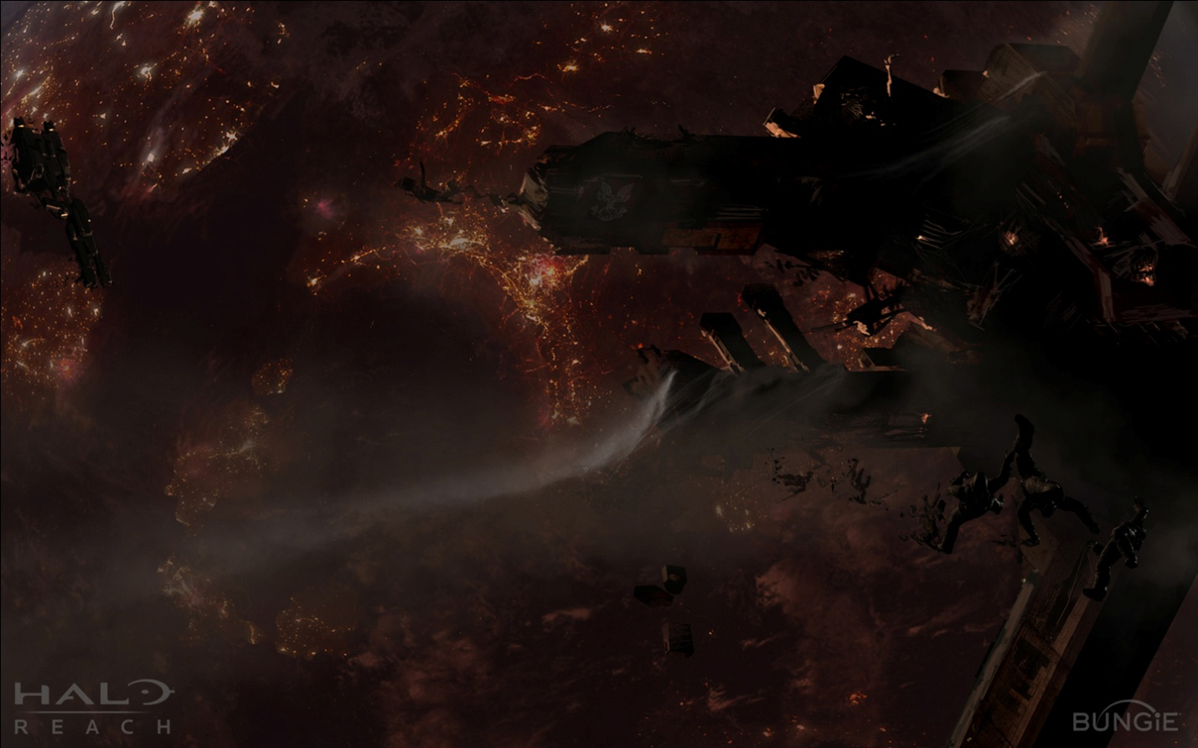

Too depressing?

Then a light hearted doodle.

