Ben Tankus

Homework 1: Environment Configuration

01-01-2021

# Deliverable 1:

## Obtain:

Here I obtained the main.py code to run, and the environment to run it in.

## Scrub:

The cleaning process for this assignment involved ensuring the correct packages are installed and verifying a clean IDE setup.

## Explore:

I was able to explore the tree-data and see where San Francisco has trees.

## Model:

There is no modeling step for this assignment.

## iNterpret:

There is no interpretation step for this assignment.

# Deliverable 2:

## Code Snip:

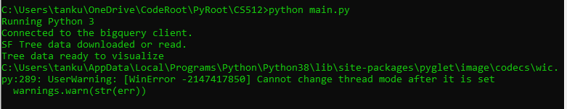

# Deliverable 3:

## Visual Screenshot: