# Abstract:

Tankus Industries (TI) was contacted to analyze Oregon housing data from the 2015 American Community Survey. The main task of this analysis is to determine how expensive electricity bills in Oregon are, and what factors contribute to their cost. TI was asked to pay close attention to the relationship between electricity cost of apartments versus houses, and to adjust for the number of bedrooms and occupants in a house. We are then asked to create a model to predict electricity costs for a typical Oregon household. TI suggests breaking these into smaller, more manageable questions to aid in analysis as follows:

1. Does the data require any cleaning?
2. How much do people pay for electricity in apartments?
3. How much do people pay for electricity in houses?
4. Is there a statistical difference between 2 and 3?
5. What model best predicts electricity cost?

Contents

Abstract: 1

Does the Data Require Any Cleaning? 3

Choosing Practically Relevant Fields 4

Cleaning Data and Transitioning Relevant Data to a Computer Digestible Format 4

Do People Living in Apartments Pay Less on Electricity than those Living in Houses? 5

Creating an Electricity Model to Predict Electricity Costs in Oregon 6

# Does the Data Require Any Cleaning?

As with most data, this set did require cleaning. Mostly regarding the missing values in the data. ACR and VALP both have many null values, 2586 and 4632 respectively. Looking at the missingness distribution histograms, it seems both VALP and ACR are missing-not-at-random, and clearly have more missing values at the low end of the ELEP histograms.

TI believes that these two variables should be removed from the analysis, as property value (VALP) and Lot Size (ACR)

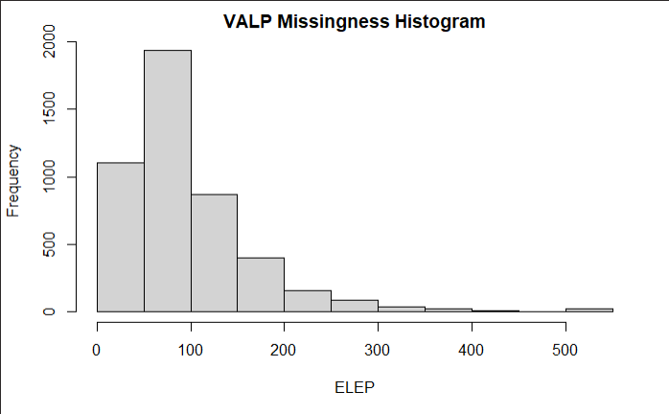

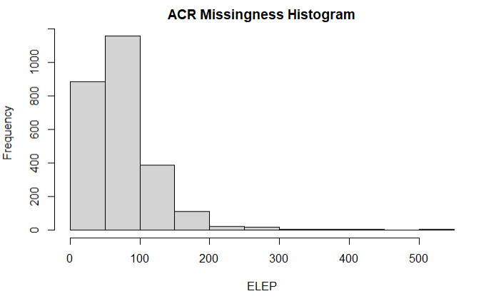

The scatter plots of ACR/VALP VS ELEP also show minimal correlation, meaning it is unlikely that removing ACR and VALP will have a negative impact on the study.

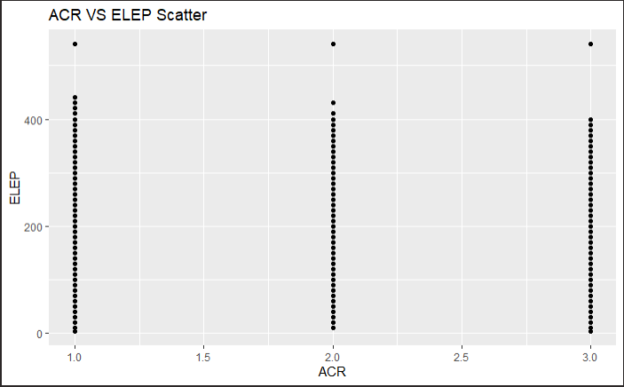 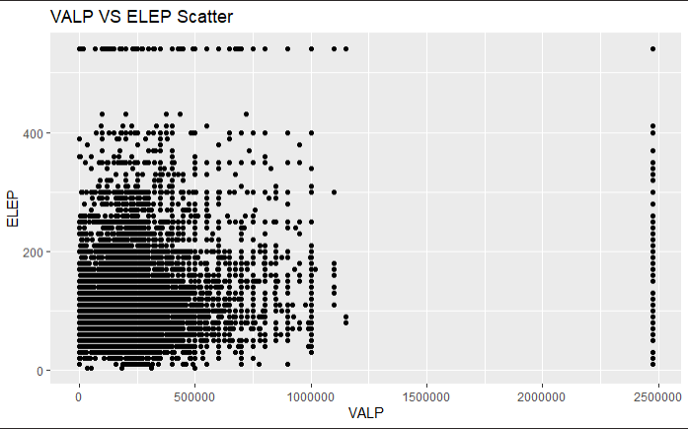

Looking at the missingness identified the large range of electricity costs in the sample. This led TI to a histogram of the monthly electricity cost (ELEP).

## Choosing Practically Relevant Fields

Once the missingness of the data was analyzed, TI took the steps to rank relevant fields, and potentially remove any practically irrelevant fields from our data. Once identified, these fields will have a correlation check with ELEP before complete removal.

Some categorical fields (BLD, HFL, TEN, YBL, R18, R60) needed converting to numeric for correlation consideration. The full scatter matrix is available IN APPENDIX X, and correlation metrics are listed below. None of the practically relevant factors have noteworthy correlation, so TI recommends removing them from the model. RMSP and BDSP are also highly correlated (0.72), so TI recommends removing RMSP to prevent redundant information. FULP, GASP, and YBL may still be relevant after further inspection, so TI recommends leaving them in along with BLD, HFL, BDSP, NP, and ELEP.

|  |  |  |  |
| --- | --- | --- | --- |
| **Field** | **Description** | **Practically Relevant to ELEP?** | **Correlation to ELEP** |
| SERIALNO | Serial Number | No | N/A |
| TYPE | Type of Unit | No (always 1) | N/A |
| R18 | Presence of persons under 18 | No | 0.16 |
| R60 | Presence of persons over 59 | No | 0.013 |
| TEN | Tenure | No | 0.077 |
| FULP | Yearly Fuel Cost (other than gas & electricity) | Maybe | 0.06 |
| GASP | Gas (monthly cost) | Maybe | 0.029 |
| YBL | When structure first built | Maybe | 0.01 |
| NP | Number of Persons in the house | Yes (not in current form) | 0.28 |
| BLD | Units in Structure | Yes (not in current form) | 0.18 |
| HFL | House Heating Fuel | Yes (not in current form) | 0.14 |
| RMSP | Number of Rooms | Yes (Redundant) | 0.23 |
| BDSP | Number of Bedrooms | Yes | 0.26 |
| ELEP | Electricity (monthly Cost) | Yes | 1 |

## Cleaning Data and Transitioning Relevant Data to a Computer Digestible Format

Now that the practically relevant fields have been identified, TI must convert them to more useable data, based on the research question. For example, there are many housing types listed under BLD, but the research question only asks for differences between apartments and houses. TI recommends analyzing these data as “Apartment” and “House” values, as shown in the table below. HFL also has many types of fuel and TI similarly recommends using “Electricity” and “Not Electricity” values for this field. TI also recommends grouping houses newer than 2005 into one “2005 to 2015” group to reduce model complexity.

|  |  |  |
| --- | --- | --- |
| **Field** | **Previous Value** | **Analyzed Value** |
| BLD | Mobile home or trailer | Removed |
| BLD | Boat, RV, van, etc. | Removed |
| BLD | One-family house detached | House |
| BLD | One-family house attached | House |
| BLD | 2 Apartments | Apartment |
| BLD | All other Apartment Fields | Apartment |
| HFL | Electricity | Electricity |
| HFL | All other non-electricity fields | Not Electricity |
| YBL | Year-by-Year for 2005+ | 2005 to 2015 |

## Do People Living in Apartments Pay Less on Electricity than those Living in Houses?

This is the main question TI was asked, and we are now able to answer it. TI has analyzed the data by fitting two separate models, one for each House and Apartment dwelling types. TI recommends iteratively fitting and analyzing these two models with the potentially relevant fields until the optimal balance between model complexity and model fit is achieved. The best explanatory variables to include in both models are HFL, NP, and BDSP which yields a R2 around 0.76 in each model. In both models NP and RMSP are both large enough to be treated as fixed effect, continuous variables while HFL will be analyzed as a categorical “Electricity” and “Not Electricity” values. Once the fitted values of these two models are compared and TI found **electricity is more expensive in a house than in an apartment** with median values at $121.60 and $81.17, respectively. This is roughly a **$40 per month difference**.

# Creating an Electricity Model to Predict Electricity Costs in Oregon

Creating a model to *predict* electricity costs is more difficult than just fitting the current data. To fit the data TI plans to fit models using the forwards and exhaustive validation set approaches with a 10-fold k-means cross-validation to ensure valid model comparison. Mean Squared Error, Adjusted R-Squared, BIC, and CP values will be analyzed for each model and compared. TI will then recommend either the exhaustive or forwards validation methods based off these four-comparison metrics.