M-module User Manual

Version: 1.0

Date: 08/20/2014
Authors: Xiaoke Ma, Peizuo Wang, Long Gao, Lin Gao, and Kai Tan
Maintainer: Kai Tan (kai-tan@uiowa.edu)

Depends: Cytoscape (version 2.8 or higher) and Java Runtime Environment (version 1.6.0 or higher).
License: GPL (>=2)

1. Introduction
The M-module algorithm is designed for identifying gene modules with common members but varied connectivity across multiple gene networks. We term these resulting modules M-modules. It takes as inputs multiple edge-weighted gene networks and a set of prior probabilities representing the importance of a gene for the conditions under study. Along with network topological features, the prior probabilities are used to rank and select seeds to initialize module search. We transform the M-module search problem into a minimum entropy problem by introducing a graph-entropy-based objective function for M-modules. Finding M-modules whose entropy values are all minimal is an NP-hard problem. We therefore developed a greedy algorithm for M-module search based on seed expansion. Empirical p-values of candidate M-modules are determined by using randomized networks. For more details of the algorithm, users are referred to the original publication on the algorithm ¹. The Cytoscape plugin version of the algorithm provides module search function as well as additional functions for analyzing and visualizing the dynamics of M-modules across multiple networks. The package also contains a command line version of the software for advanced users.

2. Software Installation
After downloading the software package, place the M-module.jar file in the plugins sub-directory under the Cytoscape directory. M-module can be launched by selecting it from the plugins drop-down menu.

3. Running M-module
3.1 Running the plugin version
Using M-module consists of three steps: inputting networks, selecting seeds, and setting running parameters.

3.1.1 Input networks
The input networks should be undirected and edge-weighted. An example of edge-weighted networks is gene co-expression network. Each network should contain the same node set and varied edge set. Network import can be handled either by Cytoscape or by the M-module plugin.

A) Use Import function of Cytoscape.
The user can input multiple networks simultaneously using the “Import Network from Table” function of Cytoscape (File/Import/Table). The user can specify the edge weights for each network (Supplemental Figure 2). Gene symbols can be imported using the node attribute (File/Import/node attribute). After importing the networks, launch the M-module plugin. M-module can automatically detect all networks that already exist in Cytoscape. Users can then select the desired networks for analysis.

Supplemental Figure 2. Import networks using the “Import Network from Table” function of Cytoscape. The user needs to give each network a unique name as shown in the red box.

B) Import networks from text files using M-module.
Within M-module, click the “Add” button in the “From text files” panel to import multiple networks. The user can also import gene symbol mapping file for nodes using the click on the “Gene symbols file” box (Supplemental Figure 3). This strategy is highly recommended because it is faster and more convenient than using Cytoscape import function, particularly for large networks.

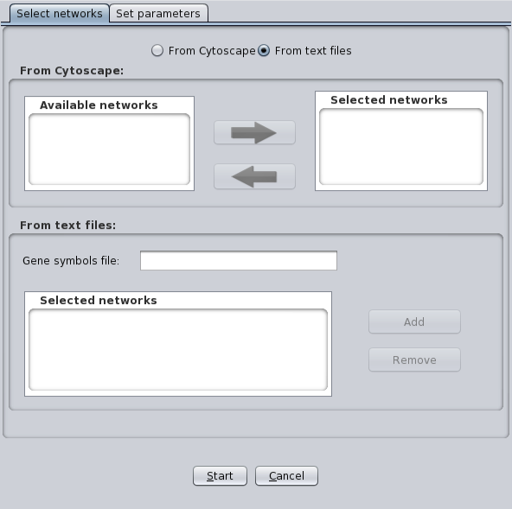
Supplemental Figure 3. Import networks using M-module directly.

3.1.2 Select seeds for initializing module search

To initialize module search, M-module needs a list of seed nodes that are ranked by their scores. The user can provide a list of seed nodes along with their prior probabilities. M-module then computes the rank scores of the seeds by combining user-supplied prior probabilities and network topological features. If no seed file is provided, M-module can compute the seed list using only network topological features (Supplemental Figure 4).

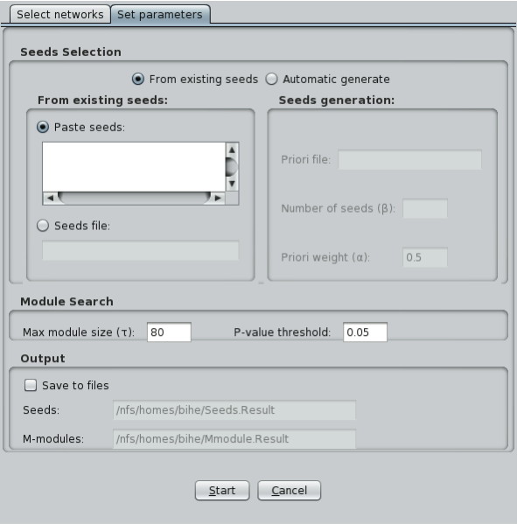
Supplemental Figure 4. Panel for seeds selection and setting running parameters.

3.1.3 Parameters for M-module search

The four parameters that control M-module search are described in Supplemental Table 1. For more details regarding how the settings of the parameters affect the performance of the algorithm, users are referred to the original publication on the algorithm ¹.

Supplemental Table 1. List of parameters used in M-module. n, number of nodes in the input networks.
Name | Meaning | Values | Default value | comment
α | Relative weight for prior information of node | [0,1] | 0.5 | Only used in “automatic seeds generation” mode
β | Number of seeds | [1, n] | 0.05*n | Only used in “automatic seeds generation” mode
τ | Maximum size of M-modules to be searched | [1, n] | 80
p-value | Threshold for significant M-modules | [0, 1] | 0.05 | Corrected for multiple testing using BH method

After importing all networks and setting running parameters, the user can start the module search by clicking the “Start” button. A window will appear to display the search status (Supplemental Figure 5).

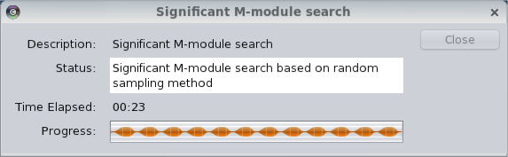
Supplemental Figure 5. Running status of M-module.

3.2 Running command line version
The package also contains a command line version of the software. Supplemental Figure 6 lists the arguments that the user can use to control the behavior of the algorithm.

Supplemental Figure 6. Running command line version of the software.

4. Output of M-module
Supplemental Figure 7 shows a screenshot of a session of the plug-in. The Cytoscape Network tab in the Control Panel displays a list of identified M-modules. Each M-module contains multiple subnetworks representing the component modules in the input networks. In this example, since there are four input networks, each M-module contains four component modules/subnetworks (Supplemental Figure 7A).
The Display Panel provides the visualization of a selected M-module with each component module displayed as a separate subnetwork (Supplemental Figure 7B). Additional visualization can be generated if the user performs additional analyses using functions provided in the Results Panel (see below). See below for detailed description of additional analysis functions provided in the Results Panel.
The “General Information” tab in the Results Panel provides various summary statistics about the input networks, algorithm run behavior, and identified M-modules (Supplemental Figure 7C). The “Module Statistics” tab provides distribution plots for various properties of the discovered M-modules. The “Dynamics Analysis” tab provides functions for analyzing and visualizing the resulting M-modules. Below we provide detailed description of the three tabs in the Results Panel.
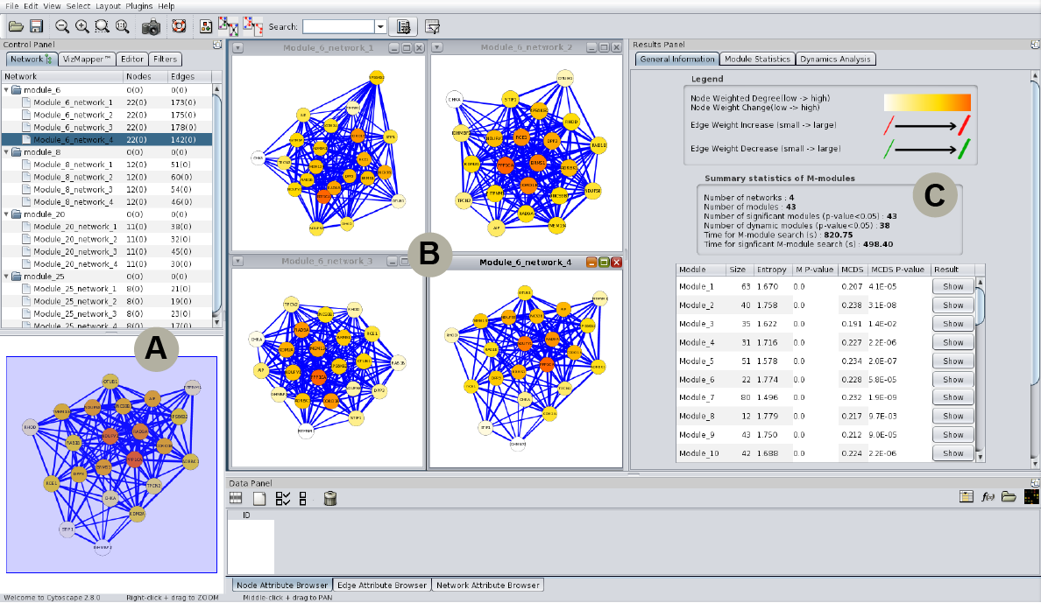
Supplemental Figure 7. Overview of an M-module session.

4.1 General Information Tab (Supplemental Figure 7C)
The top part of the tab shows the legend for mapping node and edge attributes to visual cues. For displaying component modules of an M-module, the node color is mapped to its weighted degree. For displaying changes in edge weight between two component modules of a M-module, the edge color is mapped to change in edge weight.
The bottom part of the tab provides various summary statistics about the input networks, algorithm run behavior, and identified M-modules. For discovered M-modules, the following information is displayed: module ID, size, entropy value (objective function used for module search), module p-value (multiple testing corrected using the Benjamini-Hochberg method), MCDS (module connectivity dynamic score), and MCDS p-value. The user can sort the M-modules by columns. The user can display a particular M-module by clicking the “Show” button next to the module list.

4.2 Module Statistics Tab
This tab provides the distribution plots of three metrics regarding the discovered M-modules: module sizes, entropy values, and module MCDS (Supplemental Figure 8).

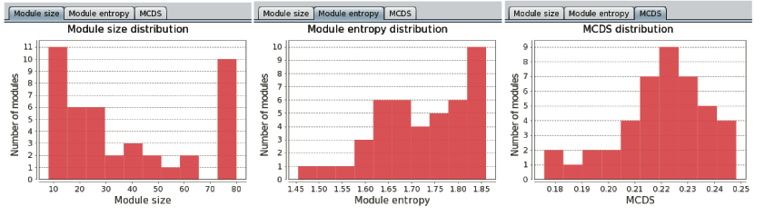
Supplemental Figure 8. Distributions of various properties of discovered M-modules. Module size (left); module entropy (middle); module MCDS (right).

4.3 Dynamics Analysis Tab
Dynamics of network connectivity has recently been shown to be critical for understanding disease progression and treatment, including the role of hub genes ² and rewiring of signaling pathways during cancer treatment ³. Because component subnetworks of an M-module share the same set of genes in multiple co-expression networks but can differ in their connectivity, M-module provides a nature way to capture pathway connectivity dynamics. Dynamics can be assessed at individual edge and node level using the “Node & Edge Dynamics” subtab and at the module level using the “Pairwise Comparison” subtab. At individual node and edge level, node weight dynamics quantifies change in the weighted node degree between any two component subnetworks of an M-module. Edge weight dynamics quantifies change in edge weight between any two component subnetworks of an M-module.

Supplemental Figure 9. Display dynamic changes of node and edge weights of an M-module.

To display dynamic changes in node or edge weight across multiple networks, the user first selects an M-module (Supplemental Figure 9) and then clicks on the “Analysis” button in the Dynamics Analysis tab. Two plots will be dynamically generated under the “Node & Edge Dynamics” subtab to display node and edge weights for the selected nodes and edges.
At the module level, the dynamics is captured by the MCDS metric. To compute the MCDS of an M-module between two networks, the user can first select an M-module and two input networks. The user then clicks on the “Compare” button in the “Pairwise Comparison” subtab to launch the comparison (Supplemental Figure 10A). This analysis will return the module MCDS value and its associated p-value (based on 1000 randomly sample modules with matched sizes). Edges that exhibit significant changes in edge weight in the two compared networks can be visualized (Supplemental Figure 10B). Edges with significant weight changes are shown with solid colors whereas edges with in-significant changes are shown with transparent colors. The significance of edge weight change is computed by using 10,000 randomly sampled edges. The empirical p-values are corrected for multiple testing using the method of Benjamini-Hochberg. The default p-value cutoff is 0.05. Edge color indicates the direction of change with red indicating increased edge weight and green indicating decreased weight. Thickness of an edge is proportional to the absolute value of the edge weight change. Node color is proportional to the sum of weight changes of the edges incident on the node. The distributions for edge weight change and node weight change can plotted by clicking on the “Statistics” button in the “Pairwise Comparison” subtab (Supplemental Figure 10C).

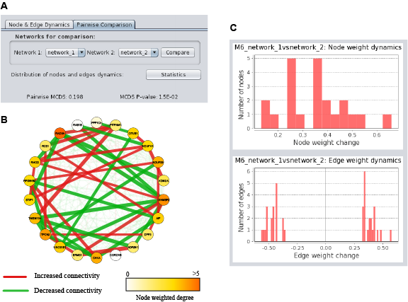
Supplemental Figure 10. Assessment of module-level connectivity dynamics. A) Connectivity dynamics of an M-module between two two networks can be done under the “Pairwise Comparison” subtab. B) Visualization of connectivity dynamics of an M-module. C) Top, the distribution of node weight changes. Bottom, distribution of edge weight changes. For edge, only those with significant weight changes are used to generate the distribution.

References

1. Ma X, Gao L, Tan K. Modeling disease progression using dynamics of pathway connectivity. Bioinformatics. 2014
2. Taylor IW, Linding R, Warde-Farley D, Liu Y, Pesquita C, Faria D, Bull S, Pawson T, Morris Q, Wrana JL. Dynamic modularity in protein interaction networks predicts breast cancer outcome. Nature biotechnology. 2009;27:199-204
3. Lee MJ, Ye AS, Gardino AK, Heijink AM, Sorger PK, MacBeath G, Yaffe MB. Sequential application of anticancer drugs enhances cell death by rewiring apoptotic signaling networks. Cell. 2012;149:780-794

