Mongodb

Doc -> collections -> databases

db.dbname.insertOne({ name: “tanmaie”})

db.dbname.insertMany

db.dbname.find()

db.dbname.limit()

db.dbname.sort()

db.dbname.skip().limit(2)

where -> db.dbname.find({name: “tanmaie”})

db.dbname.find({name:”tanmaie”}{name: 1, age:1}}

db.dbname.find({name: {$eq:”sally”})

db.dbname.find({name:{$ne

$gt

$gte

$lte

$lt less than

$in: [12,18] this or that

$nin

{age: {$

Show dbs

db.createCollection(“dbname”)

What update property can be set to true in order to insert a document if it's not found? **Upsert**

**.**deleteMany

Which update operator will replace the current value of a field with a new, specified value? $SET

.aggregate

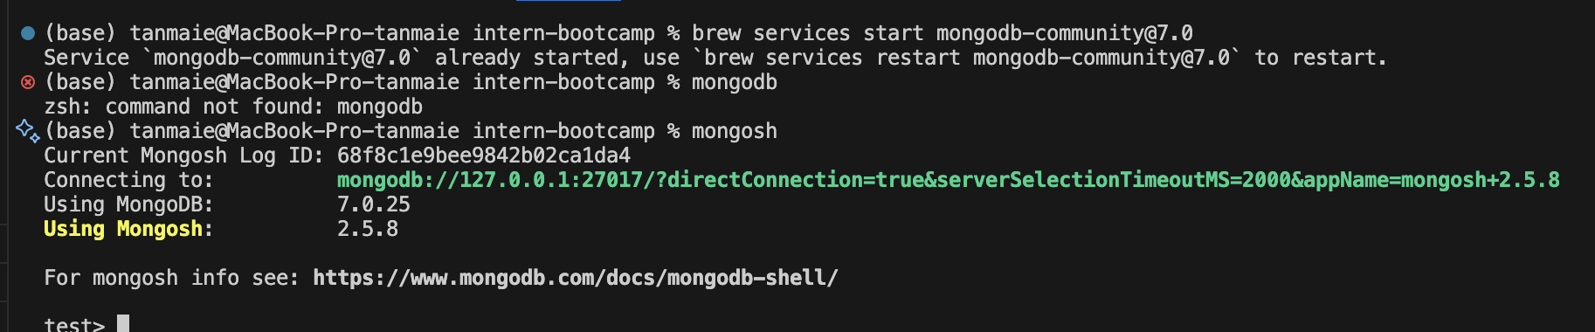

Monogodb

