PROGRAM-10
Problem Statement
Traffic congestion is a common problem in cities. This program analyses the number of vehicles on different roads during different time intervals. It identifies the peak traffic period, classifies congestion levels, and detects roads where vehicle counts exceed the allowed capacity.
2. Objectives
- To record vehicle counts for multiple roads and time intervals.
- To identify the time period with the highest traffic.
- To classify traffic as Low, Moderate, High, or Severe.
- To identify roads exceeding their capacity.
- To display a traffic analysis report.
3. Assumptions
- The program analyses three roads.
- Vehicle counts are entered for three time intervals.
- Each road has a maximum capacity of 100 vehicles per interval.
- Congestion levels are classified as follows:
Vehicles per interval | Congestion level
0–30 | Low
31–60 | Moderate
61–100 | High
Above 100 | Severe
5. The vehicle counts must be zero or positive integers.
4. Algorithm
- Start the program.
- Define the road names and time intervals.
- Set the capacity limit to 100 vehicles.
- Get vehicle counts for each road and time interval.
- Calculate the total traffic for each time interval.
- Identify the peak traffic interval.
- Classify congestion for each road and interval.
- Identify roads and intervals exceeding capacity.
- Display the analysis report.
- Stop the program.
5. Flowchart
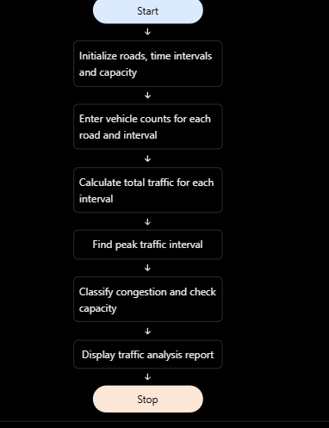
6.Pseudocode
START

SET roads = Main Road, Market Road, Highway
SET intervals = Morning, Afternoon, Evening
SET capacity = 100

FOR each road
FOR each interval
INPUT vehicle count
END FOR
END FOR

FOR each interval
CALCULATE total vehicles
END FOR

FIND interval with maximum total traffic

FOR each road
FOR each interval
IF vehicles <= 30
SET congestion = Low
ELSE IF vehicles <= 60
SET congestion = Moderate
ELSE IF vehicles <= 100
SET congestion = High
ELSE
SET congestion = Severe
END IF

IF vehicles > capacity
DISPLAY capacity exceeded
END IF
END FOR
END FOR

DISPLAY traffic report and peak interval

STOP
7. Python Source Code

roads = ["Main Road", "Market Road", "Highway"]
intervals = ["Morning", "Afternoon", "Evening"]

capacity = 100
traffic = {}

# Input vehicle counts
for road in roads:
traffic[road] = []
print("\nEnter traffic details for", road)

for interval in intervals:
while True:
try:
count = int(input(interval + " vehicle count: "))

if count < 0:
print("Enter a non-negative number.")
else:
traffic[road].append(count)
break

except ValueError:
print("Please enter a valid whole number.")

# Calculate total traffic for each interval
totals = []

for i in range(len(intervals)):
total = 0

for road in roads:
total += traffic[road][i]

totals.append(total)

# Display congestion analysis
print("\n===== TRAFFIC ANALYSIS REPORT =====")

for road in roads:
print("\nRoad:", road)

for i in range(len(intervals)):
count = traffic[road][i]

if count <= 30:
level = "Low"
elif count <= 60:
level = "Moderate"
elif count <= capacity:
level = "High"
else:
level = "Severe"

print(intervals[i], "-", count, "vehicles -", level)

if count > capacity:
print("WARNING: Capacity exceeded!")

# Find peak traffic interval
peak_index = totals.index(max(totals))

print("\n===== TIME INTERVAL TOTALS =====")

for i in range(len(intervals)):
print(intervals[i] + ":", totals[i], "vehicles")

print("\nPeak traffic period:", intervals[peak_index])
print("Maximum total vehicles:", totals[peak_index])
. Test Cases
Test case | Input condition | Expected result
1 | All counts are 20 | All roads show Low congestion
2 | A count is 50 | Moderate congestion
3 | A count is 85 | High congestion
4 | A count is 120 | Severe congestion and capacity warning
5 | Evening has the highest total | Evening is displayed as peak traffic
6 | A count is negative | Program asks for valid input again
9. Output
Enter traffic details for Main Road
Morning vehicle count: 40
Afternoon vehicle count: 75
Evening vehicle count: 110

Enter traffic details for Market Road
Morning vehicle count: 25
Afternoon vehicle count: 55
Evening vehicle count: 90

Enter traffic details for Highway
Morning vehicle count: 80
Afternoon vehicle count: 105
Evening vehicle count: 120

===== TRAFFIC ANALYSIS REPORT =====

Road: Main Road
Morning - 40 vehicles - Moderate
Afternoon - 75 vehicles - High
Evening - 110 vehicles - Severe
WARNING: Capacity exceeded!

Road: Market Road
Morning - 25 vehicles - Low
Afternoon - 55 vehicles - Moderate
Evening - 90 vehicles - High

Road: Highway
Morning - 80 vehicles - High
Afternoon - 105 vehicles - Severe
WARNING: Capacity exceeded!
Evening - 120 vehicles - Severe
WARNING: Capacity exceeded!

===== TIME INTERVAL TOTALS =====
Morning: 145 vehicles
Afternoon: 235 vehicles
Evening: 320 vehicles

Peak traffic period: Evening
Maximum total vehicles: 320

10. Conclusion
The Traffic Flow and Congestion Analysis program successfully analyses vehicle counts on multiple roads and during different time intervals. It identifies the peak traffic period, classifies congestion levels, and detects roads that exceed their capacity. This program demonstrates the use of loops, lists, dictionaries, conditional statements, and basic data analysis in Python.

