PROGRAM-7
Problem Statement
A monthly calendar displays the days of a month in rows and columns according to the starting weekday. This case study aims to develop a Python program that generates a formatted monthly calendar using the supplied starting weekday and number of days in the month. The program uses nested loops to align the dates correctly into weeks and handles valid month lengths.
2. Objectives
- To generate a monthly calendar using Python.
- To accept the starting weekday and number of days in the month.
- To align dates correctly according to the starting weekday.
- To use nested loops to generate calendar rows and columns.
- To handle valid month lengths.
- To display the calendar in a neat and readable format.
3. Assumptions
- Weekdays are numbered from 0 to 6, where 0 represents Monday and 6 represents Sunday.
- The number of days entered must be valid for a month, from 28 to 31.
- The starting weekday must be an integer between 0 and 6.
- The calendar begins with Monday and ends with Sunday.
- Empty spaces are displayed before the first date to align the starting weekday.
- The program uses basic Python concepts, including variables, loops, conditional statements, and formatted output.
4. Algorithm
- Start.
- Input the starting weekday and number of days in the month.
- Validate the starting weekday and month length.
- Display the weekday headings from Monday to Sunday.
- Print blank spaces before the first date according to the starting weekday.
- Initialize the date to 1.
- Use an outer loop to generate calendar weeks.
- Use an inner loop to display seven weekday columns.
- Display each date and increase the date by 1.
- Stop displaying dates when the number of days in the month is reached.
- Stop.
5. Flowchart
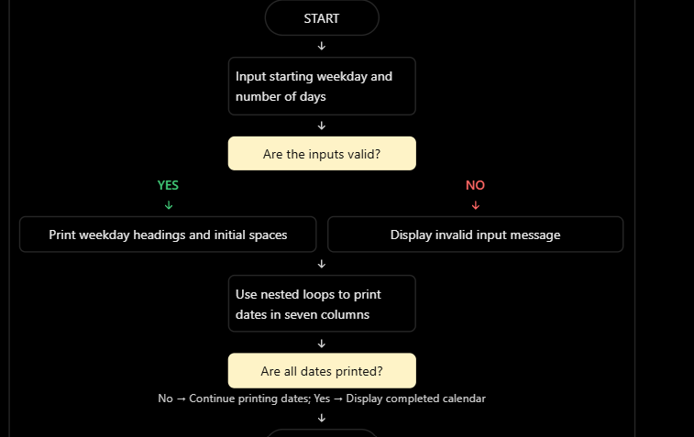6. Pseudocode
START

INPUT starting_weekday
INPUT number_of_days

IF starting_weekday is not between 0 and 6
OR number_of_days is not between 28 and 31:
DISPLAY "Invalid input"
ELSE:
DISPLAY weekday headings
day = 1

FOR i from 1 to starting_weekday:
DISPLAY blank space

WHILE day <= number_of_days:
FOR weekday from 0 to 6:
IF day <= number_of_days:
DISPLAY day
day = day + 1
ELSE:
STOP inner loop
MOVE to next line

STOP
- Python Source Code

start_day = int(input("Enter starting weekday (0=Mon, 6=Sun): "))
days = int(input("Enter number of days in the month (28-31): "))

if start_day < 0 or start_day > 6 or days < 28 or days > 31:
print("Invalid input")
else:
print("\n Mon Tue Wed Thu Fri Sat Sun")

day = 1

for weekday in range(7):
if weekday < start_day:
print(" ", end="")
else:
print(f"{day:3} ", end="")
day += 1

print()

while day <= days:
for weekday in range(7):
if day <= days:
print(f"{day:3} ", end="")
day += 1
else:
break
print()
8. Test Cases
Test case | Starting weekday | Number of days | Expected result
1 | 2 (Wednesday) | 30 | Calendar starts on Wednesday and ends on day 30
2 | 0 (Monday) | 31 | Calendar starts on Monday and ends on day 31
3 | 6 (Sunday) | 28 | Calendar starts on Sunday and ends on day 28
4 | 7 (Invalid) | 30 | Invalid input
5 | 1 (Tuesday) | 32 (Invalid) | Invalid input
- Output
Enter starting weekday (0=Mon, 6=Sun): 2
Enter number of days (28-31): 30

Mon Tue Wed Thu Fri Sat Sun
1 2 3 4 5
6 7 8 9 10 11 12
13 14 15 16 17 18 19
20 21 22 23 24 25 26
27 28 29 30

10. Conclusion
Thus, the Python program successfully generates a formatted monthly calendar using the supplied starting weekday and number of days. It uses nested loops to arrange dates into seven weekday columns and conditional statements to validate inputs and handle the end of the month.

