PROGRAM-2

1. Problem statement
Develop a Python program to process formatted invoice records using basic string operations. Extract the product code, quantity, and amount from each record, validate the data, and flag malformed invoice records.
2. Objectives
- Process invoice data stored as strings.
- Extract product codes, quantities, and amounts.
- Identify invalid or incomplete records.
- Calculate the total invoice amount.
- Display valid and malformed records separately.
3. Assumptions
Each invoice record follows this format:
P101,2,500.00
- P101 — Product code
- 2 — Quantity
- 500.00 — Total amount for that product
The three fields are separated by commas. Quantity must be a positive integer, amount must be a non-negative number, and the product code must start with P followed by digits. These are sample rules for this project.

4. Algorithm
- Start.
- Store invoice records in a list.
- Read each record and split it using commas.
- Check whether the record contains exactly three fields.
- Extract the product code, quantity, and amount.
- Validate the product code and numeric values.
- Store valid records and add their amounts.
- Flag invalid records as malformed.
- Display valid records, malformed records, and the total amount.
- Stop.

5.Flowchart
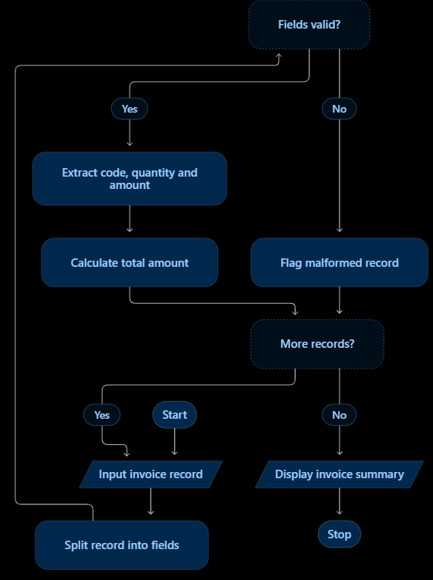
6. pseudocode
START

Initialize valid_count = 0
Initialize invalid_count = 0
Initialize total = 0

Store invoice records in a list

FOR each record in the list
Split the record using commas

IF the record has exactly 3 fields THEN
Convert quantity to integer
Convert amount to decimal

IF quantity is positive AND amount is non-negative
AND product code is not empty THEN
Increase valid_count by 1
Add amount to total
Display valid invoice record
ELSE
Increase invalid_count by 1
Display invalid record
END IF
ELSE
Increase invalid_count by 1
Display invalid record
END IF
END FOR

Display valid_count
Display invalid_count
Display total invoice amount

STOP

7.python source code
records = [
"P101,2,500.00",
"P102,3,750.50",
"P103,1,200.00",
"P104,two,100.00",
"P105,4",
"P106,1,abc",
"P107,-2,300.00",
"P108,2,150.00,extra"
]

valid_count = 0
invalid_count = 0
total = 0

print("INVOICE DATA EXTRACTION")

for record in records:
parts = record.split(",")

try:
if len(parts) != 3:
raise ValueError

code = parts[0]
quantity = int(parts[1])
amount = float(parts[2])

if quantity <= 0 or amount < 0 or code == "":
raise ValueError

valid_count += 1
total += amount

print("Valid:", code,
"Quantity:", quantity,
"Amount: Rs.", format(amount, ".2f"))

except ValueError:
invalid_count += 1
print("Invalid record:", record)

print("\nValid Records:", valid_count)
print("Invalid Records:", invalid_count)
print("Total Invoice Amount: Rs.", format(total, ".2f"))

8. Test cases
Input record | Expected result
P101,2,500.00 | Valid
P102,abc,200.00 | Invalid quantity
P103,2 | Missing field
X104,1,100.00 | Invalid product code
P105,0,250.00 | Invalid quantity
P106,2,xyz | Invalid amount
9. output
INVOICE DATA EXTRACTION
Valid: P101 Quantity: 2 Amount: Rs. 500.00
Valid: P102 Quantity: 3 Amount: Rs. 750.50
Valid: P103 Quantity: 1 Amount: Rs. 200.00
Invalid record: P104,two,100.00
Invalid record: P105,4
Invalid record: P106,1,abc
Invalid record: P107,-2,300.00
Invalid record: P108,2,150.00,extra

Valid Records: 3
Invalid Records: 5
Total Invoice Amount: Rs. 1450.50

10. Conclusion
The program extracts invoice details using basic Python string operations, validates each record, flags malformed data, and calculates the total amount of valid invoices. It demonstrates practical applications of strings, lists, tuples, loops, and conditional statements.

