PROGRAM-3
1.Problem Statement
To develop a Python program that analyzes student registration IDs, validates them according to the specified format, extracts the admission year and branch code, and displays the number of valid and invalid IDs.
2. Objectives
- To validate student registration IDs.
- To extract the admission year and branch code.
- To identify valid and invalid registration IDs.
- To count and display valid and invalid IDs.
3. Assumptions
- Each registration ID must contain exactly 7 characters.
- The first 2 characters represent the admission year.
- The next 2 characters represent the branch code.
- The last 3 characters represent the student number.
- Valid branch codes are CS, AI, EC and ME.
- The admission year is displayed by adding 20 before the first two digits.
4. Algorithm
- Start.
- Store the student registration IDs in a list.
- Initialize valid and invalid counters to zero.
- Extract the year, branch and student number from each ID.
- Check the length and validity of each part.
- If all conditions are satisfied, classify the ID as valid.
- Otherwise, classify the ID as invalid.
- Display the admission year and branch for valid IDs.
- Display the total valid and invalid IDs.
- Stop.
5. Flowchart

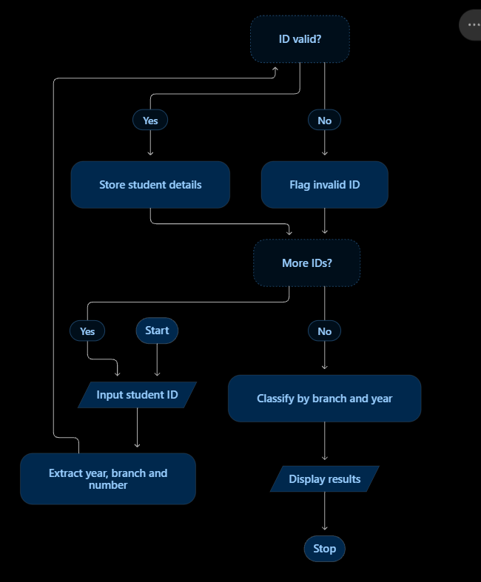
6. Pseudocode
START

Initialize student ID list
Set valid_count = 0
Set invalid_count = 0

FOR each student ID in the list
Extract year from first 2 characters
Extract branch from next 2 characters
Extract number from remaining characters

IF length is 7 AND
year contains only digits AND
branch is CS, AI, EC, or ME AND
number contains only digits THEN

Increase valid_count by 1
Display ID as Valid
Display admission year and branch
ELSE
Increase invalid_count by 1
Display ID as Invalid
END IF
END FOR

Display valid_count
Display invalid_count

STOP
7. Python Source Code

identifiers = [
"26CS001",
"25AI012",
"26EC015",
"24ME020",
"26XX030",
"2ACS010",
"26CSAB1"
]

valid_count = 0
invalid_count = 0

print("===== REGISTRATION ID ANALYSIS =====")

for student_id in identifiers:
year = student_id[:2]
branch = student_id[2:4]
number = student_id[4:]

if (len(student_id) == 7 and
year.isdigit() and
branch in ["CS", "AI", "EC", "ME"] and
number.isdigit()):

valid_count += 1
print(student_id, "- Valid",
"| Admission year: 20" + year,
"| Branch:", branch)
else:
invalid_count += 1
print(student_id, "- Invalid")

print("\nValid IDs:", valid_count)
print("Invalid IDs:", invalid_count)
8. Test cases
Student ID | Expected result
26CS001 | Valid — Computer Science, 2026
25AI012 | Valid — Artificial Intelligence, 2025
26XX030 | Invalid branch code
2ACS010 | Invalid year format
26CSAB1 | Invalid student number
26CS000 | Invalid student number
9.output

===== REGISTRATION ID ANALYSIS =====
26CS001 - Valid | Admission year: 2026 | Branch: CS
25AI012 - Valid | Admission year: 2025 | Branch: AI
26EC015 - Valid | Admission year: 2026 | Branch: EC
24ME020 - Valid | Admission year: 2024 | Branch: ME
26XX030 - Invalid
2ACS010 - Invalid
26CSAB1 - Invalid

Valid IDs: 4
Invalid IDs: 3

10. Conclusion
The program analyzes student registration IDs, validates their structure, extracts admission-year and branch information, and classifies students into groups. It demonstrates how basic Python string operations and data structures can be used to process campus registration records.

