PROGRAM-4
1. Problem statement
Develop a Python program to analyze multiple student feedback sentences using predefined positive and negative keywords. Count positive and negative indicators, calculate a sentiment score, and classify each feedback as Positive, Negative, or Neutral based on predefined thresholds.

2. Objectives
- Accept feedback from multiple students.
- Identify positive and negative keywords.
- Count positive and negative indicators.
- Calculate a sentiment score for each feedback.
- Classify feedback using predefined thresholds.
- Display individual results and an overall summary.
3. Assumptions
- Each positive keyword contributes +1 point.
- Each negative keyword contributes -1 point.
- Score greater than or equal to 2 → Positive.
- Score less than or equal to -2 → Negative.
- Scores between -1 and 1 → Neutral.
- The program uses a predefined keyword list and performs simple keyword matching, not advanced AI sentiment analysis.
4. Algorithm
- Start.
- Store positive and negative keywords in separate lists.
- Store student names and their feedback.
- Convert each feedback sentence to lowercase and split it into words.
- Initialize positive and negative word counts to zero.
- Check each word against the positive and negative keyword lists.
- Increase the corresponding count whenever a keyword is found.
- Calculate the sentiment score.
- Classify the feedback based on the score.
- Display the student name, feedback, word counts, score, and classification.
- Repeat for all students.
- Stop.
5. Flowchart

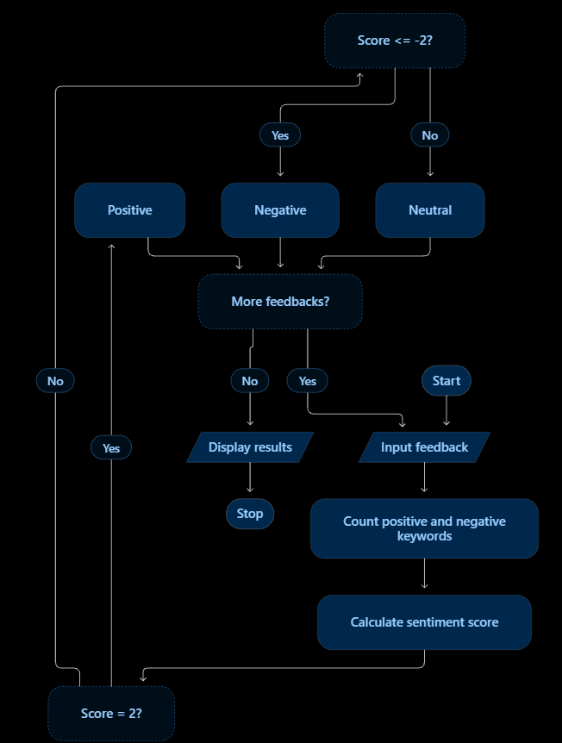
6. Pseudocode
START

Store positive keywords in a list
Store negative keywords in a list
Store student names and feedback

FOR each student and feedback
Convert feedback to lowercase
Split feedback into words

Set positive_count = 0
Set negative_count = 0

FOR each word in feedback
Remove punctuation from the word

IF word is in positive keywords THEN
Increase positive_count by 1
END IF

IF word is in negative keywords THEN
Increase negative_count by 1
END IF
END FOR

Calculate score =
positive_count - negative_count

IF score > 0 THEN
Set classification = Positive
ELSE IF score < 0 THEN
Set classification = Negative
ELSE
Set classification = Neutral
END IF

Display student name
Display feedback
Display positive and negative counts
Display score and classification
END FOR

STOP
7. Python Source Code

positive_words = [
"excellent", "helpful", "good", "clear", "interesting"
]

negative_words = [
"poor", "boring", "bad", "confusing", "difficult"
]

feedbacks = [
("Ravi", "Excellent and helpful teaching"),
("Sita", "Poor and boring classes"),
("Kiran", "The classroom is good")
]

print("===== STUDENT FEEDBACK SENTIMENT =====")

for name, feedback in feedbacks:
words = feedback.lower().split()
positive_count = 0
negative_count = 0

for word in words:
word = word.strip(".,!?;:")

if word in positive_words:
positive_count += 1

if word in negative_words:
negative_count += 1

score = positive_count - negative_count

if score > 0:
sentiment = "Positive"
elif score < 0:
sentiment = "Negative"
else:
sentiment = "Neutral"

print("\nStudent:", name)
print("Feedback:", feedback)
print("Positive Words:", positive_count)
print("Negative Words:", negative_count)
print("Sentiment Score:", score)
print("Classification:", sentiment)
8. Test cases
Feedback | Positive count | Negative count | Score | Classification
Excellent and helpful | 2 | 0 | 2 | Positive
Poor and boring | 0 | 2 | -2 | Negative
The classroom is good | 1 | 0 | 1 | Neutral
Good but confusing | 1 | 1 | 0 | Neutral
Amazing, excellent, great | 3 | 0 | 3 | Positive
9.output

===== STUDENT FEEDBACK SENTIMENT =====

Student: Ravi
Feedback: Excellent and helpful teaching
Positive Words: 2
Negative Words: 0
Sentiment Score: 2
Classification: Positive

Student: Sita
Feedback: Poor and boring classes
Positive Words: 0
Negative Words: 2
Sentiment Score: -2
Classification: Negative

Student: Kiran
Feedback: The classroom is good
Positive Words: 1
Negative Words: 0
Sentiment Score: 1
Classification: Positive

10. Conclusion
The program analyzes student feedback using predefined positive and negative keywords. It counts sentiment indicators, calculates scores, classifies feedback, and displays student-wise results and an overall summary.

