WEB TECHNOLOGY  
LAB 6  
Tanmay Amrutkar  
22IT3006

Q1.Code:-  
<!DOCTYPE html>

<html lang="en">

<head>

  <meta charset="UTF-8">

  <meta name="viewport" content="width=device-width, initial-scale=1.0">

  <title>Shopping List</title>

  <style>

    body {

      font-family: Arial, sans-serif;

      background-color: #f4f4f4;

      margin: 0;

      padding: 0;

    }

    .container {

      max-width: 600px;

      margin: 20px auto;

      background-color: #fff;

      padding: 20px;

      border-radius: 8px;

      box-shadow: 0 0 10px rgba(0, 0, 0, 0.1);

    }

    input[type="text"] {

      width: calc(100% - 60px);

      padding: 8px;

      border: 1px solid #ccc;

      border-radius: 4px;

      font-size: 16px;

    }

    button {

      padding: 8px 12px;

      font-size: 16px;

      border: none;

      border-radius: 4px;

      cursor: pointer;

      background-color: #007bff;

      color: #fff;

    }

    button:hover {

      background-color: #0056b3;

    }

    ul {

      list-style-type: none;

      padding: 0;

    }

    li {

      padding: 8px 0;

    }

  </style>

</head>

<body>

<div class="container">

  <h2>Shopping List</h2>

  <input type="text" id="item" placeholder="Add item">

  <button onclick="addItem()">Add</button>

  <ul id="list"></ul>

</div>

<script>

  function addItem() {

    var input = document.getElementById("item");

    var item = input.value;

    if (item.trim() !== "") {

      var list = document.getElementById("list");

      var li = document.createElement("li");

      li.textContent = item;

      list.appendChild(li);

      input.value = "";

    } else {

      alert("Please enter an item.");

    }

  }

</script>

</body>

</html>

Output:-  
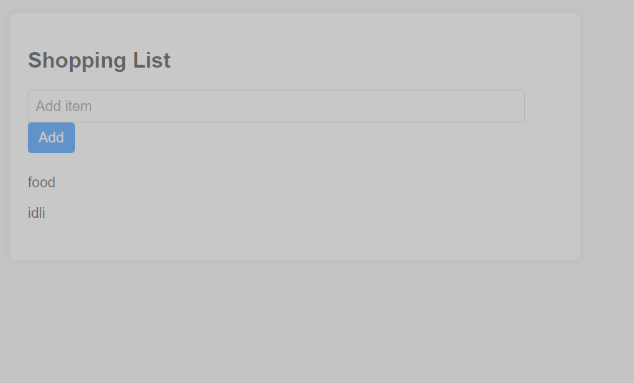

MVC PROTOTYPE:  
HTML:  
<!DOCTYPE html>

<html lang="en">

<head>

  <meta charset="UTF-8">

  <meta name="viewport" content="width=device-width, initial-scale=1.0">

  <title>Shopping List</title>

  <link rel="stylesheet" href="style.css">

</head>

<body>

<div class="container">

  <h2>Shopping List</h2>

  <input type="text" id="item" placeholder="Add item">

  <button onclick="addItem()">Add</button>

  <ul id="list"></ul>

</div>

<script src="model.js"></script>

<script src="view.js"></script>

<script src="controller.js"></script>

</body>

</html>

CSS:-

/\* Add your CSS styles here \*/

body {

  font-family: Arial, sans-serif;

  background-color: #f4f4f4;

  margin: 0;

  padding: 0;

}

.container {

  max-width: 600px;

  margin: 20px auto;

  background-color: #fff;

  padding: 20px;

  border-radius: 8px;

  box-shadow: 0 0 10px rgba(0, 0, 0, 0.1);

}

input[type="text"] {

  width: calc(100% - 60px);

  padding: 8px;

  border: 1px solid #ccc;

  border-radius: 4px;

  font-size: 16px;

}

button {

  padding: 8px 12px;

  font-size: 16px;

  border: none;

  border-radius: 4px;

  cursor: pointer;

  background-color: #007bff;

  color: #fff;

}

button:hover {

  background-color: #0056b3;

}

ul {

  list-style-type: none;

  padding: 0;

}

li {

  padding: 8px 0;

}

Model:-

// Model - Data structure for the shopping list

var shoppingList = [];

// Function to add item to the shopping list

function addItemToList(item) {

    shoppingList.push(item);

}

// Function to get the shopping list

function getShoppingList() {

    return shoppingList;

}

View:

// View - Render the UI

function renderShoppingList() {

    var list = document.getElementById("list");

    list.innerHTML = "";

    var items = getShoppingList();

    items.forEach(function(item) {

        var li = document.createElement("li");

        li.textContent = item;

        list.appendChild(li);

    });

}

// Initialize view

window.onload = function() {

    renderShoppingList();

};

Controller:

// Controller - Handle user input and update the model and view

function addItem() {

    var input = document.getElementById("item");

    var item = input.value;

    if (item.trim() !== "") {

        addItemToList(item);

        renderShoppingList();

        input.value = "";

    } else {

        alert("Please enter an item.");

    }

}

Output:-

