# User guide

## Code Structure

Following is the code structure in the project :

* Src/main/java – This folder consists of two classes
  + APICallHandler.java – contains methods to handler the POST,PUT and GET request against the endpoint
  + Helper methods.java – contains methods to place Order, take Order etc which could be directly used in the test cases.
* Src/test/java -- This folder contains Test classes for different API operations and a total of 22 test cases.
* Testng is the test execution engine used here.

## Functionality

* All the test cases are passing
* Endpointurl is read from the properties file and is stored in a global variable before execution begins
* Test cases use helper methods to perform different operations as test steps

## Test scenarios covered

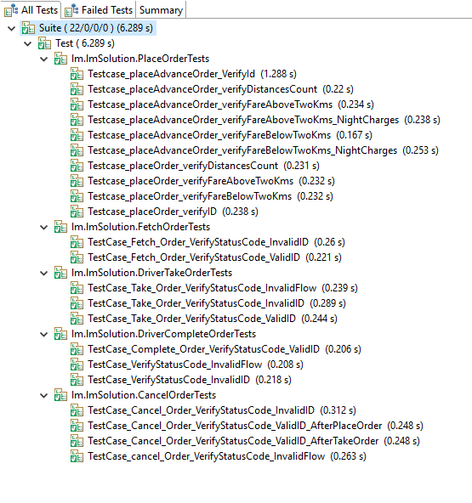

## Execution

* A runnable jar has been created to execute the test cases.
* On completion test-output folder will be created to view the testing reports for execution

## Things not covered so far

* Exception Handling is there but not to its completeness. This could be improved with more time.
* Although comments have been added at all the relevant places it might not be in accordance with reviewer’s coding standards.
* Scenarios for night charges in case of place order are covered for only Advance orders and not for current orders
* For scenarios of incorrect flow order, tests are written for some of the common cases and not all.