Table of Contents

User guide 2

Setup 2

Prerequisites for Setup 2

Project Setup 2

Project Structure 2

Code Structure 2

Configuration, test data and logging 4

Steps to create runnable jar 4

Test Case Execution 5

Reports 6

Test scenarios covered 6

# User guide

## Setup

### Prerequisites for Setup

* Install Eclipse (To run the tests from IDE and view the code). Link for steps : <https://www.ntu.edu.sg/home/ehchua/programming/howto/EclipseJava_HowTo.html>
* Install and Setup JAVA 1.8 on your machine. Steps can be referred here : <https://www3.ntu.edu.sg/home/ehchua/programming/howto/JDK_Howto.html>
* Install and setup maven:

<https://www.tutorialspoint.com/maven/maven_environment_setup.htm>

* Setup Eclipse :
  + For Maven - <https://www.toolsqa.com/java/maven/how-to-install-maven-eclipse-ide/>
  + For TestNg - <https://www.ecanarys.com/Blogs/ArticleID/169/How-to-Install-TestNG-framework-Step-by-Step-installation-process>

### Project Setup

* Download the project folder from GitHub.
* In Eclipse import this project as existing maven project
* Right click on Project ->Maven->Update Project

## Project Structure

### Code Structure

Following is the code structure in the project :

* Src/main/java – This folder consists of following classes
  + APICallHandler.java – contains methods to handler the POST,PUT and GET request against the endpoint

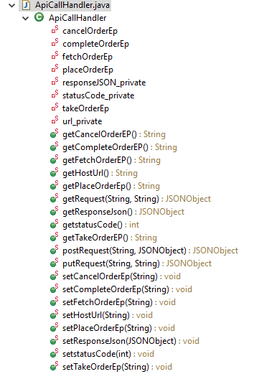

* + Helper methods.java – contains methods to place Order, take Order etc which could be directly used in the test cases. 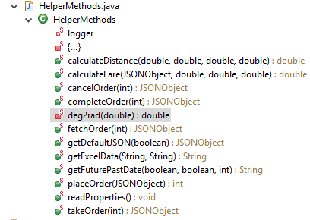
  + ExcelReader.java – This is the utility class containing methods to read excel data.
* Src/test/java -- This folder contains Test classes for different API operations and a total of 37 test cases.

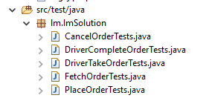

* Test Executor.java – This class contains the main method which executes the testing test cases when executed as runnable jar.

### Configuration, test data and logging

* **config.Properties** file is used to configure some of the global configuration such as app url, endpoints, path of test data file.
* **Test Data** – Test data to be used by test cases have been saved in .xls file containing 3 sheets as of now:
  + TestCaseInputJSON – This sheet contains the test case wise JSON payload data.
  + ErrorMessages – This sheet contains different error messages for various scenarios covered in test cases.
  + VerificationData – This sheet contains additional variable data which is used in the test cases for verifications.
  + Constants – This sheet contains different status related constants used in test cases.
* **Logging –** Log4j library is used for logging. Log4jlogger could be used to modify the level of logging as well as to change the path of output log file.

## Steps to create runnable jar

* Right click on the project and select Export.

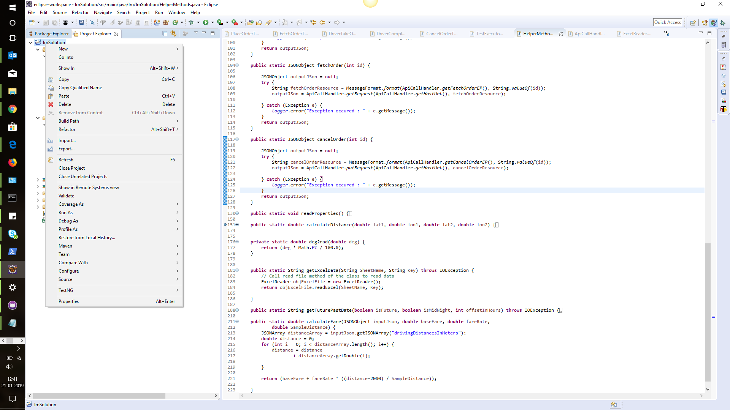

* The wizard to export opens. In that window. Select Java -> Runnable jar file. Click Next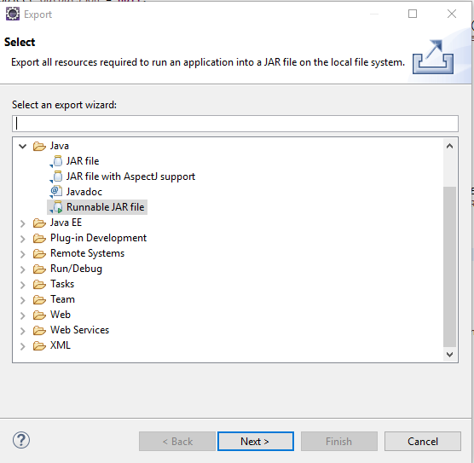
* In the Next screen, configure as follows: 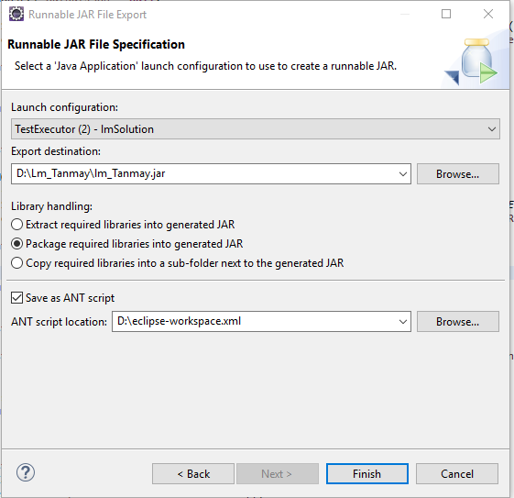  
  Launch of configuration – Select the configuration containing the class having the main() method. This will be the starting point of the runnable jar.  
  Export destination – Select the directory to export to. Click Finish.
* Go to the destination where export is done. Executable jar would be present there.
* Copy and paste the following files from your project folder to jar location as they would be required for execution by the JAR file :
  + config.properties
  + log4j.properties
  + TestData.xls

## Test Case Execution

Test case execution could be done in the following ways:

* **Using TestNg from Eclipse IDE**: In Eclipse, right click on the **testing.xml** file in the project and select TestNG 🡪 Run As 🡪 TestNg Suite. All the test classes specified in the testing.xml file will be executed.
* **Using the Runnable Jar:**
  + Create runnable jar as described in previous section
  + Copy the config.properties, log4j.properties and TestData.xls in same directory as jar file. In case TestData.xls is present in some different directory update the path to excel sheet in the config.properties file.
  + Go to the JAR directory and from there open the command prompt and run the following command: java -jar *<JarfileName.jar>*

## Reports

* In case of both above specified executions there would be “**test-output**” folder created containing the testing reports for the previous execution
* Along with it there would be “**log4j-application.log**” containing the log4j logs for the execution. The name of this file could be changes using the log4j.properties file.

## Test scenarios covered

