Washer Analysis

Tanmay Redkar (2022008)

INTRODUCTION

Nuts, bolts, Washers are the bread and butter of every machine. Our whole life revolves around these simple tools we call fasteners. If any defective washer is used it can cause serious quality control issues. In this paper, I have prepared a python program to automate the process to identify and sort out defective washers. This has been achieved using Image processing tools such as Thresholding, Morphological operations and mathematical operations such as Circularity.

METHODOLOGY

Several pictures of Washers were captured to be used for analysis. All the pictures were cropped to same sizes in order to maintain uniformity in detection. Thresholding was applied on these pictures to filter out redundant information and obtain edges. However, this wasn’t enough as different lighting conditions made it difficult to get the edge-to-edge extraction of the washer. Thus, Morphological operations were performed and circularity of the washer was calculated. All the operations were performed using OpenCV and Numpy libraries in Python.

LITERATURE REVIEW

*A. Edge Detection*

The aim of performing edge detection in general is to

significantly reduce the amount of data in an image, which

will be used in the further processing. This step increases

the computation speed of the approach while preserving

the structural properties of the image. Edge detection in

image processing can be applied to the RGB images and

can also be applied to the grayscale image. Applying on the

grayscale images decrease the computational requirements.

Several algorithms exist for edge detection, such as Prewitt,

Sobel, Roberts and canny are available [10], [11], [8], out of

which the performance of canny is far better. Even though it

is quite old, it has become one of the standard edge detection

methods and is used in our work.

The Canny Edge Detection algorithm consists of five steps:

(1) Smoothing: In this step, the image is blurred to remove

noise, so that it can be used for further processing.

(2) Finding gradients: The edges should be marked where

the gradients of the image has large magnitudes. It means

that the edges where the intensity of the image has an abrupt

change will be marked as an edge.

(3) Non-maximum suppression: Non-maximum is actually

a technique to perform edge thinning. Only local maxima

should be marked as edges, and edges with the values

less than the local maximum are discarded to obtain more

accurate and sharp edge detections.

(4) Double thresholding: Potential edges are determined

by thresholding. Even after the application of non-maximum

suppression, the detected edge pixels are quite good enough

to present the real edge. However, there are still some edge

pixels at this step caused by noise and color variation. In

order to remove the noise caused by these two factors, it is

required to filter out the edge pixels having the weak gradient

value and only preserve the edges with the high gradient

value.

(5) Edge tracking by hysteresis: After performing all the

above steps we obtain almost accurate edges but still there

can be edges which are separate, raising the possibility of the

edges detected caused due to noise, so the final edges will be

determined by suppressing all edges that are not connected

to a very certain or strong edge.

*B. Contour detection*

Contour detection is a technique to find out the boundaries

of pixels with sharp intensity changes. Contours consist of

a set of points connected to each other, most likely to be

located on the outlines of objects. Contour detections take

a binary image as an input which is the output of the

canny edge detector or a binary image obtained by applying

the global thresholding technique on a grayscale image. It

calculates the boundaries of objects, makes a hierarchy of

the object contours to keep the record of the holes inside the

parent objects. This information can be used to extract and draw any contour depending upon the user requirement.

*C. Hough Transform*

The Hough Transform (HT) has been recognized as a

very powerful tool for the detection of parametric curves in

images[12], [13]. It is implemented by a voting process that

maps image edge points into manifolds in a properly defined

parameter space. The Circular Hough Transform (CHT) is

one of the modified versions of the HT. The purpose of

using CHT is to find the circular patterns within an image

scene [14]. The CHT is used to transform a set of feature

points in the image space into a set of accumulated votes

in a parameter space. Then, for each feature point, votes

are accumulated in an accumulator array for all parameter

combinations. The array elements that contain the highest

number of votes indicate the presence of the shape. A circle

pattern is described by

**

where *x*0 and *y*0 are the coordinates of the center and *r* is

the radius of the circle.

C. Circularity

In order to detect or classify objects in images, features

are extracted which are thought to provide discriminatory

information. For example, to detect the presence

of lobular calcifications in a digital mammogram,

knowledge that such calcifications are generally spherical

in shape and of higher density than surrounding

tissue, motivates searching for peaks in the intensity

surface with circular cross section [2]. This settles the

choice of feature, but a method for extracting the feature,

in this case a measure of the circularity of the

region, must be selected also.

Ultimately, the feature measured is defined by the

algorithm chosen for extraction, regardless of the original

intention. The value of the feature in terms of

discriminatory power and its accuracy in representing

the intented feature are really separate issues. In most

cases, however, it is highly desirable to chose methods

of feature extraction which measure the intended feature

faithfully.

In the case of measuring the circularity of an object,

a popular technique is to measure the perimeter and

the area of set of pixels representing the object and to

compute.

OpenCV provides a convenient way to detect blobs and filter them based on different characteristics. There are various different parameters that control the identification process and the results.

A better and cleaner way of detecting if a geometrical shape is of circular shape using circularity

Circularity = 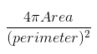

, and decide a threshold such as 0.9, to check if the shape is circular. For perfect circle circularity == 1. You may fine tune this threshold as per your needs.

We used cv2.arcLength to find the perimeter of the contour and cv2.contourArea to get the area of the contour which are required to calculate the circularity.

RESULTS

For Good Washer:

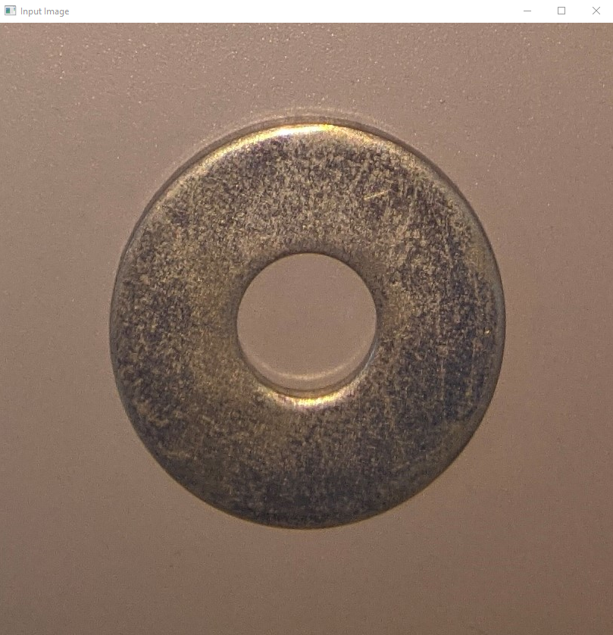

(1) Input image

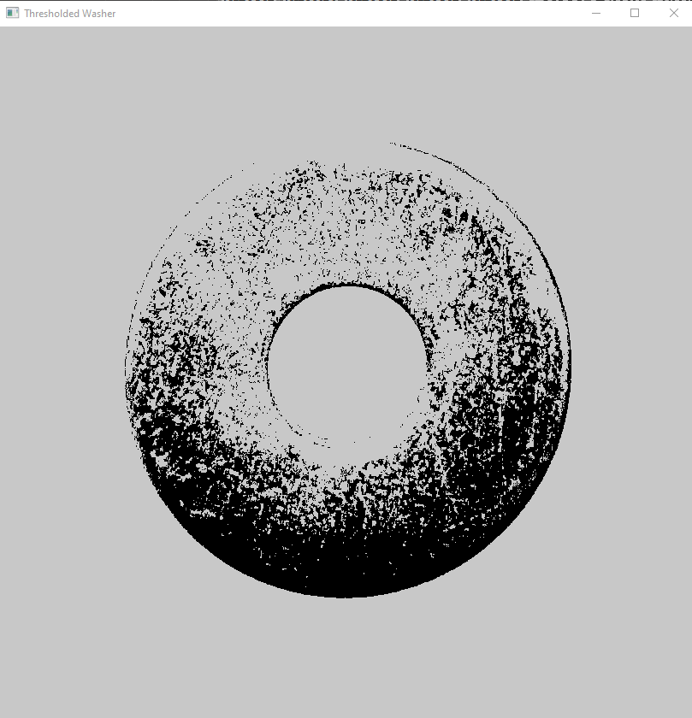

(2) Thresholding

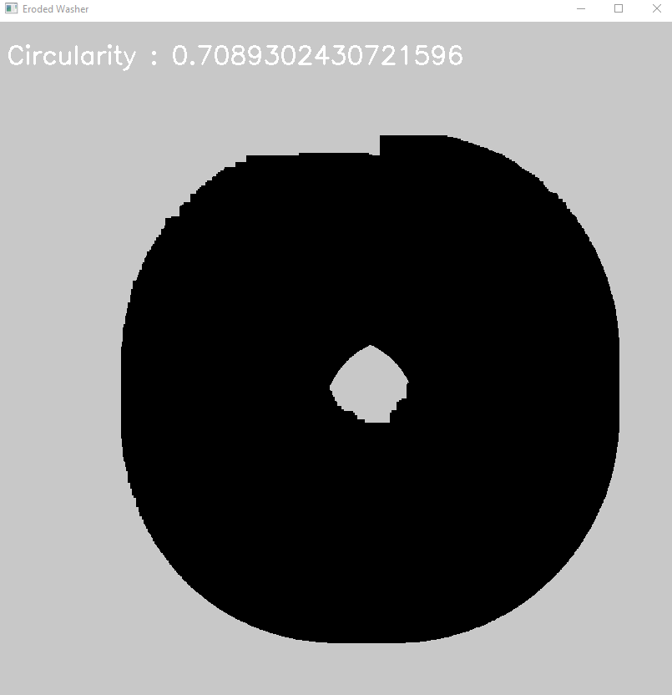

(3) Morphological Operations

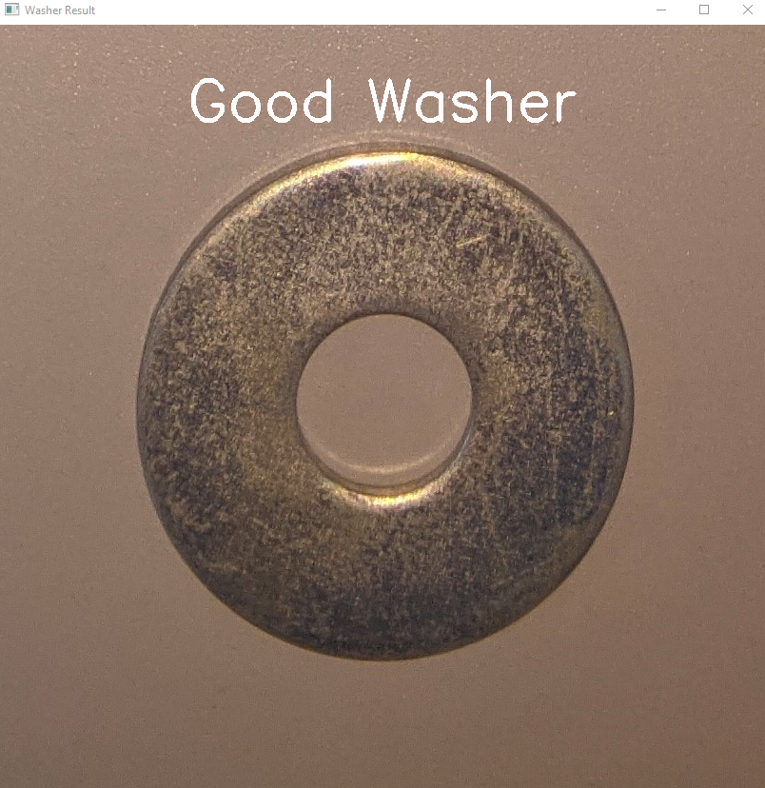

(4) Detected Output

For Defective Washer:

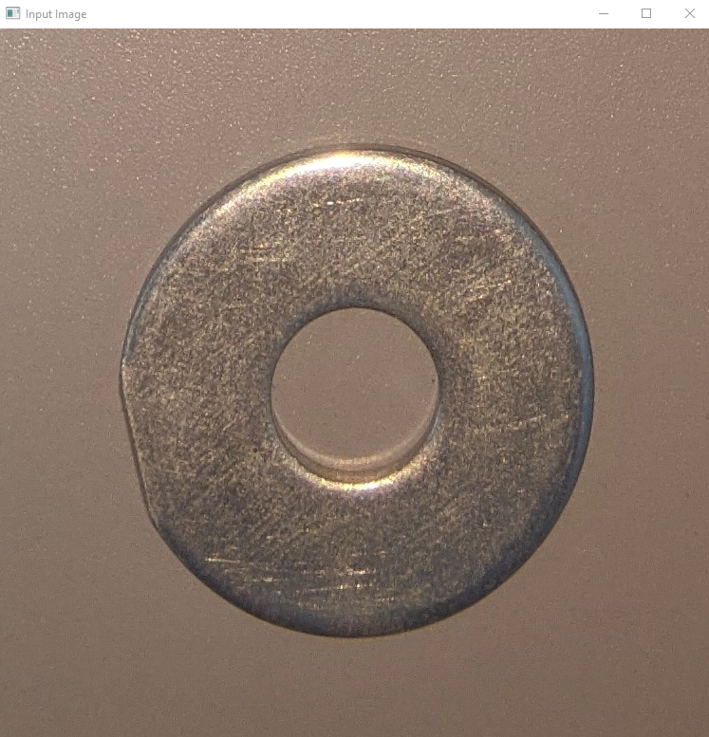

(1) Input image

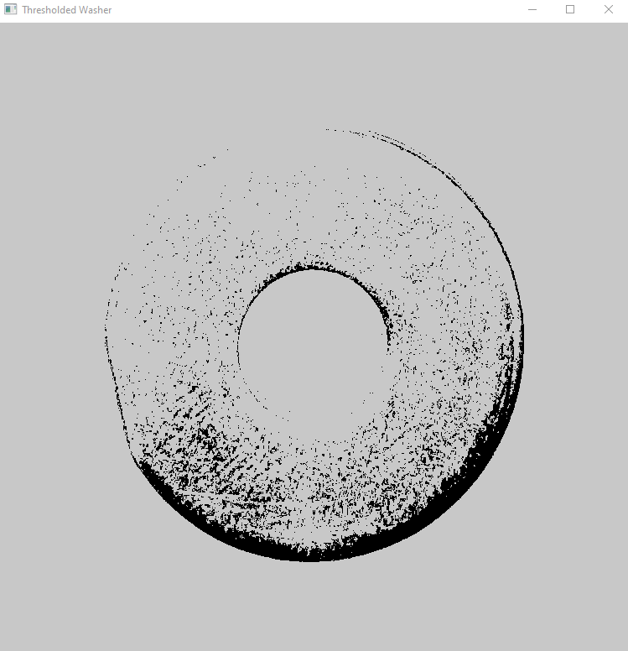

(2) Thresholding

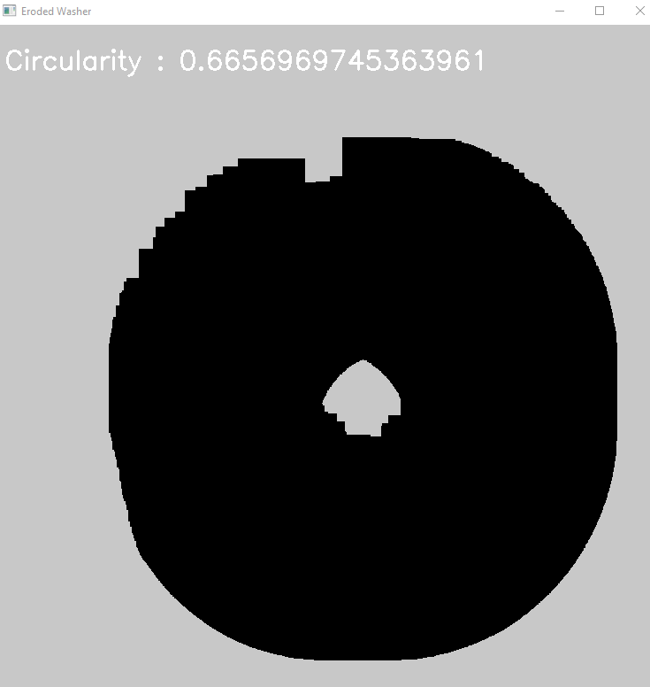

(3) Morphological Operations

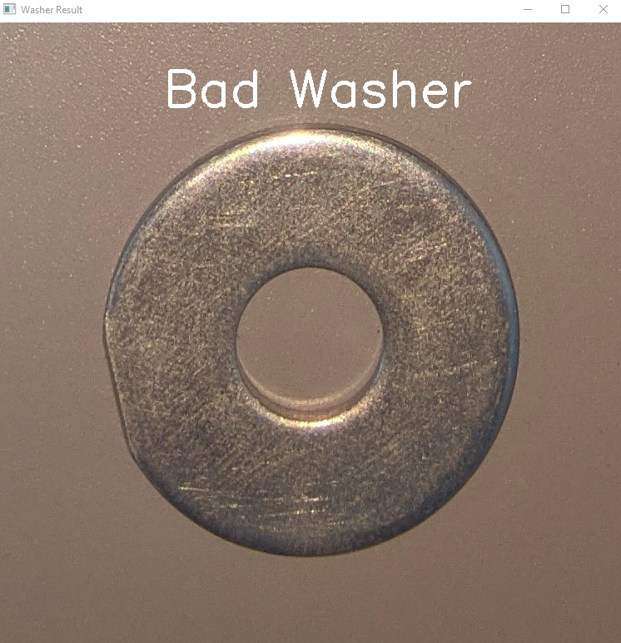

(4) Detected Output

CONCLUSION

It was found that, the perfect Washers had circularity between 0.7 & 1.0 & defective Washers had circularity had circularity between 0.4 & 0.69. Based on this value, it was possible to categorize Good & Defective Washers. This project can be used in Conveyer belts to ensure the Quality Analysis of these simple tools we call fasteners.

APPENDIX

1. https://github.com/tanmay-redkar/washer-analysis-dip.git
2. Application of Python-OpenCV to detect contour of shapes and colour of a real image - Mohammed Khalid Hossen - Memorial University of Newfoundland
3. Automatic detection and counting of circular shaped overlapped objects using circular hough transform and contour detection - Jianjun Ni - Hohai University
4. CIRCULARITY OF OBJECTS IN IMAGES - Murk J. Bottema - School of Information Science and Engineering, Flinders University of South Australia
5. Descriptive analysis of circular data with outliers using Python programming language - N.S. Zulkipli1\*, S.Z. Satari1 and W.N.S. Wan Yusoff1 - 1Centre for Mathematical Sciences, College of Computing and Applied Sciences, Universiti Malaysia Pahang
6. Fast algorithm for Multiple-Circle detection on images using Learning Automata - Erik Cuevasa, Fernando Warioa, Valentín Osuna-Encisob, Daniel Zaldivara and Marco Pérez-Cisnerosa - Departamento de Ciencias Computacionales, Universidad de Guadalajara, CUCEI