Cloud and Web Services Lab

Tanmay Vig 21803003 B12

Eval 2

**Eval 2**

Ques 1.

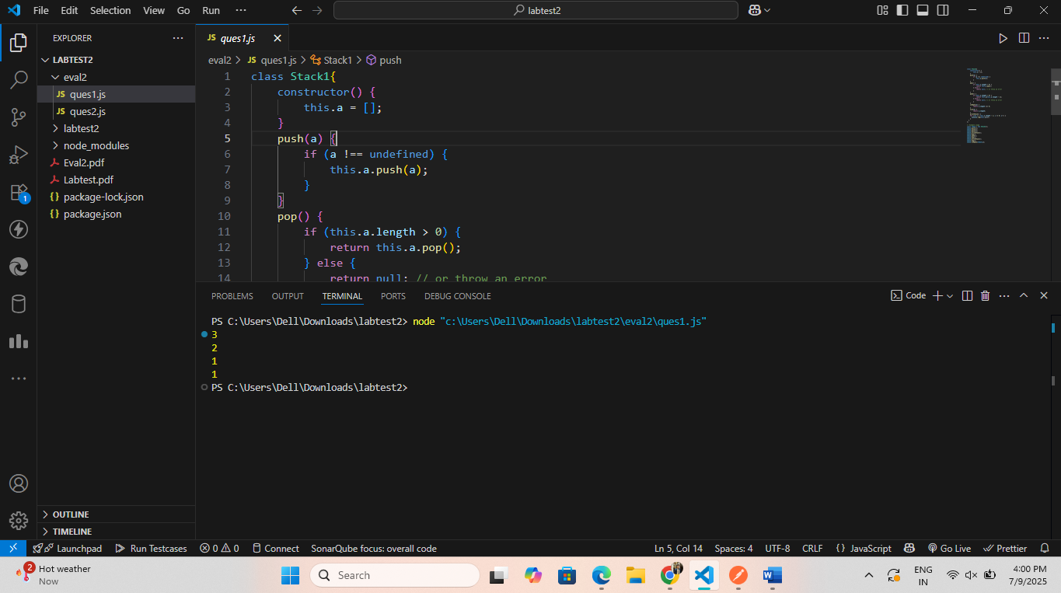

Ques 2

