**Bansilal Ramnath Agarwal Charitable Trust’s**

**Vishwakarma Institute of Technology, Pune-37** *(An autonomous Institute of Savitribai Phule Pune University)*



**Department Of CSE (AI)**

**Lab Manual**

|  |  |  |  |  |
| --- | --- | --- | --- | --- |
| Name | Roll No. | PRN No. | Email ID | Phone No. |
| Tanmay Walke | 65 | 12210091 | tanmay.walke22@vit.edu | 9004319217 |
| Yashsinh Bhosale Patil | 41 | 12211763 | bhosale.patil22@vit.edu | 7715851208 |

Class: - TY Branch: - CSE(AI)

Year: - 2024-25 Prepared By: - Tanmay Walke,

Yashsinh Bhosale Patil

Group – 5

Batch – 01

**Experiment Number: 01**

**Title:** Setting up small computer network and Hands-on networking commands:

**OBJECTIVES:**

1. To learn how to setup a wired and wireless network and understand working of various internetworking devices

2. To learn the network commands

**PROBLEM STATEMENT**

Setting up small wireless computer network and hands-on networking command:

Hands on for network commands - ping, pathping, ipconfig/ifconfig, arp, netstat, nbtstat, nslookup, route, traceroute/tracert, nmap.

**THEORY: TYPES OF NETWORK**

Common examples of area network types are:

**Local Area Network (LAN):**

LAN is privately owned networks use to interconnect computers within a single building or campus up to few kilometers in size. For the LAN, diameters spans over 550 meters to 2.5 Kilometers. Nowadays organizations have Campus Wide Network which is an extension of LAN using OFC at backbone and diameter IS up to 10 Kilometers. LANs are setup using IEEE802.3 standard. (**Active**).

**Wide Area Network (WAN):**

WAN is a telecommunication or computer network span over the area often country or continent. WAN: 100km to 1000 km Country and Continent. Uses Packet Switching and Data Switching Exchanges. Uses IEEE 802.1 standard.

**Personal Area Network (PAN):**

PAN is the interconnection of mobile devices within the range of an individual person. typically within a range of 10 meters. PAN : 10 meters. Uses IEEE 802.15 standard (**Active**).

**Internet:**

The Internet is the global system of interconnected computer networks that use the Internet protocol suite (TCP/IP) to link devices worldwide. Internet is WAN hence covers Country, Continent or entire planet. Uses Packet Switching and networks are connected by routers.

**Internetwork:**

Connecting homogeneous or heterogeneous LAN and MAN to extend network reach. Uses IEEE 802 standards. It covers LAN/MAN architecture, internetworking among 802 LANs, MANs and wide area networks, 802 Link Security and 802 overall network management

**Network Architectures:**

**Client – Server:**

**Server:** Powerful (High End) machine consisting databases, applications, Internet Protocol servers (Blade Server) at central place. **Client:** Employee having low end machine to access the information.

**Peer to Peer** Network**:**

A network of computers configured to allow certain files and folders to be shared with everyone or with selected users. Peer-to-peer networks are quite common in small offices that do not use a dedicated file server.

**Distributed Network (DN):**

Distributed network is a distributed computing network system in which computer programming functionality and the data to be worked on are spread out across more than one computer. Usually, this is implemented over a computer network.

**Software Defined Networking (SDN):** Software-defined networking (SDN) technology is an approach to computer networking that allows network administrators to programmatically initialize, control, change, and manage network behavior dynamically via open interfaces and abstraction of lower-level functionality**.**

**Infrastructure network:**

Infrastructure mode supports central connection points for clients. An Infrastructure mode network requires the use of an Access Point. The Access Point controls Wireless communication and offers several important advantages over an Ad-hoc network. For example, a Infrastructure based network supports increased levels of security, potentially faster data transmission speeds and integration with a wired­ network.

**Ad-hoc network:**

An Ad-hoc network allows each device to communicate directly with each other. There is no central Access Point controlling device communication. Ad-hoc networks are only able to communicate with other Ad-hoc devices, they are not able to communicate with any Infrastructure devices or any other devices connected to a wired network. In addition, Ad-hoc mode security is less sophisticated compared to an Infrastructure mode.

**Part A: Study of network devices:-**

1. **Network Hub:-**

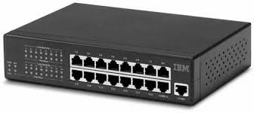 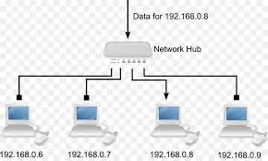

**Introduction:** A network hub is a basic networking device that connects multiple computers or other network devices together in a local area network (LAN). Hubs operate at the physical layer (Layer 1) of the OSI model, and they function as a central point of connection. When a data packet arrives at one port, it is copied and sent out to all other ports on the hub, regardless of the destination. Hubs do not filter or process any data, making them less efficient than more advanced devices like switches.

**Use Cases:**

* Small home networks or very basic LAN setups.
* Educational purposes, to demonstrate simple network communication.
* Environments where monitoring or capturing all traffic is needed.

**Comparison with Other Devices:**

* **Hub vs. Switch:** Hubs are less efficient than switches, as they broadcast data to all devices, while switches send data only to the intended device.
* **Hub vs. Router:** Hubs work at the physical layer and are used for internal network communication, while routers work at Layer 3 and connect different networks.

**Connection Diagram:** A hub is connected to multiple devices in a star topology, where all devices connect through the hub.

1. **Network Switch**

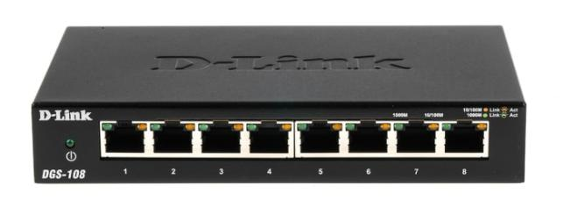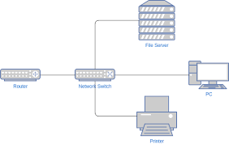

**Introduction:** A network switch is a more intelligent networking device than a hub. It operates at the data link layer (Layer 2) of the OSI model and can forward data only to the device that it is intended for. Switches maintain a MAC address table that allows them to know which devices are connected to which ports. This reduces unnecessary traffic and improves network efficiency.

**Use Cases:**

* Commonly used in modern LANs for businesses and homes.
* Data centers and enterprise networks where efficient traffic handling is critical.
* Networks with high data traffic where reducing congestion is important.

**Comparison with Other Devices:**

* **Switch vs. Hub:** Switches only forward data to the device intended, reducing collisions and improving efficiency, whereas hubs broadcast to all devices.
* **Switch vs. Router:** Switches are used for internal device communication within the same network, while routers connect different networks together.

**Connection Diagram:** A switch is connected to multiple devices in a star topology, like a hub, but with more efficient data handling.

1. **Router**

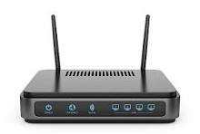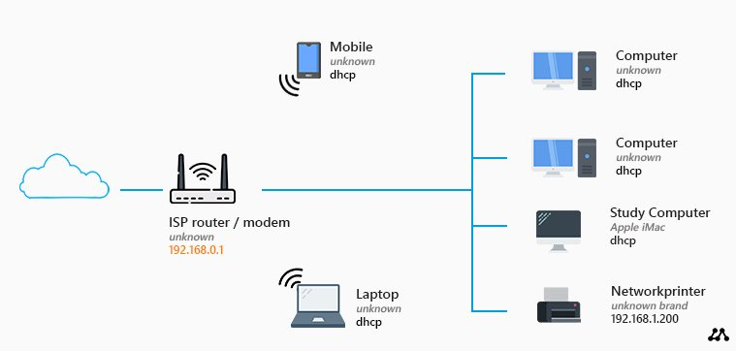

**Introduction:** A router is a network device that operates at the network layer (Layer 3) of the OSI model. Its primary function is to route data between different networks, such as between a local area network (LAN) and a wide area network (WAN). Routers determine the best path for data to travel, often using IP addresses to forward packets to their destination.

**Use Cases:**

* Connecting different networks, such as a home or office network to the internet.
* Managing traffic between multiple subnets in an organization.
* Setting up network security through firewalls and VPNs.

**Comparison with Other Devices:**

* **Router vs. Switch:** A switch operates within a single network (LAN), while a router connects different networks and routes traffic between them.
* **Router vs. Gateway:** While both devices connect different networks, gateways often act as translators between different network protocols.

**Connection Diagram:** A router connects a local area network (LAN) to an external network, such as the internet, often through a WAN interface.

1. **Network Gateway**

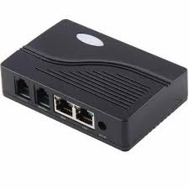 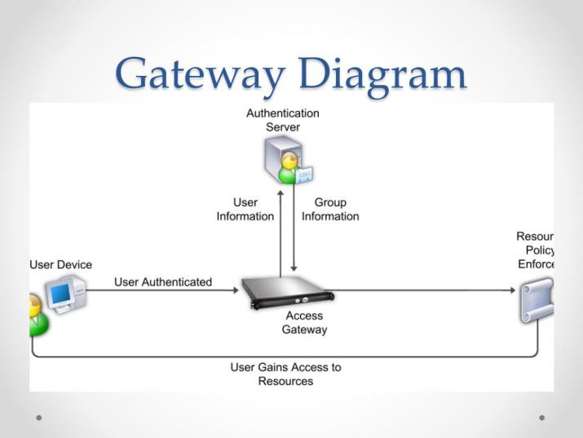

**Introduction:** A network gateway is a device that acts as a translator between different network architectures or protocols. It operates at multiple layers of the OSI model, from Layer 3 (network) to Layer 7 (application), depending on the function it performs. Gateways are used to connect two networks that use different protocols, such as between a corporate network and an external network with different communication standards.

**Use Cases:**

* Connecting two networks with different communication protocols.
* Acting as a firewall or proxy in corporate environments.
* Enabling communication between IoT devices and traditional computer networks.

**Comparison with Other Devices:**

* **Gateway vs. Router:** While both connect different networks, a gateway also translates different network protocols, whereas a router forwards packets based on IP addresses.
* **Gateway vs. Switch:** Gateways work at higher OSI layers to manage protocol conversion, while switches manage communication within the same network.

**Connection Diagram:** A gateway connects two different networks and translates the data being passed between them.

**Part B: Network Router Configuration and small network formation.**

Router name and description:-

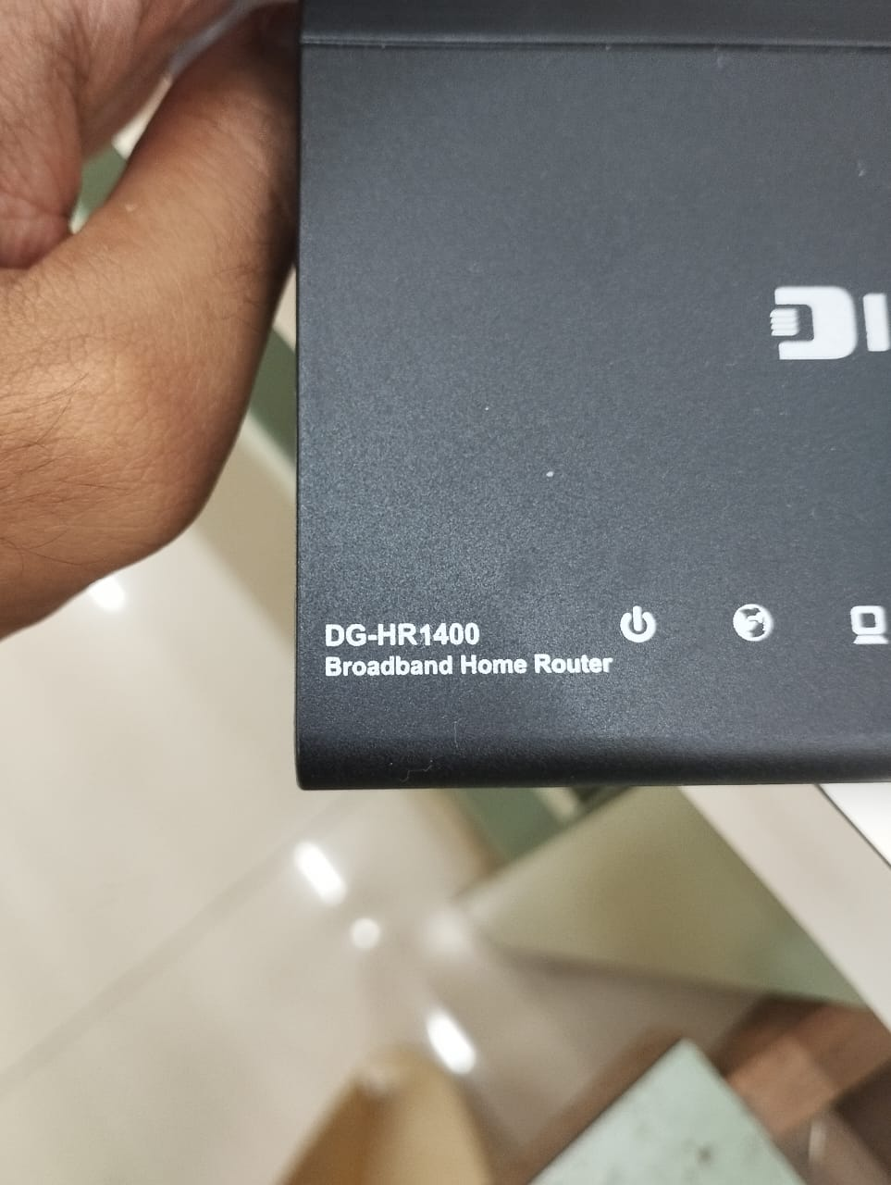

Procedure and its screenshot:-

1. Check the router configuration from the below side of your router.

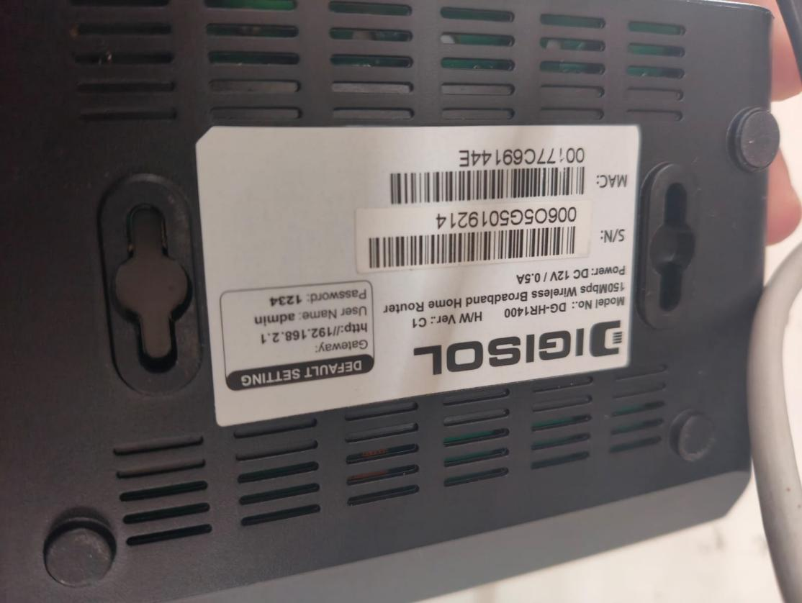

1. Go to the IP address/gateway which is written on the backside of your router on your chrome and login.

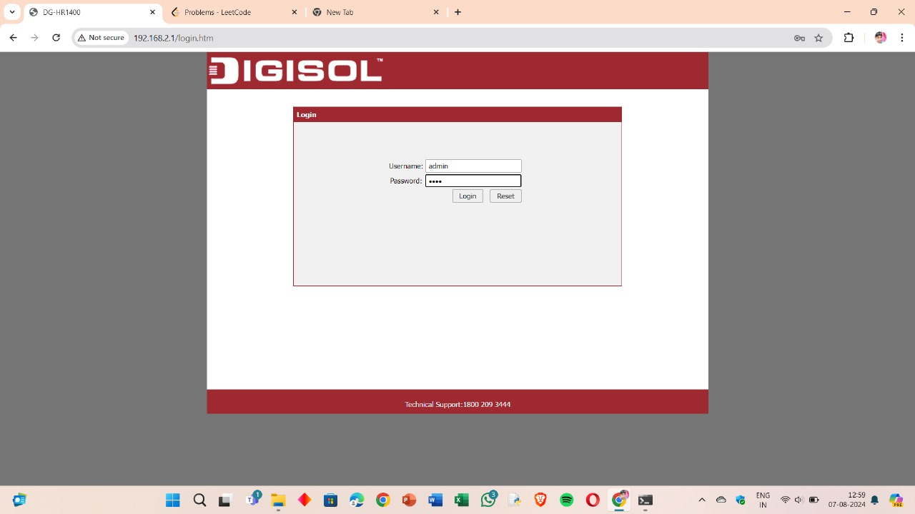

1. After you login the index.htm page will be visible where u can see the wireless router status, System configurations, LAN,WAN & WLAN configurations.

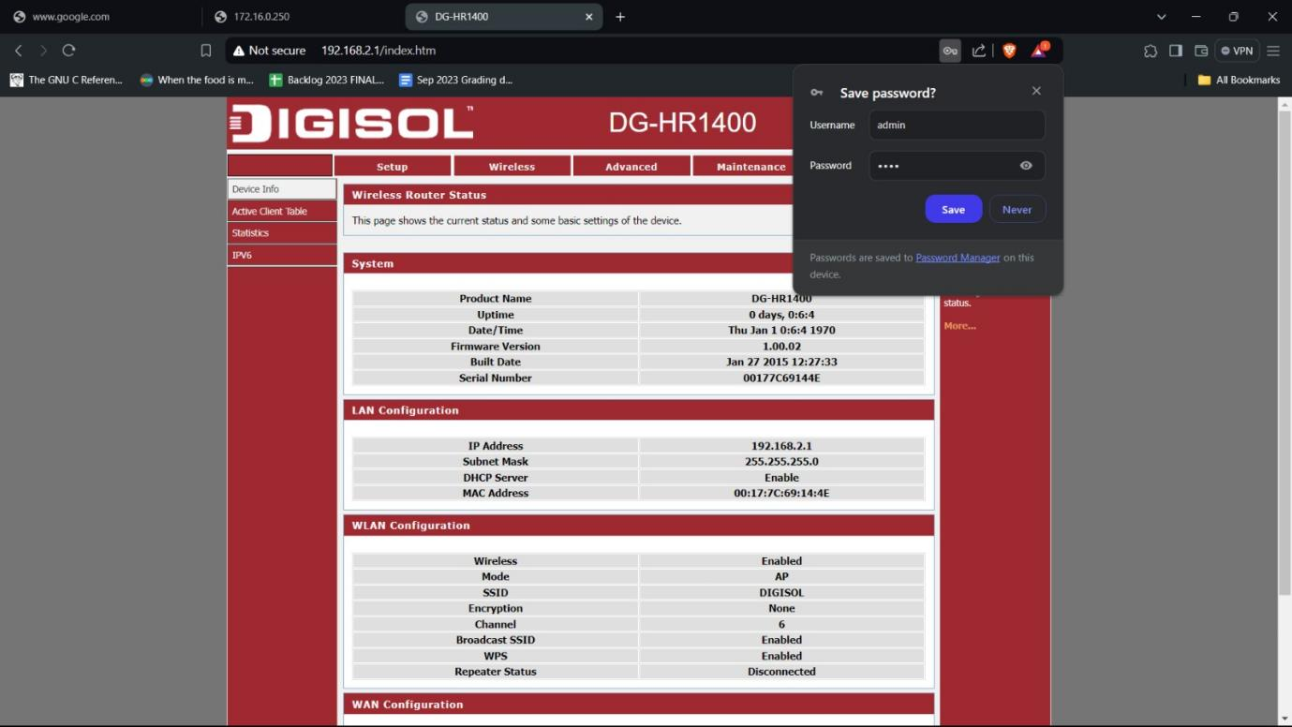

1. You can see the setup by going into wizard tab.

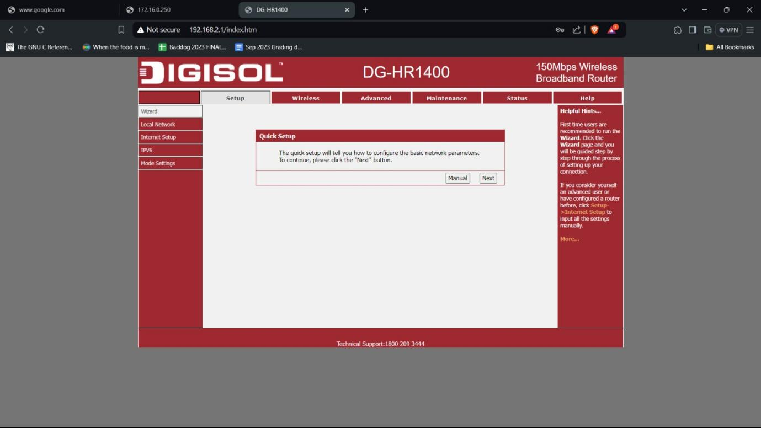

1. Now in Internet Setup , set the DNS servers.

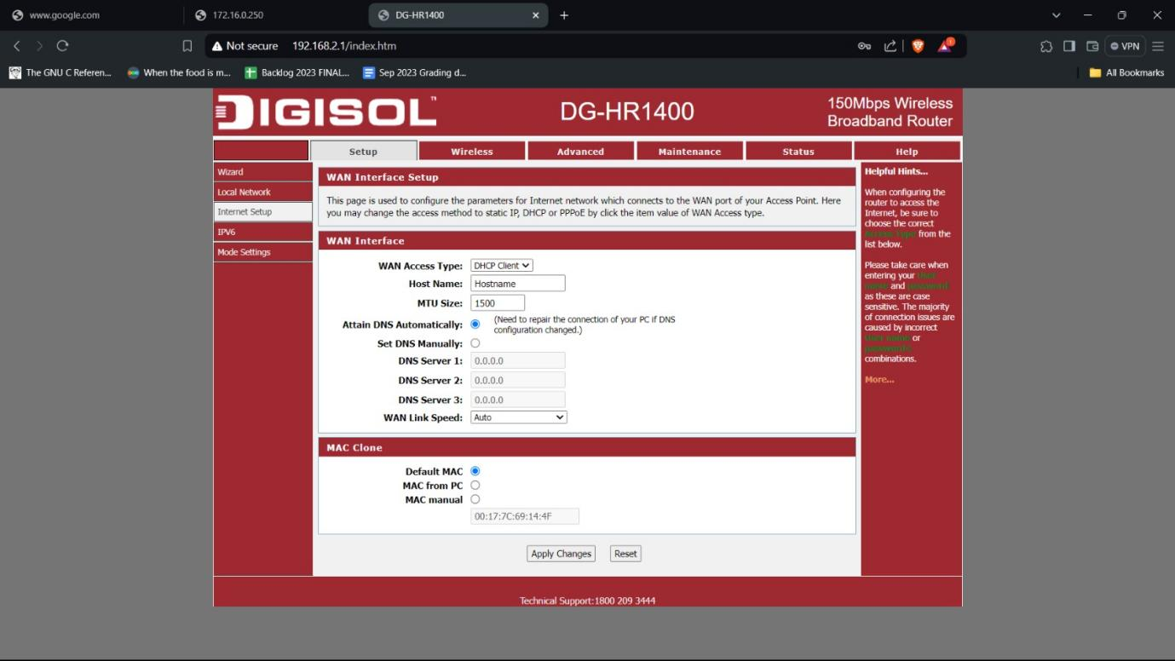

1. Now change WAN Access type to static IP and enter the DNS server1.

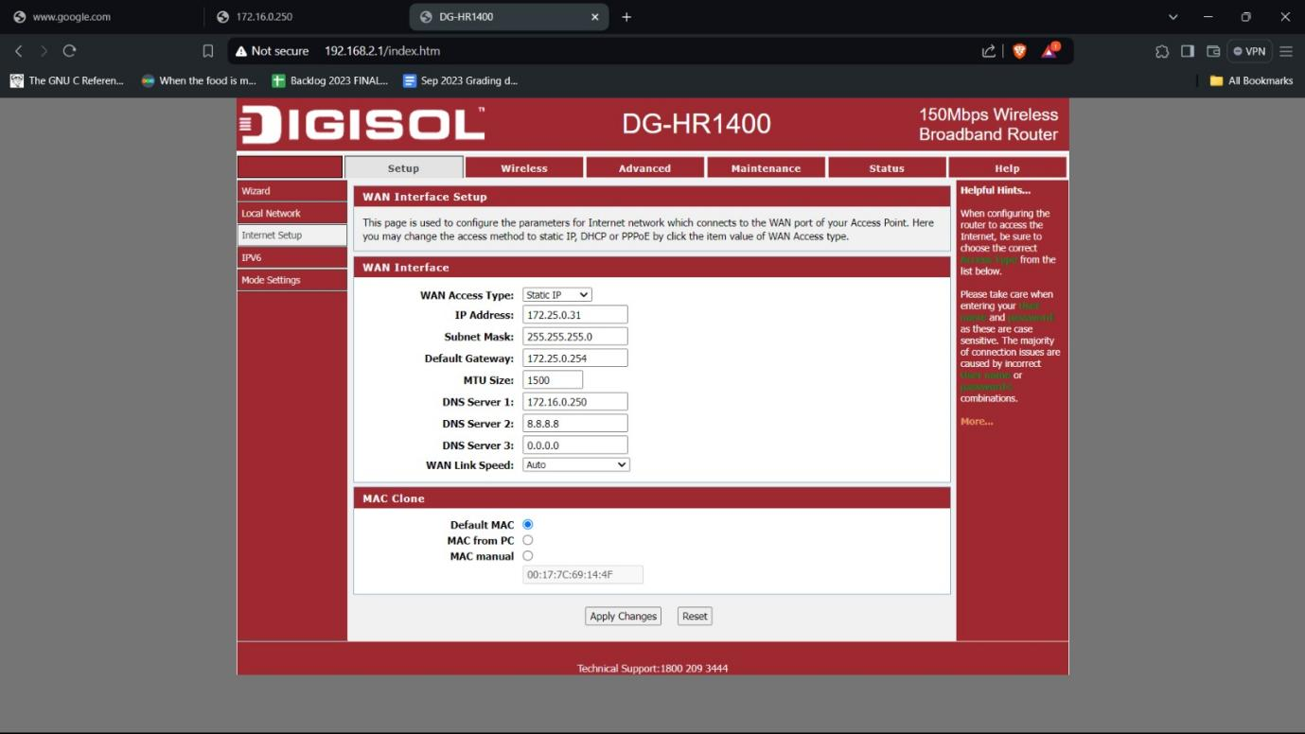

1. Click on apply changes and you will be directed to index.htm page.

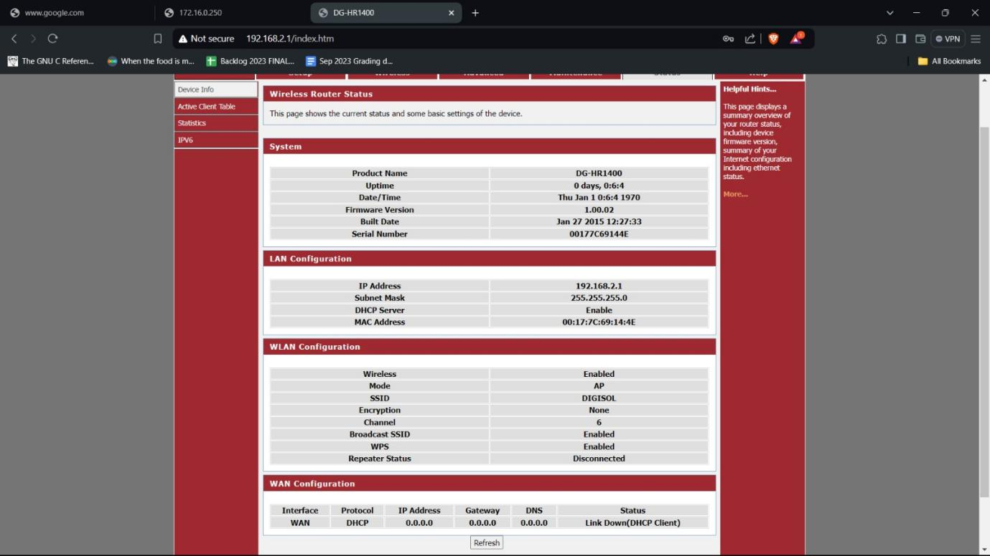

1. Now test it by searching any website on chrome.

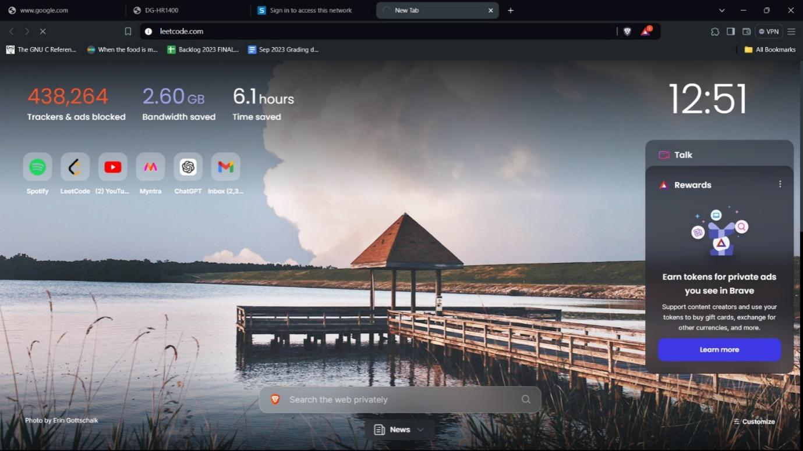

1. As you can see the site can’t be reached because we still haven’t logged in httpclient server.

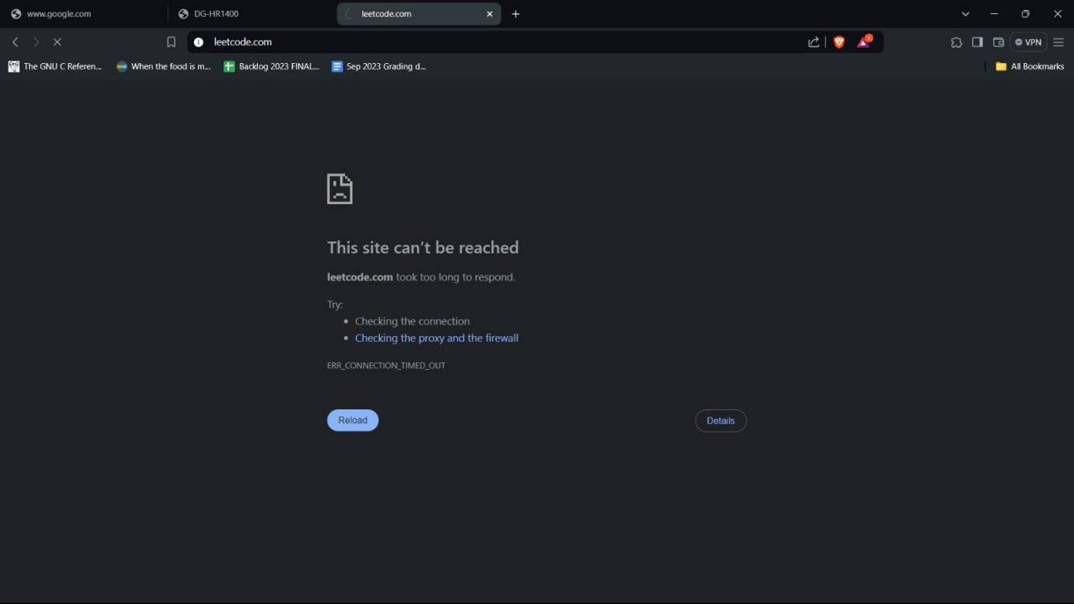

1. Login into your http client server.

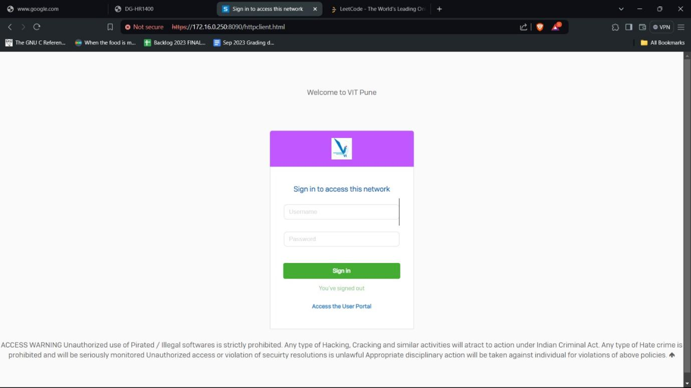

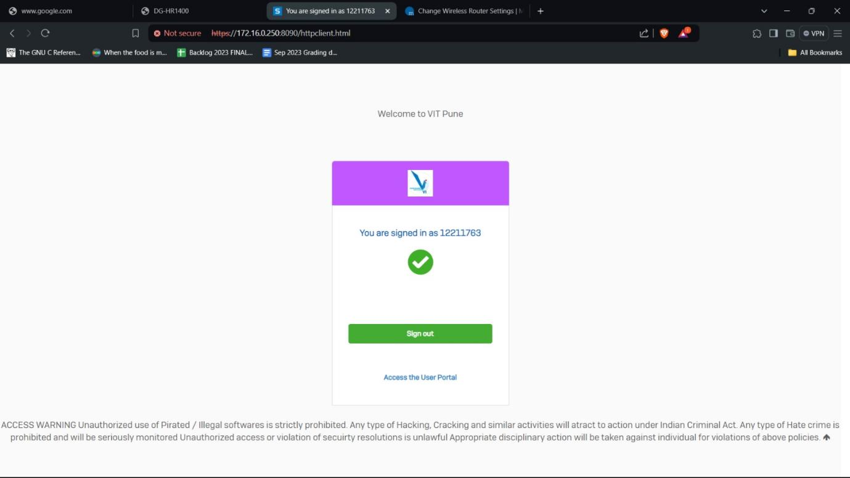

1. Now your internet is setup and you can search any site for testing.



**Part C: File Transfer:-**

Process and results:-

1. Go to your device settings and in system settings enable the nearby sharing option.

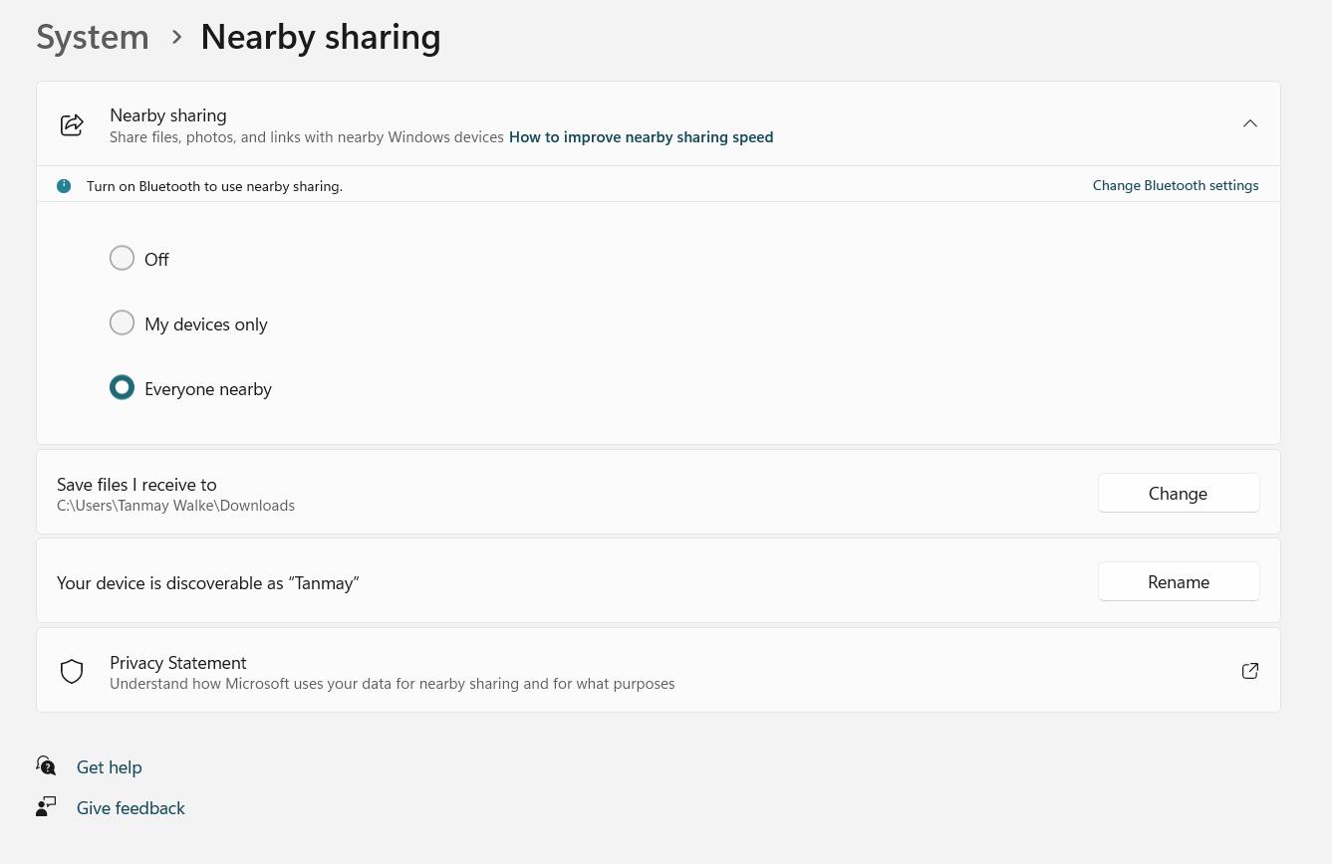

1. Right click on the image to be shared, then click on share button and select the receiver’s device name.

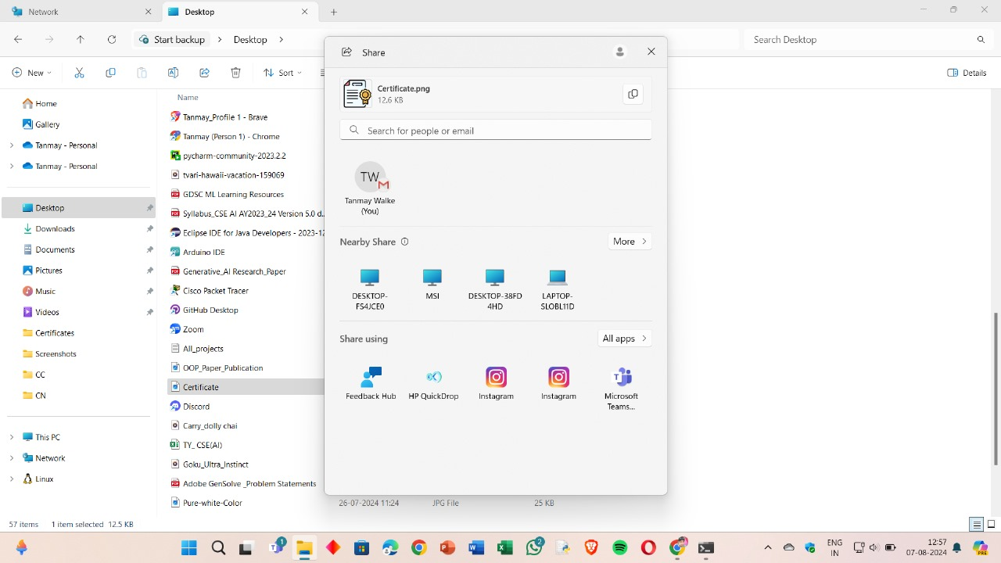

1. A notification shall pop up that the file is being transferred.

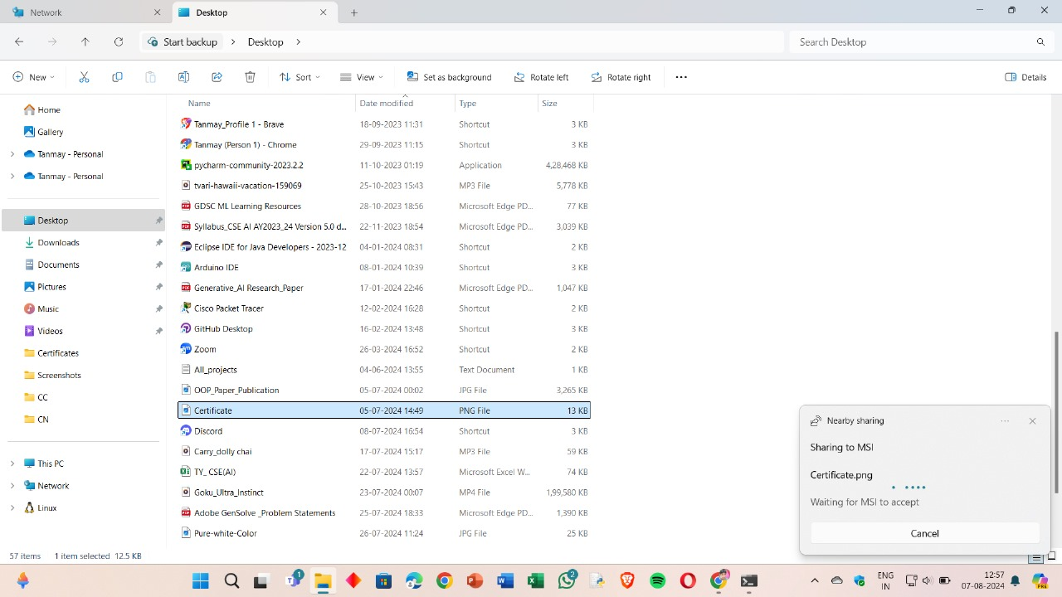

1. The receiver shall also receive a notification that the file is being shared.

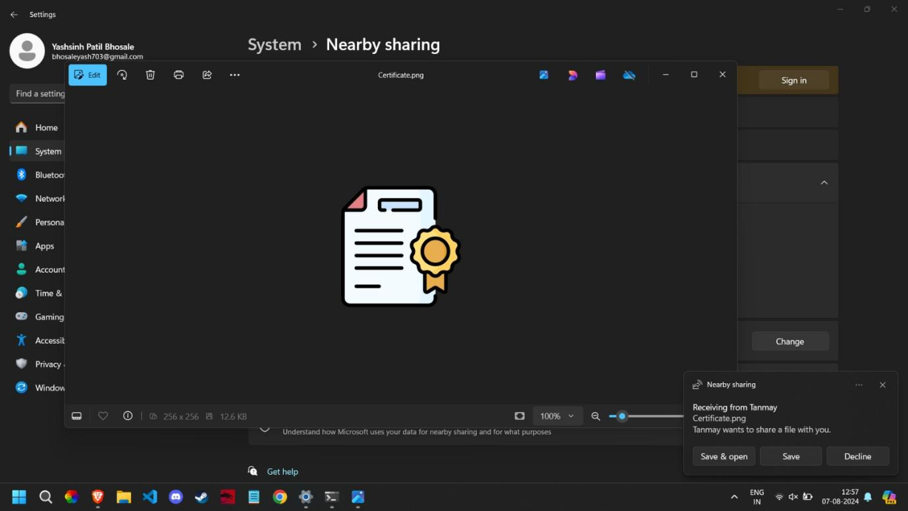

1. The receiver may save the file to their device.

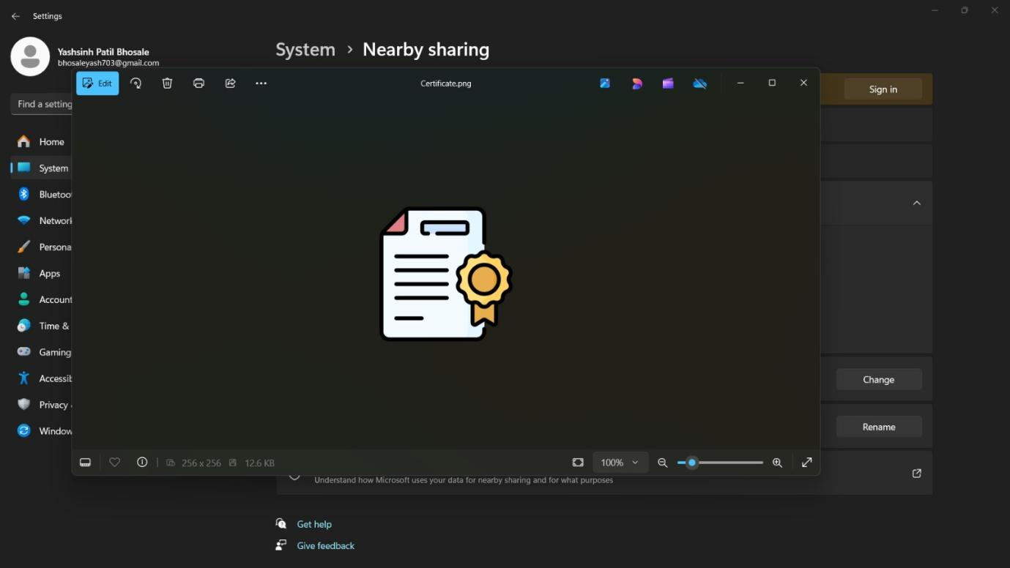

**Part D: Network commands**

Network commands are used to configure, manage, and troubleshoot network connections and devices on a system.

Some of the networking commands are as under:-

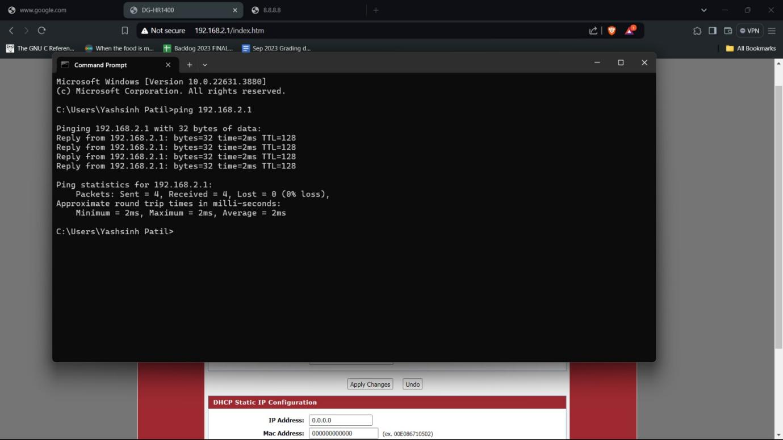

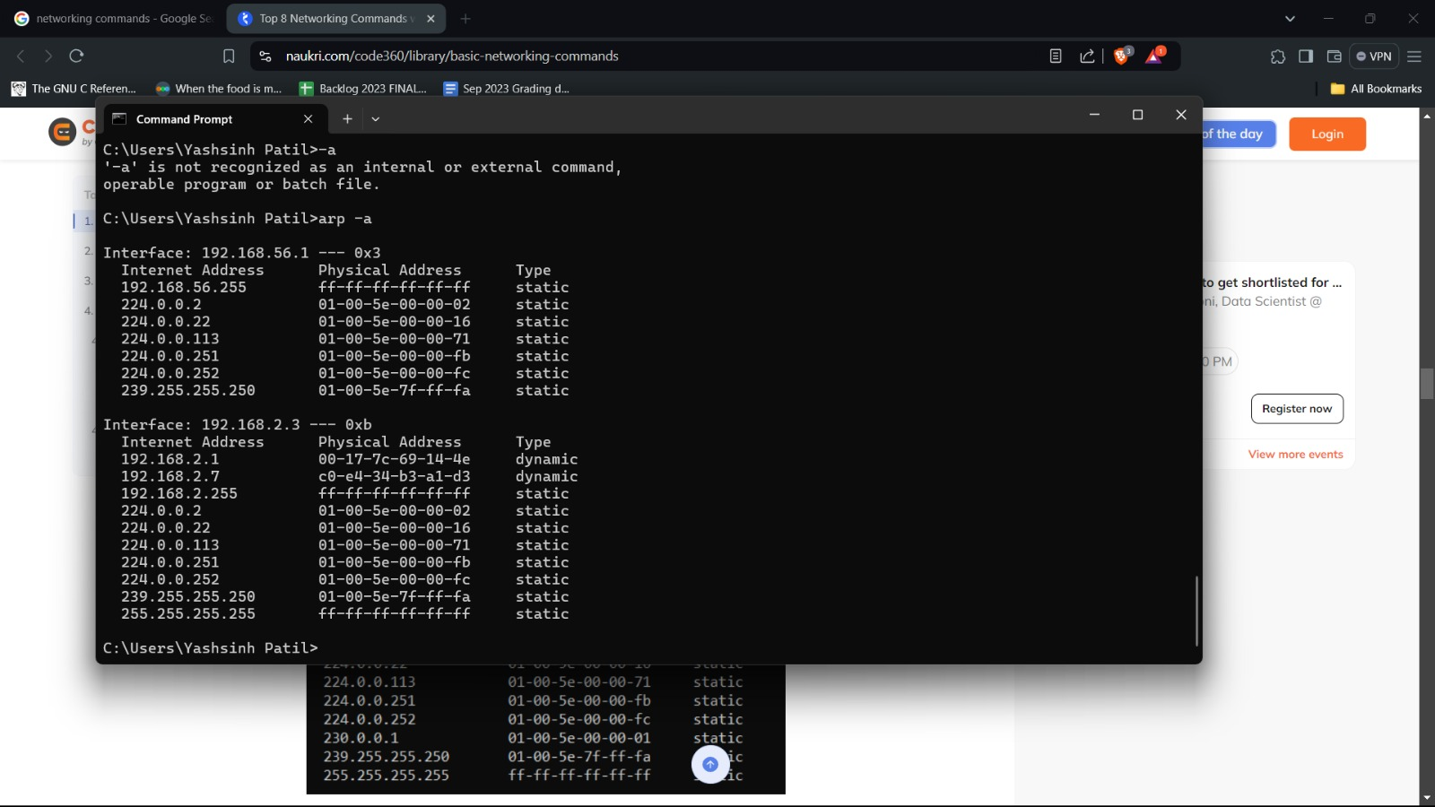

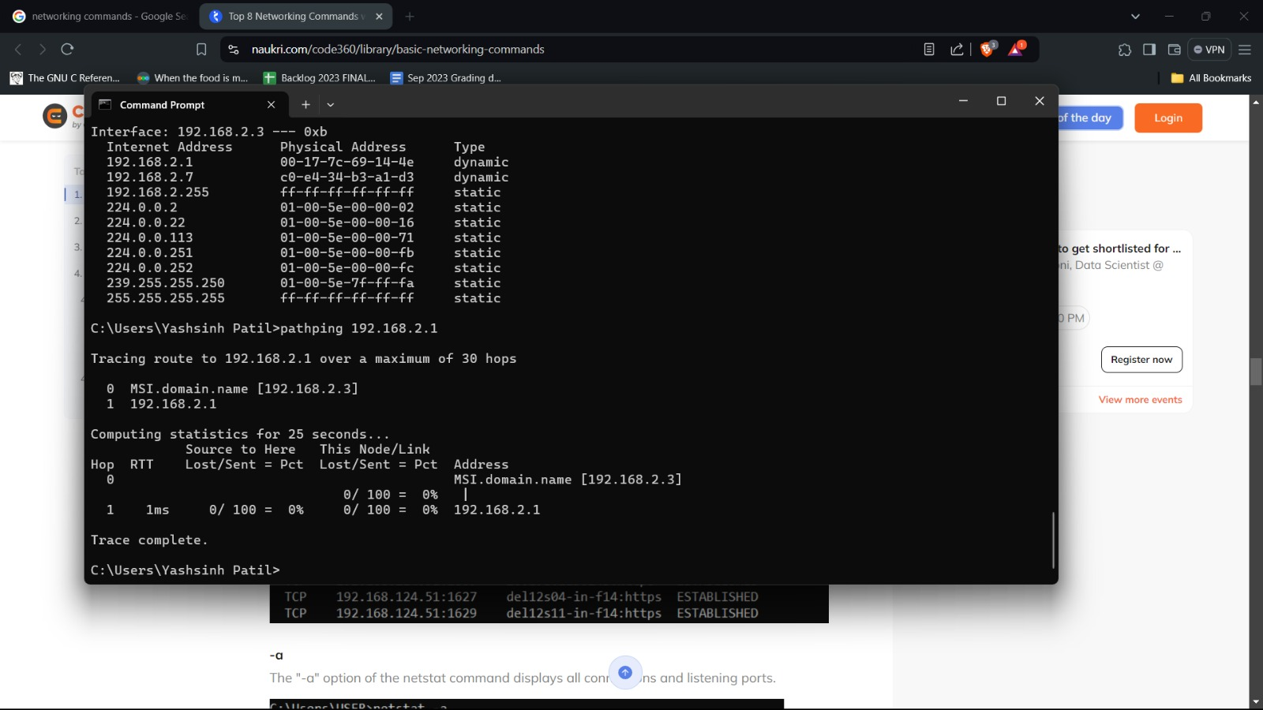

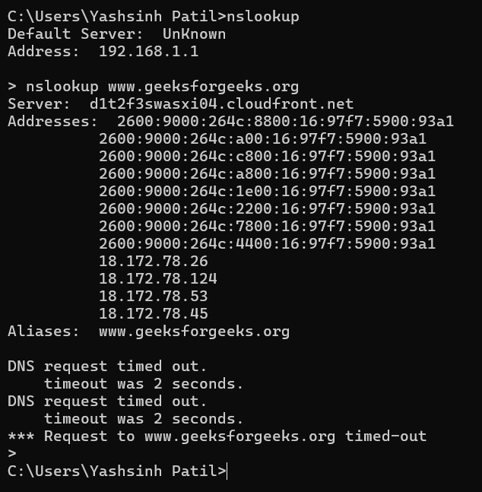

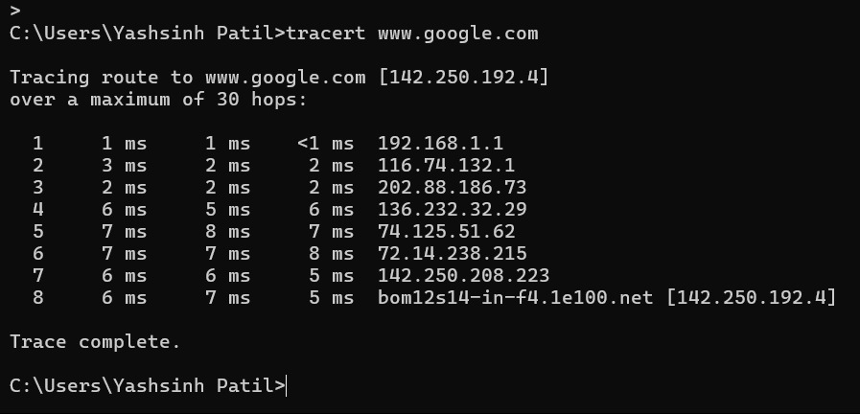

**tracert** :This command can be understood as trace root. Which tells that our computer reaches or hits which-which server for reaching the particular root. Here again we will search for geeksforgeeks site and it tells us the path taken by our computer to reach the root server. It tells us in maximum of 30 hops (30 node to node delivery).

We can search by giving the IP address and destination site name also.

**nslookup** :This command is use to transform the given searched words into their corresponding IP addresses. Such as if i search for geeks for geeks website then our browser don’t search for geeks for geeks. It search’s the corresponding IP address associated to the geeksforgeeks site.

**arp** :The arp command is a short form for Address Resolution Protocol. This command is used to display and modify the IP to the physical address translation table used by the address resolution protocol. It has many options, of which a few are to display current ARP entries, specify an internet address, delete a host in the ARP table, specify a physical address, and many more.

**-a :**The "-a" command in arp displays current ARP entries by interrogating the current protocol data. If inet_addr is specified, the IP and physical addresses for only the specified computer are displayed.

**pathping**: PathPing command is a combination of ping and tracert command. It sends request to each routers that comes between source and destination and compute result based on response from each router. It provide continues monitoring of the network path which allow network administrator to observe changes in performance.